Program:

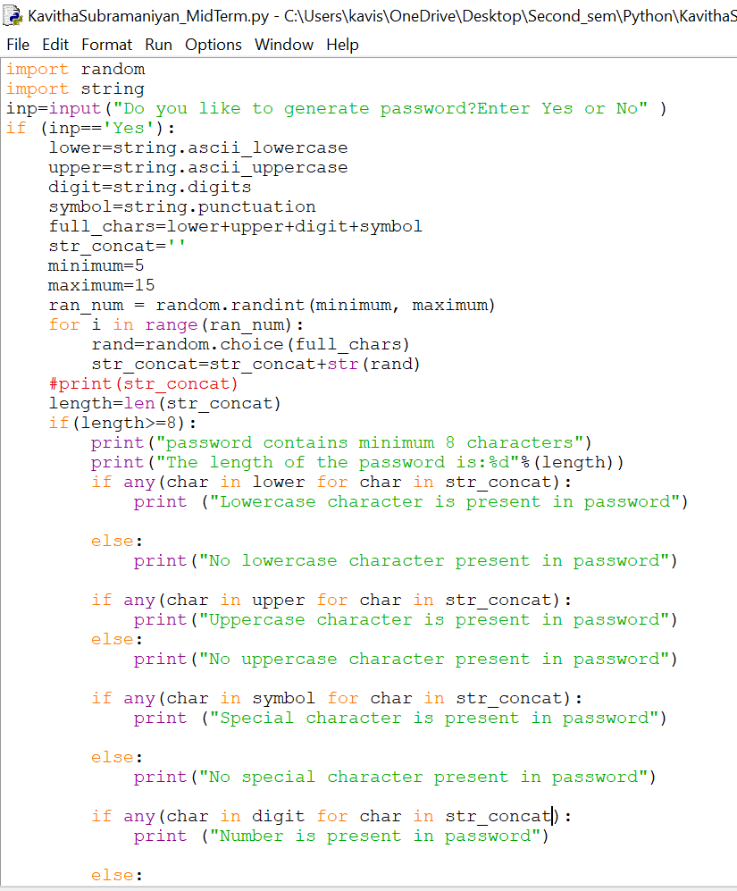

1.Getting input from user:

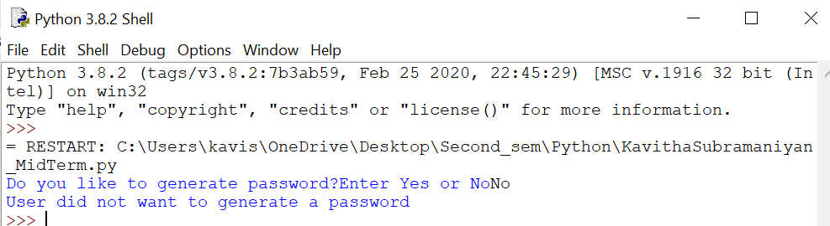

2.Getting input from user and generating valid password

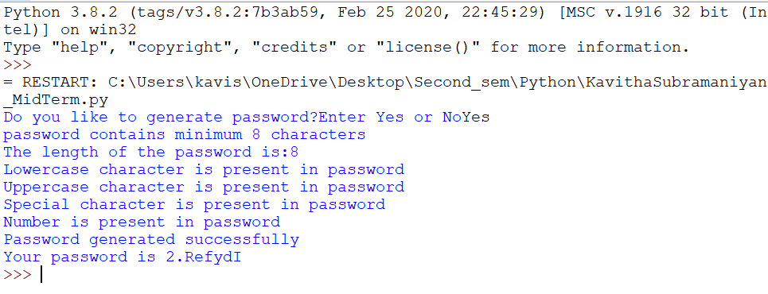

3.Getting input from user and generating password which does not meet password policy:

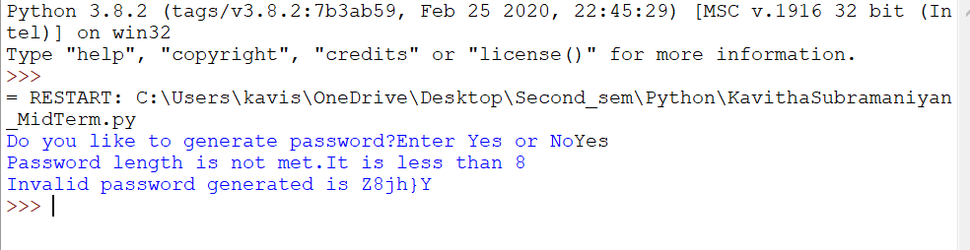

4.Getting input from user and generating valid password:

