***Name:Kavitha Raji Subramaniyan***

***Date:6/9/2020***

***Lab_Num:1***

***Course_Number:ITMD513***

***Program:***

from datetime import datetime#Importing datetime

start_time = datetime.now()#Taking the current time

import pandas as pd#Importing pandas library

import numpy as np#Importing numpy library

from math import sqrt#importing sqrt method from math module

cols=['Appliances','KW/Hr','Annual_Use']#Creating column names for each input we get in run-time

appl_name=[]#Creating list for collecting appliance name

appl_cost=[]#Creating list for collecting cost per KW-hr

appl_usage=[]#Creating list for annual usuage

count=input("Enter the count of appliances:")#Using input function to get input from user

count=int(count)#changing to int type

for i in range(count):#Initializinf for loop from 1 till length of count variable

appl_name1=input("Please enter the appliance name:")#Input from user for appliance name

appl_name.append([appl_name1])#Appending the input value to list

appl_cost1=input("please enter the cost per KW - hr of the appliance (in cents):")#Input from user for cost per KW-hr

appl_cost.append([appl_cost1])#Appending the input value to list

appl_ann_usage1=input("please enter the annual usage (in KW - hr):") #Input from user for annual usage

appl_usage.append([appl_ann_usage1])#Appending input value to list

#Creating dataframe and assigning column names for respective columns

df=pd.DataFrame(np.column_stack([appl_name, appl_cost, appl_usage]),columns=cols)#Using np.column_stack to stack the input as columns to make a single 2D array

df[['KW/Hr','Annual_Use']]=df[['KW/Hr','Annual_Use']].astype(float)#Converting the column type to float

df['total_cost']=df['KW/Hr']*df['Annual_Use']#Multiplying the KW/Hr and Annual_Use columns and assigning to new column 'total_cost'

total_cost_sum=df['total_cost'].sum(axis=0)#Using sum function to find the total of total_cost column

print("Total Annual Cost $%.2f"%(total_cost_sum))#Printing the total annual cost upto two decimal places.

items=len(df)#Finding the length of the dataframe

kw_hr_sum = df['KW/Hr'].sum(axis=0)#Finding the sum of KW/Hr column

#print("The sum of total KW/Hr is %.4f"%(kw_hr_sum).astype(float))

kw_hr_avg=kw_hr_sum/items#Finding the average ofkw_hr column

print("Average $%.4f"%kw_hr_avg)#Printing the average

df['Variance']=pow((kw_hr_avg-df['KW/Hr']),2)#Finding the variance and assigning value to variance column

variance_sum=df['Variance'].sum(axis=0)#Taking the sum function and applying for variance column

variance=variance_sum/items#Taking the variance_sum and dividing by length of dataframe

print("Variance $%.4f"%(variance).astype(float))#Printing variance value

print("Standard deviation $%.4f"%(sqrt(variance)))#Printing standard deviation

end_time = datetime.now()#Taking current time

print('Duration: {}'.format(end_time - start_time))#Printing the run time of the program

***Screenshot:***

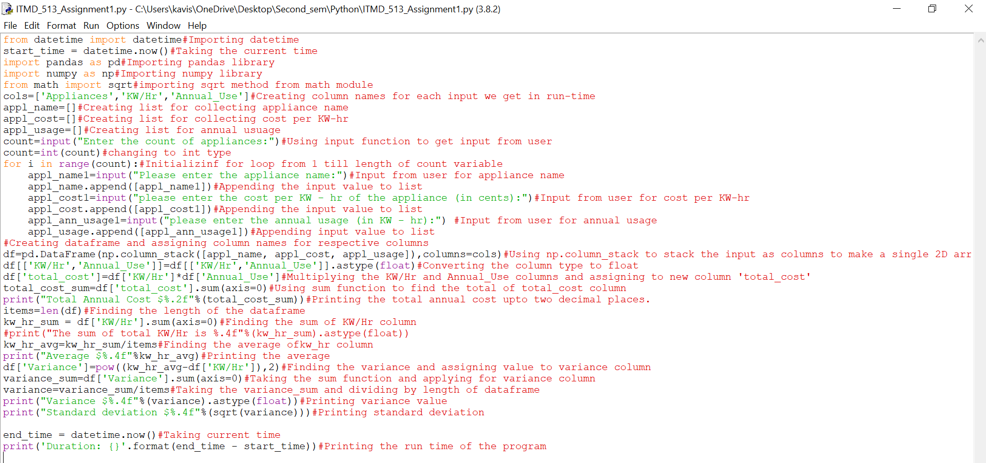

***Output Screenshot:***

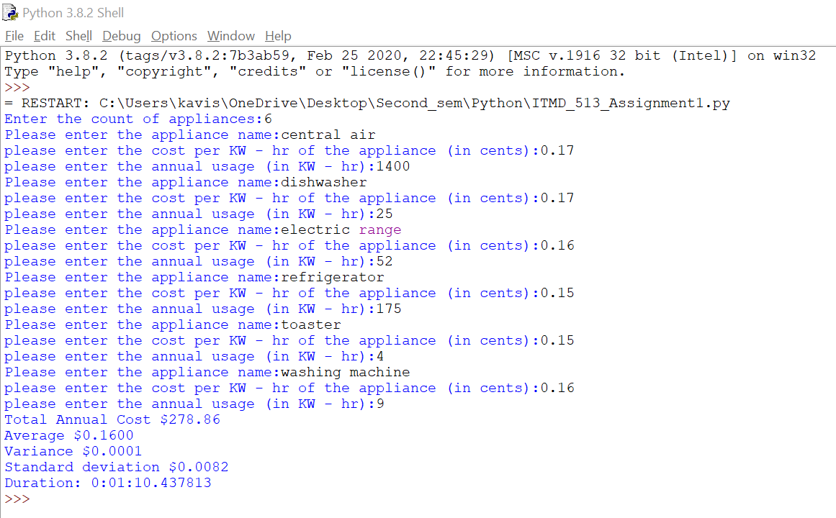

**(1)** What is meant by Sequential Program Control?

Sequential Program control is about line-by-line execution as how it is written in program. It is used to maintain the program flow in a controlled manner.

**(2)** Without using selection control or repetitive control, how would you modify the program to account for a coupon, for a new energy - saving appliance, that the program user can implement to lower the total cost?

We can get coupon code as an input from the user in run-time. After the input is read,

the corresponding coupon code can be applied on the total cost which in turn subtracts the coupon code amount from total cost,thus lowering the total cost.

**(3)** What is the purpose of adding comment statements?

1.Comment statements are very helpful in knowing what each line of code does.

2.Provides extra information as why and how each line is derived.

3.Comments also helps in understanding what the program does when we revisit the code after a long time or when a different user tries to work on our code.

**(4)**What is the function of the interpreter?

Python interpreter is used to run the python script. It reads the script line by line and converts script into byte code,and then writes byte code into pyc file.Once the first pyc file is loaded into memory,interpreter executes the file instruction by instruction .During this stage,runtime errors are created if code generates such errors.The standard interpreter for python is in C.

**(5)** Why is it important to test your program?

After code development, it is necessary to test the program as testing ensures how well the code works as per the requirement. We need to prepare the test cases and run the code against each test case and check if the requirement is met.