***Name:Kavitha Raji Subramaniyan***

***Date:6/12/2020***

***Lab_Num:2***

***Course_Number:ITMD513***

BMI Calculation Program:

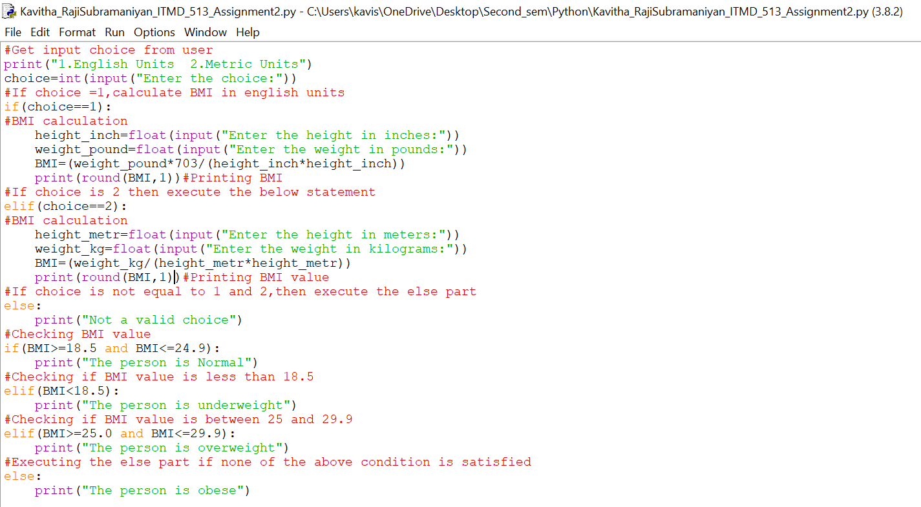

Output:

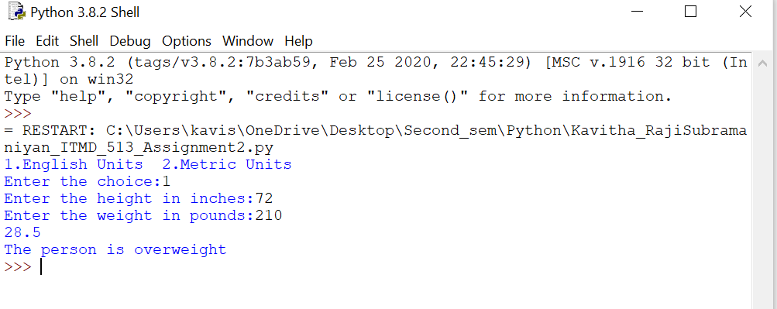

Questions:

**(1)** What is meant by variable declaration and initialization?

Variable declaration: We use variables to tell if the data is string,integer,list etc.To manipulate this data,we do through variables.

Initialization:First,we initialize a variable by creating container and assign it a name.Secondly,we assign value to that variable which is assignment.

**(2)** Explain how selection control is used in your program code for this application.

We use If condition to check the choice entered by user as input.Based on the choice,the program will compute the BMI value.Now,again using if condition the value of BMI is checked to identify if the person is obese/normal,overweight,underweight.

**(3)** This program application made use of an **if - elif - else** statement block. Could you also have coded this application with just a sequence of one - way **if** statements? Explain your answer.

We can code this application with one-way if statement,but the conditions to check BMI value for obese,normal,overweight,underweight cannot be specified explicitly.So,for proper functioning of this application,we need to go with if-elif-else statement.

**(4)** Which kinds of datatypes were used for the variables in your application?

To get the choice from the user,we used integer datatype.To get the height,weight from the user,we used float variables.

**(5)** What have you learned from performing and coding for this lab assignment?

The multi-way If statement is the most efficient of all since one or more alternative conditions can be given.This is made possible using ‘elif’(a combination of else and if).In our application,the bmi value is checked first if it is >=18.5 and <=24.9.If the value does not fall in this range,it checks if it is less than 18.5,even if this condition failes,it checks the next condition in sequence which is if bmi between 25.0 and 29.9.And if none of the conditions meet,then else part is executed.