Program:

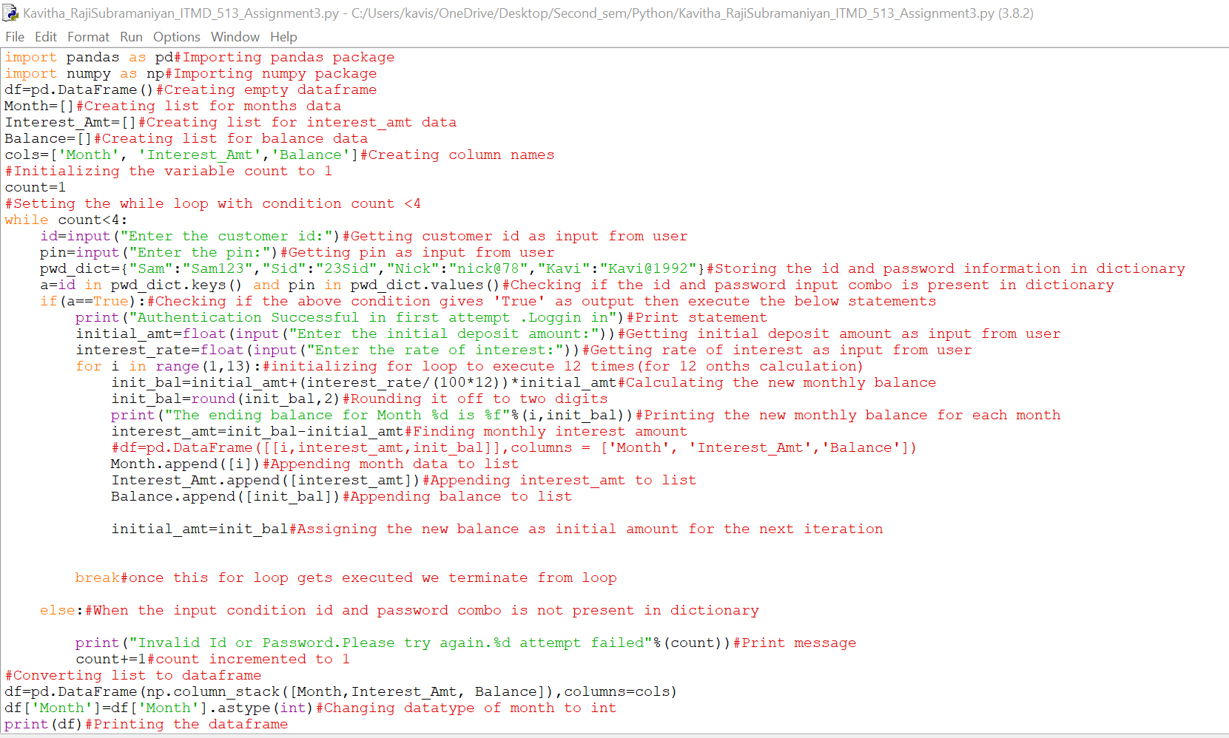

Output:

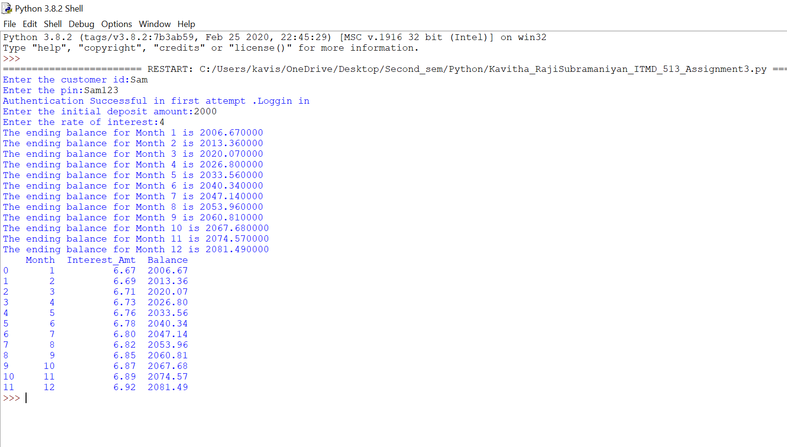

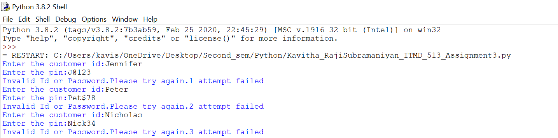

Questions:

**(1)** Explain how looping techniques ( repetitive program control ) are used in this program application.

* We use while loop to make sure if the user and password combination is successful. If the first attempt is not successful, we let the user to try for another two more attempts.
* For loop is used in this program to iterate and compute the interest and current balance for all 12 months.

**(2)** Loops often incorporate accumulating variables which amass a sum that builds every time the loop is executed. Did your application include any accumulating variables? What amount(s) were accumulated?

Yes,we use one accumulating variable in the program.

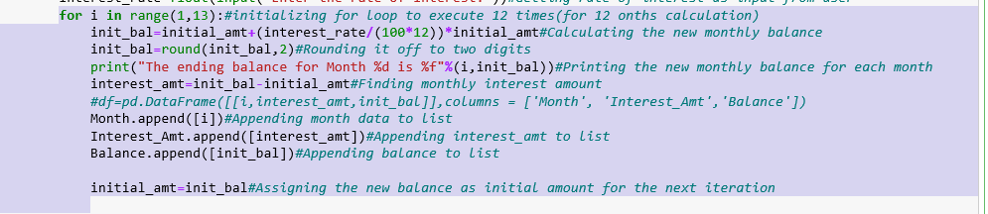

Here, the init_bal variable will hold the initial amount the user gives at run-time and some calculated amount.This value is then assigned to initial_amt which will take the total amount as initial amount for the second iteration and the loop goes on until the 12th iteration completes.

Also,we use count variable which will get added up for each iteration.

**(3)** Prior to their use in a looping structure, accumulating variables are often declared and initialized. For an accumulating sum variable, what is the typical value for which the variable is initialized?

* We use count variable which is initialized to 1 and then incremented for each iteration.
* While loop starts with checking if the count variable value is less than 4.Once it succeeds, the loop gets executed and does the operation specified within the loop.When the count variable reaches 4,it breaks the loop and exits the program.

**(4)** Which datatype is the following variableassociated with?

**success = False**

The success variable is associated with the boolean datatype. The ‘True’ or ‘False’ values represent the Boolean value.

**(5)** What have you learned from performing and coding for this lab assignment?

Learnt Looping statements by coding this lab assignment.

While loop:

while loop is used to execute a block of statements repeatedly until a given a condition is satisfied. And when the condition becomes false, the line immediately after the loop in program is executed.

For loop:

The for statement is used to iterate over the elements of a sequence.

It’s traditionally used when you have a piece of code which you want to repeat n number of time.

The for loop is often distinguished by an explicit loop counter or loop variable.