**(1)**Run option 3 and add in yourself as a employee when prompted. Include your name appropriately, rate of pay and hours worked and have the data added to your **employees.txt** file.

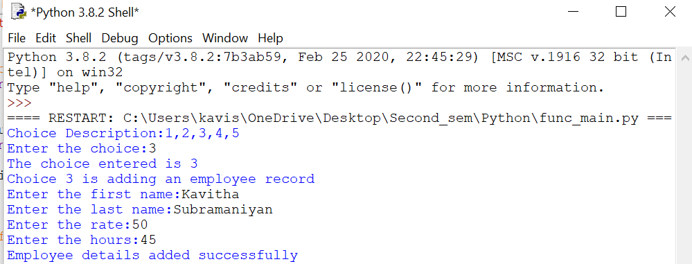

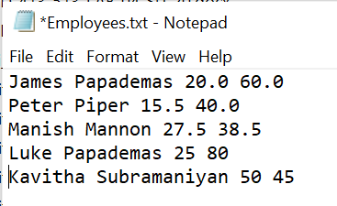

**(2)** Run option 4 and delete Peter Piper from the **employees.txt** file.

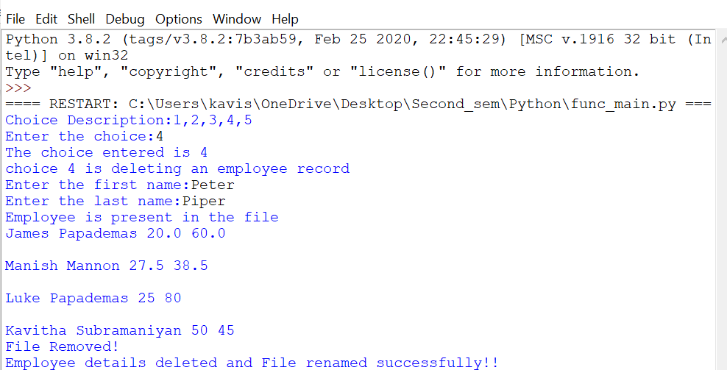



**(3)** Run option 4 again and attempt to delete Peter Jones, a former employee from the file. There should be an error message to the screen to show the employee does not exist.

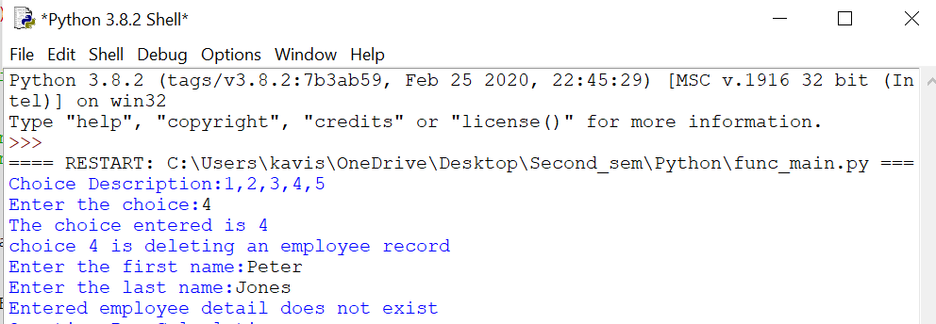

**(4)** Run option 5 modify Manish Mannon and change his pay rate to 21.22 .

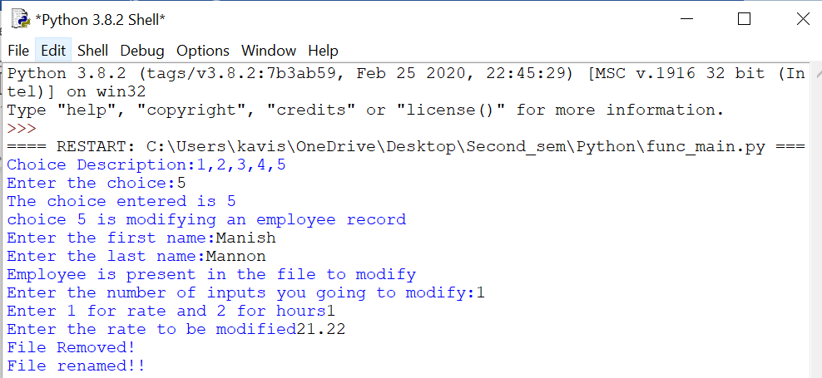

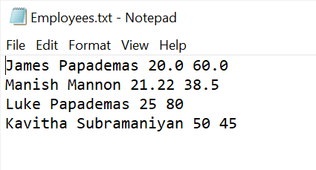

**(5)** Run option 2 and show the employee result for Manish Mannon.

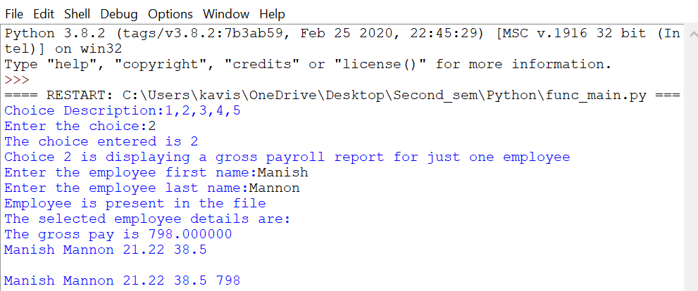

**(6)** Run option 1 and show all employee results.

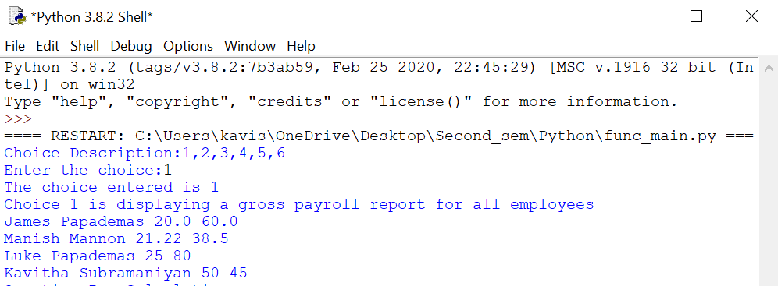

**7)Over-time pay calculation:**

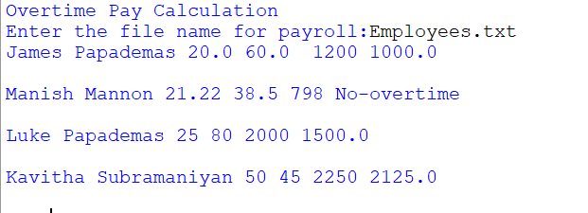

**8)Error Message when no payroll is found:**

