Program:

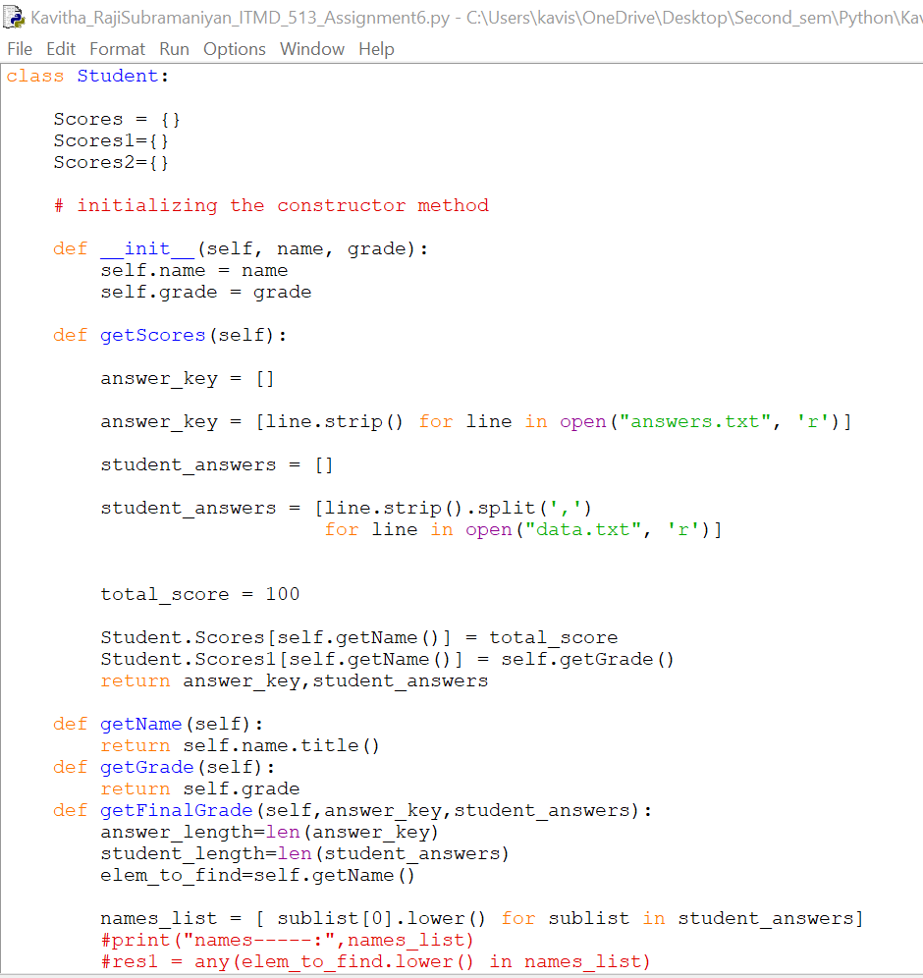

Output:

Step1:

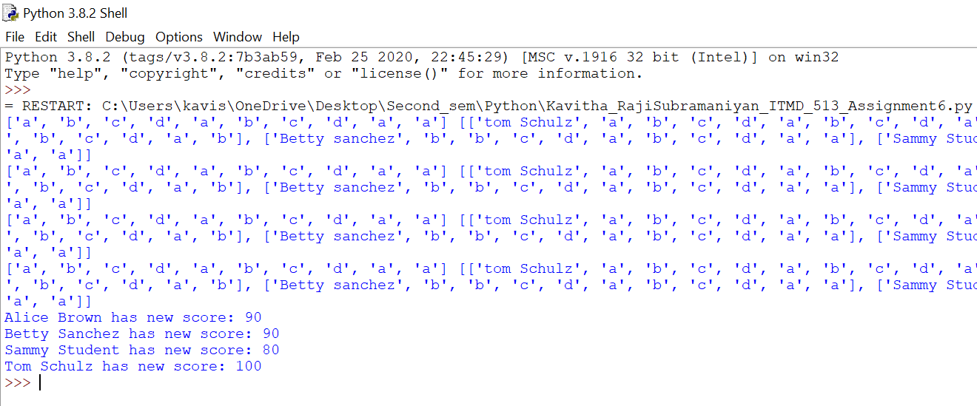

Step2:

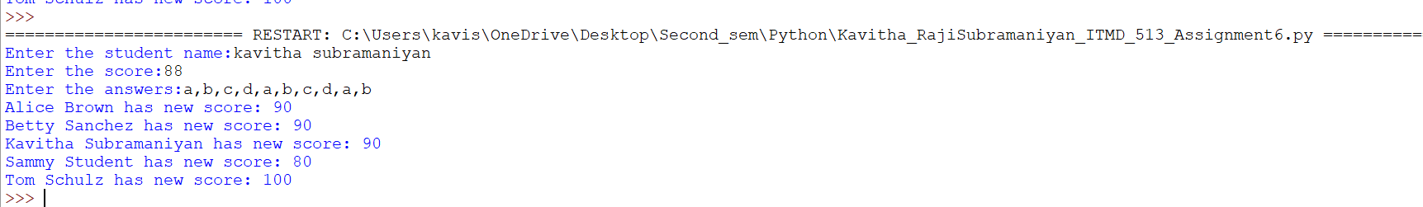

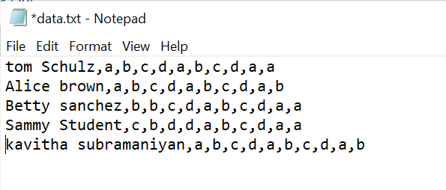

Display grade range for each student:

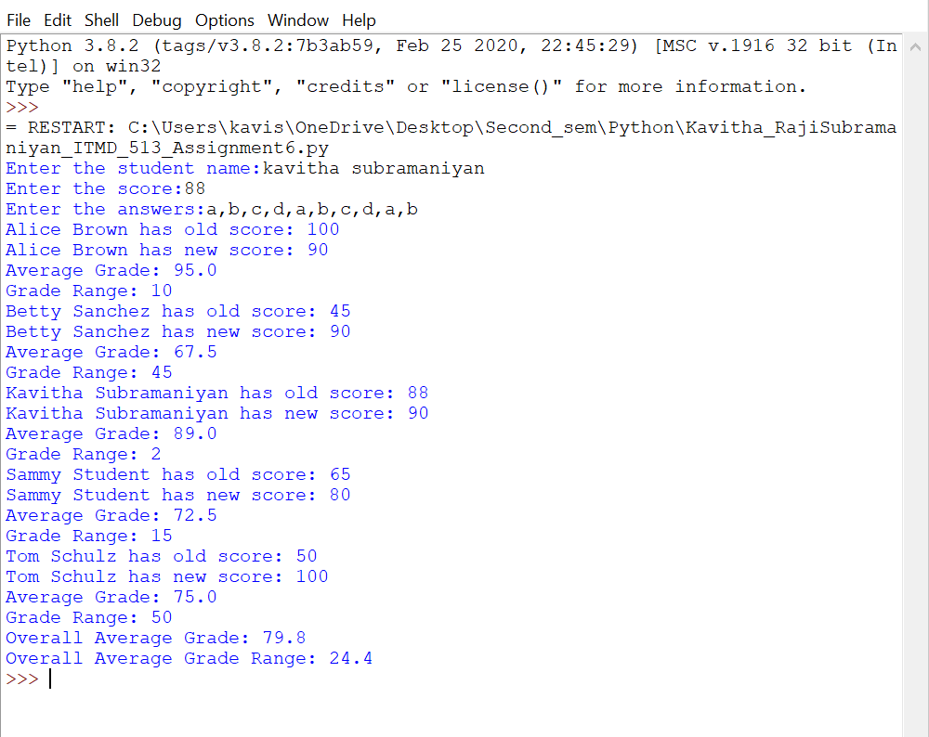

**(1)** What is the purpose of this function?

**def __init__()**

This is the reserved method used in python class which is also known as constructor in object oriented .We call this method when an object is created from class which in turn allows to initialize the attributes of class.

**(2)** Is **self** considered a keyword in Python?

Yes,it is considered as a keyword.By using this ,we can access attributes and methods of class.

**(3)** What is meant by object - oriented programming?

Object-oriented programming is a software programming model which is used only with objects .This model defines data as objects and describes contents of objects through the method declaration.This OOP has three features which is encapsulation,polymorphism,inheritance.

**(4)** How are text files used in your program code for this project?

The text file ‘data.txt’ is read and stored in a list. Similarly the answer.txt file is also read and stored in a separate list. These two operations are performed by using the method getScores().Then we do comparison to check the data.txt(list of list) by taking the second item till last item(answers) from each list and comparing with the answers list to find the new score which we do using getFinalGrade method().

**(5)** What have you learned from performing and coding for this lab assignment?

1.Class-a template for object creation.Each object can use variables and functions.’class’-a reserved keyword.

2.Constructor- “__init__()” method which is assicated with every class.For each object creation,this method is called automatically.The main purpose of this method is to initialize the attributes with user given values.

3.Static Method-Does not require any special keyword as parameter.This can be called without an object.Mainly useful for creating helper or utility functions.

4.Object-instance of class created at runtime.

5.self keyword-represents instance of class which is used to access class members like attributes from the method of a class.