Program:

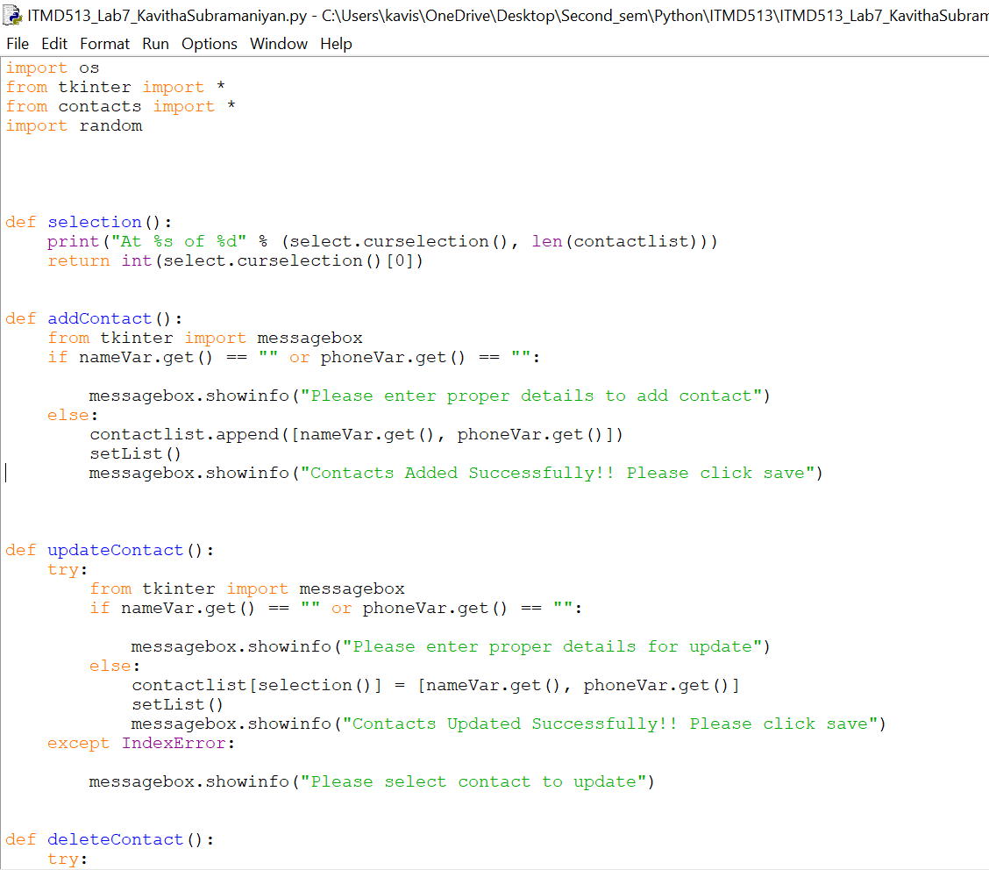

1. Your entire interface at runtime including your save button added on

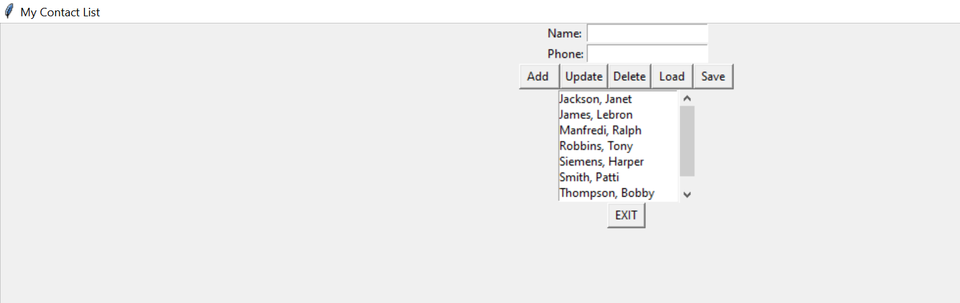

2. Initial snapshot of listbox at runtime

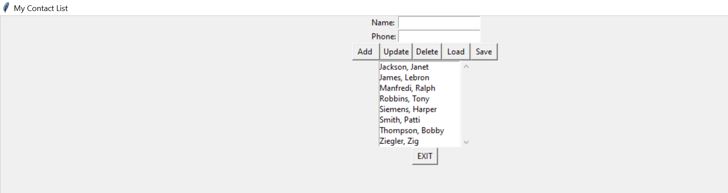

3. Show a contact being added (add in a contact name by last name, first name)

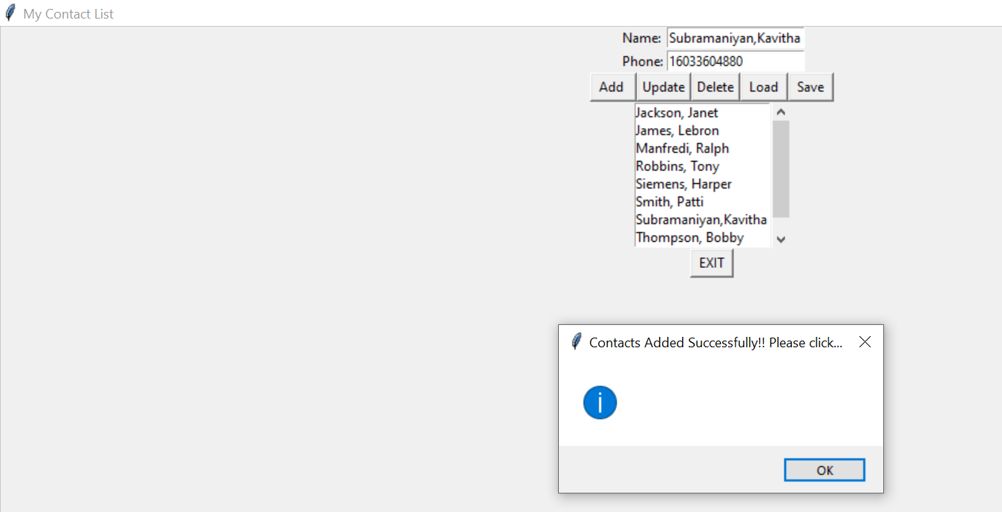

4. Show a contact deleted

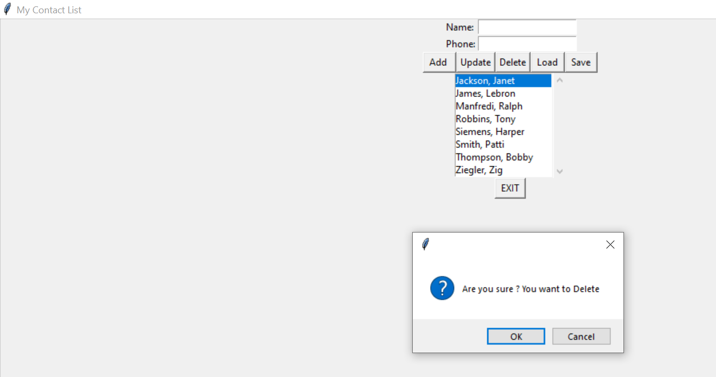

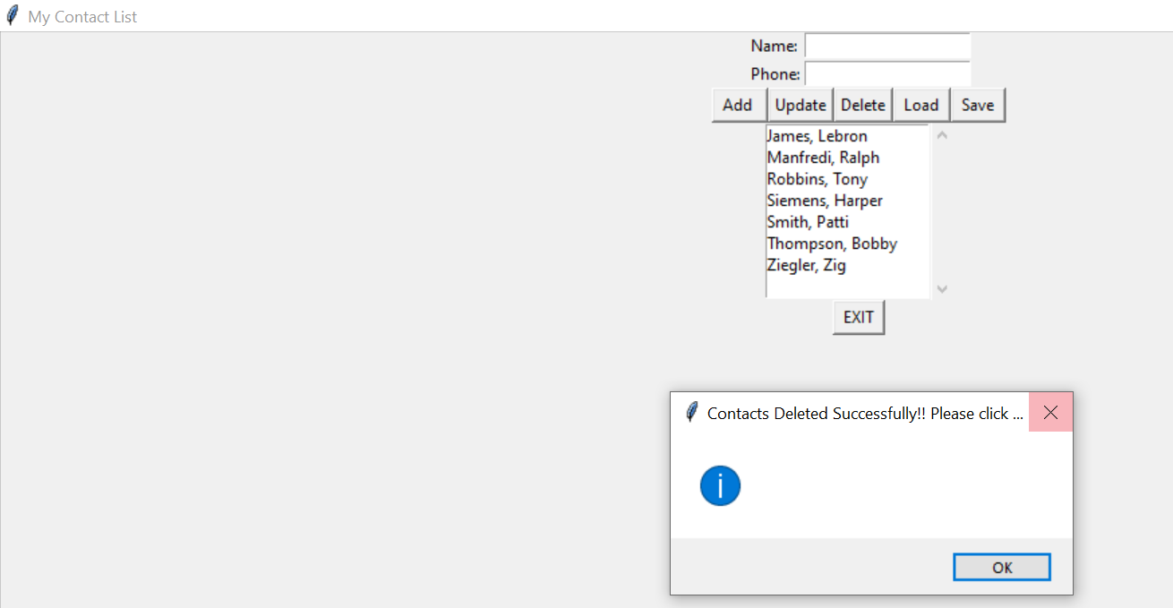

5. Show a contact being updated

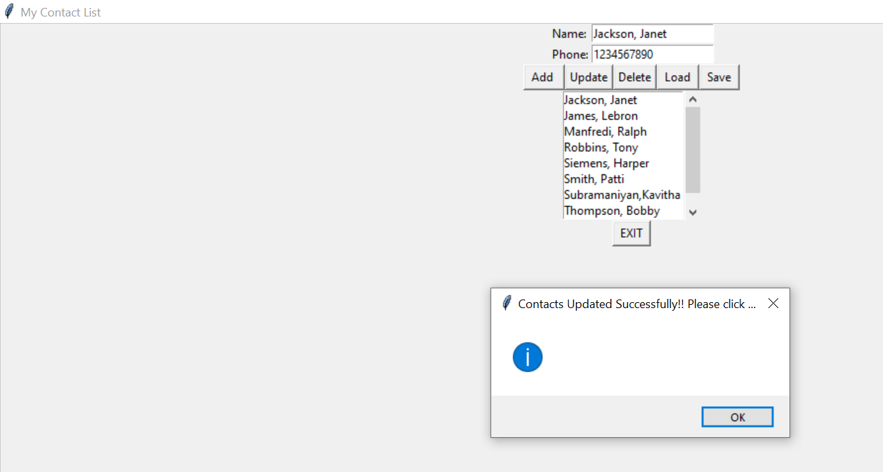

6. Show modified contactlist file (contained in contacts.py)

