1.Screenshot of eclipse with index.jsp output as well as the navigator on the left panel showing the folder structure

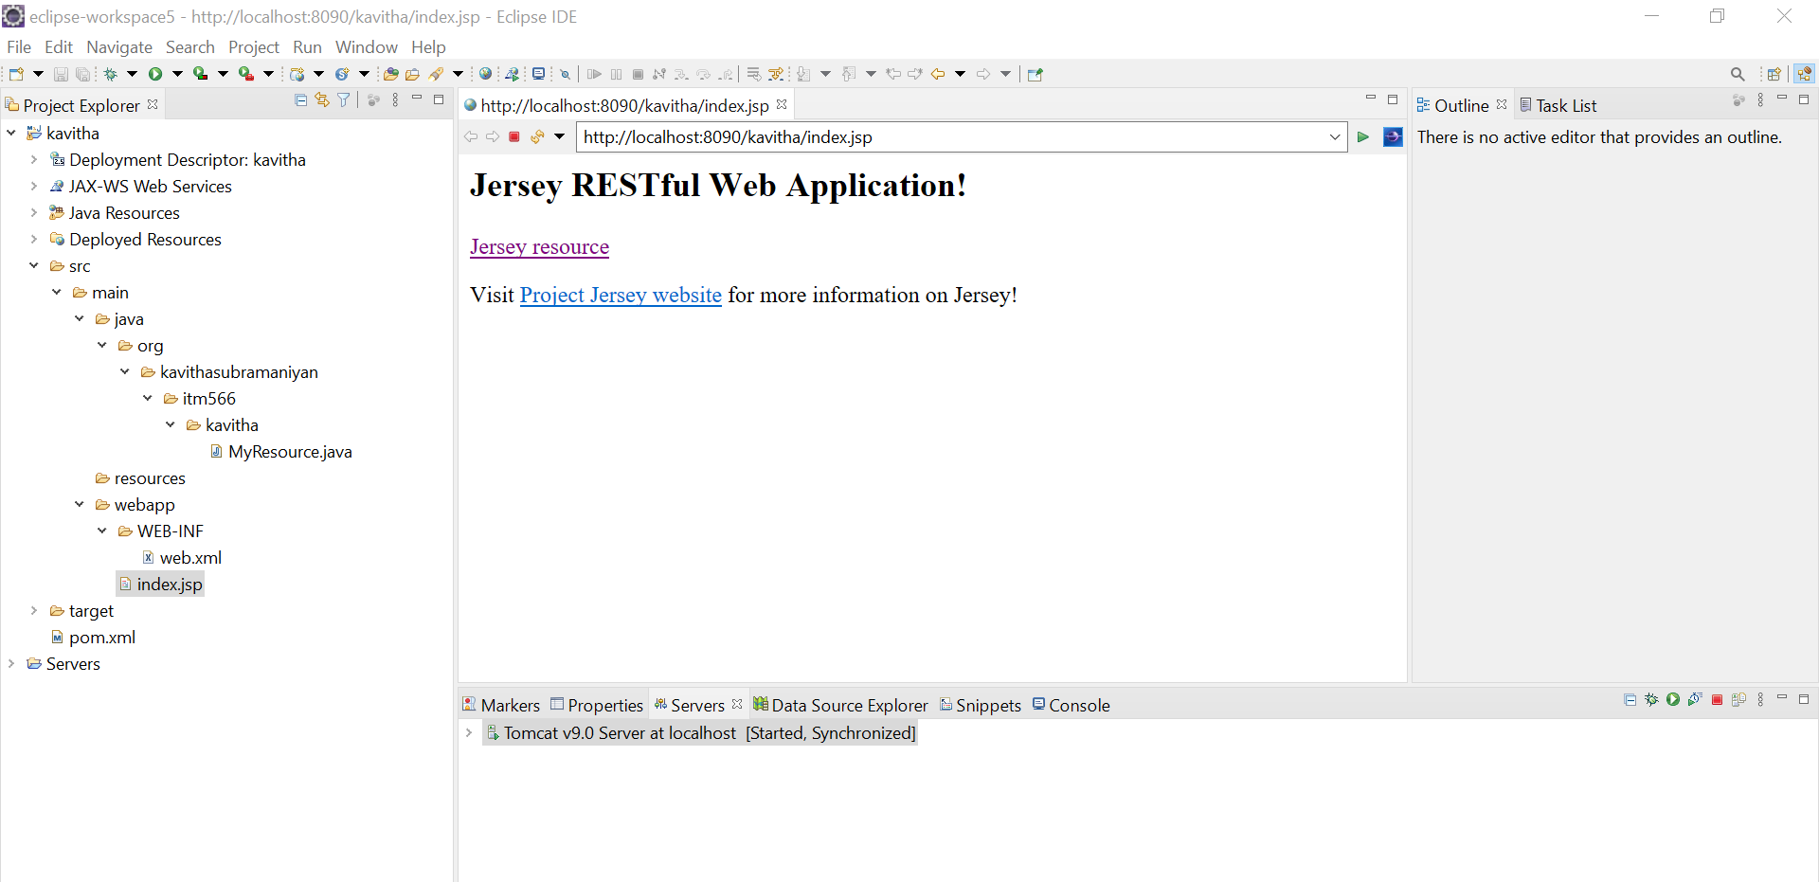

2.Result on clicking the link "Jersey Resource" from index.jsp page

