Assignment 1-Twitter REST API

1.Extracting key and token information from apps.twitter.com

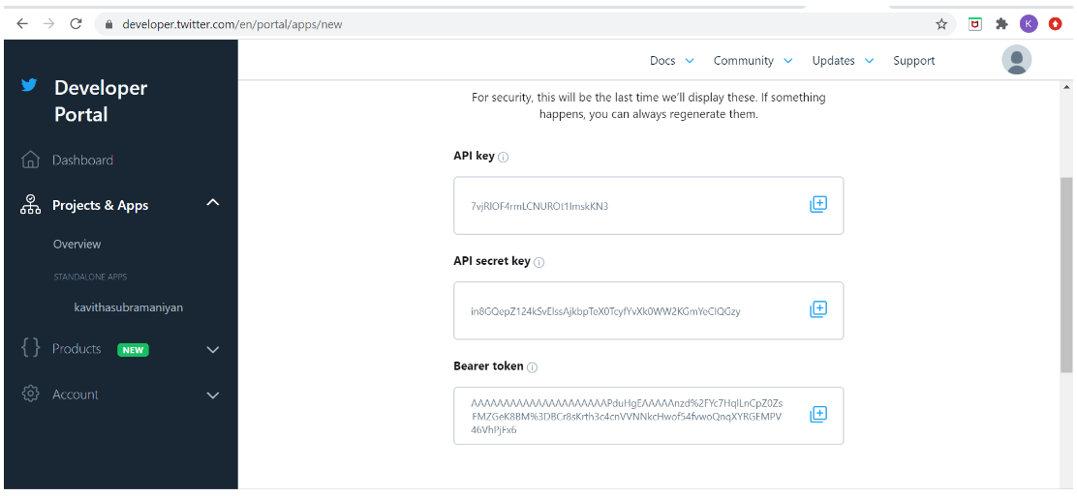

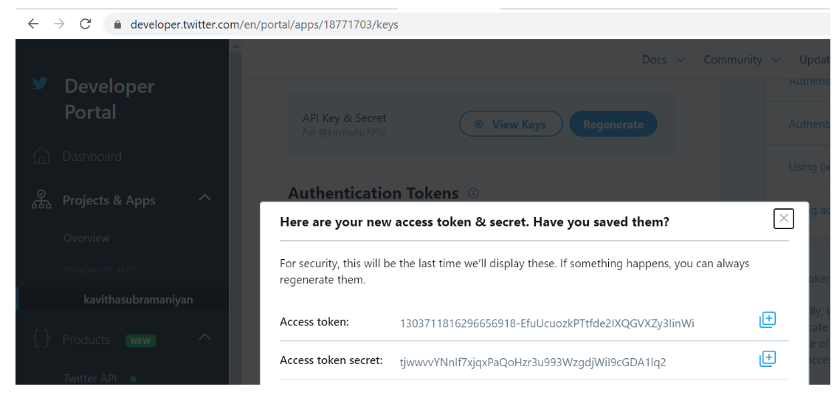

2.Incorporating the id details in get_tweets.php file:

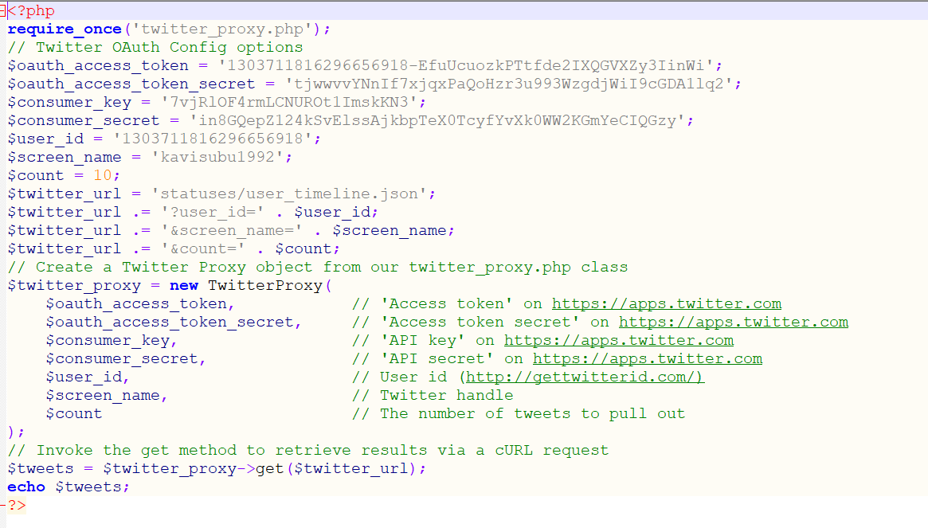



3.Tweets in my twitter account:

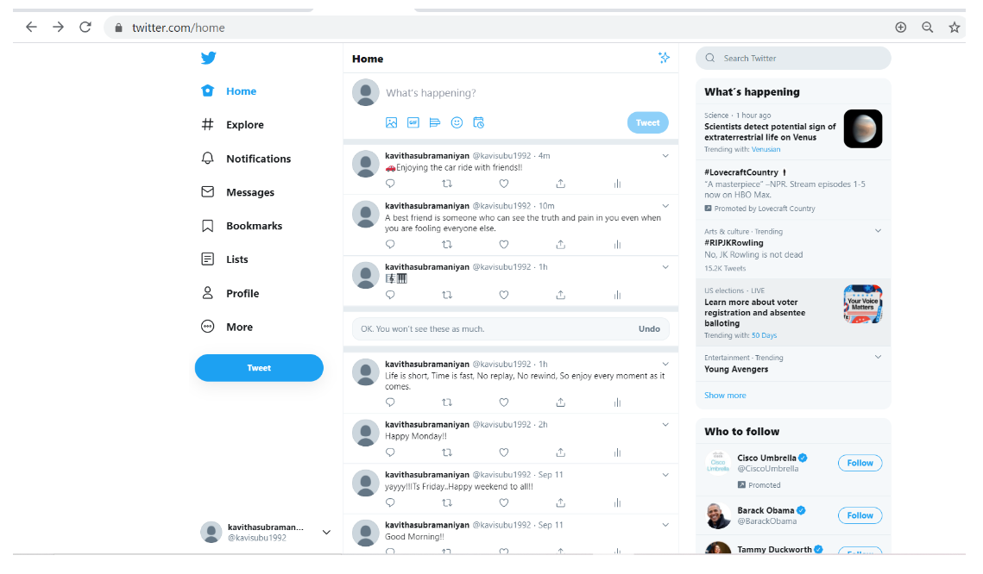

4.Starting web server:

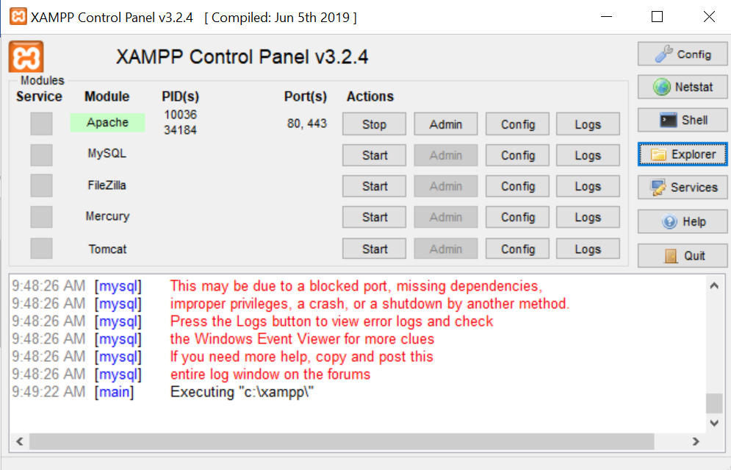

5.Display tweets in my webpage:

