1. What kind of output you are looking for:

First query- To display the earthquake events given from the start date to the present date for the specified location parameters which is a rectangular search (minlatitude,minlongitude,maxlatitude,maxlongitude).Also,the query looks for additional parameter results which is alert_level=green(based on the severity level) and limit the final result to 10 using limit parameter.Also to limit the results based on review status,we use the reviewstatus=reviewed parameter.

Second query- To display the earthquake events given from the start date to the present date for the specified location parameters which is a circle search (latitude,longitude,maxradius).Also,the query looks for additional parameter results which is reviewstatus=automatic and maxdepth=6(events displayed with depth less than the value specified in maxdepth parameter).

1. API queries:

First Query:

<https://earthquake.usgs.gov/fdsnws/event/1/query?format=geojson&minlatitude=-70&minlongitude=-150&maxlatitude=70&maxlongitude=150&alertlevel=green&starttime=2020-09-01&limit=10&reviewstatus=reviewed>

Second Query:

https://earthquake.usgs.gov/fdsnws/event/1/query?format=geojson&latitude=80&longitude=160&maxradius=180&starttime=2020-09-21&reviewstatus=automatic&maxdepth=6

1. copy of your API output in json format:

First Query:

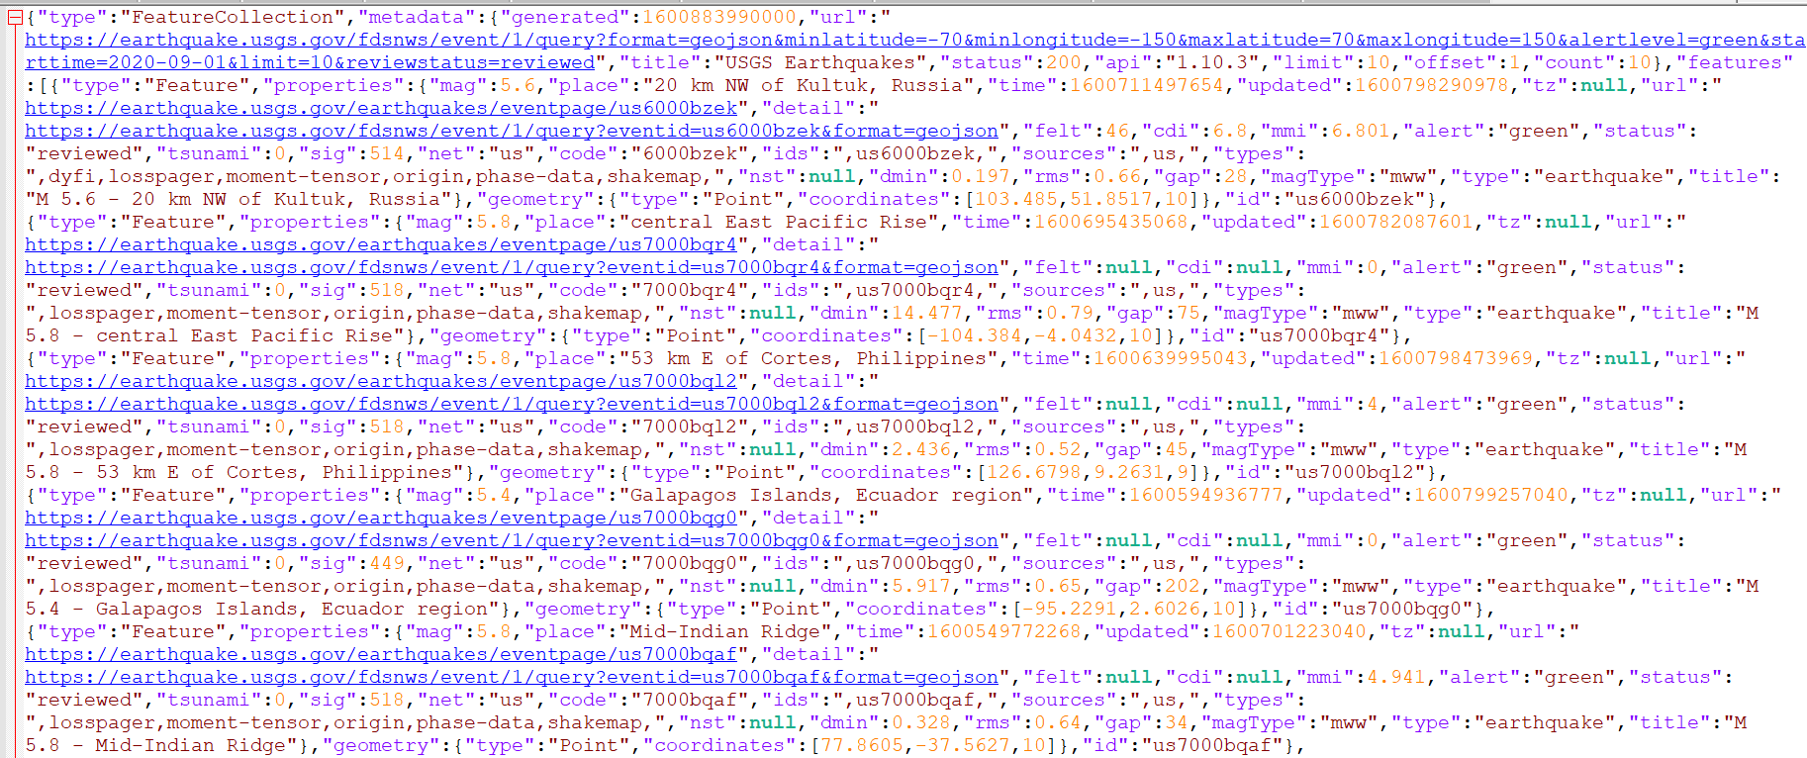



Though this query returned 35 results(without using limit parameter),on using limit parameter(limit=10),it displayed only 10 events.

POSTMAN tool:

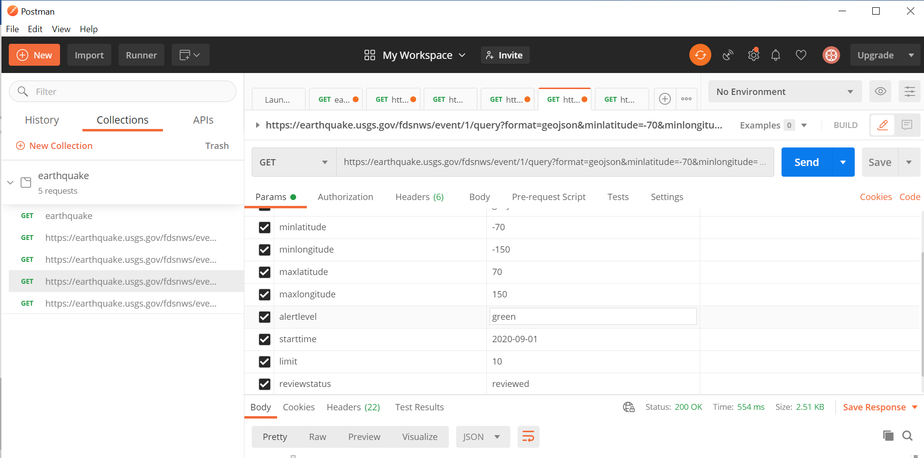

Front end View - query result for one feature :

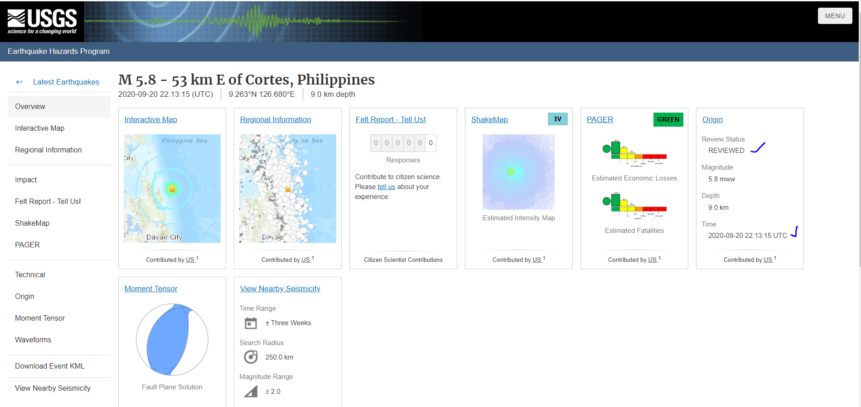

Second query:

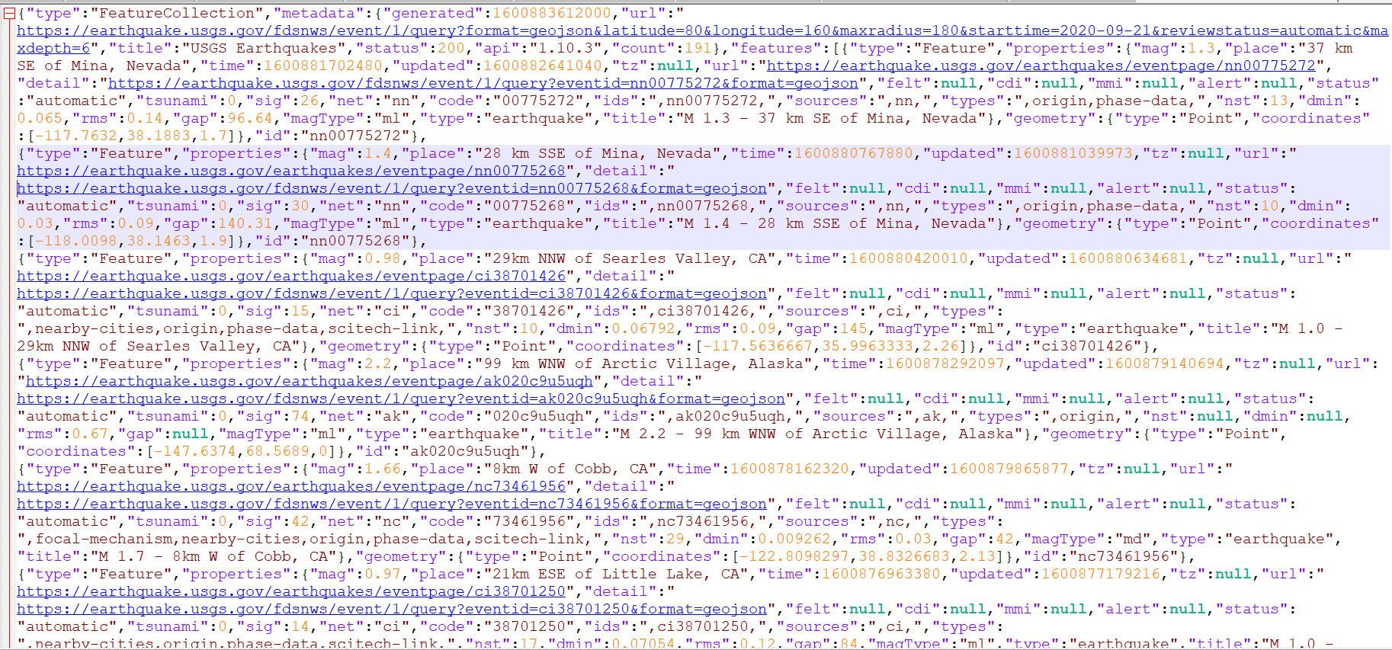



POSTMAN tool:

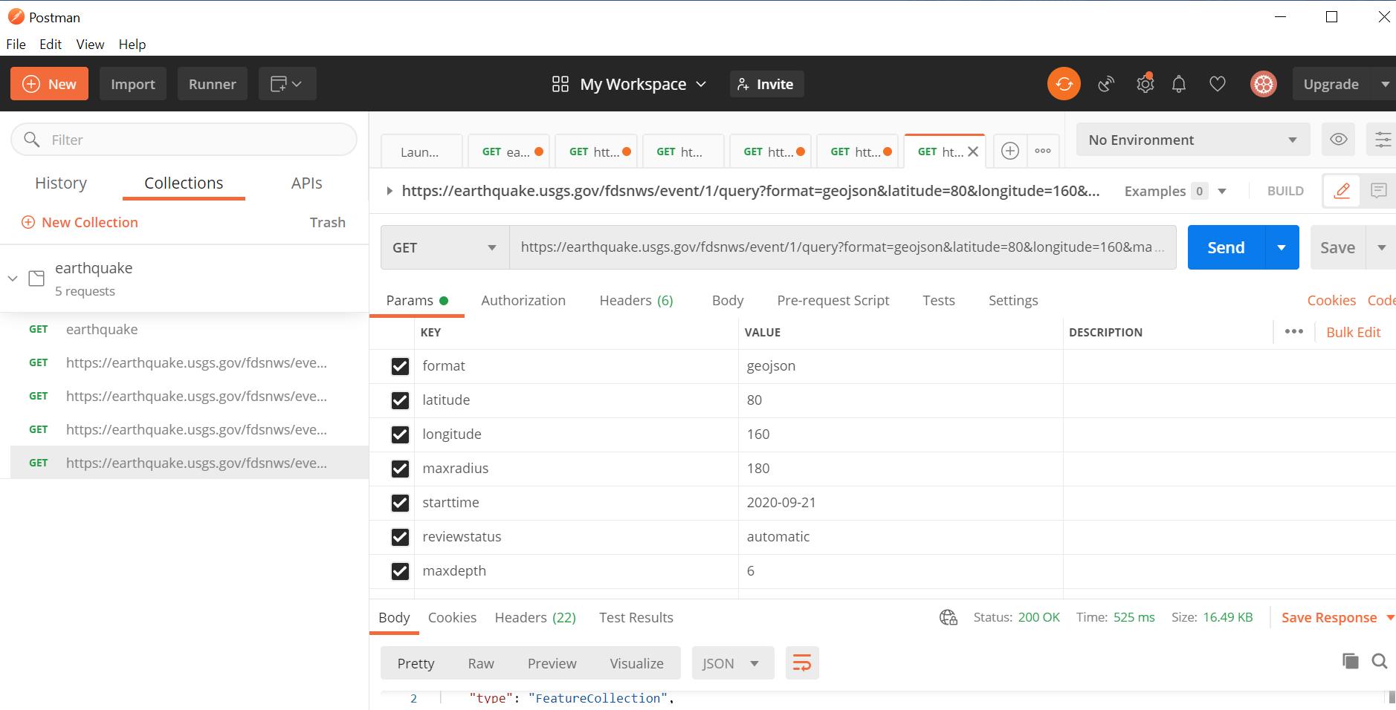

Front end View - query result for one feature :

