Message Service:

1.Url specification screenshot:

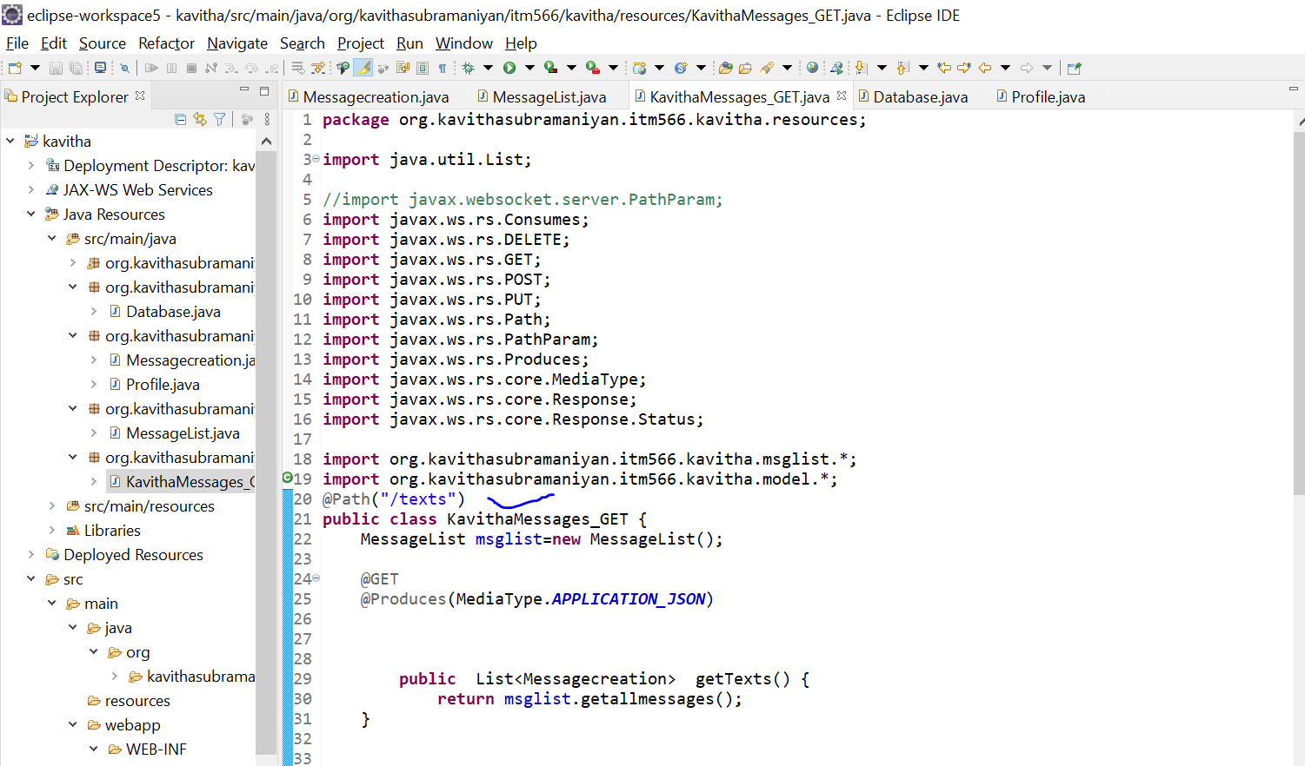

2.Retrieving the existing resources using ‘GET’ method:

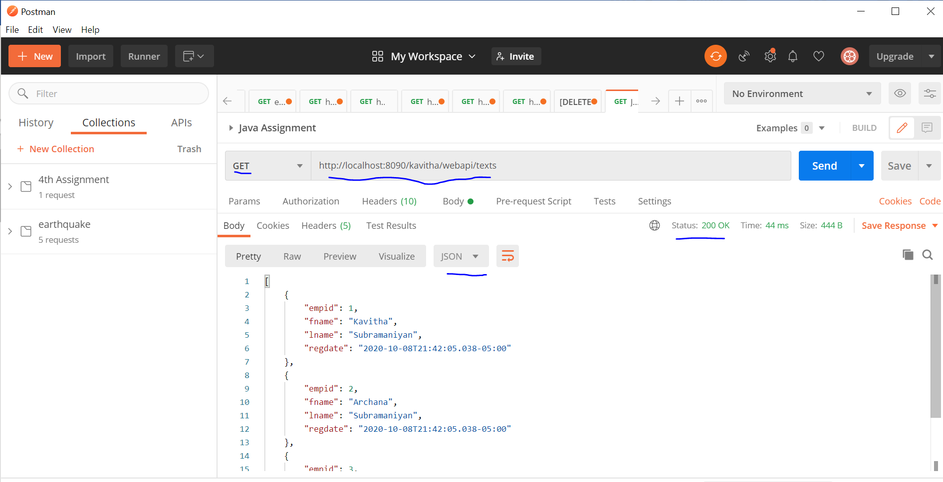

This status_code:200 shows that it is successful in retrieving the request.It has 3 existing resources.

Attaching the JSON file for output of ‘GET’:



3.Creating a new resource using ‘POST’ method:

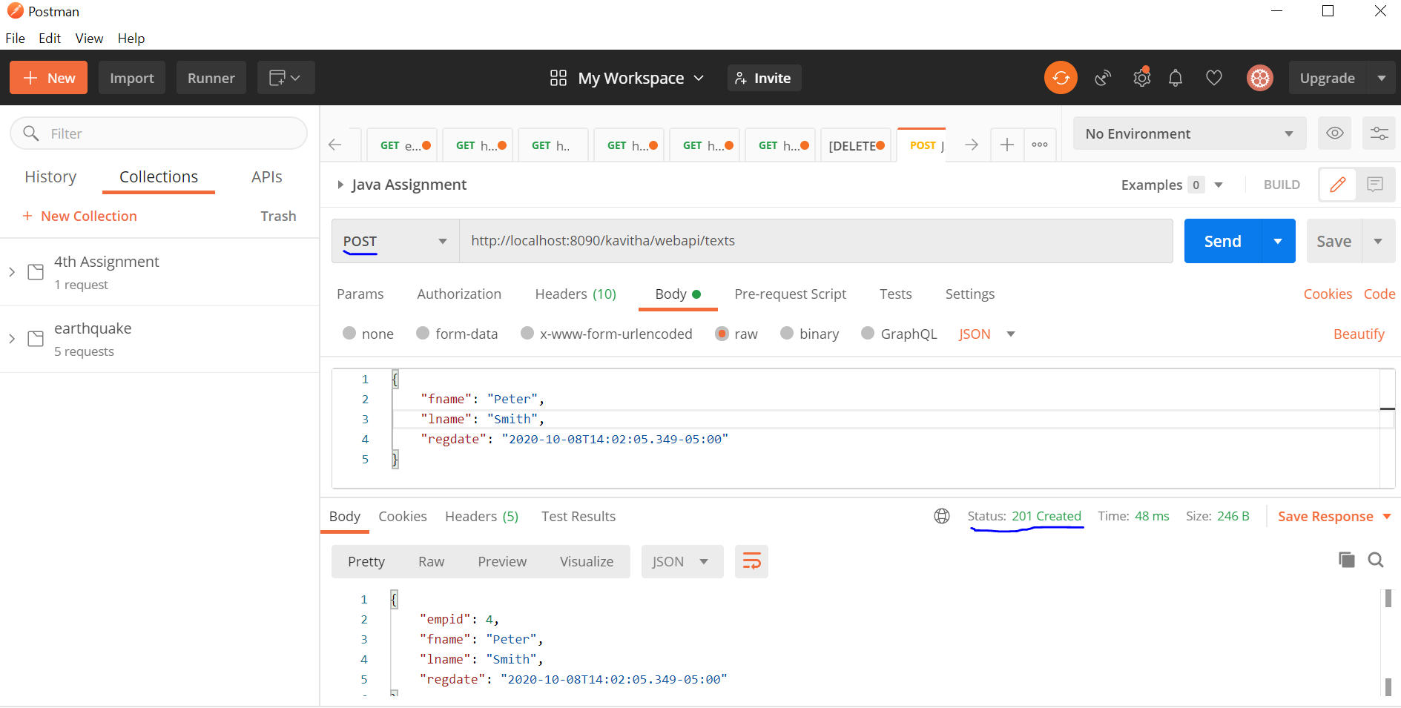

This status_code:201 shows the new resource is created successfully using POST method.A new record is created whatever is mentioned as input by the user and the empid is automatically incremented to ‘4’.

With the same details,again if POST method is used,it would create a new resource with empid automatic increment to ‘5’.

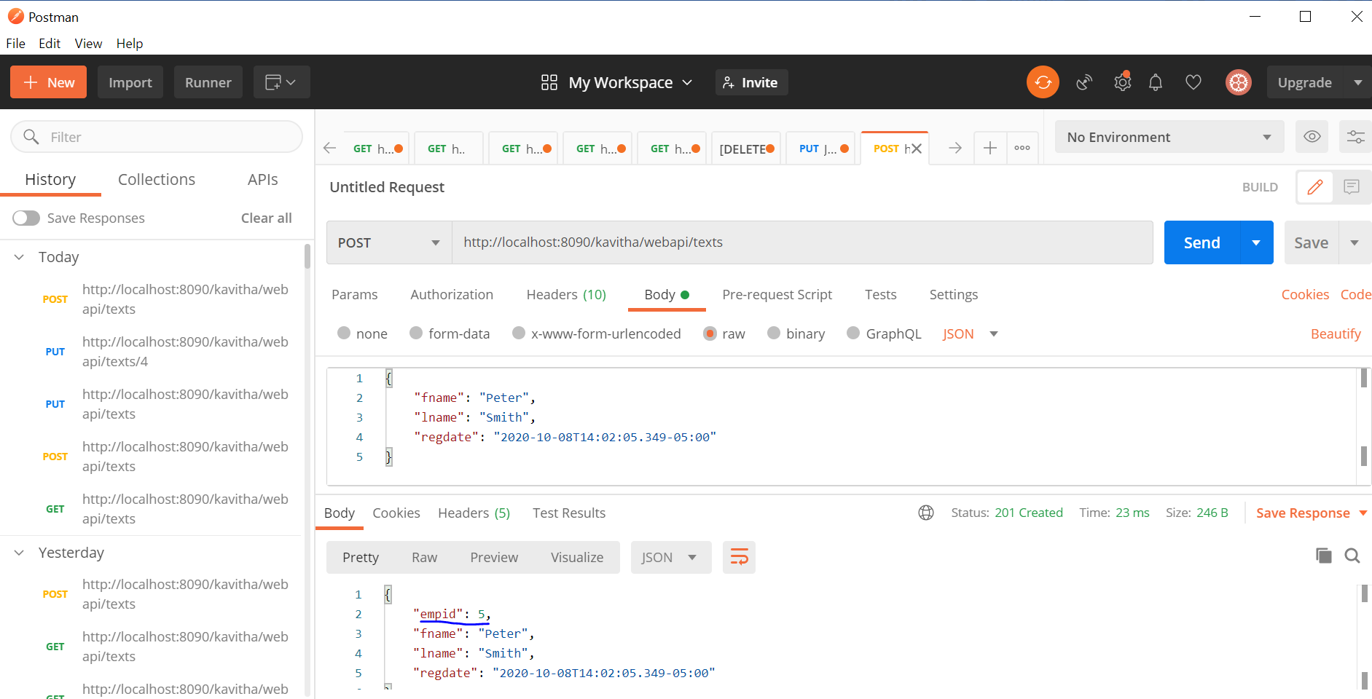

Attaching the JSON file for POST output:



4.Updating the 4th record to fname using PUT:

When u try it without mentioning the empid in the request url,the below error would throw

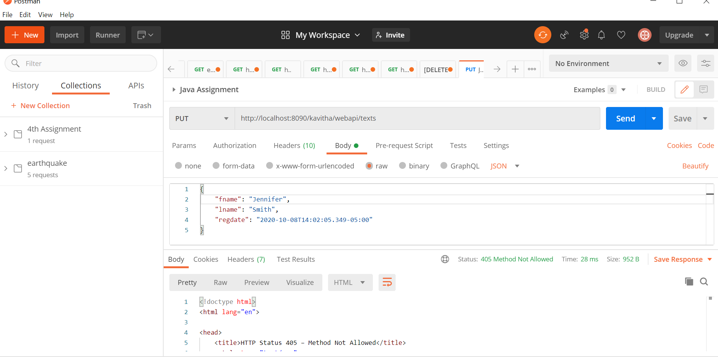

The status_code: 405 is an  [HTTP response status code](https://developer.mozilla.org/en-US/docs/Web/HTTP/Status) indicating that the specified request [HTTP method](https://developer.mozilla.org/en-US/docs/Web/HTTP/Methods) was received and recognized by the server, but the server has rejected that particular method for the requested resource.

To correct this,check the requested url again as many web servers are tightly secured to disallow access to improper URLs that the server isn’t prepared to provide access to. This could be anything from trying to access a file directory via a URL to attempting to gain access to a private page meant for other usersSo,to exactly specify its 4th resource to be updated,it should be updated in the url as per the @path annotation mentioned in the code.

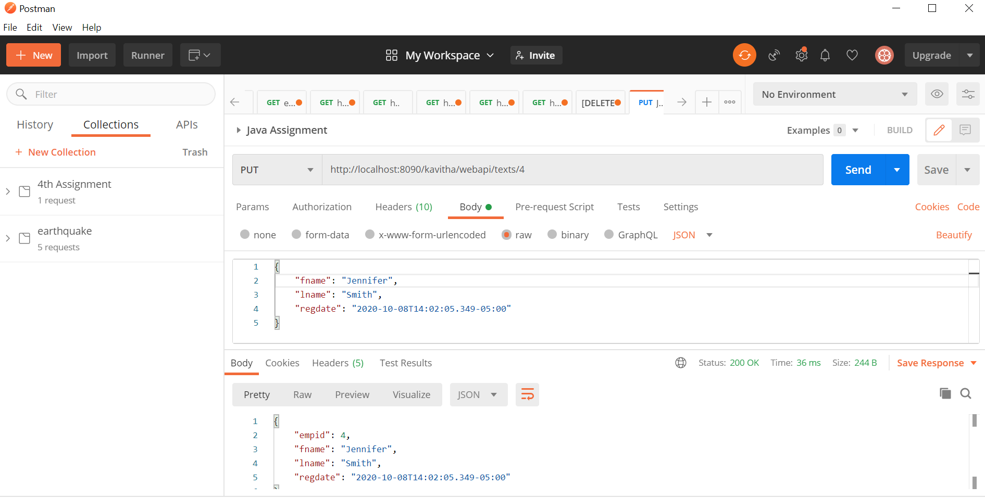

The fname for empid:4 is successfully changed to ‘Jennifer’ from ‘Peter’.

@Path annotation screenshot:

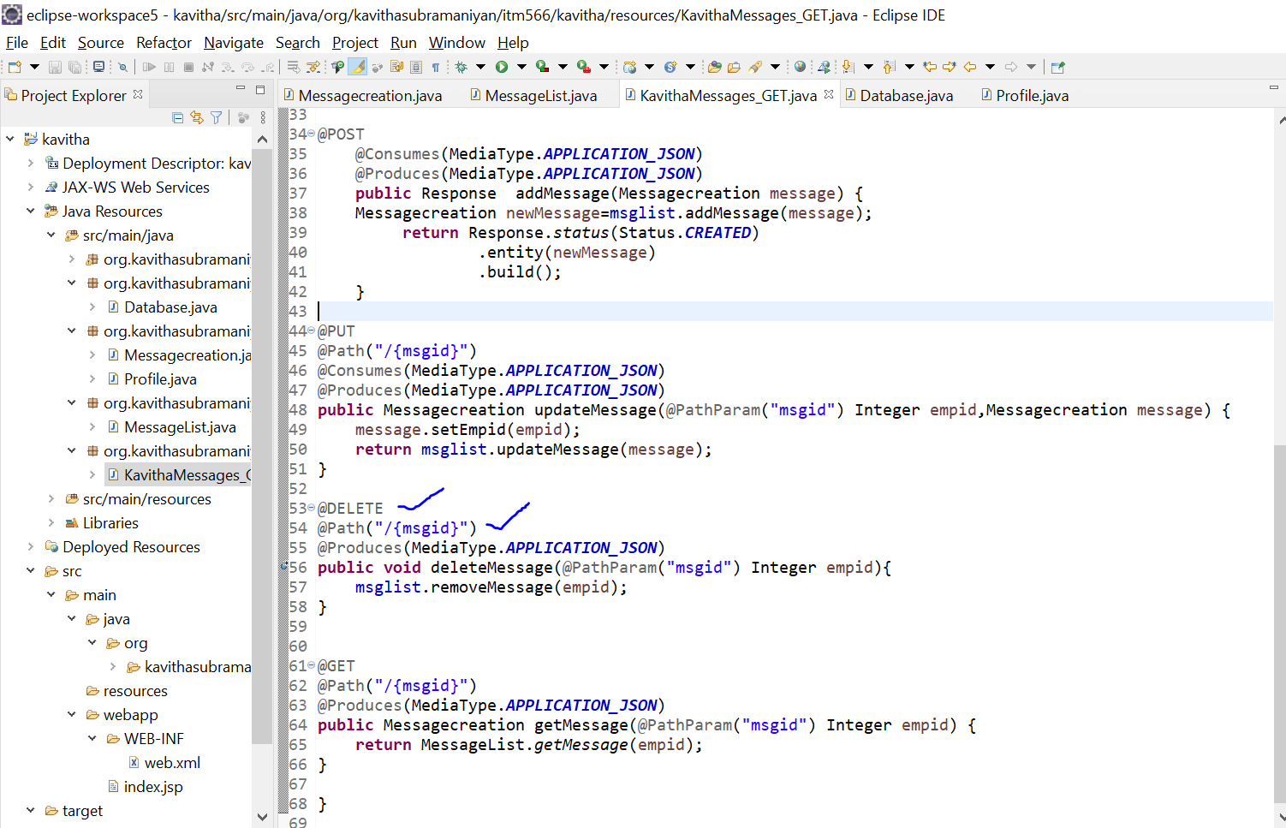

Attaching the JSON file for PUT output:



5.Deleting the resource:

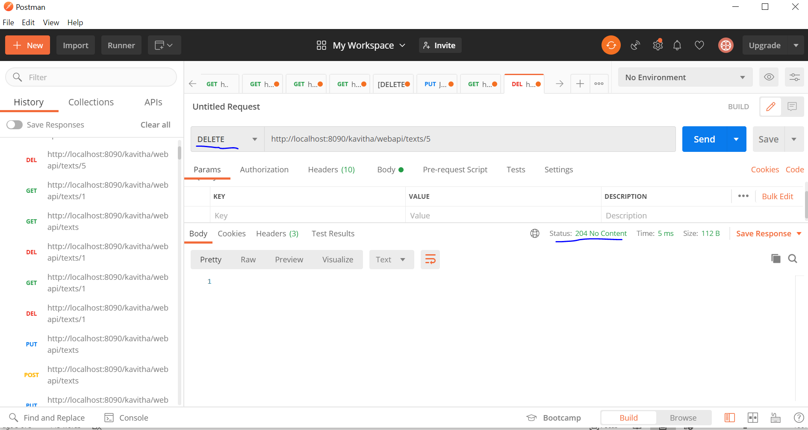

This status code:204 shows that the resource is deleted and to confirm this lets call the collection url using ‘GET” method,

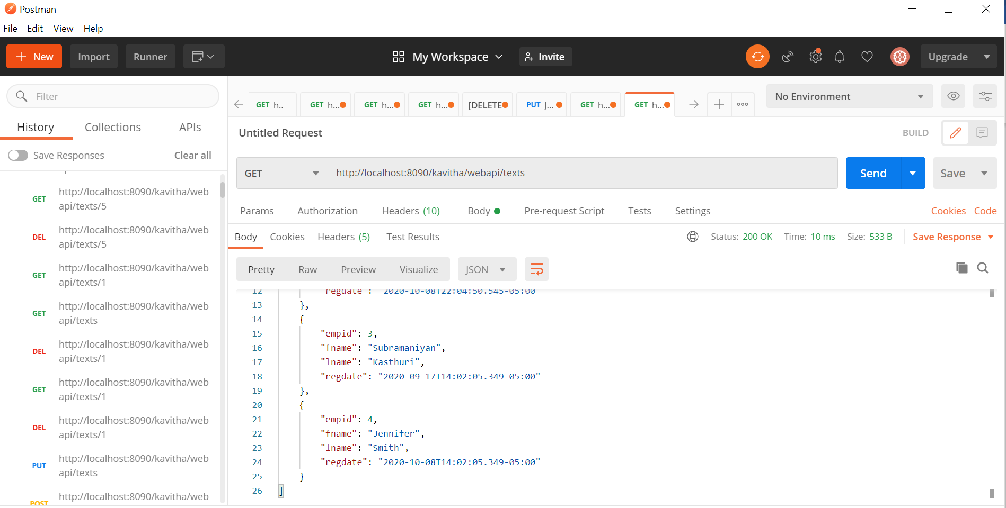

This screenshot shows that empid:4 is the last resource and hence it’s a proof that empid:5 is deleted.

Attaching the JSON file created after deleting a resource:

