Profile Service:

Existing Profile view:

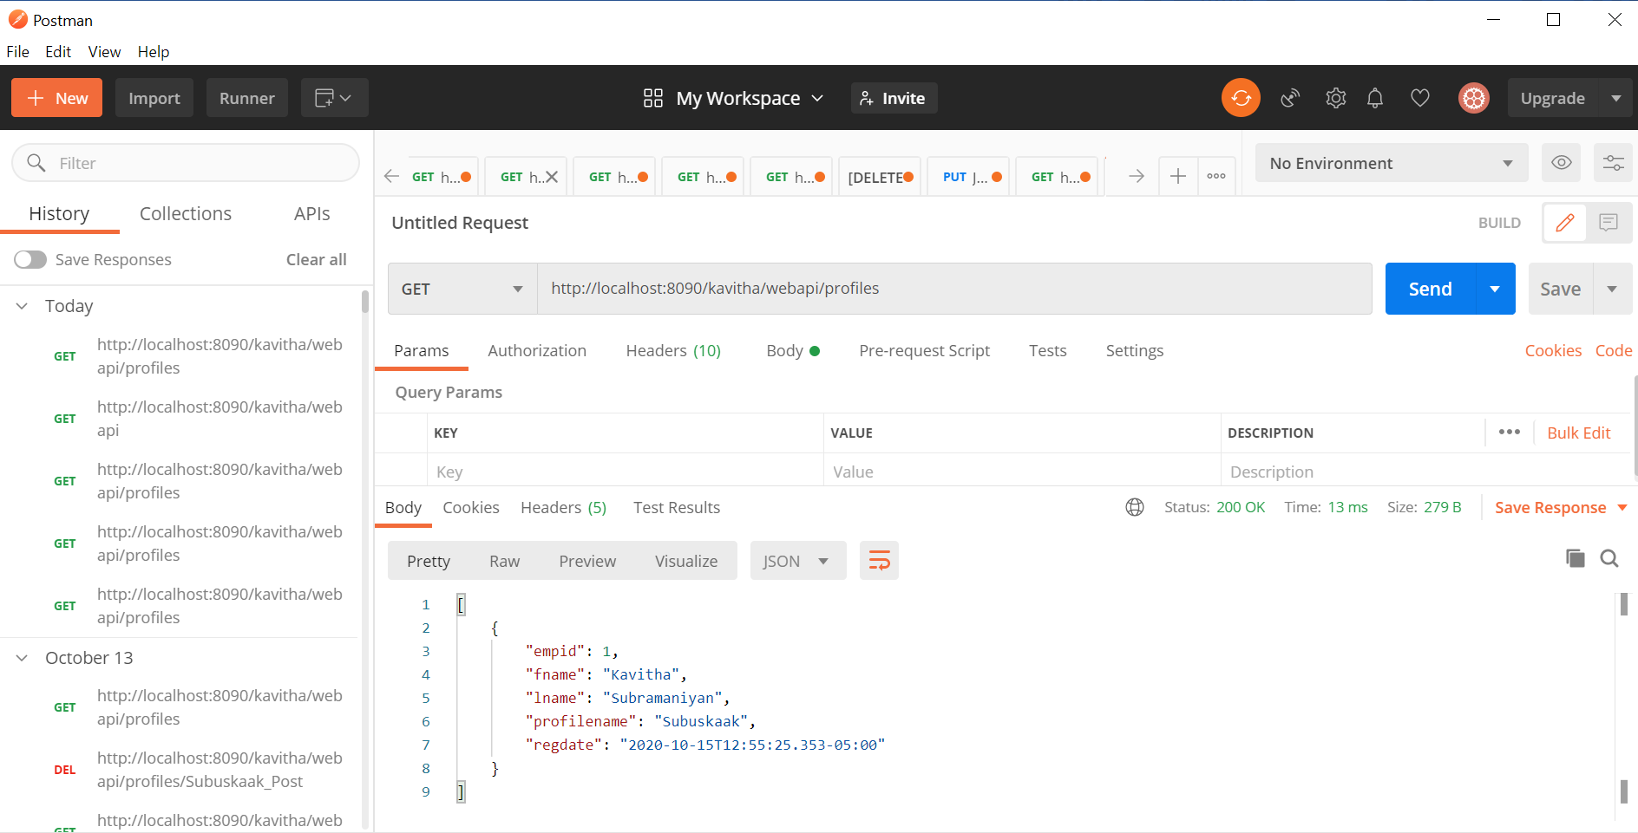

New Profile creation:

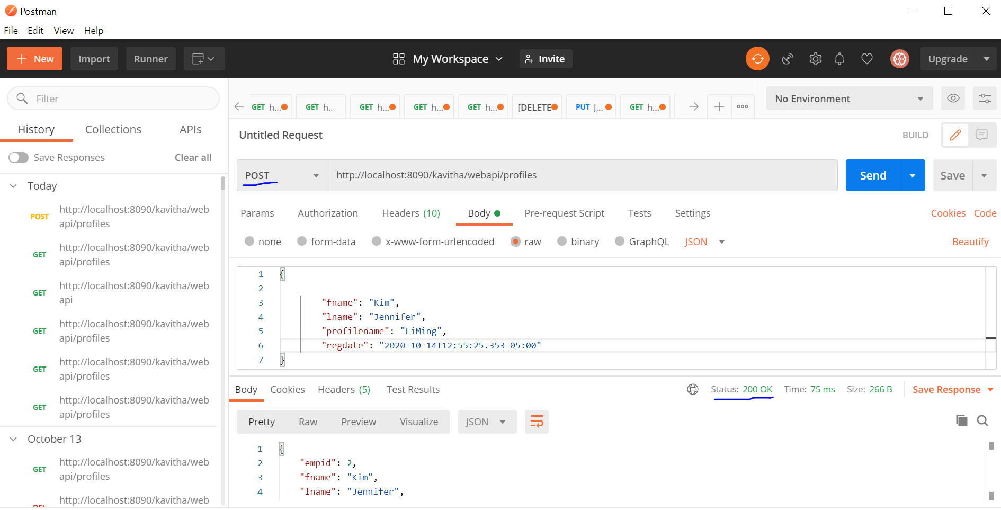

New profile ‘LiMing’ is created using POST method and the status 200 shows it is successfully created.

And the empid column is automatically incremented to 2 here.

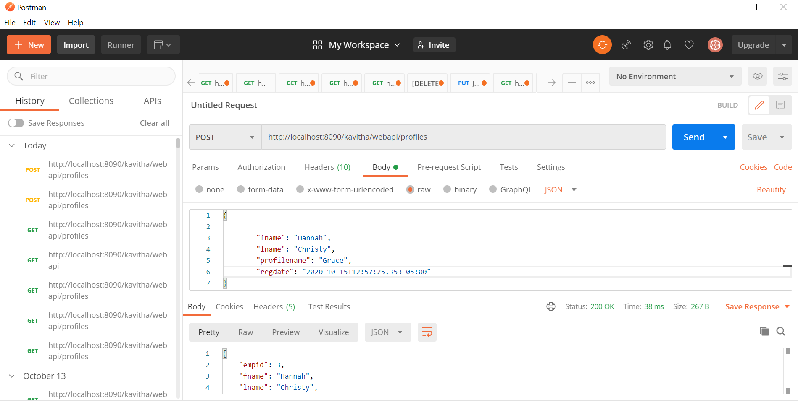

New profile ‘Grace’ is created and the status code-200 shows ,the profile is successfully created. And the empid is automatically incremented to ‘3’.

We can add one more profile.

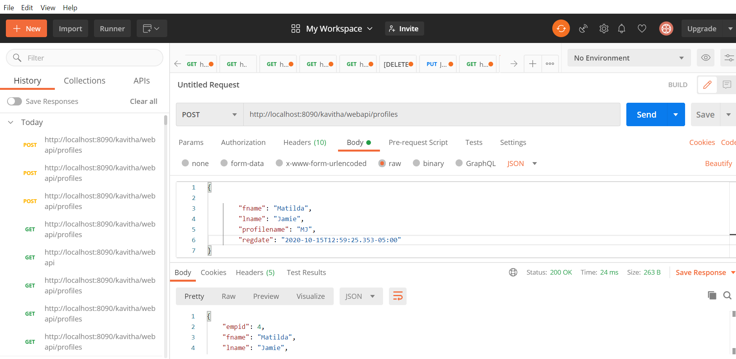



Using ‘GET’ method to viewing the profiles.

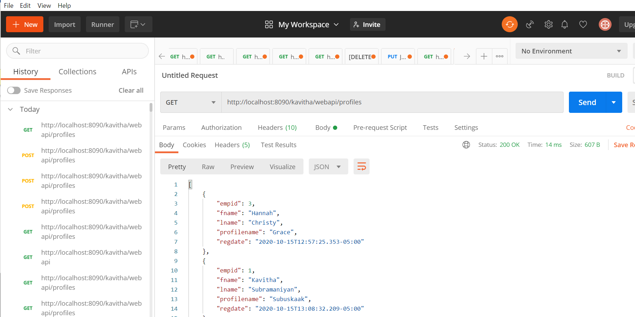



Updating the profile:

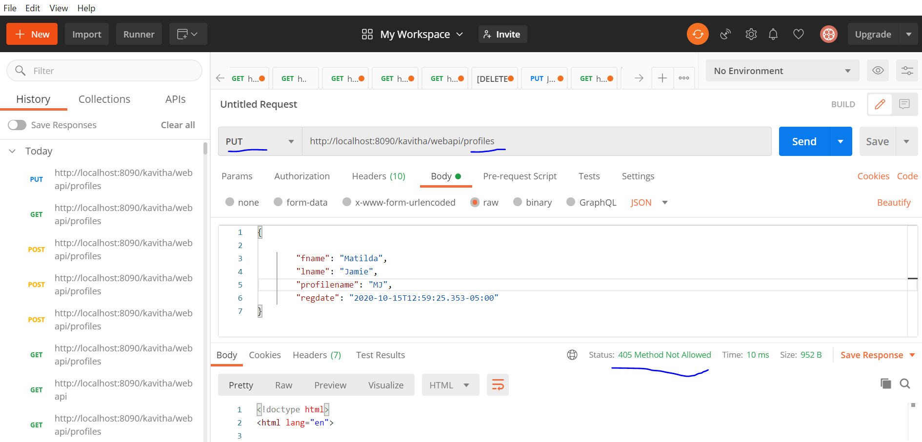

This ‘PUT’ method with the above url shows error code ‘405 Method Not Allowed’ which means the request url may not be right.So here,we need to make sure the profilename is also mentioned.

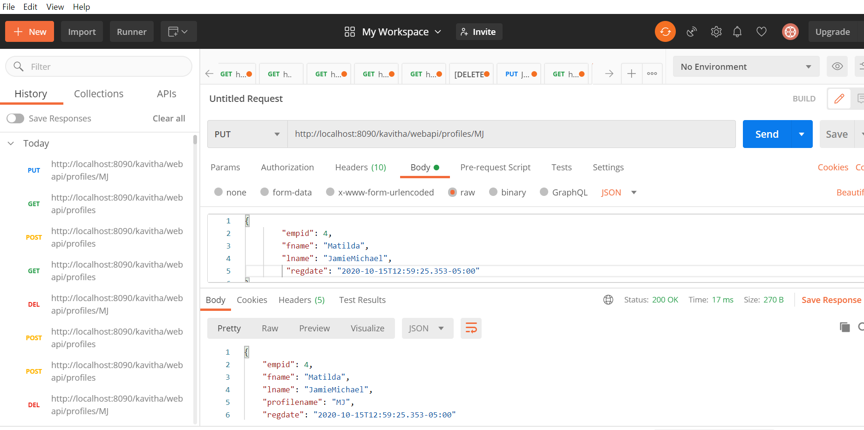

Here the profilename ‘MJ’ had lname Jamie which we are updating to JamieMichael now.



Deleting a profile:

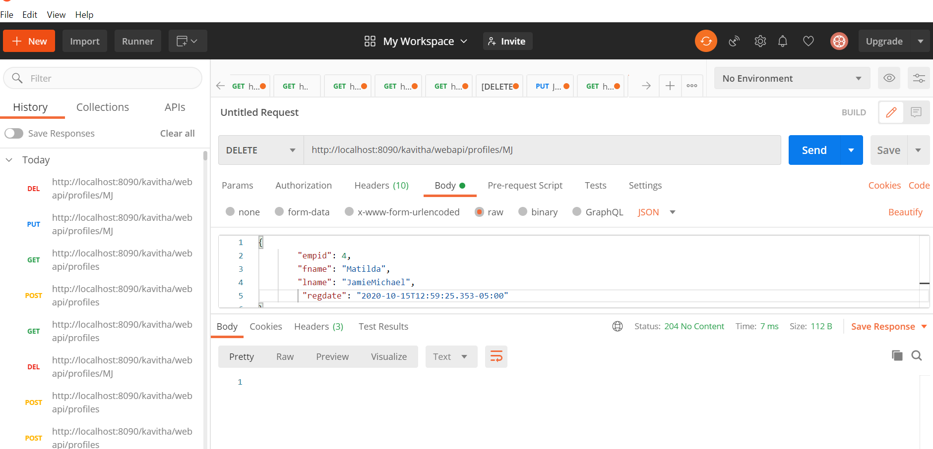

The profilename ‘MJ’ has been deleted and the status code:204 No Content shows the action has been successfully applied to target resource while implying that user agent does not need to traverse away from its current documentation view.

To confirm the deletion,’GET’ method is used with profilename indicated in request url ‘MJ’.

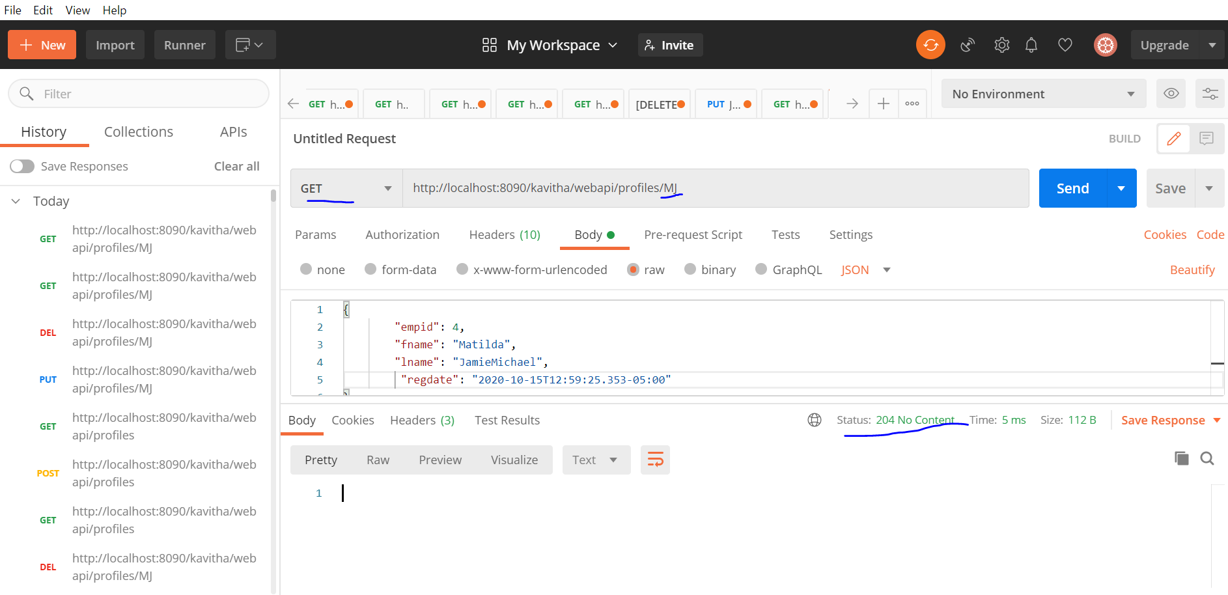

Since there is no content to display for the profilename ‘MJ’(which is already deleted),it shows the status code:204.

After deletion,using again ‘GET’ method to list all the available profiles.

