 1.Take a screenshot of message service in a browser (minimum 5 messages) including links. Your screenshot must include URLs.

port 8090 for JAX-RS Tomcat

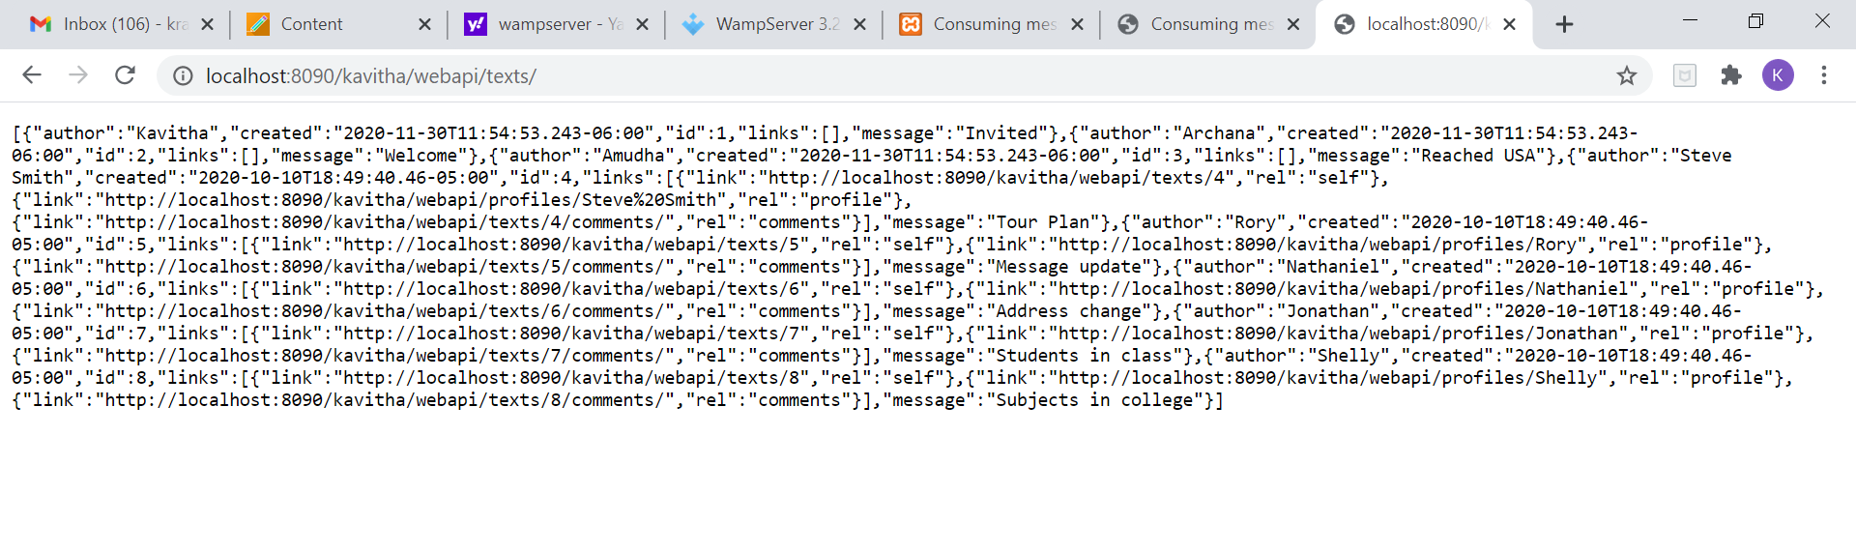

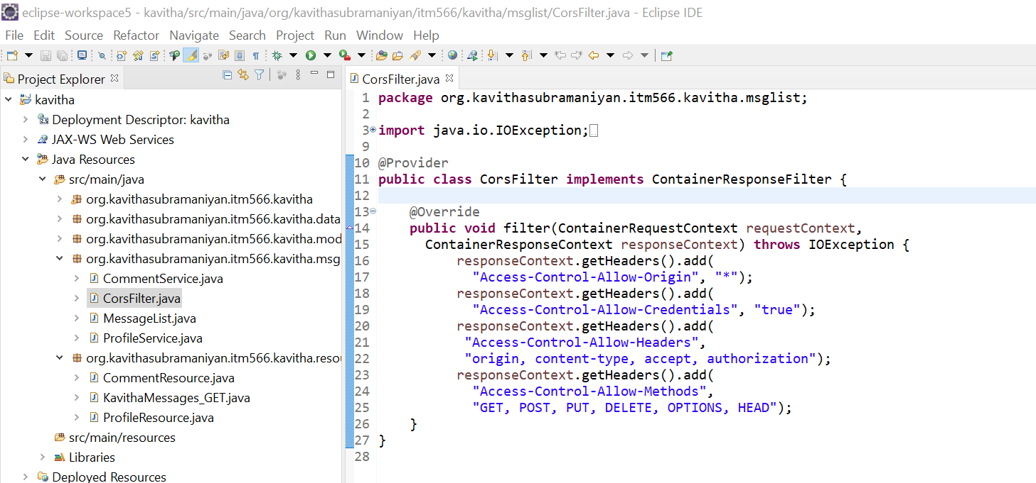

2. Take a screenshot of FooTable display including ID, author, message, dates, and links // displaying links is for extra credit.

Using (XAMPP)Apache server and retrieving it.

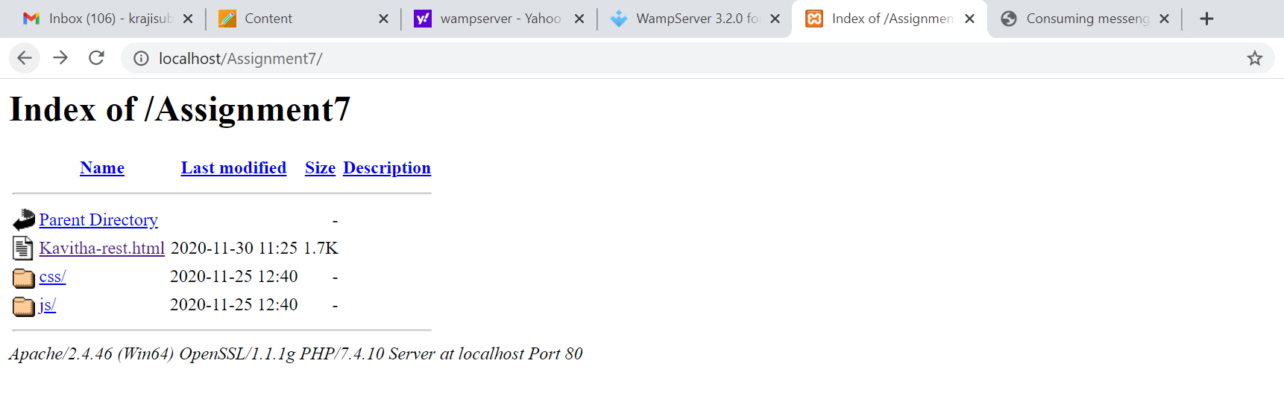

First 3 Ids no links and from id-4 to 8,links are displayed.

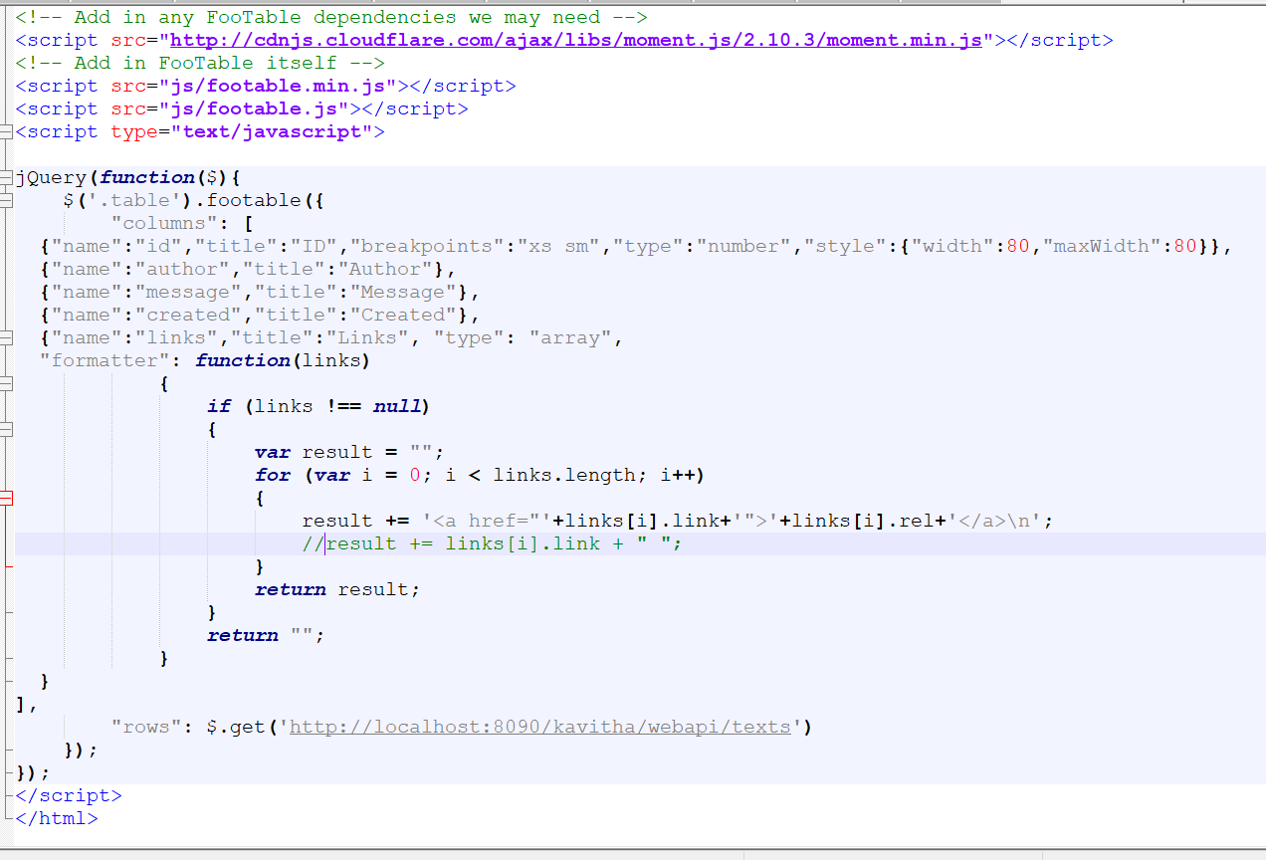

Commenting the line highlighted in green in above screenshot.

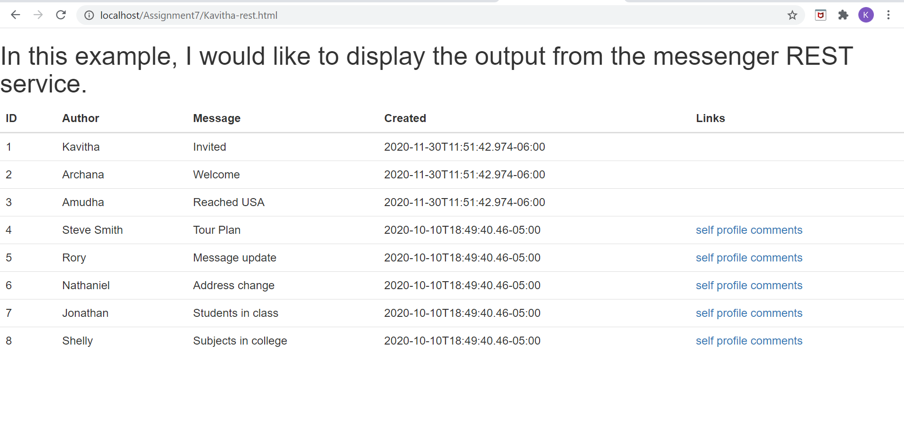

Displaying the comments on clicking ‘comments’ hyperlink:

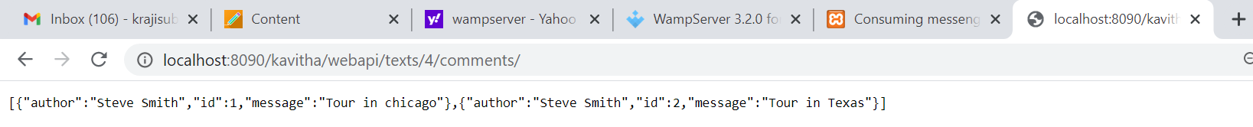

Executing .html file directly from windows machine:

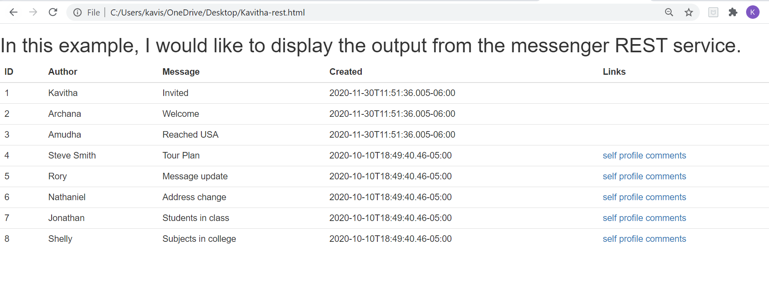

Getting full records from POSTMAN client:

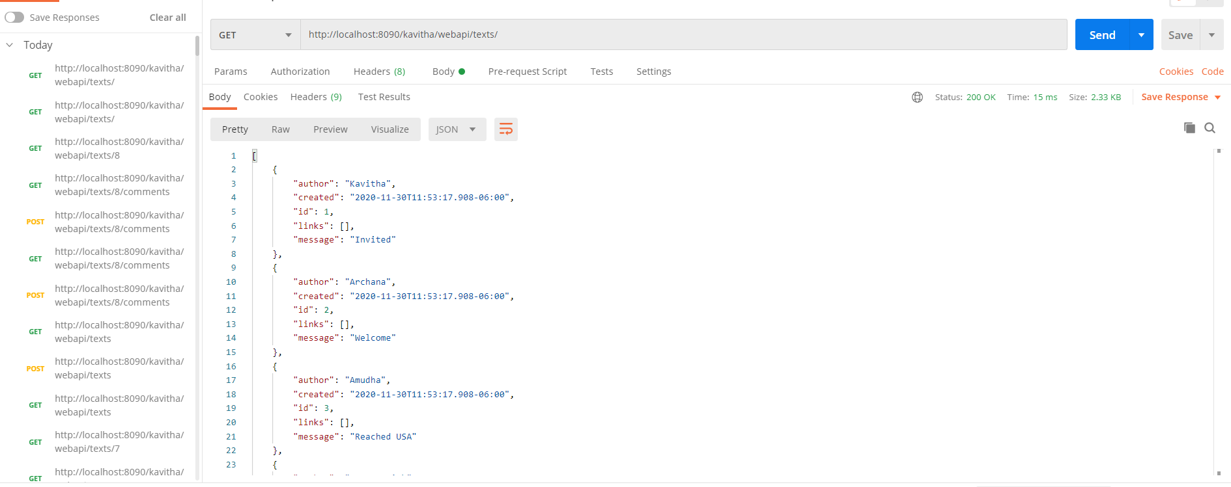

Attached the .json response file from GET request .



3.Displaying link in the other way.(From apache server)

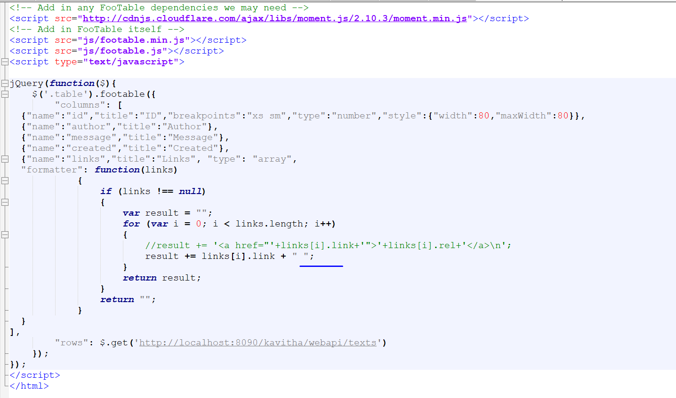

By commenting the line highlighted in green in above screenshot.

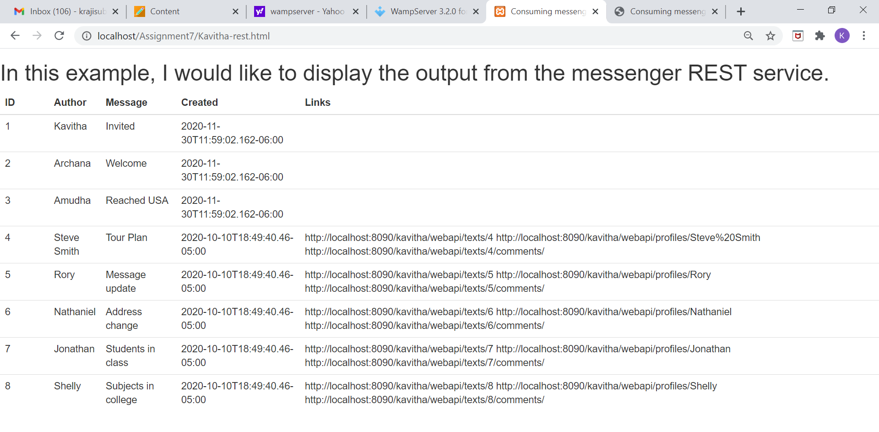

From directly executing the .html file in windows machine.

