

**9 V May 2021**

**IOT based Monitoring System for Coal Mining Environment using Li-Fi**

Vinmathi M S1, Kavitha V2, Kushmasri V3, Lavanya V 4

*1Associate Professor, 2, 3, 4UG Students, Panimalar Engineering College*

***Abstract: Nowadays, coal miners suffer a lot from accidents in coal mines due to the complexity of mining environment. The number of accidents in coal mining is increasing day by day. There are many dangers in every mine. Environmental parameters are monitored to protect those who work in the mines. Miners are more susceptible to a variety of threats, including gas explosions, gas leakages and severe changes in temperature and humidity. This paper describes the monitoring system for coal miners using LIFI. The device is equipped with a network of sensors such as a humidity sensor, a gas sensor , a temperature sensor and the data from these sensors can be reliably transmitted using LiFi. Most mining accidents are caused by slow data transmission and loss in transmission. This problem can be solved with the Light Fidelity technology known as high speed data transfer technology. This project implements a mine safety system using the Thinkspeak Iot cloud platform to store and monitor the data . All sensor estimates are continuously monitored using the finest analysis method using Thinkspeak.. This system log all data in the cloud using data logging. This data is sent to a server that is managed by the administrator through Thinkspeak cloud platform. This paper provides an Li-Fi system for underground mining to communicate emergency information to workers at risk.***

***Keywords: Coal mining, LiFi, Sensors, LDR, IOT cloud***

1. **INTRODUCTION**

The Internet of Things can be defined as devices that communicate with each other over the Internet. The Internet of Things is a cutting edge innovation that allows all sensor data to be stored in the cloud and easily accessed from the cloud. The IOT also features sensors and actuators for collecting and transmitting data over the Internet. The cloud is used not only for storing data, but also for analyzing, collecting and visualizing data.Nowadays, coal miners face a lot of accidents in coal mines due to the complexity of mining environment. Therefore, it is very important to regulate environmental conditions during mining. Adequate communication systems must be used to prevent damage to these lives and products.Human safety is the most important aspect of underground mining. Communication is essential to meet all risk parameters.To improve the safety and productivity of the mine, it is necessary to establish flexible communication between workers and senior officials. Wireline communication systems are not very effective in the process of being damaged. In addition, the cost of the connecting cables is very high. These cable connections fail during natural disasters such as landslides and earthquakes. Therefore, the wiring costs are also detrimental to this connection. Finally, wiring maintenance is expensive. Coal is the most important commodity in the world. Coal is an unsustainable resource and humans cannot replace it. There are many accidents in mines and excavators are life-threatening when working in mines. The sad part of the coal mine is these accidents are mainly due to the use of outdated equipment and cabling systems and have been the cause of recent accidents. The ingress of harmful gases into the mine poses a serious threat to mining excavators. Light is essential for conveying your work in underground mines. In our work, we solve the problem by examining information from the sensors used and performing observations using the Thinkspeak platform. The microcontroller used here is Arduino uno. Li-Fi is used for communication using visible light. This step is identified as transmitting a information for analyzing data from the sensors. Underground mines need to be transported for safety and cost reasons. Transmission, on the other hand, controls the amount and rate of transmission of information through the transmission medium Lifi. Visible light communication seems fundamental because it can transmit large amounts of information at high speeds.

# RELATED WORKS

Jingjiang Song and Yingli Zhu [1] proposed an automatic coal mine safety monitoring system based on a wireless sensor network. This coal mine safety design monitoring system was built on MSP430F and nRF2401. A group of sensors in the system centrally controls temperature, humidity and other parameters of an underground mine. The measured parameters are sent from the microcontroller to the wireless module. The collected information is connected to a remote monitoring center. The problem with this implementation is that the hardware.

Natural disasters or falling from the roof can damage the system. As a result, conventional communication systems are inferior in reliability and durability. This system is very difficult to install and maintain due to the harsh mining conditions. Another problem is that the mining working conditions are very noisy, and the distance between the miner and the system is large, the miner does not receive the correct message.

Lihuietal., [2] This develops a coal mine safety monitoring system based on the Zigbee wireless sensor network. The monitoring system records underground temperature, humidity and coal mine methane values through ZigBee sensor nodes around the mine and sends the data to an ARM-based information processing terminal. The terminal sends data back to the ground over Ethernet, and the monitor monitors the data by transmitting it to the local network for use by remote users. If the data is very limited, the system can send an SMS to the responsible security officer. This system provides real-time monitoring of the working surface.

Mohit Kumar et al. [3] This proposes a wireless asynchronous motor control and monitoring system based on the ZigBee communication protocol for safe and economical data transmission in industrial areas where wired communication is expensive or impossible due to physical conditions. The system monitors the parameters of the induction machine and sends data. It uses a microcontroller-based system to collect and store data, generate control signals, and stop or start inductors wirelessly through a computer interface developed with Zigbee.

Pranjal Khazarika [4] introduces the use of protective helmets for miners. This helmet is equipped with methane and carbon monoxide sensors. The sensor detects gas and its data is transmitted wirelessly to the helmet via a wireless module called Zigbee. When the concentration of methane or carbon monoxide exceeds a threshold, controllers in the control room activate alarms to ensure the safety of the plant and operator and prevent accidents. The system cannot determine if someone is falling or if the miner has a helmet.

RajkumarBodduetal., [5] has developed a safety monitoring system for coal mines. In this operation, a safe coal monitoring system replaces the traditional coal mine monitoring system, which is usually a cable network system. It plays a vital role in the safe mining of coal. With the continuous expansion of the mining area and the increasing depth of the mine, many jobs have become blind spots with many hidden dangers. In addition, it is impractical to run expensive cables and thus it is time consuming . To solve this problem, we have developed a security monitoring system for coal mines based on a wireless sensor network. This increases the level of safety control at work and reduces the number of accidents in mines. LiFi technology provides direction to solve safety problems in coal mines.

# EXISTING SYSTEM

In conventional systems, the device is equipped with a gas sensor that can detect harmful gases such as carbon monoxide and methane in a miner's work environment. If a dangerous event is suspected, the microcontroller sends an alarm signal to the control room. Here, data transmission is done through ZigBee The biggest disadvantage of existing systems is scalability. ZigBee tends to send data over short distances. Poor data coverage makes data transfers ineffective and delays data transfers to recipients which threatens the life of the miner. In the event of natural disasters such as landslides and earthquakes, the wiring breaks down. The cost of wiring is also a disadvantage of such a connection. The wiring also requires a lot of maintenance. ZigBee, Wi-Fi data transmission can only be used for short distance communication. A traditional coal mine monitoring system has a network of transmission cables. The cable communication system is not very effective in the process of damage. The mine's most commonly used underground communications system is the radio frequency system . Many wireless systems are available, such as WLAN, Bluetooth and Zigebee based wireless data transmission, which are widely used in coal mine monitoring systems. The system uses ZigBee to transmit data on hazardous gases and hazardous concentrations from the mine to the base station. Wireless systems are short-range communications with very low power consumption and very high data rates.

# PROPOSED SYSTEM

The main goal of the proposed method is to improve the efficiency of data transmission from a base station in an underground mine to a receiving station. Currently, Wi-Fi technology is used to exchange information with long delays that affect data transfer rates and data loss. This problem is solved by the proposed method and provides efficient communication between the transmitter and the receiver. Here, the procedure is the same as with Wi-Fi, but instead of radio waves, light waves from underground mountain lanterns are used, and the power consumption of these lamps is very low. The lighting system consists of a Li-Fi circuit controller that picks up the signal from the base station using light. The device's photo detector picks up the signal and sends the data to the underground mine control department. The mine protection system is determined by the gas sensor module, light-**dependent** resistor (LDR sensor), temperature sensor, humidity sensor.

It integrates all sensors with Arduino uno. It is a monitoring system that tracks all data from various sensors. The gas sensor detects gases in the mine. The mine is also monitored for temperature and humidity. LDR sensors are used to measure light intensity by varying resistance. Li-Fi transmission is faster than other wireless transmission systems. Light waves are fast and invisible to the human eye. With Li-Fi innovation, it is difficult to hack the amount of data and information. The information has been specially secured. These sensor values are continuously uploaded to the cloud (Thinkspeak iot cloud) for analysis and detailing. The control system is fully implemented with a thinkspeak platform.

# SYSTEM DESIGN

*A. Hardware Components*

1. Arduino Uno
2. MQ6 Sensor
3. MQ7 Sensor
4. LDR
5. DHT11 Sensor
6. Li-Fi Transmitter/Receiver
7. *Arduino Uno*: Arduino is a single board microcontroller that can be used to increase the availability of interactive objects or applications in the environment. It recognize the environment by receiving information from various sensors. It is an Arduino microcontroller that controls the entire system. All sensors are connected to this controller. The Arduino board is a printed circuit board specially designed for programming and prototyping with an Atmel microcontroller. The microcontroller of the card is programmed using the Arduino programming language and the Arduino development environment .It's relatively inexpensive and can connect directly to your computer's USB port, either an AC / DC adapter, or a battery. Arduino Uno can be ATmega328 compatible microcontroller card . There are 14 digital I / Os, 6 analog inputs, a 16 MHz crystal oscillator, USB port, power connector, ICSP header, and a reset button. It contains everything you need to support your microcontroller. Choose the Atmega8U2 instead, which is programmed as a USB-to-serial converter. Arduino Uno is supported via USB connection or external power supply. External power supply is given via the supplied AC adapter (wall socket) or battery. The adapter is connected by connecting a pair of plugs plus 1 mm to the power connector on the PCB. The battery cable is located on the Gnd and VIN pins of the capacitive terminal. This card supports accompanying external power supplies from 5 tens to 20 volts. However, when the 5v pin is set to 7v, it can output 5V and the board is unstable. Explosions higher than 12 V can cause overheating of the voltage regulator and damage to printed circuit boards. The recommended range is 7 to 12 V.
8. *DHT11:* DHT11 sensor is used to monitor temperature and humidity values in a mine. The DHT11 sensor has 3 pins, the dht11 power supply is 3.3V, the GND pin is connected to the GND pin of the Microcontroller, and the dht11 sensor digital pin is connected to the Arduino digital pin. DHT11 is an important temperature and humidity sensor that works at a very low cost.. This sensor is used to monitor changes in moisture in the environment .It is a digital sensor that measures the moisture level as a percentage.
9. *MQ7:* The MQ7 semiconductor sensor is mainly used for detecting carbon monoxide (CO). The MQ-7 gas sensor is made of micro-ceramic tubes made of Al2O3 and tin dioxide (SnO2). An electrode and a heater are attached to the scab. The heater provides the necessary working conditions for working with sensitive parts. The conductivity of the sensor increases with increasing gas concentration. When the sensor, heated to 5V, reaches a high temperature, it cleans other adsorbed gases at low temperatures. The MQ-7 has 6 pins, 4 of which are used for signal reception and 2 for heat supply.
10. *MQ6:* MQ-6 is used in mining and industrial gas leak detection devices. This module is very sensitive to LPG, isobutane, propane and LNG. It can also be used to check for alcohol, smoking and tobacco smoke. This module transmits the gas concentration with an analog voltage that corresponds to the gas concentration. This module contains presets and equations that can be adjusted for comparison and display digital high or low values. The MQ-6 sensor module, composed of propane, isobutane and liquid oil, is suitable for determining the concentration of propane and butane in the air . The MQ-6 can measure gas concentrations from 200 to 10,000 ppm. This sensor has high sensitivity and fast response time. The sensor output is an analog resistor. It is very easy to drive trains. Just move the heating coil to 5V, add a pull-up resistor and connect the output to the ADC.
11. *LDR:* Light Dependent Resistance (LDR) is a special type of resistance that has no polarity. When the light intensity exceeds a certain frequency, the photons that are absorbed by the semiconductor provide electrons in the energy band needed to go into the conduction band. This allows electrons or holes to conduct electricity freely, which greatly reduces resistance. This is ideal for bread plates and can also be conveniently transported on the perfect plate. When the light intensity exceeds a certain frequency, the photons that are absorbed by the semiconductor provide electrons in the energy band needed to go into the conduction band. This allows holes or free electrons to conduct electricity, which greatly reduces resistance. The LDR sensor is mainly composed of 4 pins A0, GND and digital pins, the sensor power is 3.3V, and the sensor GND pin is connected to the Microcontroller node GND pin and the LDR sensor digital pin.
12. *LIFI Transmitter/Receiver:* Light Fidelity technology is well known for its high-speed data that is sent electronically and works in visible light. Using a conventional LED on the transmitter side, the photo detector is placed in the receiver and the analog signal recorded by the various sensors is sent to the LI-FI transmitter. Here, the analog signal is converted to digital, and the data received from the digital photo detector or LI_FI receiver can be converted to any format, such as video and audio applications and web services. The main advantages of LI-FI are high speed, data density, security and device connectivity. Analog signals recorded by various sensors are sent to the LIFI transmitter. Here, the analog signal is converted to digital, and this digital data is received by the photo detector or LIFI receiver. Each LED light needs to be powered by an LED driver, which receives information from the internet server and encodes the driver data. Based on this encoded data, the LED flashes very quickly, invisible to the human eye. On the other hand, a photo detector can read any flicker and that data is amplified and processed and then decoded. LIFI data transmission is much faster than RF data transmission. Here, a solar panel receiver is used to capture the light.

# SYSTEM ARCHITECTURE

This architecture is set by several sensors such as a temperature sensor, a gas sensor, a humidity sensor, and an LDR sensor, which are all connected to the microcontroller. Arduino uno connects to the Li-Fi transmitter module and sends information to the receiving computer's Li-Fi receiver module when fluctuations occur in the mining area. The central node consists of a receiving computer that connects wirelessly to the Li-Fi receiver module, collects information stored in the cloud via the IoT, and provides a level of values in the event of a hazardous situation in the mining area.The system uses an LDR sensor to detect the presence of light. Temperature, humidity, gas and ldr values are also continuously monitored and displayed on the serial monitor and on the ThinkSpeak platform. Li- Fi technology is wireless communication, which is environmentally friendly for nature. We can get information with the help of LEDs (i.e. lights). Then send them the information and get out of there. In our project, the PIC controller is the core of our project, it controls all parameters

1. 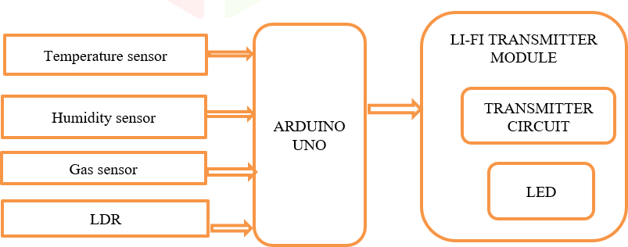*Transmitter Side*

Fig. 1 Transmitter section.

1. *Receiver Side*

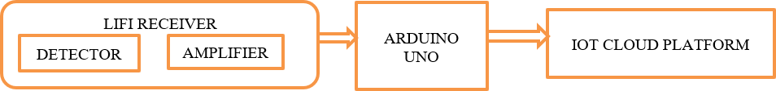

Fig. 2 Receiver section.

# RESULT

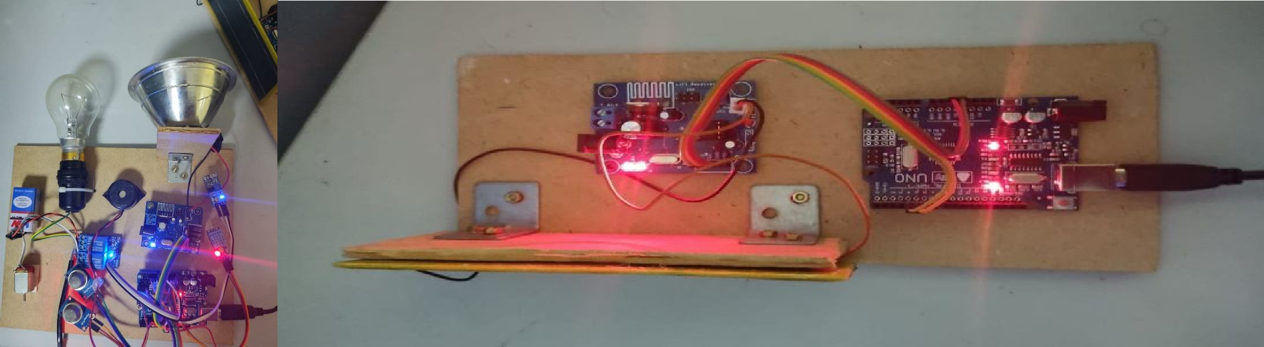The IOT based coal mining monitoring system’s experimental setup consists of transmitter and receiver sections.

Fig. 3 Experimental setup of transmitter and receiver sections.

The images given below represents the values and the message displayed on the in thinkspeak platform.The Temperature, Humidity ,LDR and gas values are displayed on the Thinkspeak platform.

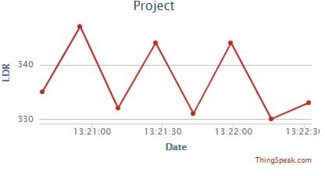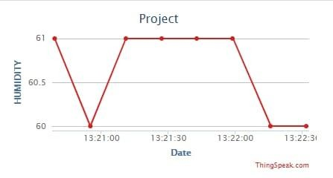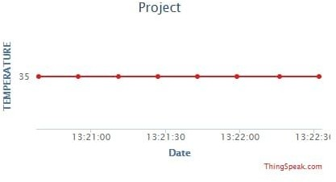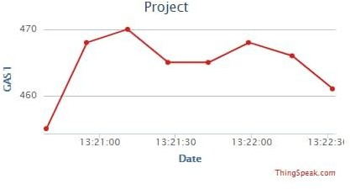

Fig.4 Represents LDR, Humidity, Temperature and Gas values

# CONCLUSION

The mine safety system is implemented with gas sensors, LDR sensors and DHT11 sensors to improve the safety of miners and prevent hazards. This system is used to continuously monitor the mine and employees are alerted via Thinkspeak. This system is inexpensive and effective. The use of a wireless sensor network improves the safety of a coal mine. The wireless connection is more flexible, eliminates the need for reconnection and greatly improves the performance and efficiency of data transfer in mining security systems. When you we parameter values to a computer, the saved values can be used to identify them before a risk occurs. This helps to rescue the miners at right time and save their lives.

# REFERENCES

1. VALDO HENRIQUES AND REZA ALEKIAN,”Mine safety date system using wireless sensor network”, June 16, 2016,IEEE Trans. Ind. Appl., of publication.
2. Muzaffer Kanaan ;Eda Simsek,”On the use of zigbee technology for coal mine safety”, 24th signal processing and communication application conference. IEEE Trans Ind.,published in 2016.
3. Gang sun; Zhongxin Wang; Jia Zhao; Hao Wang;, 2016”A coal mine safety evaluation method based on concept drifting data stream classification”, 12th International conference on National Computation, Fuzzy Systems and Knowledge Discovery.
4. Pranjal Hazarika, “Implementation of safety helmet for coal mine workers”, 2016,1st IEEE International Conference on Power Electronics Intelligent Control and Energy Systems, pp. 1-3.
5. P. Deshpande and M. S. Madankar, „„Techniques improving throughput of wireless sensor network: A survey,‟‟ in Proc. Int. Conf. Circuit, Power Comput.

Technol., Mar. 2015, pp. 1–5.

1. Ashish “Coalmine safety monitoring using Wireless sensor Networks”, International Journal of Scientific Engineering and Technology (IJSET) Volume 2, Issue 10, October 2013.
2. Wakode “Coalmine safety monitoring and alerting system”, International research journal on Engineering and Technology (IRJET) Volume 4, Issue 3, March 2017.
3. Aarthi “Coal Mine safety Monitoring system using ARM 9”, International Journal of Science and Research (IJSR),Volume3,Issue-11,November 2014.
4. Dheeraj “IoT in mining for sensing, Monitoring and prediction of underground mines Roof support”, conference on recent information and advancement technology 2018.
5. Cheng “Coal Mine safety Monitoring system based on Zigbee and GPRS”, Applied Mechanics and Material Volume 422, 2013 .

