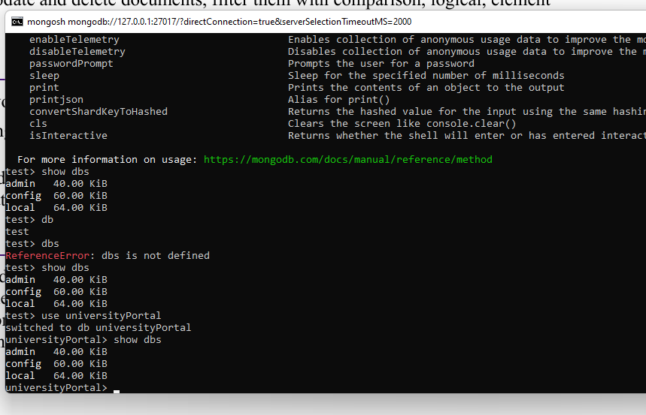
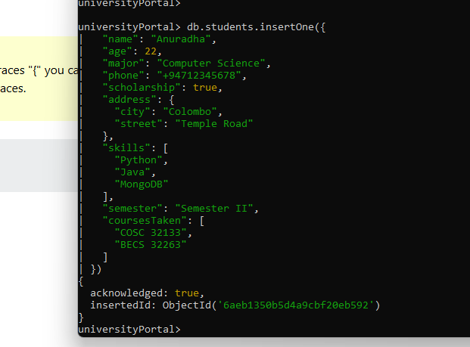
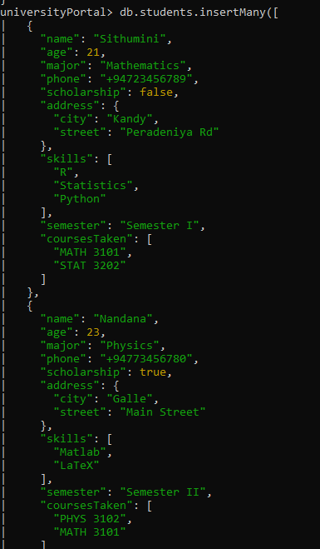
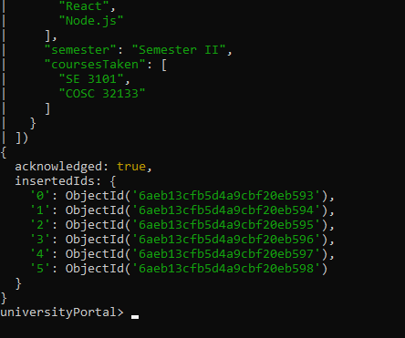

db.students.find({},{_id:0,name:1,phone:1})
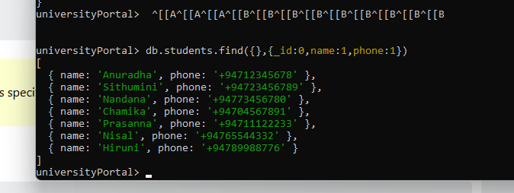
Db.students.find({skills: “python”})
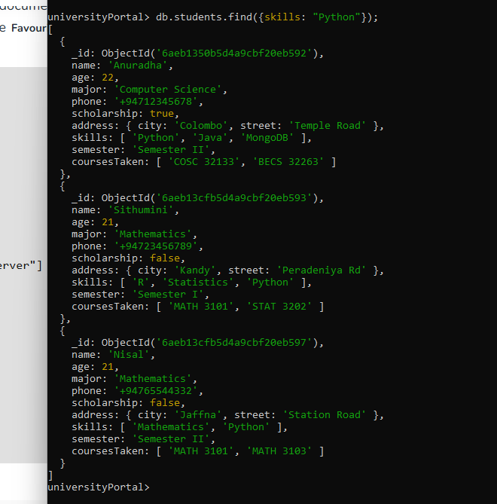
db.students.find({},{_id:0,name:1,age:1}).sort({age:-1,name:1})
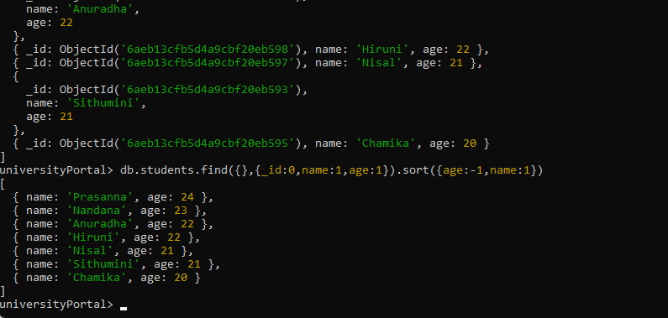
db.students.find({name:Anuradha”})
db.students.updateOne( { name: "Anuradha" },
{ $set: { phone: "+94726677555", scholarship: false},
$push: coursesTaken: ["COSC 32253"] } } )
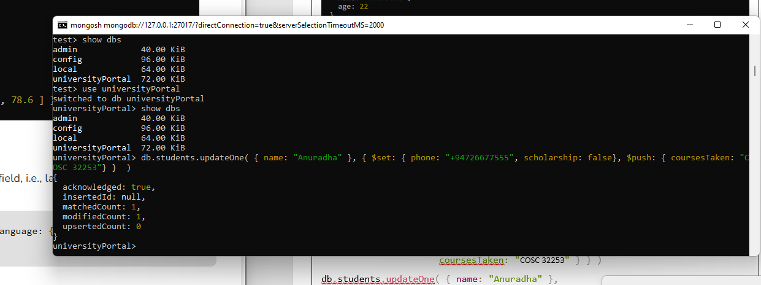
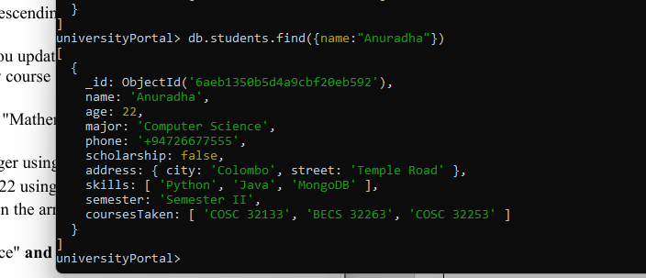
db.students.updateMany({major:’Mathematics”}, { $inc: { age: 1 } })
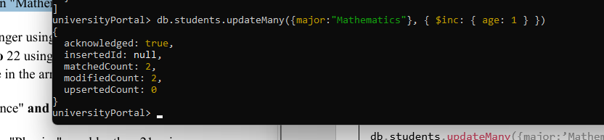
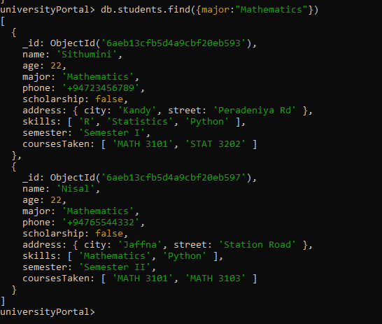
db.students.find({ age: { $lte:21 } })
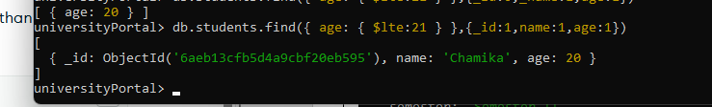
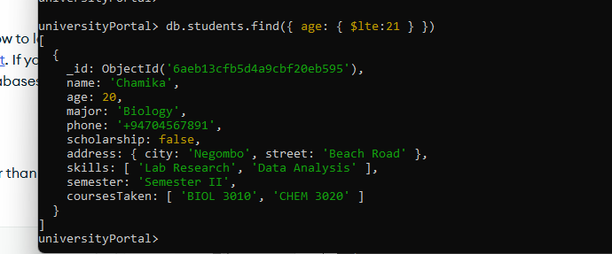
db.students.find({ age: { $ne:22 } })
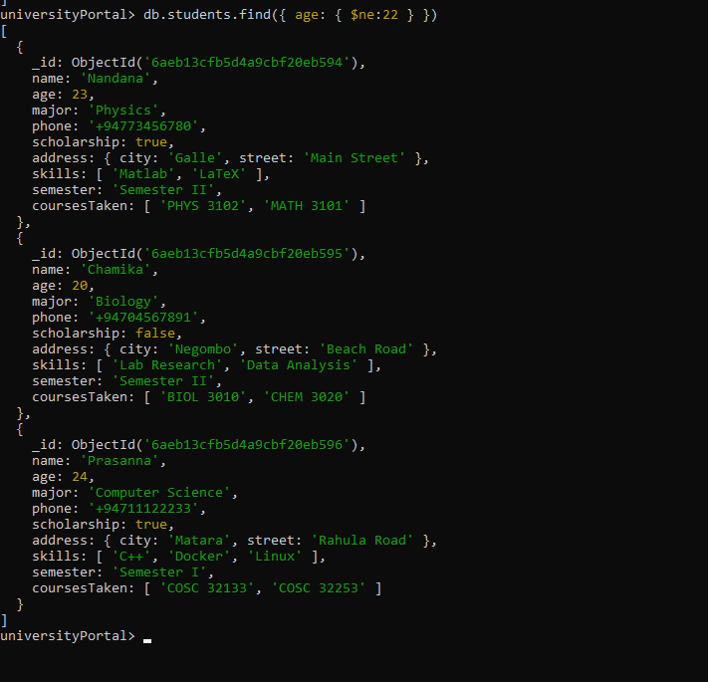

db.students.find({ age: { $in:[20,22,25] } })
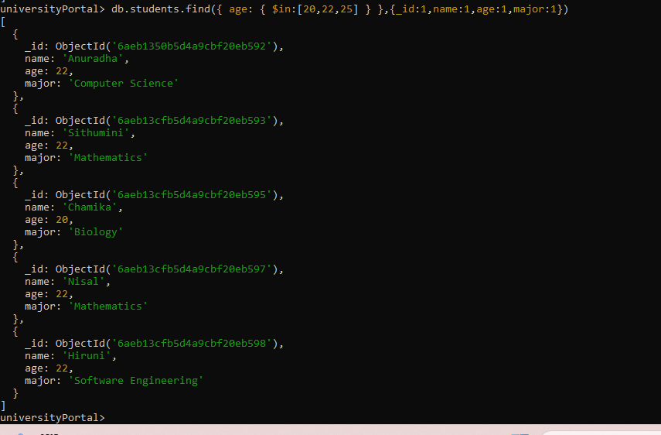
db.students.find({ $and: [major: "Computer Science" , $and ‘(scholarship: true})

