Intelligent Citizen Engagement Platform

# Introduction

* + Project title: Intelligent Citizen Engagement Platform
  + Team Leader: S.Harini
  + Team member: M.Kaviya
  + Team member: K.Hema
  + Team member: A.Kiruthiga

# Project Overview

The purpose of the Intelligent Citizen Engagement Platform is to empower cities and their residents by leveraging AI and real-time data to foster efficient, inclusive, and resilient urban environments.

# Features

Conversational Interface, Policy Summarization, Resource Forecasting, Eco-Tip Generator, Citizen Feedback Loop, KPI Forecasting, Anomaly Detection, Multimodal Input Support, Streamlit or Gradio UI

# Architecture

Frontend (Streamlit): Interactive web UI Backend (FastAPI): RESTful API endpoints

LLM Integration (IBM Watsonx Granite): Natural language processing Vector Search (Pinecone): Document semantic search

ML Modules: Forecasting and Anomaly Detection

# Setup Instructions

Python 3.9+, pip, virtual environment tools, API keys for IBM Watsonx and Pinecone. Installation: clone repo, install dependencies, configure .env, run backend and frontend.

# Folder Structure

app/, app/api/, ui/, smart_dashboard.py, granite_llm.py, document_embedder.py, kpi_file_forecaster.py, anomaly_file_checker.py, report_generator.py

# Running the Application

Run FastAPI server, start Streamlit dashboard, navigate via sidebar, upload documents, interact with chat, view outputs.

# API Documentation

POST /chat/ask, POST /upload-doc, GET /search-docs, GET /get-eco-tips, POST /submit-feedback

# Authentication

JWT, OAuth2, Role-based access, planned user sessions and history tracking.

# User Interface

Minimalist design, sidebar navigation, KPI visualizations, tabbed layouts, real-time form handling, PDF report downloads.

# Testing

Unit Testing, API Testing, Manual Testing, Edge Case Handling

# Screenshot and demo link

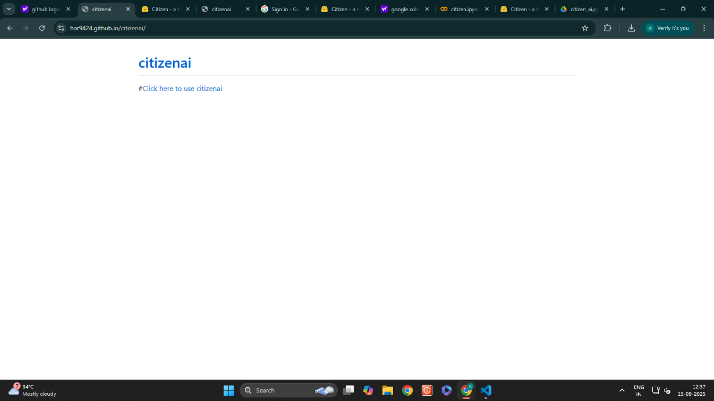

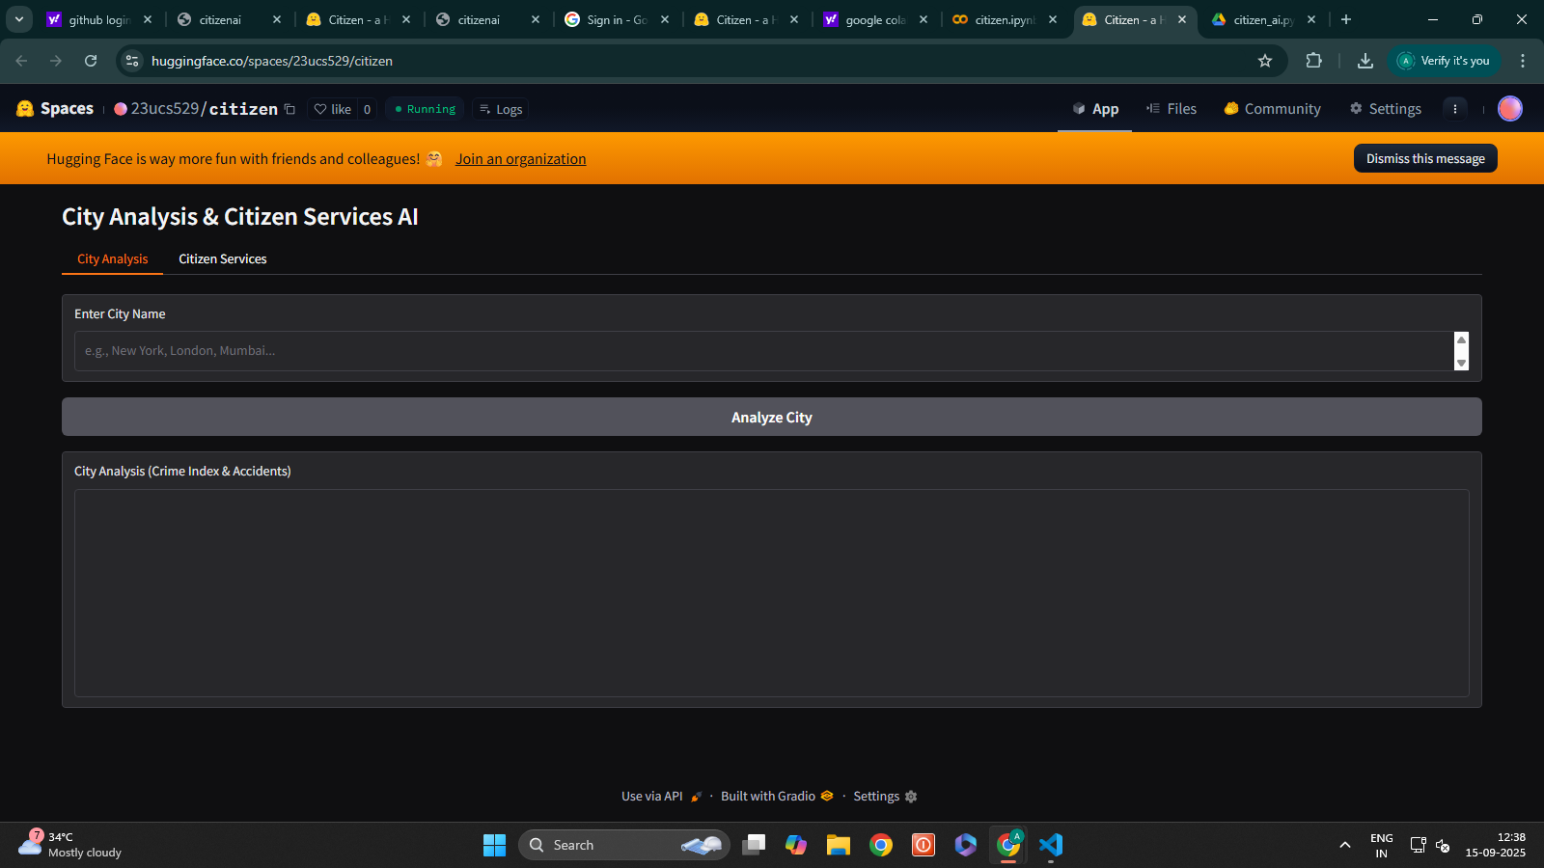

# Future Enhancement

# 