REACTJS
HANDSON 1
Objective
To develop a React application named cricketapp that demonstrates key ES6 features such as map, filter, destructuring, and spread operator through a list of cricket players, and renders different views based on a flag variable.

Step 1: Create the React App
npx create-react-app cricketapp
cd cricketapp
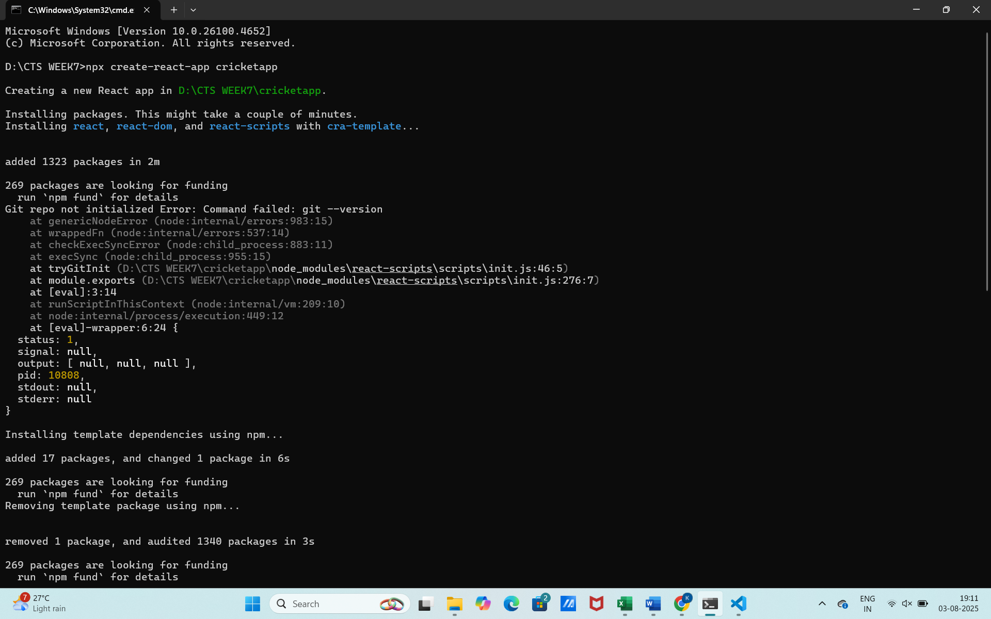
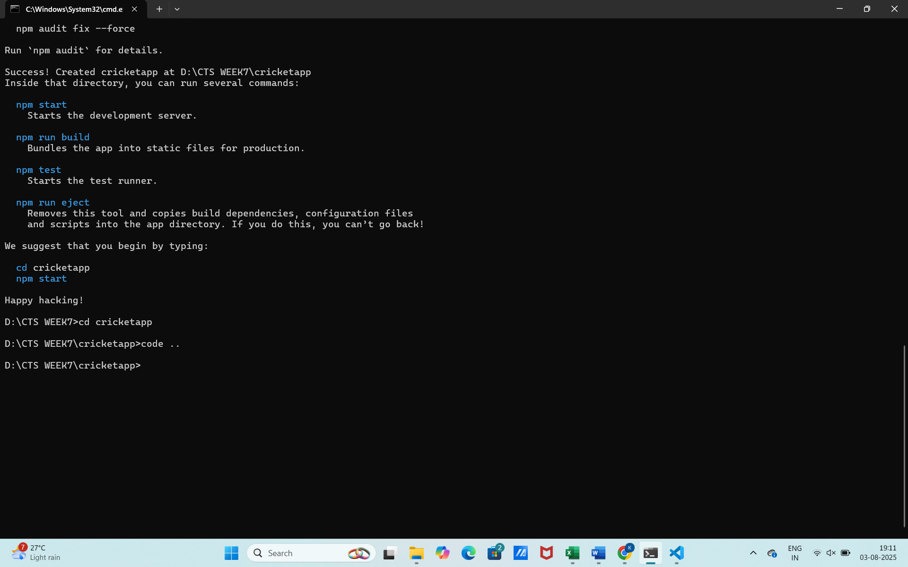
Step 2: Create Components
Inside src, create a folder called components, and inside it create the following files:
ListofPlayers.js
Scorebelow70.js
IndianPlayers.js
OddPlayers.js
EvenPlayers.js
ListofIndianPlayers.js
Step 3: Add Code to Each Component
ListofPlayers.js
import React from 'react';

function ListofPlayers({ players }) {
return (
<ul>
{players.map((item, index) => (
<li key={index}>Mr. {item.name} <span>{item.score}</span></li>
))}
</ul>
);
}

export default ListofPlayers;

Scorebelow70.js
import React from 'react';

function Scorebelow70({ players }) {
const players70 = players.filter((item) => item.score <= 70);
return (
<ul>
{players70.map((item, index) => (
<li key={index}>Mr. {item.name} <span>{item.score}</span></li>
))}
</ul>
);
}

export default Scorebelow70;

IndianPlayers.js
export const IndianTeam = ["Sachin 1", "Dhoni 2", "Virat3", "Rohit4", "Yuvarajs5", "Raina6"];

export const T20Players = ["First Player", "Second Player", "Third Player"];
export const RanjiTrophyPlayers = ["Fourth Player", "Fifth Player", "Sixth Player"];

export const IndianPlayers = [...T20Players, ...RanjiTrophyPlayers];

OddPlayers.js
import React from 'react';

function OddPlayers([first, , third, , fifth]) {
return (
<ul>
<li>First: {first}</li>
<li>Third: {third}</li>
<li>Fifth: {fifth}</li>
</ul>
);
}

export default OddPlayers;

EvenPlayers.js
import React from 'react';

function EvenPlayers([, second, , fourth, , sixth]) {
return (
<ul>
<li>Second: {second}</li>
<li>Fourth: {fourth}</li>
<li>Sixth: {sixth}</li>
</ul>
);
}

export default EvenPlayers;

ListofIndianPlayers.js
import React from 'react';

function ListofIndianPlayers({ IndianPlayers }) {
return (
<ul>
{IndianPlayers.map((player, index) => (
<li key={index}>Mr. {player}</li>
))}
</ul>
);
}

export default ListofIndianPlayers;
Step 4: Set Up App.js
Replace the contents of App.js with:
import React from "react";
import ListofPlayers from "./components/ListofPlayers";
import Scorebelow70 from "./components/Scorebelow70";
import { IndianTeam, IndianPlayers } from "./components/IndianPlayers";
import OddPlayers from "./components/OddPlayers";
import EvenPlayers from "./components/EvenPlayers";
import ListofIndianPlayers from "./components/ListofIndianPlayers";

function App() {
const flag = true; // Change to false to see the second view

const players = [
{ name: "Jack", score: 50 },
{ name: "Michael", score: 70 },
{ name: "John", score: 40 },
{ name: "Ann", score: 61 },
{ name: "Elisabeth", score: 61 },
{ name: "Sachin", score: 95 },
{ name: "Dhoni", score: 100 },
{ name: "Virat", score: 84 },
{ name: "Jadeja", score: 64 },
{ name: "Raina", score: 75 },
{ name: "Rohit", score: 80 },
];

if (flag) {
return (
<div>
<h1>List of Players</h1>
<ListofPlayers players={players} />
<hr />
<h1>List of Players having Scores Less than 70</h1>
<Scorebelow70 players={players} />
</div>
);
} else {
return (
<div>
<h1>Indian Team</h1>
<h2>Odd Players</h2>
<OddPlayers team={IndianTeam} />
<hr />
<h2>Even Players</h2>
<EvenPlayers team={IndianTeam} />
<hr />
<h2>List of Indian Players Merged:</h2>
<ListofIndianPlayers IndianPlayers={IndianPlayers} />
</div>
);
}
}

export default App;

Step 5: Run the App
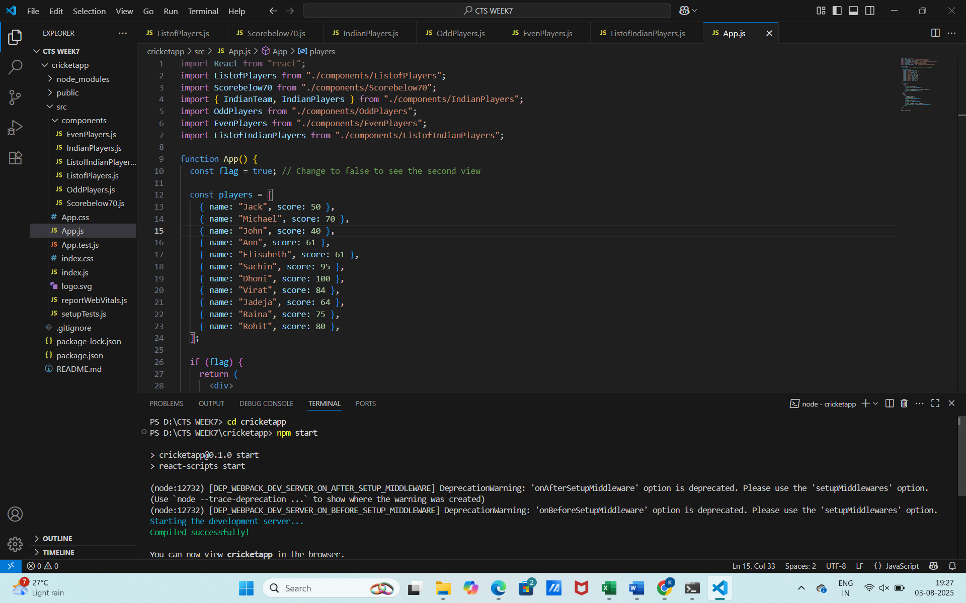
This will open http://localhost:3000 in your browser.

OUTPUT:
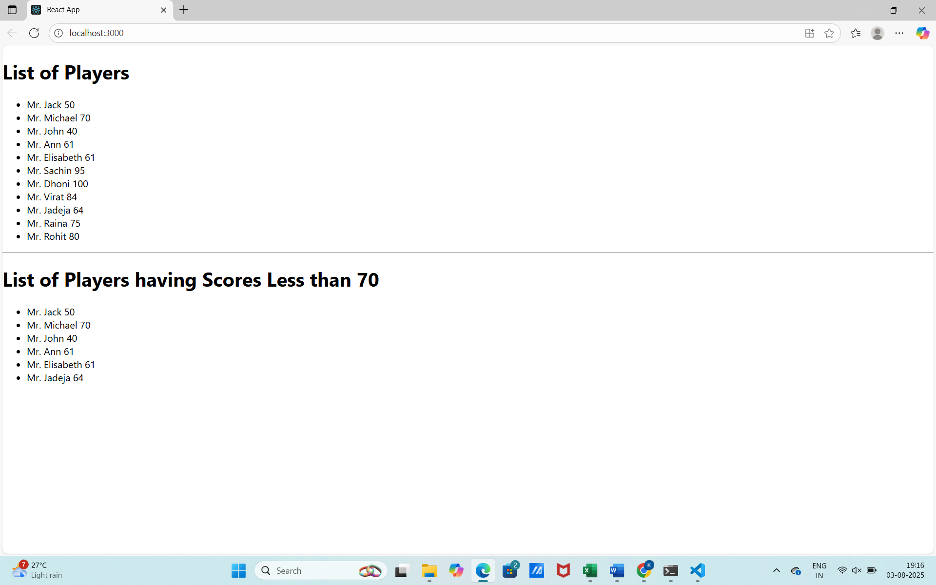

HANDSON 2
Objective:
Build a React app named officespacerentalapp that displays office space details using JSX elements, handles attributes like images, and conditionally renders rent color based on its value.
Step 1: Create the React App
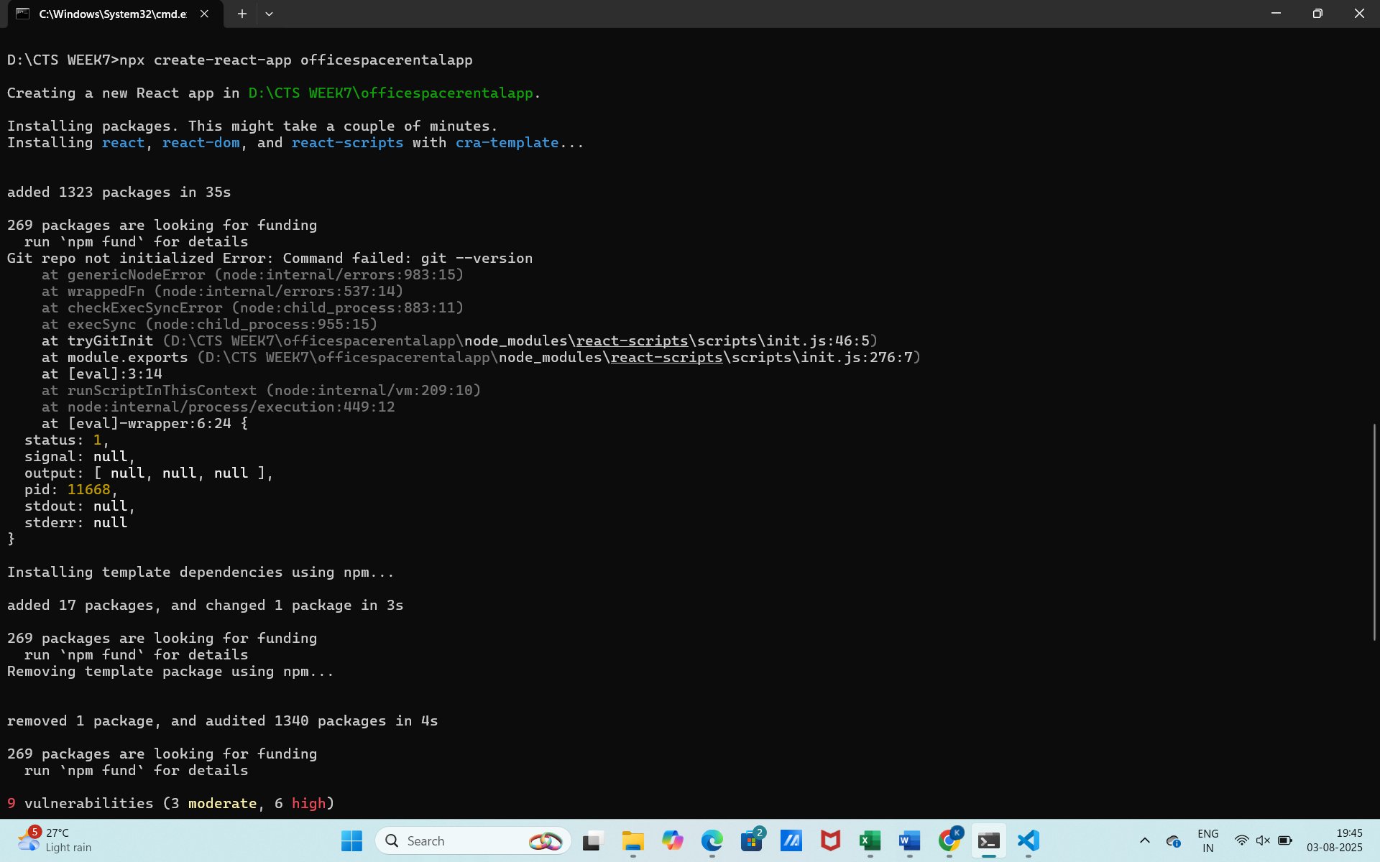

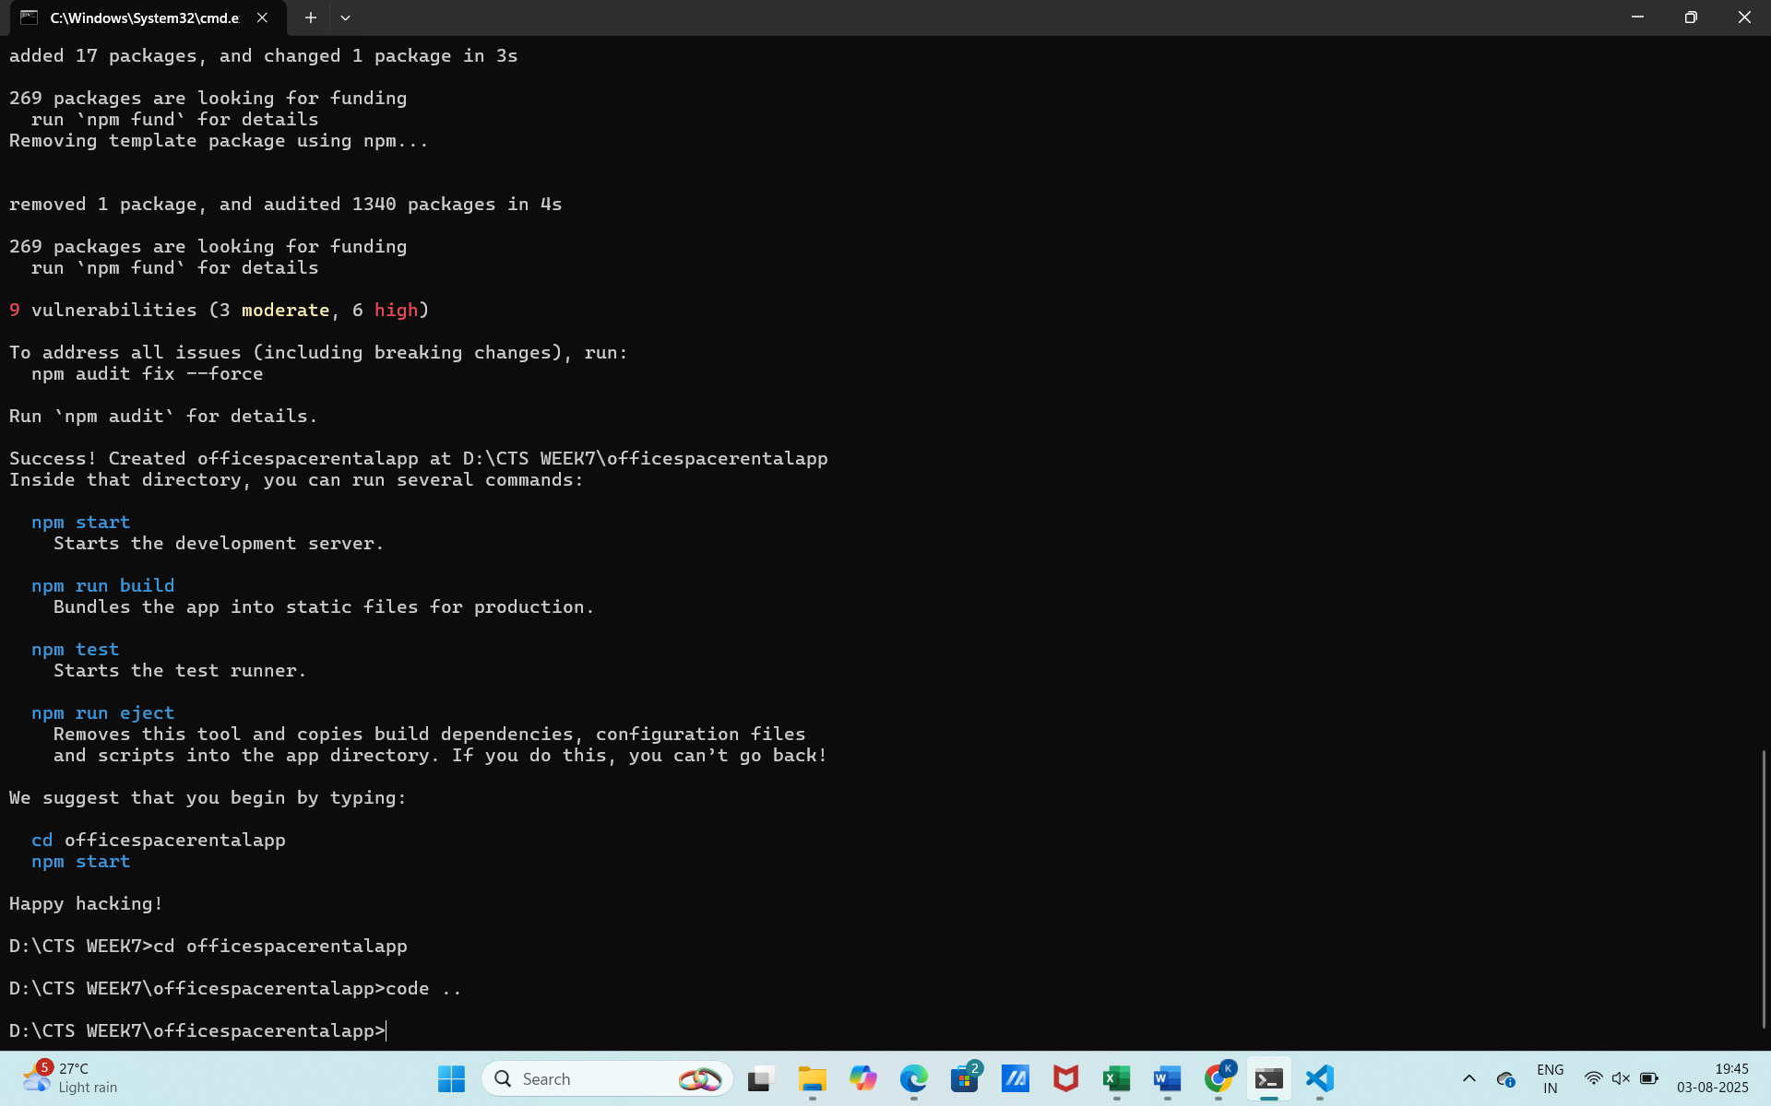
Step 2: Create Components Folder and Files
Inside src/, create a folder called components. Inside it, create:
OfficeList.js
Also place an office image (e.g., office.png) in src/assets/.
Step 3: Add Sample Office Data
OfficeList.js
import React from 'react';
import officeImage from '../assets/office.jpg'; // You must place an image in assets folder
import './OfficeList.css'; // We will create this CSS next

function OfficeList() {
const heading = "Office Space";

const offices = [
{ Name: "DBS", Rent: 50000, Address: "Chennai" },
{ Name: "Regus", Rent: 75000, Address: "Bangalore" },
{ Name: "WeWork", Rent: 65000, Address: "Hyderabad" },
{ Name: "Smartworks", Rent: 48000, Address: "Coimbatore" }
];

return (
<div className="office-container">
<h1>{heading}, at Affordable Range</h1>
<img src={officeImage} width="25%" height="25%" alt="Office Space" />

{offices.map((item, index) => {
const rentColor = item.Rent <= 60000 ? "textRed" : "textGreen";
return (
<div key={index} className="office-item">
<h2>Name: {item.Name}</h2>
<h3 className={rentColor}>Rent: Rs. {item.Rent}</h3>
<h3>Address: {item.Address}</h3>
<hr />
</div>
);
})}
</div>
);
}

export default OfficeList;

Step 4: Add CSS for Rent Colors
Create OfficeList.css inside src/components/:
.office-container {
padding: 20px;
font-family: Arial, sans-serif;
}

.office-item {
margin-bottom: 20px;
}

.textRed {
color: red;
}

.textGreen {
color: green;
}

Step 5: Update App.js
Replace contents of App.js with:
import React from 'react';
import OfficeList from './components/OfficeList';

function App() {
return (
<div className="App">
<OfficeList />
</div>
);
}

export default App;

Step 6: Run the App
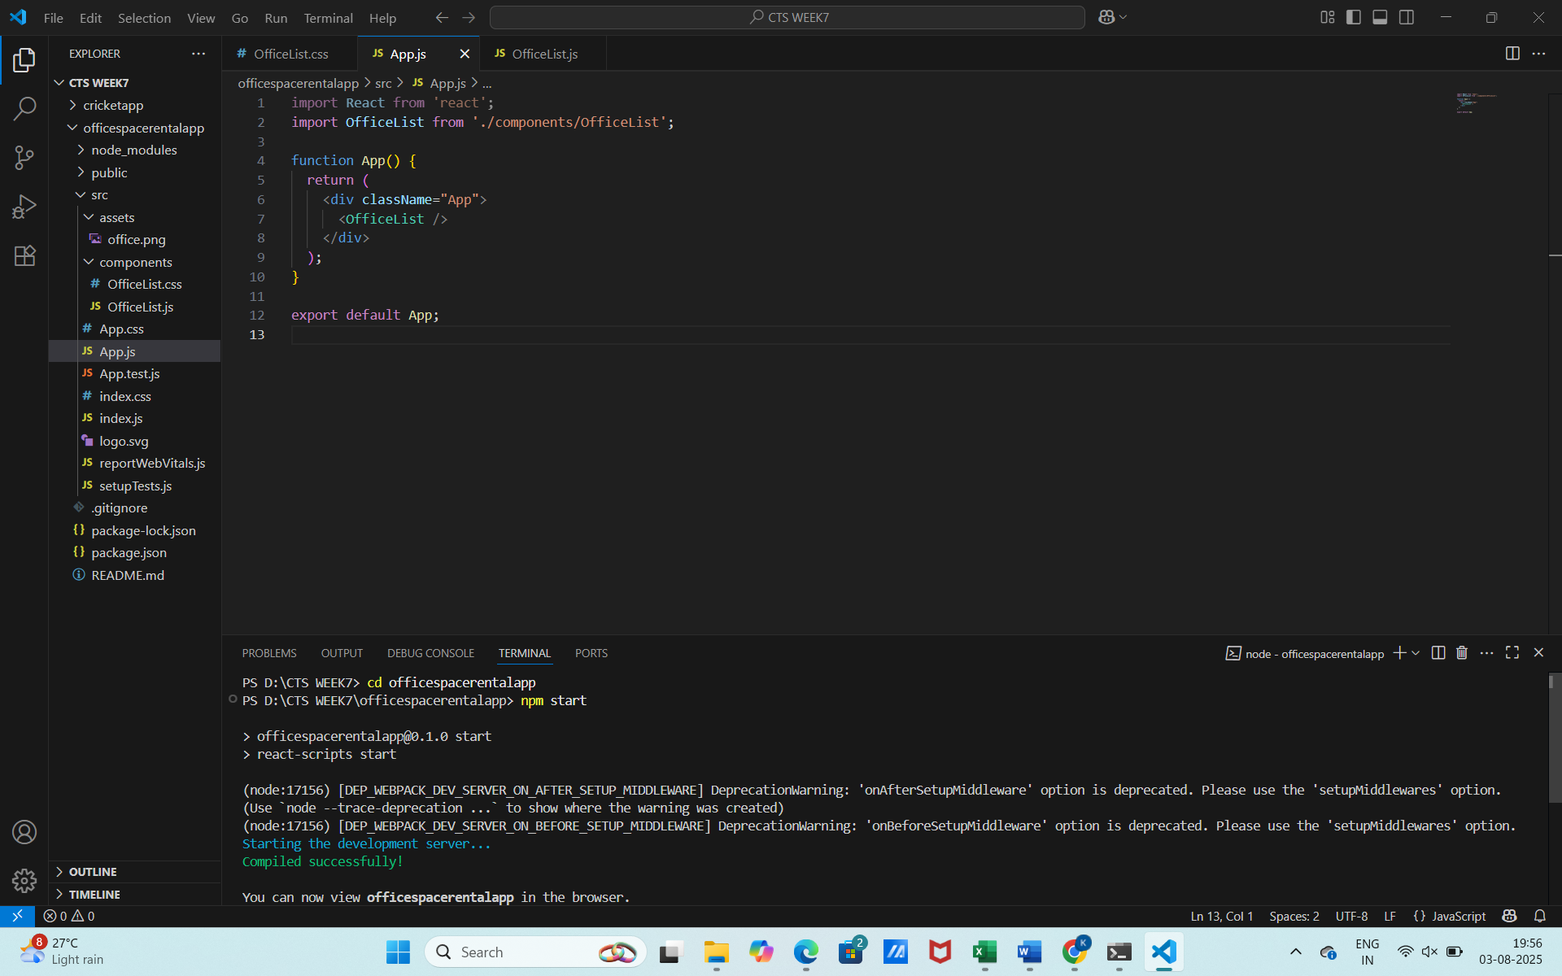

OUTPUT:
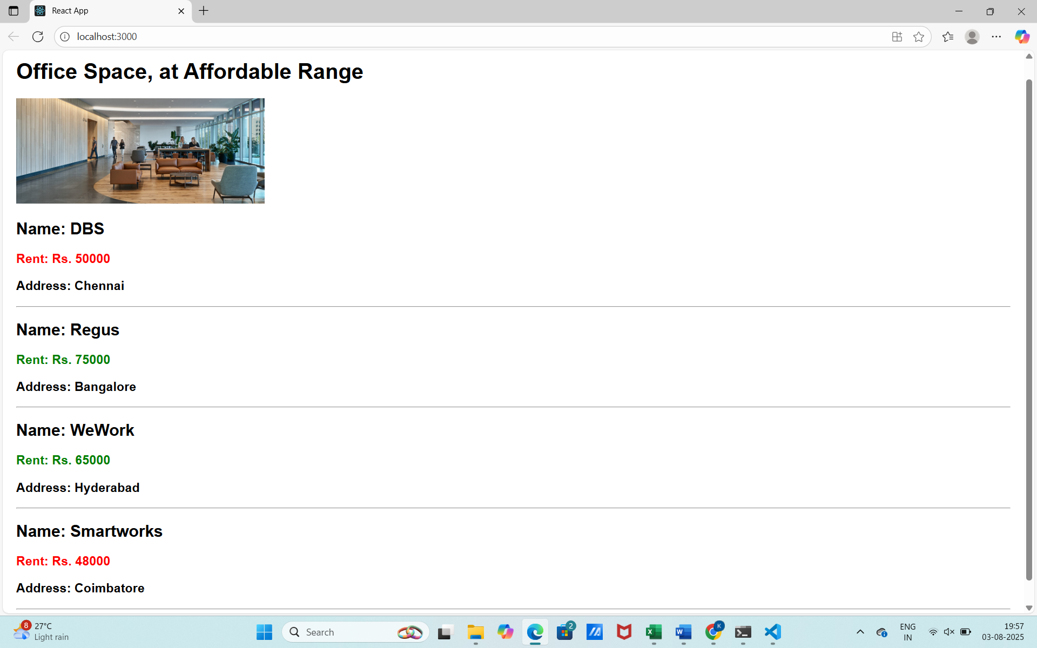

HANDSON 3
Objective
Develop a React application named eventexamplesapp that demonstrates handling various events in form elements using React and JSX. The application includes:
- A counter with Increment and Decrement buttons, where the increment action triggers multiple methods.
- A "Say Welcome" button that invokes a function with a string argument.
- A synthetic event button that displays a message on click.
- A Currency Converter that converts Indian Rupees to Euro using form input and onSubmit event handling.

Step 1: Create the React App
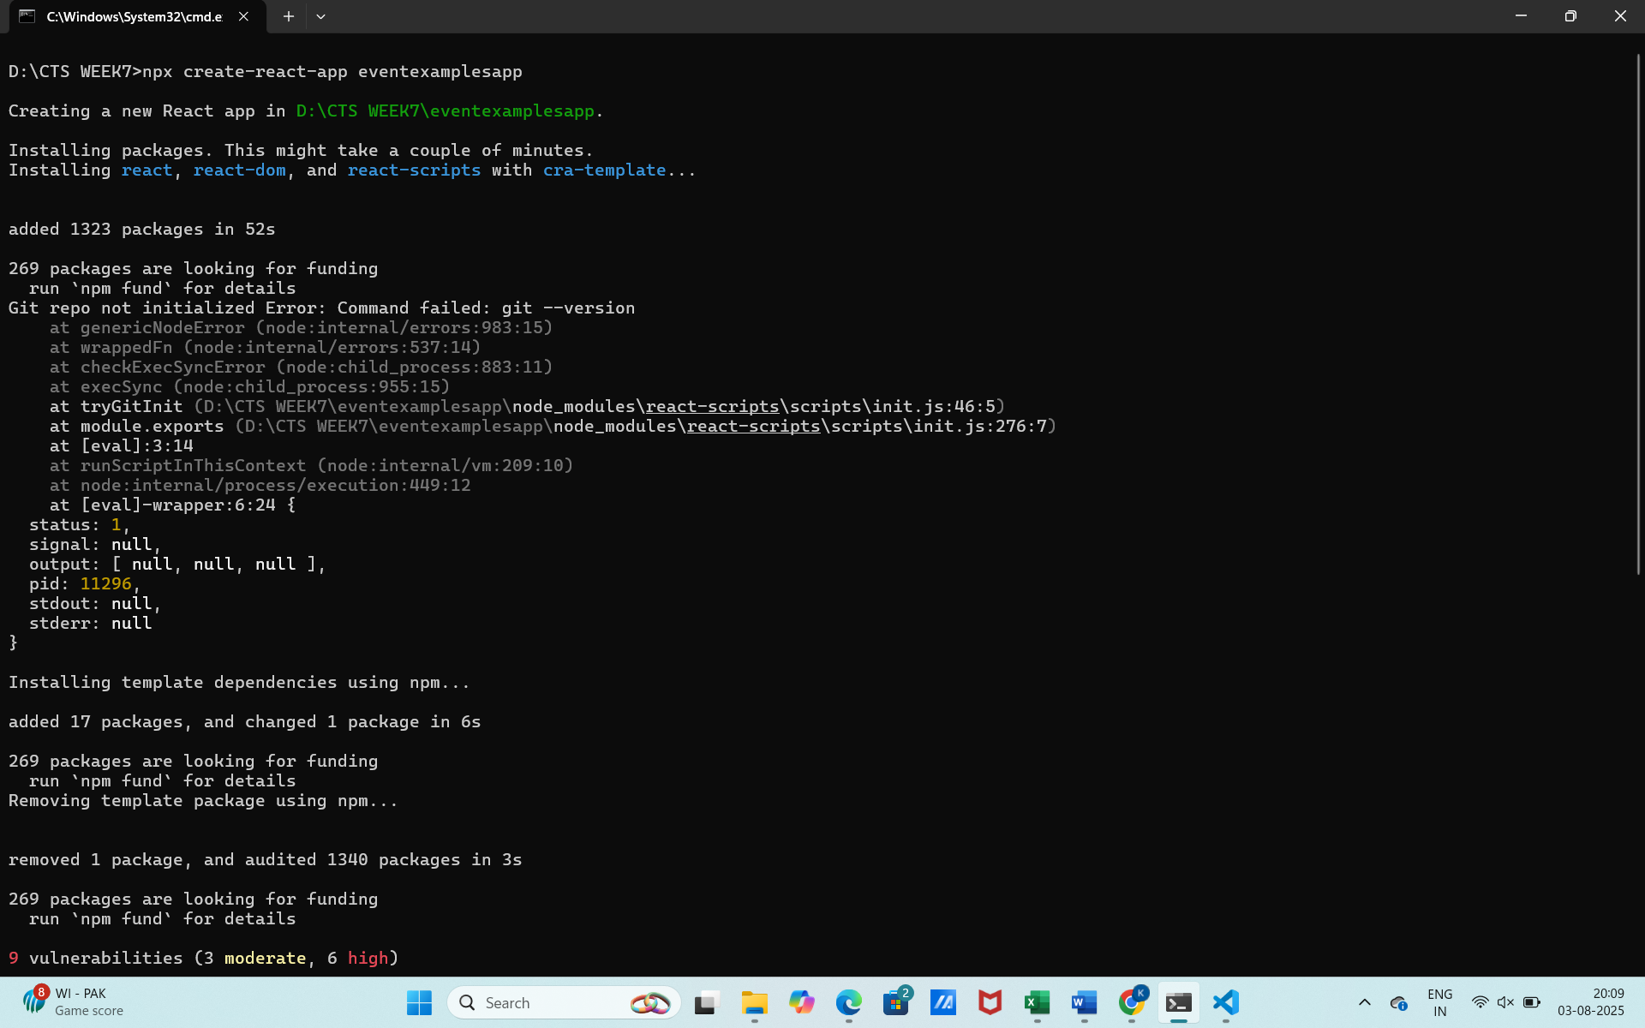
Step 2: Create Components
Inside src/, create a components/ folder with the following files:
- Counter.js
- SayWelcome.js
- ClickEvent.js
- CurrencyConvertor.js
Component 1: Counter.js
Handles Increment and Decrement, and triggers an additional function when incrementing.
import React, { useState } from 'react';

function Counter() {
const [count, setCount] = useState(0);

const increment = () => {
setCount(count + 1);
sayHello();
};

const decrement = () => {
setCount(count - 1);
};

const sayHello = () => {
console.log("Hello! You incremented the counter.");
};

return (
<div>
<h2>Counter: {count}</h2>
<button onClick={increment}>Increment</button>
<button onClick={decrement}>Decrement</button>
</div>
);
}

export default Counter;
Component 2: SayWelcome.js
Button that calls a function with an argument ("Welcome").
import React from 'react';

function SayWelcome() {
const sayMessage = (message) => {
alert(message);
};

return (
<div>
<button onClick={() => sayMessage('Welcome!')}>Say Welcome</button>
</div>
);
}

export default SayWelcome;

Component 3: ClickEvent.js
Handles a synthetic event on button click.
import React from 'react';

function ClickEvent() {
const handleClick = () => {
alert("I was clicked!");
};

return (
<div>
<button onClick={handleClick}>OnPress</button>
</div>
);
}

export default ClickEvent;

Component 4: CurrencyConvertor.js
Converts Rupees to Euro on form submission.
import React, { useState } from 'react';

function CurrencyConvertor() {
const [rupees, setRupees] = useState('');
const [euro, setEuro] = useState('');

const handleSubmit = (e) => {
e.preventDefault();
const result = (parseFloat(rupees) / 90).toFixed(2); // Example conversion rate
setEuro(result);
};

return (
<div>
<h2>Currency Convertor (INR ➡ Euro)</h2>
<form onSubmit={handleSubmit}>
<input
type="number"
placeholder="Enter INR"
value={rupees}
onChange={(e) => setRupees(e.target.value)}
/>
<button type="submit">Convert</button>
</form>
{euro && <p>Euro: €{euro}</p>}
</div>
);
}

export default CurrencyConvertor;
Step 3: Update App.js to Use All Components
import React from 'react';
import Counter from './components/Counter';
import SayWelcome from './components/SayWelcome';
import ClickEvent from './components/ClickEvent';
import CurrencyConvertor from './components/CurrencyConvertor';

function App() {
return (
<div className="App" style={{ padding: '20px' }}>
<h1>Event Examples App</h1>
<Counter />
<hr />
<SayWelcome />
<hr />
<ClickEvent />
<hr />
<CurrencyConvertor />
</div>
);
}

export default App;

Step 4: Run the App
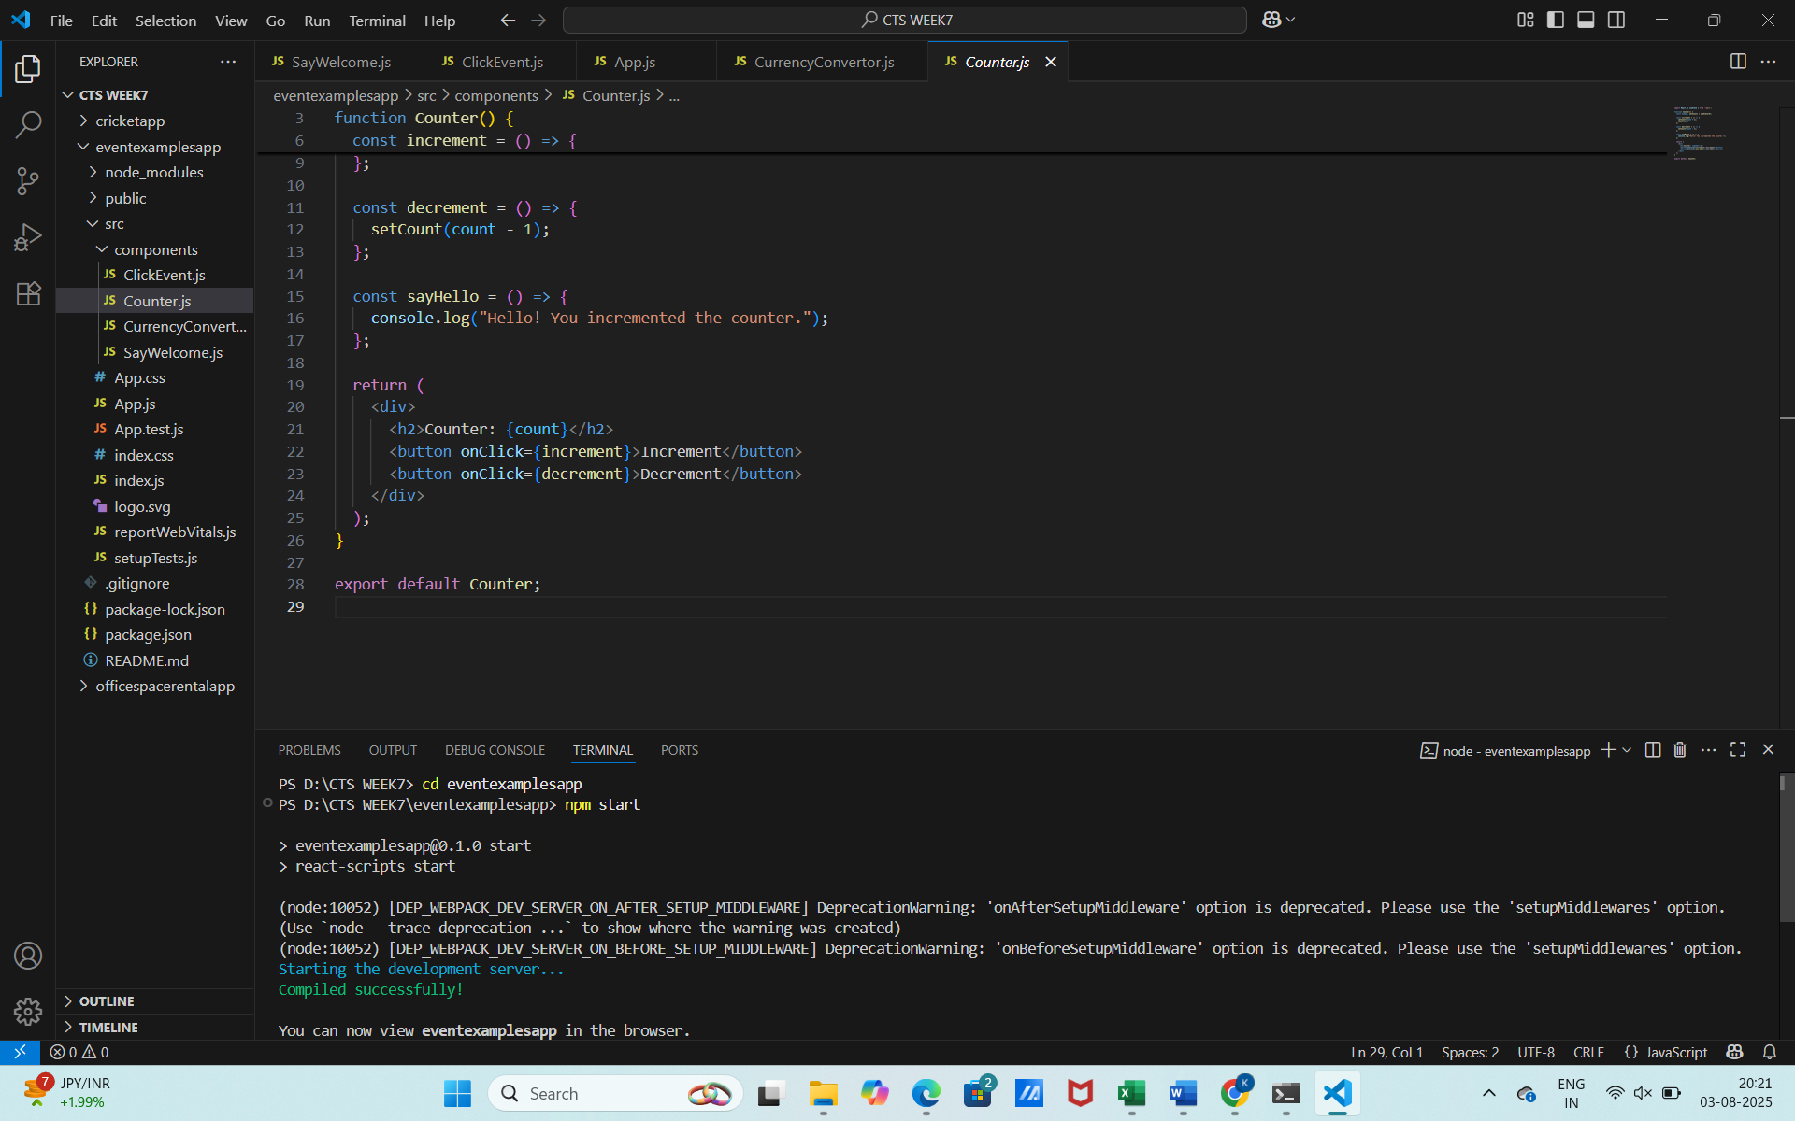
OUTPUT:
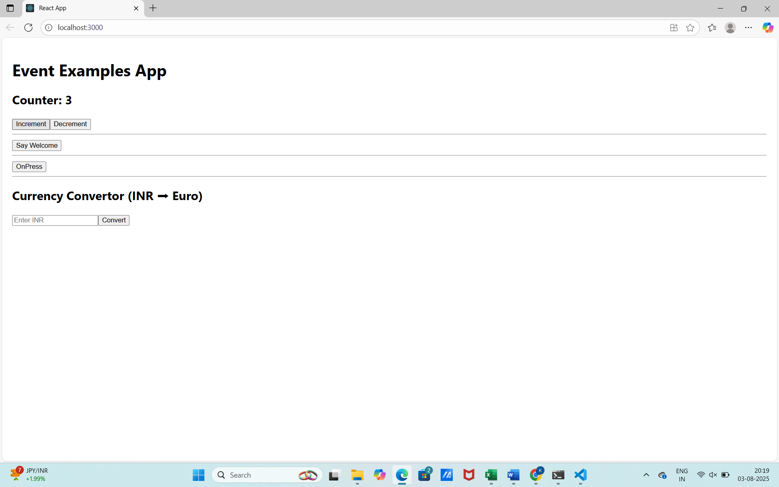

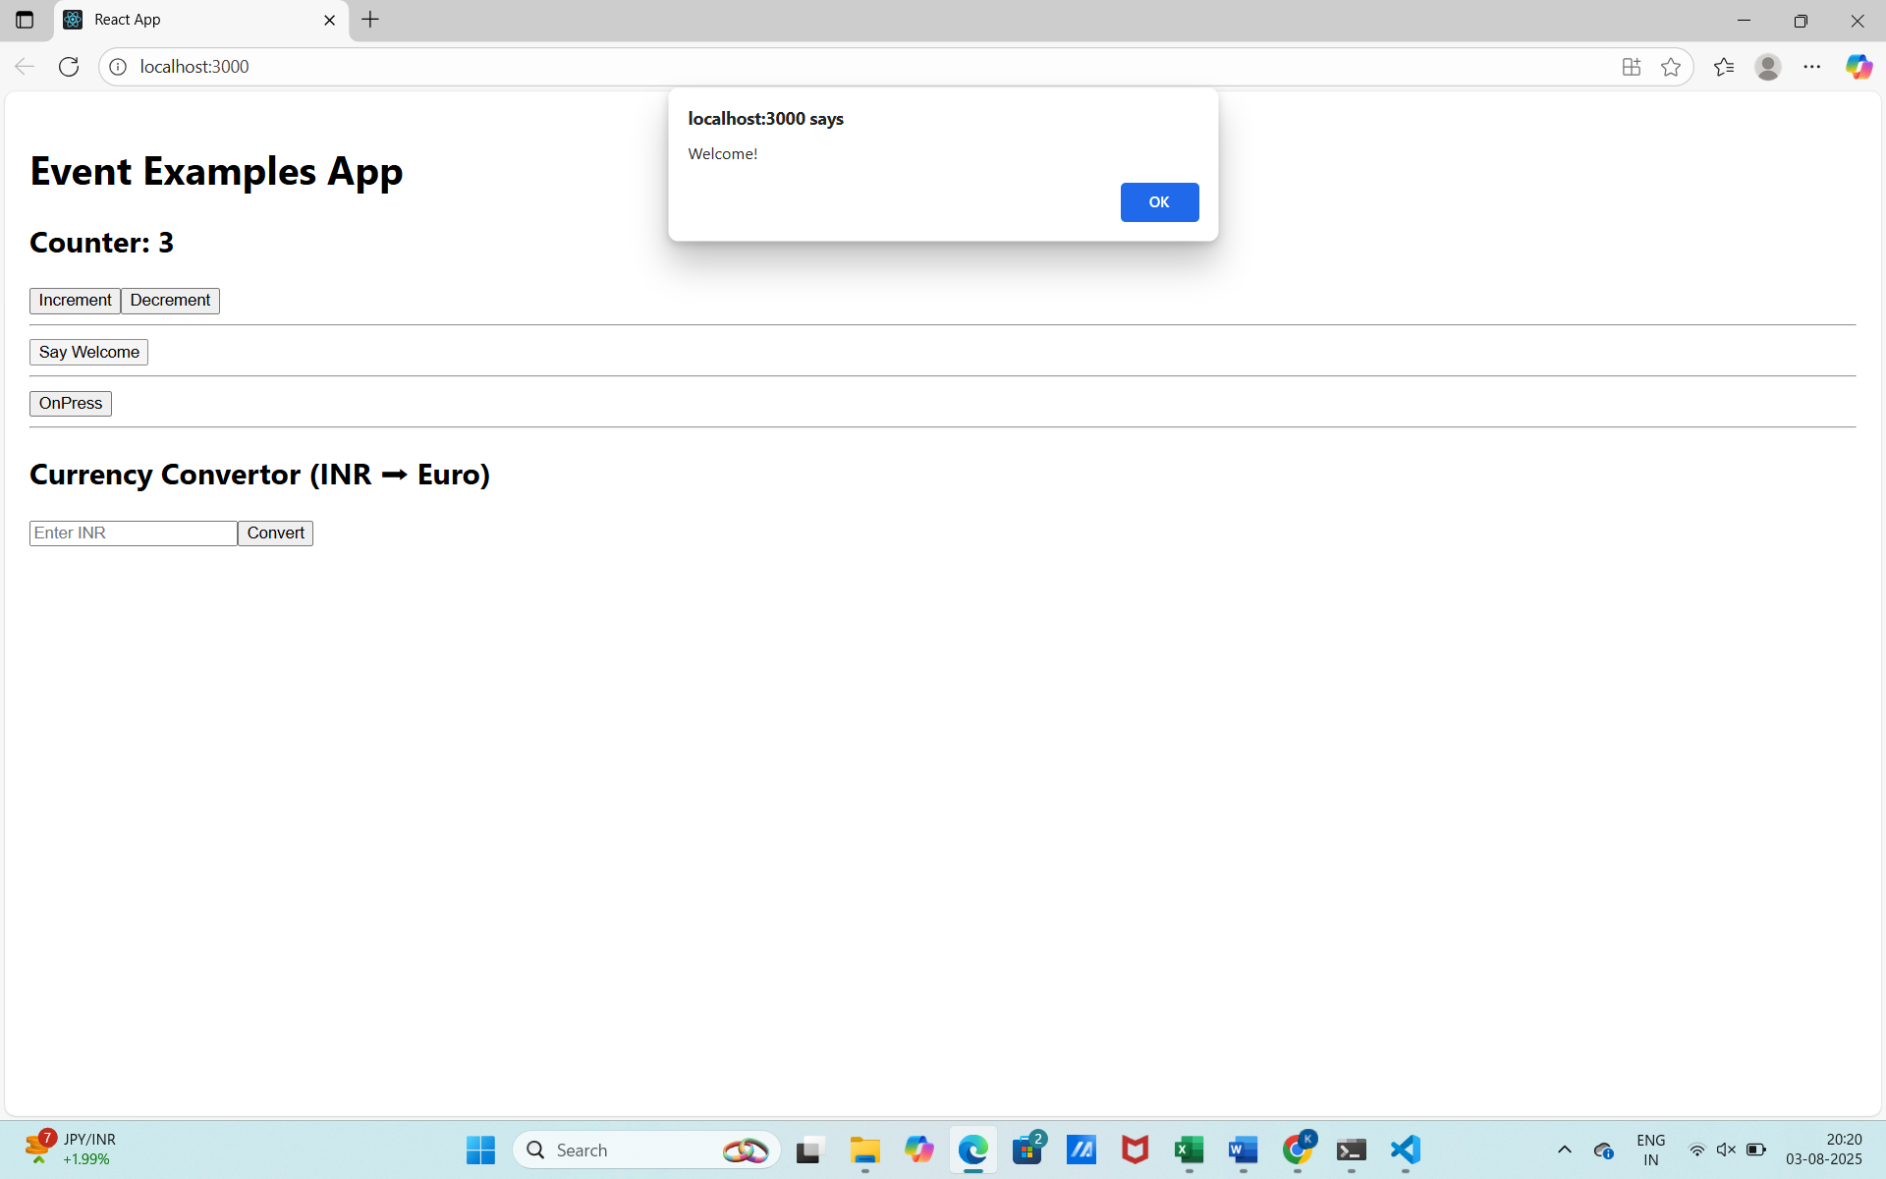
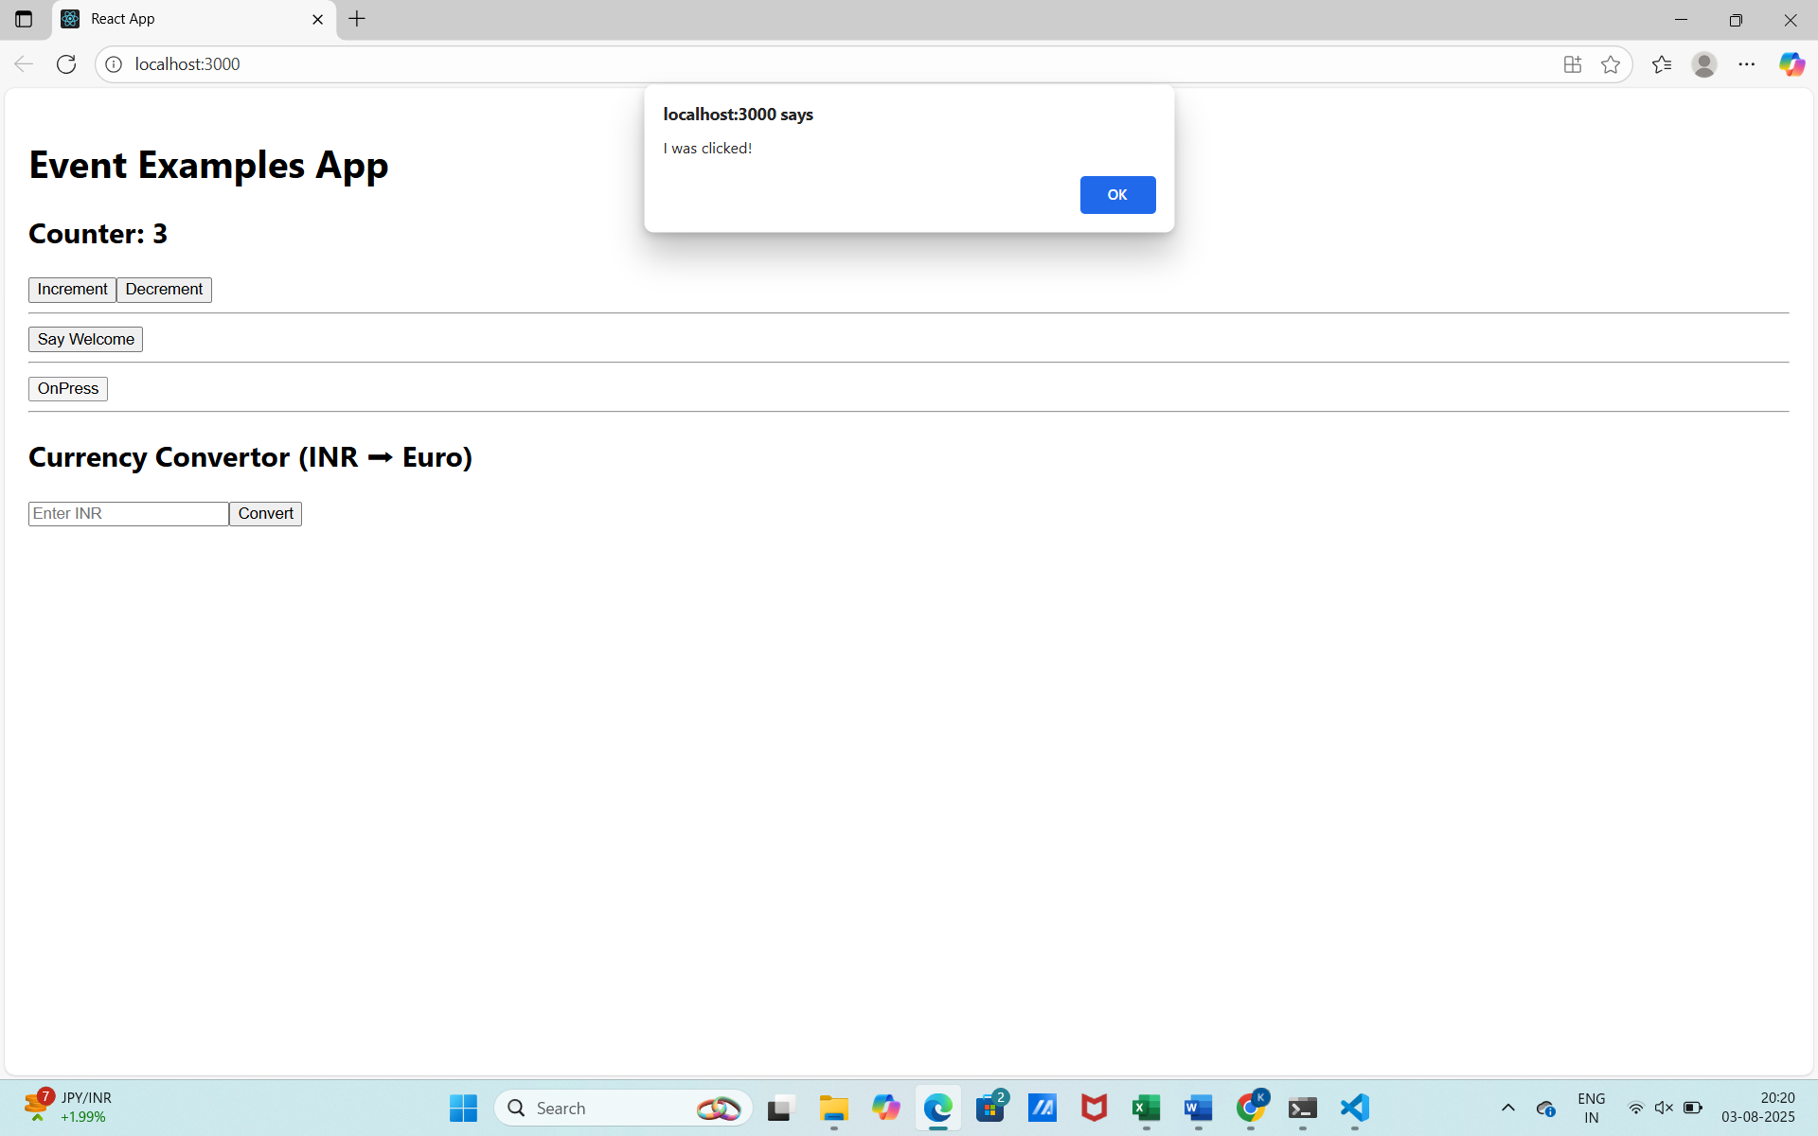

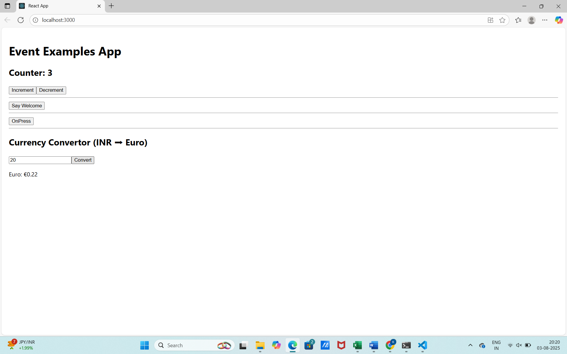
HANDSON 4
Objective
To build a React app named ticketbookingapp where:
- Guest users can view flight details
- Logged-in users can book tickets
- Login and Logout buttons toggle the UI dynamically
Step 1: Create the React App
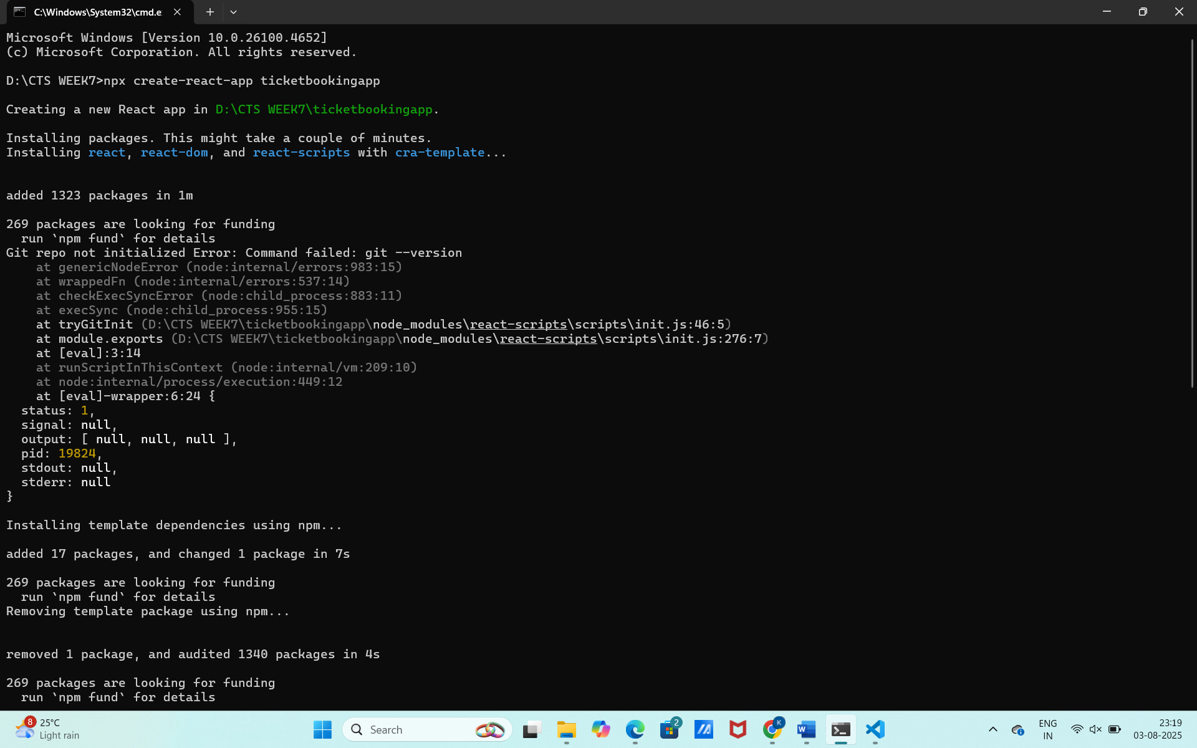
Step 2: Create Component Files
Inside src/, create a folder named components/ with these files:
GuestGreeting.js
UserGreeting.js
LoginButton.js
LogoutButton.js
Greeting.js
FlightDetails.js
Step 3: Add Component Code
GuestGreeting.js
import React from 'react';

function GuestGreeting() {
return (
<div>
<h2>Welcome, Guest!</h2>
<p>Please login to book your flight tickets.</p>
</div>
);
}

export default GuestGreeting;

UserGreeting.js
import React from 'react';

function UserGreeting() {
return (
<div>
<h2>Welcome Back!</h2>
<p>You can now book your flight tickets.</p>
<button>Book Now</button>
</div>
);
}

export default UserGreeting;

LoginButton.js
import React from 'react';

function LoginButton(props) {
return (
<button onClick={props.onClick}>Login</button>
);
}

export default LoginButton;

LogoutButton.js
import React from 'react';

function LogoutButton(props) {
return (
<button onClick={props.onClick}>Logout</button>
);
}

export default LogoutButton;

Greeting.js
import React from 'react';
import GuestGreeting from './GuestGreeting';
import UserGreeting from './UserGreeting';

function Greeting(props) {
const isLoggedIn = props.isLoggedIn;
return isLoggedIn ? <UserGreeting /> : <GuestGreeting />;
}

export default Greeting;

FlightDetails.js
import React from 'react';

function FlightDetails() {
const flights = [
{ id: 1, origin: "Chennai", destination: "Mumbai", price: 4500 },
{ id: 2, origin: "Delhi", destination: "Bangalore", price: 5200 },
{ id: 3, origin: "Hyderabad", destination: "Kolkata", price: 4800 }
];

return (
<div>
<h2>Available Flights</h2>
<ul>
{flights.map(flight => (
<li key={flight.id}>
{flight.origin} ✈ {flight.destination} - ₹{flight.price}
</li>
))}
</ul>
</div>
);
}

export default FlightDetails;

Step 4: Update App.js
import React, { useState } from 'react';
import Greeting from './components/Greeting';
import LoginButton from './components/LoginButton';
import LogoutButton from './components/LogoutButton';
import FlightDetails from './components/FlightDetails';

function App() {
const [isLoggedIn, setIsLoggedIn] = useState(false);

const handleLoginClick = () => {
setIsLoggedIn(true);
};

const handleLogoutClick = () => {
setIsLoggedIn(false);
};

return (
<div className="App" style={{ padding: '20px' }}>
<h1>✈️ Ticket Booking App</h1>
{isLoggedIn ? (
<LogoutButton onClick={handleLogoutClick} />
) : (
<LoginButton onClick={handleLoginClick} />
)}

<hr />

<Greeting isLoggedIn={isLoggedIn} />

<hr />

<FlightDetails />
</div>
);
}

export default App;

Step 5: Run the App
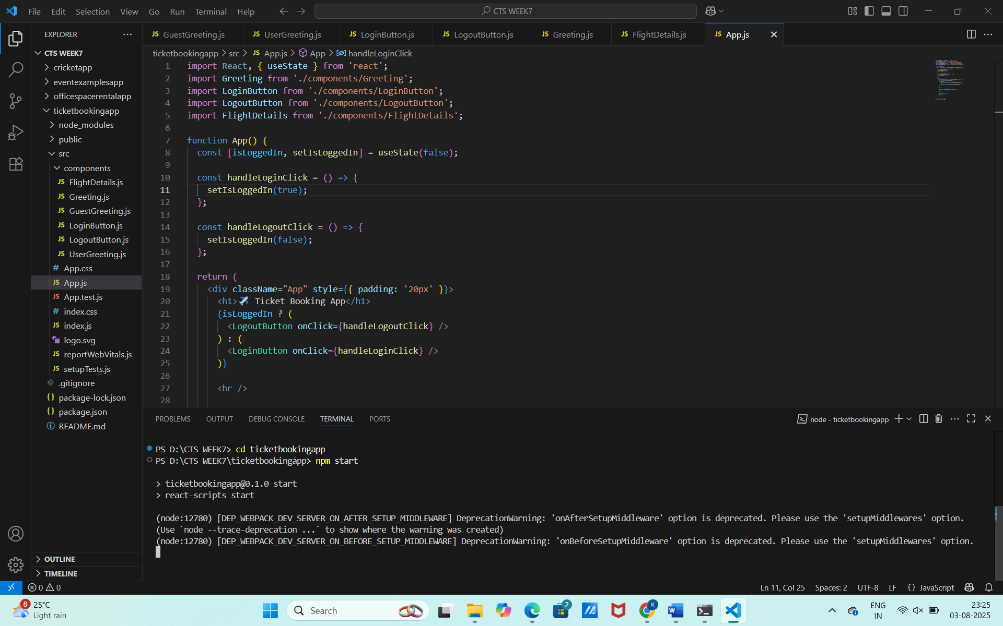

OUTPUT:
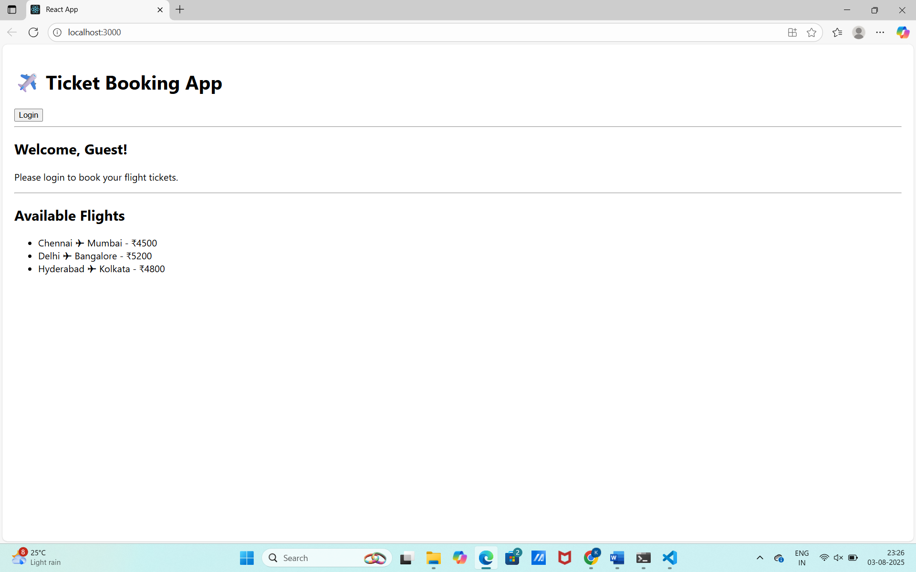

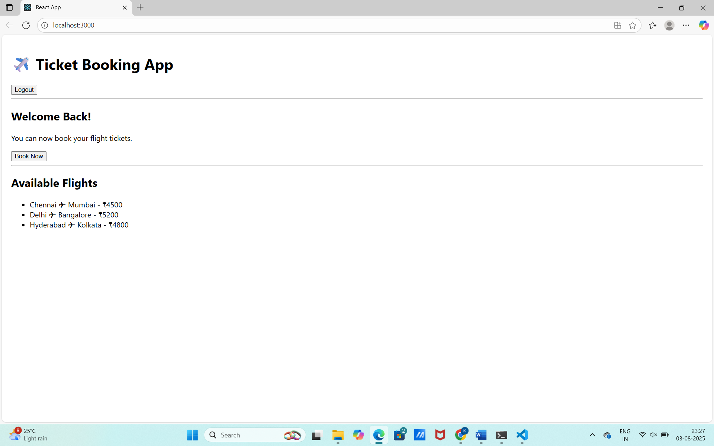

HANDSON 5
Objective
- Create a React app with three components.
- Use conditional rendering to show data dynamically.
Step 1: Create the App
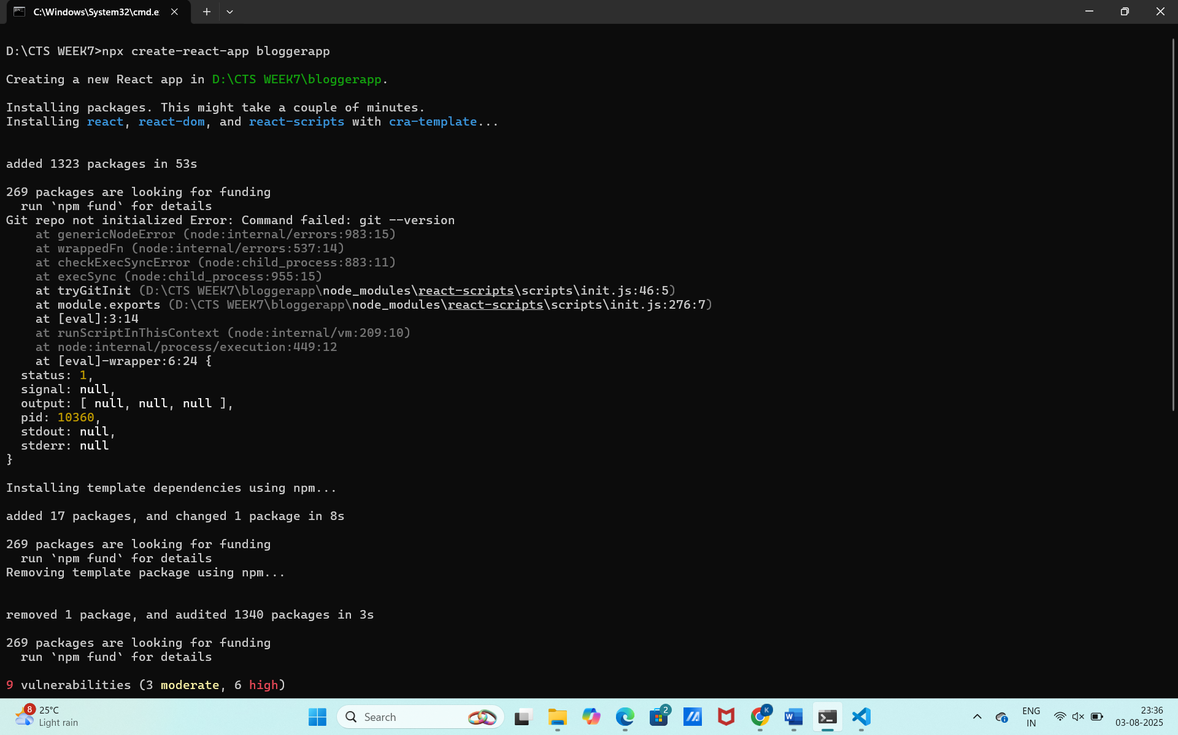
Step 2: Folder Structure
Inside src/, create a folder components/ and add:
- BookDetails.js
- BlogDetails.js
- CourseDetails.js
Also create App.css for styling.
Step 3: Sample Data
src/data.js
export const books = [
{ id: 101, bname: 'Master React', price: 670 },
{ id: 102, bname: 'Deep Dive into Angular 11', price: 800 },
{ id: 103, bname: 'Mongo Essentials', price: 450 },
];

export const blogs = [
{
id: 1,
title: 'React Learning',
author: 'Stephen Biz',
content: 'Welcome to learning React!',
},
{
id: 2,
title: 'Installation',
author: 'Schewzdenier',
content: 'You can install React from npm.',
},
];

export const courses = [
{ id: 1, cname: 'Angular', date: '04/08/2025' },
{ id: 2, cname: 'React', date: '05/08/2025' },
];

Step 4: Components
BookDetails.js
import React from 'react';

function BookDetails({ books }) {
const showBooks = books.length > 0;

return (
<div className="section">
<h1>Book Details</h1>
<ul>
{showBooks ? (
books.map((book) => (
<div key={book.id}>
<h3>{book.bname}</h3>
<h4>{book.price}</h4>
</div>
))
) : (
<p>No Books Found</p>
)}
</ul>
</div>
);
}

export default BookDetails;

BlogDetails.js
import React from 'react';

function BlogDetails({ blogs }) {
return (
<div className="section">
<h1>Blog Details</h1>
{blogs.length === 0 && <p>No Blogs</p>}
{blogs.length > 0 &&
blogs.map((blog) => (
<div key={blog.id}>
<h3>{blog.title}</h3>
<h4>{blog.author}</h4>
<p>{blog.content}</p>
</div>
))}
</div>
);
}

export default BlogDetails;
CourseDetails.js
import React from 'react';

function CourseDetails({ courses }) {
const renderCourses = () => {
if (courses.length === 0) return <p>No Courses</p>;
return courses.map((course) => (
<div key={course.id}>
<h3>{course.cname}</h3>
<h4>{course.date}</h4>
</div>
));
};

return (
<div className="section">
<h1>Course Details</h1>
{renderCourses()}
</div>
);
}

export default CourseDetails;

Step 5: Style the App
src/App.css
.container {
display: flex;
justify-content: space-around;
margin: 40px;
font-family: Arial, sans-serif;
}

.section {
border-left: 4px solid green;
padding-left: 20px;
}

Step 6: Main App Setup
src/App.js

import React from 'react';
import './App.css';
import BookDetails from './components/BookDetails';
import BlogDetails from './components/BlogDetails';
import CourseDetails from './components/CourseDetails';
import { books, blogs, courses } from './data';

function App() {
return (
<div className="container">
<CourseDetails courses={courses} />
<BookDetails books={books} />
<BlogDetails blogs={blogs} />
</div>
);
}

export default App;

Step 7: Run the App

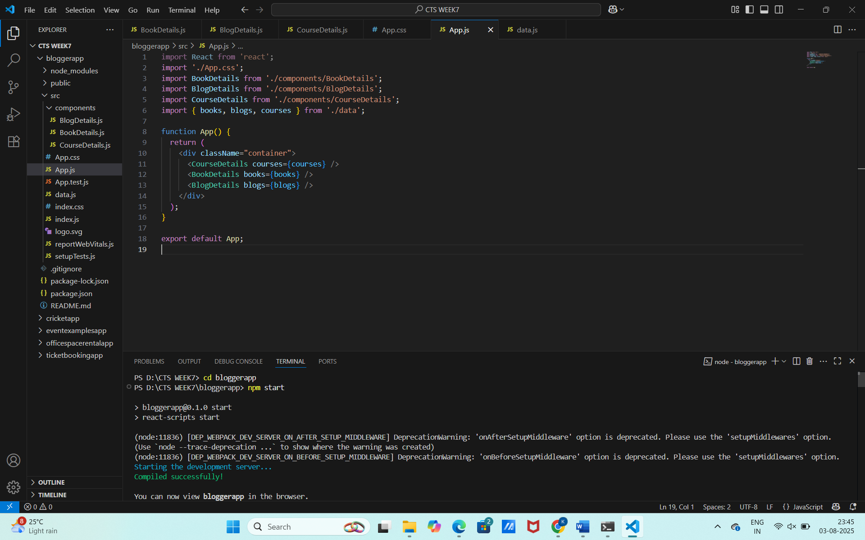
OUTPUT:

