GIT
HANDS ON 1 - Getting Started with Git — Setup, Configuration, and Basic Commands
Objective:
- Learn and practice Git commands
- Configure Git on your machine
- Set Notepad++ as the default Git editor
- Add and manage files in a Git repository
Prerequisites:
- Git for Windows (includes Git Bash) installed
- Notepad++ installed
- GitHub account created
- Internet connection
Step 1: Verify Git Installation
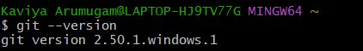
Step 2: Configure Git Identity
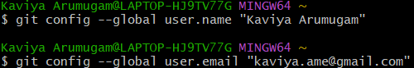
Verify:
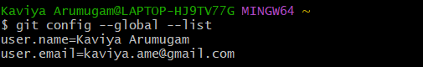

Step 3: Set Notepad++ as Default Editor
1.Ensure Notepad++ is added to PATH (Control Panel → System → Advanced System Settings → Environment Variables → Edit PATH).

2.Set as Git editor:
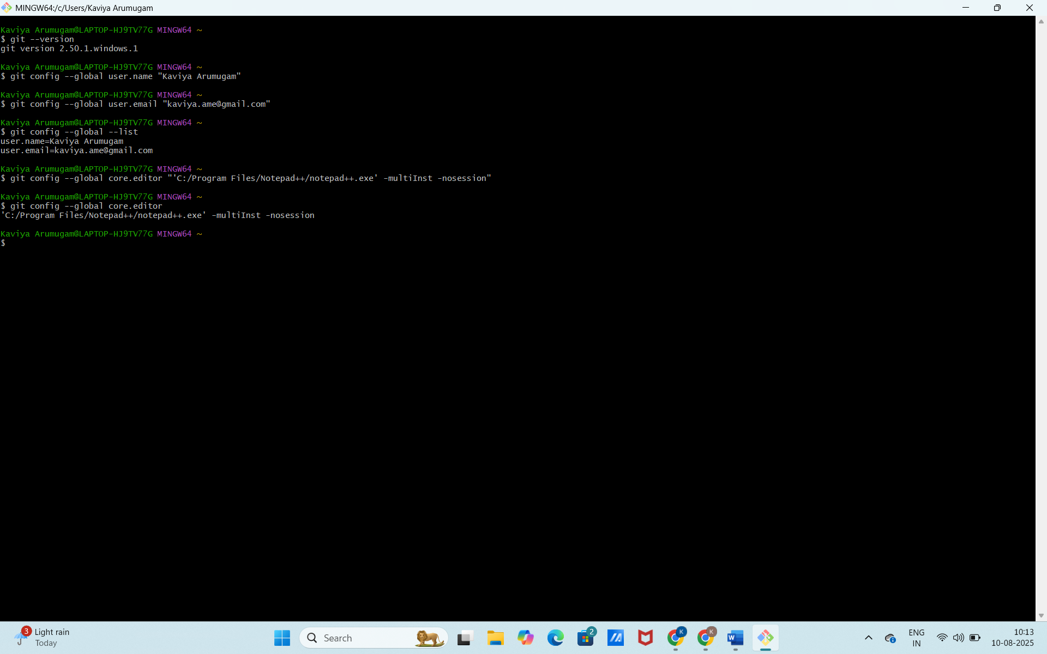
Step 4: Create Local Repository
1.In Git Bash, navigate to desired folder:

2. Initialize Git:
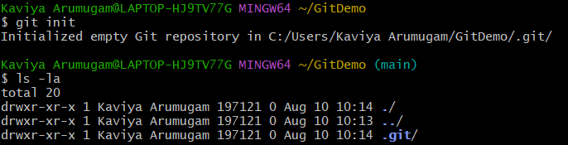
Step 5: Add a File
1. Create file:
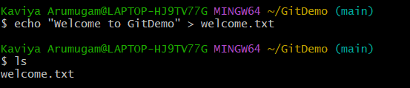
2. Check status:
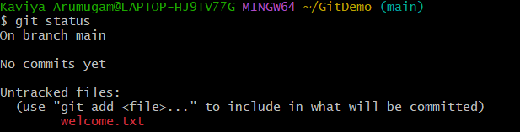
3. Stage the file:

4. Commit using Notepad++:
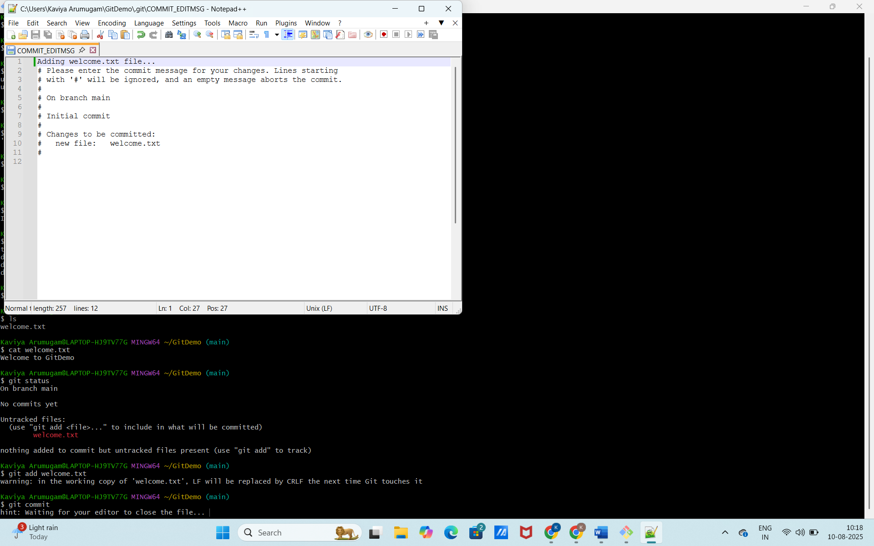
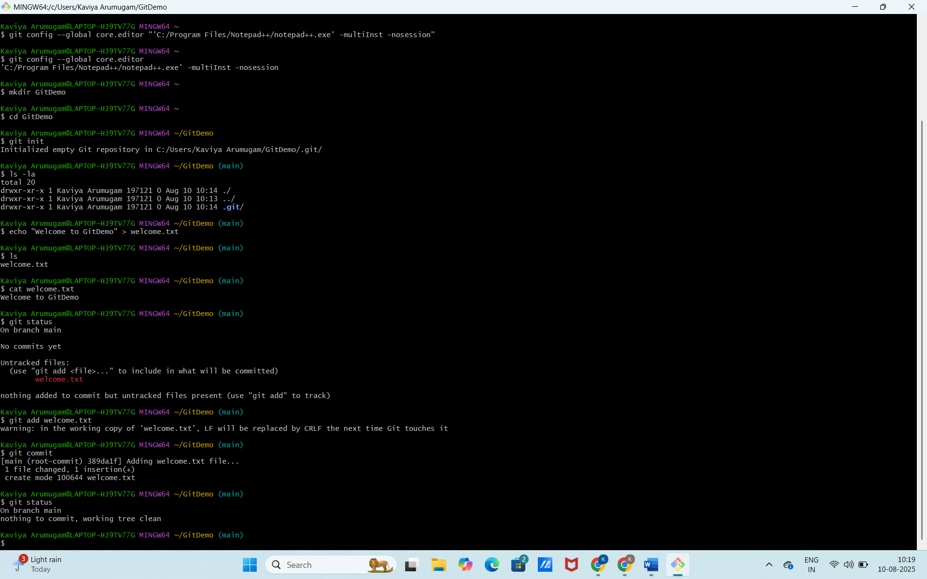
Step 6: Create Remote Repository on GitHub
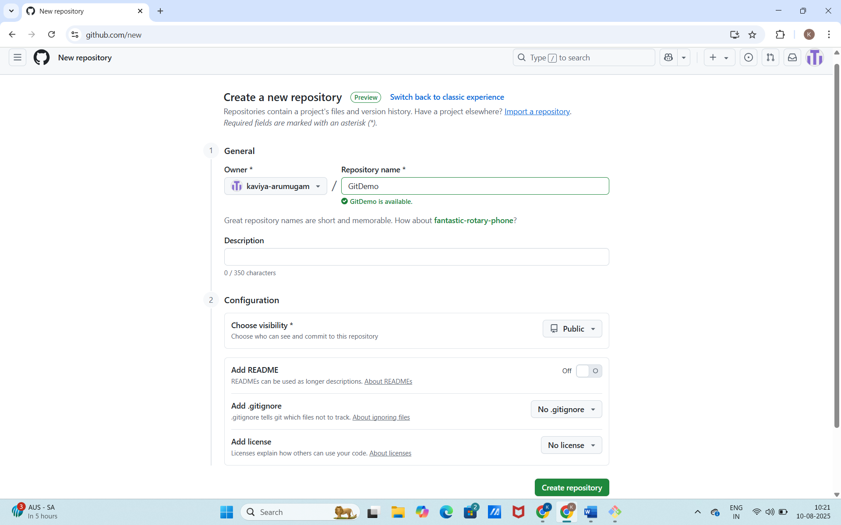

Step 7: Link Local Repo to Remote
Step 8: Push Code to GitHub
Authenticate when prompted:
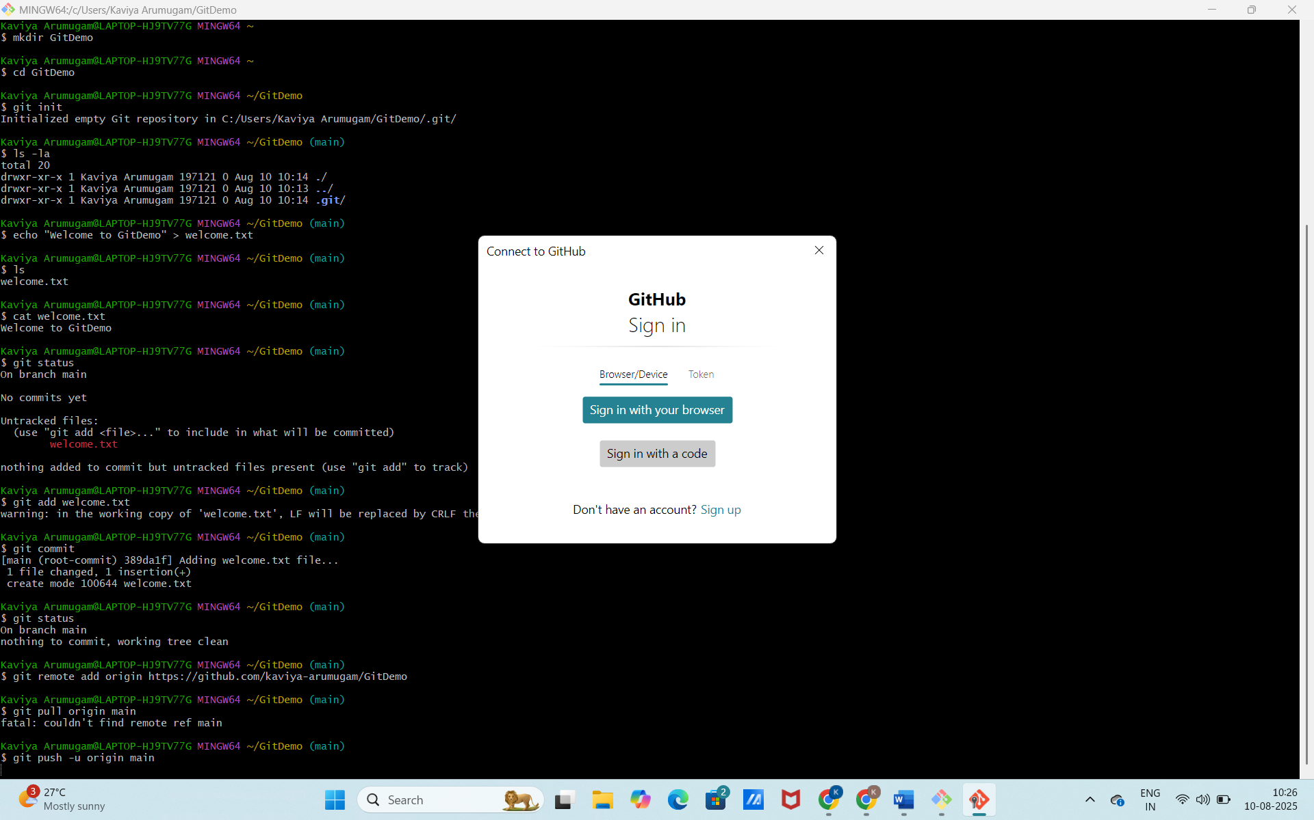
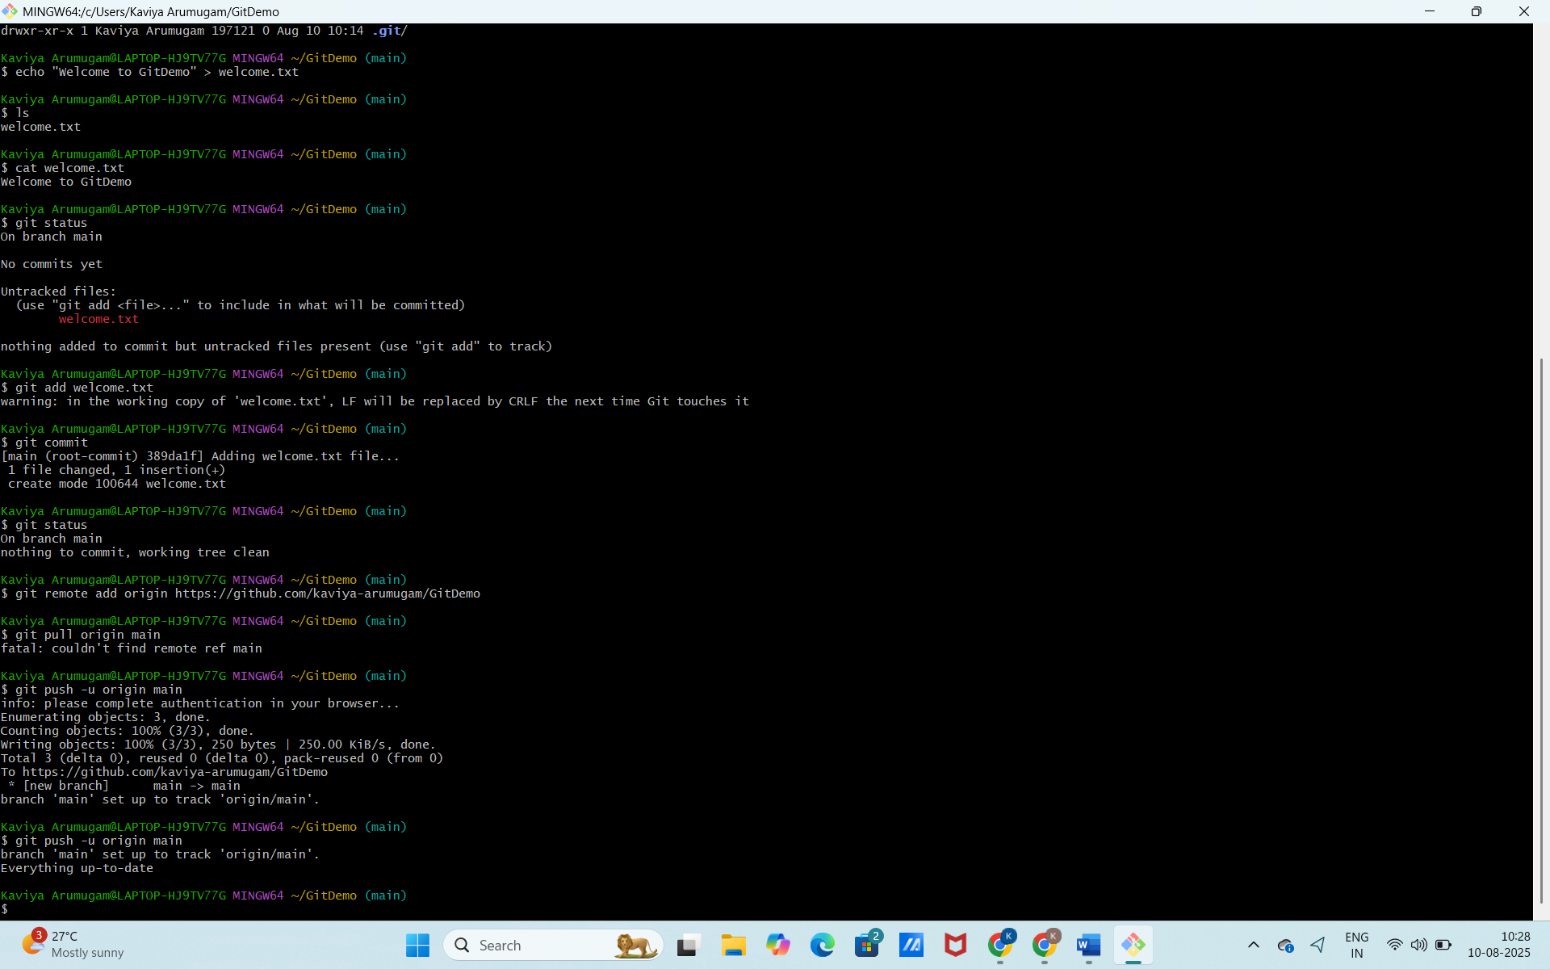
Step 9: Verify in GitHub
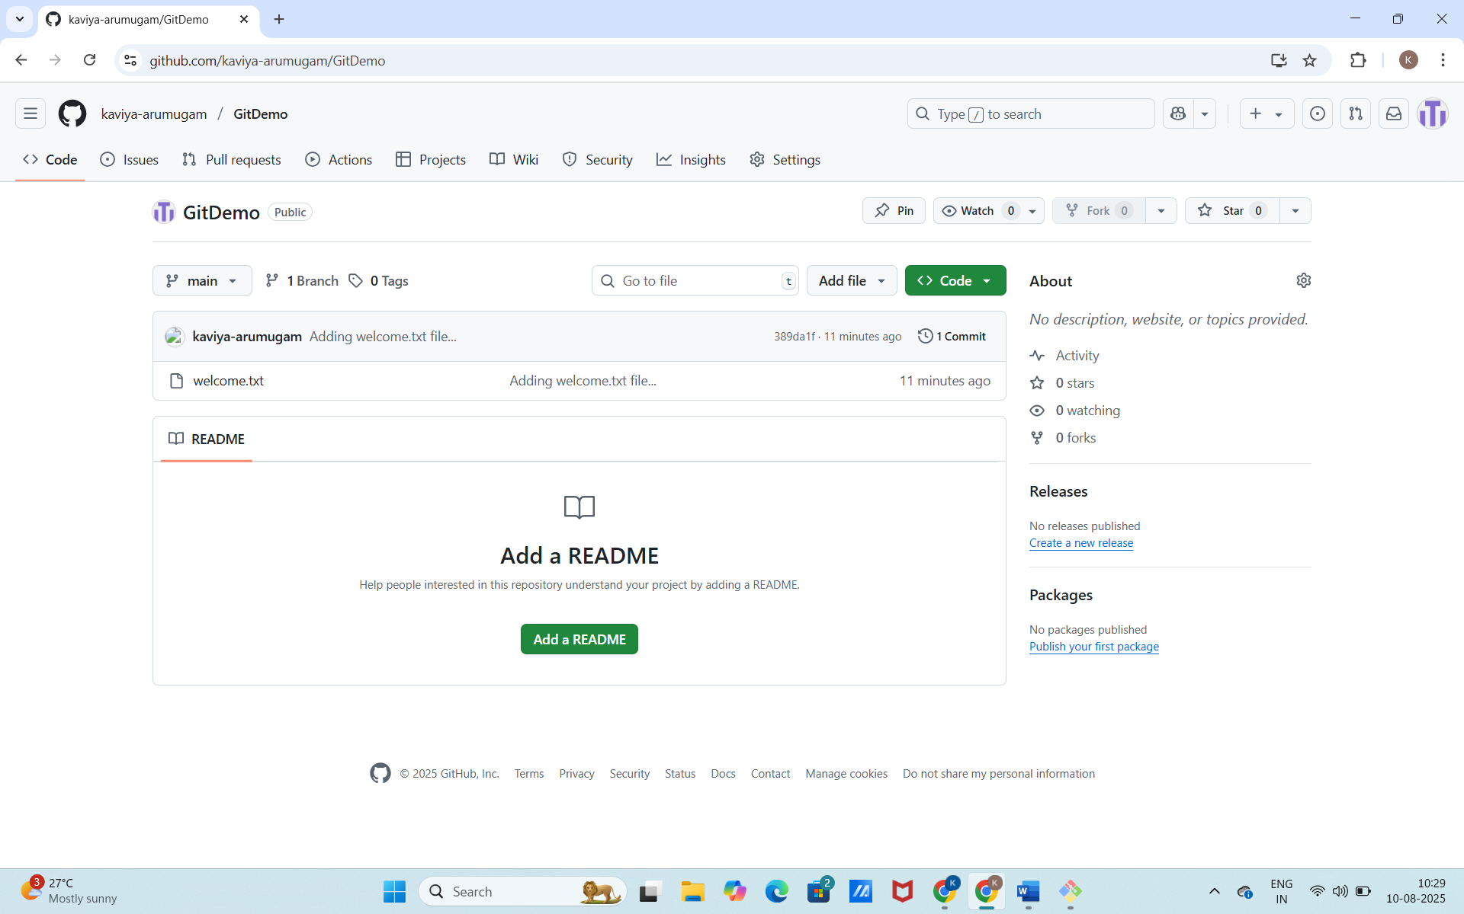
HANDS ON 2 - Using .gitignore to Exclude Unwanted Files and Folders in GiT
Objectives:
- Create and configure a .gitignore file.
- Exclude .log files and a log folder from being tracked by Git.
Prerequisites:
- Git environment already set up.
- Notepad++ integrated as the default Git editor.
- Local Git repository created and linked to a remote repository (GitHub or GitLab).
Step 1: Navigate to your Git repository
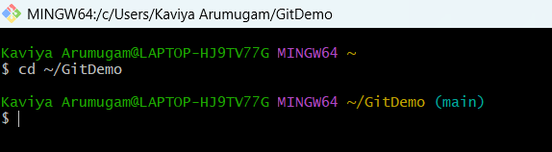
Step 2: Create sample files and folders to ignore

Step 3: Create/Edit .gitignore
Open .gitignore in Notepad++ by running the command:
- notepad++ .gitignore

If command not found
1.Edit user variables
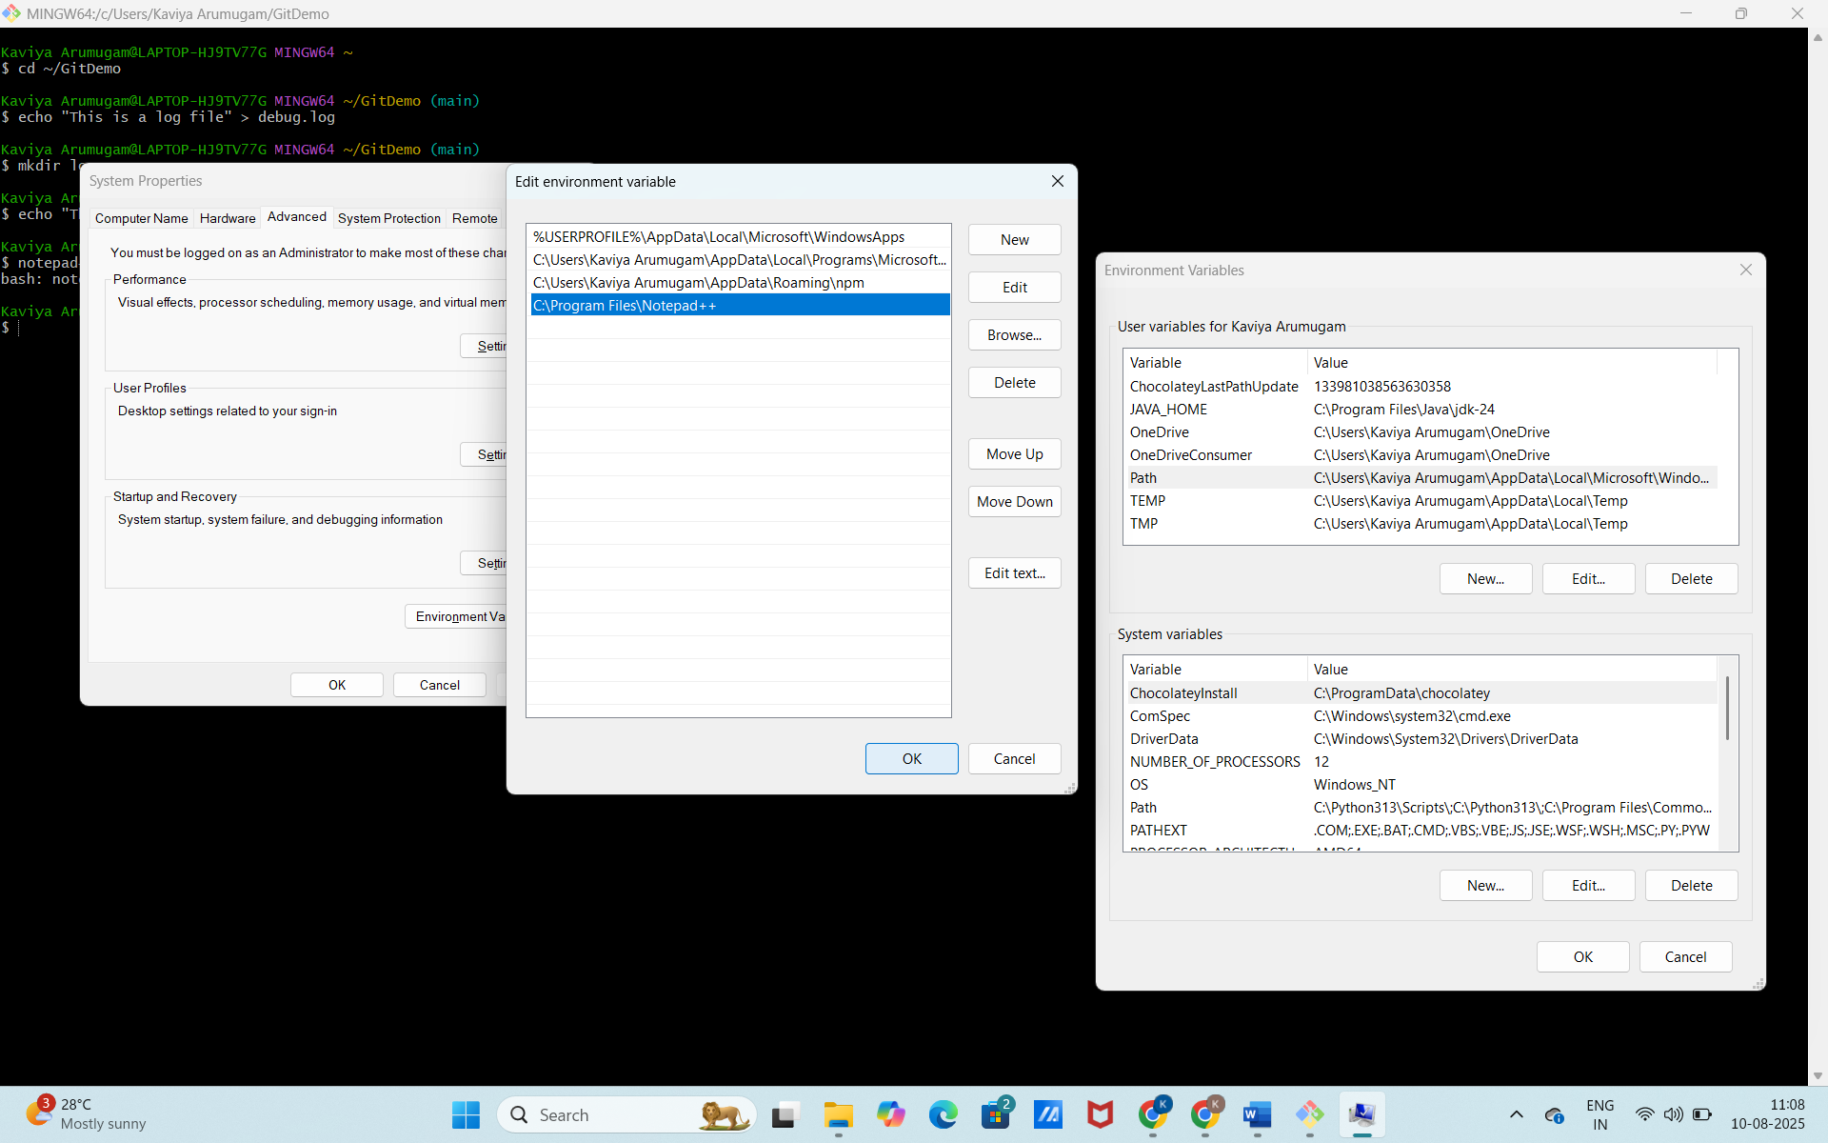
2.Now run the command in bash
3.Add the following lines:
*.log
log/
This will:
- Ignore all files ending with .log
- Ignore the log folder

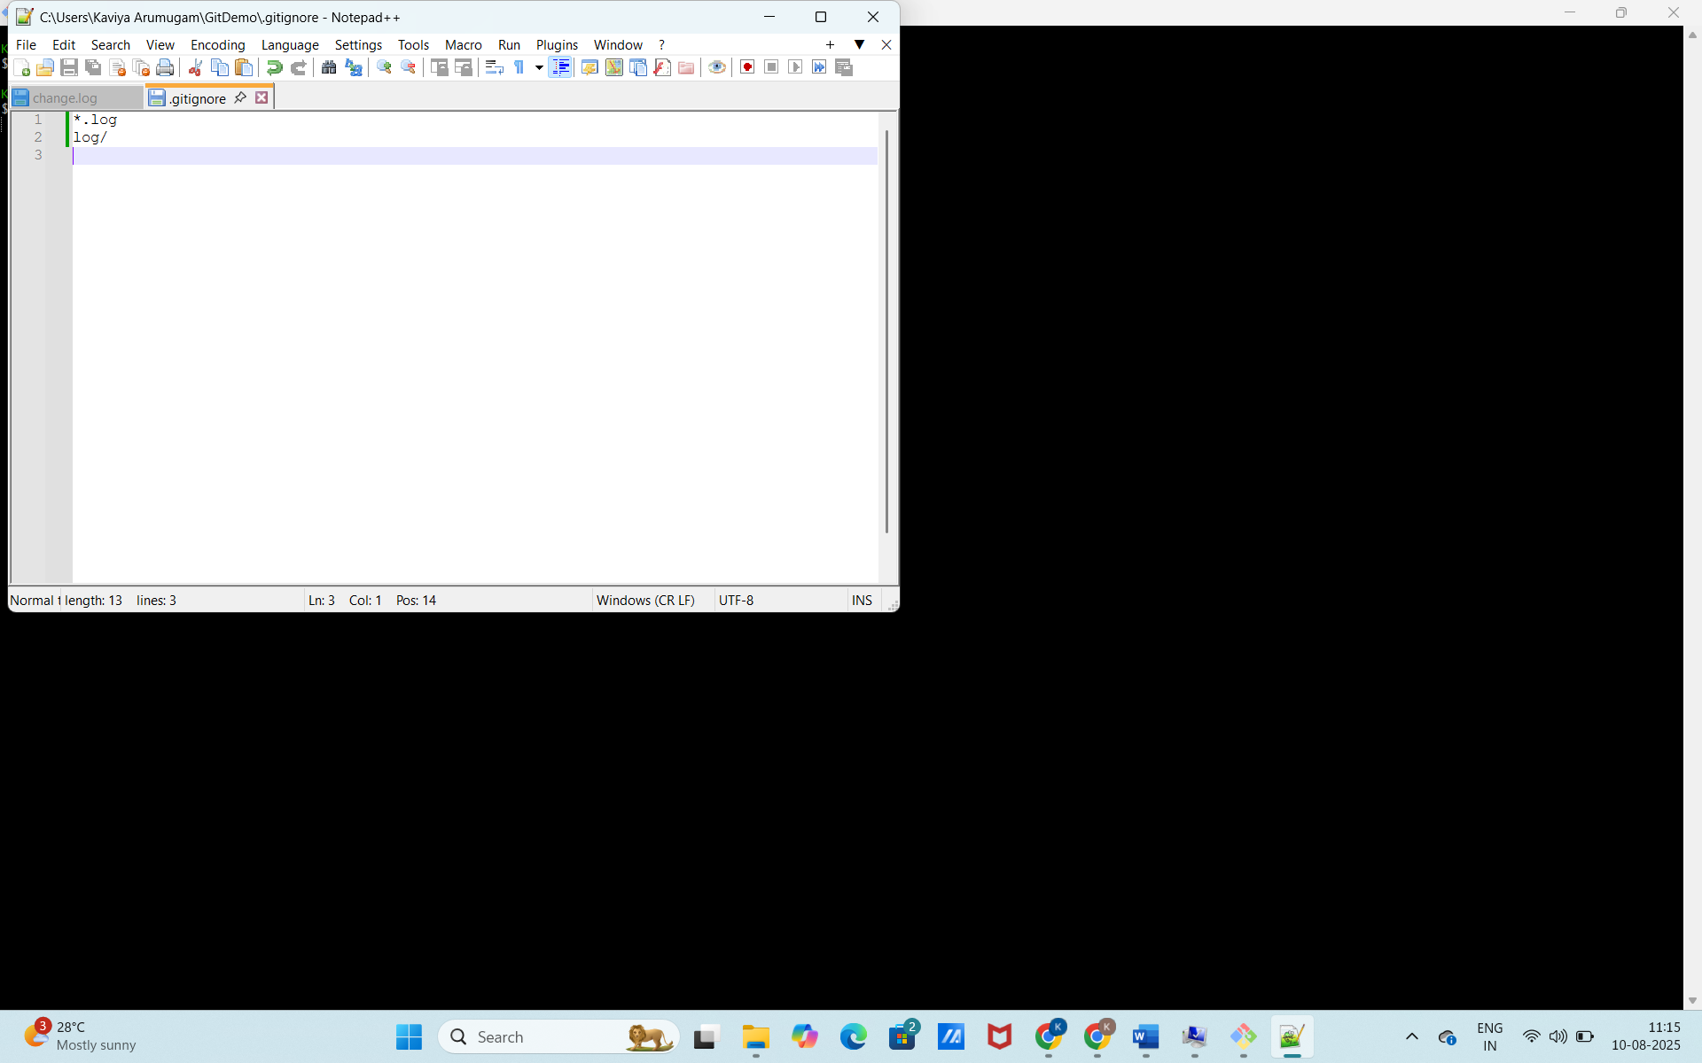
4. Save and close the file.
Step 4: Stage and commit .gitignore
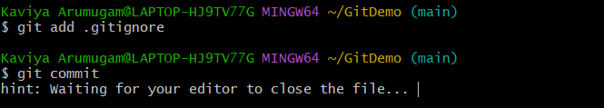
In Notepad++, type commit message:
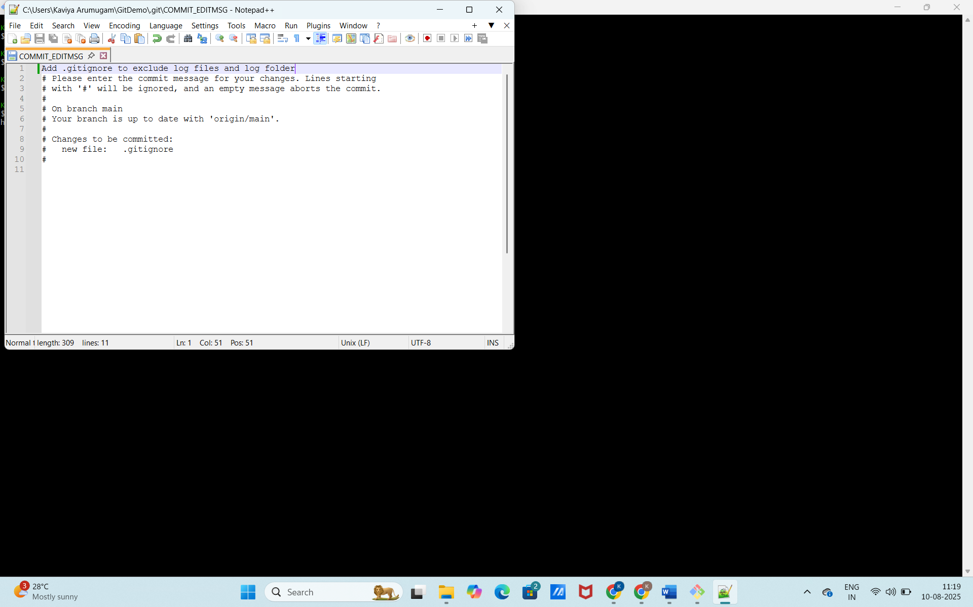

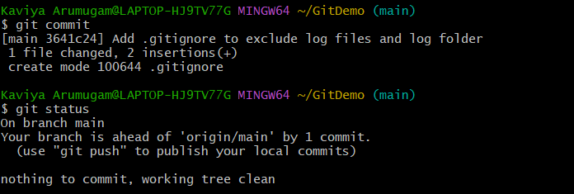

Step 5: Verify .gitignore is working


You should not see debug.log or the log folder listed as untracked.
Step 6: Push changes to remote
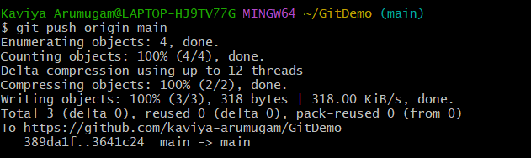

HANDS ON 3 – Branching and Merging in Git
Objectives
- Demonstrate creating and merging branches
- Show visual comparison using P4Merge
Prerequisites
Before starting, ensure the following are complete:
Step 1 – Verify Local and Remote Repository
1. Open Git Bash and go to your project folder:
2. Check if it’s already a Git repository:
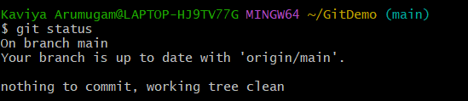
If not, initialize:
- git init
3. Check if remote is set:
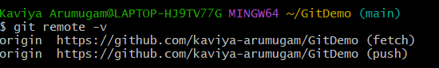
If no remote is linked, add it:
- git remote add origin https://github.com/<your-username>/<repo-name>.git
Step 2 – Install and Configure P4Merge
1. Download P4Merge
2. Install P4Merge (default location is usually C:\Program Files\Perforce\p4merge.exe).
3. Configure Git to use P4Merge:
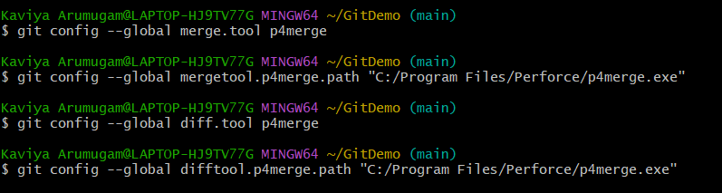
Branching
Step 3 – Create a New Branch
Step 4 - List All Branches
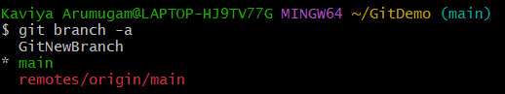
Step 5 – Switch to the New Branch
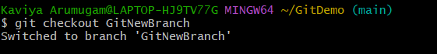
Step 6 – Add Files in the New Branch
Step 7 – Commit Changes
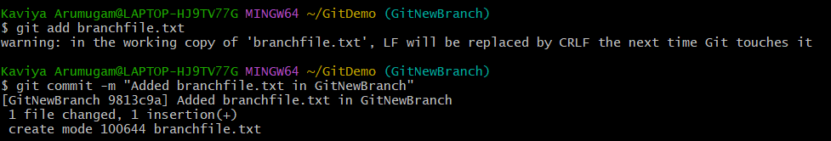
Step 8 – Check Branch Status
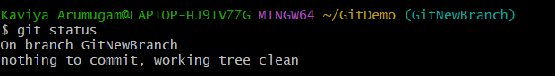

Merging
Step 9 – Switch to the Main Branch
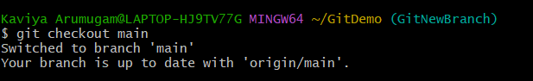
Step 10 – Compare Changes in Command Line
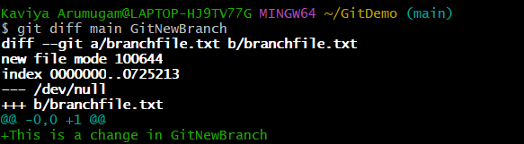
Step 11 – Compare Changes Using P4Merge
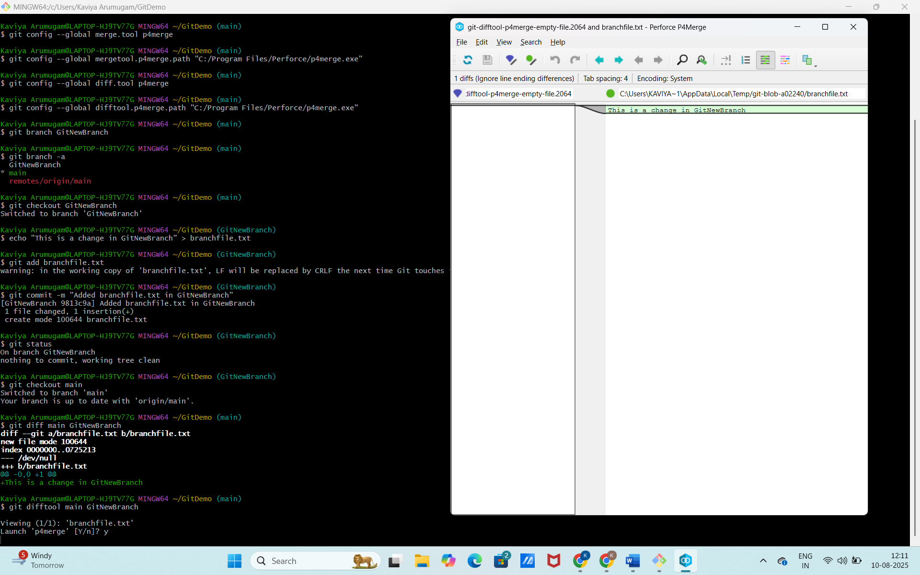

Step 12 – Merge the Branch into Main
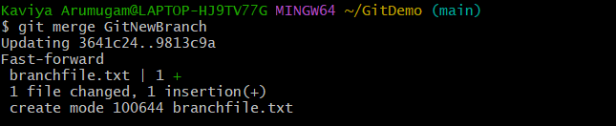
Step 13 – View Merge History
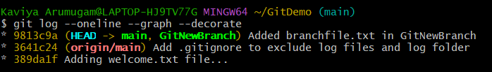
Step 14 – Delete the Branch
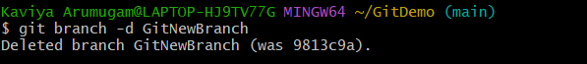
Step 15 – Push Changes to Remote
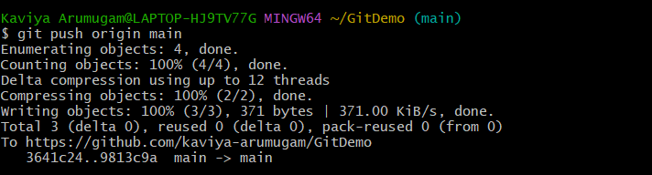

HANDS ON 4 - Conflict Resolution during Merge
Objective
Implement conflict resolution when multiple users are updating the trunk (or master) in such a way that it results in a conflict with the branch’s modifications.
Prerequisites
- Hands-on ID: Git-T03-HOL_001
- Git environment set up.
- P4Merge tool installed and configured.
Step 1: Configure P4Merge as the default merge and diff tool in Git.
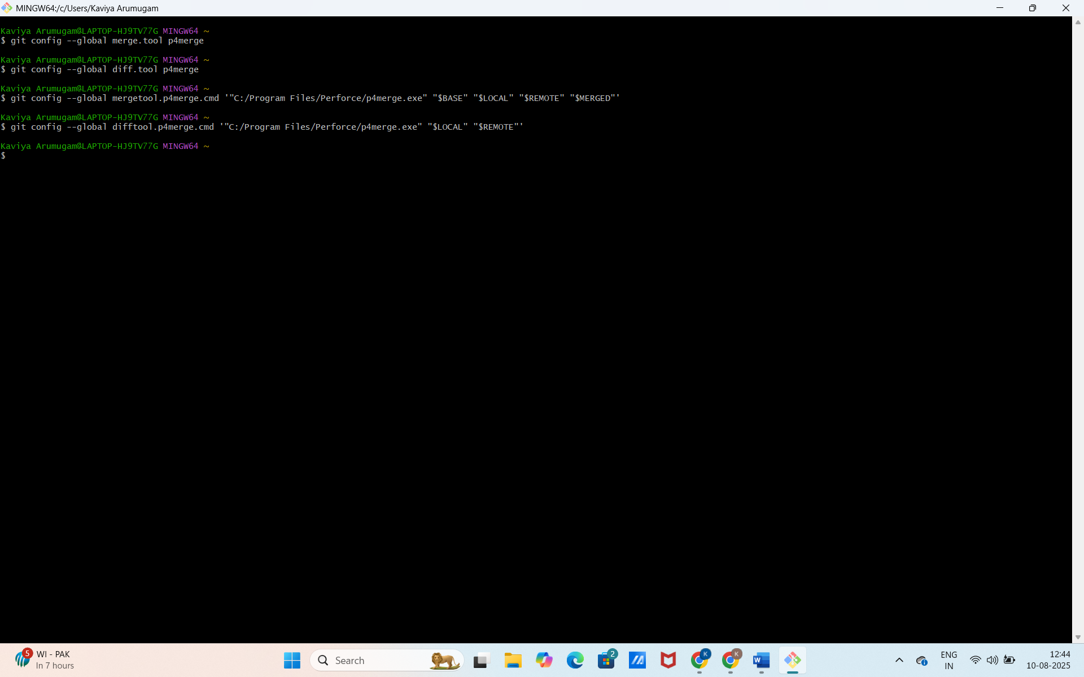
Step 2: Verify main is in a clean state
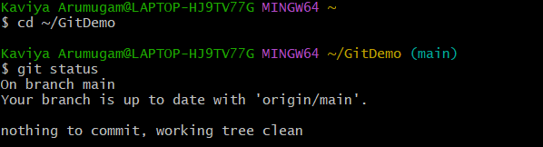
Step 3: Create a branch GitWork and switch to it.
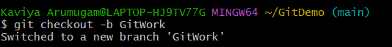

Step 4: Add a file hello.xml and add initial content.
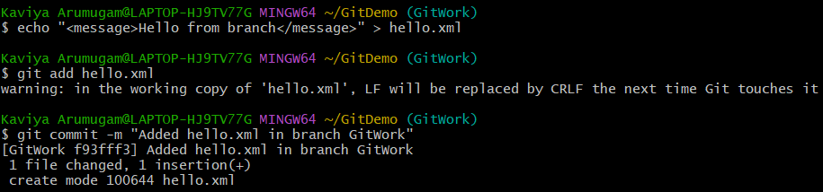
Step 5: Update the content of hello.xml in the branch and check status.
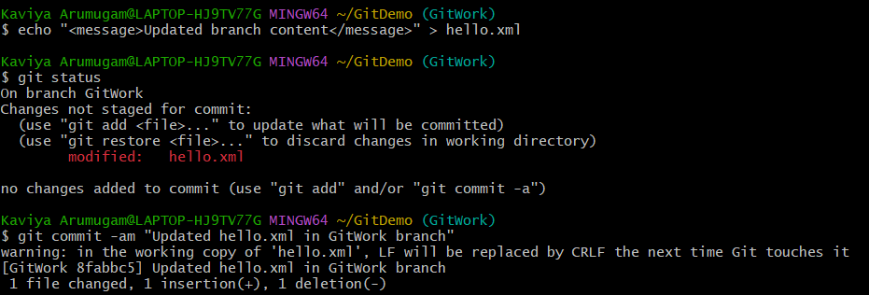
Step 6: Switch back to main

Step 7: Add a file hello.xml to main branch with different content.
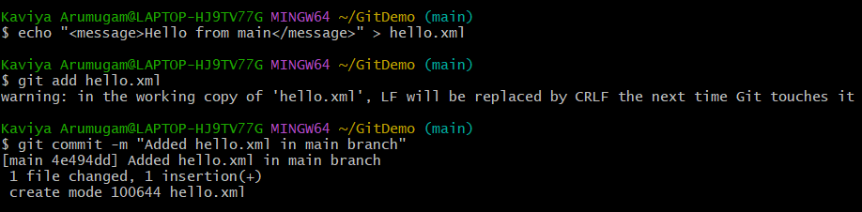

Step 8: View the commit history graph to see branches and commits.
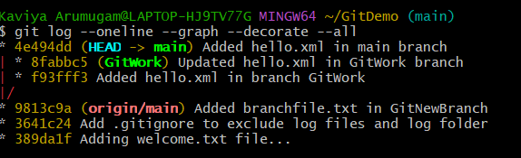
Step 9: Check the differences between the main branch and GitWork branch.
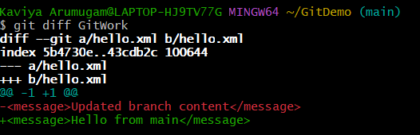
Step 10: Open a visual diff of changes with P4Merge.
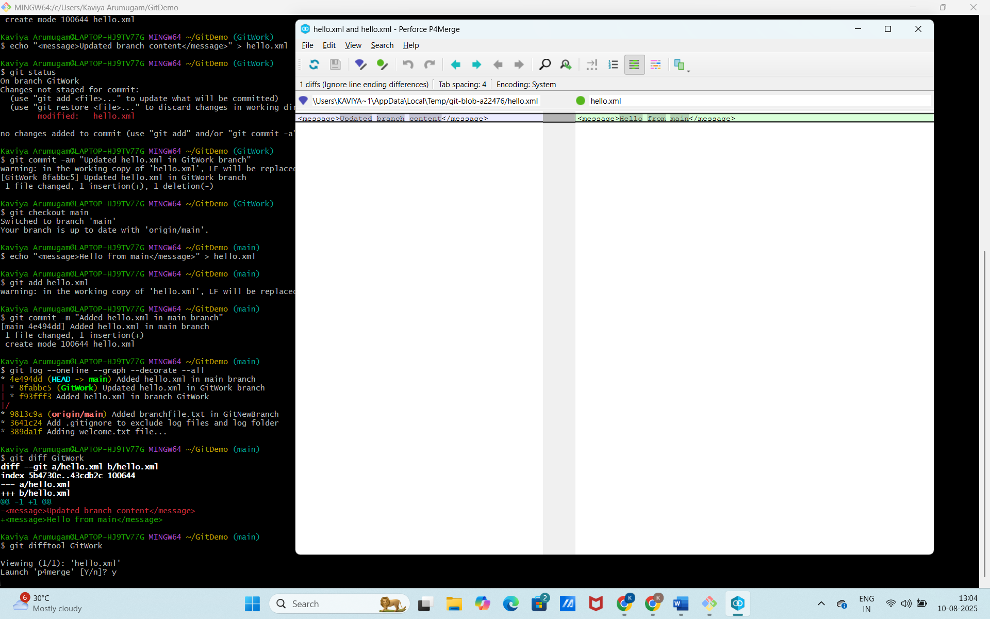

Step 11: Attempt to merge the GitWork branch into main
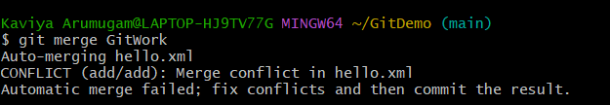
Step 12: Notice the merge conflict markers (<<<<<<<, =======, >>>>>>>) in hello.xml.
Step 13: Use P4Merge to resolve the merge conflict.
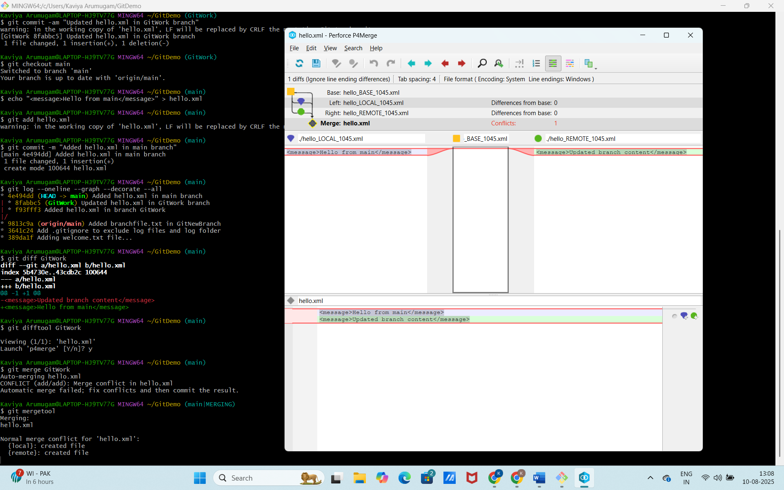
Choose the correct changes, save the resolved file, and exit the tool.
Step 14: Commit the resolved merge to the main branch.
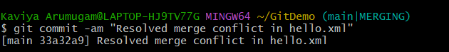

Step 15: Add backup files (like .orig) generated during merge to .gitignore.
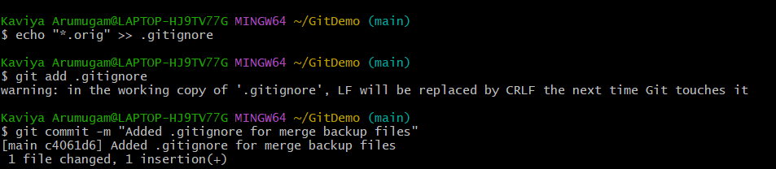
Step 16: List all branches.
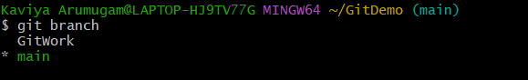

Step 17: Delete the merged branch GitWork.

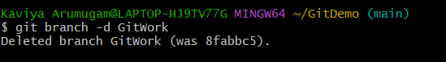

Step 18: Review the final commit history graph.

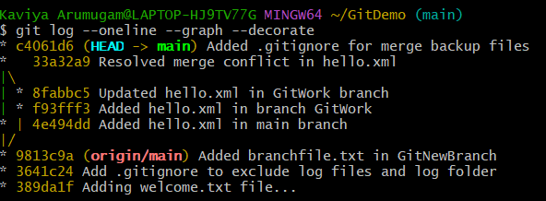

HANDS ON 5 - Clean Up and Push Back to Remote Git
Objectives
- Check if your local branch is clean and up to date.
- Update your local master branch with remote changes.
- Push your changes from your working branch to the remote repository.
- Verify that your changes are visible on GitHub.
Step 1: Make sure you are in your Git repository folder

Step 2: Verify you are on the main branch and check if it is clean
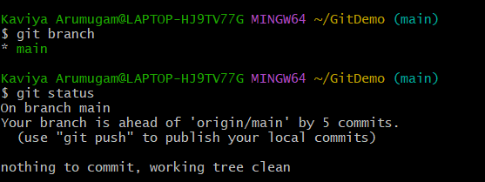
Step 3: List all branches (local and remote)
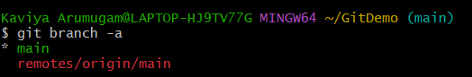

Step 4: Pull the latest changes from the remote main branch
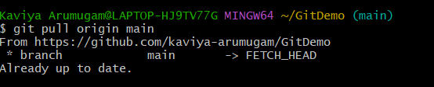

Step 5: Stage and commit your changes (if any)

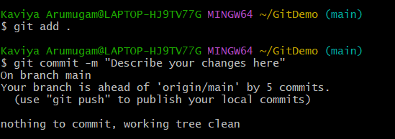

Step 6: Push your local main branch changes to the remote repository

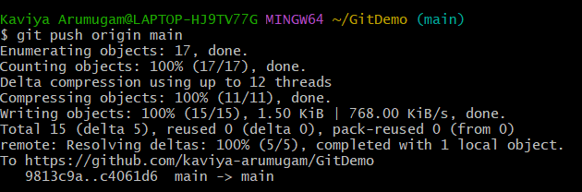

Step 7: Verify your changes on the remote repository

