MICROSERVICES
EX 1: Creating Microservices for account and loan
PART 1: Create the folder structure
- Create a folder named with your Employee ID in your D: drive.
Example: D:\123456
- Inside that folder, create another folder named microservices.
Example: D:\123456\microservices
PART 2: Create the Account Microservice
- Go to Spring Initializr
URL: https://start.spring.io
- Fill the form like this:
Group: com.cognizant
Artifact: account
Dependencies:
  - Spring Web
  - Spring Boot DevTools
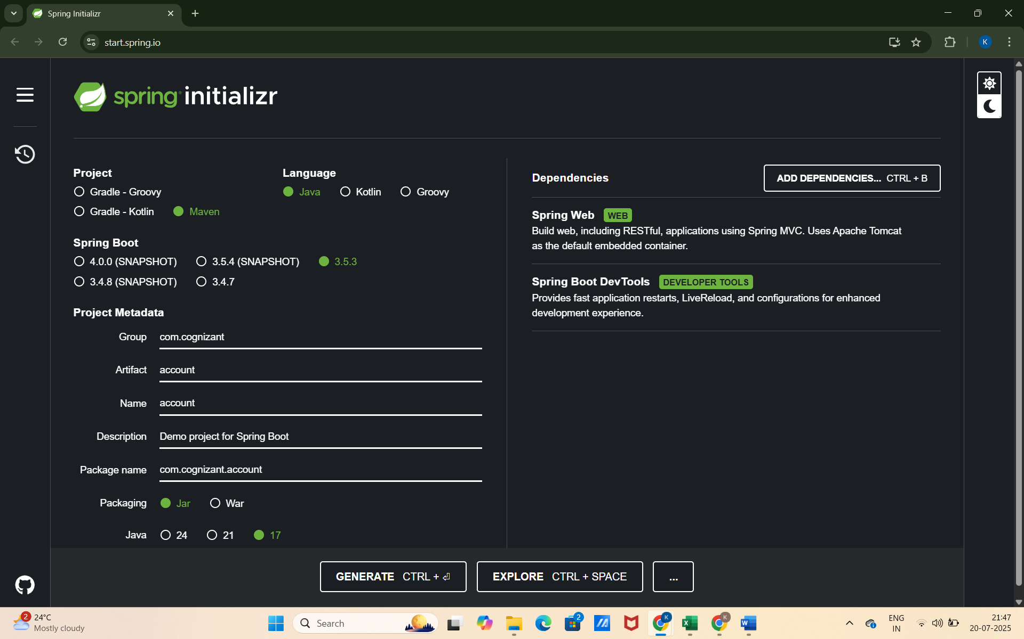
- Download the project
Click Generate, extract the ZIP, and place the account folder inside:
D:\123456\microservice
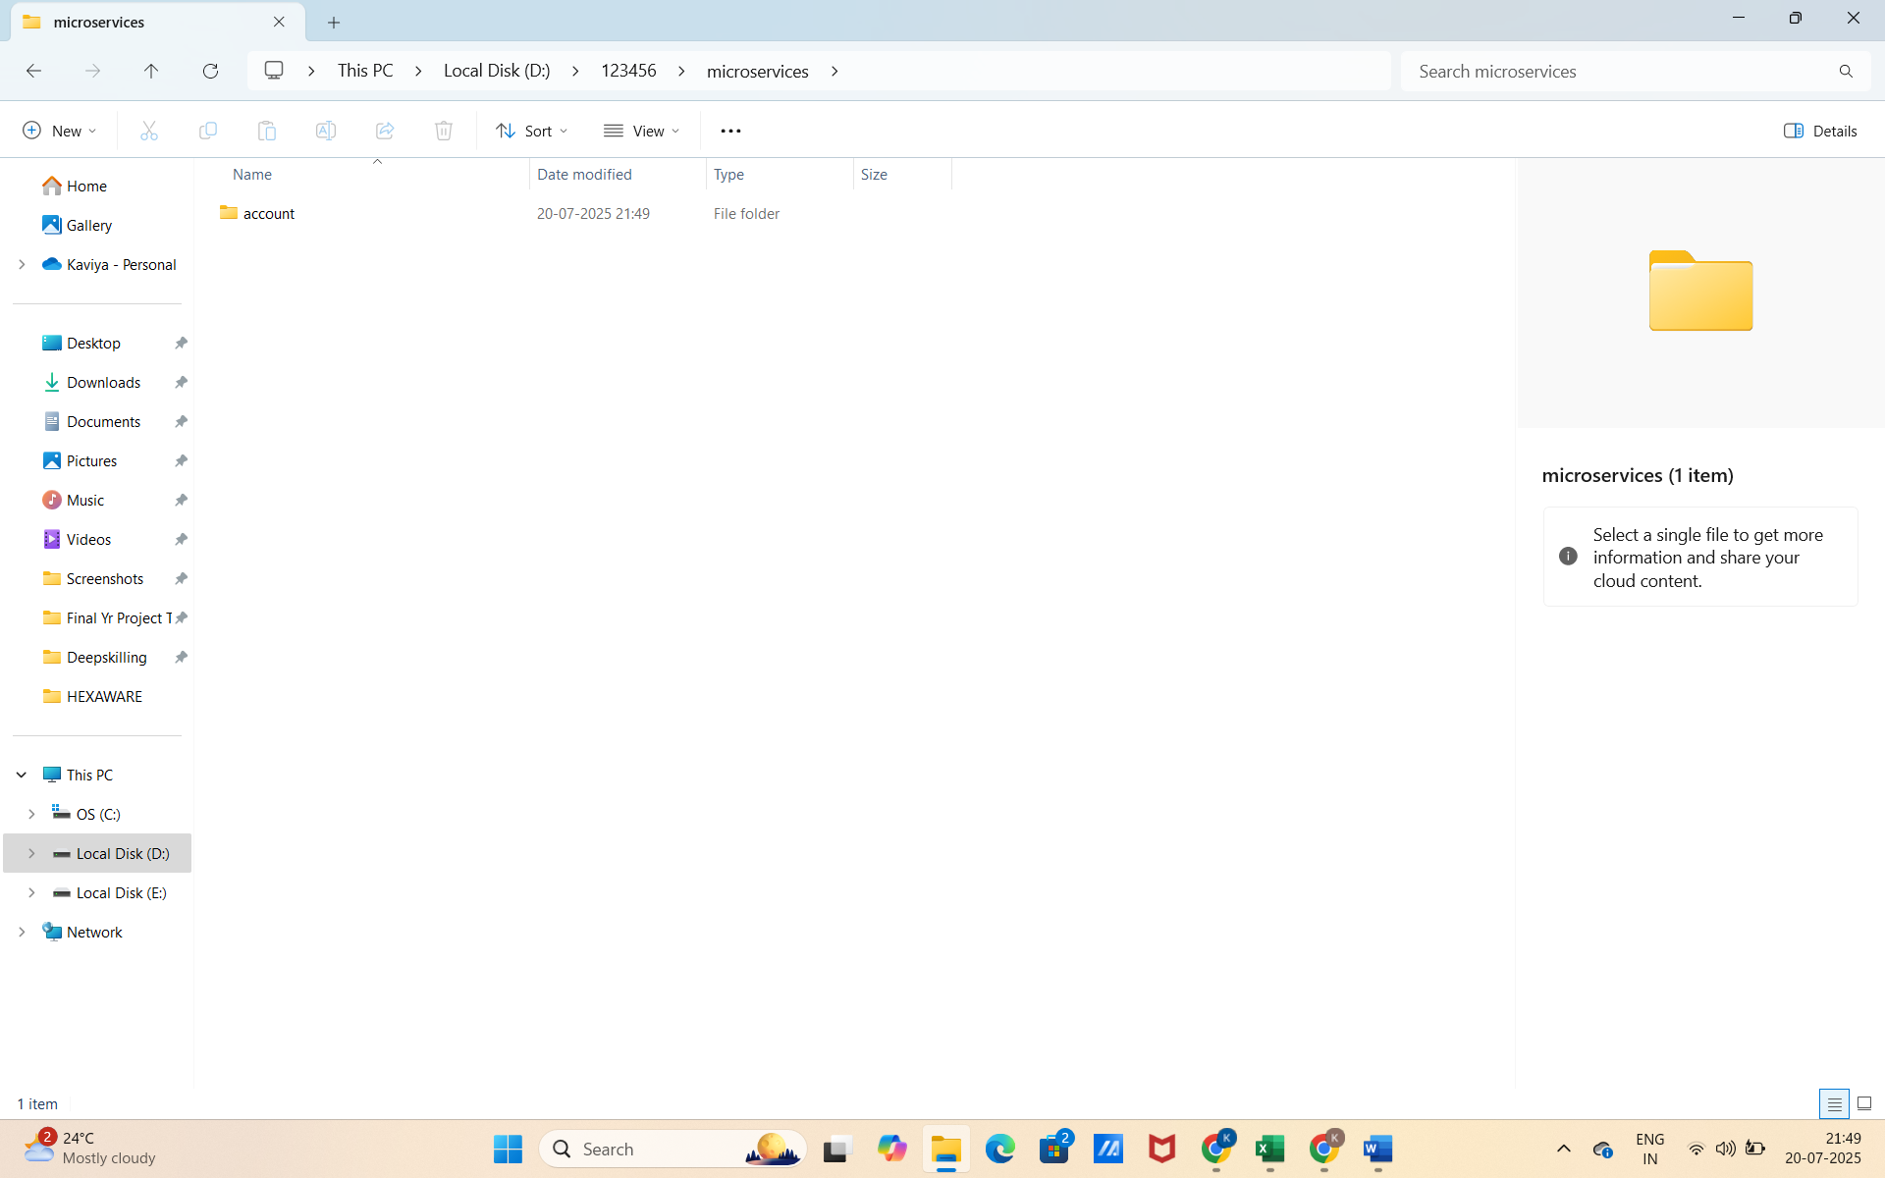

- Build using Maven
Open Command Prompt and do the following.
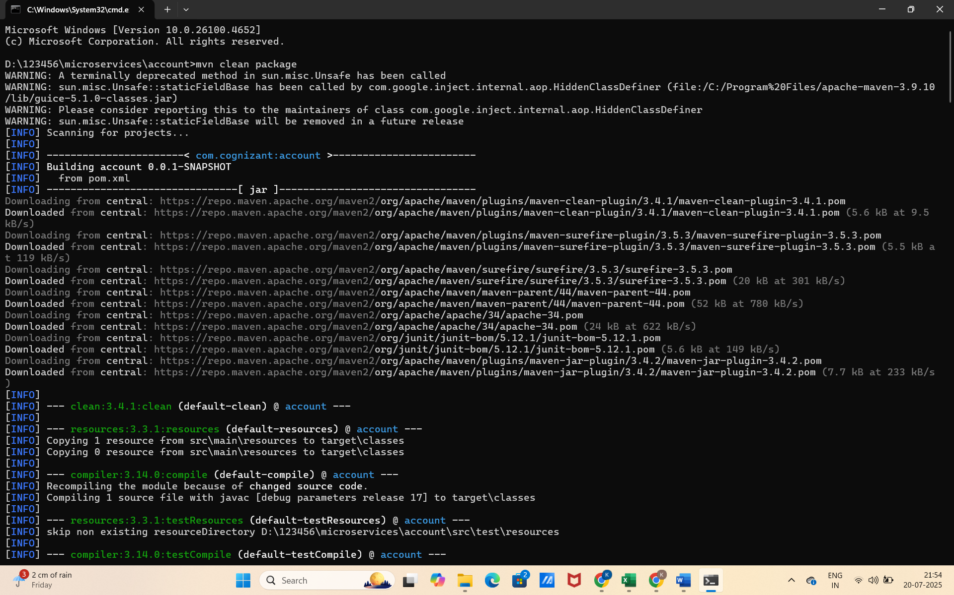

- Import into Eclipse
- Go to Eclipse > File > Import > Existing Maven Projects
- Select: D:\123456\microservices\account
- Create the Controller
In your account project:
src/main/java/com/cognizant/account/controller/AccountController.java
AccountController.java
CODE:
package com.cognizant.account.controller;

import org.springframework.web.bind.annotation.*;

@RestController
@RequestMapping("/accounts")
public class AccountController {

@GetMapping("/{number}")
public Account getAccount(@PathVariable String number) {
return new Account(number, "savings", 234343);
}
}

class Account {
private String number;
private String type;
private double balance;

public Account(String number, String type, double balance) {
this.number = number;
this.type = type;
this.balance = balance;
}

public String getNumber() { return number; }
public String getType() { return type; }
public double getBalance() { return balance; }
}

- Run the Application
- Run the AccountApplication.java class.
- Test URL: http://localhost:8080/accounts/00987987973432
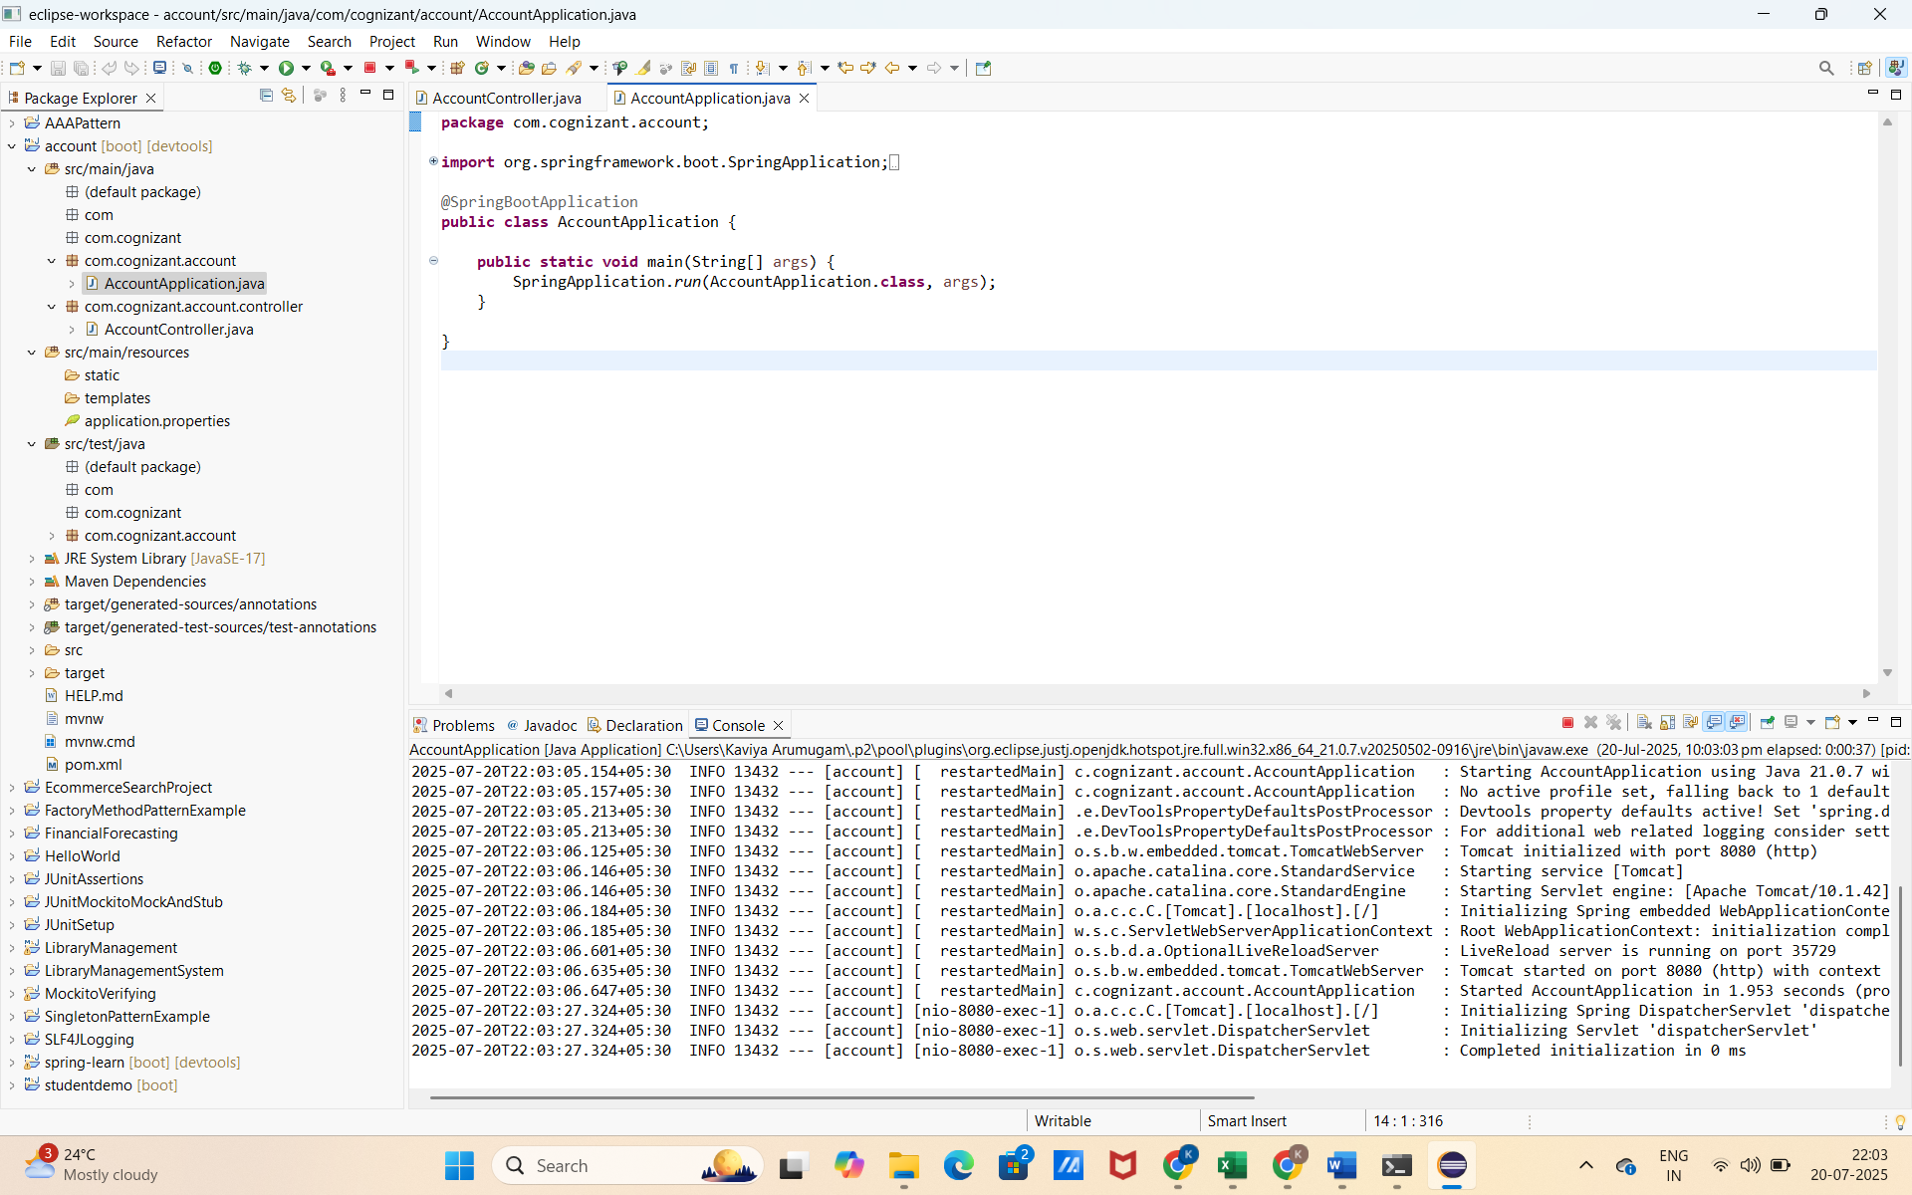

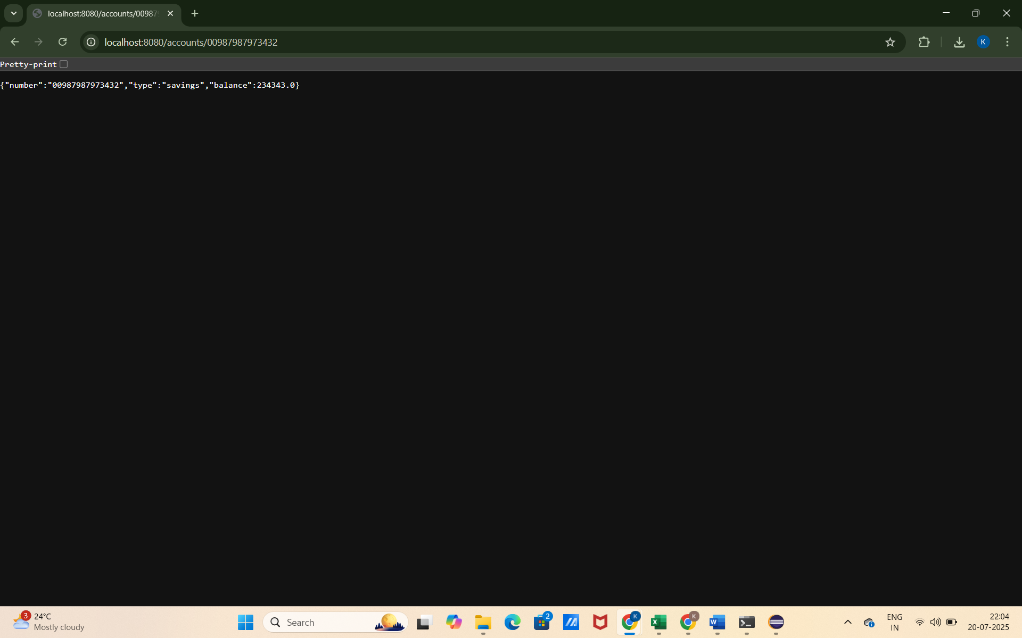

PART 3: Create the Account Microservice
1) Go to Spring Initializr
URL: https://start.spring.io
- Fill the form like this:
Group: com.cognizant
Artifact: loan
Dependencies:
  - Spring Web
  - Spring Boot DevTools
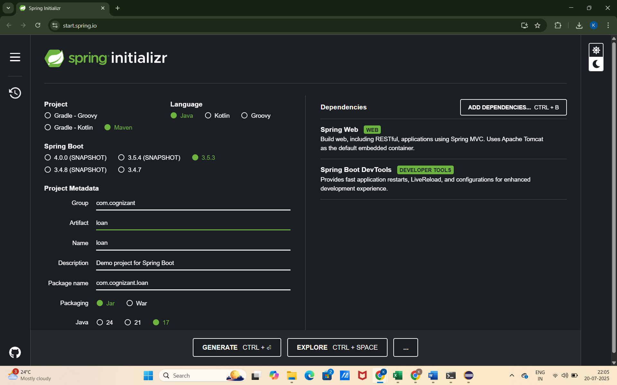
- Download the project
Click Generate, extract the ZIP, and place the account folder inside:
D:\123456\microservice

- Build using Maven
Open Command Prompt and do the following.
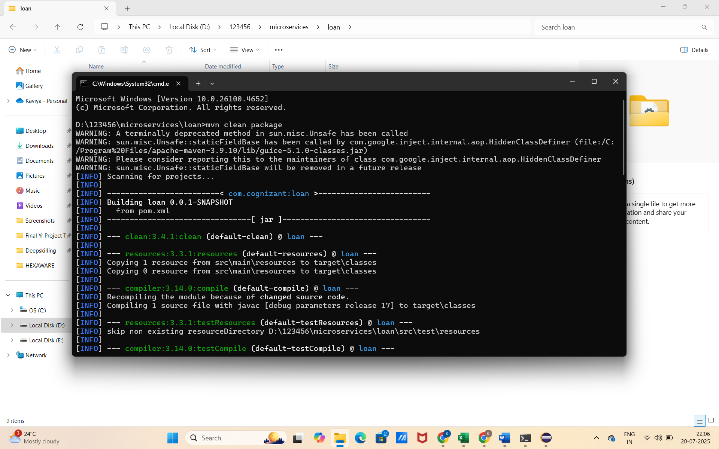
- Import into Eclipse

- Change the Port Number

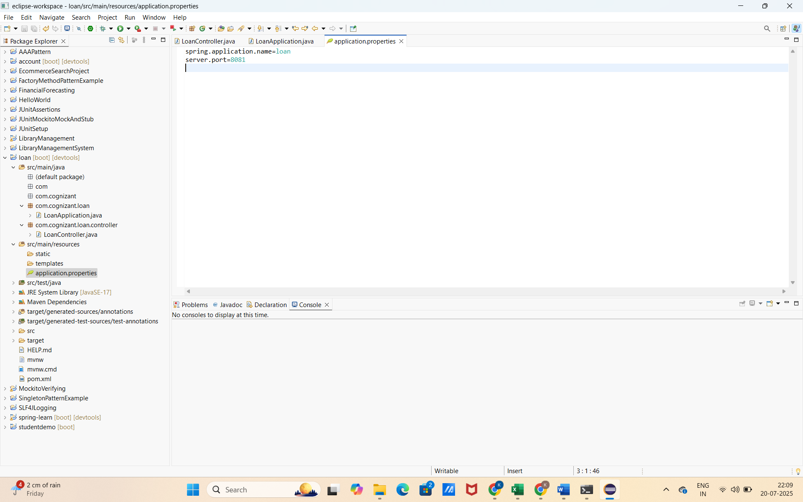

- Create the Controller
In your loan project:
src/main/java/com/cognizant/loan/controller/LoanController.java
LoanController.java
CODE:
package com.cognizant.loan.controller;

import org.springframework.web.bind.annotation.*;

@RestController
@RequestMapping("/loans")
public class LoanController {

@GetMapping("/{number}")
public Loan getLoan(@PathVariable String number) {
return new Loan(number, "car", 400000, 3258, 18);
}
}

class Loan {
private String number;
private String type;
private double loan;
private int emi;
private int tenure;

public Loan(String number, String type, double loan, int emi, int tenure) {
this.number = number;
this.type = type;
this.loan = loan;
this.emi = emi;
this.tenure = tenure;
}

public String getNumber() { return number; }
public String getType() { return type; }
public double getLoan() { return loan; }
public int getEmi() { return emi; }
public int getTenure() { return tenure; }
}

- Run the Loan Application
- Make sure Account Service (on 8080) is running before launching Loan Service (on 8081).
- Test URL:
http://localhost:8081/loans/H00987987972342
