REACTJS
HandsOn 1:
Objective:
To create and run a new React application named “myfirstreact” and display the message:
"Welcome to the first session of React" as a heading.
Step 1: Install Node.js and npm
- Download Node.js from the official site:
https://nodejs.org/en/download/
- Install the LTS version, which includes npm (Node Package Manager).
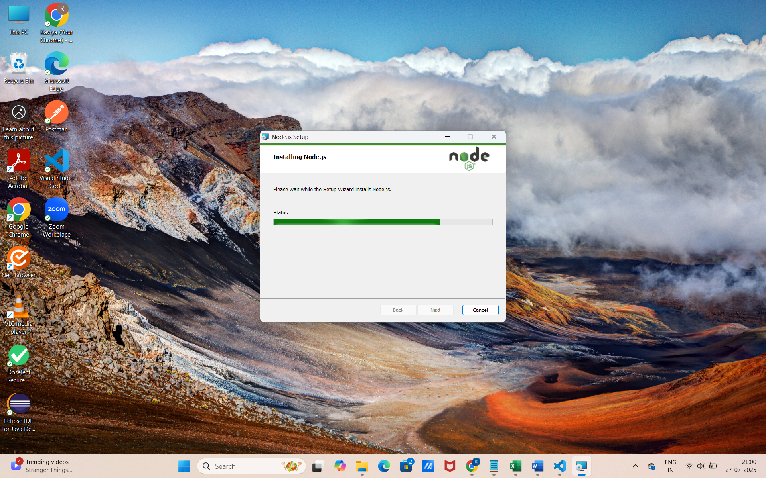
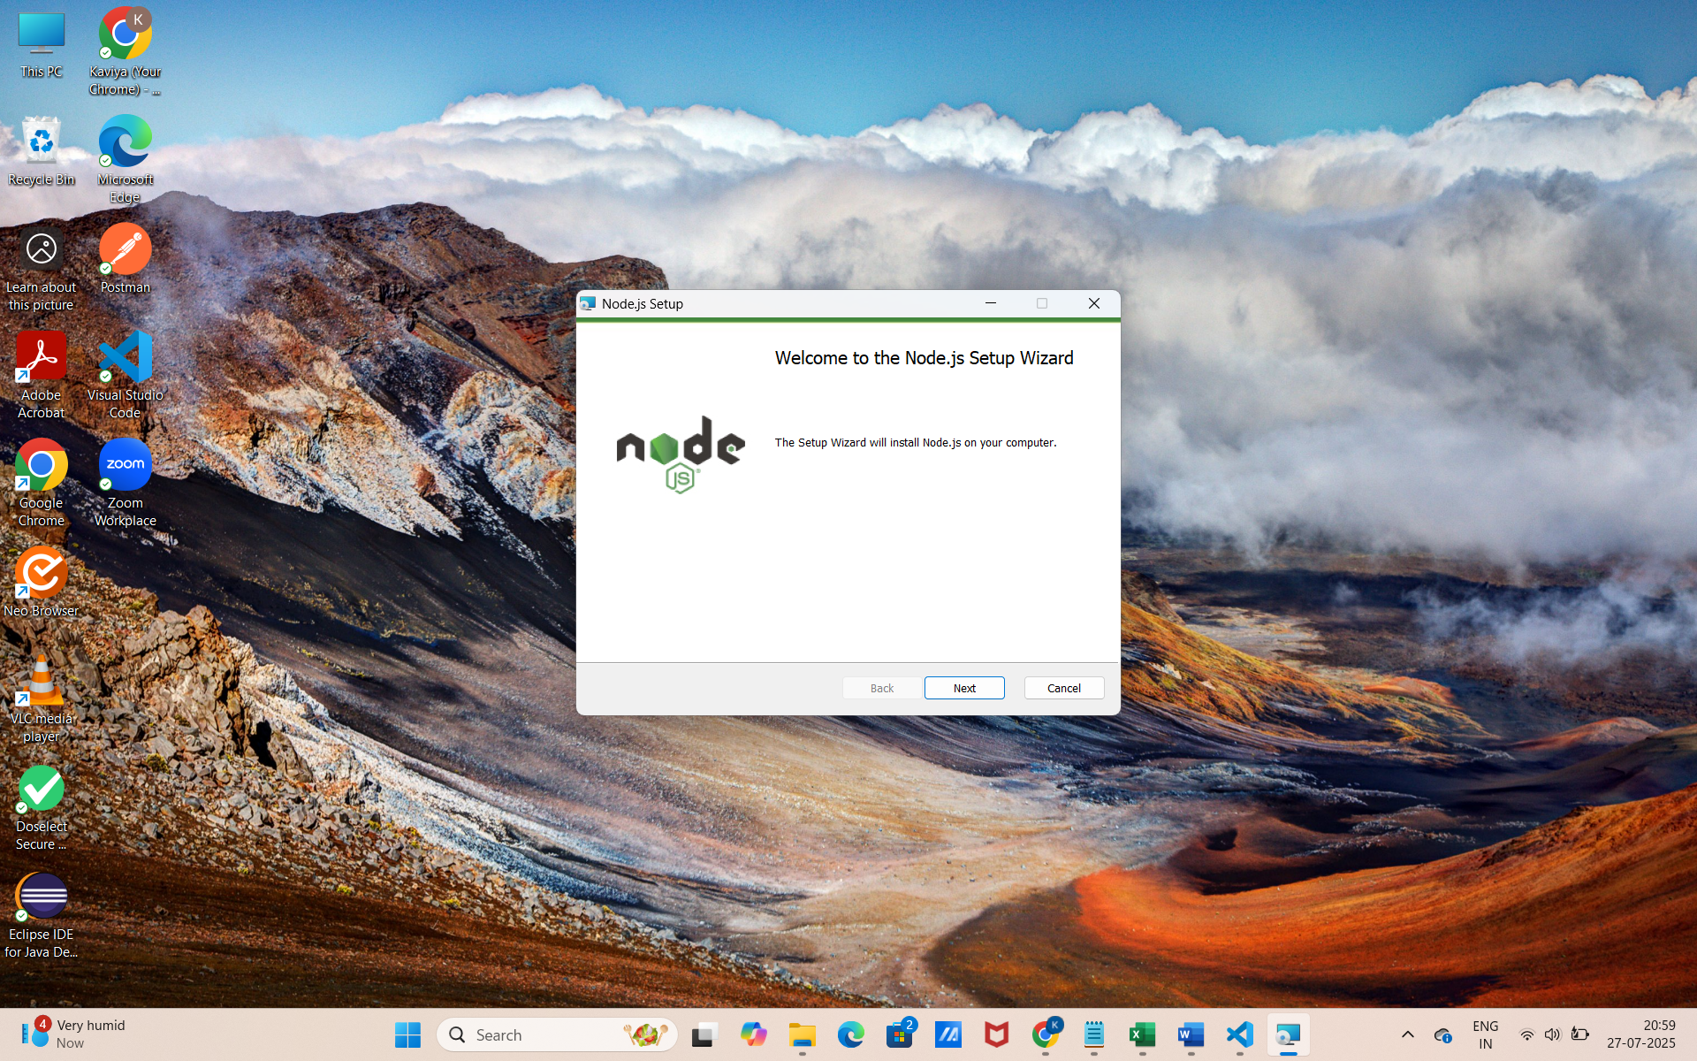
Step 2: Install Create React App Tool
- Open Command Prompt.
- Run the following command to install the React setup tool globally:
  - npm install -g create-react-app
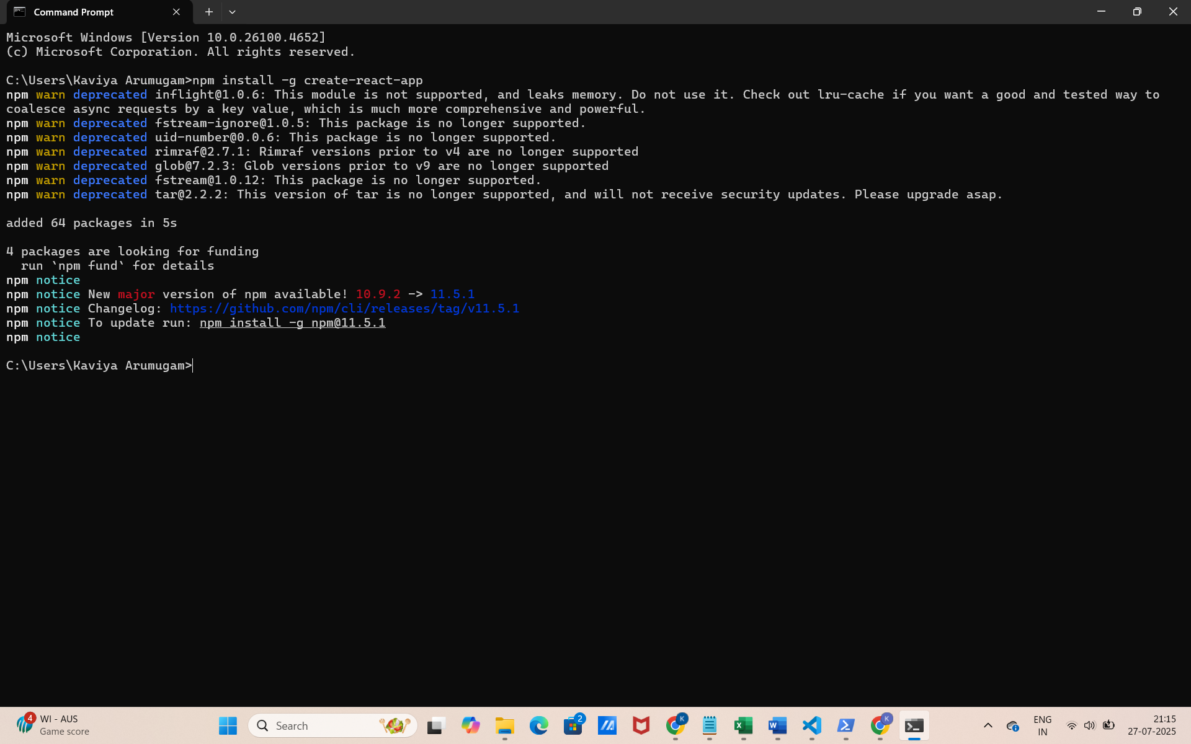

Step 3: Create the React App
- Create a new React app named myfirstreact using:
  - npx create-react-app myfirstreact
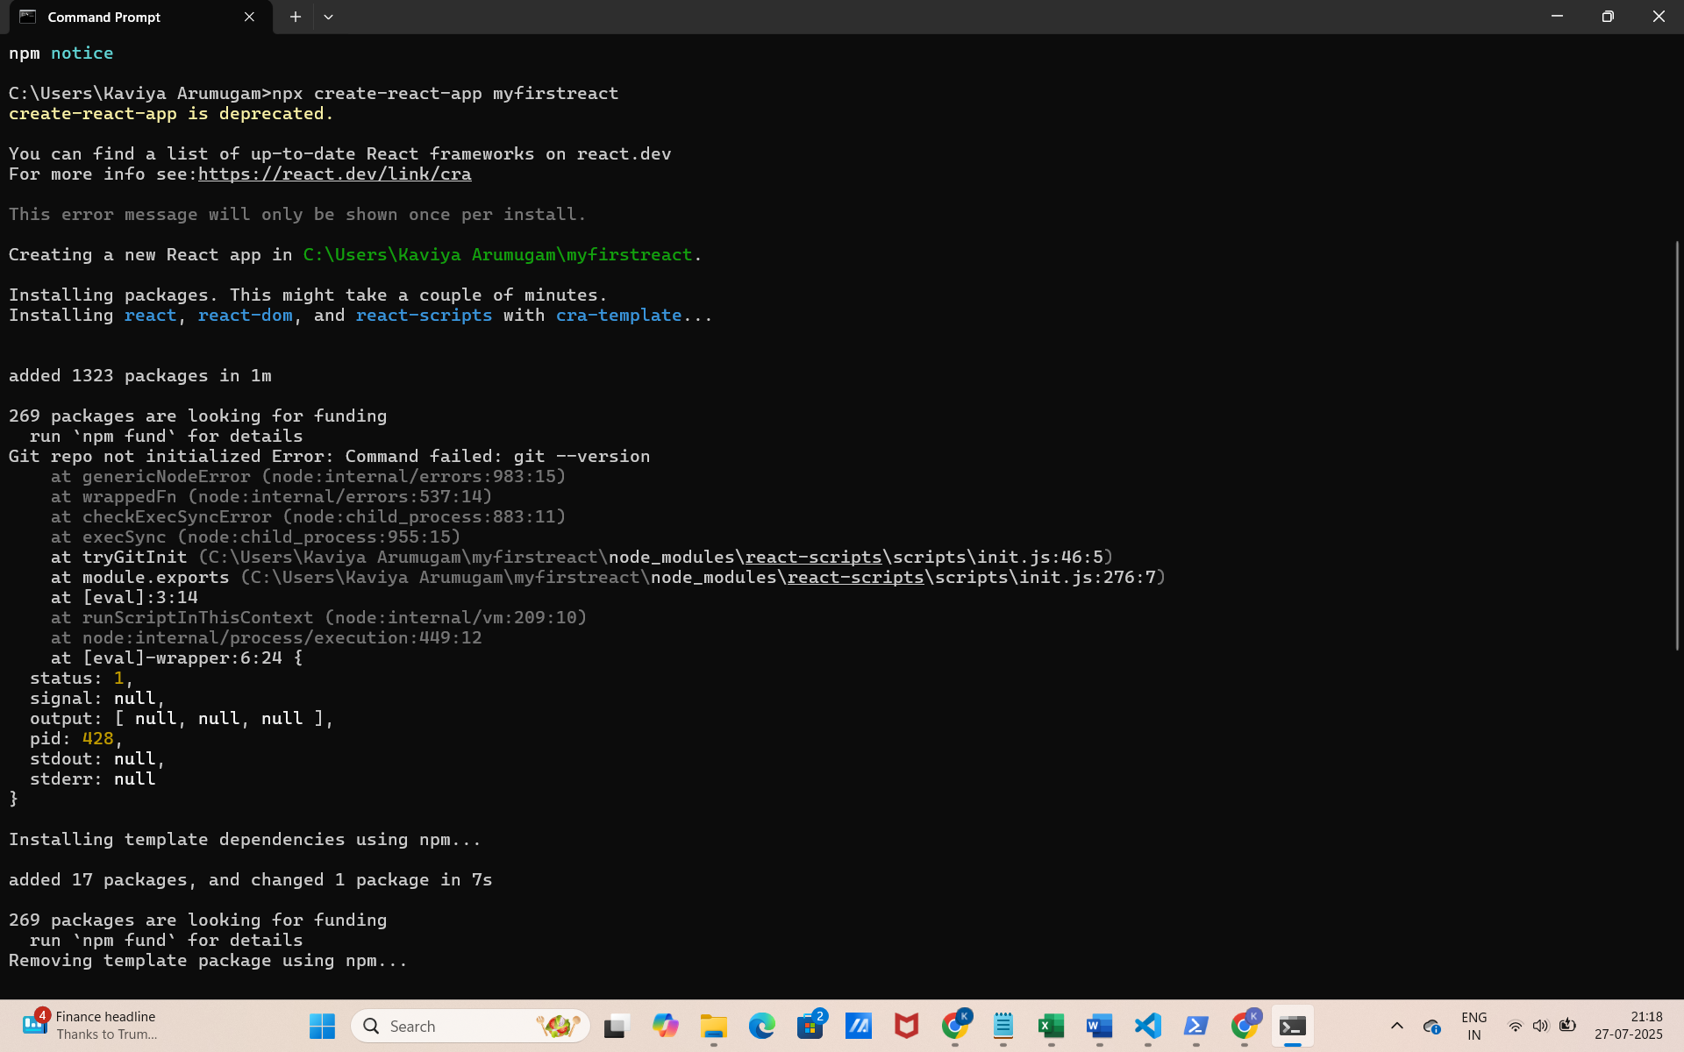
- This creates a project folder with all dependencies.

Step 4: Navigate to the Project Folder and open it in VS code
- cd myfirstreact
- code .
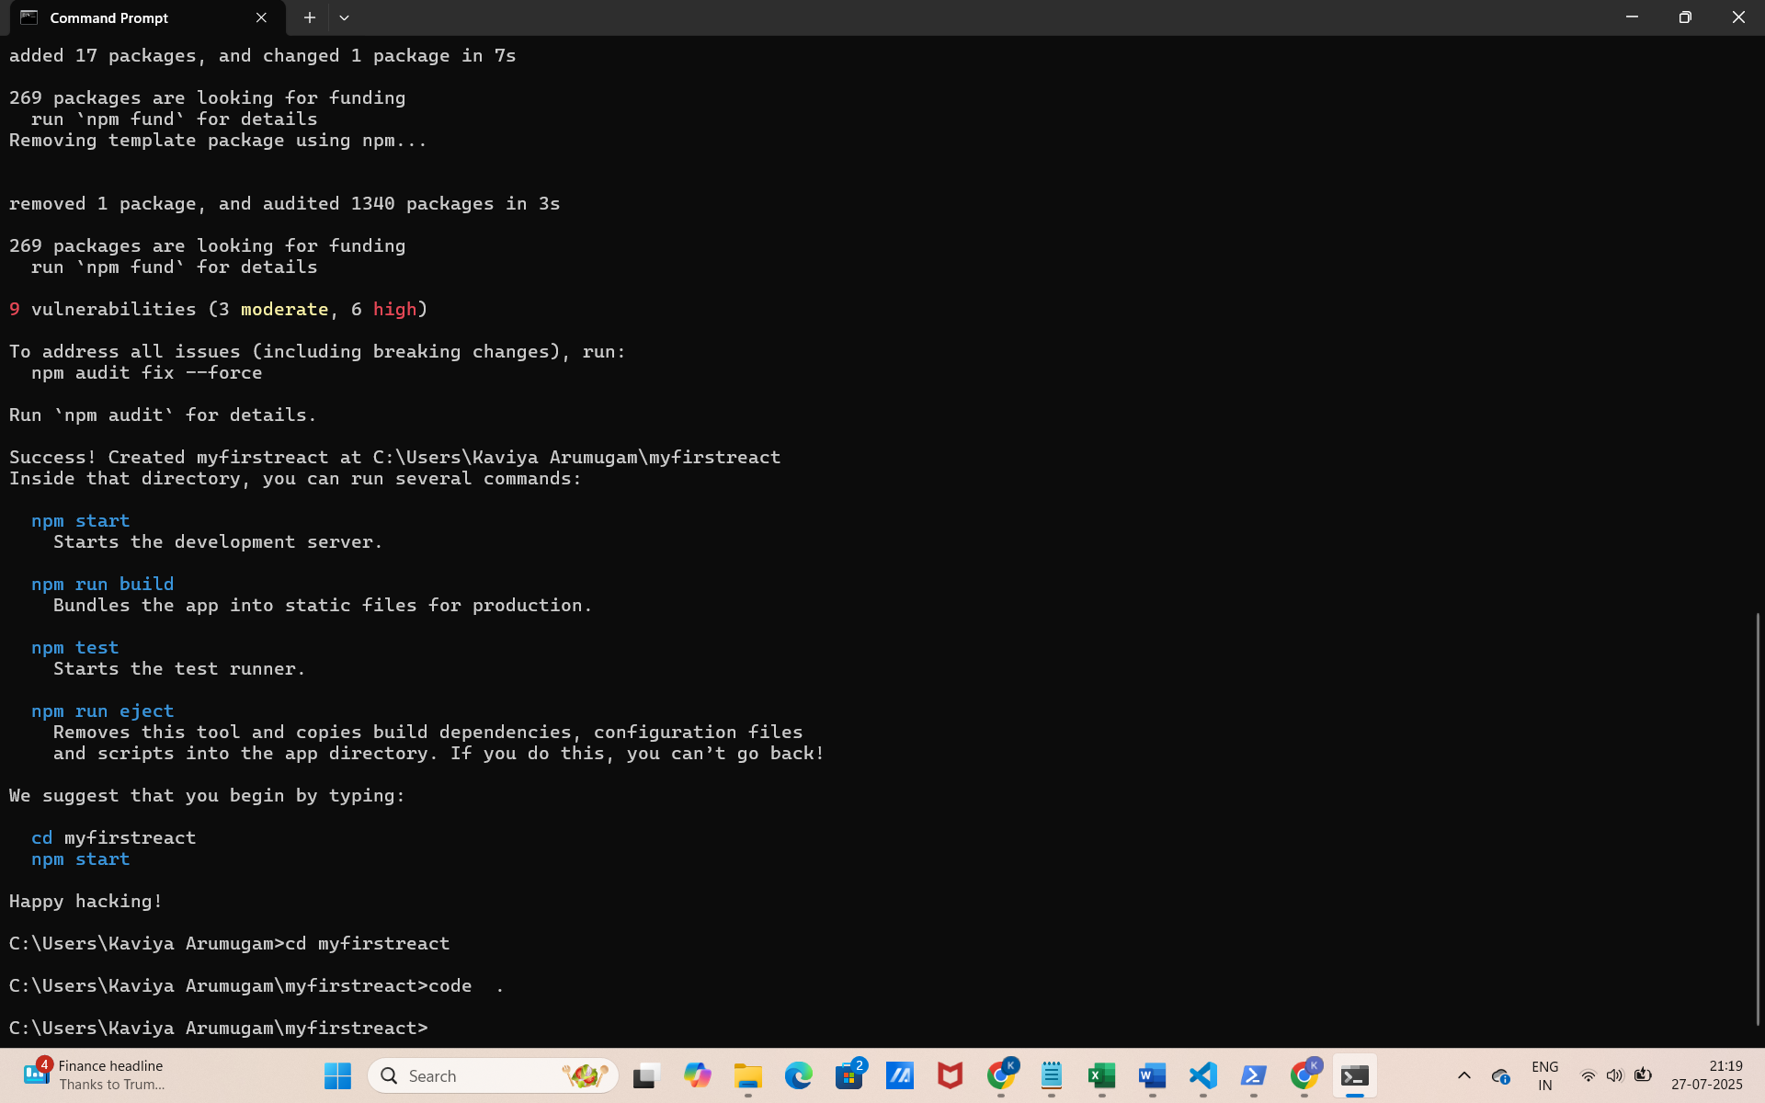
Step 5: Modify App.js
- Go to the src folder
- Open App.js
- Delete the existing content
- Replace it with:

import React from 'react';

function App() {
return (
<div>
<h1>Welcome to the first session of React</h1>
</div>
);
}

export default App;

Step 6: Run the Application
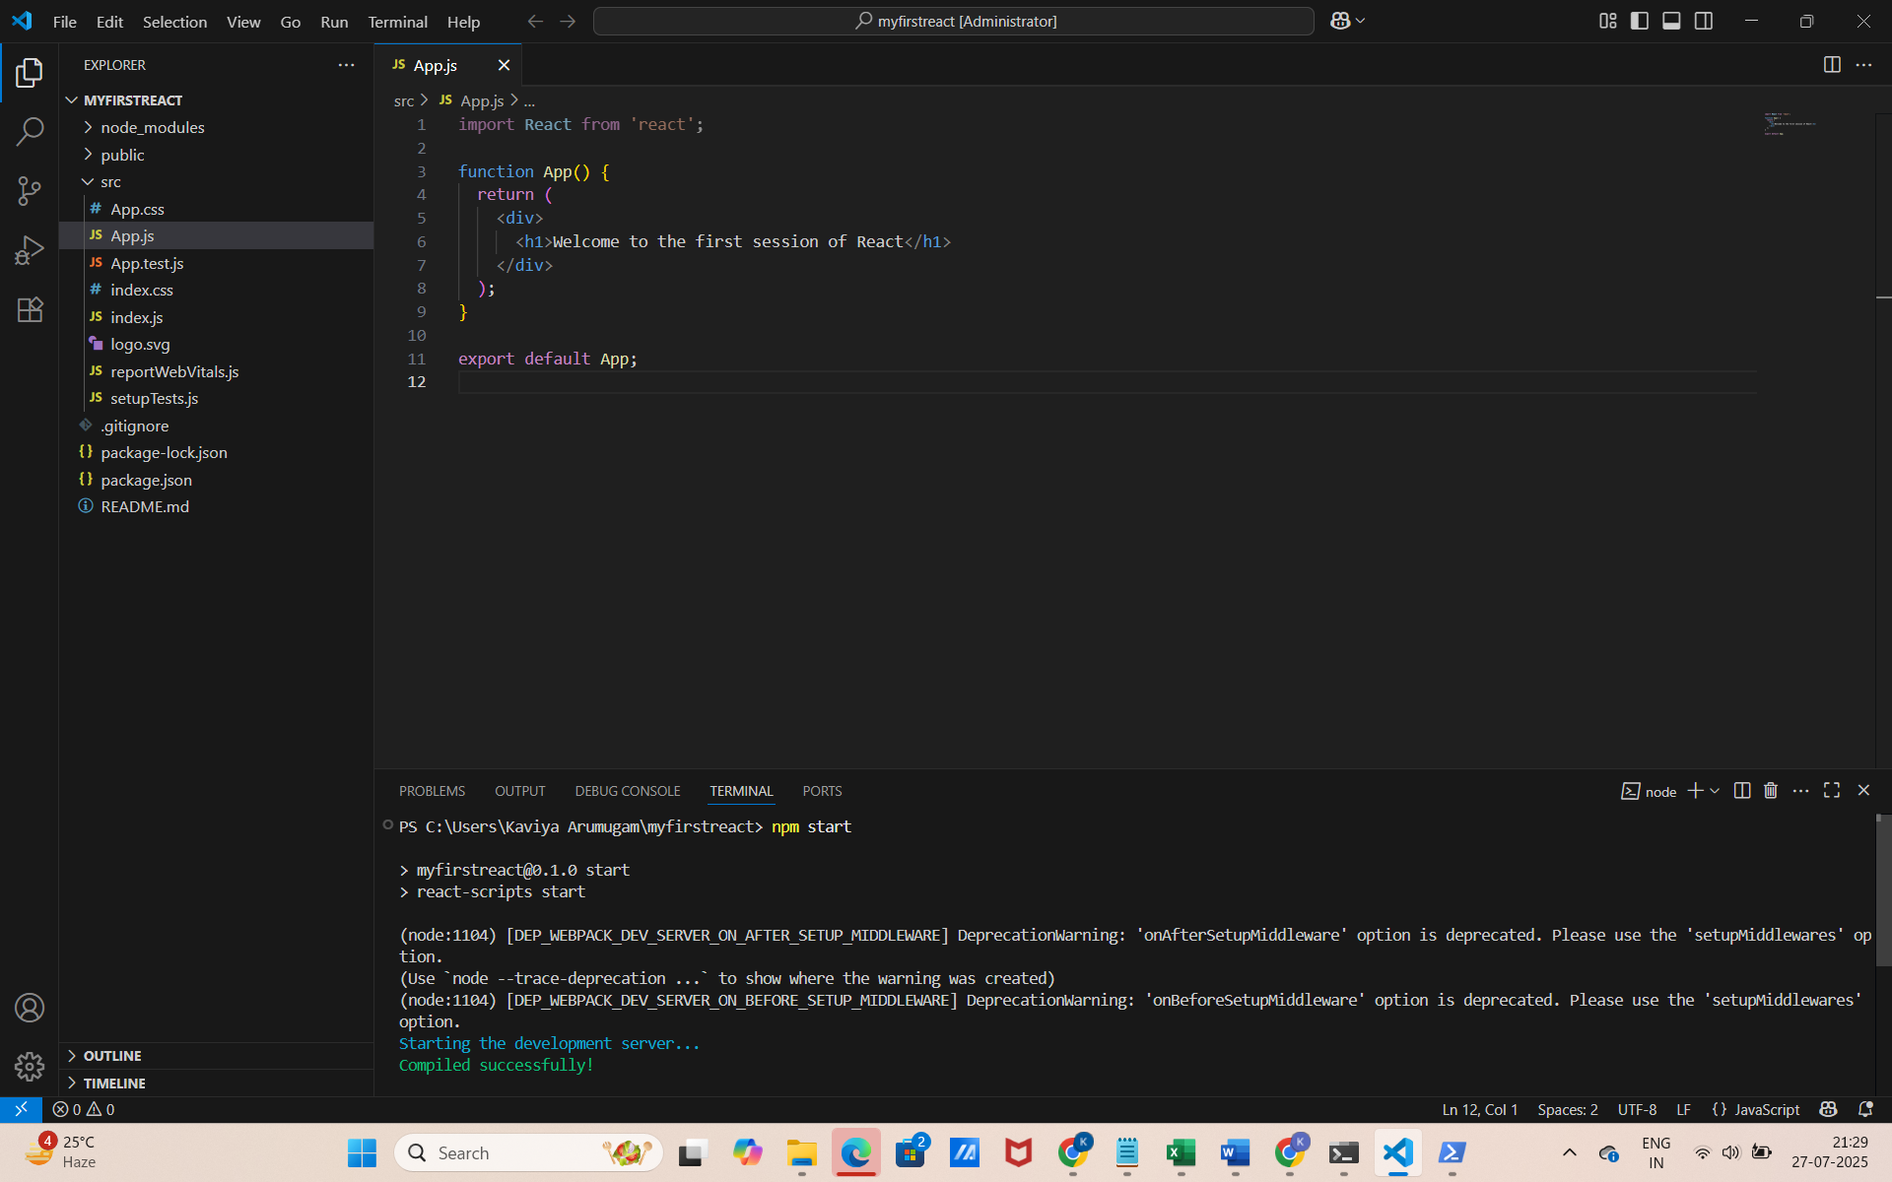
Step 7: Output
- Browser opens automatically at:
- http://localhost:3000
- You will see the output:

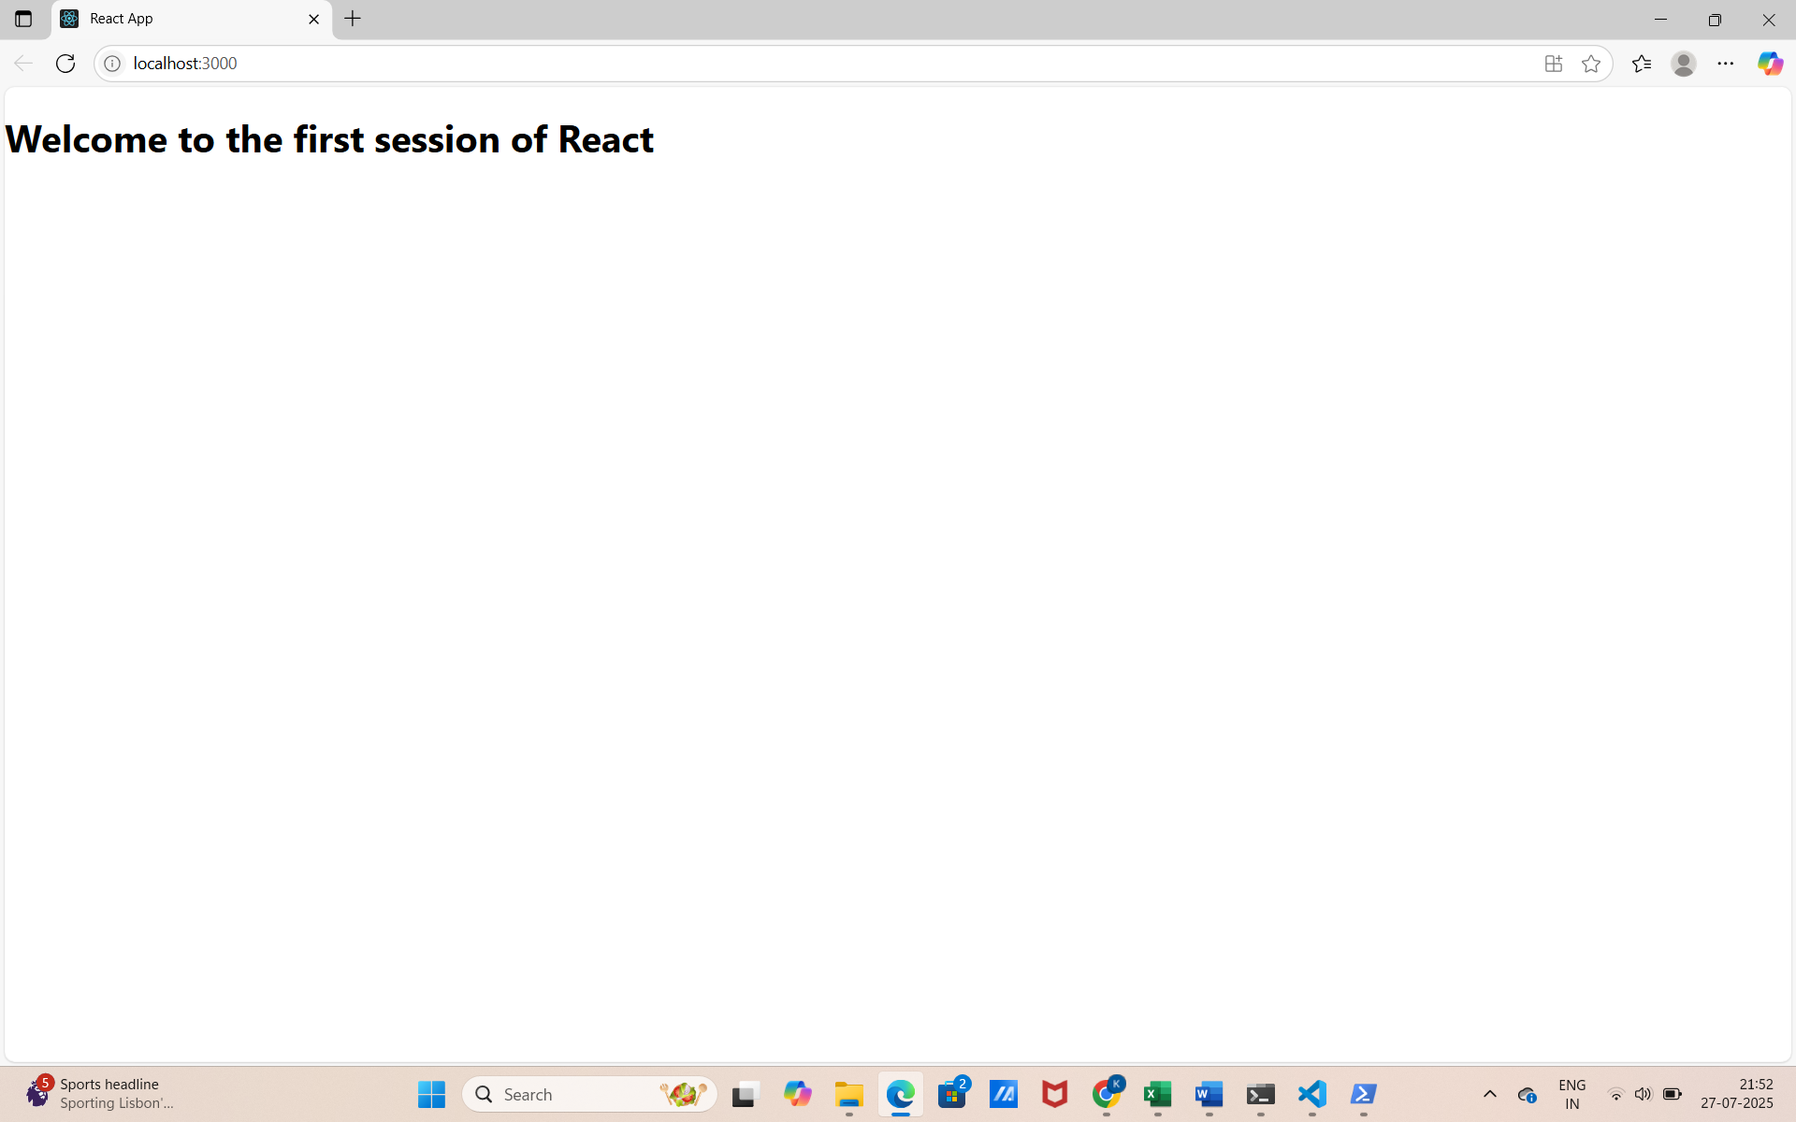

HandsOn 2:
Objective:
To create a React Application named StudentApp with 3 components:
- Home: “Welcome to the Home page of Student Management Portal”
- About: “Welcome to the About page of the Student Management Portal”
- Contact: “Welcome to the Contact page of the Student Management Portal”
Step 1: Create the React App
- In your terminal, run:
  - npx create-react-app studentapp
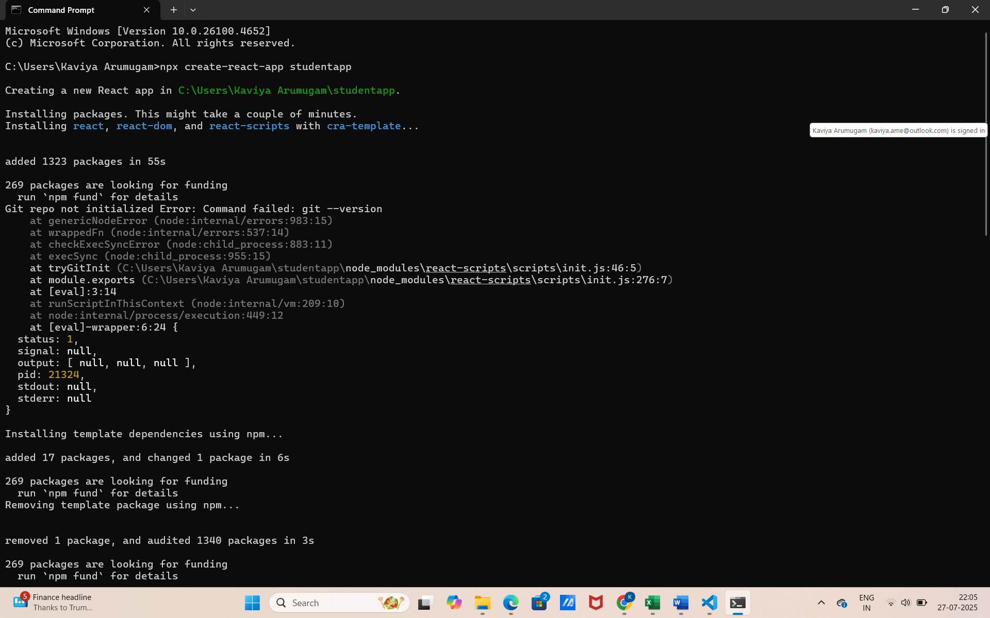

Step 2: Open the Project in VS Code
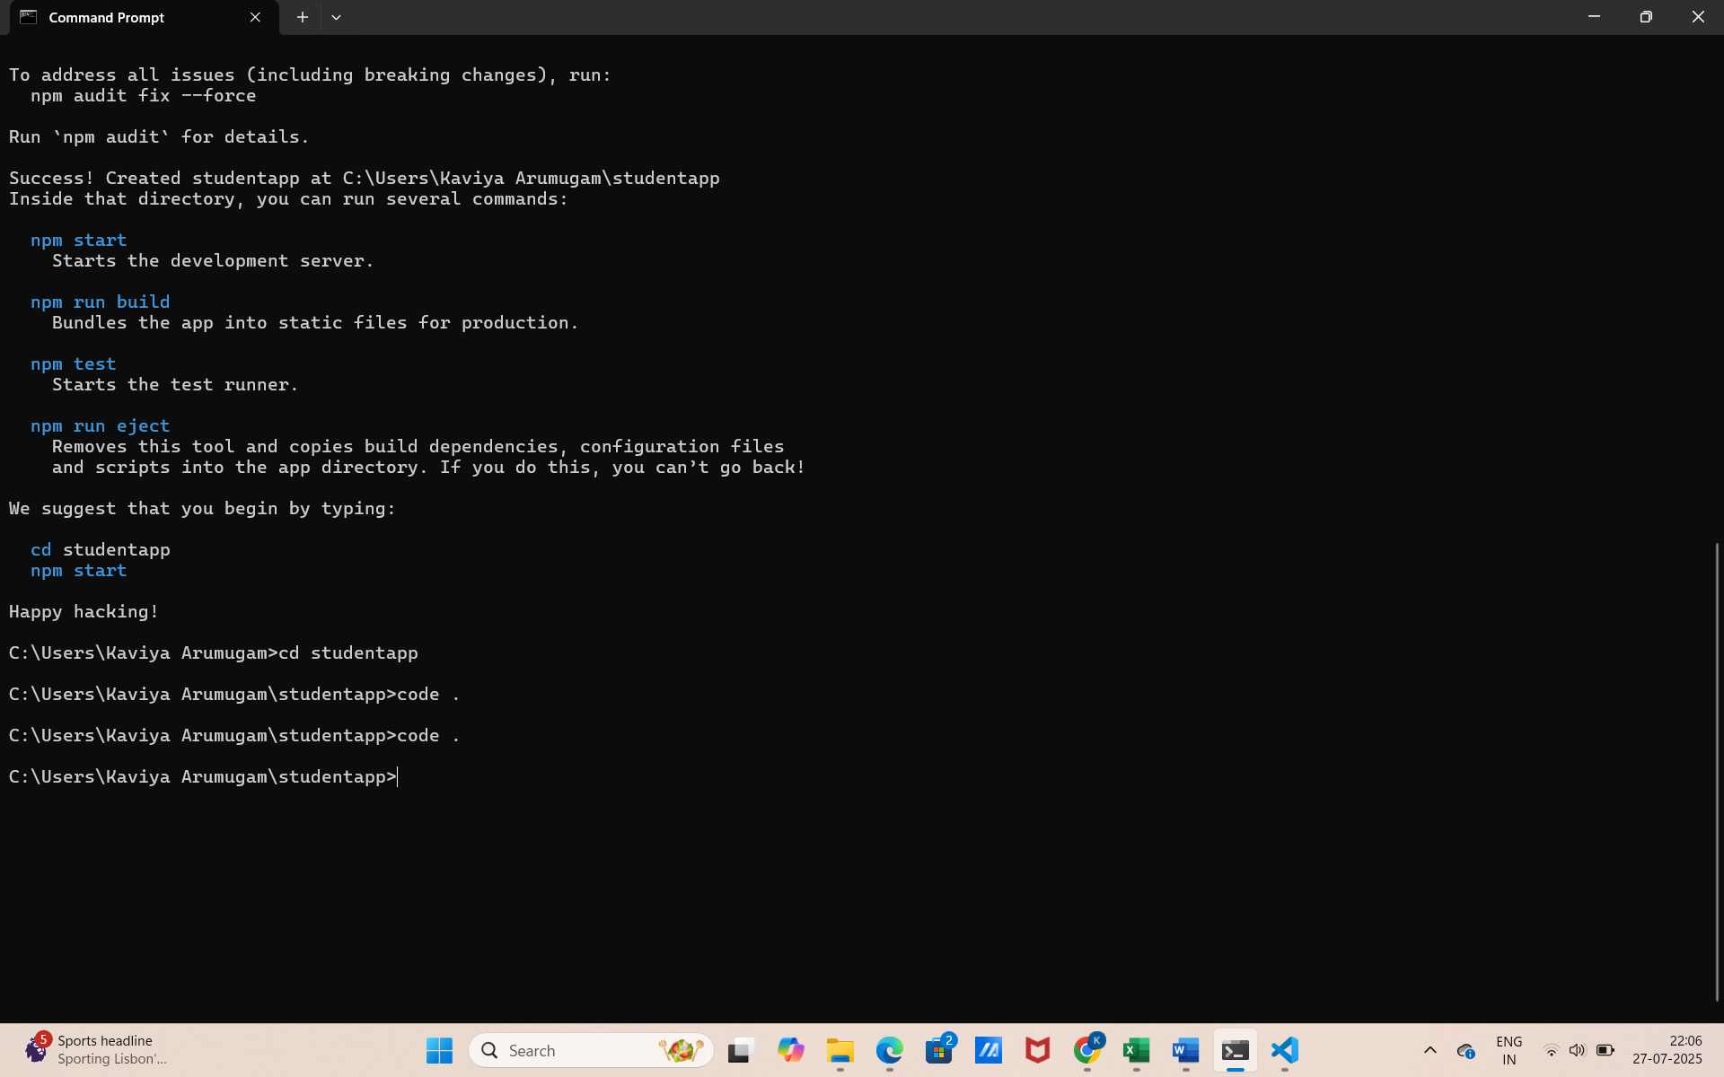
Step 3: Create a “Components” folder
Create Home.js in Components
import React from 'react';

function Home() {
return (
<div>
<h1>Welcome to the Home page of Student Management Portal</h1>
</div>
);
}

export default Home;
Create About.js in Components
import React from 'react';

function About() {
return (
<div>
<h1>Welcome to the About page of the Student Management Portal</h1>
</div>
);
}

export default About;
Create Contact.js in Components
import React from 'react';

function Contact() {
return (
<div>
<h1>Welcome to the Contact page of the Student Management Portal</h1>
</div>
);
}

export default Contact;
Step 4: Modify App.js to use all 3 components
import React from 'react';
import Home from './Components/Home';
import About from './Components/About';
import Contact from './Components/Contact';

function App() {
return (
<div className="App">
<Home />
<About />
<Contact />
</div>
);
}

export default App;

Step 5: Start the App
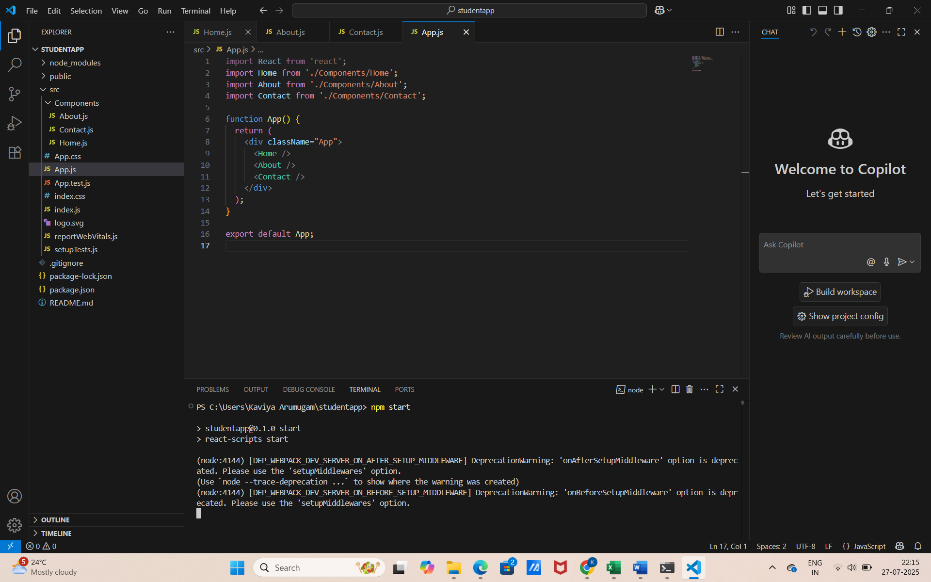

Step 6: Output
- Browser opens automatically at:
- http://localhost:3000
- You will see the output:
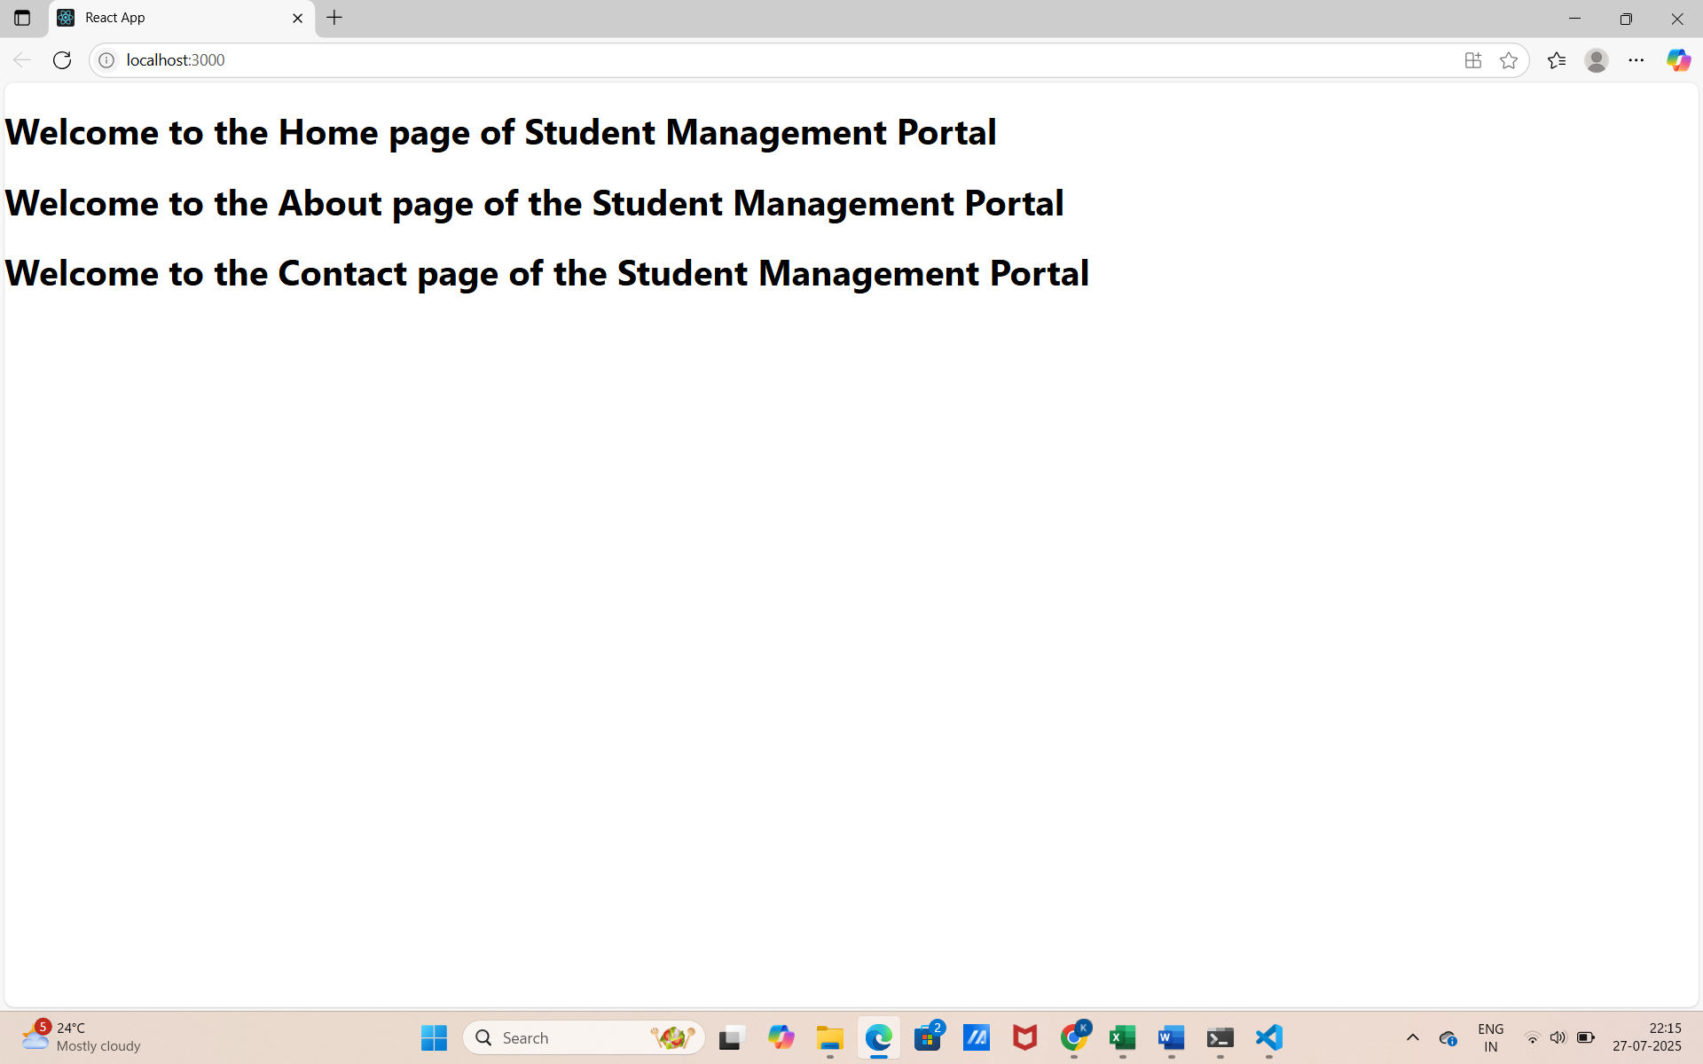
HandsOn 3:
Objective:
To create a React application named scorecalculatorapp that contains a functional component called CalculateScore, which:
- Accepts: Name, School, Total, and Goal
- Calculates and displays the average score
Step 1: Create the React App
- In your terminal, run:
  - npx create-react-app scorecalculatorapp
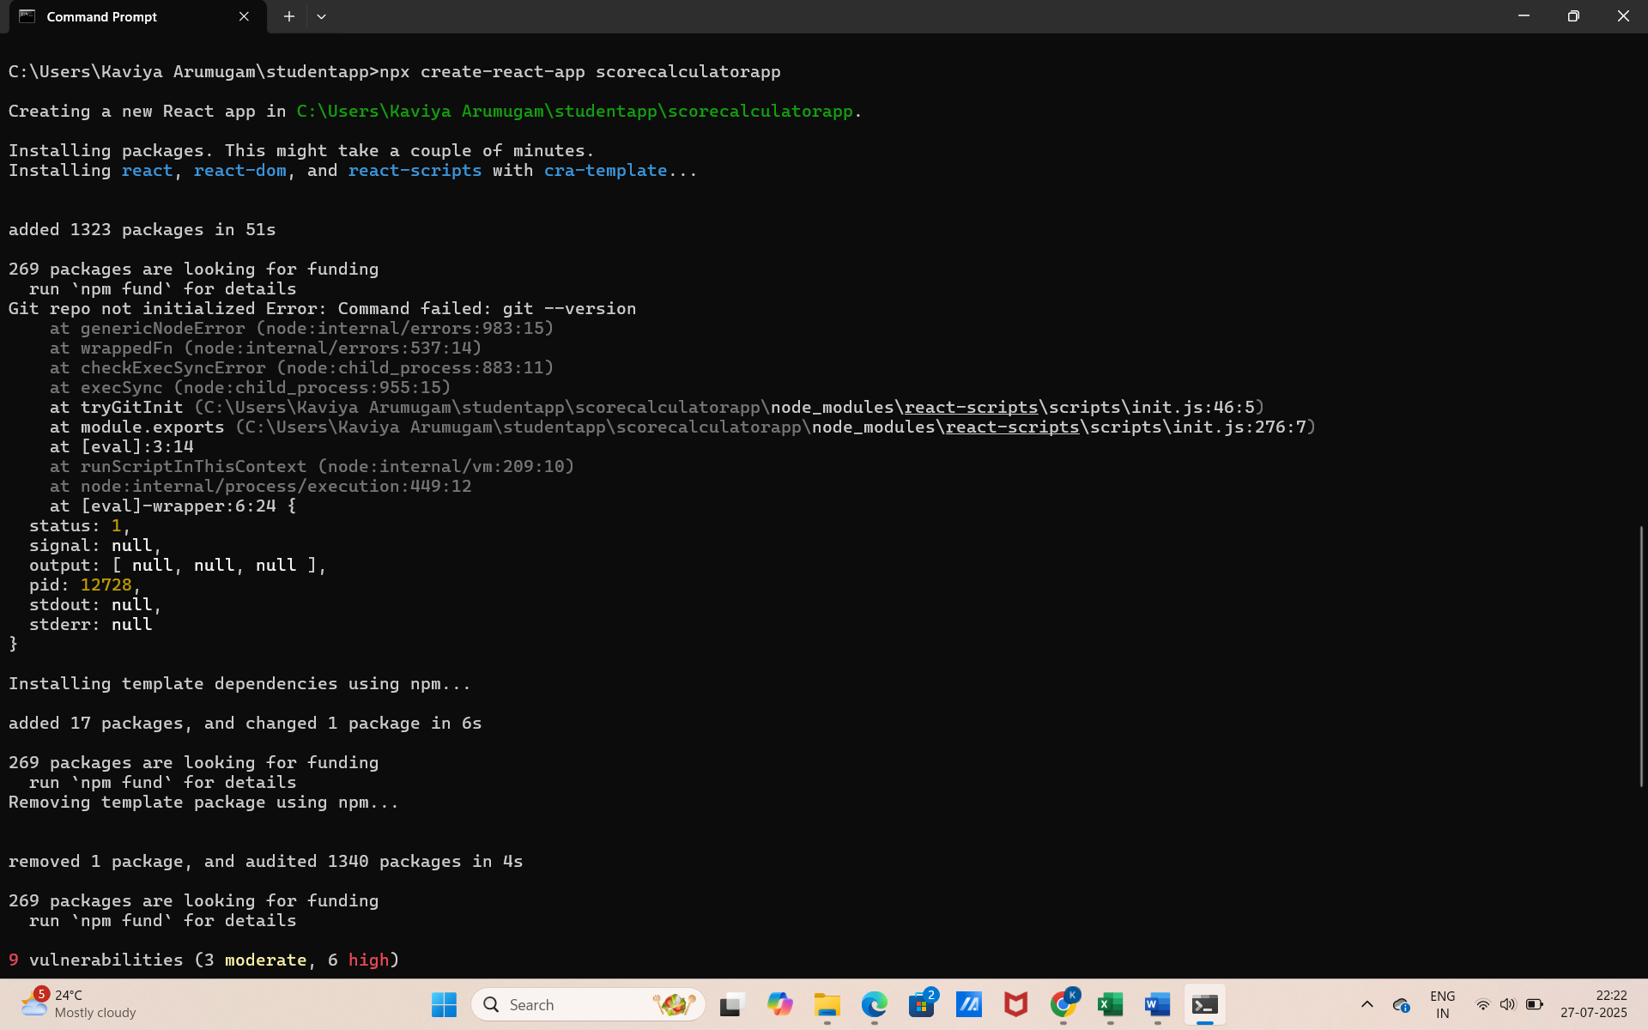

Step 2: Open the Project in VS Code
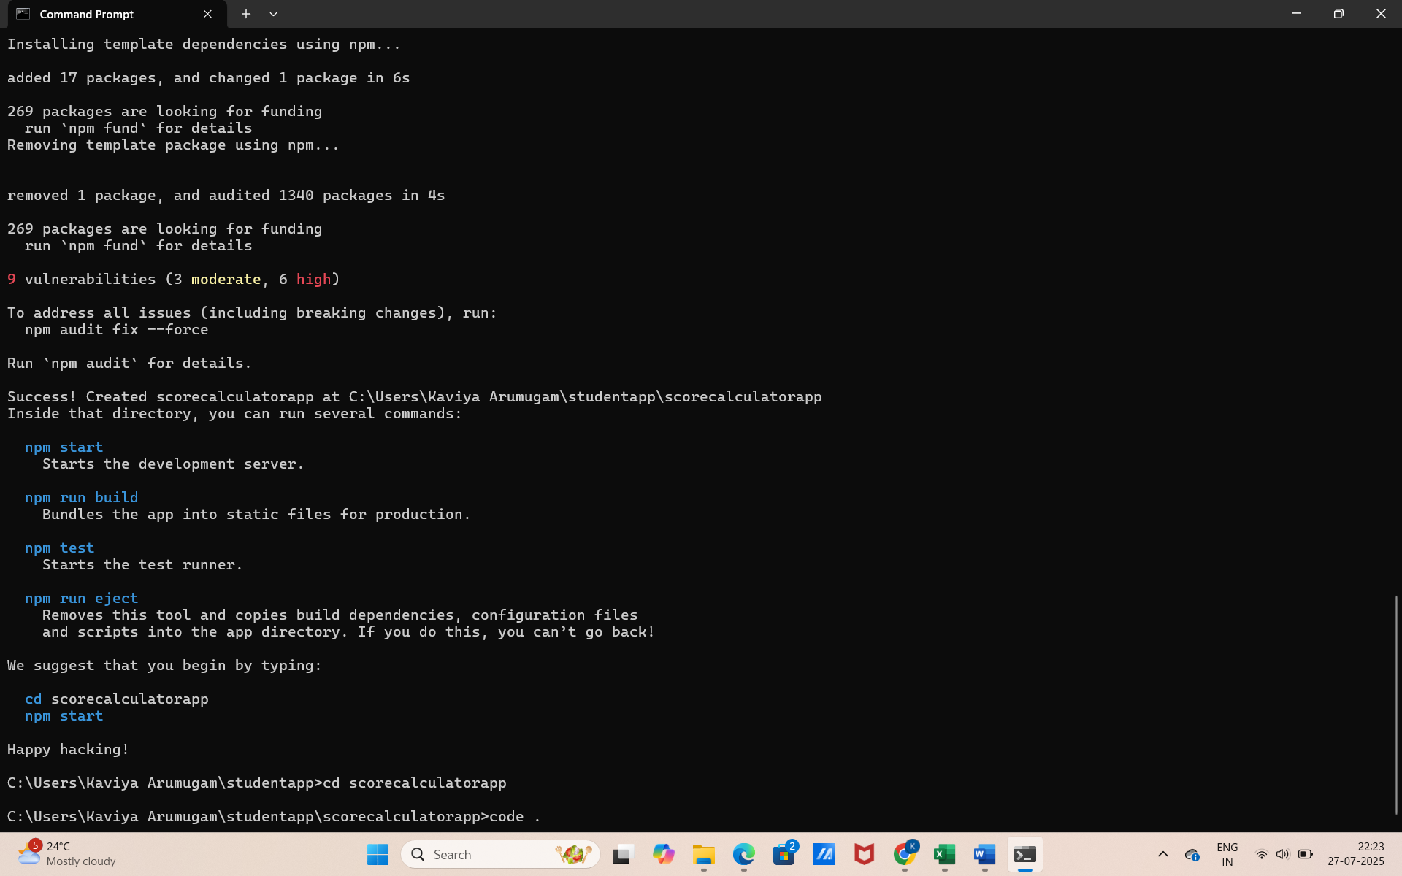
Step 3: Create the Components folder in src
- Inside Components, create a file: CalculateScore.js
import React from 'react';
import '../Stylesheets/mystyle.css';

function CalculateScore(props) {
const { name, school, total, goal } = props;
const average = total / goal;

return (
<div className="score-card">
<h2>Student Score Report</h2>
<p><strong>Name:</strong> {name}</p>
<p><strong>School:</strong> {school}</p>
<p><strong>Total Marks:</strong> {total}</p>
<p><strong>Goal:</strong> {goal}</p>
<p><strong>Average Score:</strong> {average.toFixed(2)}</p>
</div>
);
}

export default CalculateScore;

Step 4: Create Stylesheets folder in src
- Inside Stylesheets, create a file: mystyle.css
.score-card {
background-color: #f0f8ff;
border: 2px solid #007acc;
border-radius: 10px;
padding: 20px;
margin: 20px auto;
width: 400px;
font-family: Arial, sans-serif;
box-shadow: 0 4px 8px rgba(0, 0, 0, 0.1);
}

.score-card h2 {
text-align: center;
color: #007acc;
}

.score-card p {
font-size: 16px;
margin: 8px 0;
}

Step 5: Modify App.js to Use the Component
import React from 'react';
import './App.css';
import CalculateScore from './Components/CalculateScore';

function App() {
return (
<div className="App">
<CalculateScore name="Kaviya" school="SKCT" total={450} goal={5} />
</div>
);
}

export default App;

Step 6: Start the React App
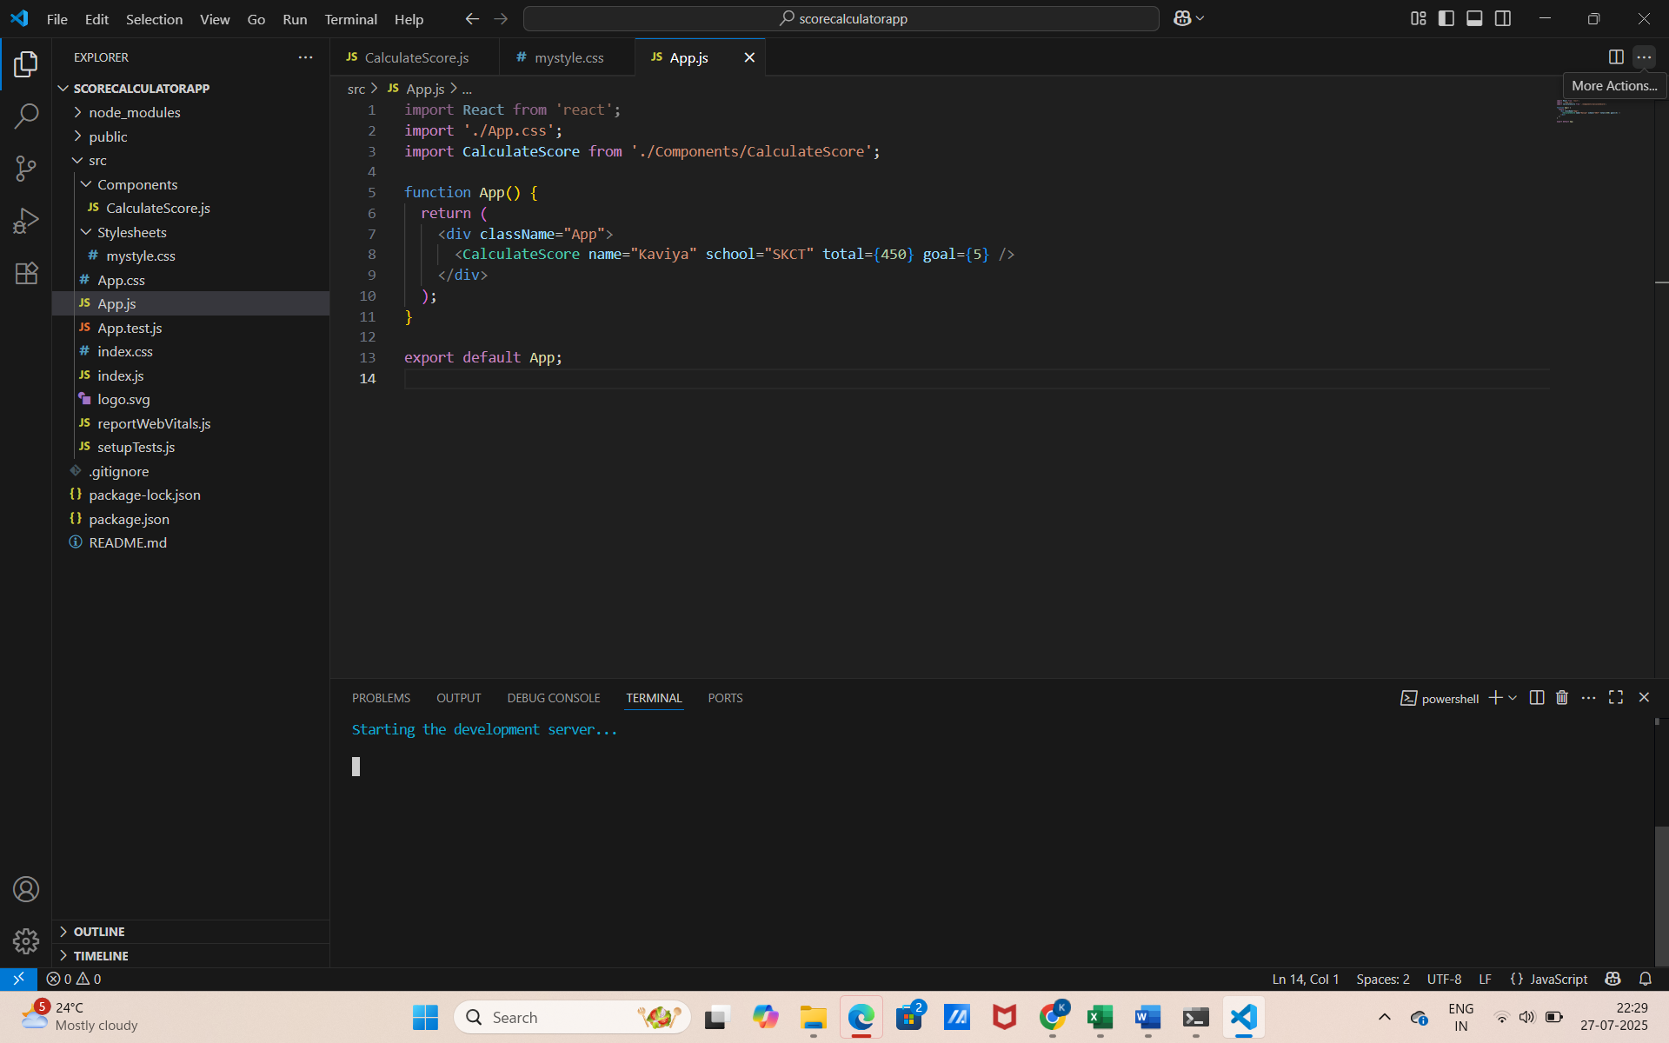
Step 7: Output
- Browser opens automatically at:
- http://localhost:3000
- You will see the output:
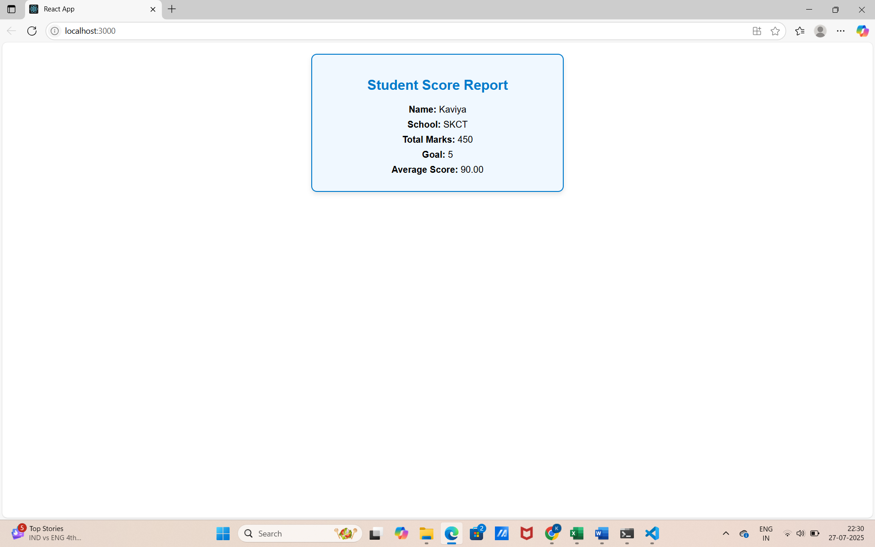
HandsOn 4:
Objective:
Create a React app named blogapp, use class components to:
- Fetch and display posts from an API (https://jsonplaceholder.typicode.com/posts)
- Handle lifecycle methods: constructor, componentDidMount, componentDidCatch
- Display post title and body on the page
Step 1: Create the React App
- In your terminal (or VS Code terminal), run:
- npx create-react-app blogapp
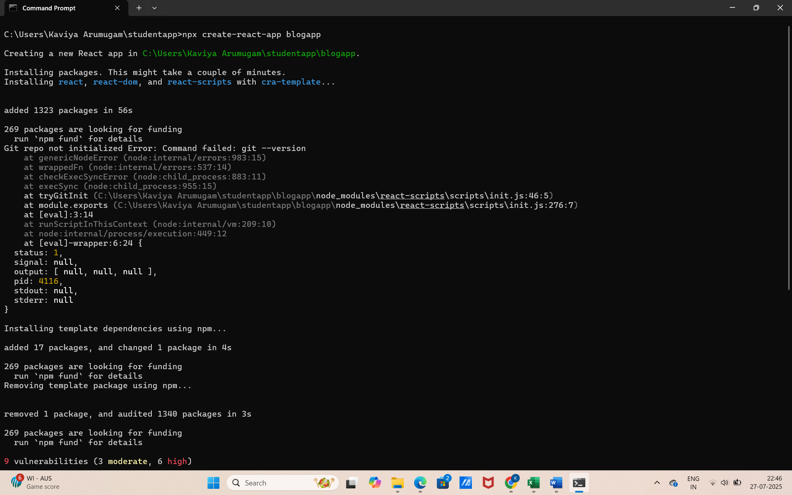

Step 2: Open the Project in VS Code
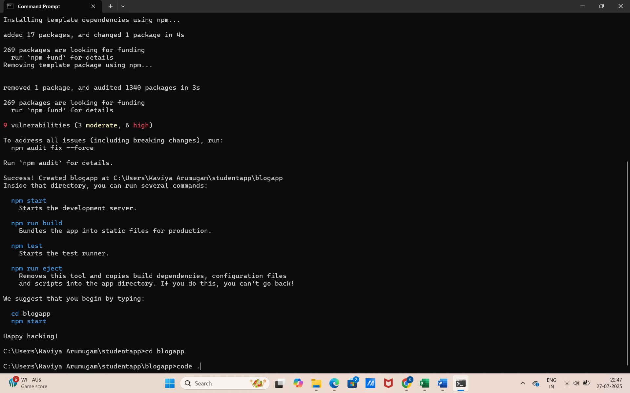
Step 3: Create Post.js in src Folder
import React from 'react';

function Post({ title, body }) {
return (
<div className="post">
<h2>{title}</h2>
<p>{body}</p>
<hr />
</div>
);
}

export default Post;

Step 4: Create Class Component Posts in src
import React, { Component } from 'react';
import Post from './Post';

class Posts extends Component {
constructor(props) {
super(props);
this.state = {
posts: [],
error: null
};
}

loadPosts = () => {
fetch('https://jsonplaceholder.typicode.com/posts')
.then((response) => response.json())
.then((data) => this.setState({ posts: data }))
.catch((error) => this.setState({ error }));
};

componentDidMount() {
this.loadPosts();
}

componentDidCatch(error, info) {
alert('An error occurred while rendering posts.');
console.error('Error:', error);
console.error('Info:', info);
}

render() {
const { posts, error } = this.state;

if (error) {
return <p>Error loading posts.</p>;
}

return (
<div>
<h1>Blog Posts</h1>
{posts.slice(0, 10).map((post) => (
<Post key={post.id} title={post.title} body={post.body} />
))}
</div>
);
}
}

export default Posts;

Step 5: Add Posts Component to App.js
import React from 'react';
import './App.css';
import Posts from './Posts';

function App() {
return (
<div className="App">
<Posts />
</div>
);
}

export default App;

Step 6: Run the App
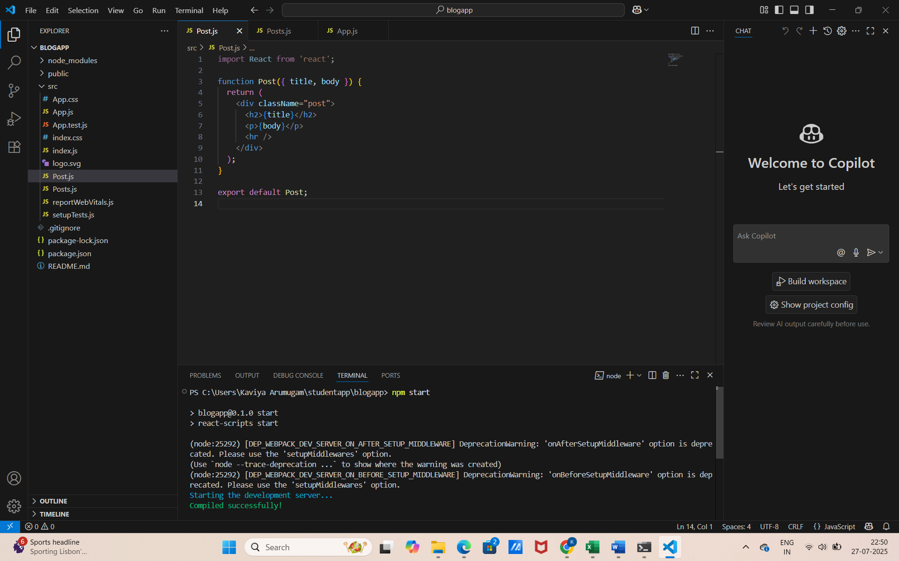

Step 7: Open Browser
Go to: http://localhost:3000
You’ll see:
- A list of blog post titles and bodies displayed from the API
- If any error occurs, it’s handled by componentDidCatch
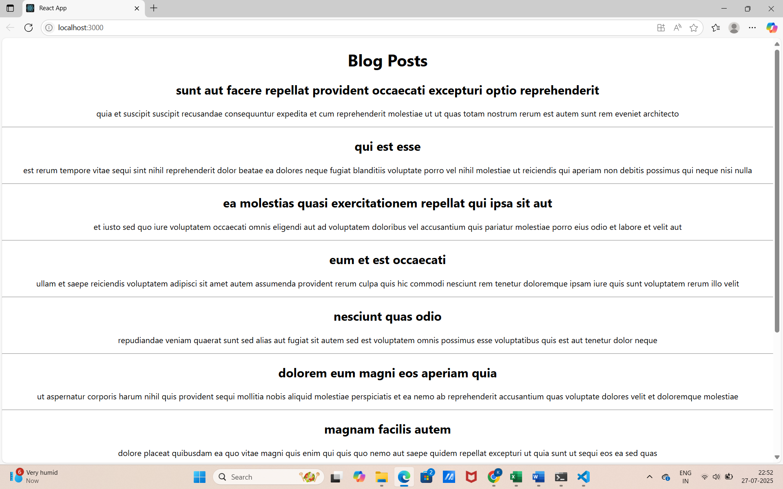

HandsOn 5:
Objective:
To style the Cohort Dashboard React application using CSS Modules. The app displays ongoing and completed cohort details.
Step 1: Create a New React App and open the project in VS Code
- In your terminal:
- npx create-react-app cohortdashboard
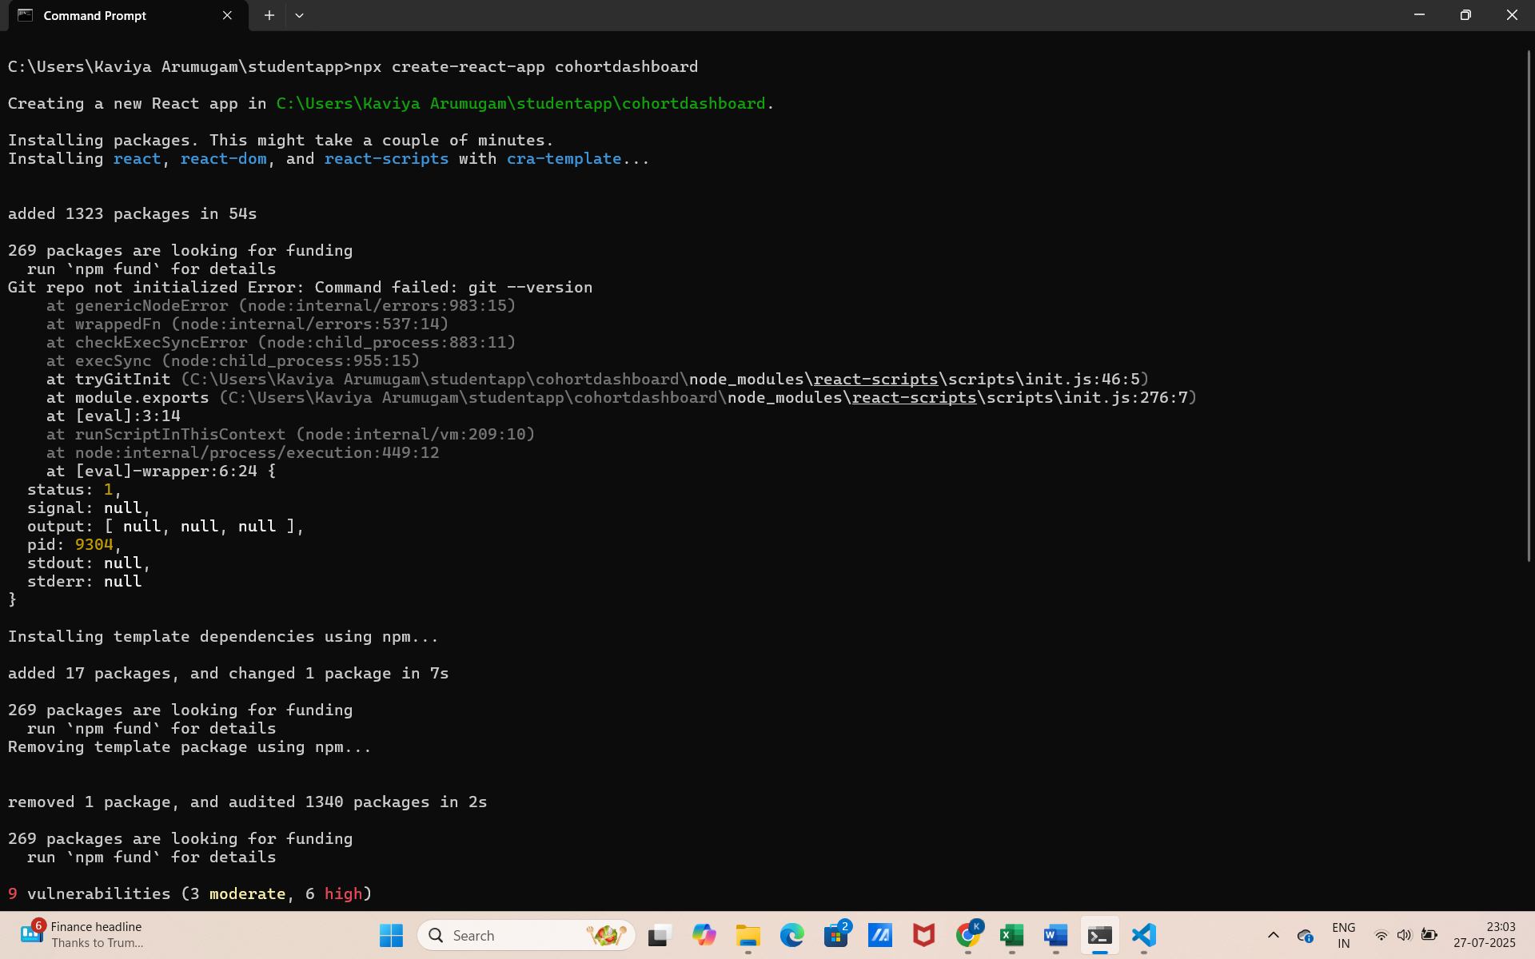

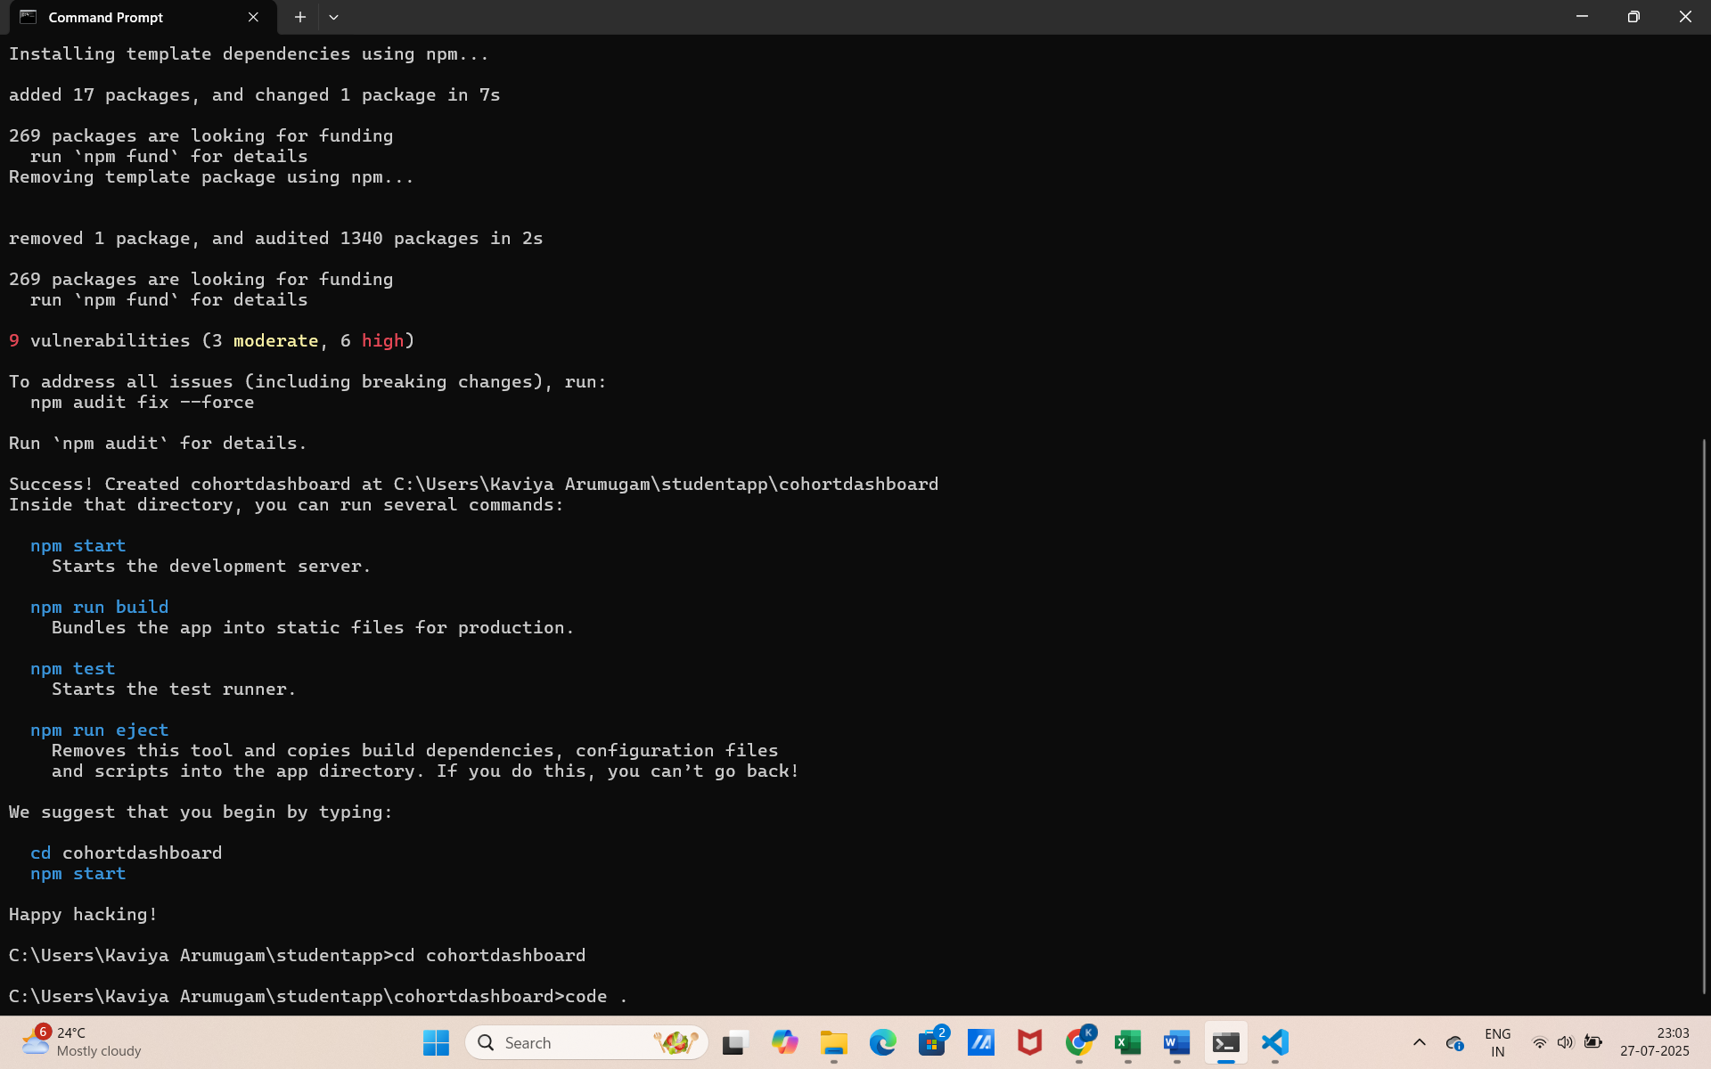
Step 2: Create a Folder for Components
Inside the src folder:
- Create a new folder: components
- Inside it, create a file: CohortDetails.js
import React from 'react';
import styles from './CohortDetails.module.css';

function CohortDetails({ title, status, startDate, endDate }) {
const headingStyle = {
color: status === 'ongoing' ? 'green' : 'blue'
};

return (
<div className={styles.box}>
<h3 style={headingStyle}>{title}</h3>
<dl>
<dt>Status:</dt>
<dd>{status}</dd>
<dt>Start Date:</dt>
<dd>{startDate}</dd>
<dt>End Date:</dt>
<dd>{endDate}</dd>
</dl>
</div>
);
}

export default CohortDetails;

Step 3: Create the CSS Module File
In the same components folder:
- Create another file: CohortDetails.module.css
.box {
width: 300px;
display: inline-block;
margin: 10px;
padding: 10px 20px;
border: 1px solid black;
border-radius: 10px;
}

dt {
font-weight: 500;
}

Step 4: Modify App.js to Use the Component
import React from 'react';
import './App.css';
import CohortDetails from './components/CohortDetails';

function App() {
return (
<div className="App">
<h2>Cognizant Cohort Dashboard</h2>
<CohortDetails
title="React Cohort - July"
status="ongoing"
startDate="2024-07-01"
endDate="2024-08-15"
/>
<CohortDetails
title="Node.js Cohort - May"
status="completed"
startDate="2024-05-10"
endDate="2024-06-30"
/>
</div>
);
}

export default App;

Step 5: Run the Application

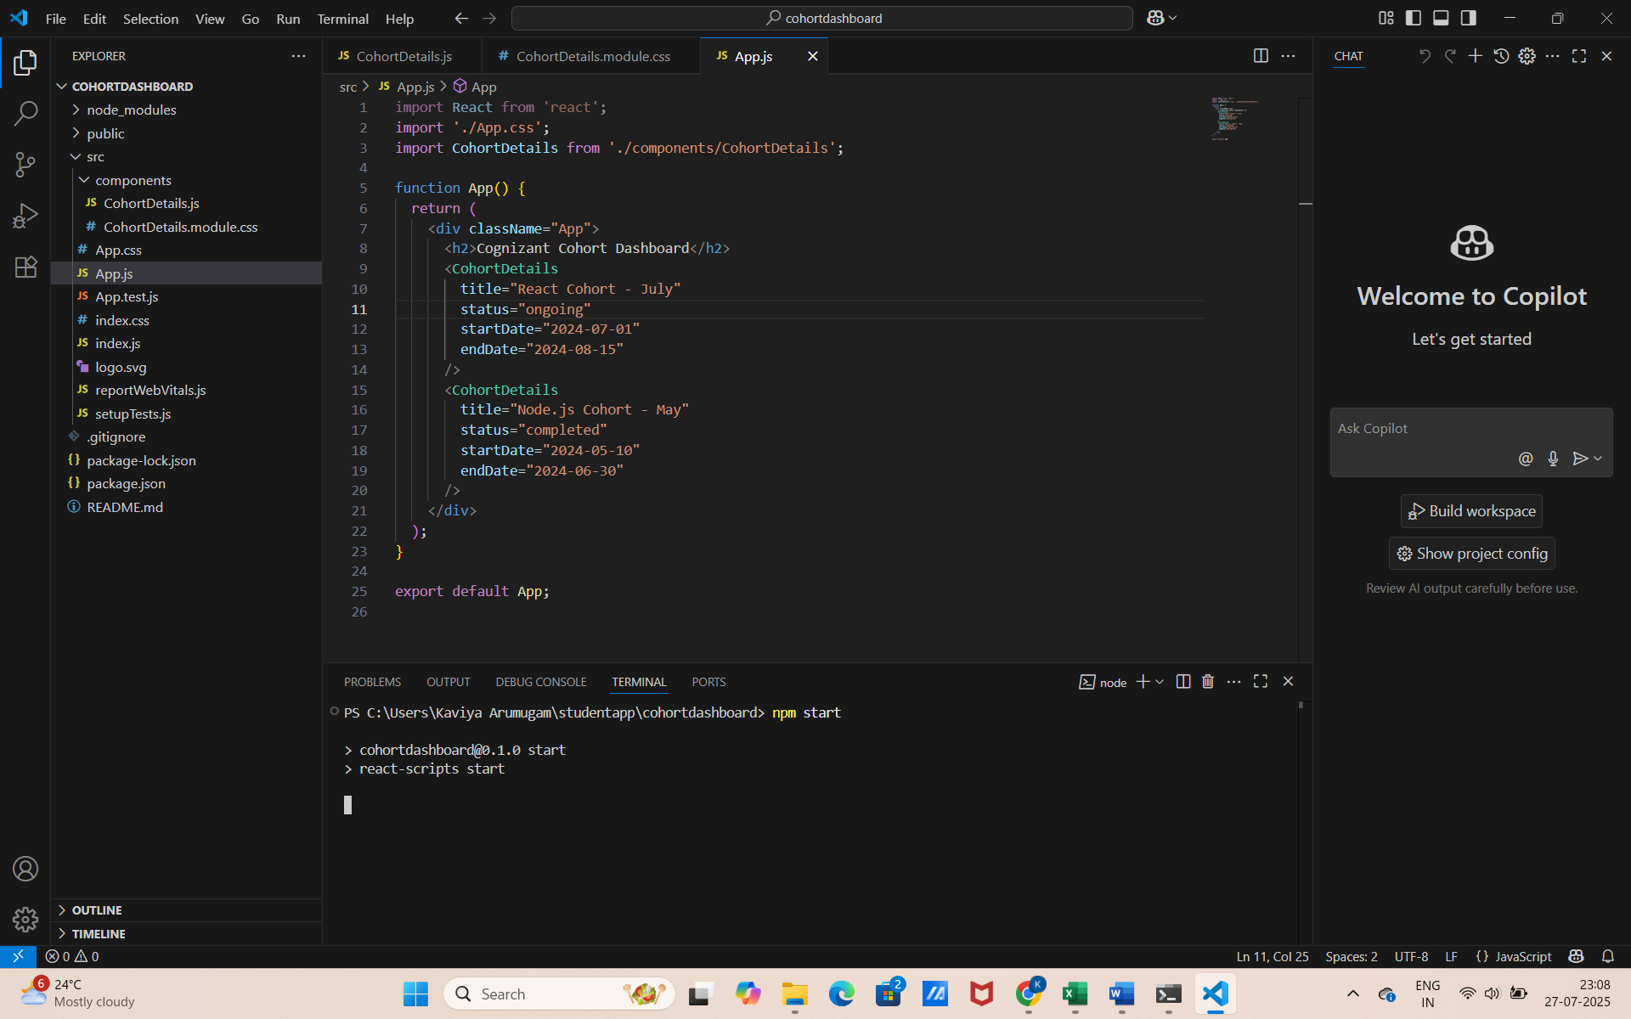
Step 6: Open the browser
http://localhost:3000
