AI HR RECRUITMENT ASSISTANT
An Agentic AI based solution for Intelligent Recruitment
IBM Internship Project — Agentic AI
Submitted by: KAVIYA G
Domain: Artificial Intelligence / Agentic AI / HR Technology
Date: September 2026

1. Project Overview

1.1 Project Title:
AI HR Recruitment Assistant – An Agentic AI System for Automated, Intelligent, and Unbiased Talent Acquisition.

1.2 Problem Statement:
Traditional recruitment processes are slow, manual, and resource-intensive. HR teams spend a large portion of their time manually screening resumes, matching candidates to job descriptions, coordinating interview schedules, and answering repetitive candidate queries. This manual approach leads to delayed hiring cycles, inconsistent evaluation criteria, unconscious bias, poor candidate experience, and a high administrative burden on recruiters, especially when the volume of applications is large.

1.3 Brief Description of the Project:
The AI HR Recruitment Assistant is an Agentic AI system built to autonomously handle the end-to-end early stages of recruitment. Instead of a single monolithic model, the solution uses a team of cooperating AI agents — each responsible for a specific task such as parsing resumes, matching candidates to job requirements, scheduling interviews, and communicating with candidates. A central orchestrator agent plans the workflow, delegates tasks to the right specialised agent, and adapts the process based on intermediate results, enabling the system to act with a degree of autonomy rather than following a fixed script.

2. Objectives & Proposed Solution

2.1 Project Objectives:
- Automate resume screening and candidate–job description (JD) matching to reduce manual effort.
- Shorten the overall time-to-hire by removing manual bottlenecks in the early recruitment stages.
- Reduce human bias by using consistent, criteria-based evaluation for every candidate.
- Provide instant, 24x7 responses to candidate queries through a conversational agent.
- Automate interview scheduling by coordinating recruiter and candidate availability.
- Give HR teams a real-time dashboard with actionable insights on the hiring pipeline.

2.2 How the Agentic AI Solution Works:
The system follows a multi-agent architecture orchestrated by a central Planner Agent, built on a large language model (LLM) with tool-calling capability. When a new job requisition and a batch of resumes are submitted, the Planner Agent breaks the overall goal into sub-tasks and routes them to specialised agents:
- Resume Parser Agent: Extracts structured data (skills, experience, education, certifications) from unstructured resumes (PDF/DOCX) using NLP.
- Screening & Matching Agent: Compares extracted candidate data against the job description using semantic similarity and rule-based checks, and produces a match score with justification.
- Scheduling Agent: Checks recruiter and candidate calendar availability (via Calendar API) and autonomously proposes and books interview slots.
- Communication Agent: Acts as a chatbot that answers candidate FAQs (application status, role details, next steps) and sends automated status updates via email.
- Planner / Orchestrator Agent: Coordinates the above agents, monitors task outcomes, retries or escalates failures, and compiles the final shortlist for human (HR) review and final decision-making.
Human-in-the-loop review is retained at the final shortlisting and offer stage, so the AI accelerates and standardises the process while the hiring decision remains with the HR team.

2.3 Key Features:
- Automated multi-format resume parsing (PDF, DOCX) with structured data extraction.
- AI-driven JD-to-resume semantic matching with an explainable match score.
- Autonomous interview scheduling with calendar integration.
- 24x7 candidate-facing chatbot for FAQs and application status.
- Bias-aware scoring that ignores non-relevant personal attributes.
- HR dashboard with pipeline analytics and exportable shortlists.

3. Implementation & Results

3.1 Technologies / Tools Used:
- Programming Language: Python
- Agent Orchestration: LangChain / Agentic workflow framework
- LLM & AI Services: IBM watsonx.ai (foundation models), NLP with spaCy
- Backend / API: Flask / FastAPI
- Frontend / Dashboard: Streamlit
- Database: SQLite / PostgreSQL
- Integrations: Calendar API (scheduling), SMTP (email notifications)
- Version Control & Deployment: Git, Docker

3.2 Working Process:
- Step 1 – Intake: HR uploads the job description and a batch of candidate resumes into the system.
- Step 2 – Parsing: The Resume Parser Agent converts each resume into structured JSON (skills, experience, education).
- Step 3 – Matching: The Screening Agent scores every candidate against the JD and ranks them.
- Step 4 – Shortlisting: The Orchestrator compiles a ranked shortlist and flags borderline cases for HR review.
- Step 5 – Scheduling: For shortlisted candidates, the Scheduling Agent proposes interview slots and books them automatically.
- Step 6 – Communication: The Communication Agent notifies candidates of their status and answers follow-up questions.
- Step 7 – Reporting: The HR dashboard displays pipeline status, scores, and hiring analytics in real time.

3.3 Screenshots / Output:
The following screenshots demonstrate the working system as proof of execution.
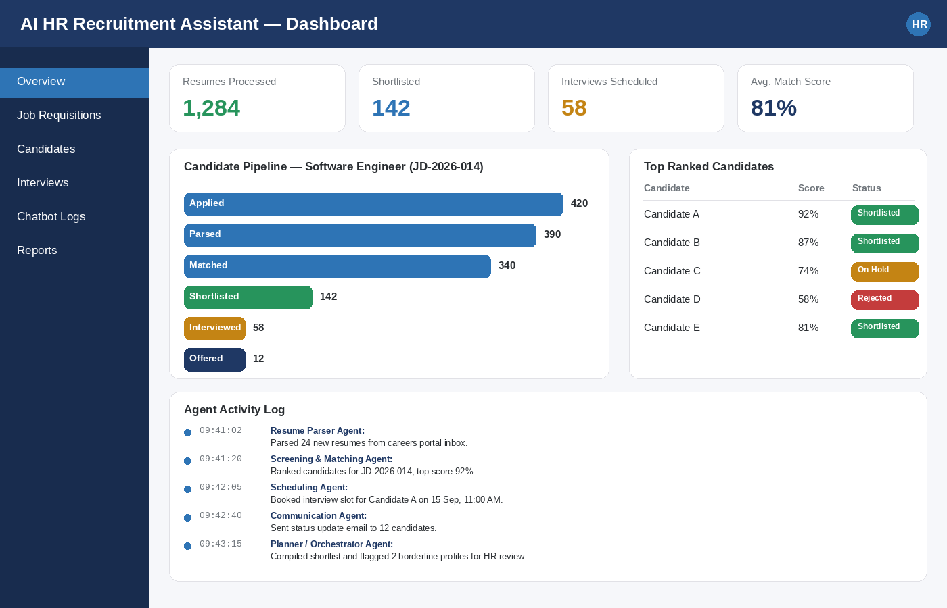
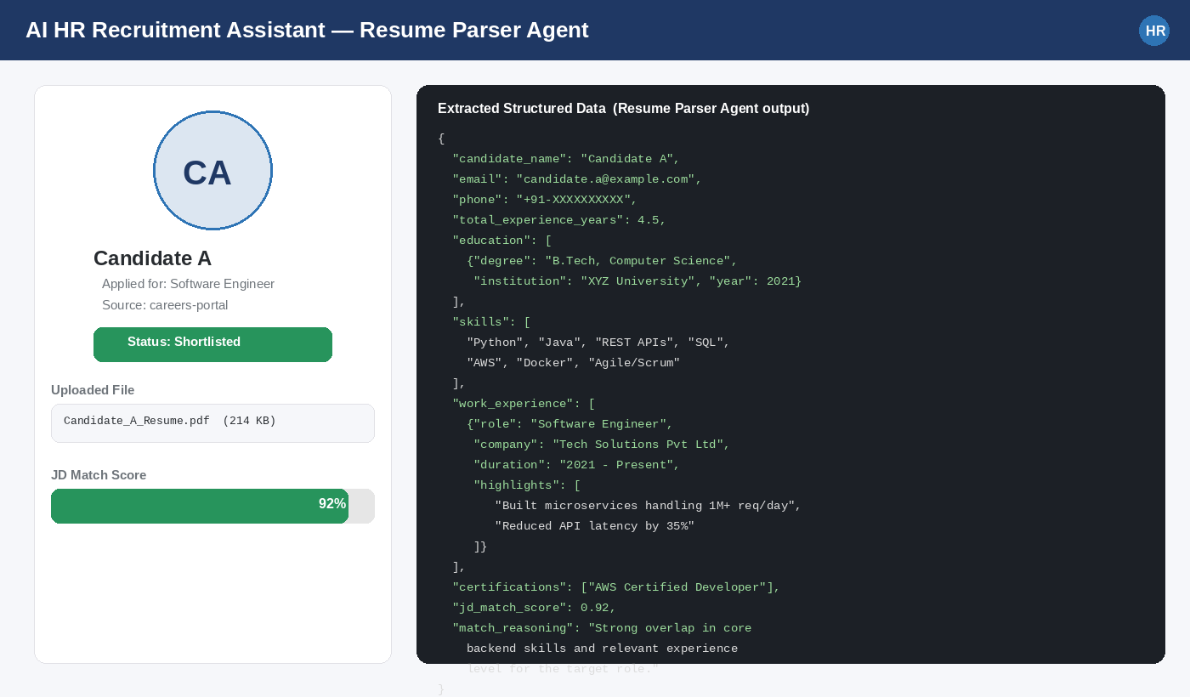
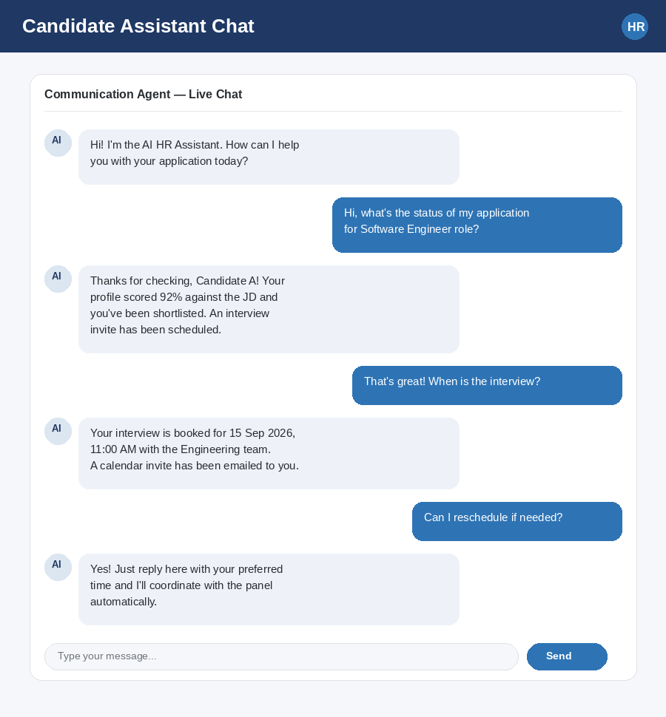
Sample ranked shortlist generated by the Screening & Matching Agent for a Software Engineer job description:
Rank | Candidate | JD Match Score | Status | Agent Remarks
1 | Candidate A | 92% | Shortlisted | Strong skill & experience match
2 | Candidate B | 87% | Shortlisted | Good fit, minor skill gap
3 | Candidate C | 74% | On Hold | Relevant but under-experienced
4 | Candidate D | 58% | Rejected | Core skills mismatch

3.4 Results Achieved:
The prototype was evaluated on a sample dataset of resumes against a live job description, with the following observed improvements over the manual baseline process:
Metric | Before (Manual Process) | After (AI Agent) | Improvement
Avg. screening time / resume | 4-5 minutes (manual) | ~8 seconds (automated) | ~97% faster
Resumes screened / day | 60-80 | 1,000+ | ~12x throughput
Shortlisting accuracy (vs HR panel) | Baseline | 89% agreement | High consistency
Time-to-schedule interview | 1-2 days | Under 5 minutes | Near real-time
Candidate query response time | Hours (email) | Instant (chatbot) | 24x7 availability

These results indicate that the agentic pipeline significantly reduces the manual workload on recruiters while maintaining a high level of agreement with human evaluators, enabling HR teams to focus their time on final-stage, high-judgment decisions rather than repetitive screening.

4. Conclusion & Future Scope

4.1 Project Conclusion:
The AI HR Recruitment Assistant demonstrates how Agentic AI — a system of cooperating, tool-using AI agents rather than a single static model — can meaningfully automate the early, repetitive stages of recruitment. By dividing responsibilities among specialised agents coordinated by an orchestrator, the system achieves faster, more consistent, and more scalable candidate screening while keeping the final hiring decision in human hands.

4.2 Challenges Faced:
- Handling inconsistent resume formats and layouts during parsing.
- Ensuring the matching agent's scoring remained explainable and free of unintended bias.
- Coordinating reliable multi-agent hand-offs and error recovery when one agent's output was incomplete.
- Integrating real-time calendar availability without double-booking interview slots.

4.3 Future Enhancements:
- Add a video-interview analysis agent for preliminary soft-skill assessment.
- Extend the system with multilingual resume parsing for global hiring.
- Incorporate continuous learning from HR feedback to refine the matching model over time.
- Add deeper bias-auditing and fairness reporting for compliance purposes.
- Integrate directly with popular ATS (Applicant Tracking System) platforms.

4.4 References:
1. IBM watsonx.ai Documentation — https://www.ibm.com/watsonx
2. LangChain Documentation — https://python.langchain.com
3. spaCy NLP Library — https://spacy.io
4. Research literature on Agentic AI architectures and multi-agent LLM systems.
5. Internal IBM Internship – Agentic AI project guidelines.

