TASK 3 – VARIABLES AND CONSTANTS

Introduction
This task demonstrates how to define named constants and variables for the milk payment calculator. Constants store the standard fat and SNF percentages, base rate and adjustment values. Variables store farmer details and milk measurements. The program also demonstrates multiple assignment, swapping two values, and Python’s dynamic typing.

Python Code
BASE_RATE = 30.00
FAT_STANDARD = 3.5
SNF_STANDARD = 8.5
FAT_STEP_VALUE = 0.40
SNF_STEP_VALUE = 0.30
STEP_SIZE = 0.1
MIN_FAT = 2.0
MAX_FAT = 7.0

farmer_id = "F101"
litres = 10
fat = 4.2
snf = 8.7

print("Base rate:", BASE_RATE)
print("Fat standard:", FAT_STANDARD)
print("SNF standard:", SNF_STANDARD)
print("Farmer ID:", farmer_id)
print("Quantity:", litres)
print("Fat:", fat)
print("SNF:", snf)

a = 10
b = 20
a, b = b, a
print("After swapping:", a, b)

value = 10
print(value, type(value))
value = "ten"
print(value, type(value))

Output Screenshot
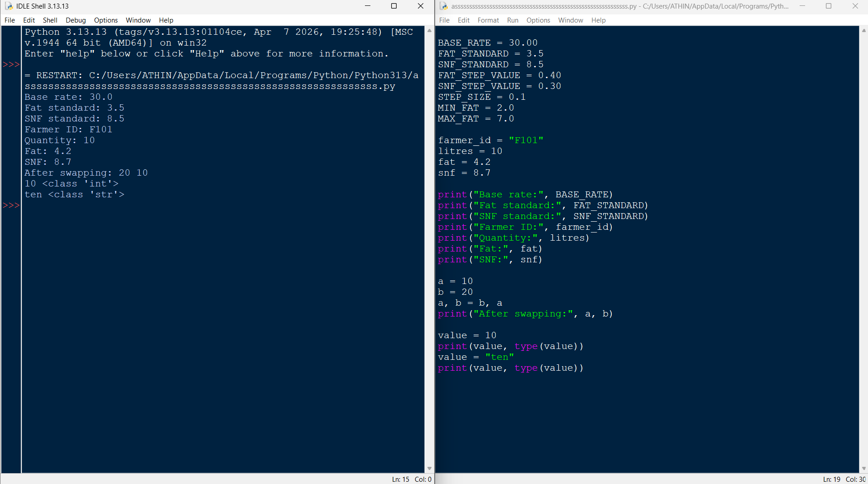

Conclusion
The program successfully displays the milk payment constants and farmer variables. Uppercase names are used for constants by convention, helping keep rate values in one place for future revisions. The statement a, b = b, a swaps the values without a temporary variable. Python is dynamically typed, so the same variable can refer first to an integer and later to a string.

