TASK 2 – VALUES AND TYPES IN PYTHON

Introduction
This task explores Python data types, arithmetic operators, floating-point precision and the Decimal module. These concepts are important for the milk co-operative because payment totals must be calculated accurately to the nearest paisa. The program compares float and Decimal totals using 1,000 payments of Rs 33.40 and three adjustments of Rs 0.10.

Python Code
from decimal import Decimal

print(type(10))
print(type(10.0))
print(type("10"))
print(type(True))
print(type([10, 8.5]))

print("7 / 2 =", 7 / 2)
print("7 // 2 =", 7 // 2)
print("7 % 2 =", 7 % 2)
print("-7 // 2 =", -7 // 2)

print("Float comparison:", 0.1 + 0.2 == 0.3)
print("Decimal comparison:",
Decimal("0.1") + Decimal("0.2") == Decimal("0.3"))

payments = ["33.40"] * 1000 + ["0.10"] * 3

def total_float(items):
total = 0.0
for amount in items:
total += float(amount)
return total

def total_decimal(items):
total = Decimal("0.00")
for amount in items:
total += Decimal(amount)
return total

print("float :", total_float(payments))
print("Decimal:", total_decimal(payments))
print(0.1 + 0.2 == 0.3,
Decimal("0.1") + Decimal("0.2") == Decimal("0.3"))

Output Screenshot
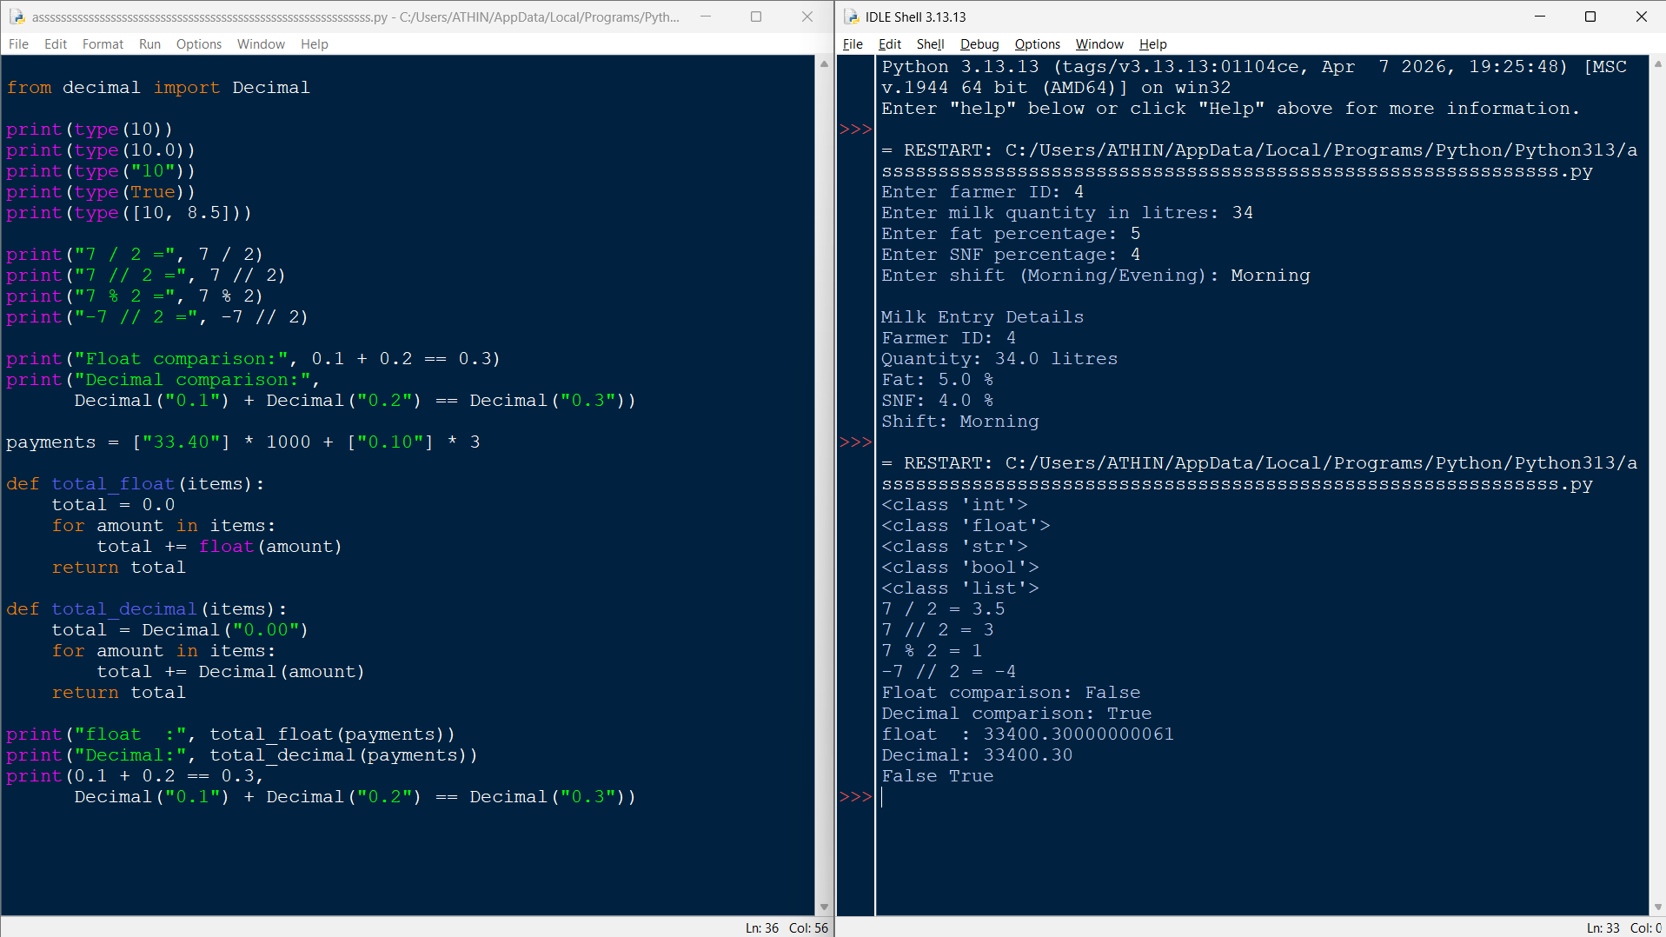

Conclusion
The program demonstrates that integers, floats, strings, booleans and lists have different Python types. Division produces 3.5, floor division produces 3, and the remainder is 1; negative floor division rounds down to -4. The expression 0.1 + 0.2 == 0.3 is False because binary floating-point cannot represent these decimal fractions exactly. Decimal values created from strings give the exact total Rs 33400.30, so Decimal is more suitable than float for financial calculations.

