TASK 4 – WRITE CORRECT EXPRESSIONS

Introduction
This task demonstrates how Python expressions calculate fat steps, SNF steps and the milk rate per litre. The step count is found by dividing the difference from the standard percentage by 0.1 and using round() to obtain the nearest whole step. The program also explores floating-point surprises, negative floor division, rounding, integer conversion, floor(), and comparison chaining.

Python Code
import math

BASE_RATE = 30.00
FAT_STANDARD = 3.5
SNF_STANDARD = 8.5
FAT_STEP_VALUE = 0.40
SNF_STEP_VALUE = 0.30
STEP_SIZE = 0.1

for fat, snf in [(4.2, 8.7), (3.1, 8.3), (3.5, 8.5)]:
fat_steps = round((fat - FAT_STANDARD) / STEP_SIZE)
snf_steps = round((snf - SNF_STANDARD) / STEP_SIZE)

rate = BASE_RATE + fat_steps * FAT_STEP_VALUE + snf_steps * SNF_STEP_VALUE
print("Fat steps:", fat_steps)
print("SNF steps:", snf_steps)
print("Rate:", round(rate, 2))

print("Unexpected 1:", (4.2 - 3.5) / 0.1)
print("Unexpected 2:", 0.1 + 0.2 == 0.3)
print("Unexpected 3:", -7 // 2)

print("round(-2.5):", round(-2.5))
print("int(-2.5):", int(-2.5))
print("floor(-2.5):", math.floor(-2.5))

fat = 4.2
print("Valid fat:", 2.0 <= fat <= 7.0)

Output Screenshot
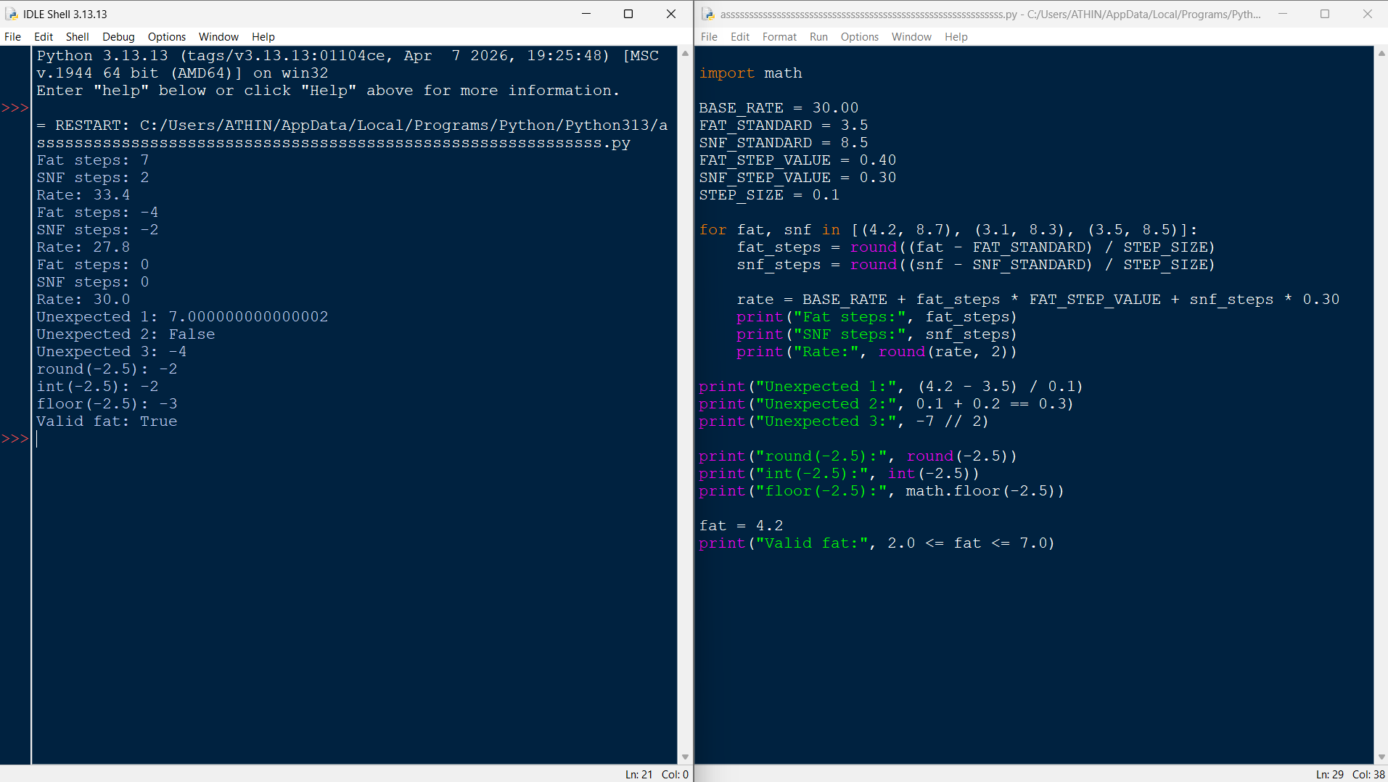

Conclusion
The program shows that rounding the step calculation avoids errors caused by binary floating-point representation. For the sample readings, the rates are Rs 33.40, Rs 27.80 and Rs 30.00 per litre. The results also show that round(), int() and math.floor() behave differently for negative values, and that chained comparisons provide a clear way to validate a range. These expressions help make the rate calculation consistent.

