TASK 7 – BUILD A PYTHON MODULE

Introduction
This task organises the milk rate constants and calculation functions into a reusable Python module. A module allows the same rate and payment logic to be used by multiple programs without copying the functions. The Decimal module is used for accurate monetary calculations, and the main guard prevents example output from running automatically when the module is imported.

Python Code
# milkrate.py
from decimal import Decimal, ROUND_HALF_UP

BASE_RATE = Decimal("30.00")
FAT_STANDARD = Decimal("3.5")
SNF_STANDARD = Decimal("8.5")
FAT_STEP_VALUE = Decimal("0.40")
SNF_STEP_VALUE = Decimal("0.30")
STEP_SIZE = Decimal("0.1")
CENT = Decimal("0.01")

def rate_per_litre(fat, snf):
"""Calculate the milk rate per litre."""
fat = Decimal(str(fat))
snf = Decimal(str(snf))
fat_steps = ((fat - FAT_STANDARD) / STEP_SIZE).quantize(
Decimal("1"), rounding=ROUND_HALF_UP)
snf_steps = ((snf - SNF_STANDARD) / STEP_SIZE).quantize(
Decimal("1"), rounding=ROUND_HALF_UP)
rate = BASE_RATE + fat_steps * FAT_STEP_VALUE + snf_steps * SNF_STEP_VALUE
return rate.quantize(CENT, rounding=ROUND_HALF_UP)

def payout(litres, fat, snf):
"""Calculate the payment for one milk entry."""
amount = Decimal(str(litres)) * rate_per_litre(fat, snf)
return amount.quantize(CENT, rounding=ROUND_HALF_UP)

def ten_day_total(payments):
"""Return the total of ten-day payments."""
return sum((Decimal(str(p)).quantize(CENT) for p in payments),
Decimal("0.00"))

if __name__ == "__main__":
print("Rate:", rate_per_litre(4.2, 8.7))
print("Payment:", payout(8.5, 4.2, 8.7))
print("Ten-day total:", ten_day_total([300, 283.9, 333.6]))

# test_milkrate.py (separate script)
import milkrate as mr

print("Rate:", mr.rate_per_litre(4.2, 8.7))
print("Payment:", mr.payout(8.5, 4.2, 8.7))
print("Ten-day total:", mr.ten_day_total([300, 283.9, 333.6]))

Output Screenshot
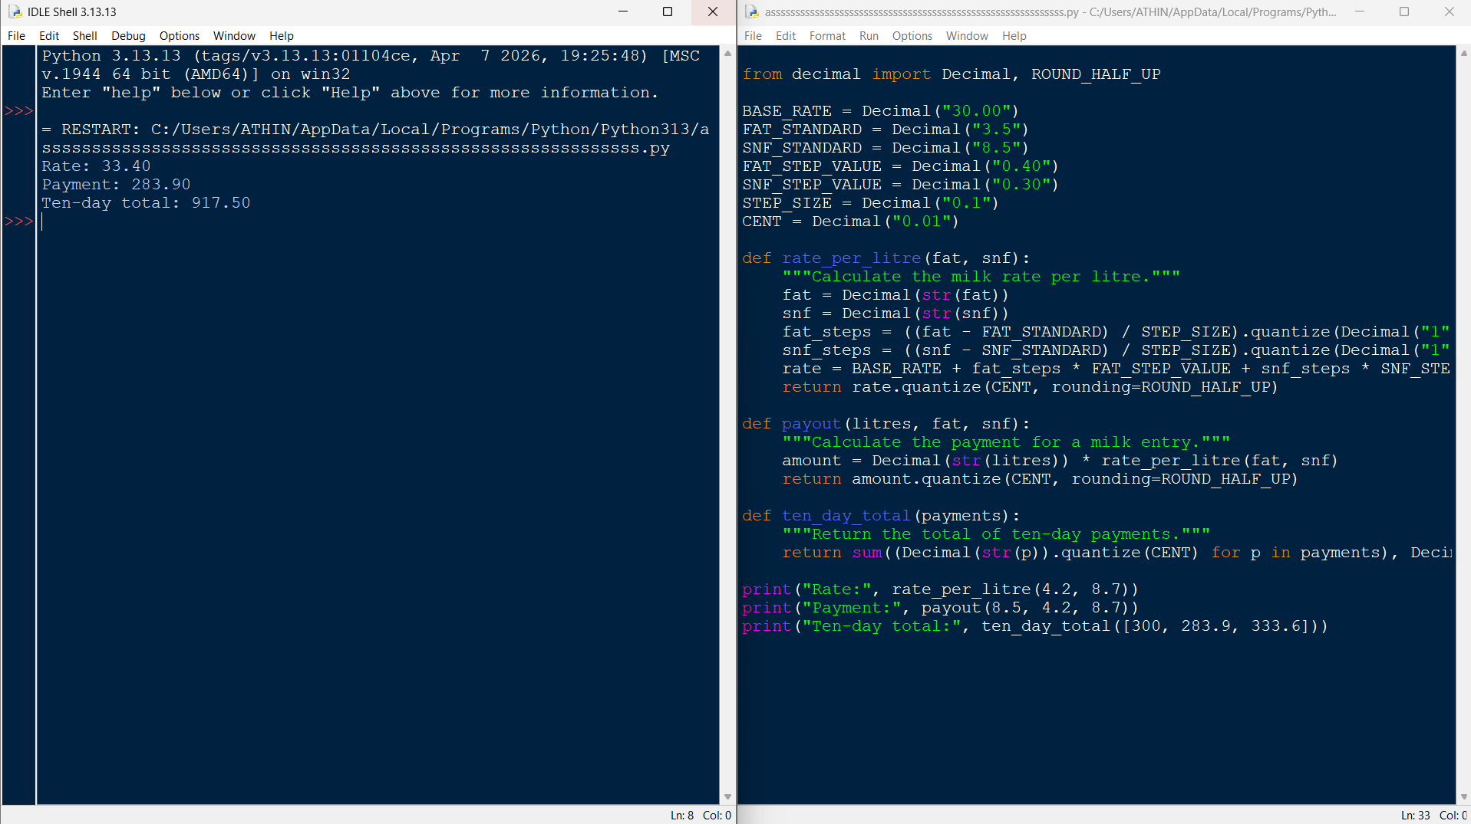

Conclusion
The rate card and calculation functions can be reused through the milkrate module. Importing it as import milkrate as mr allows functions to be called with the mr prefix, while the if __name__ == '__main__' condition keeps the example run limited to direct execution. This structure reduces repeated code and makes future rate revisions easier to manage.

