TASK 5 – READ INPUT AND CONVERT TYPES

Introduction
This task demonstrates how a Python program reads farmer details and converts numerical input into floating-point values. Since input() returns text, litres, fat percentage and SNF percentage must be converted before calculations. The program uses try/except to handle invalid numbers, validates the entries, and displays the accepted values in aligned columns using f-strings.

Python Code
def read_number(prompt):
while True:
text = input(prompt).strip()
try:
return float(text)
except ValueError:
print("Invalid number. Try again.")

farmer_id = input("Enter farmer ID: ").strip()

litres = read_number("Enter litres: ")
fat = read_number("Enter fat percentage: ")
snf = read_number("Enter SNF percentage: ")

if not farmer_id:
print("Invalid farmer ID")
elif litres <= 0:
print("Quantity must be positive")
elif not 2.0 <= fat <= 7.0:
print("Fat must be between 2.0 and 7.0")
else:
print(f"{'Farmer ID':<15}{'Litres':>10}{'Fat':>10}{'SNF':>10}")
print(f"{farmer_id:<15}{litres:>10.2f}{fat:>10.2f}{snf:>10.2f}")

Output Screenshot
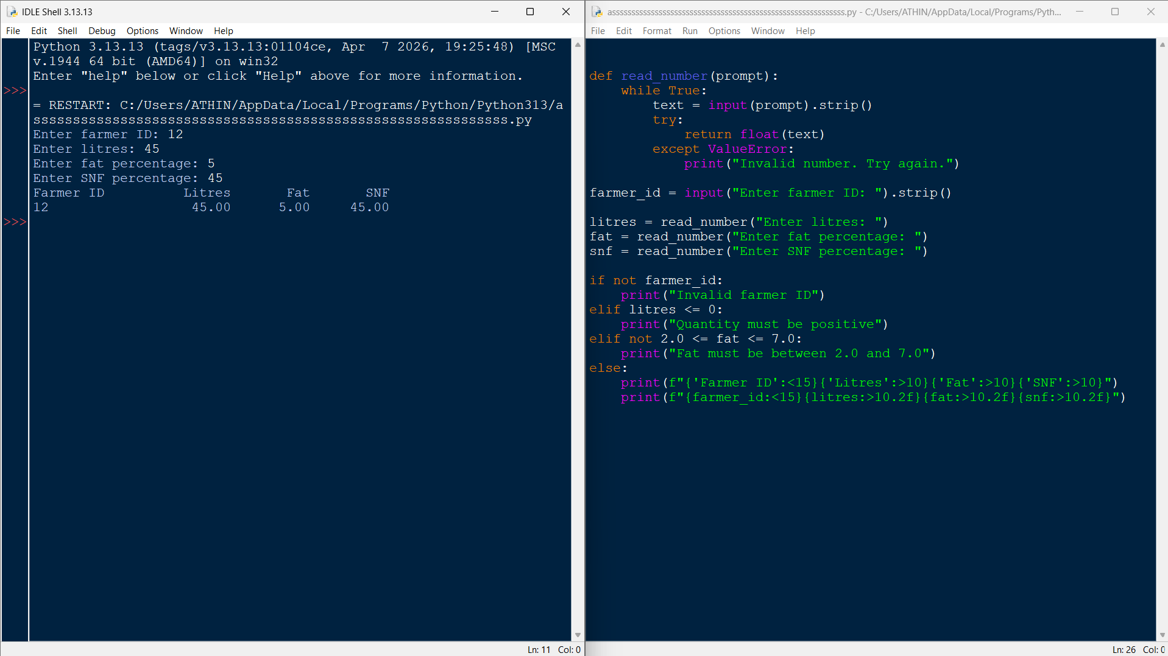

Conclusion
The program accepts the farmer ID and numerical milk details, handles invalid numeric input without crashing, and checks that the quantity is positive and fat lies within the allowed range. The formatted table makes the data easy to read. For this task, try/except conversion is clearer and more reliable than manually checking every possible numeric string.

