AI-Assisted Threat Detection Dashboard
Using Google Cloud Platform (GCP)

ARCHITECTURE AND WORKFLOW REPORT

Project Domain
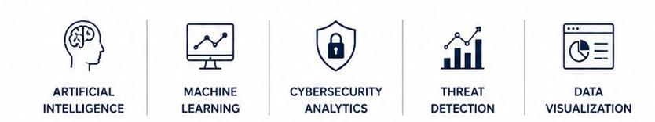
Artificial Intelligence | Machine Learning | Cybersecurity | Data Analytics

Submitted By
Name: KAVIYA
Team: B
College: SRM INSTITUTE OF SCIENCE AND TECHNOLOGY
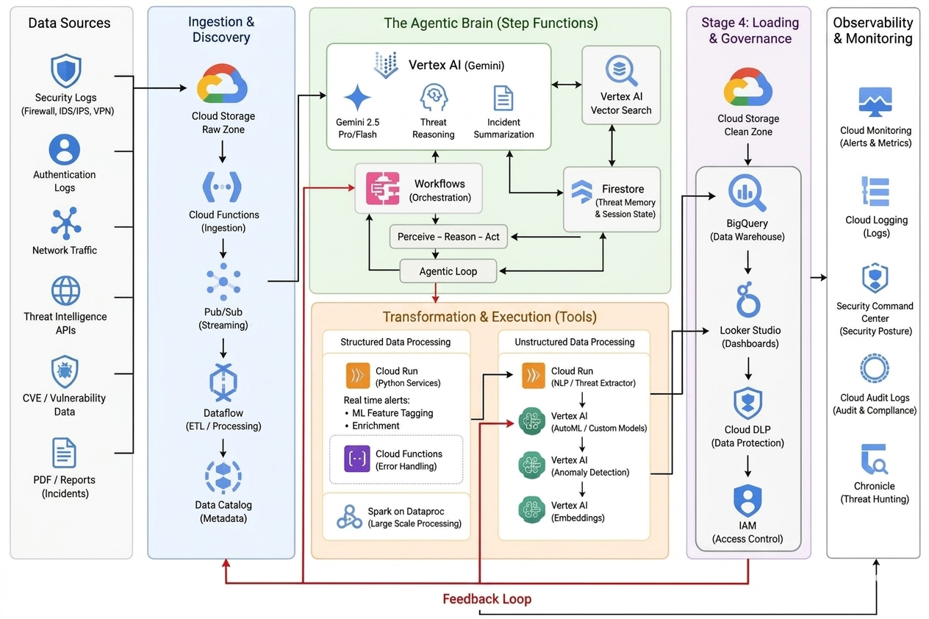
SYSTEM ARCHITECTURE

Explanation:
The architecture is designed as a cloud-native, end-to-end data pipeline built on the Google Cloud Platform (GCP). It is structured to ingest, normalize, analyze, and visualize enterprise security logs in real time.
The system modernizes traditional security workflows by separating infrastructure operations into distinct processing zones. Instead of relying on static, rigid security rules, this design uses an advanced Agentic AI approach alongside automated machine learning.
High-throughput streaming components handle incoming network and authentication data without lagging. It then leverages custom machine learning models on Vertex AI to flag statistical anomalies. Once an anomaly is caught, the platform routes it to an autonomous reasoning engine powered by Google Gemini and Vector Search to understand the threat's context.
Finally, a dedicated corporate governance layer ensures that all data is masked and secured before it lands on an interactive monitoring dashboard, balancing advanced threat intelligence with strict data privacy compliance.

WORKFLOW:
START
│
Real-Time Security Logs Stream In
│
Cloud Storage (Raw Storage Zone)
│
Cloud Functions Triggered Automatically
│
Pub/Sub Streaming Queue
│
Cloud Dataflow (Data Preprocessing)
│
Cloud Run (Feature Tagging & Enrichment)
│
Vertex AI Anomaly Detection (ML Prediction)
│
Vertex AI Gemini & Vector Search (AI Detective Reasoning)
│
Cloud Firestore (Store Threat Memory)
│
Google BigQuery Warehouse
│
Cloud DLP (Data Privacy Masking)
│
Looker Studio Dashboard Visualization
│
Generate Executive Reports
│
END
STEP-BY-STEP WORKFLOW EXPLAINATION

Step 1: Real-Time Stream Ingestion and Landing
The pipeline begins by capturing continuous, high-throughput security logs across the enterprise infrastructure. These raw payloads are buffered inside the Cloud Storage Raw Storage Zone. This ingestion step decouples the system, ensuring that heavy log volumes do not cause downstream processing bottlenecks.
Step 2: Automated Orchestration and Message Queuing
The moment a raw log file is committed to storage, an event-driven Cloud Function triggers instantly. It ingests the data packets and publishes them to a Google Cloud Pub/Sub messaging queue. This component acts as a high-speed buffer, stabilizing spikes in network traffic to guarantee zero packet loss during an active cyberattack.
Step 3: Distributed Stream Preprocessing (ETL)
Google Cloud Dataflow acts as a real-time stream consumer, pulling data directly from the Pub/Sub queue. It cleans the messy, unstructured log files on the fly by removing noise parameters, resolving missing records, parsing timestamps, and standardizing diverse inputs into a unified schema for analytics.
Step 4: Containerized Feature Tagging and Enrichment
The standardized logs pass down to serverless Cloud Run microservices. Cloud Run executes rapid feature tagging, injecting real-time system metadata and security telemetry markers onto each data payload. This steps prepares the data vectors for machine learning analysis.
Step 5: Machine Learning Inference and Anomaly Prediction
The enriched data enters Vertex AI Anomaly Detection Models. Instead of using fragile, hard-coded rules, this dedicated machine learning layer applies mathematical classification algorithms to isolate structural anomalies and flag behavioral outliers that deviate from normal system baselines.
Step 6: Agentic RAG Reasoning and State Tracking
When an anomaly is predicted, the platform triggers an autonomous Gemini AI Agent. Gemini utilizes Retrieval-Augmented Generation (RAG) to query a vectorized index in Vertex AI Vector Search, cross-referencing log attributes against live MITRE ATT&CK patterns and CVE vulnerabilities. The analytical reasoning and session context are securely cached in Cloud Firestore for state management.

Step 7: Centralized Warehousing and Security Governance
The completed threat dossiers pass into the enterprise data warehouse inside Google BigQuery. Before the data is archived or exposed to users, Cloud DLP (Data Loss Prevention) automatically intercepts the payload to detect and mask sensitive personal profile data (PII), achieving strict compliance with global security regulations.
Step 8: Dynamic BI Visualization and Executive Reporting
Finally, Looker Studio executes direct, low-latency live queries against BigQuery. The dashboard dynamically updates with real-time risk scores, visual asset threat distributions, and chronological attack trends. This grants security operations teams immediate situational awareness to trigger defensive playbooks and generate compliance reports before reaching the system end state.

