**Cracking the Market Code with AI-Driven Stock Price Prediction Using Time Series Analysis**

**Student Name:M.Kaviya**

**Register Number:** 613023104050

**Institution:**Vivekanandha college of Technology for women

**Department:** [Enter Your Department Name]

**Date of Submission:** 02.05.2025

**Github Repository Link:** https://github.com/kaviya230/Cracking-the-Market-Code-with-AI-Driven-Stock-Price-Prediction-Using-Time-Series-Analysis.git

# 1. Problem Statement

The objective of this project is to build an AI-driven predictive model that forecasts future stock prices of Reliance Industries by integrating time series stock data with sentiment scores from financial news. This addresses the regression problem of predicting the next day's closing price using both historical patterns and real-world sentiments.]

# 2. Abstract

[This project combines time series forecasting and sentiment analysis to enhance stock market prediction. Stock price data was collected using Yahoo Finance, while news headlines were fetched from NewsAPI. Sentiment polarity scores were derived using TextBlob and merged with stock data by date. A Long Short-Term Memory (LSTM) model was trained on 10-day sequences of stock prices and corresponding sentiment. The model achieved an RMSE of ₹18.08, demonstrating the benefit of integrating sentiment for short-term market prediction.

# 3. System Requirements

Hardware: Minimum 4GB RAM, Dual-core processor

Software: Google Colab, Python 3.10+

Libraries: pandas, numpy, matplotlib, yfinance, textblob, keras, sklearn

# 4. Objectives

[Predict stock closing prices using time series trends

Use news sentiment scores as an additional predictive feature

Build and train an LSTM-based deep learning model

Evaluate model performance using RMSE and visualizations

**5. Flowchart of Project Workflow** [Include Stock Price Data: Yahoo Finance (Open, High, Low, Close, Volume)

News Headlines: NewsAPI articles containing the term "Reliance"

Sentiment Scoring: TextBlob used to compute polarity (range: -1 to 1)

Merged Data: Based on common dates between prices and sentiment

Final Features: Date, Close Price, Average Sentiment

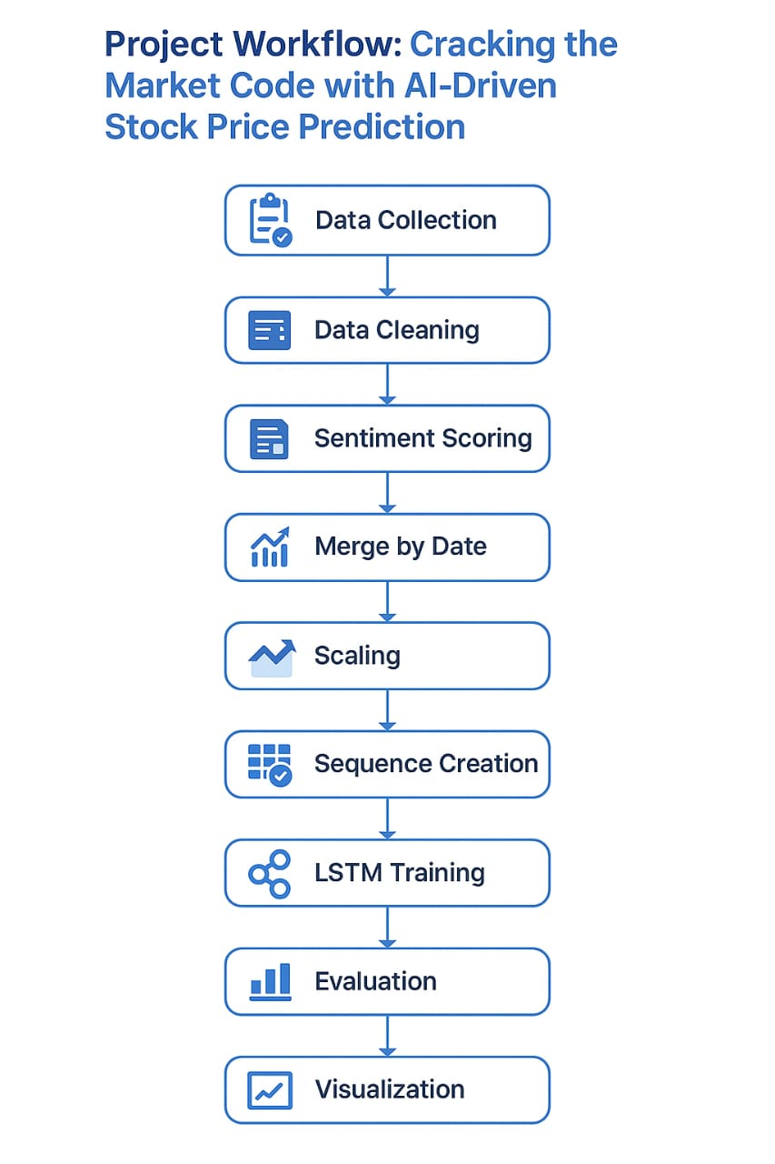

# 6. Dataset Description

Stock Price Data: Yahoo Finance (Open, High, Low, Close, Volume)

News Headlines: NewsAPI articles containing the term "Reliance"

Sentiment Scoring: TextBlob used to compute polarity (range: -1 to 1

Merged Data: Based on common dates between prices and sentiment

Final Features: Date, Close Price, Average Sentiment

# 7. Data Preprocessing

* Converted all date fields to a common format
* Removed missing or duplicate data points
* Fetched ~100 headlines, computed sentiment using TextBlob
* Merged news sentiment scores with daily stock prices
* Normalized the data using MinMaxScaler
* Built 10-day input sequences for training

# 8. Exploratory Data Analysis (EDA)

* Line plot of stock price over time showed fluctuations
* Sentiment scores varied with market-relevant news
* Moderate correlation observed between positive sentiment and price increase
* Visual comparison suggested sentiment has short-term influence

# 9. Feature Engineering

Created sequences of 10 days of [Close Price, Sentiment]

Target variable: Next day’s Close Price

Filled missing sentiment with 0 for neutral

Applied feature scaling to normalize input for LSTM

# 10. Model Building

* TMetric Used: RMSE (Root Mean Squared Error)
* Test RMSE: ₹18.08
* Results: Actual and predicted prices were closely aligned
* Sample Output:
* Day 1: Actual = ₹1275.10, Predicted = ₹1259.30
* Day 2: Actual = ₹1252.60, Predicted = ₹1270.90Model: LSTM with 2 hidden layers and dropout
* Input Shape: (10 timesteps, 2 features per timestep)
* Loss Function: Mean Squared Error
* Optimizer: Adam
* Batch Size: 1 | Epochs: 20
* Validation: 20% of data split for testing

# 11. Model Evaluation

* SMetric Used: RMSE (Root Mean Squared Error)
* Test RMSE: ₹18.08
* Results: Actual and predicted prices were closely aligned
* Sample Output:
* Day 1: Actual = ₹1275.10, Predicted = ₹1259.30
* Day 2: Actual = ₹1252.60, Predicted = ₹1270.90

# 12. Deployment

Streamlit app planned (for local dashboard deployment)

Input: Last 10 days of Close + Sentiment

Output: Next-day predicted Close price

**13. Source code**

https://github.com/kaviya230/Cracking-the-Market-Code-with-AI-Driven-Stock-Price-Prediction-Using-Time-Series-Analysis.git

# 14. Future scope

[Expand dataset to 1 year for better training

Use transformer models (e.g., BERT) for more accurate sentiment

Deploy as a web-based prediction app with live news integration

# 13. Team Members and Roles

|  |  |  |
| --- | --- | --- |
| Name | Role | Responsibilities |
| Kaviya.M | Team Lead & Model Developer | Model selection, implementation (LSTM, ML), evaluation |
| Dhivya.R | Data Analyst & EDA Specialist | Data collection, cleaning, exploratory analysis |
| Kanitha.S | NLP / Sentiment Analyst | News data processing, sentiment scoring |
| Amutha.V | Frontend & Deployment Specialist | Build Streamlit/Gradio interface, visualization dashboard |
| Brindhashree .R | Research and Documentation Specialist | Literature survey, report writing, project documentation |