OPERATIONS INTELLIGENCE PLATFORM AND FLOOR-PLAN DIGITISATION: A DATA AND AI INTERNSHIP AT BPO INTEGRA INDIA

A REPORT

submitted by

SHARAN K (23BDS1153)

in partial fulfilment for the award

of

B. Tech. Computer Science and Engineering

School of Computer Science and Engineering



October - 2026

School of Computer Science and Engineering

DECLARATION

I hereby declare that the project entitled "Operations Intelligence Platform and Floor-Plan Digitisation: A Data and AI Internship at BPO Integra India" submitted by me to the School of Computer Science and Engineering, Vellore Institute of Technology, Chennai Campus, Chennai 600127 in partial fulfilment of the requirements for the award of the degree of Bachelor of Technology – Computer Science and Engineering is a record of bonafide work carried out by me. I further declare that the work reported in this report has not been submitted and will not be submitted, either in part or in full, for the award of any other degree or diploma of this institute or of any other institute or university.

Signature

SHARAN K (23BDS1153)

School of Computer Science and Engineering

CERTIFICATE
The project report entitled "Operations Intelligence Platform and Floor-Plan Digitisation: A Data and AI Internship at BPO Integra India" is prepared and submitted by SHARAN K (Register No: 23BDS1153). It has been found satisfactory in terms of scope, quality and presentation as partial fulfilment of the requirements for the award of the degree of Bachelor of Technology – Computer Science and Engineering in Vellore Institute of Technology, Chennai, India.

Examined by:

Examiner I



ACKNOWLEDGEMENT

I express my sincere gratitude to Dr. Vergin Raja Sarobin N, Head of the Department, B. Tech. Computer Science and Engineering (Data Science), Vellore Institute of Technology, Chennai, for the encouragement and support to pursue an industry internship.
I thank Dr. Viswanathan V, Dean, School of Computer Science and Engineering, Vellore Institute of Technology, Chennai, for providing the academic framework and the opportunity to undertake this internship.
I am grateful to Dr. Nithyanandam P, Dr. Suganya G and Dr. Sweetlin Hemalatha C, Associate Deans, School of Computer Science and Engineering, Vellore Institute of Technology, Chennai, for their guidance and support throughout the programme.
I thank BPO Integra India Private Limited, Chennai, for giving me the opportunity to work with its Data & AI team. I am grateful to my project guide, who introduced me to the floor-plan visualisation platform and reviewed my pre-processing and extraction work, and to my mentor on the Operations Intelligence Platform, who guided me through the data, the SQL, the reporting work and the analytics with patience and clear feedback. I also thank the members of the Data & AI team, the reporting team and the operations team leaders who explained their work and answered my questions.
Finally, I thank my parents and friends for their constant support and encouragement.

CONTENTS

Chapter | Title | Page
 | Title Page | i
 | Declaration | ii
 | Certificate | iii
 | Industry certificate | iv
 | Acknowledgement | v
 | Table of contents | vi
 | List of Tables | vii
 | List of Figures | viii
 | List of Abbreviations | ix
 | Abstract | x
1 | Introduction | 1
2 | Technologies Learnt | 4
3 | Project I: Floor-Plan Input Processing for 2D-to-3D Interior Visualisation | 6
4 | Project II: Operations Intelligence Platform | 12
5 | Results and Discussion | 35
6 | Conclusion and Future Work | 37
 | References | 38
 | Appendix I: Sample Source Code and Screenshots | 40

LIST OF TABLES

Title | Page
Table 1 : Technologies learnt during the internship | 4
Table 2 : Sample catalogue categories used for testing | 7
Table 3 : OCR failure groups and the change made for each | 9
Table 4 : Examples of dimension notations and their normalised values | 9
Table 5 : Validation checks applied before values enter the floor-plan JSON | 10
Table 6 : Floor-plan module: baseline and final extraction accuracy (fill from the accuracy sheet) | 11
Table 7 : Core operational metrics as defined in the metric registry | 14
Table 8 : Main warehouse tables (reconstruction) | 16
Table 9 : Saved SQL queries in the reconstruction mapped to the log | 17
Table 10 : Profiling findings on the raw extracts (reconstruction) | 18
Table 11 : Cleaning rules and their effect (reconstruction) | 19
Table 12 : Reconciliation of answered contacts against the source daily report (reconstruction) | 21
Table 13 : Candidate causes tested on the billing queue (breach vs normal intervals, reconstruction) | 25
Table 14 : Staffing gap in the hotspot intervals on breach days since 6 April (reconstruction) | 26
Table 15 : Forecast features and why each is included | 27
Table 16 : Forecast accuracy on the hold-out period, billing queue and mean over nine queues (reconstruction) | 28
Table 17 : Retrieval evaluation on 32 test questions (reconstruction) | 32
Table 18 : Automated test suite of the reconstruction | 34
Table 19 : Summary of outcomes | 35
Table 20 : Challenges faced and their resolution | 35

LIST OF FIGURES

Title | Page
Fig 1 : Internship timeline from the daily activity log, 15 May to 30 June 2026 | 2
Fig 2 : Floor-plan to 3D pipeline, showing the stages assigned to me | 6
Fig 3 : Floor-plan pre-processing stages on a sample plan (from the company demonstration) | 8
Fig 4 : Text regions isolated from the structural line work (from the company demonstration) | 8
Fig 5 : 3D reconstruction and styled render from the demonstration (downstream stages owned by the team) | 11
Fig 6 : Layers of the Operations Intelligence Platform | 13
Fig 7 : Command center of the reconstructed platform (30-day view, all clients) | 13
Fig 8 : Star schema of the reconstructed warehouse, with relationship cardinalities | 15
Fig 9 : Row-level security: the same Agents page viewed as a client viewer (two queues, agent names masked) | 16
Fig 10 : The same query before and after optimisation: a full scan replaced by an index search on the date key (242 ms to 33 ms) | 18
Fig 11 : Data pipeline and quality page: pipeline summary, profiling findings and rule log (reconstruction) | 20
Fig 12 : Exploratory analysis: distributions, handle time by queue, tenure and shift (reconstruction) | 22
Fig 13 : Queue performance page in the reconstruction: queue matrix against each queue's own targets and drill-down for Billing | 24
Fig 14 : Root-cause workbench: findings, Pareto of breaches by half-hour stacked by primary cause, change point and Shapley shares (reconstruction) | 26
Fig 15 : Hypotheses tested and staffing gap in the hotspot intervals, with the Erlang C what-if (reconstruction) | 27
Fig 16 : Model comparison, actual vs predicted with residuals, and feature importance (reconstruction) | 29
Fig 17 : Recursive 14-day forecast and the interval staffing plan against the current roster (red = short) | 30
Fig 18 : Recommendation module pipeline and the steps I assisted with | 30
Fig 19 : Copilot answer grounded in live billing-queue data and cited passages, with the retrieved sources and their scores | 32
Fig 20 : Alerts: incidents ordered by severity and duration, with the daily KPI around the incident and copilot recommendations | 33
Fig 21 : Command center at phone width (left) and in the dark theme (right) | 42

LIST OF ABBREVIATIONS

Abbreviation | Expansion
ACD | Automatic Call Distributor
ACW | After-Call Work
AHT | Average Handle Time
API | Application Programming Interface
ASA | Average Speed of Answer
BM25 | Best Matching 25 (keyword ranking function)
BPO | Business Process Outsourcing
CRM | Customer Relationship Management
CSAT | Customer Satisfaction
CTE | Common Table Expression
DAX | Data Analysis Expressions (Power BI formula language)
EDA | Exploratory Data Analysis
ERD | Entity Relationship Diagram
FCR | First Contact Resolution
IQR | Interquartile Range
JSON | JavaScript Object Notation
KPI | Key Performance Indicator
LLM | Large Language Model
LSA | Latent Semantic Analysis
MAD | Median Absolute Deviation
MAE | Mean Absolute Error
MAPE | Mean Absolute Percentage Error
MMR | Maximal Marginal Relevance
MRR | Mean Reciprocal Rank
OCR | Optical Character Recognition
OIP | Operations Intelligence Platform
PII | Personally Identifiable Information
QA | Quality Audit
RAG | Retrieval-Augmented Generation
RBAC | Role-Based Access Control
RCA | Root-Cause Analysis
RLS | Row-Level Security
RMSE | Root Mean Square Error
RRF | Reciprocal Rank Fusion
RTA | Real-Time Analyst
SL / SLA | Service Level / Service Level Agreement
SOP | Standard Operating Procedure
SQL | Structured Query Language
SVD | Singular Value Decomposition
TF-IDF | Term Frequency - Inverse Document Frequency
WFM | Workforce Management

ABSTRACT

Delivery centres that run customer service for several clients produce large volumes of operational data from diallers, chat and email platforms, back-office tools, CRM and workforce-management systems. Managers track contractual targets such as service level, abandonment, handle time and first contact resolution, but the data arrives with inconsistent labels, duplicates, missing fields and personal information, the same metric is often calculated differently in different reports, and daily averages hide problems that recur in particular half-hours.
This report describes my Data & AI internship at BPO Integra India Private Limited, Chennai, from 15 May to 30 June 2026, across two assignments. On a platform that converts 2D floor plans into editable 3D interiors, where walls, doors, windows and dimensions must never change after they are read, I built the input stage: OpenCV pre-processing, dimension-text extraction with Tesseract OCR, a parser that normalises mixed units to millimetres, and a validation script that checks values against the floor-plan JSON schema. On the Operations Intelligence Platform I supported, under mentor supervision, SQL data processing, profiling, cleaning and reconciliation, metric definitions and reporting views, a Power BI dashboard page, a root-cause analysis of repeated SLA breaches, a volume forecast and the knowledge base of an LLM recommendation module using Retrieval-Augmented Generation (RAG).
Because the production data is confidential, I rebuilt the platform end to end on synthetic data for this review: masked ingestion, thirteen logged cleaning rules, a star-schema warehouse with one metric registry, a root-cause workbench combining significance tests with Shapley attribution over an Erlang C model, chronologically validated forecasting with an Erlang C staffing plan, anomaly alerts and a cited copilot. On the synthetic data all 552 queue-days reconcile with the source report, the analysis isolates the planted roster gap (four morning half-hours where staffing explains 75% of breaches), the random-forest forecast cuts mean absolute percentage error from 19.5% for a moving-average baseline to 9.3%, and hybrid retrieval finds an expected source in the top three passages for all 32 test questions. The report also covers the technologies learnt, the challenges faced and the professional practices followed.

1 INTRODUCTION

1.1 About the organisation
BPO Integra India Private Limited is a business process outsourcing company and a member of NASSCOM, with its registered office in Coimbatore and a delivery centre in Chennai, Tamil Nadu. Its service lines covered during my induction include inbound and outbound voice support, chat and email support, and back-office processing for clients in industries such as telecom, insurance, retail and banking. The company also runs a Data & AI team that builds internal analytics and AI tools for delivery operations and solution prototypes for clients.
I joined the Data & AI team as a Data & AI Intern (Intern ID IGS1022) from 15 May 2026 to 30 June 2026. A project guide supervised my first assignment and a mentor supervised my second. All access to client data followed the company's information security policy: I signed a confidentiality undertaking on the first day and worked on approved, masked extracts in a read-only development environment.

1.2 Internship overview
The internship had two assignments, and the change between them was planned with my guide:
- Floor-plan to 3D interior visualisation (15 to 30 May). The team is building a platform that turns a 2D floor plan (PDF, PNG or JPG) into a structured floor-plan JSON, an editable 3D reconstruction, furniture and layout, generated styles and a photorealistic render that can be edited region by region and exported. My scope was limited to the input side: image pre-processing and the extraction of dimension text from the plans into the team's existing JSON structure.
- Operations Intelligence Platform (1 to 30 June). The OIP is the internal analytics system used to monitor delivery operations. I supported the data and reporting work under mentor supervision: SQL, data extraction and cleaning, metric definitions and reporting views, a Power BI dashboard page, a root-cause analysis, a forecasting component and the knowledge base of an LLM-based recommendation module.

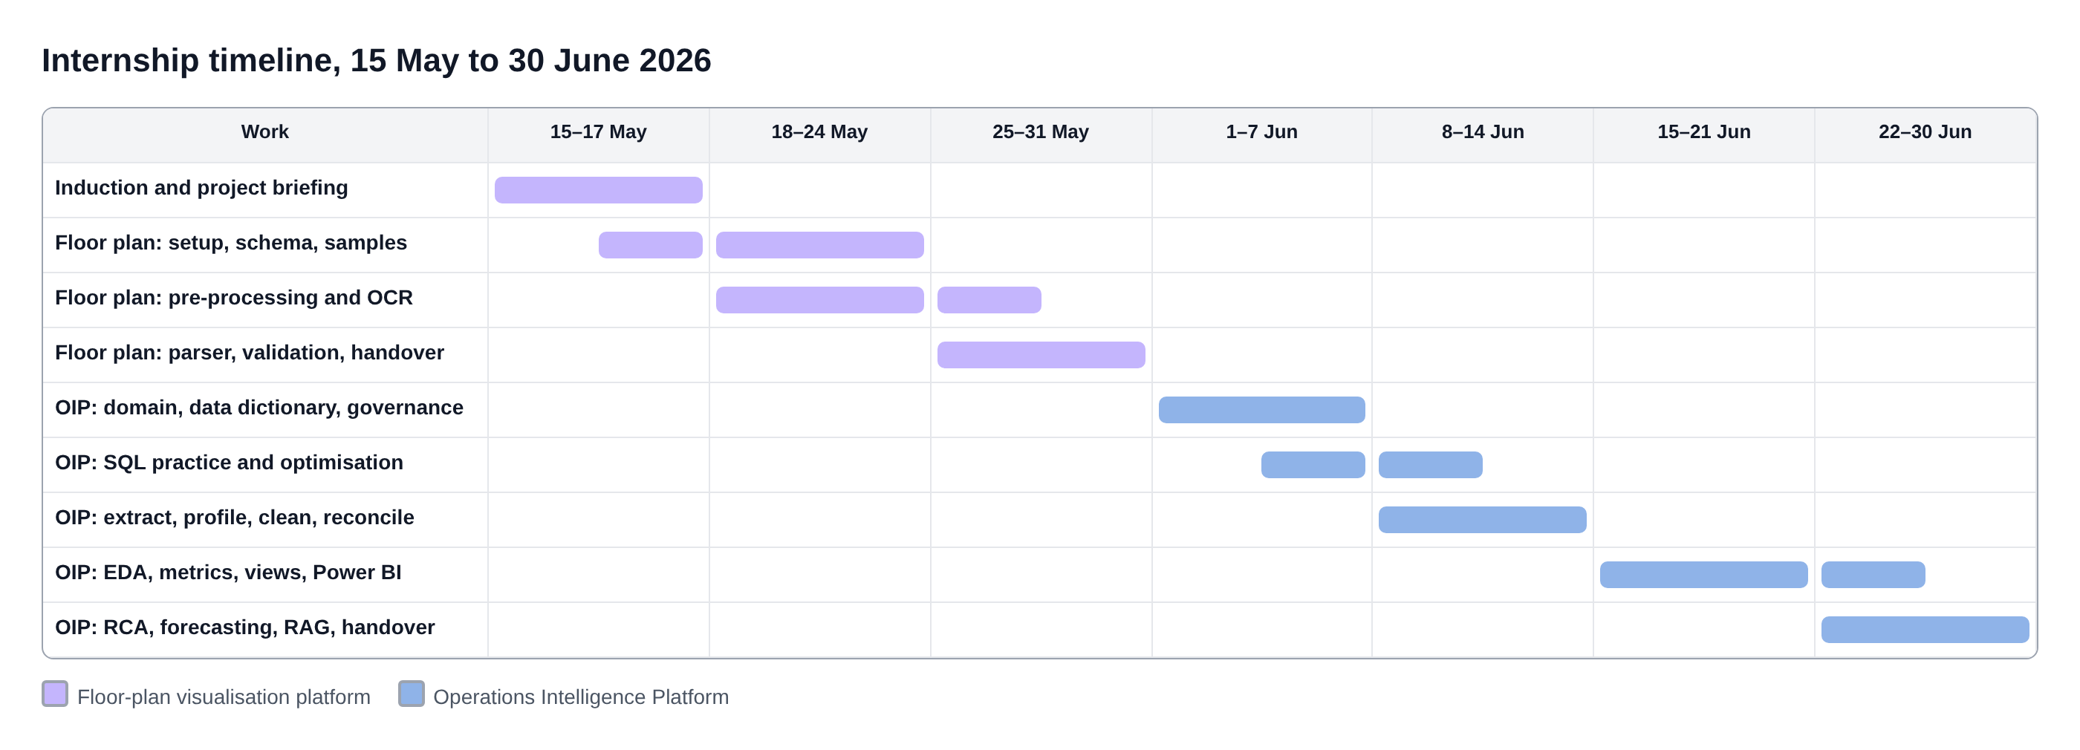
Fig 1. Internship timeline from the daily activity log, 15 May to 30 June 2026

1.3 Objectives
- Understand how a production data and AI system is organised, from source systems to reporting, and where each team member's work fits.
- Learn the domain of contact-centre operations well enough to define metrics correctly, including their exclusions.
- Build practical skill in SQL, Python data processing, Power BI, classical machine learning and retrieval-augmented generation on real business problems.
- Follow professional practice: approvals before data access, reviews before changes, documented decisions and a clean handover.
- Deliver working, reviewed components to the team: the floor-plan pre-processing, parser and validation scripts, reviewed SQL, the cleaning pipeline, notebooks and an assigned dashboard page.

1.4 Confidentiality and the reconstruction
The OIP at BPO Integra runs on confidential client data, and my access ended with the internship. To present the work in this review without disclosing company code or data, I rebuilt the platform after the internship as a reconstruction on synthetic data. It re-implements the methods I worked on, under the same structure, on generated data for four fictional clients (Northwind Telecom, Halcyon Insurance, Kestrel Retail and Meridian Bank). It contains no company code and no client data. All figures, tables and numbers in Chapter 4 come from this reconstruction unless stated otherwise. Where the reconstruction goes beyond the tasks recorded in my log, the text says so.
The floor-plan platform belongs to the team and its source and sample plans are confidential. Chapter 3 describes my part of it from the log and my notes; screenshots of the module are taken from the demonstration provided by the company.

1.5 Organisation of the report
Chapter 2 lists the technologies I learnt and where I used them. Chapter 3 covers the floor-plan input module. Chapter 4 covers the Operations Intelligence Platform: architecture, domain and metrics, data model and governance, SQL, data cleaning and reconciliation, exploratory analysis, reporting, root-cause analysis, forecasting and the recommendation module. Chapter 5 discusses results, challenges, learnings and professional practice. Chapter 6 concludes. Appendix I contains sample source code, additional screenshots and the instructions for running the reconstruction.

2 TECHNOLOGIES LEARNT
The internship touched most layers of a data and AI system. Table 1 summarises what I learnt and where I applied it; the sections that follow explain the main areas.
Table 1. Technologies learnt during the internship
Area | Technology | Where I used it | What I learnt
Image processing | OpenCV, NumPy, Pillow, pdf2image | Floor-plan pre-processing | Thresholding, deskew, morphology, Hough lines, masking
OCR and parsing | Tesseract (pytesseract), regular expressions | Dimension-text extraction | Region-of-interest OCR, orientation handling, unit normalisation
Validation | JSON schema, Python | Floor-plan validation script | Plausibility and scale checks, readable error reports
LLM (observed) | Google Gemini | Room-label interpretation | Prompt test sets, using a model for text only, never geometry
3D (observed) | React Three Fiber, Three.js | Downstream walkthrough | How the JSON drives the 3D scene and the geometry lock
Databases | SQL (SELECT to window functions), indexes, execution plans | OIP queries and views | Aggregation, joins and cardinality, CTEs, ROW_NUMBER, RANK, AVG OVER, sargable filters
Data processing | Python, pandas, SQLAlchemy | Extract, profile, clean | Profiling, imputation, mapping dictionaries, IQR outliers, reconciliation
Reporting | Power BI, Power Query, DAX | Queue performance page | Star schema, date table, CALCULATE and time intelligence, slicers, RLS
Statistics | SciPy | Root-cause analysis | Pareto, hypothesis tests, change points
Machine learning | scikit-learn | Volume forecast | Feature engineering, chronological split, baselines, MAE/RMSE/MAPE
Generative AI | Embeddings, vector store, BM25, LLM APIs | Recommendation module | Chunking, embeddings, retrieval, prompt grounding, evaluation
Engineering | Git, FastAPI, pytest | Repository, reconstruction | Branches, README-driven handover, APIs, tests

2.1 Computer vision and OCR
OpenCV provided the image operations for the floor plans: colour conversion, Gaussian and median filtering, adaptive thresholding that copes with uneven scan brightness, binarisation, rotation by an estimated skew angle, erosion and dilation to separate thick wall strokes from thin dimension lines, and the probabilistic Hough transform for straight segments [1], [6]. Tesseract [18] read the dimension annotations once the text regions were isolated. The main lesson was that OCR accuracy depends far more on what is fed to the engine (crop, scale, orientation, contrast) than on the engine's settings.

2.2 SQL and data modelling
On the OIP I moved from basic aggregation to the patterns used in the platform's reporting queries: joins across the fact and dimension tables of a star schema [10], common table expressions, window functions for de-duplication, ranking and moving averages, and query optimisation using execution plans and indexed predicates. I learnt to check row counts before and after every join and to state the grain of every table.

2.3 Python data processing
pandas with SQLAlchemy was used to extract approved data into DataFrames, profile it, and build a cleaning pipeline of reusable functions. I learnt rule-based and median imputation, mapping dictionaries for inconsistent labels, composite business keys for de-duplication, the IQR method for outliers [19] and, most importantly, reconciliation of cleaned totals against the source system.

2.4 Power BI
I learnt to model a star schema in Power BI, mark a date table, apply Power Query steps, write DAX measures with CALCULATE and time intelligence [14], build a page with KPI cards, a trend and a matrix, synchronise slicers, and validate every measure against SQL.

2.5 Statistics and machine learning
The root-cause work used Pareto analysis and hypothesis testing (the Mann-Whitney U test [13]). The forecasting work used lag, rolling and calendar features, a chronological train-test split, a moving-average baseline, linear regression and random forest models [2], [15], and the error metrics MAE, RMSE and MAPE [9]. Workforce planning in contact centres rests on the Erlang C queueing model [7], [8], which converts forecast volume and handle time into the number of agents needed to meet a service level.

2.6 Large language models and RAG
The recommendation module uses Retrieval-Augmented Generation [11]: documents are chunked, embedded and stored with source metadata, and the most relevant chunks are placed in the prompt so that the model answers from the organisation's own SOPs and RCAs and cites them. I learnt why chunk size matters, how keyword (BM25 [16]) and semantic retrieval complement each other, and how to test retrieval before trusting answers.

3 PROJECT I: FLOOR-PLAN INPUT PROCESSING FOR 2D-TO-3D INTERIOR VISUALISATION

3.1 Problem and pipeline
Architects and homeowners usually have a floor plan as a PDF or an image. The team's platform turns that 2D plan into a 3D interior that can be furnished, styled, rendered photorealistically and edited region by region. The pipeline has ten stages (Fig. 2): input, pre-processing and dimension reading, label interpretation with Gemini, a structured floor-plan JSON, 3D reconstruction in React Three Fiber and Three.js, AI-assisted furniture and layout, style generation, rendering, and selective editing and export.
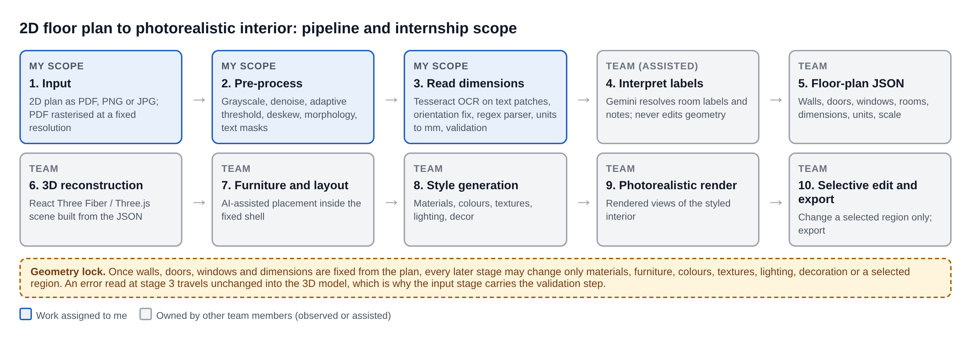
Fig 2. Floor-plan to 3D pipeline, showing the stages assigned to me

3.2 The geometry-preservation constraint
The project's central rule is geometry preservation. Once walls, doors, windows and dimensions are fixed from the plan, later stages may change only materials, furniture, colours, textures, lighting, decoration or a selected region. This makes the input stage critical: a dimension read wrongly at the start is carried into the 3D reconstruction and cannot be corrected later without re-reading the plan. On 19 May I traced how a wrong dimension would propagate through the JSON into the scene, and agreed with my guide which schema fields my module was responsible for and what accuracy was expected.

3.3 Scope and setup
My assignment was fixed on 16 May as assisting with image pre-processing and dimension-text extraction, feeding the team's existing floor-plan JSON. On 18 May I set up Python, VS Code and Git, installed OpenCV, NumPy, Pillow, pdf2image and Tesseract with its Python wrapper, studied the repository structure and branch naming convention, ran the team's existing parsing script on a sample plan to see its output before changing anything, and created a personal working branch so that experiments stayed separate from the main codebase.

3.4 Sample catalogue
On 20 May I collected the sample plans in PDF, PNG and JPG shared by my guide, rasterised the PDF plans at one fixed resolution so that all samples were processed consistently, and catalogued each plan by image quality, resolution, line weight and the dimension notation used. Grouping the samples into clean, moderate and poor quality made the later accuracy results interpretable: a method that only works on clean vector exports is not useful for scanned plans.
Table 2. Sample catalogue categories used for testing
Category | Typical source | Characteristics | Main risk for extraction
Clean | Vector PDF export from CAD | Sharp lines, uniform weight, horizontal text | Text touching dimension lines
Moderate | High-resolution image or good scan | Slight noise, mixed line weights, some rotated text | Rotated and small text
Poor | Phone photo or low-resolution scan | Skew, uneven lighting, blur, compression artefacts | Binarisation failure, broken characters

3.5 Image pre-processing
On 21 and 22 May I implemented the pre-processing sequence: grayscale conversion, noise reduction, adaptive thresholding and binarisation, followed by a deskew step that estimates the dominant angle of the drawing and rotates scanned plans back to horizontal. Instead of one fixed set of parameters, I compared threshold block sizes and kernel sizes across the three quality groups and recorded which settings worked best for which category, then reviewed the comparison with my guide.
Morphological erosion and dilation separate the thick wall strokes from the thinner dimension lines and annotation text. Removing the structural line work leaves masked images in which the text regions are isolated, which is what the OCR step needs. I also experimented with the Hough line transform for straight wall segments and recorded where it produced broken or duplicated lines; because wall detection is owned by a senior team member, I reported these observations rather than changing that component.
Insert screenshot from the floor-plan module demonstration: a sample plan before and after pre-processing (grayscale, adaptive threshold, deskew).
Fig 3. Floor-plan pre-processing stages on a sample plan (from the company demonstration)
Insert screenshot from the floor-plan module demonstration: the masked image with dimension-text regions isolated from walls.
Fig 4. Text regions isolated from the structural line work (from the company demonstration)

3.6 Reading dimensions with OCR
On 23 May I ran Tesseract on the isolated text regions and measured raw recognition accuracy against a manual reading of the same annotations on ten sample plans. The failures fell into three groups: vertically rotated dimension text, very small font sizes, and text touching the dimension lines. I tabulated the failures by type so that the next day's work went to the largest group first, and reviewed the baseline with my guide before trying any improvement.
On 25 May I made three changes. OCR now runs on small region-of-interest patches instead of the whole sheet; small text patches are upscaled and sharpened before recognition, which improved the reading of small fonts; and the orientation of each text block is detected so that vertical dimension text is rotated before it is passed to the engine. I re-measured accuracy on the same ten plans against the recorded baseline and documented each change with its measured effect.
Table 3. OCR failure groups and the change made for each
Failure group | Cause | Change made | Log
Rotated text | Vertical dimension strings read as noise | Detect block orientation, rotate before OCR | 25 May
Small font | Too few pixels per character | Crop region of interest, upscale and sharpen | 25 May
Touching lines | Dimension line merges with digits | Morphological separation and masking of line work | 22 May
Whole-page noise | Engine reads hatching and symbols | OCR on text patches only | 25 May

3.7 Dimension parser and unit normalisation
OCR returns strings, not numbers. On 26 May I wrote a parser using regular expressions that interprets the written forms found across the samples, including millimetres, centimetres, metres, and feet and inches, and normalises every value to millimetres so that downstream stages receive one unit. Readings that could be interpreted in more than one way are flagged rather than silently converted. Table 4 shows the kind of normalisation the parser performs (illustrative inputs).
Table 4. Examples of dimension notations and their normalised values
Notation on plan | Interpreted as | Normalised (mm) | Note
3600 | millimetres (plan default) | 3600 | Bare number uses the plan's stated unit
360 cm | centimetres | 3600
3.6 m | metres | 3600
11'-10" | feet and inches | 3607 | 11 ft 10 in = 142 in x 25.4
11' 10 1/2" | feet, inches and fraction | 3620 | Fractions supported
12' | feet | 3658
3,600 / 3.600 | ambiguous separator | flagged | Thousands separator or decimal; needs review

3.8 Schema validation
On 27 May I wrote a validation script that checks the extracted values against the team's floor-plan JSON schema before they enter the pipeline. It reports missing units, values outside a plausible range for a room dimension, and inconsistencies with the drawing's stated scale, listing each flagged item with the plan name and the region it came from. After running it across the full sample set and reviewing the flags with my guide, I corrected two checks that were raising false alarms on plans that used an abbreviated notation.
Table 5. Validation checks applied before values enter the floor-plan JSON
Check | Rule | Output when it fails
Unit present | Every value has an explicit or plan-default unit | Plan, region, raw text, 'unit missing'
Plausible range | Room dimensions within a realistic minimum and maximum | Value and the range it violated
Scale consistency | Measured pixel length x scale agrees with the written value within tolerance | Expected vs written length
Ambiguity | No reading with two interpretations | Both interpretations for manual choice
Schema fields | Required JSON fields present with the right types | Field name and expected type

3.9 Label interpretation with Gemini
On 28 May my guide explained how the Gemini model interprets room labels and annotations that OCR alone cannot classify. I prepared structured input samples and expected outputs used while the team refined the prompt, ran the samples, and recorded which outputs were correct and which needed human correction. The model is used only for interpreting labels and text and never for producing or adjusting geometry, in line with the geometry-preservation rule.

3.10 Results and handover
On 29 May I manually annotated ground-truth dimensions for the sample plans so that the module's output could be scored objectively, measured the final extraction accuracy against this ground truth and compared it with the baseline, and compiled the remaining error cases into a sheet with each failure and its likely cause. I also attended a walkthrough of the downstream stages: the React Three Fiber scene, the geometry lock, furniture placement and the render step, and saw how the parsed JSON is consumed by the 3D reconstruction.
On 30 May I committed the pre-processing utilities, the dimension parser, the validation script and the accuracy sheet to the repository with a README explaining how to run each script, its parameters and the limitations found in testing, and walked my guide and the component owner through the work so that it could be continued. The module was still in progress when I was reassigned.
Table 6. Floor-plan module: baseline and final extraction accuracy (fill from the accuracy sheet)
Measure | Baseline (23 May) | Final (29 May) | Evaluation set
Dimension strings read correctly | [ ] | [ ] | Ten sample plans, manual ground truth
Values normalised to mm correctly | n/a | [ ] | All parsed strings
Items flagged by validation | n/a | [ ] | Full sample set

Insert screenshot from the floor-plan module demonstration: the 3D reconstruction and a styled render produced from a parsed plan.
Fig 5. 3D reconstruction and styled render from the demonstration (downstream stages owned by the team)

4 PROJECT II: OPERATIONS INTELLIGENCE PLATFORM
All figures, tables and numbers in this chapter are from the reconstruction on synthetic data described in Section 1.4.

4.1 Background and problem statement
A delivery centre serving several clients is judged against contractual targets per queue, for example 80% of calls answered within 20 seconds for a billing line, or 90% of emails answered within four hours. Supervisors watch live queues on the floor, workforce-management (WFM) planners build forecasts and rosters, quality teams audit interactions, and client-services teams report results to clients. Each relies on data from different systems: the dialler or ACD for calls, chat and email platforms, a back-office workflow tool, the CRM, the WFM system and HR rosters.
Three problems follow. First, the data is messy: queue names are spelt differently across exports, the same rows are exported twice, timestamps arrive in two formats, dispositions are blank, agent sessions are left open, and the CRM holds personal data. Second, the same metric is computed differently in different reports, so numbers disagree and meetings argue about the figure instead of the problem. Third, daily averages hide interval-level problems: a queue can meet its target for the day while failing every weekday morning. The OIP addresses these with one governed data model, one definition per metric, interval-level analytics and an assistant that turns findings into actions from the organisation's own procedures.

4.2 Platform architecture
On 1 June I attended an overview of the platform's layers: source systems, ingestion and staging, the data warehouse, the analytics layer and the reporting layer (Fig. 6). Data reaches staging from the dialler, CRM and WFM systems; the warehouse holds a star schema; analytics produce RCA, forecasts and recommendations; and reports are delivered in Power BI with role-based access.
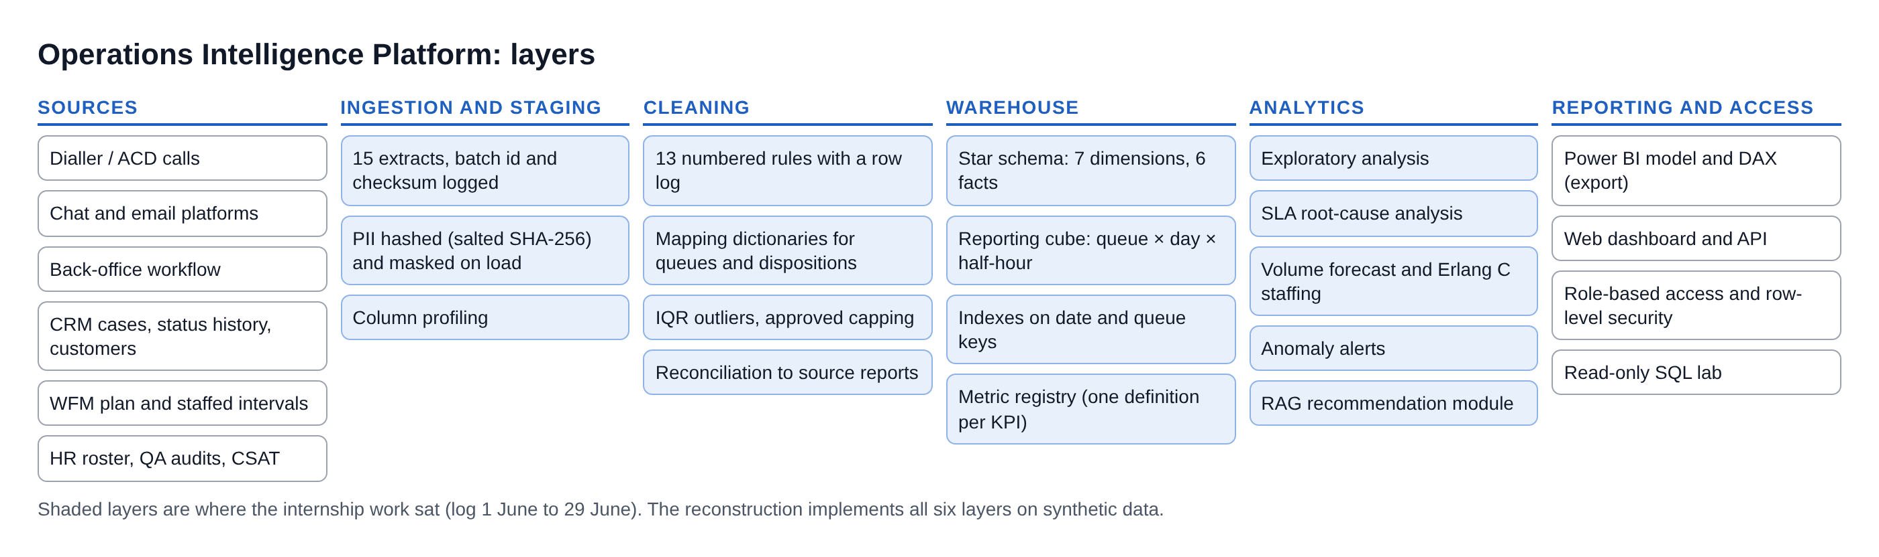
Fig 6. Layers of the Operations Intelligence Platform
The reconstruction implements every layer. Source extracts are generated with realistic defects and four planted business events (a roster change on the billing queue from 6 April, a card-system slowdown from 20 to 24 April, a retail sale from 15 to 18 May and a chat CSAT drop after an app release). A FastAPI service applies role-based access and row-level security and serves a web application with thirteen pages, a read-only SQL lab and the copilot; a Power BI export produces the same model and measures for Power BI Desktop (Fig. 7).
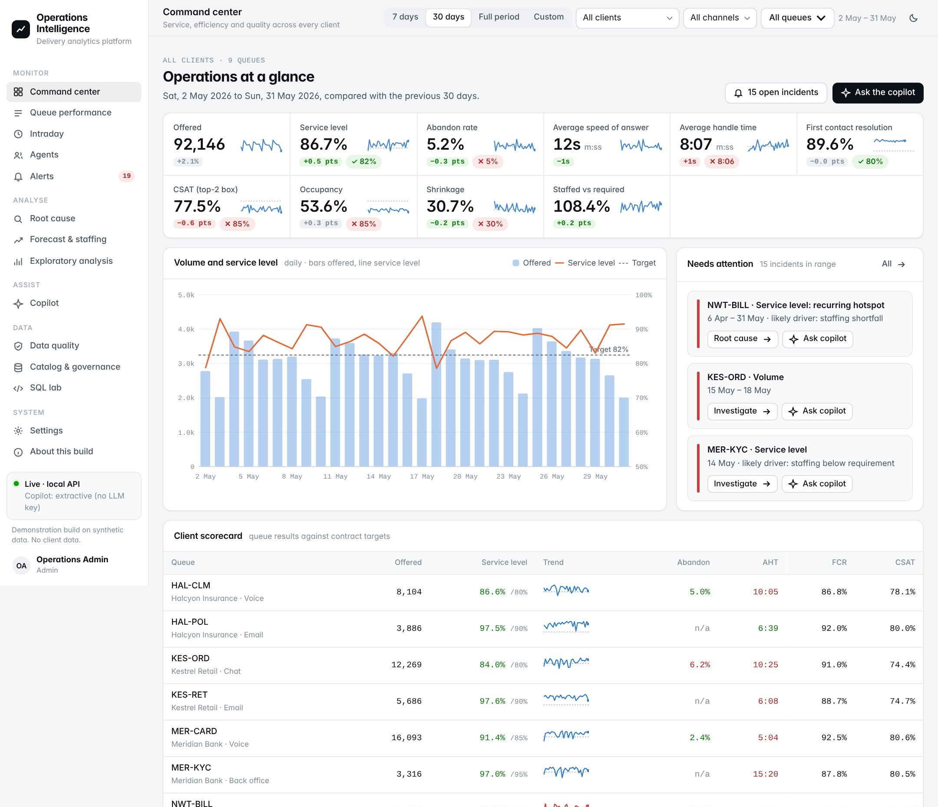
Fig 7. Command center of the reconstructed platform (30-day view, all clients)

4.3 Domain and metric definitions
On 2 June a domain session covered the lifecycle of an interaction from routing and handling to disposition capture and quality audit, and the floor metrics: AHT, ACW, FCR, CSAT, SLA attainment, abandonment, occupancy and shrinkage. I prepared notes mapping each metric to the business question it answers. On 16 June I helped the reporting team document the definitions of AHT, SLA attainment and abandonment rate, wrote the SQL for each with the numerator, denominator and exclusions stated explicitly, and cross-checked the results against the operations team's month-end figures.
That cross-check found a mismatch in SLA attainment, which the team traced to the treatment of short abandoned calls (callers who hang up within five seconds, before an agent could reasonably answer). The month-end method excluded them from the denominator; the draft query did not. Once the rule was confirmed, the metric SQL was updated. In the reconstruction this rule is part of a single metric registry in code (Table 7): each ratio is stored as additive numerator and denominator columns and divided last, so it re-aggregates correctly over any date range or queue set, and the same registry generates the SQL, the dashboard calculations and the Power BI measures.
Table 7. Core operational metrics as defined in the metric registry
Metric | Numerator | Denominator | Exclusions and notes
Service level | Contacts answered within the queue threshold | Offered minus short abandons (<= 5 s) | Email and back office: responded within threshold over received
Abandon rate | Abandoned minus short abandons | Real-time offered minus short abandons | Voice and chat only
Average speed of answer | Total wait of answered contacts | Answered real-time contacts
Average handle time | Talk + hold + after-call work | Handled contacts | Unclosed sessions capped by rule R08
First contact resolution | Handled with no repeat from the same customer in 7 days | Handled contacts | Last 7 days excluded until mature
CSAT (top-2 box) | Survey scores of 4 or 5 | Valid survey responses | Scores outside 1-5 removed
Occupancy | Handle time | Staffed time x concurrency | Chat counts concurrent sessions
Shrinkage | Scheduled minus staffed time | Scheduled time | Planning assumption 30%
Staffed vs required | Staffed agent-intervals | Erlang C required agent-intervals

4.4 Data model and governance
On 3 June I studied the data dictionary and the entity relationship diagram, distinguished fact tables from dimension tables, traced the keys linking the interaction fact to the agent, queue, client and date dimensions, and checked row counts, date coverage and grain with exploratory queries. On 4 June a governance session covered PII handling, masking, retention and role-based access, and the approval needed before any dataset leaves production; I was given read-only access to the development database after the approval was recorded.
The reconstructed warehouse (Fig. 8, Table 8) follows the same design. Its grain is one row per offered contact in fact_interaction, with dimensions for date, half-hour interval, client, queue, agent, team leader and a masked customer. A reporting cube at queue x day x half-hour holds every metric's numerator and denominator, because thirty minutes is the workforce-planning grain and daily figures hide the problems the RCA must find.
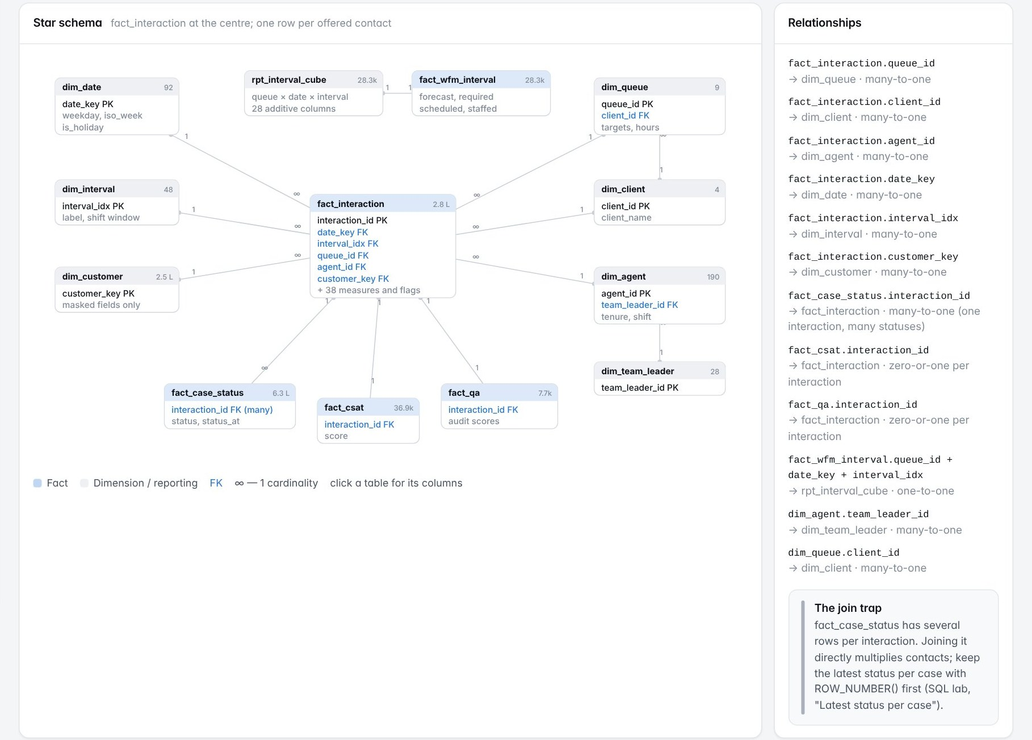
Fig 8. Star schema of the reconstructed warehouse, with relationship cardinalities
Table 8. Main warehouse tables (reconstruction)
Table | Type | Grain | Rows
fact_interaction | Fact | One offered contact (call, chat, email, case) | 278,957
fact_case_status | Fact | One CRM status change (many per interaction) | 625,213
fact_csat / fact_qa | Fact | One survey response / one quality audit | 36,892 / 7,666
fact_wfm_interval | Fact | Queue x date x 30-minute interval plan | 28,336
dim_date, dim_interval | Dimension | Day (92) and half-hour (48) | 92 / 48
dim_queue, dim_client | Dimension | Queue with contractual targets; client | 9 / 4
dim_agent, dim_team_leader | Dimension | Agent with tenure and shift; team leader | 190 / 28
rpt_interval_cube | Reporting | Queue x date x interval, all metric parts | 28,336

Governance is enforced in the pipeline and the API rather than left to convention. Customer phone numbers, emails and names are hashed with a salted SHA-256 on the way into staging and kept only in masked display form, so the clear values never reach the warehouse while customers remain joinable across channels for FCR. The API uses a read-only connection and applies row-level security per role: a billing team leader sees only the billing queue, and a client viewer sees only that client's queues with agent names replaced by IDs (Fig. 9). Requests outside a role's scope return HTTP 403.
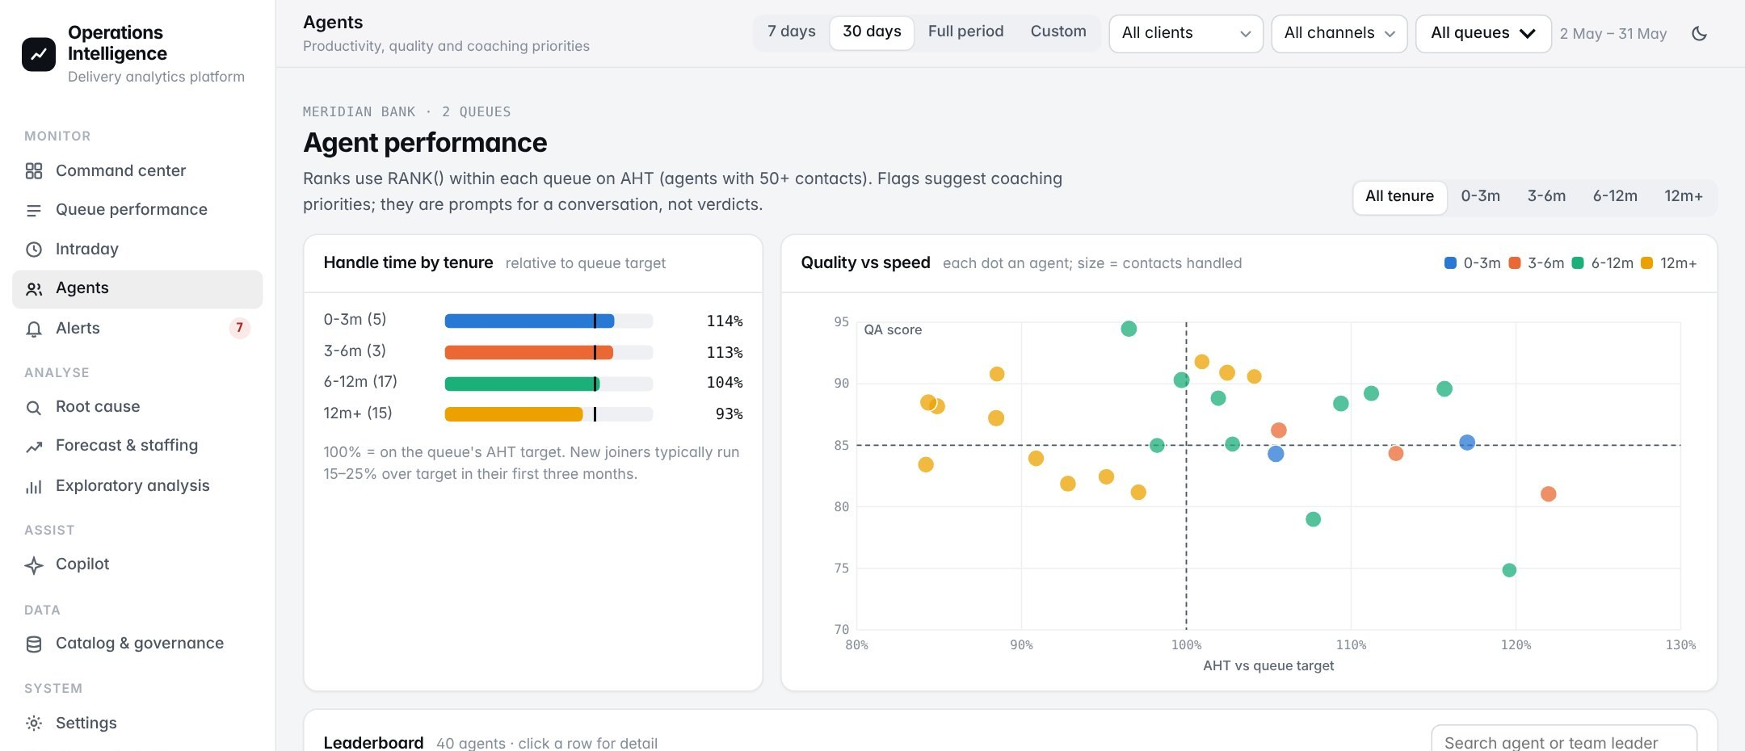
Fig 9. Row-level security: the same Agents page viewed as a client viewer (two queues, agent names masked)

4.5 SQL development
From 5 to 9 June I practised and then applied SQL on the interaction fact table under my mentor's direction. Each step is reproduced as a saved query in the reconstruction's SQL lab (Table 9).
- Aggregation (5 June). Daily volume, AHT and talk time by queue with GROUP BY and HAVING. The practical lesson was the difference between filtering rows before aggregation (WHERE) and filtering groups after it (HAVING). I validated the output against an existing operational report before saving the queries with comments.
- Joins and the one-to-many trap (6 June). A query joining four tables for agent-day performance returned too many rows. With my mentor I traced the duplication to the disposition history table, where one interaction has several status rows. Since then I check row counts before and after each join and document the cardinality of every relationship.
- CTEs and window functions (8 June). ROW_NUMBER() keeps only the latest status per case, which fixes the duplication; RANK() lists the best and worst AHT agents within each queue; AVG() OVER produces a seven-day moving average. I rewrote a nested subquery as layered CTEs and compared readability with my mentor.
- Optimisation (9 June). A slow reporting query performed a full scan because its filter wrapped the date column in a function. Rewriting it with a filtered CTE and a range predicate on the indexed date key replaced the scan with an index search (Fig. 10). I also traced the logic of the stored procedures that refresh the daily reporting tables without modifying them.

Table 9. Saved SQL queries in the reconstruction mapped to the log
Query | Technique | Log
Daily volume, AHT and talk time by queue | GROUP BY, HAVING | 5 Jun
Agent daily performance | Four-table join at agent x day grain | 6 Jun
The one-to-many join trap | Row counts before and after a join | 6 Jun
Latest status per case | ROW_NUMBER() in a CTE | 8 Jun
Best and worst AHT agents per queue | RANK() OVER (PARTITION BY queue) | 8 Jun
Seven-day moving average | AVG() OVER (ROWS 6 PRECEDING) | 8 Jun
Slow vs fast version of one query | Execution plan, sargable predicate, index | 9 Jun
Service level and abandon rate with exclusions | Explicit numerator, denominator, exclusion | 16 Jun
First contact resolution | LEAD() over customer contacts | 16 Jun
Pareto of SLA breaches; staffed vs required | Window share, interval grain | 23-24 Jun

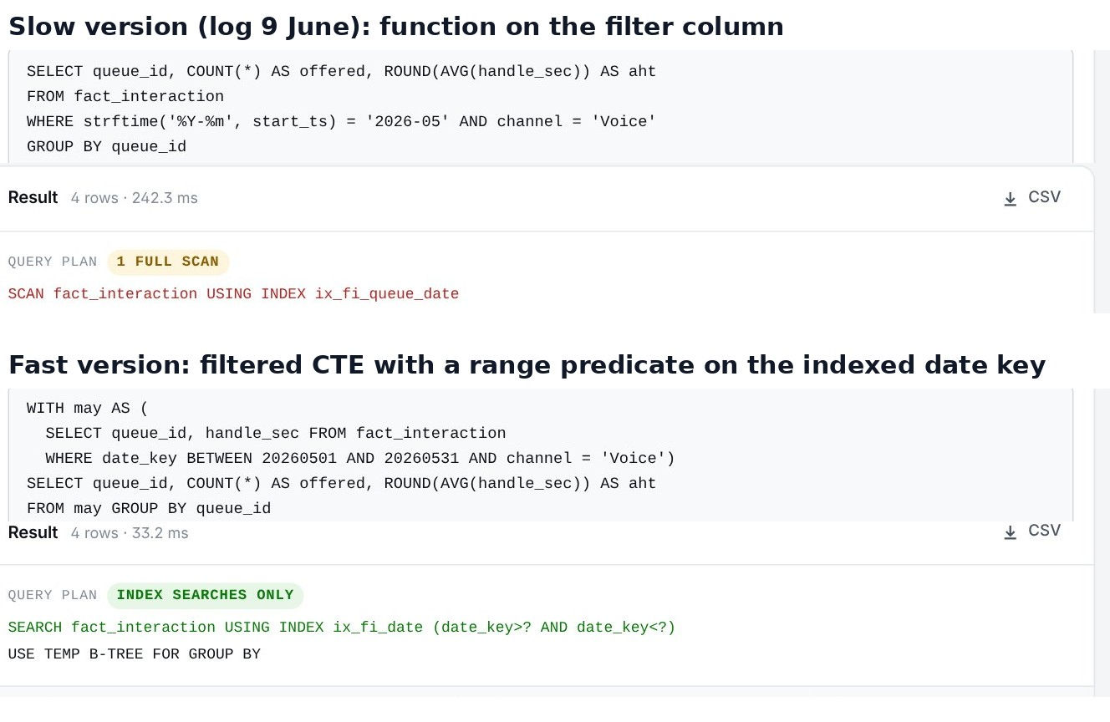
Fig 10. The same query before and after optimisation: a full scan replaced by an index search on the date key (242 ms to 33 ms)

4.6 Data extraction, profiling and cleaning
On 10 June an approved, masked three-month extract was loaded into a staging table, connected from Python with SQLAlchemy and profiled for row counts, types, null percentages, distinct values and date coverage. The findings went into a data-quality worksheet reviewed with my mentor. Table 10 shows the equivalent findings in the reconstruction's raw extracts.
Table 10. Profiling findings on the raw extracts (reconstruction)
Severity | Table and column | Finding
High | dialler_calls (all columns) | 2,135 exact duplicate rows (ingestion re-run)
High | dialler_calls.queue_label | 17 label variants for the same queues
High | dialler_calls.talk_sec | Extreme values up to 30,493 s; investigate before treating
High | chat_sessions (all columns) | 507 exact duplicate rows
High | crm_cases.disposition_label | 18 spellings of 4 outcomes; 3.98% blank
Medium | dialler_calls.call_start | 14,530 timestamps in dd/mm/yyyy format without seconds
Medium | dialler_calls.wait_sec | 173 negative values (clock skew)
Medium | dialler_calls.hold_sec | 2.84% missing
Low | csat_responses.score | Scores outside the 1-5 scale

On 11 June I handled missing values with rule-based imputation for categorical fields and median imputation for skewed numeric fields, standardised queue names and disposition codes with a mapping dictionary agreed with the reporting team, converted date and time columns and derived date, hour, weekday and shift, removed exact duplicates identified by a composite business key, and arranged the steps as reusable functions in one script. In the reconstruction each step is a numbered rule that logs rows before, after and affected, together with the decision and its history (Table 11, Fig. 11).
Table 11. Cleaning rules and their effect (reconstruction)
Rule | Step | Rows affected | Decision
R01 | Parse timestamps | 14,530 | Day-first timestamps converted; none quarantined
R02 | Remove duplicates | 2,642 | Composite key: source system + source reference + start time
R03 | Standardise queue names | 55,692 | 32 variants mapped to 9 queues
R04 | Correct negative waits | 172 | Set to zero and flagged
R05 | Impute missing hold time | 5,055 | Median by queue; flagged hold_imputed
R06 | Keep answered contacts with no agent | 662 | Retained and flagged agent_missing (fix of v1 rule)
R07 | Derive time attributes | 278,957 | Date, hour, interval, weekday, shift window
R08 | Treat unclosed-session outliers | 538 | Capped at queue P99; 1,715 long calls kept
R09 | Flag short abandons and service level | 685 | Aligned with operations month-end method
R10 | Standardise and impute dispositions | 10,602 | Blank labels from latest CRM status
R11 | Resolve customer identity | 12,559 | Hashed keys linked through the CRM
R12 | Drop invalid survey scores | 122 | Scores outside 1-5

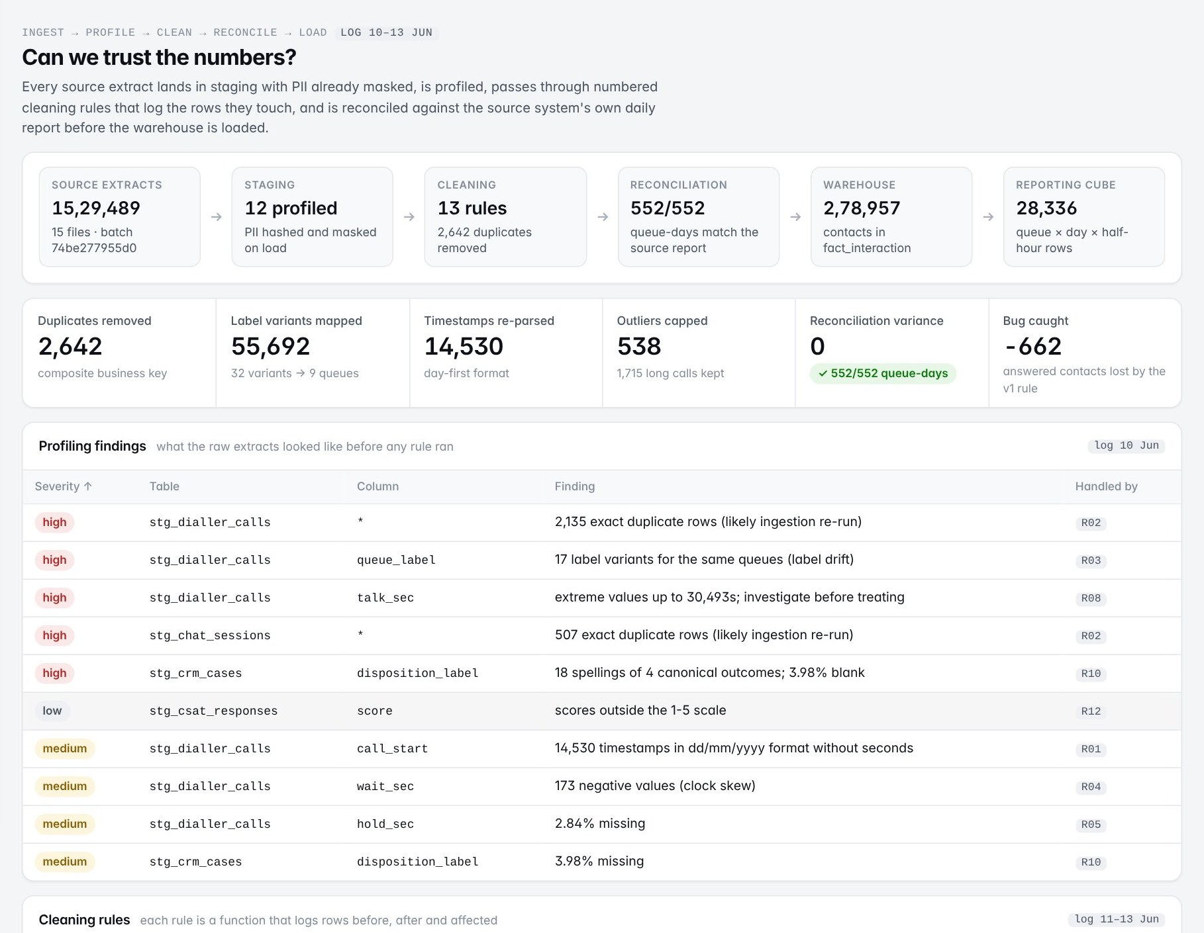
Fig 11. Data pipeline and quality page: pipeline summary, profiling findings and rule log (reconstruction)

4.6.1 Outliers in handle time
On 12 June I detected outliers in handle time and wait time with the interquartile-range method. Investigating the extreme handle times showed that many were caused by unclosed agent sessions, where the agent never logged out and the clock kept running, rather than by genuinely long calls. After discussing this with my mentor, business-rule capping was applied only after the rule was approved, and the distributions before and after treatment were compared. In the reconstruction 2,253 handle times were flagged; 538 matched unclosed sessions and were capped at the queue's 99th percentile, while 1,715 had normal session closes and were kept, because removing genuine long calls would understate AHT.

4.6.2 Reconciliation to source
On 13 June I reconciled the cleaned totals against the source system's reports for three sample dates and found a small variance. I traced it to one cleaning rule that excluded valid records: answered contacts with a blank agent login were being dropped. The rule was changed to keep and flag those rows, and the reconciliation was re-run until the figures agreed. The reconstruction replays both versions (Table 12): the first version loses 662 answered contacts over the period; the fixed version matches the source report on all 552 queue-days.
Table 12. Reconciliation of answered contacts against the source daily report (reconstruction)
Sample date | Source report | v1 pipeline | v1 variance | Fixed pipeline | Variance
Mon, 16 Mar 2026 | 3,258 | 3,250 | -8 | 3,258 | 0
Tue, 14 Apr 2026 | 2,053 | 2,047 | -6 | 2,053 | 0
Mon, 11 May 2026 | 2,995 | 2,986 | -9 | 2,995 | 0
All 552 queue-days | 228,713 | 228,051 | -662 | 228,713 | 0

4.7 Exploratory data analysis
On 15 June I examined the distributions of volume, handle time, wait time and CSAT with histograms and box plots, analysed handle time by queue, shift and agent tenure, studied hour-of-day and day-of-week volume patterns to locate the peak intervals, and built a correlation view of the core metrics. The reconstruction's EDA page (Fig. 12) reproduces this analysis. Its main observations on the synthetic data are:
- Peak load is on Mondays around 11:00; Mondays carry about 24% more real-time volume than Wednesdays.
- Agents in their first three months take about 35% longer per contact than agents with more than a year's tenure (median handle time).
- Service level moves with staffing coverage (r = +0.61) more than with volume (r = -0.33).
- Abandon rate mirrors service level (r = -0.93), while CSAT is only weakly tied to daily service level (r = +0.05).
- Handle time is right-skewed, so medians and percentiles are reported alongside means.

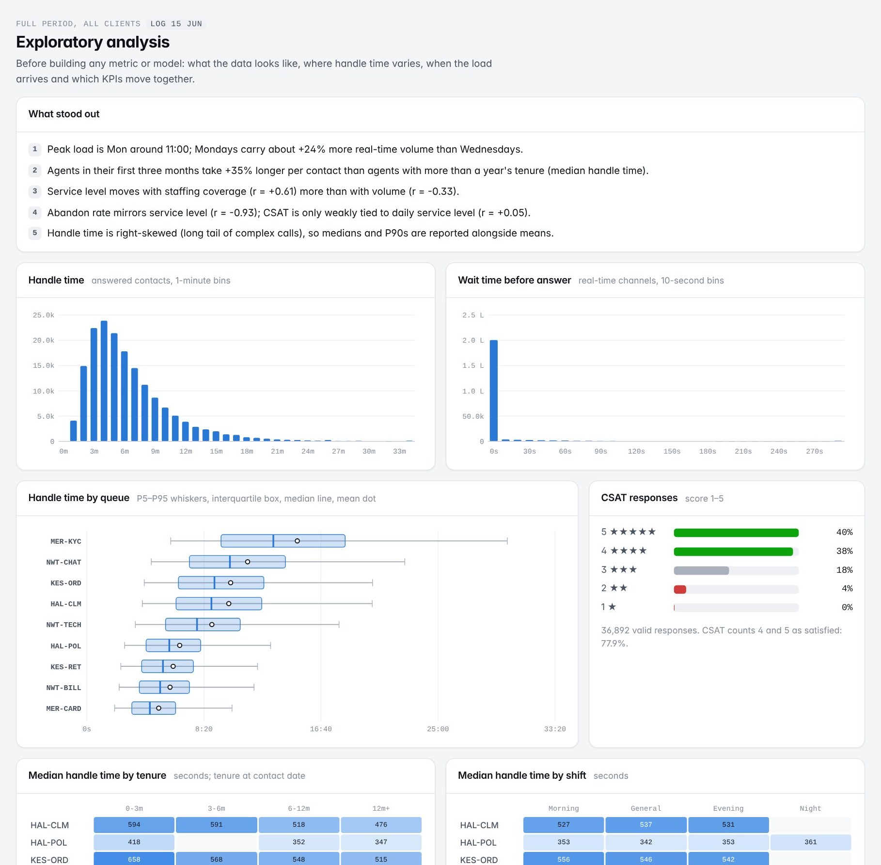
Fig 12. Exploratory analysis: distributions, handle time by queue, tenure and shift (reconstruction)

4.8 Reporting views and the Power BI dashboard
On 17 June I built the reporting views that the dashboard would read from, based on the agreed metric definitions, and attended a requirements discussion where team leaders described what they needed to see daily and weekly. I passed the requested metrics, filters and refresh frequency to the dashboard designer and confirmed that the views contained every field the visuals needed; the views were approved by my mentor before use.
From 18 to 22 June I imported the views into Power BI Desktop, assisted in building the star-schema model, created and marked the date table, and applied Power Query steps for types, renaming and removing unused fields. I wrote base DAX measures for total interactions, AHT and SLA attainment, and month-to-date and previous-month measures with CALCULATE and the date table, validating each against SQL. One measure returned a wrong figure because of the filter context applied by a slicer; I corrected it and the measures were reviewed by the report owner.
[Service level] =
DIVIDE(
SUM(rpt_interval_cube[sl_num]),
SUM(rpt_interval_cube[sl_den])
)

[Service level MTD] = CALCULATE([Service level], DATESMTD(dim_date[date]))
[Service level PM] = CALCULATE([Service level], DATEADD(dim_date[date], -1, MONTH))

Listing. DAX measures generated from the metric registry (ratio of sums, month to date, previous month)
I built the queue performance page assigned to me following the approved wireframe: KPI cards, a trend line and a queue-wise matrix with slicers for date, queue and shift kept in sync across pages, in the colours and layout of the existing report; one chart was simplified after feedback that it carried too much at once. On 22 June I tested slicers, drill-through and cross-filtering, reconciled the dashboard against the SQL baseline for three sample dates, logged defects and retested fixes. I observed publishing, scheduled refresh and the row-level security set-up, and recorded change requests in a walkthrough with two team leaders. Fig. 13 shows the equivalent page in the reconstruction; python -m oip export-powerbi writes the star-schema CSVs, the generated measures and model notes for Power BI Desktop.
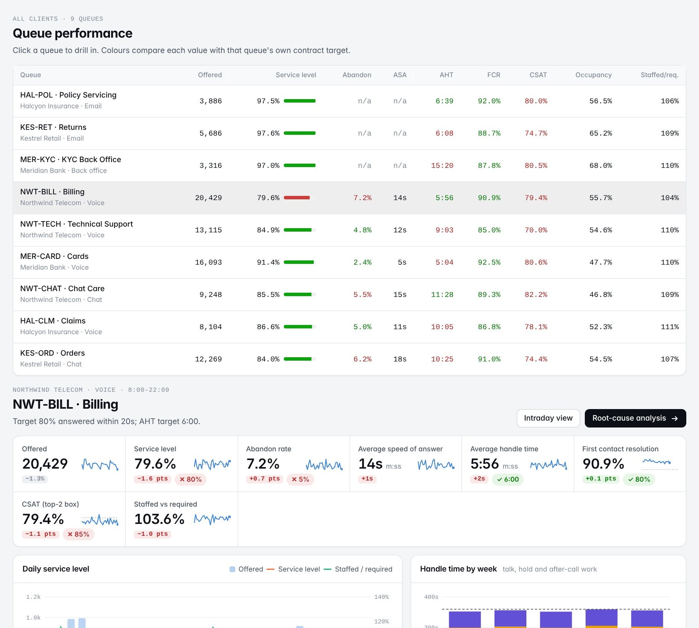
Fig 13. Queue performance page in the reconstruction: queue matrix against each queue's own targets and drill-down for Billing

4.9 Root-cause analysis of repeated SLA breaches
On 23 June I was asked to support an ongoing root-cause analysis of repeated SLA breaches in one queue. I extracted the breach records for the quarter, segmented them by interval, day of week and shift, and built a Pareto chart showing that a few half-hour intervals accounted for most breaches. I prepared the tables and charts for the senior analyst leading the analysis and recorded the candidate causes raised in the five-whys discussion with the operations team. On 24 June I tested those candidates against the data (staffing shortfall, volume spikes and handle-time inflation), showed that breaches concentrated in intervals where scheduled staffing lagged forecast volume, quantified the staffing gap, checked the numbers quoted in the RCA document against the source, and attended the review with the operations manager.
The reconstruction turns this into a repeatable workbench (Fig. 14, Fig. 15) and adds statistical rigour:
- Breach rule. An interval is a breach only when its service level is below target by more than 1.645 binomial standard errors at its volume (one-sided 95%). A half-hour with eight calls that misses by one call is noise, not a breach.
- Pareto and hotspots. Breaches are counted by half-hour; a half-hour is a recurring hotspot when its breach rate is significantly above the queue's (binomial test).
- Change point. A split search on the hotspot breach rate dates when the problem started.
- Hypothesis tests. Each candidate cause is compared between breach and normal intervals with the Mann-Whitney U test [13].
- Attribution. For each breach interval, service level is recomputed with an Erlang C model [7] with staffing, volume and handle time each reset to plan in all eight combinations, and the gap is split fairly with Shapley values [17].

On the billing queue, 576 of 2,574 intervals finished under the 80% target and 353 were material breaches. Four half-hours (10:00, 10:30, 11:00 and 11:30) carry 39% of all breaches at a breach rate of 37%, against 14% for the queue. The breach rate in those intervals changed on 6 April from 9% to 55%, the date of the planted roster change, and the staffed-to-required ratio fell from 1.10 to 0.84. Table 13 shows the hypothesis results.
Table 13. Candidate causes tested on the billing queue (breach vs normal intervals, reconstruction)
Hypothesis | Median in breaches | Median otherwise | Mann-Whitney p | Primary cause in hotspots | Verdict
Staffing shortfall (staffed / required) | 0.90 | 1.13 | < 0.0001 | 75% | Supported
Volume spike (z-score vs forecast) | 1.29 | -0.20 | < 0.0001 | 22% | Supported
Handle-time inflation (actual / plan) | 1.02 | 1.02 | 0.51 | 3% | Not supported

Across all breaches, random volume peaks are the larger contributor (51% of the lost service level against 35% for staffing), but those breaches are scattered and cannot be rostered for. The recurring hotspots are different: there, staffing is the primary cause of 75% of breaches. Staffing averaged 7.2 agents against 9.4 required, and closing the gap needs about four more rostered heads at the worst interval (Table 14). An Erlang C what-if estimates that staffing the hotspots to requirement lifts the queue from 82.4% to 85.0% service level and the hotspot intervals themselves from 34% to 63%.
Table 14. Staffing gap in the hotspot intervals on breach days since 6 April (reconstruction)
Interval | Breach days | Volume (forecast) | Required | Scheduled | Staffed | Heads to add
10:00 | 36 | 34.0 (32.0) | 9.4 | 10.0 | 6.9 | +4
10:30 | 30 | 33.3 (32.0) | 9.5 | 10.0 | 6.9 | +4
11:00 | 30 | 34.9 (32.1) | 9.3 | 10.6 | 7.4 | +3
11:30 | 28 | 38.2 (33.7) | 9.6 | 11.1 | 7.6 | +3

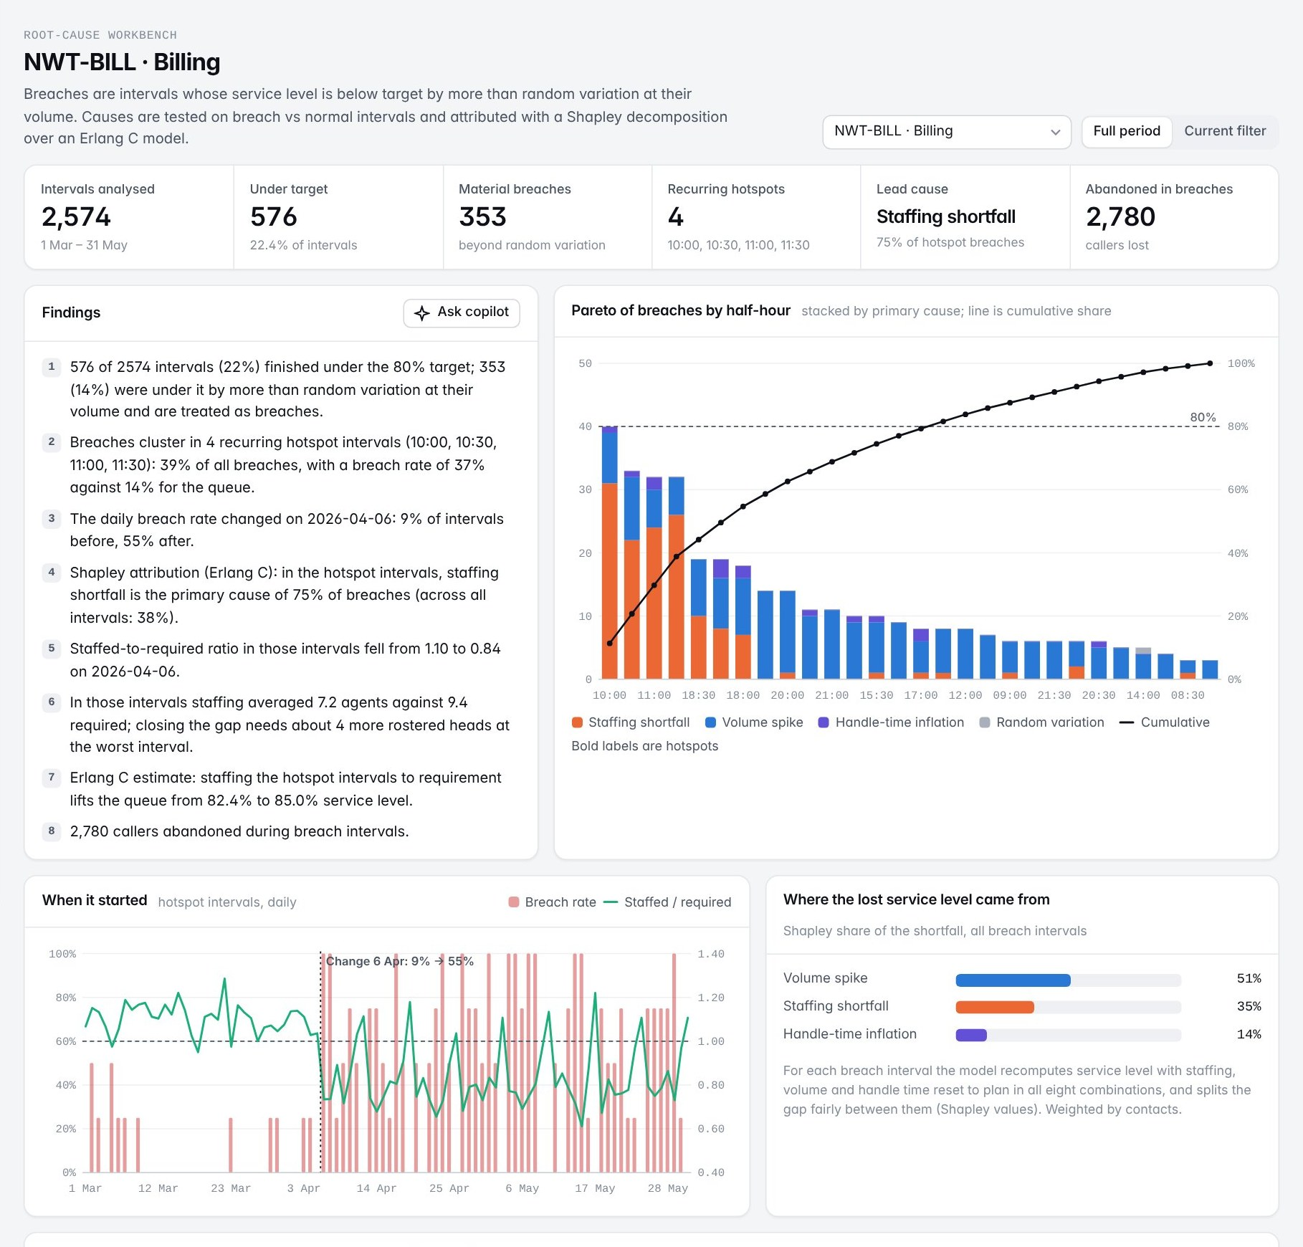
Fig 14. Root-cause workbench: findings, Pareto of breaches by half-hour stacked by primary cause, change point and Shapley shares (reconstruction)
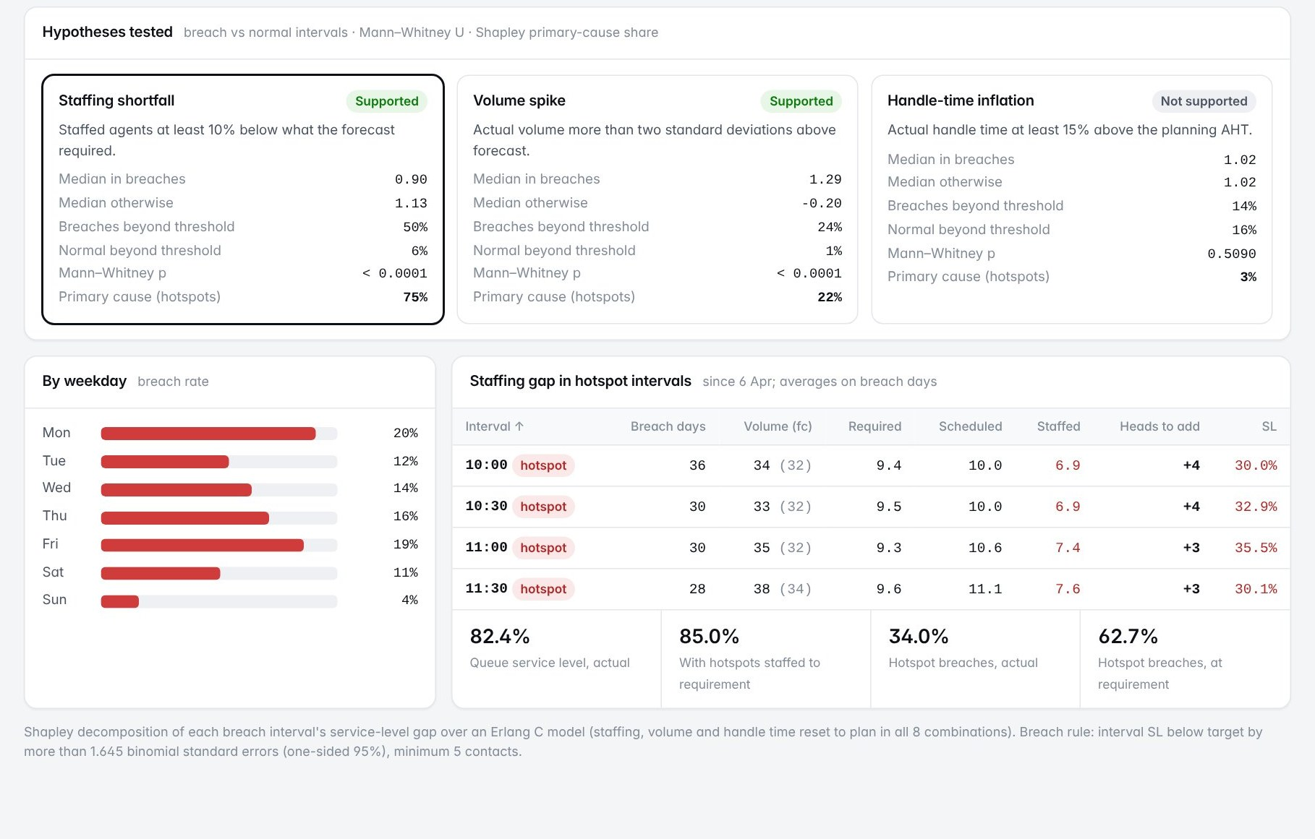
Fig 15. Hypotheses tested and staffing gap in the hotspot intervals, with the Erlang C what-if (reconstruction)

4.10 Volume forecasting
On 25 June I prepared the input dataset for the team's volume-forecasting component: lag values, rolling means, day of week, month and holiday indicators, plus the operational features specified by the team (staffing ratio and prior-day handle time). I applied a chronological train-test split after being shown why a random split leaks future information into training through the lag features, and documented each feature with the reason it was included (Table 15).
Table 15. Forecast features and why each is included
Feature | Definition | Reason
lag_1, lag_7, lag_14 | Volume 1, 7 and 14 days before | Recent level and weekly pattern
roll_mean_7, roll_mean_28 | Mean of the previous 7 and 28 days | Short and medium-term level
roll_std_7 | Standard deviation of the previous 7 days | Recent volatility
dow, dow_0..dow_6 | Day of week (number and flags) | Strong weekly seasonality
month, day_of_month, trend | Calendar position | Billing-cycle days and drift
is_holiday, pre_holiday | Holiday indicators | Holiday dips and the day before
staffing_ratio_lag1 | Prior-day staffed / required | Abandons and repeat calls after understaffed days
aht_lag1 | Prior-day average handle time | Operational load signal

On 26 June I built a moving-average baseline so that any model could be judged against a simple benchmark, assisted in training linear regression and random forest models, computed MAE, RMSE and MAPE for each, and prepared the comparison table and residual plots the team used to select a model, with its assumptions and limitations. The reconstruction trains on daily volume per queue before 11 May and tests on 11 to 31 May (21 days), with a seasonal-naive forecast and gradient boosting added for comparison (Table 16).
Table 16. Forecast accuracy on the hold-out period, billing queue and mean over nine queues (reconstruction)
Model | MAE (Billing) | RMSE (Billing) | MAPE (Billing) | Mean MAPE (9 queues)
Moving average (7-day) baseline | 107.2 | 133.2 | 18.5% | 19.5%
Seasonal naive (same day last week) | 62.9 | 90.4 | 8.8% | 12.8%
Linear regression | 124.1 | 137.8 | 18.3% | 15.0%
Random forest | 39.5 | 47.5 | 6.1% | 9.3%
Gradient boosting | 76.1 | 93.6 | 11.5% | 13.6%

Random forest is the best model on eight of nine queues and reduces mean MAPE from 19.5% to 9.3% against the moving-average baseline; day of week and the 14-day lag are its most important features. Every model under-forecasts the retail sale of 15 to 18 May because promotions are not a feature, which is stated as a limitation and the next improvement. The reconstruction extends the forecast beyond the log: a recursive 14-day forecast is spread over half-hours with each queue's intraday profile and converted to required heads with Erlang C and 30% shrinkage, then compared with the current roster (Fig. 16, Fig. 17).
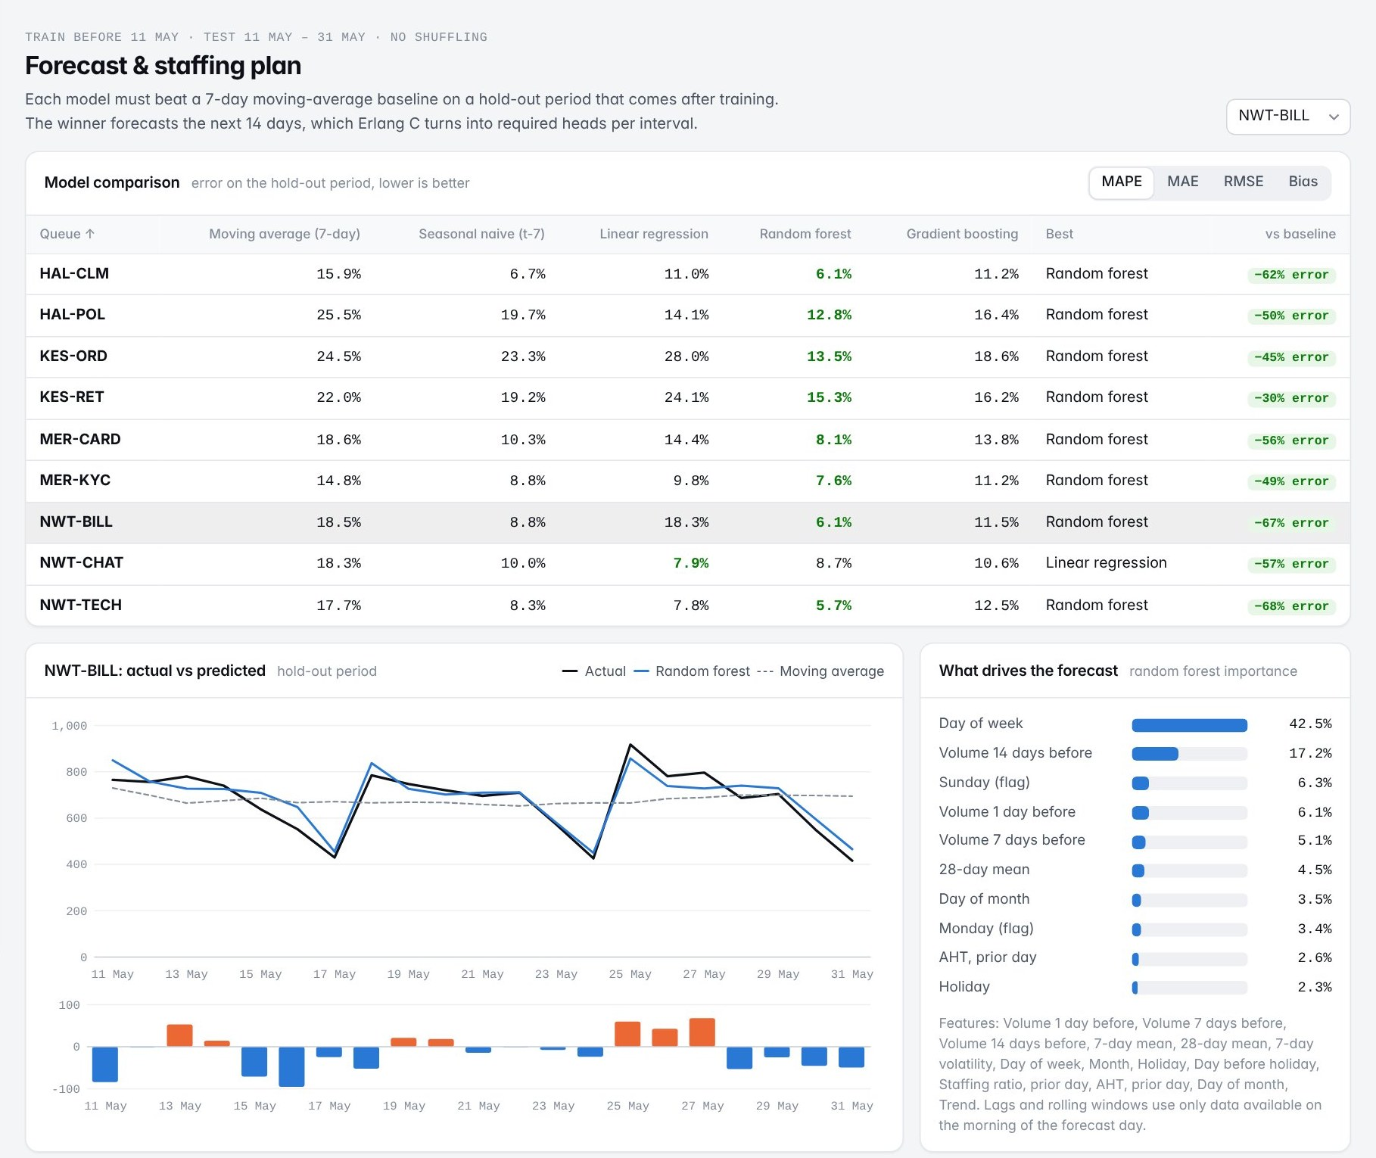
Fig 16. Model comparison, actual vs predicted with residuals, and feature importance (reconstruction)
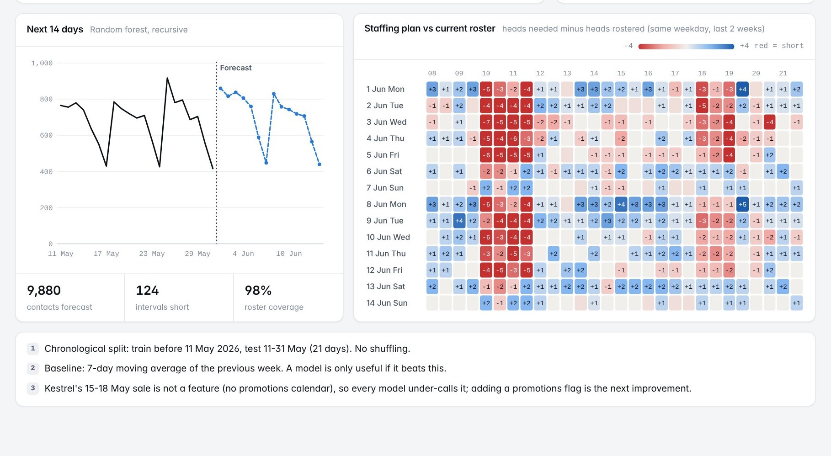
Fig 17. Recursive 14-day forecast and the interval staffing plan against the current roster (red = short)

4.11 LLM recommendation module (RAG)
On 27 June a session covered large language models and RAG as used in the platform's recommendation module: document loading, chunking, embedding, vector storage, retrieval and prompt augmentation before generation (Fig. 18). I assisted by cleaning and preparing the SOP, RCA and quality documents for the knowledge base, generated embeddings for the prepared chunks and loaded them into the vector store with their source metadata, and tested different chunk sizes at the team's request, reporting which returned more relevant passages. On 29 June I ran a set of test queries and recorded which answers cited the correct source document, logged the cases with weak context or wrong citations for the module owner, and left the remaining test cases to the team because the module was still under development.
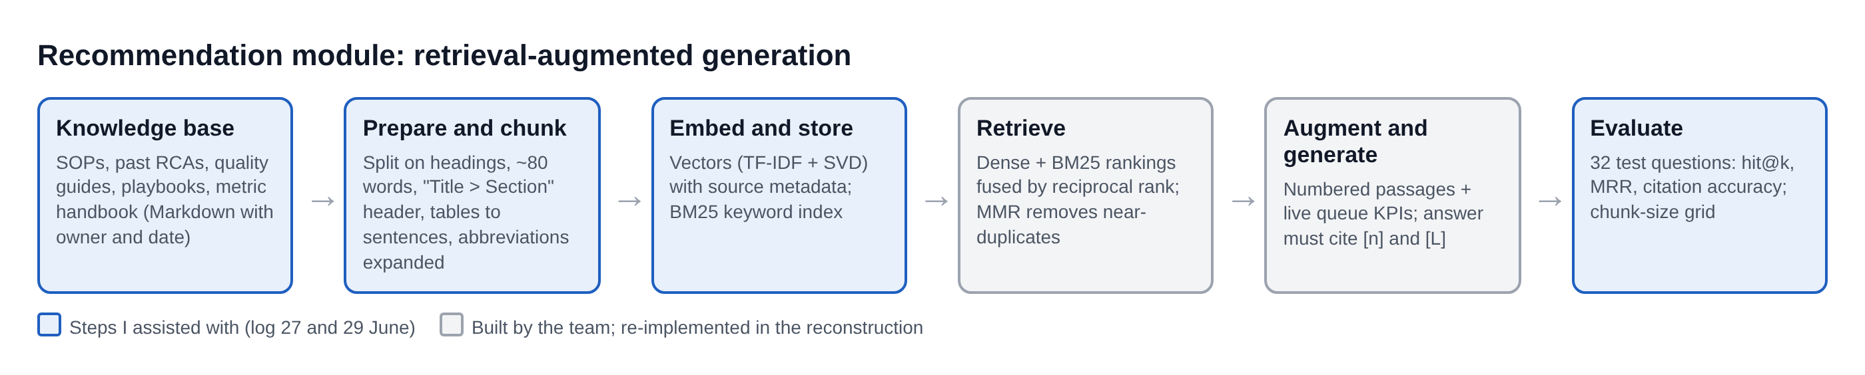
Fig 18. Recommendation module pipeline and the steps I assisted with
The reconstruction implements the module end to end. Its knowledge base has fifteen Markdown documents with owner and date: SOPs for intraday management, roster change control, escalation, callbacks, disposition coding and data corrections; three past RCAs; a sale-readiness playbook; quality guides; client service-level schedules; a metric handbook generated from the registry; and the governance policy. Documents are split on headings into chunks of about 80 words, each prefixed with a 'Title > Section' header so that it reads on its own; tables are rewritten as sentences because a retrieved table row loses its column names; and abbreviations such as AHT and RTA are expanded at index and query time.
Retrieval combines dense embeddings (TF-IDF reduced by SVD, a form of latent semantic analysis [5]) with BM25 keyword ranking [16], fuses the two rankings with reciprocal rank fusion [4] and removes near-duplicate passages with maximal marginal relevance [3]. The prompt contains numbered passages and, when a queue is selected, a live data block with that queue's last seven days; the model must answer only from them and cite [n] and [L]. With an API key the answer is written by Claude or a local model; without one, an extractive mode quotes the most relevant sentences with the same citations (Fig. 19).
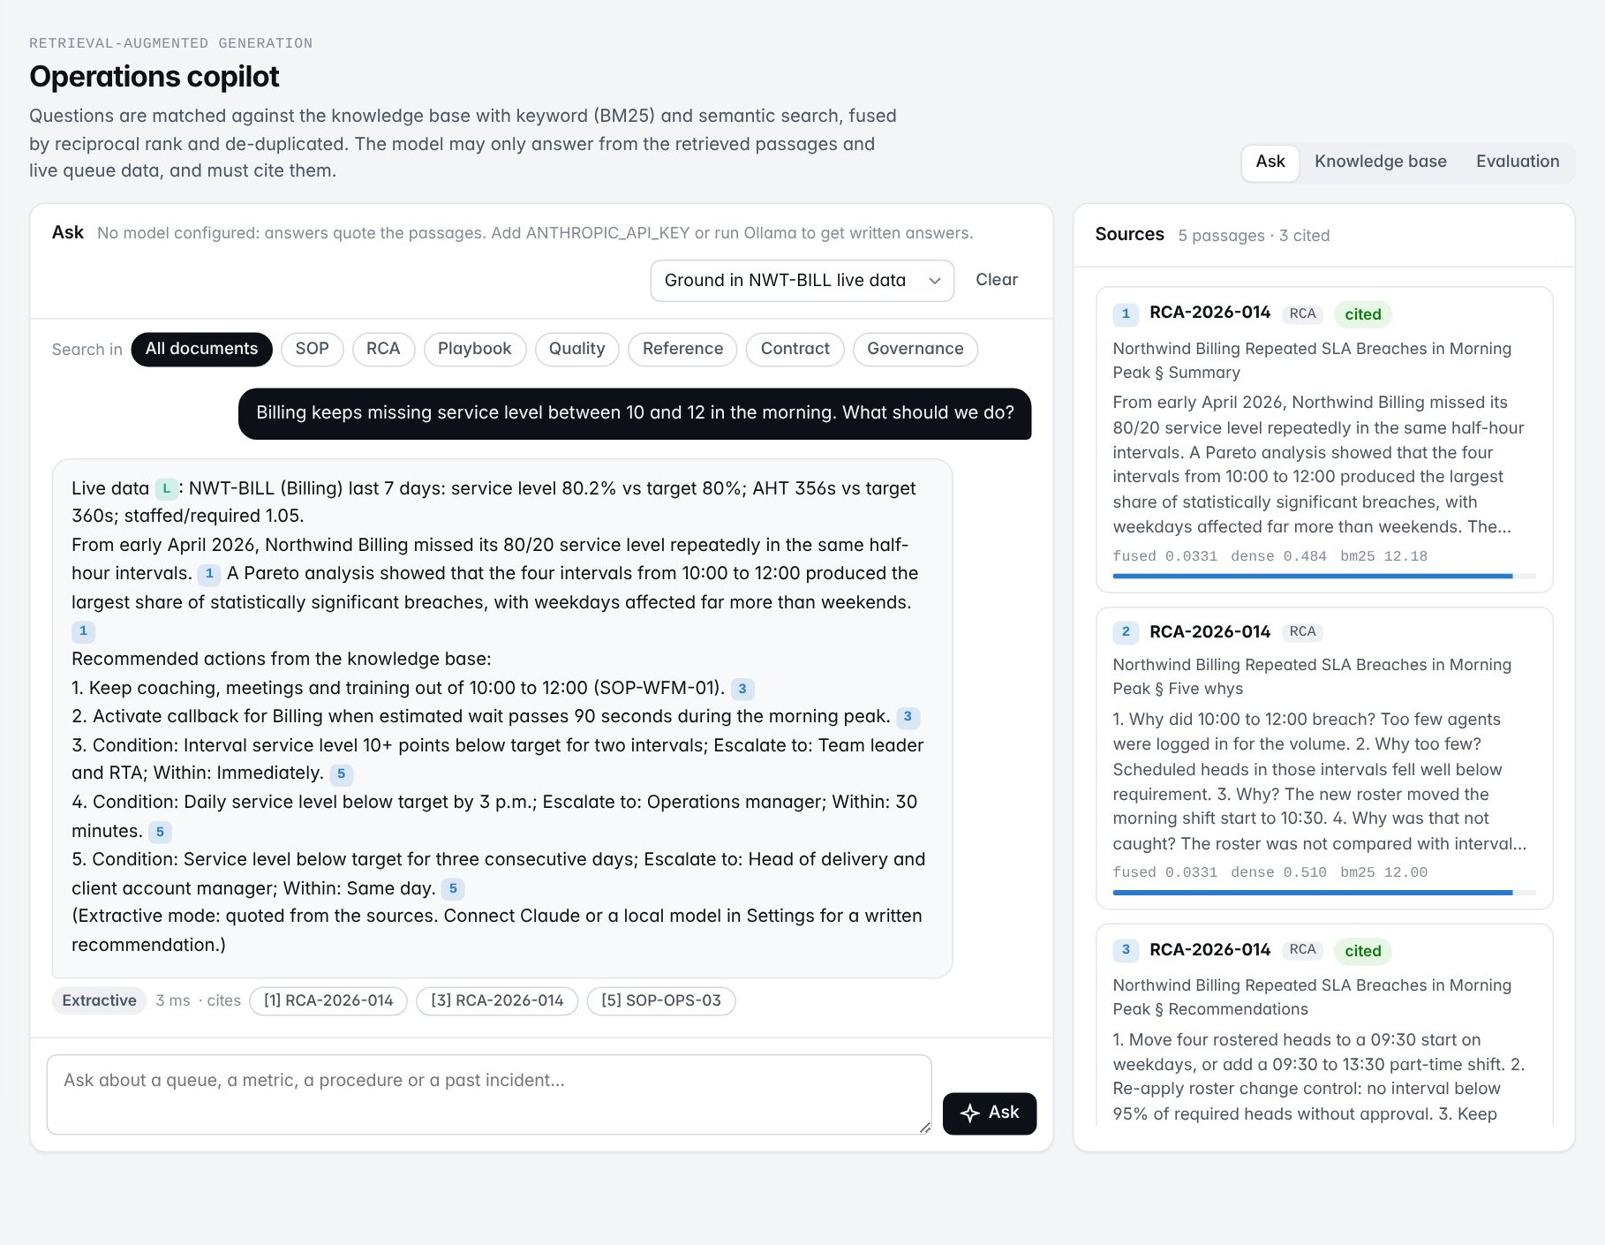
Fig 19. Copilot answer grounded in live billing-queue data and cited passages, with the retrieved sources and their scores
The chunk-size test from the log is reproduced as an evaluation grid: 32 questions, each with the documents that should answer it, scored by hit@1, hit@3, mean reciprocal rank and citation accuracy (whether the top passage is an expected source) across three chunk sizes and three retrieval modes (Table 17).
Table 17. Retrieval evaluation on 32 test questions (reconstruction)
Chunk size | Mode | Hit@1 | Hit@3 | MRR | Citation accuracy
80 words | Keyword (BM25) | 0.91 | 0.97 | 0.93 | 1.00
80 words | Semantic (dense) | 0.81 | 0.94 | 0.88 | 0.94
80 words | Hybrid (RRF) | 0.88 | 1.00 | 0.93 | 1.00
160 words | Hybrid (RRF) | 0.84 | 0.97 | 0.91 | 0.97
320 words | Hybrid (RRF) | 0.84 | 0.97 | 0.91 | 0.97

Keyword search wins on exact terms such as queue codes and SOP numbers; semantic search wins on paraphrases. Fused, they put an expected document in the top three for every test question at 80-word chunks. Larger chunks mix several procedures in one passage, which blurs the ranking and makes citations less precise, which matches what I reported on 27 June.

4.12 Extensions built in the reconstruction
To make the reconstruction a complete product, it includes modules that go beyond the tasks recorded in my log. They are listed separately so that the review can distinguish them:
- Alerts. Daily KPIs are compared with a 28-day rolling median and MAD (robust z >= 3.5) [12], with a same-weekday baseline for volume, a seven-day shift test and RCA hotspots as incidents; each incident can be turned into cited recommendations (Fig. 20). On the synthetic data it raises 49 incidents including all four planted events.
- Intraday and agent views, Shapley attribution and the what-if in the RCA, the Erlang C staffing plan, answer generation in the copilot and a read-only SQL lab.

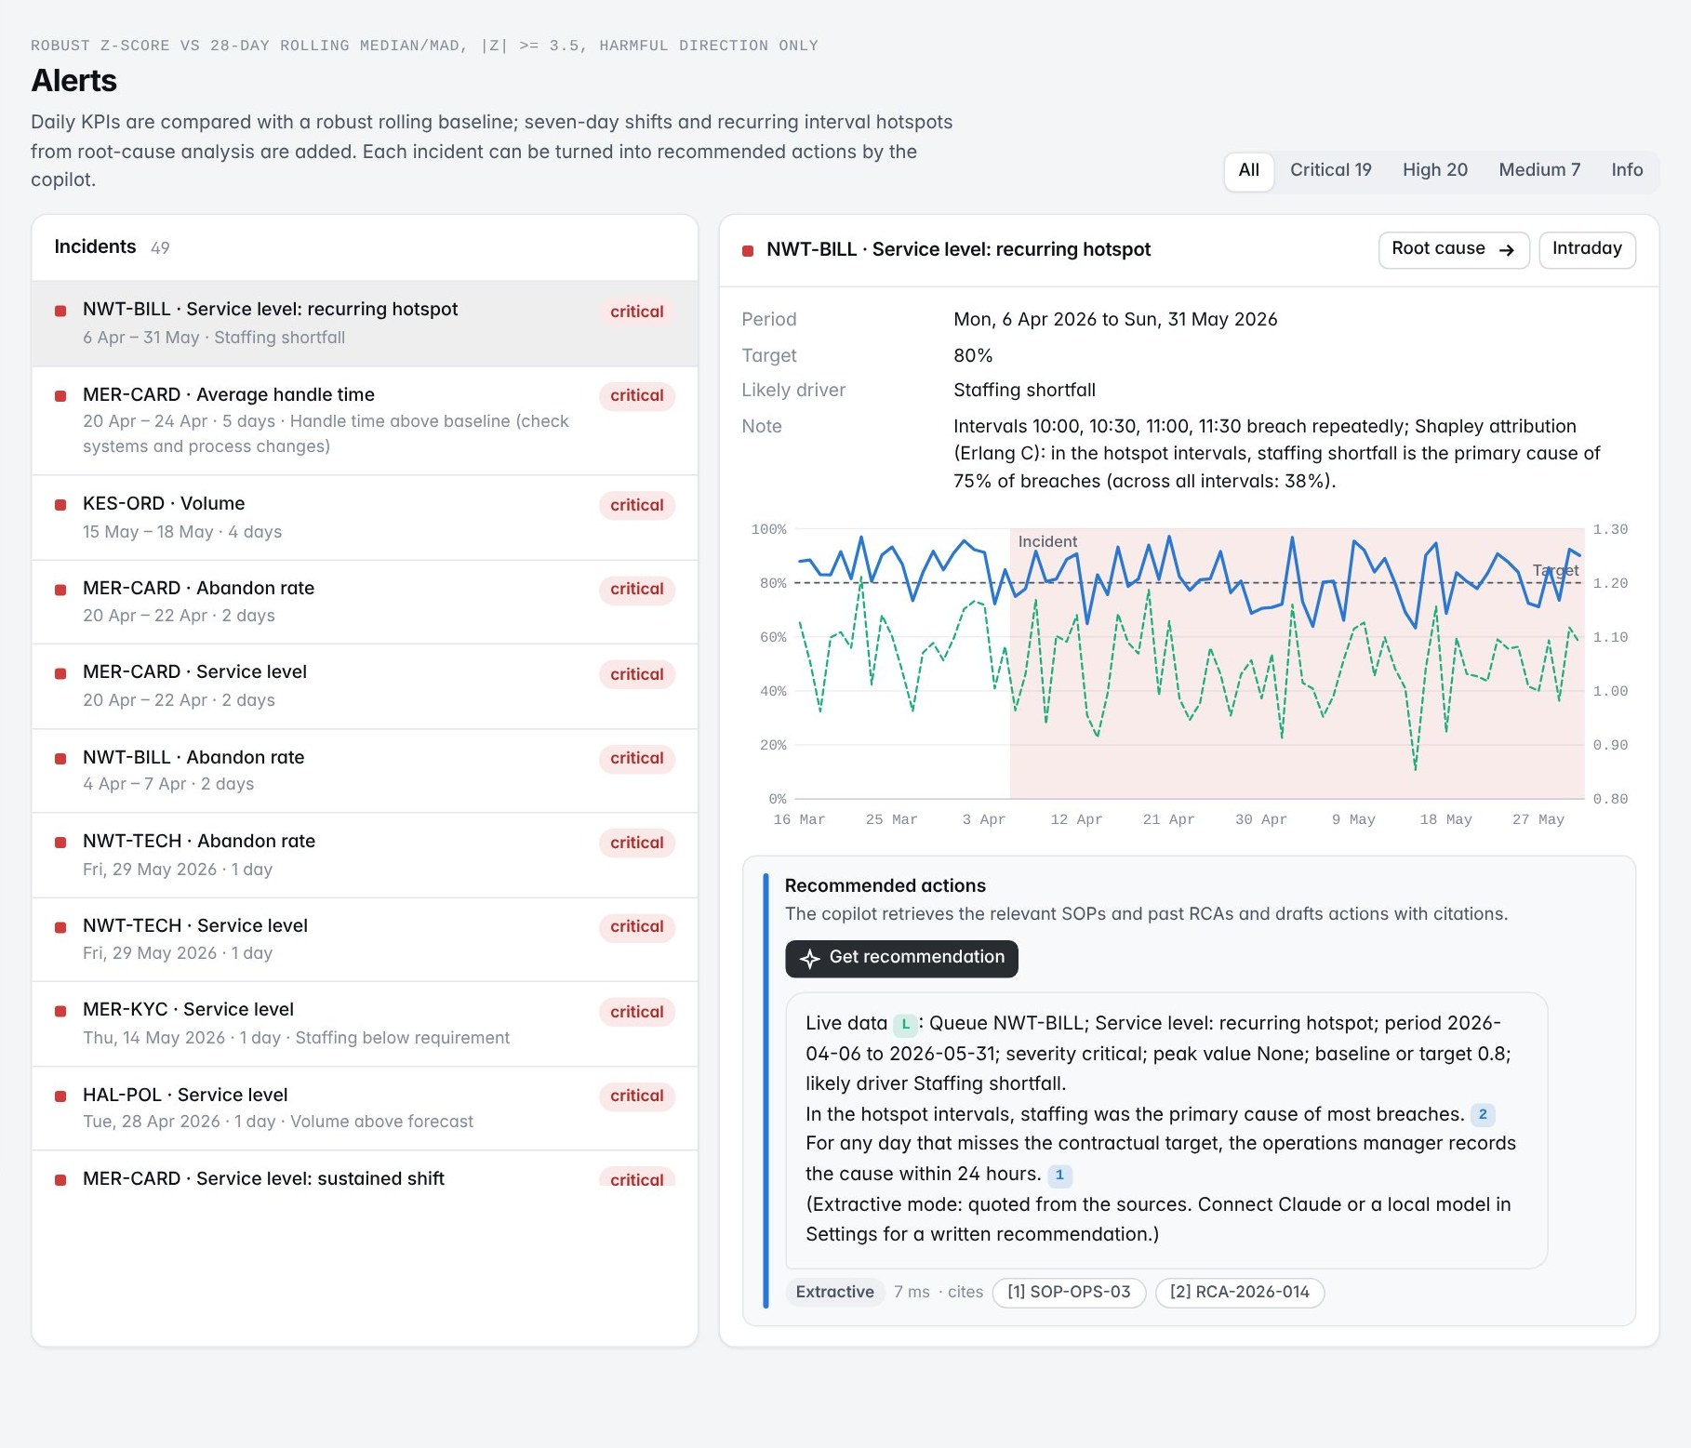
Fig 20. Alerts: incidents ordered by severity and duration, with the daily KPI around the incident and copilot recommendations

4.13 Testing and validation
The reconstruction has 40 automated tests (Table 18) that run against the built warehouse. They automate the checks I performed manually during the internship: reconciling figures against SQL, row counts across joins, and each measure against its agreed definition.
Table 18. Automated test suite of the reconstruction
Area | What is checked | Tests
Metric parity | Service level and AHT from the cube equal the fact table; totals match; short-abandon exclusion; FCR window | 8
Pipeline | No duplicate business keys, canonical queues, no negative times, flagged rows kept, capping, reconciliation, rule log, no clear PII | 8
Analytics | Erlang C against the textbook formula, minimal required agents, RCA finds the planted cause, chronological split beats baseline, planted events detected | 9
API and security | Row-level security, 403 outside scope, masked names, role restrictions, six SQL guard-rail cases, saved queries run, index plan | 13
Copilot | Retrieval thresholds (hit@3, MRR, citation accuracy) and cited answers | 2

5 RESULTS AND DISCUSSION

5.1 Summary of results
Table 19. Summary of outcomes
Work | Outcome
Floor-plan input module | Pre-processing utilities, region-based OCR with orientation handling, unit parser to millimetres, schema validation with readable reports, ground-truth accuracy sheet, README and handover (company repository)
SQL | Reviewed queries for aggregation, joins, window functions; a slow report query rewritten from a full scan to index searches
Data pipeline | Profiling worksheet, reusable cleaning functions, approved outlier capping, reconciliation that found and fixed a rule losing valid records
Metrics and reporting | SQL for AHT, SLA and abandonment with explicit exclusions; short-abandon mismatch resolved; reporting views; Power BI queue performance page with validated DAX
Root-cause analysis | Pareto, candidate-cause tests and staffing-gap figures for the RCA document
Forecasting | Feature set, chronological split, baseline, model comparison and residual analysis
RAG module | Prepared knowledge base, embeddings in the vector store, chunk-size comparison, citation test results
Reconstruction | End-to-end platform on synthetic data: 552/552 queue-days reconciled; planted roster gap found (75% staffing-driven, +2.6 pts SL with four heads); forecast MAPE 19.5% to 9.3%; retrieval hit@3 1.00; 40 tests passing

5.2 Challenges and how they were resolved
Table 20. Challenges faced and their resolution
Challenge | How it was resolved
Rotated and small dimension text defeated OCR | Measured a baseline first, grouped failures by type, then fixed the largest group with region cropping, upscaling and orientation detection; re-measured on the same plans
Validation raised false alarms on abbreviated notations | Reviewed every flag with the guide and corrected the two checks responsible
Agent-day query returned duplicated rows | Traced the one-to-many relationship in status history with the mentor; adopted row counts before and after each join; used ROW_NUMBER() for the latest status
Extreme handle times | Investigated before treating; found unclosed sessions; capped only those, and only after approval
Cleaned totals did not reconcile | Traced the variance to a rule dropping valid records; changed it to keep and flag; re-ran until zero variance
SLA attainment differed from month-end figures | Found the short-abandon exclusion difference; aligned the rule with operations
A DAX measure was wrong under a slicer | Diagnosed the filter context; corrected the measure; validated against SQL
Confidential data for the review | Rebuilt the platform on synthetic data with planted events, so methods can be demonstrated and checked against known causes

5.3 Key learnings
- Data work is mostly verification. The most valuable habits were the cheapest: row counts across joins, reconciliation against the source, and validating every measure against an independent query.
- Definitions are a business decision. A metric is only correct once its exclusions are agreed with the people who report it.
- Grain matters. Interval-level data found a problem that daily averages concealed.
- Baselines keep models honest. A model is useful only if it beats a simple forecast on a period it has not seen.
- Retrieval must be tested before generation. A fixed question set with expected sources made chunking and retrieval choices measurable.
- Constraints shape design. The floor-plan geometry lock made validation at the input stage essential, and confined the language model to text.

5.4 Professional practice
Professional conduct was part of the work. I signed the confidentiality undertaking, accessed only approved masked extracts through read-only connections, and confirmed the datasets in scope with my mentor. I worked on a personal branch and changed nothing owned by others; observations about other components (the Hough-based wall detection, the RAG module's weak cases) were reported to their owners rather than fixed by me. Treatments that changed data were applied only after approval, queries and views were reviewed before use, and each piece of work was handed over with a README and a walkthrough. On 29 June I prepared a note of the parts left incomplete (unresolved OCR failure cases and dashboard change requests not yet applied) so that the team could continue without gaps, and on 30 June I completed the exit formalities, returned assets and had my access revoked.

6 CONCLUSION AND FUTURE WORK
The internship gave me experience of two different kinds of data and AI system. On the floor-plan platform, I built the input stage that reads dimensions reliably enough to respect the geometry lock: pre-processing tuned per quality group, region-based OCR with orientation handling, a unit-normalising parser and a validation step that stops bad values before they reach the 3D model. On the Operations Intelligence Platform, I followed the data from source extracts to decisions: SQL, cleaning and reconciliation, agreed metric definitions, reporting views and a Power BI page, a root-cause analysis, a forecasting component and the knowledge base of a RAG recommendation module.
Rebuilding the OIP on synthetic data for this review let me show the methods end to end and check them against known planted causes. The reconstruction reconciles exactly with its source, isolates the roster gap behind the billing queue's breaches and quantifies the fix, forecasts volume at about half the error of the baseline and turns it into a staffing plan, and answers operational questions with cited procedures.
Future work for the reconstruction includes a promotions calendar as a forecast feature, interval-level forecasting instead of spreading a daily forecast, a server warehouse with scheduled orchestration and single sign-on, a larger and harder retrieval test set with human-rated answers, and alert thresholds tuned with operations feedback. For the floor-plan module, the open items are the remaining OCR failure cases recorded in the handover sheet and an automated regression test on the annotated ground truth.

REFERENCES
[1] G. Bradski, "The OpenCV Library", Dr. Dobb's Journal of Software Tools, vol. 25, no. 11, pp. 120-125, 2000.
[2] L. Breiman, "Random Forests", Machine Learning, vol. 45, no. 1, pp. 5-32, 2001.
[3] J. Carbonell and J. Goldstein, "The Use of MMR, Diversity-Based Reranking for Reordering Documents and Producing Summaries", Proceedings of the 21st Annual International ACM SIGIR Conference on Research and Development in Information Retrieval, pp. 335-336, 1998.
[4] G. V. Cormack, C. L. A. Clarke and S. Buettcher, "Reciprocal Rank Fusion Outperforms Condorcet and Individual Rank Learning Methods", Proceedings of the 32nd International ACM SIGIR Conference on Research and Development in Information Retrieval, pp. 758-759, 2009.
[5] S. Deerwester, S. T. Dumais, G. W. Furnas, T. K. Landauer and R. Harshman, "Indexing by Latent Semantic Analysis", Journal of the American Society for Information Science, vol. 41, no. 6, pp. 391-407, 1990.
[6] R. O. Duda and P. E. Hart, "Use of the Hough Transformation to Detect Lines and Curves in Pictures", Communications of the ACM, vol. 15, no. 1, pp. 11-15, 1972.
[7] A. K. Erlang, "Solution of Some Problems in the Theory of Probabilities of Significance in Automatic Telephone Exchanges", Elektroteknikeren, vol. 13, 1917.
[8] N. Gans, G. Koole and A. Mandelbaum, "Telephone Call Centers: Tutorial, Review, and Research Prospects", Manufacturing & Service Operations Management, vol. 5, no. 2, pp. 79-141, 2003.
[9] R. J. Hyndman and G. Athanasopoulos, Forecasting: Principles and Practice, 3rd ed. Melbourne, Australia: OTexts, 2021.
[10] R. Kimball and M. Ross, The Data Warehouse Toolkit: The Definitive Guide to Dimensional Modeling, 3rd ed. Indianapolis, IN, USA: Wiley, 2013.
[11] P. Lewis et al., "Retrieval-Augmented Generation for Knowledge-Intensive NLP Tasks", Advances in Neural Information Processing Systems, vol. 33, pp. 9459-9474, 2020.
[12] C. Leys, C. Ley, O. Klein, P. Bernard and L. Licata, "Detecting Outliers: Do Not Use Standard Deviation around the Mean, Use Absolute Deviation around the Median", Journal of Experimental Social Psychology, vol. 49, no. 4, pp. 764-766, 2013.
[13] H. B. Mann and D. R. Whitney, "On a Test of Whether One of Two Random Variables Is Stochastically Larger than the Other", Annals of Mathematical Statistics, vol. 18, no. 1, pp. 50-60, 1947.
[14] Microsoft, "DAX Function Reference", Microsoft Learn, 2026. [Online]. Available: https://learn.microsoft.com/en-us/dax/
[15] F. Pedregosa et al., "Scikit-learn: Machine Learning in Python", Journal of Machine Learning Research, vol. 12, pp. 2825-2830, 2011.
[16] S. Robertson and H. Zaragoza, "The Probabilistic Relevance Framework: BM25 and Beyond", Foundations and Trends in Information Retrieval, vol. 3, no. 4, pp. 333-389, 2009.
[17] L. S. Shapley, "A Value for n-Person Games", in Contributions to the Theory of Games II, H. W. Kuhn and A. W. Tucker, Eds. Princeton, NJ, USA: Princeton University Press, pp. 307-317, 1953.
[18] R. Smith, "An Overview of the Tesseract OCR Engine", Proceedings of the Ninth International Conference on Document Analysis and Recognition (ICDAR), pp. 629-633, 2007.
[19] J. W. Tukey, Exploratory Data Analysis. Reading, MA, USA: Addison-Wesley, 1977.

APPENDIX I
SAMPLE SOURCE CODE AND SCREENSHOTS
The listings below are excerpts from the reconstruction's source code (Python, SQL). The complete project, with a README, design notes and 40 tests, accompanies this report.

A1.1 Metric registry entry: service level with the short-abandon exclusion (oip/warehouse/metrics.py)
Metric("sl", "Service level", "pct", "up", (("sl_num", 1),), (("sl_den", 1),),
"Share of contacts answered within the queue's threshold.",
"Contacts answered within threshold",
"Offered minus short abandons (<= 5 s)",
"Abandons within 5 s are excluded (aligned with the operations month-end method)",
"SUM(f.within_sl) * 1.0 / SUM(f.sl_eligible)", target_key="sl_target")

def dax_measures(table="rpt_interval_cube"):
def expr(terms):
return " ".join(("+ " if s > 0 else "- ") + f"SUM({table}[{c}])" for c, s in terms).lstrip("+ ")
for m in METRICS:
body = f"DIVIDE({expr(m.num)}, {expr(m.den)})" if m.den else expr(m.num)
yield f"[{m.label}] = {body}"

A1.2 Window functions: latest status per case and agent ranking (SQL lab)
WITH ranked AS (
SELECT s.case_id, s.status,
ROW_NUMBER() OVER (PARTITION BY s.case_id ORDER BY s.status_at DESC) AS rn
FROM fact_case_status s
JOIN fact_interaction f ON f.interaction_id = s.interaction_id
WHERE f.date_key = 20260520)
SELECT status AS latest_status, COUNT(*) AS cases
FROM ranked WHERE rn = 1 GROUP BY status ORDER BY cases DESC;

WITH a AS (
SELECT q.queue_code, ag.full_name AS agent, COUNT(*) AS handled, ROUND(AVG(f.handle_sec)) AS aht_sec
FROM fact_interaction f
JOIN dim_agent ag ON ag.agent_id = f.agent_id
JOIN dim_queue q ON q.queue_id = f.queue_id
WHERE f.handled = 1 AND f.date_key BETWEEN 20260501 AND 20260531
GROUP BY q.queue_code, ag.agent_id HAVING COUNT(*) >= 150)
SELECT *, RANK() OVER (PARTITION BY queue_code ORDER BY aht_sec) AS rank_fastest
FROM a ORDER BY queue_code, rank_fastest;

A1.3 Erlang C probability of waiting (oip/analytics/erlang.py)
def erlang_c(n_agents, load):
"""Probability that an arriving contact waits (M/M/N). Returns 1.0 where N <= a."""
n = np.atleast_1d(np.asarray(n_agents, dtype=float))
a = np.atleast_1d(np.asarray(load, dtype=float))
n, a = np.broadcast_arrays(n, a)
n_int = np.maximum(np.round(n).astype(int), 0)
b = np.ones_like(a) # Erlang B via the stable recursion
out_b = np.where(n_int == 0, 1.0, np.nan)
for k in range(1, int(n_int.max()) + 1):
b = a * b / (k + a * b)
out_b = np.where(n_int == k, b, out_b)
c = n * out_b / (n - a * (1 - out_b))
return np.clip(np.where((n <= a) | (n_int == 0), 1.0, c), 0.0, 1.0)

def service_level(n, a, aht_sec, threshold_sec):
return 1.0 - erlang_c(n, a) * np.exp(-(n - a) * threshold_sec / aht_sec)

A1.4 Breach rule in the root-cause analysis (oip/analytics/rca.py)
# SL below target by more than 1.645 binomial standard errors (one-sided 95%).
se = np.sqrt(q.sl_target * (1 - q.sl_target) / c.sl_den.clip(lower=1))
c["miss"] = c.eligible & (c.sl < q.sl_target)
c["breach"] = c.eligible & (c.sl < q.sl_target - 1.645 * se)

A1.5 Hybrid retrieval with reciprocal rank fusion (oip/copilot/answer.py)
dense = idx.vectors @ idx.embedder.encode([q])[0]
sparse = idx.bm25.scores(q)
rd = {int(i): r for r, i in enumerate(ids[np.argsort(-dense[ids])])}
rs = {int(i): r for r, i in enumerate(ids[np.argsort(-sparse[ids])])}
fused = {int(i): 1 / (60 + rd[int(i)]) + 1 / (60 + rs[int(i)]) for i in ids}
cand = sorted(fused, key=lambda i: -fused[i])[:20]
# maximal marginal relevance: relevance minus similarity to passages already chosen
while len(chosen) < k:
best = max((i for i in cand if i not in chosen),
key=lambda i: 0.7 * rel[i] - 0.3 * max((vec[i] @ vec[c] for c in chosen), default=0))
chosen.append(best)

A1.6 Floor-plan dimension parser (simplified illustration written for this report)
The company's floor-plan code is confidential. The listing below is a simplified illustration of the parsing approach described in Section 3.7.
import re
FT_IN = re.compile(r"^(\d+)\s*'\s*-?\s*(\d+)?(?:\s+(\d+)/(\d+))?\s*\"?$")
METRIC = re.compile(r"^(\d+(?:\.\d+)?)\s*(mm|cm|m)?$")
TO_MM = {"mm": 1, "cm": 10, "m": 1000}

def parse_dimension(text, plan_unit="mm"):
t = text.strip().replace("\u2019", "'").replace("\u201d", '"')
if re.fullmatch(r"\d{1,3}[.,]\d{3}", t): # 3,600 or 3.600: separator is ambiguous
return {"value_mm": None, "flag": "ambiguous separator", "raw": text}
m = FT_IN.match(t)
if m:
feet, inch = int(m[1]), int(m[2] or 0)
frac = int(m[3]) / int(m[4]) if m[3] else 0.0
return {"value_mm": round((feet * 12 + inch + frac) * 25.4), "flag": None, "raw": text}
m = METRIC.match(t.replace(",", ""))
if m:
unit = m[2] or plan_unit
return {"value_mm": round(float(m[1]) * TO_MM[unit]), "flag": None, "raw": text}
return {"value_mm": None, "flag": "unrecognised notation", "raw": text}

A1.7 Screenshots and running the reconstruction
Additional views of the reconstructed platform. The complete set of page screenshots is in the project folder (docs/screenshots). The interface supports light and dark themes and phone-width layouts.
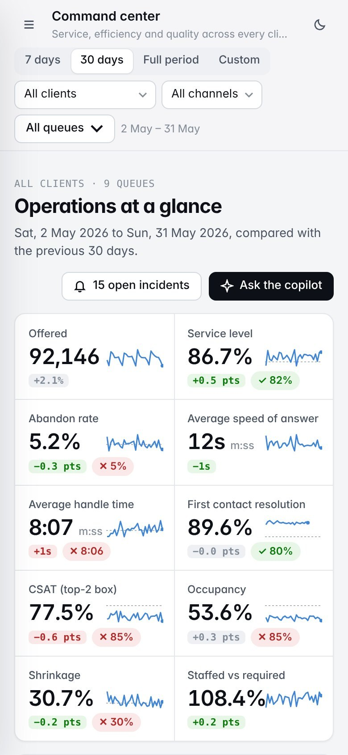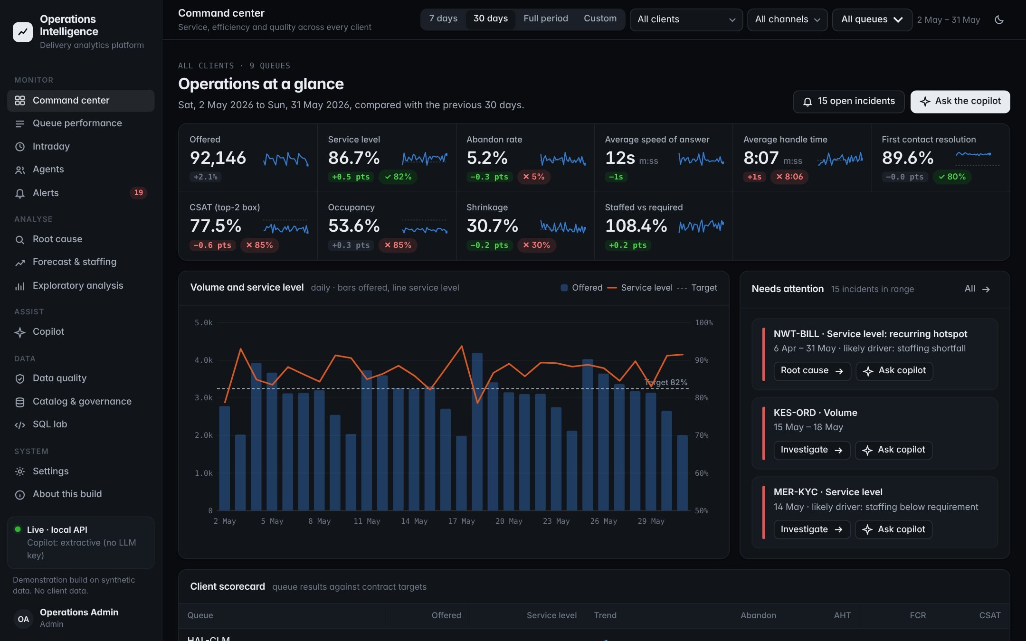
Fig 21. Command center at phone width (left) and in the dark theme (right)

A1.8 Running the reconstruction
python -m venv .venv && source .venv/bin/activate
pip install -r requirements.txt
python -m oip build # generate sources, ingest, profile, clean, reconcile, warehouse, analytics, copilot index (~100 s)
python -m oip serve # http://127.0.0.1:8050 (API documentation at /api/docs)
python -m oip status # last build, row counts, reconciliation, retrieval quality, incidents
python -m oip ask "How do we handle an SLA breach in the morning peak?"
python -m oip export-powerbi # CSVs, measures.dax and MODEL.md for Power BI Desktop
python -m pytest # 40 tests

