Screenshot 1: Create the Amazon S3 Bucket
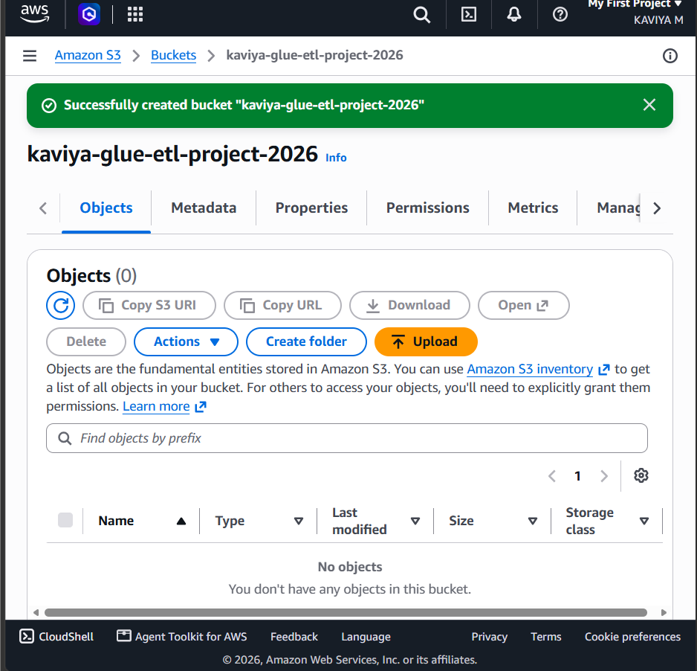

Screenshot 2: Upload the Source CSV File to the S3 Bucket
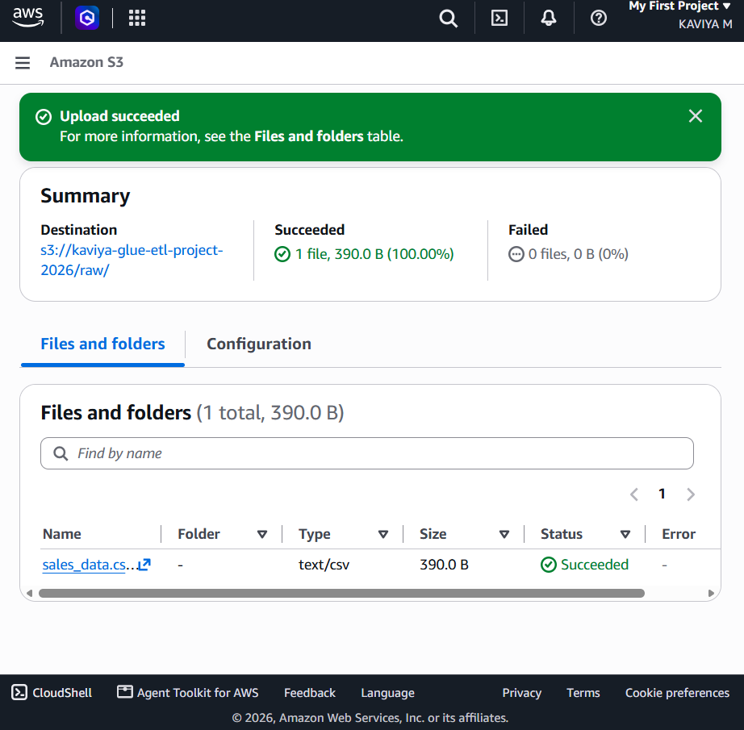
Screenshot 3: Open AWS Glue Studio
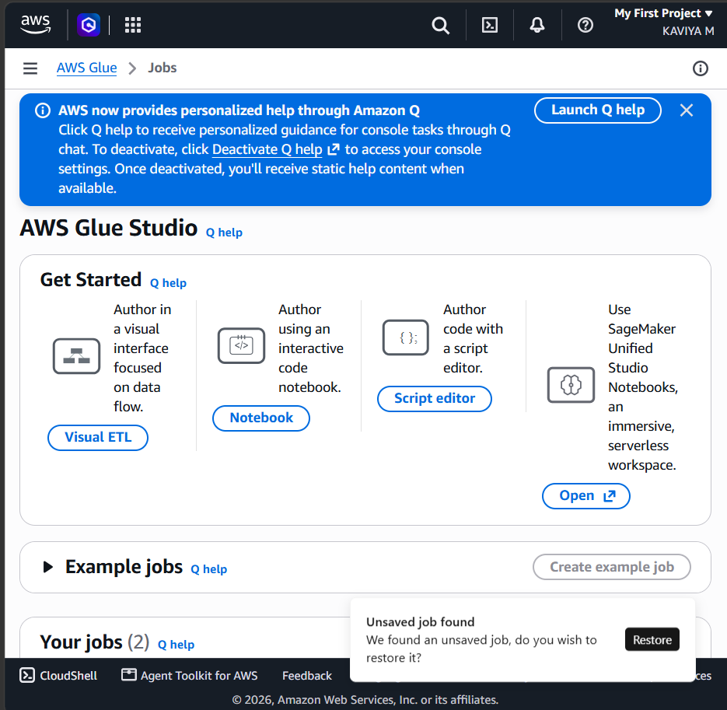
Screenshot 4: Create a New AWS Glue ETL Job
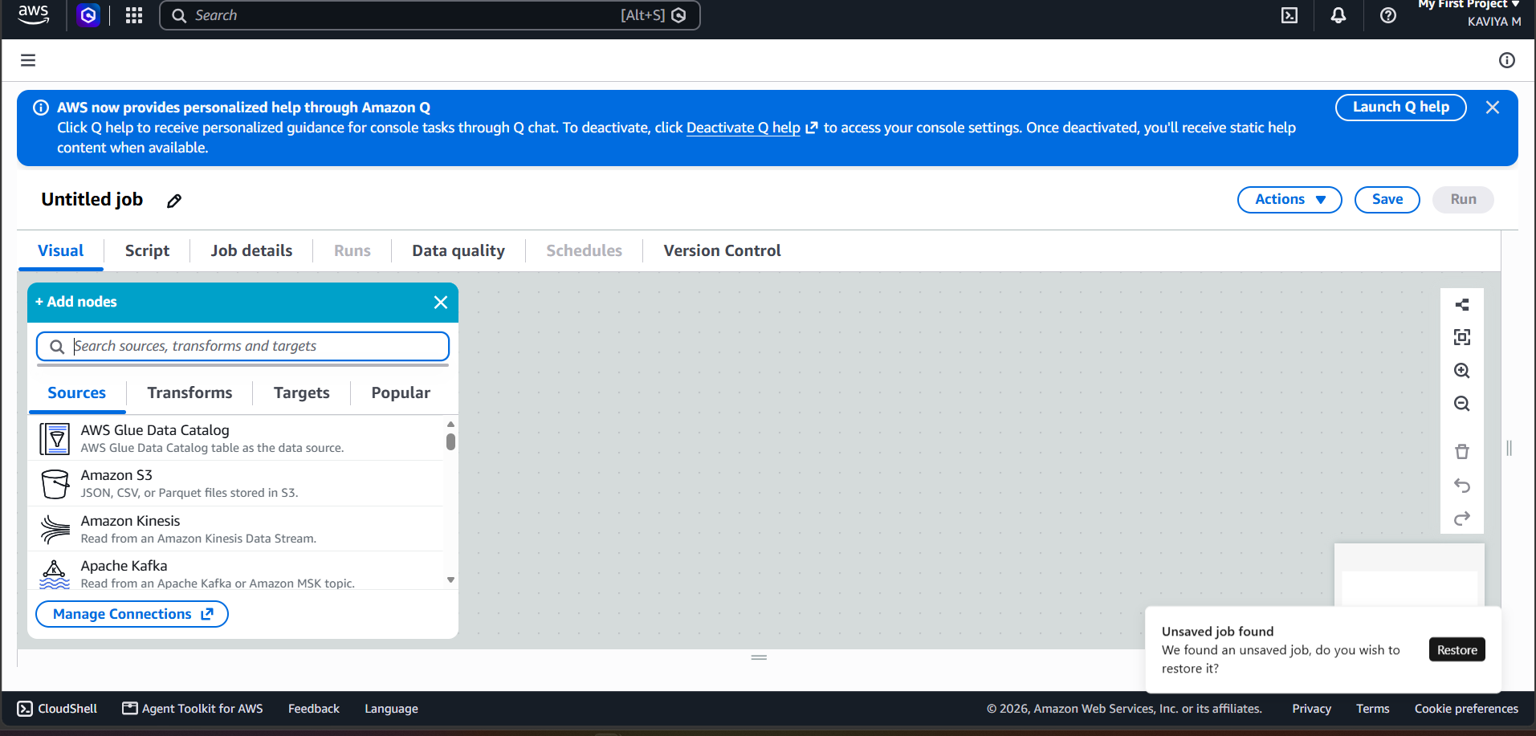
Screenshot 5: Configure the Amazon S3 Source and Preview the Data
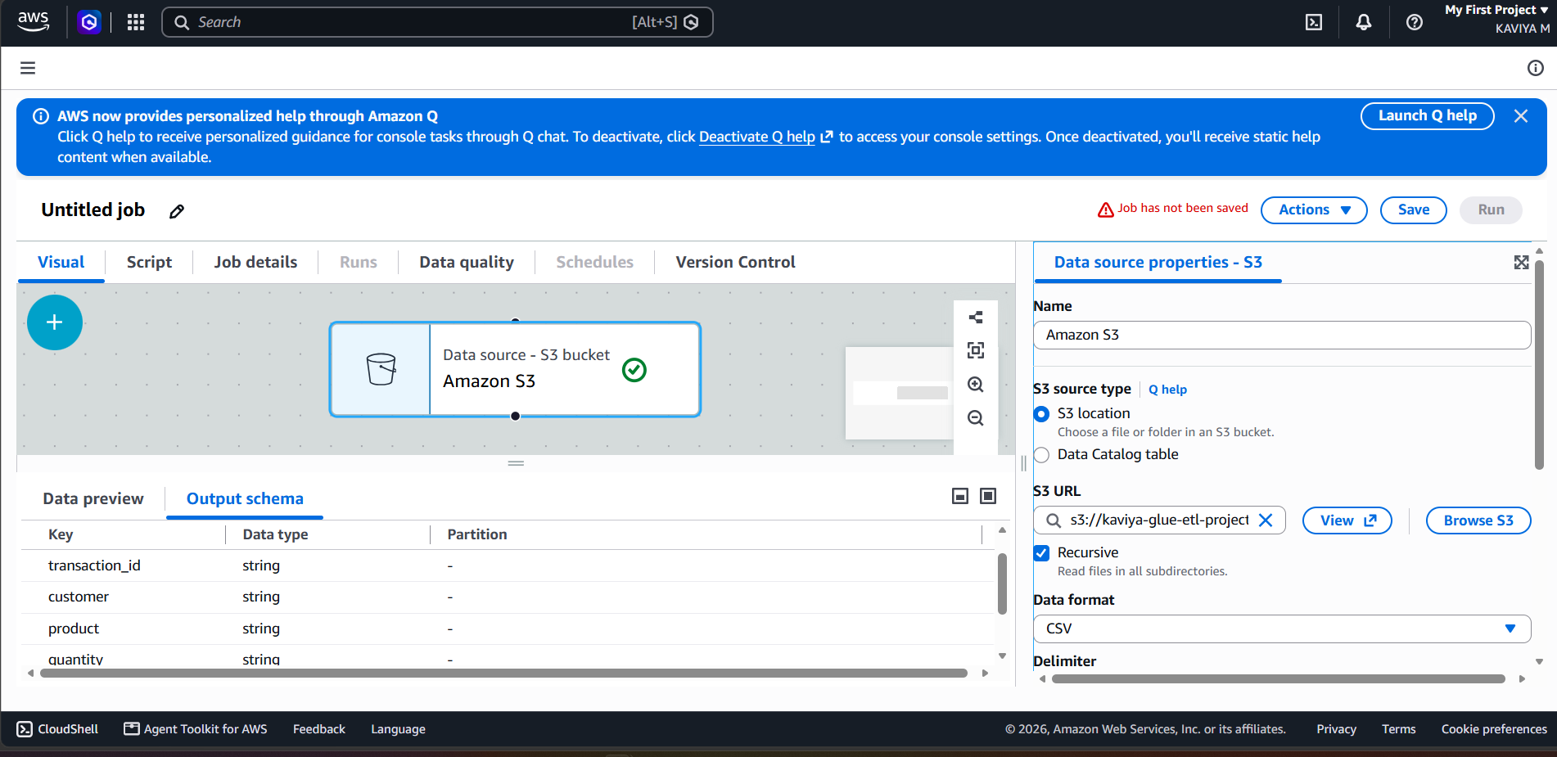
Screenshot 6: Add and Configure the Data Transformation
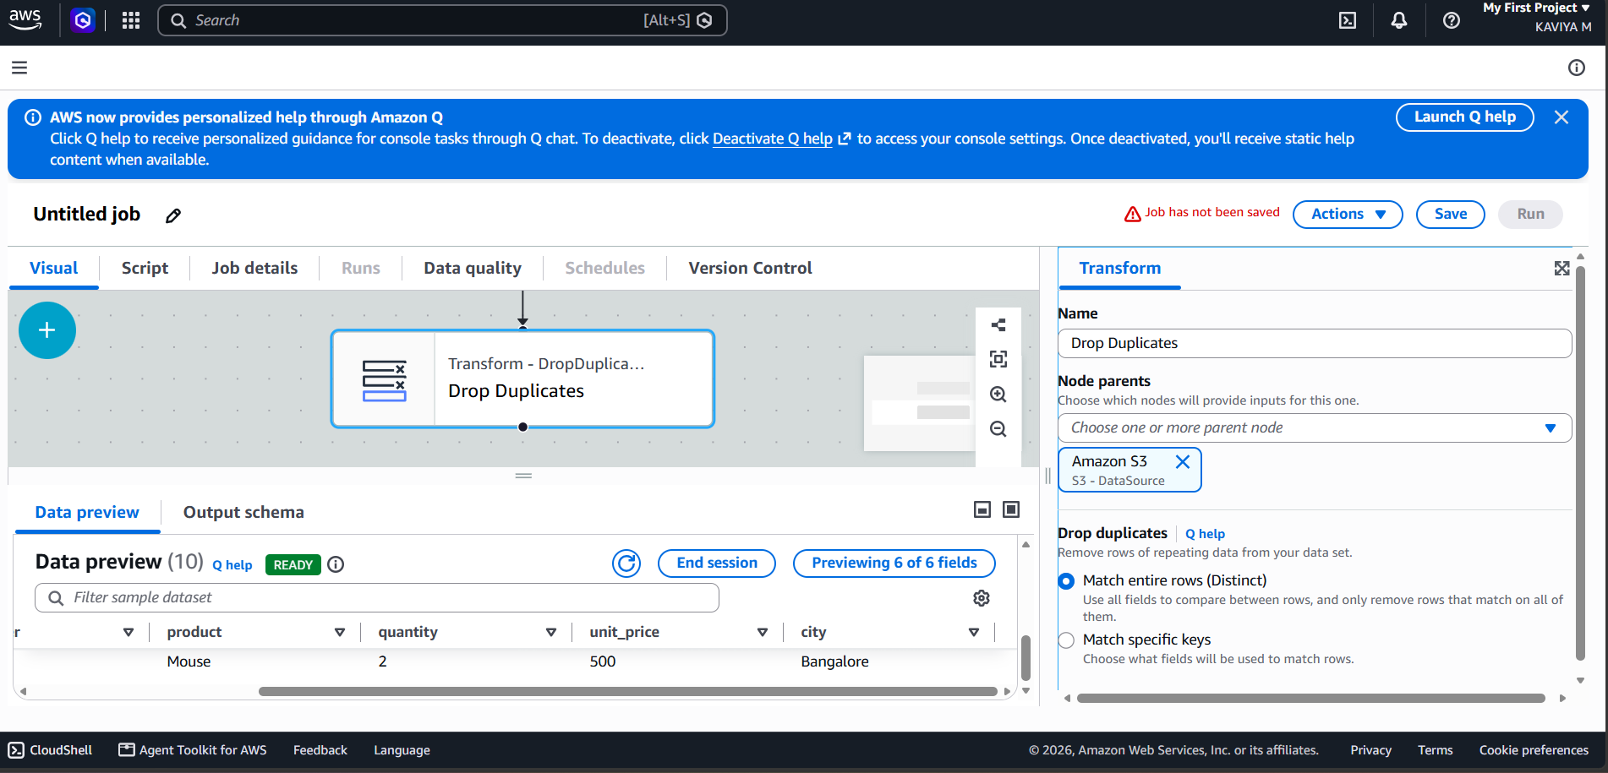
Screenshot 7: Configure the Glue Job Details and IAM Role
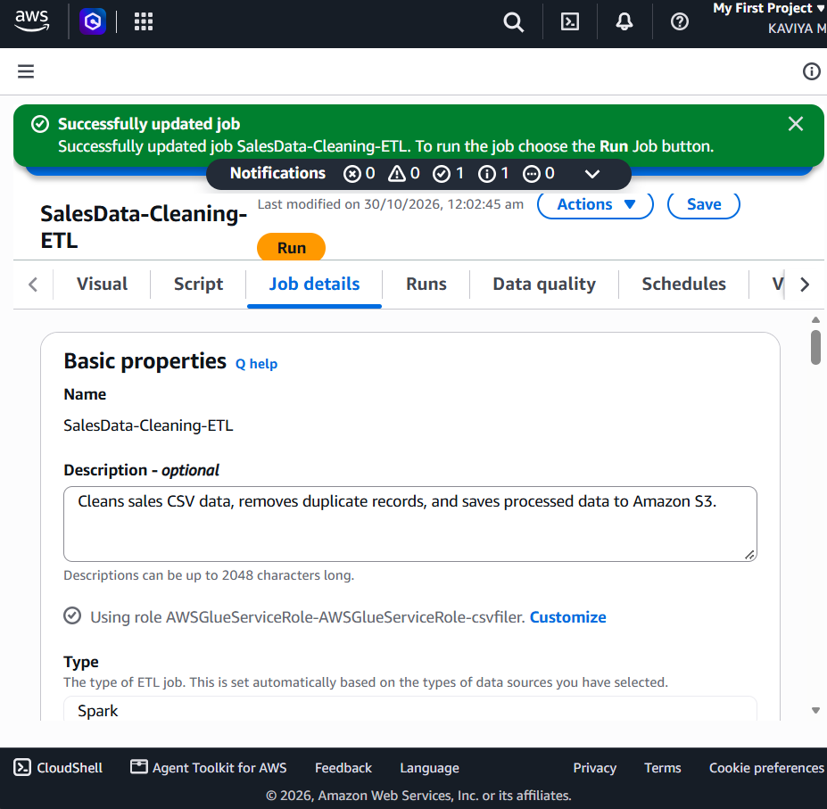
Screenshot 8: Review the Completed ETL Pipeline and Output Schema
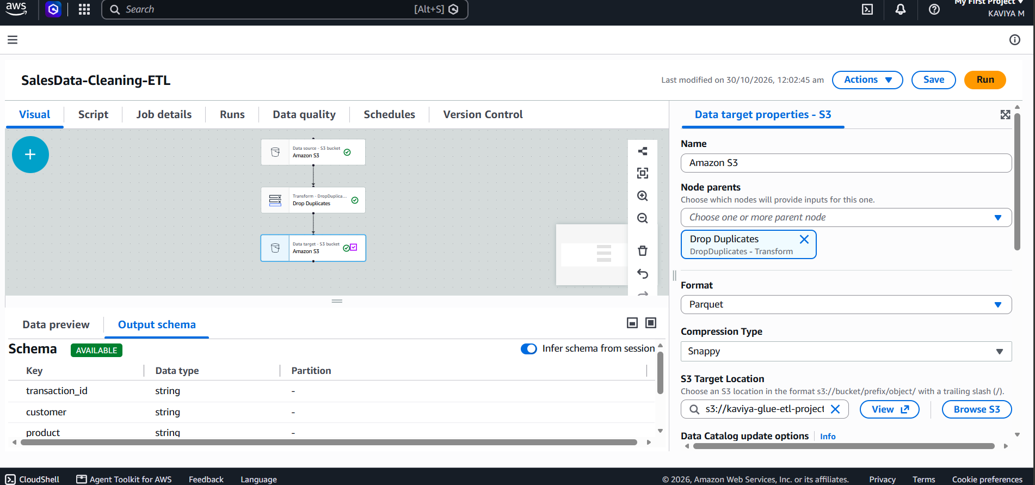
Screenshot 9: Run the Glue Job and Verify Execution Status
