Step 1: Create the S3 Bucket (aviya-s3-lambda-automation-2026)
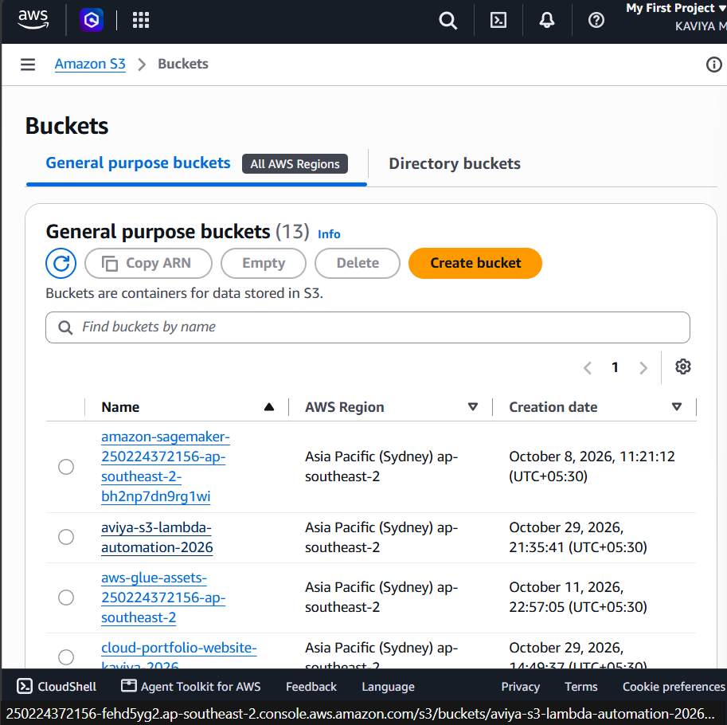
Step 2: Create the Lambda Function (s3-file-upload-processor)
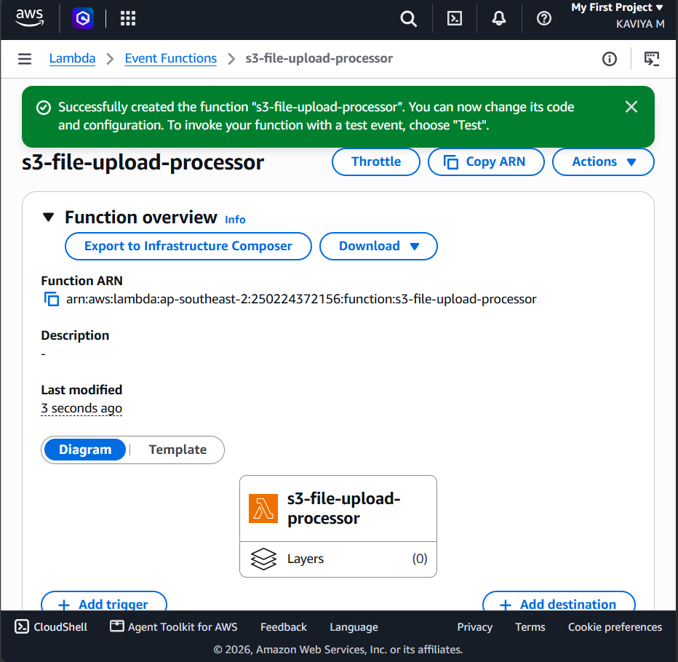

Step 3: Add the Lambda Function Code (lambda_function.py)
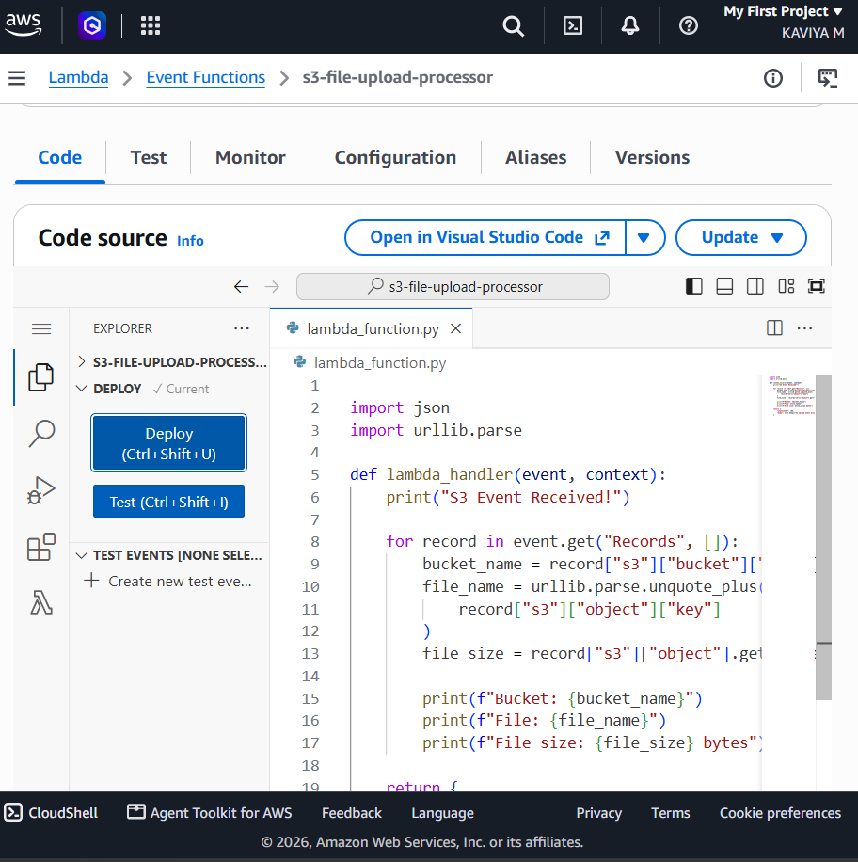
Step 4: Configure the S3 Event Notification (S3FileUploadEvent)
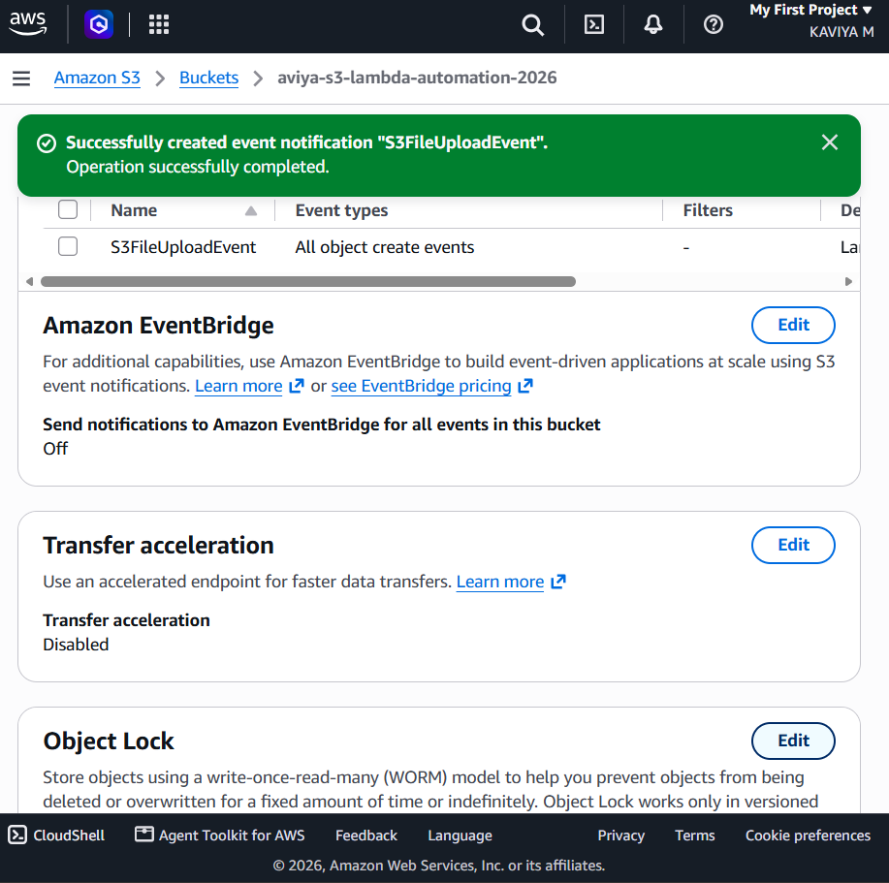
Step 5: Upload a Test File to the S3 Bucket
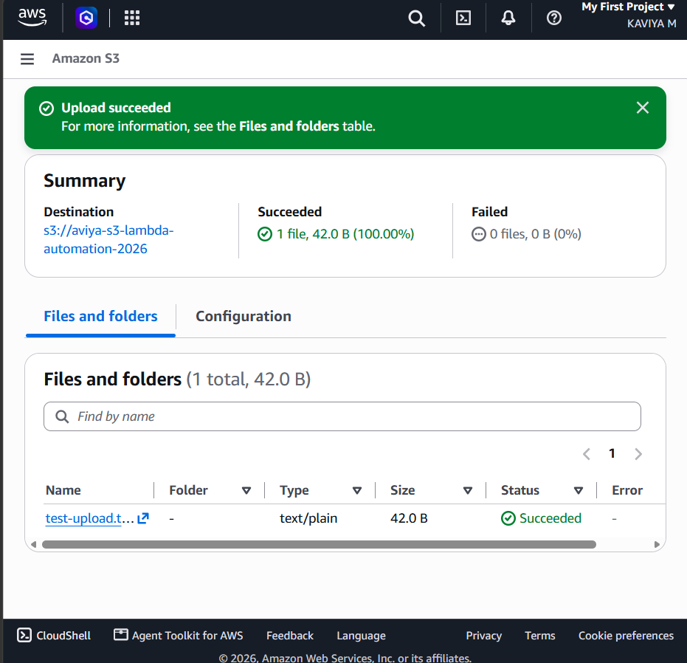
Step 6: CloudWatch Log Events – Lambda Triggered by the Upload
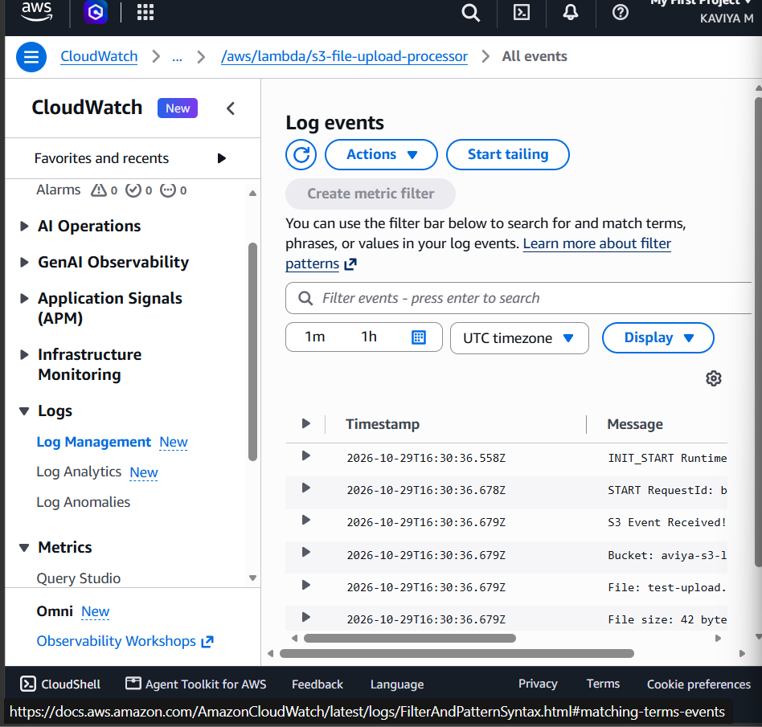
Step 7: CloudWatch Logs Output – Bucket Name, File Name and File Size
