**Difference between JPA, Hibernate and Spring Data JPA**

Java Persistence API (JPA)

* JSR 338 Specification for persisting, reading and managing data from Java objects
* Does not contain concrete implementation of the specification
* Hibernate is one of the implementation of JPA

Hibernate

* ORM Tool that implements JPA

Spring Data JPA

* Does not have JPA implementation, but reduces boiler plate code
* This is another level of abstraction over JPA implementation provider like Hibernate
* Manages transactions

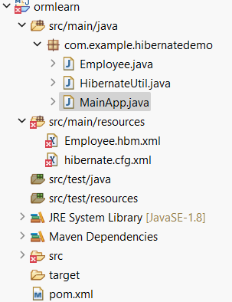

**Employee.java**

**package** com.example.hibernatedemo;

**public** **class** Employee {

**private** **int** id;

**private** String firstName;

**private** String lastName;

**private** **float** salary;

**public** **int** getId() { **return** id; }

**public** **void** setId(**int** id) { **this**.id = id; }

**public** String getFirstName() { **return** firstName; }

**public** **void** setFirstName(String firstName) { **this**.firstName = firstName; }

**public** String getLastName() { **return** lastName; }

**public** **void** setLastName(String lastName) { **this**.lastName = lastName; }

**public** **float** getSalary() { **return** salary; }

**public** **void** setSalary(**float** salary) { **this**.salary = salary; }

}

**HibernateUtil.java**

**package** com.example.hibernatedemo;

**import** org.hibernate.SessionFactory;

**import** org.hibernate.cfg.Configuration;

**public** **class** HibernateUtil {

**private** **static** **final** SessionFactory ***sessionFactory***;

**static** {

**try** {

***sessionFactory*** = **new** Configuration().configure().buildSessionFactory();

} **catch** (Throwable ex) {

**throw** **new** ExceptionInInitializerError(ex);

}

}

**public** **static** SessionFactory getSessionFactory() {

**return** ***sessionFactory***;

}

}

**MainApp.java**

**package** com.example.hibernatedemo;

**import** org.hibernate.Session;

**import** org.hibernate.Transaction;

**public** **class** MainApp {

**public** **static** **void** main(String[] args) {

Session session = HibernateUtil.*getSessionFactory*().openSession();

Transaction tx = **null**;

**try** {

tx = session.beginTransaction();

Employee emp = **new** Employee();

emp.setFirstName("John");

emp.setLastName("Doe");

emp.setSalary(55000);

session.save(emp);

tx.commit();

System.***out***.println("Employee inserted.");

} **catch** (Exception e) {

**if** (tx != **null**) tx.rollback();

e.printStackTrace();

} **finally** {

session.close();

}

}

}

**Employee.hbm.xml**

<?xml version="1.0" encoding="utf-8"?>

<!DOCTYPE hibernate-mapping PUBLIC

"-//Hibernate/Hibernate Mapping DTD 3.0//EN"

"http://hibernate.sourceforge.net/hibernate-mapping-3.0.dtd">

<hibernate-mapping>

<class name="com.example.hibernatedemo.Employee" table="EMPLOYEE">

<id name="id" column="ID">

<generator class="native"/>

</id>

<property name="firstName" column="FIRST_NAME"/>

<property name="lastName" column="LAST_NAME"/>

<property name="salary" column="SALARY"/>

</class>

</hibernate-mapping>

**Hibernate.cfg.xml**

<?xml version='1.0' encoding='utf-8'?>

<!DOCTYPE hibernate-configuration PUBLIC

"-//Hibernate/Hibernate Configuration DTD 3.0//EN"

"http://hibernate.sourceforge.net/hibernate-configuration-3.0.dtd">

<hibernate-configuration>

<session-factory>

<property name="hibernate.connection.driver_class">com.mysql.cj.jdbc.Driver</property>

<property name="hibernate.connection.url">jdbc:mysql://localhost:3306/ormlearn</property>

<property name="hibernate.connection.username">root</property>

<property name="hibernate.connection.password">your-password</property>

<property name="hibernate.dialect">org.hibernate.dialect.MySQLDialect</property>

<property name="hibernate.show_sql">true</property>

<mapping resource="Employee.hbm.xml"/>

</session-factory>

</hibernate-configuration>

**Pom.xml**

project xmlns="http://maven.apache.org/POM/4.0.0"

xmlns:xsi="http://www.w3.org/2001/XMLSchema-instance"

xsi:schemaLocation="http://maven.apache.org/POM/4.0.0 http://maven.apache.org/xsd/maven-4.0.0.xsd">

<modelVersion>4.0.0</modelVersion>

<groupId>com.example</groupId>

<artifactId>ormlearn</artifactId>

<version>1.0-SNAPSHOT</version>

<dependencies>

<dependency>

<groupId>org.hibernate</groupId>

<artifactId>hibernate-core</artifactId>

<version>5.6.15.Final</version>

</dependency>

<dependency>

<groupId>mysql</groupId>

<artifactId>mysql-connector-java</artifactId>

<version>8.0.29</version>

</dependency>

</dependencies>

</project>

**MYSQL**

Create Database ormlearn;

USE ormlearn;

CREATE TABLE EMPLOYEE (

ID INT PRIMARY KEY AUTO_INCREMENT,

FIRST_NAME VARCHAR(50),

LAST_NAME VARCHAR(50),

SALARY FLOAT

);

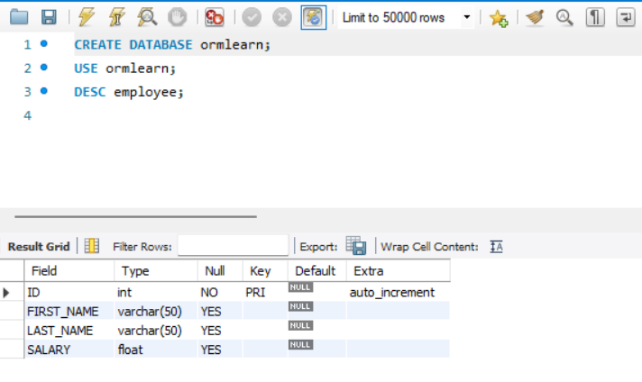

**Output:**

