**Create a Spring Web Project using Maven**

Spring intializer

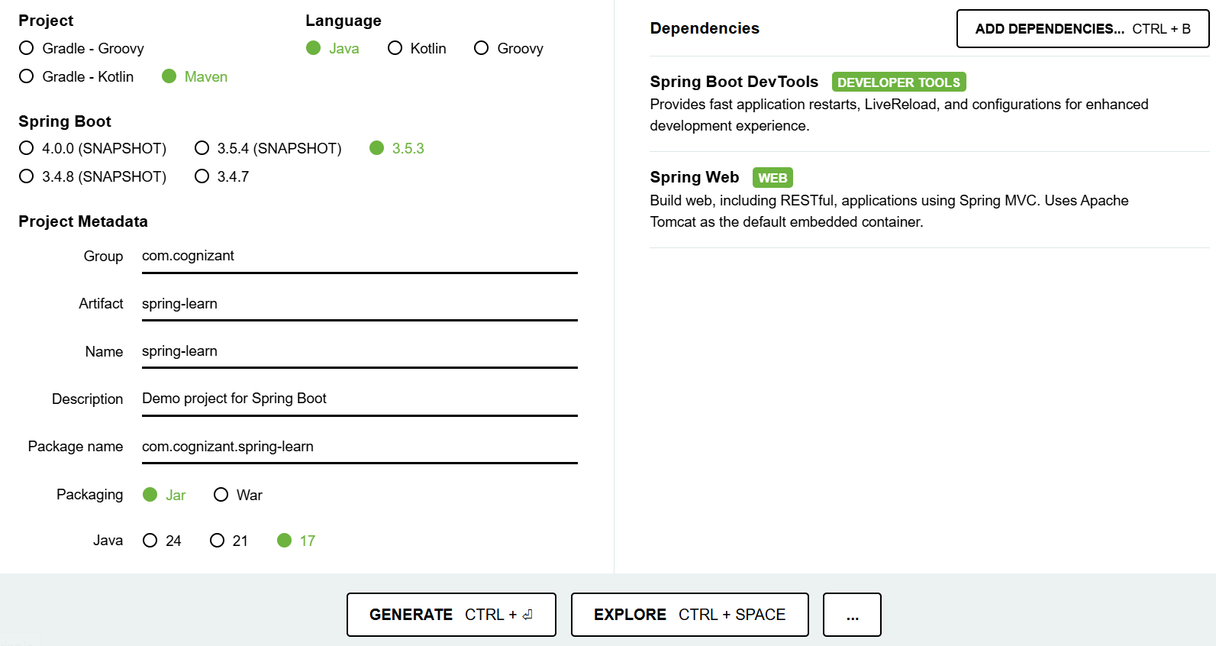

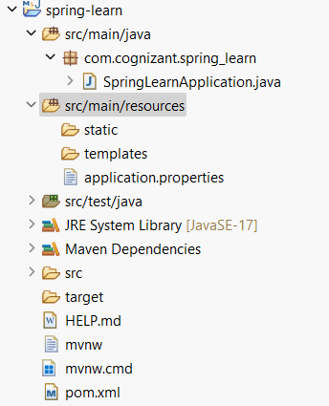

**SpringLearnApplication.java**

**package** com.cognizant.spring_learn;

**import** org.springframework.boot.SpringApplication;

**import** org.springframework.boot.autoconfigure.SpringBootApplication;

@SpringBootApplication

**public** **class** SpringLearnApplication {

**public** **static** **void** main(String[] args) {

System.***out***.println("SpringLearnApplication started...");

SpringApplication.*run*(SpringLearnApplication.**class**, args);

}

}

**Pom.xml**

<project xmlns="http://maven.apache.org/POM/4.0.0"

xmlns:xsi="http://www.w3.org/2001/XMLSchema-instance"

xsi:schemaLocation="http://maven.apache.org/POM/4.0.0

http://maven.apache.org/xsd/maven-4.0.0.xsd">

<modelVersion>4.0.0</modelVersion>

<groupId>com.cognizant</groupId>

<artifactId>spring-learn</artifactId>

<version>0.0.1-SNAPSHOT</version>

<name>spring-learn</name>

<description>Demo project for Spring Boot</description>

<packaging>jar</packaging>

<parent>

<groupId>org.springframework.boot</groupId>

<artifactId>spring-boot-starter-parent</artifactId>

<version>3.2.0</version> <!-- or latest version -->

<relativePath/> <!-- lookup parent from repository -->

</parent>

<dependencies>

<!-- Spring Boot Starter Web -->

<dependency>

<groupId>org.springframework.boot</groupId>

<artifactId>spring-boot-starter-web</artifactId>

</dependency>

<!-- Spring Boot DevTools -->

<dependency>

<groupId>org.springframework.boot</groupId>

<artifactId>spring-boot-devtools</artifactId>

<scope>runtime</scope>

<optional>true</optional>

</dependency>

<!-- Test -->

<dependency>

<groupId>org.springframework.boot</groupId>

<artifactId>spring-boot-starter-test</artifactId>

<scope>test</scope>

</dependency>

</dependencies>

<build>

<plugins>

<!-- Spring Boot Maven Plugin -->

<plugin>

<groupId>org.springframework.boot</groupId>

<artifactId>spring-boot-maven-plugin</artifactId>

</plugin>

</plugins>

</build>

</project>

**OUTPUT:**

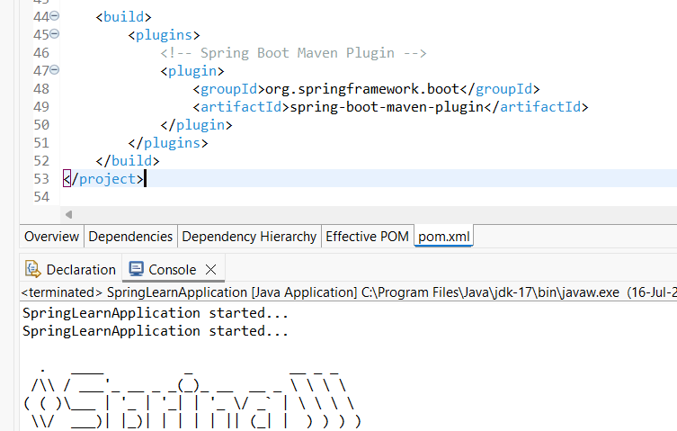

**Spring Core – Load Country from Spring Configuration XML**

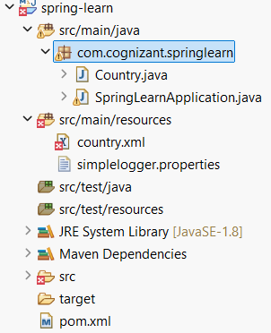

**Country.java**

**package** com.cognizant.springlearn;

**import** org.slf4j.Logger;

**import** org.slf4j.LoggerFactory;

**public** **class** Country {

**private** **static** **final** Logger ***LOGGER*** = LoggerFactory.*getLogger*(Country.**class**);

**private** String code;

**private** String name;

**public** Country() {

***LOGGER***.debug("Inside Country Constructor.");

}

**public** String getCode() {

***LOGGER***.debug("Getting country code: {}", code);

**return** code;

}

**public** **void** setCode(String code) {

***LOGGER***.debug("Setting country code: {}", code);

**this**.code = code;

}

**public** String getName() {

***LOGGER***.debug("Getting country name: {}", name);

**return** name;

}

**public** **void** setName(String name) {

***LOGGER***.debug("Setting country name: {}", name);

**this**.name = name;

}

@Override

**public** String toString() {

**return** "Country [code=" + code + ", name=" + name + "]";

}

}

**SpringLearnApplication.java**

**package** com.cognizant.springlearn;

**import** org.slf4j.Logger;

**import** org.slf4j.LoggerFactory;

**import** org.springframework.context.ApplicationContext;

**import** org.springframework.context.support.ClassPathXmlApplicationContext;

**public** **class** SpringLearnApplication {

**private** **static** **final** Logger ***LOGGER*** = LoggerFactory.*getLogger*(SpringLearnApplication.**class**);

**public** **static** **void** main(String[] args) {

***LOGGER***.info("START");

*displayCountry*();

***LOGGER***.info("END");

}

**public** **static** **void** displayCountry() {

ApplicationContext context = **new** ClassPathXmlApplicationContext("country.xml");

Country country = context.getBean("country", Country.**class**);

***LOGGER***.debug("Country : {}", country.toString());

}

}

**Country.xml**

<?xml version="1.0" encoding="UTF-8"?>

<beans xmlns="http://www.springframework.org/schema/beans"

xmlns:xsi="http://www.w3.org/2001/XMLSchema-instance"

xsi:schemaLocation="http://www.springframework.org/schema/beans

http://www.springframework.org/schema/beans/spring-beans.xsd">

<bean id="country" class="com.cognizant.springlearn.Country">

<property name="code" value="IN" />

<property name="name" value="India" />

</bean>

</beans>

Simplelogger.properties

org.slf4j.simpleLogger.defaultLogLevel=debug

pom.xml

<project xmlns="http://maven.apache.org/POM/4.0.0"

xmlns:xsi="http://www.w3.org/2001/XMLSchema-instance"

xsi:schemaLocation="http://maven.apache.org/POM/4.0.0

http://maven.apache.org/xsd/maven-4.0.0.xsd">

<modelVersion>4.0.0</modelVersion>

<groupId>com.cognizant</groupId>

<artifactId>spring-learn</artifactId>

<version>0.0.1-SNAPSHOT</version>

<dependencies>

<!-- Spring Context -->

<dependency>

<groupId>org.springframework</groupId>

<artifactId>spring-context</artifactId>

<version>5.3.33</version>

</dependency>

<!-- SLF4J Logging -->

<dependency>

<groupId>org.slf4j</groupId>

<artifactId>slf4j-api</artifactId>

<version>2.0.13</version>

</dependency>

<dependency>

<groupId>org.slf4j</groupId>

<artifactId>slf4j-simple</artifactId>

<version>2.0.13</version>

</dependency>

</dependencies>

</project>

**Output**

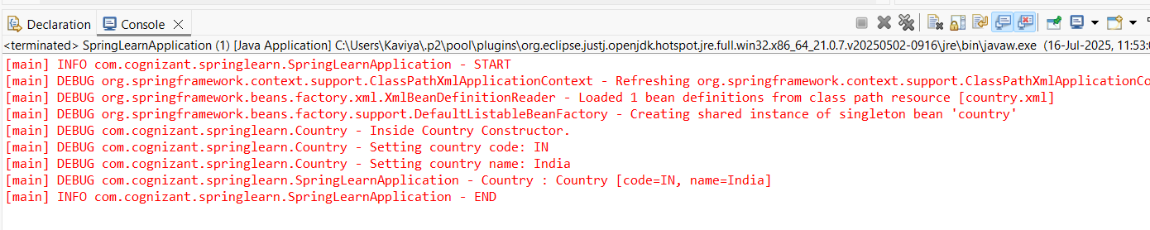

**Hello World RESTful Web Service**

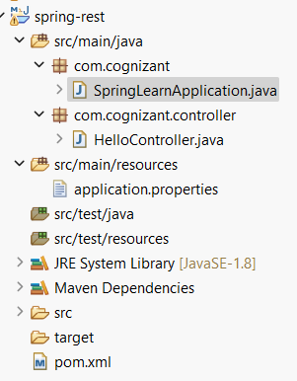

**SpringLearnApplication.java**

**package** com.cognizant;

**import** org.springframework.boot.SpringApplication;

**import** org.springframework.boot.autoconfigure.SpringBootApplication;

@SpringBootApplication

**public** **class** SpringLearnApplication {

**public** **static** **void** main(String[] args) {

SpringApplication.*run*(SpringLearnApplication.**class**, args);

}

**HelloController.java**

**package** com.cognizant.controller;

**import** org.slf4j.Logger;

**import** org.slf4j.LoggerFactory;

**import** org.springframework.web.bind.annotation.GetMapping;

**import** org.springframework.web.bind.annotation.RestController;

@RestController

**public** **class** HelloController {

**private** **static** **final** Logger ***LOGGER*** = LoggerFactory.getLogger(HelloController.**class**);

@GetMapping("/hello")

**public** String sayHello() {

***LOGGER***.info("START - sayHello()");

String message = "Hello World!!";

***LOGGER***.info("END - sayHello()");

**return** message;

}

}

**application.properties**

server.port=8083

**pom.xml**

<project xmlns="http://maven.apache.org/POM/4.0.0"

xmlns:xsi="http://www.w3.org/2001/XMLSchema-instance"

xsi:schemaLocation="http://maven.apache.org/POM/4.0.0

http://maven.apache.org/xsd/maven-4.0.0.xsd">

<modelVersion>4.0.0</modelVersion>

<groupId>com.cognizant</groupId>

<artifactId>spring-rest</artifactId>

<version>1.0.0</version>

<packaging>jar</packaging>

<name>spring-rest</name>

<description>Spring Boot Hello World REST API</description>

<!-- Spring Boot Parent -->

<parent>

<groupId>org.springframework.boot</groupId>

<artifactId>spring-boot-starter-parent</artifactId>

<version>2.7.5</version> <!-- Or use latest stable version -->

<relativePath/>

</parent>

<properties>

<java.version>11</java.version> <!-- Use 17 if your JDK is 17 -->

</properties>

<dependencies>

<!-- Spring Web for REST controllers -->

<dependency>

<groupId>org.springframework.boot</groupId>

<artifactId>spring-boot-starter-web</artifactId>

</dependency>

<!-- Logging (comes with web) -->

<dependency>

<groupId>org.springframework.boot</groupId>

<artifactId>spring-boot-starter-logging</artifactId>

</dependency>

<!-- Optional: Spring Boot testing -->

<dependency>

<groupId>org.springframework.boot</groupId>

<artifactId>spring-boot-starter-test</artifactId>

<scope>test</scope>

</dependency>

</dependencies>

<build>

<plugins>

<!-- Enables `mvn spring-boot:run` and JAR packaging -->

<plugin>

<groupId>org.springframework.boot</groupId>

<artifactId>spring-boot-maven-plugin</artifactId>

</plugin>

</plugins>

</build>

</project>

**Console output**

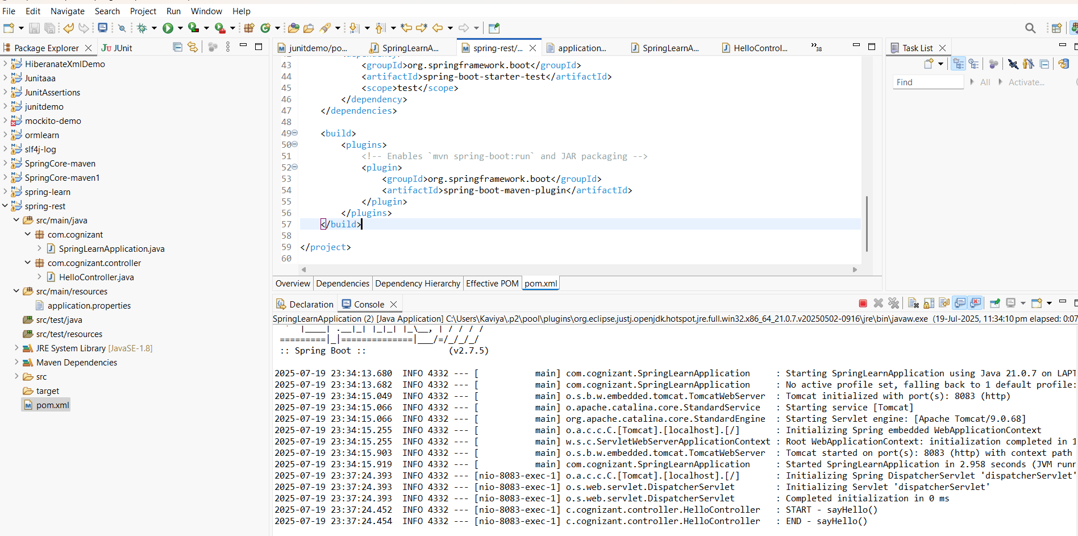

URL : http://localhost:8083/hello

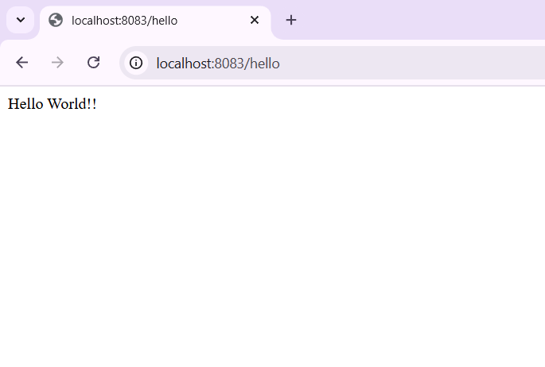

**REST - Country Web Service**

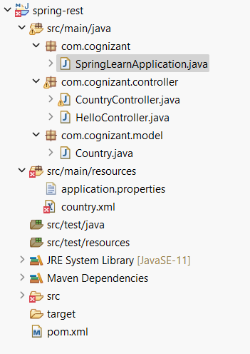

**SpringLearnApplication.java**

**package** com.cognizant;

**import** org.springframework.boot.SpringApplication;

**import** org.springframework.boot.autoconfigure.SpringBootApplication;

@SpringBootApplication(scanBasePackages = "com.cognizant")

**public** **class** SpringLearnApplication {

**public** **static** **void** main(String[] args) {

SpringApplication.*run*(SpringLearnApplication.**class**, args);

}

}

**CountryController.java**

**package** com.cognizant.controller;

**import** com.cognizant.model.Country;

**import** org.springframework.context.ApplicationContext;

**import** org.springframework.context.support.ClassPathXmlApplicationContext;

**import** org.springframework.web.bind.annotation.RequestMapping;

**import** org.springframework.web.bind.annotation.RestController;

@RestController

**public** **class** CountryController {

@RequestMapping("/country")

**public** Country getCountryIndia() {

ApplicationContext context = **new** ClassPathXmlApplicationContext("country.xml");

Country india = (Country) context.getBean("in");

**return** india;

}

}

**HelloController.java**

**package** com.cognizant.controller;

**import** org.slf4j.Logger;

**import** org.slf4j.LoggerFactory;

**import** org.springframework.web.bind.annotation.GetMapping;

**import** org.springframework.web.bind.annotation.RestController;

@RestController

**public** **class** HelloController {

**private** **static** **final** Logger ***LOGGER*** = LoggerFactory.*getLogger*(HelloController.**class**);

@GetMapping("/hello")

**public** String sayHello() {

***LOGGER***.info("START - sayHello()");

String message = "Hello World!!";

***LOGGER***.info("END - sayHello()");

**return** message;

}}

**Country.java**

**package** com.cognizant.model;

**public** **class** Country {

**private** String code;

**private** String name;

**public** Country() {}

**public** Country(String code, String name) {

**this**.code = code;

**this**.name = name;

}

**public** String getCode() {

**return** code;

}

**public** **void** setCode(String code) {

**this**.code = code;

}

**public** String getName() {

**return** name;

}

**public** **void** setName(String name) {

**this**.name = name;

}

}

**Country.xml**

<?xml version="1.0" encoding="UTF-8"?>

<beans xmlns="http://www.springframework.org/schema/beans"

xmlns:xsi="http://www.w3.org/2001/XMLSchema-instance"

xsi:schemaLocation="

http://www.springframework.org/schema/beans

http://www.springframework.org/schema/beans/spring-beans.xsd">

<bean id="in" class="com.cognizant.model.Country">

<property name="code" value="IN"/>

<property name="name" value="India"/>

</bean>

</beans>

**Pom.xml**

<project xmlns="http://maven.apache.org/POM/4.0.0"

xmlns:xsi="http://www.w3.org/2001/XMLSchema-instance"

xsi:schemaLocation="http://maven.apache.org/POM/4.0.0

http://maven.apache.org/xsd/maven-4.0.0.xsd">

<modelVersion>4.0.0</modelVersion>

<!-- Project coordinates -->

<groupId>com.cognizant</groupId>

<artifactId>spring-rest</artifactId>

<version>1.0.0</version>

<packaging>jar</packaging>

<name>spring-rest</name>

<description>Spring Boot REST Web Service Project</description>

<!-- Spring Boot parent -->

<parent>

<groupId>org.springframework.boot</groupId>

<artifactId>spring-boot-starter-parent</artifactId>

<version>2.7.5</version> <!-- You can change to latest stable version -->

<relativePath/>

</parent>

<properties>

<java.version>11</java.version> <!-- Change to 17 if using JDK 17 -->

</properties>

<dependencies>

<!-- Spring Boot Starter for building REST APIs -->

<dependency>

<groupId>org.springframework.boot</groupId>

<artifactId>spring-boot-starter-web</artifactId>

</dependency>

<!-- Spring Context (for XML-based bean loading) -->

<dependency>

<groupId>org.springframework</groupId>

<artifactId>spring-context</artifactId>

</dependency>

<!-- Logging support (comes with spring-boot-starter-web) -->

<dependency>

<groupId>org.springframework.boot</groupId>

<artifactId>spring-boot-starter-logging</artifactId>

</dependency>

<!-- Spring Boot Testing (optional) -->

<dependency>

<groupId>org.springframework.boot</groupId>

<artifactId>spring-boot-starter-test</artifactId>

<scope>test</scope>

</dependency>

</dependencies>

<build>

<plugins>

<!-- Spring Boot Maven plugin to enable spring-boot:run -->

<plugin>

<groupId>org.springframework.boot</groupId>

<artifactId>spring-boot-maven-plugin</artifactId>

</plugin>

</plugins>

</build>

</project>

**OUTPUT**

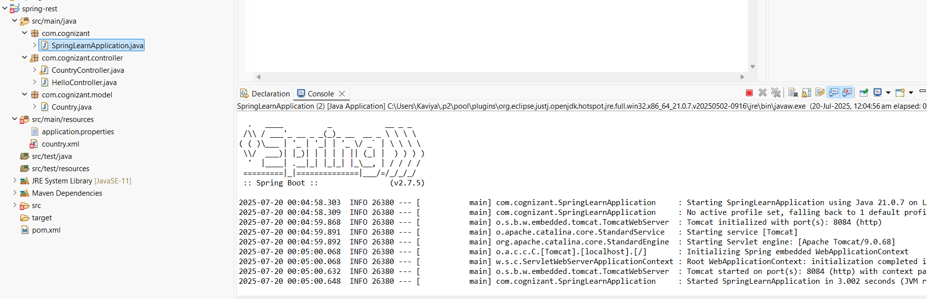

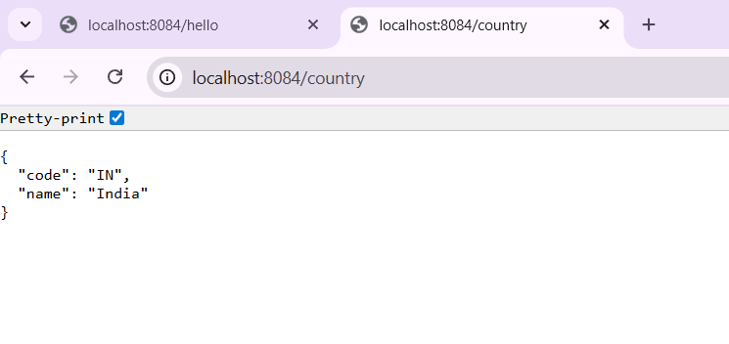

**REST - Get country based on country code**

**SpringRestApplication.java**

package com.cognizant;

import org.springframework.boot.SpringApplication;

import org.springframework.boot.autoconfigure.SpringBootApplication;

import org.springframework.context.annotation.ImportResource;

@SpringBootApplication

@ImportResource("classpath:country.xml")

public class SpringRestApplication {

public static void main(String[] args) {

SpringApplication.*run*(SpringRestApplication.class, args);

}

}

**CountryController.java**

**package** com.cognizant.controller;

**import** com.cognizant.model.Country;

**import** com.cognizant.service.CountryService;

**import** org.springframework.beans.factory.annotation.Autowired;

**import** org.springframework.web.bind.annotation.*;

@RestController

**public** **class** CountryController {

@Autowired

**private** CountryService countryService;

@GetMapping("/countries/{code}")

**public** Country getCountry(@PathVariable String code) {

**return** countryService.getCountry(code);

}

}

**Country.java**

**package** com.cognizant.model;

**public** **class** Country {

**private** String code;

**private** String name;

**public** Country() {}

**public** Country(String code, String name) {

**this**.code = code;

**this**.name = name;

}

**public** String getCode() {

**return** code;

}

**public** **void** setCode(String code) {

**this**.code = code;

}

**public** String getName() {

**return** name;

}

**public** **void** setName(String name) {

**this**.name = name;

}

}

**CountryNotFoundException**

**package** com.cognizant.service;

**public** **class** CountryNotFoundException **extends** RuntimeException {

**public** CountryNotFoundException(String message) {

**super**(message);

}

}

**CountryService.java**

**package** com.cognizant.service;

**import** com.cognizant.model.Country;

**import** org.springframework.beans.factory.annotation.Autowired;

**import** org.springframework.stereotype.Service;

**import** java.util.List;

@Service

**public** **class** CountryService {

@Autowired

**private** List<Country> countryList;

**public** Country getCountry(String code) {

**return** countryList.stream()

.filter(c -> c.getCode().equalsIgnoreCase(code))

.findFirst()

.orElseThrow(() -> **new** CountryNotFoundException("Country code " + code + " not found"));

}

}

**Country.xml**

<?xml version="1.0" encoding="UTF-8"?>

<beans xmlns="http://www.springframework.org/schema/beans"

xmlns:xsi="http://www.w3.org/2001/XMLSchema-instance"

xsi:schemaLocation="http://www.springframework.org/schema/beans

http://www.springframework.org/schema/beans/spring-beans.xsd">

<bean id="country" class="com.cognizant.model.Country">

<property name="code" value="IN"/>

<property name="name" value="India"/>

</bean>

<bean id="countryList" class="java.util.ArrayList">

<constructor-arg>

<list>

<ref bean="country"/>

<bean class="com.cognizant.model.Country">

<property name="code" value="US"/>

<property name="name" value="United States"/>

</bean>

<bean class="com.cognizant.model.Country">

<property name="code" value="FR"/>

<property name="name" value="France"/>

</bean>

</list>

</constructor-arg>

</bean>

</beans>

**Pom.xml**

**<**project xmlns="http://maven.apache.org/POM/4.0.0"

xmlns:xsi="http://www.w3.org/2001/XMLSchema-instance"

xsi:schemaLocation="http://maven.apache.org/POM/4.0.0

http://maven.apache.org/xsd/maven-4.0.0.xsd">

<modelVersion>4.0.0</modelVersion>

<groupId>com.cognizant</groupId>

<artifactId>springrest</artifactId>

<version>1.0.0</version>

<packaging>jar</packaging>

<name>springrest</name>

<description>Spring Boot REST to get country by code</description>

<parent>

<groupId>org.springframework.boot</groupId>

<artifactId>spring-boot-starter-parent</artifactId>

<version>3.1.1</version>

<relativePath/>

</parent>

<properties>

<java.version>17</java.version>

</properties>

<dependencies>

<!-- Spring Web -->

<dependency>

<groupId>org.springframework.boot</groupId>

<artifactId>spring-boot-starter-web</artifactId>

</dependency>

<!-- XML Config Support -->

<dependency>

<groupId>org.springframework.boot</groupId>

<artifactId>spring-boot-starter</artifactId>

</dependency>

<!-- Optional: Testing -->

<dependency>

<groupId>org.springframework.boot</groupId>

<artifactId>spring-boot-starter-test</artifactId>

<scope>test</scope>

</dependency>

</dependencies>

<build>

<plugins>

<!-- Spring Boot Plugin -->

<plugin>

<groupId>org.springframework.boot</groupId>

<artifactId>spring-boot-maven-plugin</artifactId>

</plugin>

</plugins>

</build>

</project>

**Application.properties**

server.port=8085

OUTPUT:

