**CREATING MICROSERVICES FOR ACCOUNT AND LOAN**

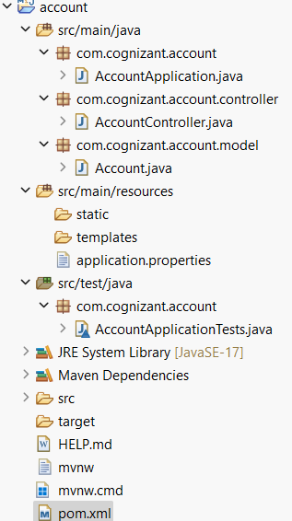

**AccountApplication.java**

package com.cognizant.account;

import org.springframework.boot.SpringApplication;

import org.springframework.boot.autoconfigure.SpringBootApplication;

@SpringBootApplication

public class AccountApplication {

public static void main(String[] args) {

SpringApplication.*run*(AccountApplication.class, args);

}

}

**AccountController.java**

**package** com.cognizant.account.controller;

**import** com.cognizant.account.model.Account;

**import** org.springframework.web.bind.annotation.*;

@RestController

**public** **class** AccountController {

@GetMapping("/accounts/{number}")

**public** Account getAccountDetails(@PathVariable String number) {

**return** **new** Account(number, "savings", 234343.0);

}

}

**Account.java**

**package** com.cognizant.account.model;

**public** **class** Account {

**private** String number;

**private** String type;

**private** **double** balance;

**public** Account(String number, String type, **double** balance) {

**this**.number = number;

**this**.type = type;

**this**.balance = balance;

}

**public** String getNumber() {

**return** number;

}

**public** String getType() {

**return** type;

}

**public** **double** getBalance() {

**return** balance;

}

}

**Application.properties**

spring.application.name=account

# Server will run on port 8080 (default)

server.port=8080

**AccountApplicationTests.java**

**package** com.cognizant.account;

**import** org.junit.jupiter.api.Test;

**import** org.springframework.boot.test.context.SpringBootTest;

@SpringBootTest

**class** AccountApplicationTests {

@Test

**void** contextLoads() {

}

}

**Pom.xml**

<project xmlns="http://maven.apache.org/POM/4.0.0"

xmlns:xsi="http://www.w3.org/2001/XMLSchema-instance"

xsi:schemaLocation="http://maven.apache.org/POM/4.0.0

http://maven.apache.org/xsd/maven-4.0.0.xsd">

<modelVersion>4.0.0</modelVersion>

<groupId>com.cognizant</groupId>

<artifactId>account</artifactId>

<version>0.0.1-SNAPSHOT</version>

<name>account</name>

<description>Account Microservice</description>

<packaging>jar</packaging>

<parent>

<groupId>org.springframework.boot</groupId>

<artifactId>spring-boot-starter-parent</artifactId>

<version>3.2.4</version>

<relativePath/>

</parent>

<properties>

<java.version>17</java.version>

</properties>

<dependencies>

<!-- Spring Web -->

<dependency>

<groupId>org.springframework.boot</groupId>

<artifactId>spring-boot-starter-web</artifactId>

</dependency>

<!-- DevTools -->

<dependency>

<groupId>org.springframework.boot</groupId>

<artifactId>spring-boot-devtools</artifactId>

<scope>runtime</scope>

</dependency>

<!-- Test (optional) -->

<dependency>

<groupId>org.springframework.boot</groupId>

<artifactId>spring-boot-starter-test</artifactId>

<scope>test</scope>

</dependency>

</dependencies>

<build>

<plugins>

<!-- Spring Boot Maven Plugin -->

<plugin>

<groupId>org.springframework.boot</groupId>

<artifactId>spring-boot-maven-plugin</artifactId>

</plugin>

</plugins>

</build>

</project>

WEB:

http://localhost:8080/accounts/00987987973432

OUTPUT:

