REACT 1:

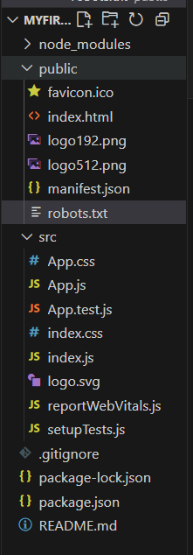

**App.js**

import React from 'react';

function App() {

  return (

    <div>

      <h1>Welcome to the first session of React</h1>

    </div>

  );

}

export default App;

**App.css**

.App {

  text-align: center;

}

.App-logo {

  height: 40vmin;

  pointer-events: none;

}

@media (prefers-reduced-motion: no-preference) {

  .App-logo {

    animation: App-logo-spin infinite 20s linear;

  }

}

.App-header {

  background-color: #282c34;

  min-height: 100vh;

  display: flex;

  flex-direction: column;

  align-items: center;

  justify-content: center;

  font-size: calc(10px + 2vmin);

  color: white;

}

.App-link {

  color: #61dafb;

}

@keyframes App-logo-spin {

  from {

    transform: rotate(0deg);

  }

  to {

    transform: rotate(360deg);

  }

}

OUTPUT:

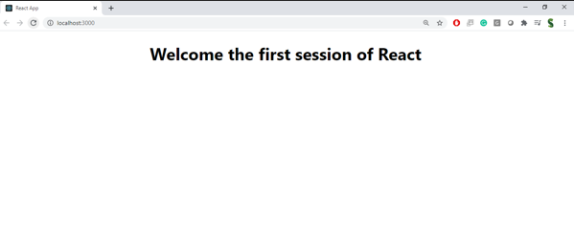

**REACT 2**

Create a react app for Student Management Portal named StudentApp and create a component named Home which will display the Message “Welcome to the Home page of Student Management Portal”. Create another component named About and display the Message “Welcome to the About page of the Student Management Portal”. Create a third component named Contact and display the Message “Welcome to the Contact page of the Student Management Portal”. Call all the three components

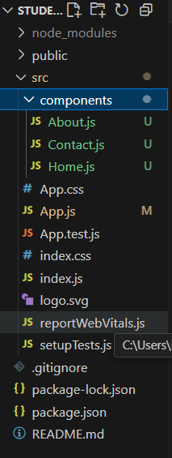

**About.js**

// src/Components/About.js

import React, { Component } from 'react';

class About extends Component {

  render() {

    return (

      <div>

        <h2>Welcome to the About page of the Student Management Portal</h2>

      </div>

    );

  }

}

export default About;

**Contact.js**

import React, { Component } from 'react';

class Contact extends Component {

  render() {

    return (

      <div>

        <h2>Welcome to the Contact page of Student Management Portal</h2>

      </div>

    );

  }

}

export default Contact;

**Home.js**

// src/Components/Home.js

import React, { Component } from 'react';

class Home extends Component {

  render() {

    return (

      <div>

        <h2>Welcome to the Home page of Student Management Portal</h2>

      </div>

    );

  }

}

export default Home;

**App.js**

import React from 'react';

import './App.css';

import Home from './Components/Home';

import About from './Components/About';

import Contact from './Components/Contact';

function App() {

return (

<div className="App">

<Home />

<About />

<Contact />

</div>

);

}

export default App;

OUTPUT:

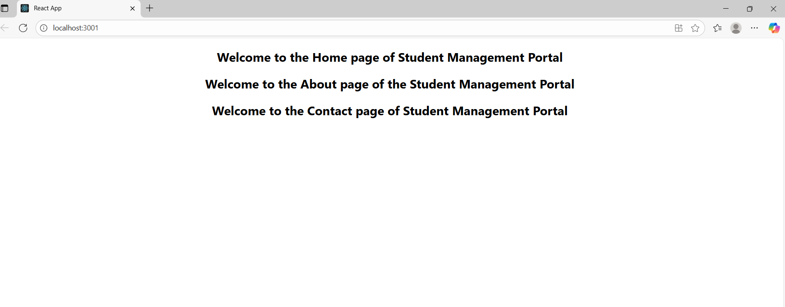

REACT 3:

Create a react app for Student Management Portal named scorecalculatorapp and create a function component named “CalculateScore” which will accept Name, School, Total and goal in order to calculate the average score of a student and display the same.

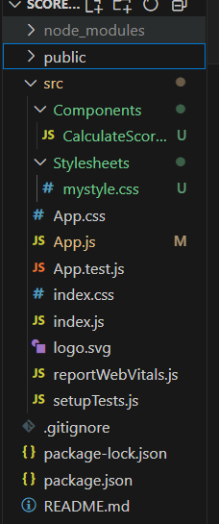

**// src/Components/CalculateScore.js**

import React from "react";

import "../Stylesheets/mystyle.css";

function CalculateScore({ name, school, total, goal }) {

// Calculate average

const average = (total / goal).toFixed(2);

return (

<div className="score-card">

<h2>Student Score Calculator</h2>

<p><strong>Name:</strong> {name}</p>

<p><strong>School:</strong> {school}</p>

<p><strong>Total Score:</strong> {total}</p>

<p><strong>Goal Score:</strong> {goal}</p>

<p className="average"><strong>Average:</strong> {average}</p>

</div>

);

}

export default CalculateScore;

**mystyle.css**

.score-card {

background-color: #f4f4f4;

padding: 20px;

margin: 15px auto;

width: 350px;

border-radius: 10px;

text-align: left;

box-shadow: 0px 4px 8px rgba(0,0,0,0.2);

}

.score-card h2 {

text-align: center;

color: #2e86de;

}

.score-card p {

font-size: 16px;

margin: 8px 0;

}

.average {

color: green;

font-weight: bold;

}

**App.js**

// src/App.js

import React from "react";

import CalculateScore from "./Components/CalculateScore";

function App() {

return (

<div>

<CalculateScore

name="Kaviya"

school="ABC School"

total={450}

goal={500}

/>

</div>

);

}

export default App;

OUTPUT:

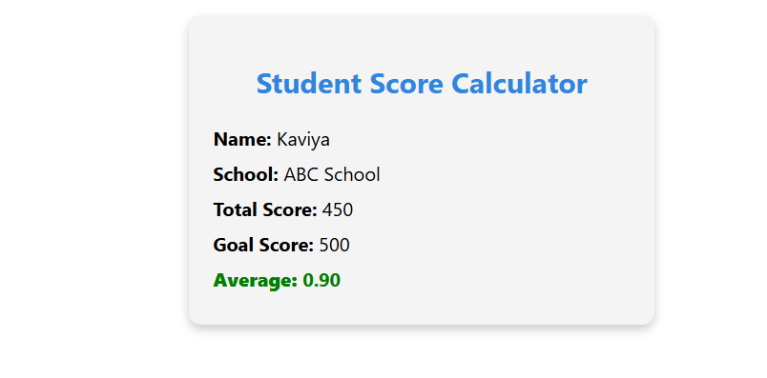

**REACT 4 :**

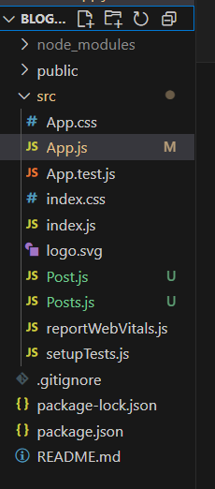

Post.js

// src/Post.js

class Post {

  constructor(userId, id, title, body) {

    this.userId = userId;

    this.id = id;

    this.title = title;

    this.body = body;

  }

}

export default Post;

posts.js

// src/Posts.js

import React, { Component } from "react";

import Post from "./Post";

class Posts extends Component {

  constructor(props) {

    super(props);

    // Initialize state

    this.state = {

      posts: [],

    };

  }

  // Method to fetch posts

  loadPosts = () => {

    fetch("https://jsonplaceholder.typicode.com/posts")

      .then((response) => response.json())

      .then((data) => {

        const postList = data.map(

          (p) => new Post(p.userId, p.id, p.title, p.body)

        );

        this.setState({ posts: postList });

      })

      .catch((error) => {

        console.error("Error fetching posts:", error);

      });

  };

  // Lifecycle method - runs after component is mounted

  componentDidMount() {

    this.loadPosts();

  }

  // Error handling lifecycle method

  componentDidCatch(error, info) {

    alert("An error occurred in Posts component!");

    console.error("Error:", error, "Info:", info);

  }

  // Render method

  render() {

    return (

      <div>

        <h1>Blog Posts</h1>

        {this.state.posts.map((post) => (

          <div key={post.id} style={{ marginBottom: "20px" }}>

            <h3>{post.title}</h3>

            <p>{post.body}</p>

            <hr />

          </div>

        ))}

      </div>

    );

  }

}

export default Posts;

App.js

// src/App.js

import React from "react";

import Posts from "./Posts";

function App() {

  return (

    <div className="App">

      <Posts />

    </div>

  );

}

export default App;

OUTPUT:

