Exercise 1: Control Structures

-- Step 1: Create Tables
-----------------------------
BEGIN
EXECUTE IMMEDIATE 'DROP TABLE Loans';
EXECUTE IMMEDIATE 'DROP TABLE Customers';
EXCEPTION
WHEN OTHERS THEN NULL;
END;
/

CREATE TABLE Customers (
CustomerID NUMBER PRIMARY KEY,
Name VARCHAR2(100),
Age NUMBER,
Balance NUMBER(10,2),
IsVIP CHAR(1) DEFAULT 'N'
);

CREATE TABLE Loans (
LoanID NUMBER PRIMARY KEY,
CustomerID NUMBER,
InterestRate NUMBER(5,2),
DueDate DATE
);

-- Step 2: Insert Sample Data
-------------------------------------
INSERT INTO Customers VALUES (1, 'Ravi', 65, 12000, 'N');
INSERT INTO Customers VALUES (2, 'Meena', 45, 8000, 'N');
INSERT INTO Customers VALUES (3, 'Kumar', 70, 15000, 'N');

INSERT INTO Loans VALUES (101, 1, 10.5, SYSDATE + 10);
INSERT INTO Loans VALUES (102, 2, 11.0, SYSDATE + 40);
INSERT INTO Loans VALUES (103, 3, 12.0, SYSDATE + 5);

COMMIT;

-- Scenario 1: Apply 1% Interest Discount to Customers Over 60
------------------------------------------------------------------------------------
BEGIN
FOR rec IN (
SELECT CustomerID FROM Customers WHERE Age > 60
) LOOP
UPDATE Loans
SET InterestRate = InterestRate - 1
WHERE CustomerID = rec.CustomerID;
END LOOP;
COMMIT;
END;
/

-- Scenario 2: Promote to VIP if Balance > 10000
----------------------------------------------------------------
BEGIN
FOR rec IN (
SELECT CustomerID FROM Customers WHERE Balance > 10000
) LOOP
UPDATE Customers
SET IsVIP = 'Y'
WHERE CustomerID = rec.CustomerID;
END LOOP;
COMMIT;
END;
/

-- Scenario 3: Reminders for Loans Due in Next 30 Days
------------------------------------------------------------------------
BEGIN
FOR rec IN (
SELECT L.LoanID, C.Name, L.DueDate
FROM Loans L
JOIN Customers C ON L.CustomerID = C.CustomerID
WHERE L.DueDate BETWEEN SYSDATE AND SYSDATE + 30
) LOOP
DBMS_OUTPUT.PUT_LINE(
'Reminder: Loan ' || rec.LoanID || ' for ' || rec.Name ||
' is due on ' || TO_CHAR(rec.DueDate, 'DD-MON-YYYY')
);
END LOOP;
END;
/

OUTPUT:
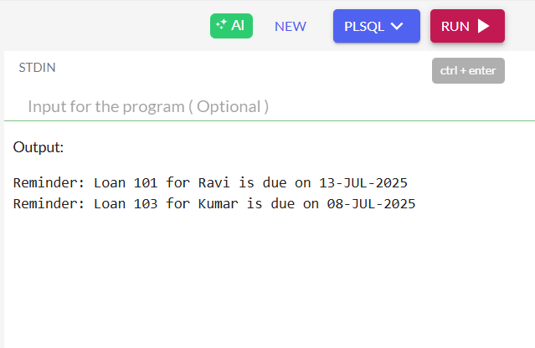

Exercise 3: Stored Procedures

Drop old tables (if any)
-------------------------------
BEGIN
EXECUTE IMMEDIATE 'DROP TABLE SavingsAccounts';
EXECUTE IMMEDIATE 'DROP TABLE Employees';
EXECUTE IMMEDIATE 'DROP TABLE Accounts';
EXCEPTION
WHEN OTHERS THEN NULL;
END;
/

Create Tables
-----------------
CREATE TABLE SavingsAccounts (
AccountID NUMBER PRIMARY KEY,
CustomerID NUMBER,
Balance NUMBER(10,2)
);

CREATE TABLE Employees (
EmpID NUMBER PRIMARY KEY,
Name VARCHAR2(100),
DepartmentID NUMBER,
Salary NUMBER(10,2)
);

CREATE TABLE Accounts (
AccountID NUMBER PRIMARY KEY,
CustomerID NUMBER,
Balance NUMBER(10,2)
);
/
Insert Sample Data
---------------------------
INSERT INTO SavingsAccounts VALUES (101, 1, 10000);
INSERT INTO SavingsAccounts VALUES (102, 2, 20000);

INSERT INTO Employees VALUES (1, 'John', 10, 50000);
INSERT INTO Employees VALUES (2, 'Priya', 10, 55000);
INSERT INTO Employees VALUES (3, 'Sam', 20, 60000);

INSERT INTO Accounts VALUES (201, 1, 15000); -- Source
INSERT INTO Accounts VALUES (202, 1, 5000); -- Target
COMMIT;

Procedure 1: ProcessMonthlyInterest
--------------------------------------------------
CREATE OR REPLACE PROCEDURE ProcessMonthlyInterest IS
BEGIN
FOR acc IN (SELECT AccountID FROM SavingsAccounts) LOOP
UPDATE SavingsAccounts
SET Balance = Balance + (Balance * 0.01)
WHERE AccountID = acc.AccountID;
END LOOP;
COMMIT;
END;
/

- Procedure 2: UpdateEmployeeBonus
---------------------------------------------------
CREATE OR REPLACE PROCEDURE UpdateEmployeeBonus (
p_dept_id IN NUMBER,
p_bonus_percent IN NUMBER
) IS
BEGIN
UPDATE Employees
SET Salary = Salary + (Salary * p_bonus_percent / 100)
WHERE DepartmentID = p_dept_id;
COMMIT;
END;
/

Procedure 3: TransferFunds
-------------------------------------
CREATE OR REPLACE PROCEDURE TransferFunds (
p_source_id IN NUMBER,
p_target_id IN NUMBER,
p_amount IN NUMBER
) IS
v_balance NUMBER;
BEGIN
SELECT Balance INTO v_balance
FROM Accounts
WHERE AccountID = p_source_id;

IF v_balance < p_amount THEN
RAISE_APPLICATION_ERROR(-20001, 'Insufficient balance in source account');
END IF;

UPDATE Accounts
SET Balance = Balance - p_amount
WHERE AccountID = p_source_id;

UPDATE Accounts
SET Balance = Balance + p_amount
WHERE AccountID = p_target_id;

COMMIT;
END;
/

Call All Procedures
---------------------------
BEGIN
DBMS_OUTPUT.PUT_LINE('Adding 1% interest to savings accounts...');
ProcessMonthlyInterest;

DBMS_OUTPUT.PUT_LINE(' Giving 10% bonus to department 10...');
UpdateEmployeeBonus(10, 10);

DBMS_OUTPUT.PUT_LINE('Transferring ₹3000 from Account 201 to 202...');
TransferFunds(201, 202, 3000);
END;
/

Show Final Output
-----------------------------
BEGIN
DBMS_OUTPUT.PUT_LINE(' Final Savings Account Balances:');
FOR rec IN (SELECT * FROM SavingsAccounts) LOOP
DBMS_OUTPUT.PUT_LINE('Account ' || rec.AccountID || ': ₹' || rec.Balance);
END LOOP;

DBMS_OUTPUT.PUT_LINE('Final Employee Salaries:');
FOR rec IN (SELECT * FROM Employees) LOOP
DBMS_OUTPUT.PUT_LINE(rec.Name || ' (Dept ' || rec.DepartmentID || '): ₹' || rec.Salary);
END LOOP;

DBMS_OUTPUT.PUT_LINE('Final Account Balances:');
FOR rec IN (SELECT * FROM Accounts) LOOP
DBMS_OUTPUT.PUT_LINE('Account ' || rec.AccountID || ': ₹' || rec.Balance);
END LOOP;
END;
/

OUTPUT
-----------
