Ex.no:8 | MINI PROJECT – BANK CUSTOMER CHURN ANALYSIS

Domain and Problem Statement:
Domain: Financial Services & Retail Banking Analytics
Problem Statement: Retail banks experience significant revenue losses and reduced customer lifetime value due to high customer churn rates across various demographic segments and credit tiers. This project addresses these challenges by transforming transactional, account-level records into business intelligence across Power BI and Tableau to evaluate retention risk drivers, analyze balance and product distributions, and identify vulnerable customer cohorts.

Dataset Description:
Dataset Name: Bank Customer Churn Modeling Dataset
Granularity: Each row represents a unique bank account customer profile.
Key Entities & Attributes:
- Demographics: CustomerId, Surname, Geography, Gender, Age.
- Booking Details: hotel, is_canceled, lead_time, arrival_date_year, arrival_date_month, arrival_date_day_of_month.
- Account & Banking Profile: CreditScore, Tenure, NumOfProducts, HasCrCard, IsActiveMember.
- Financials & Target: Balance, EstimatedSalary, Exited (1 = Churned, 0 = Retained).
Data Source:
Primary Source: Kaggle Open Datasets (Bank Customer Churn Modeling).
Storage Infrastructure: Cleaned customer account records hosted within a local MySQL database instance (bank_analytics).

Architecture:
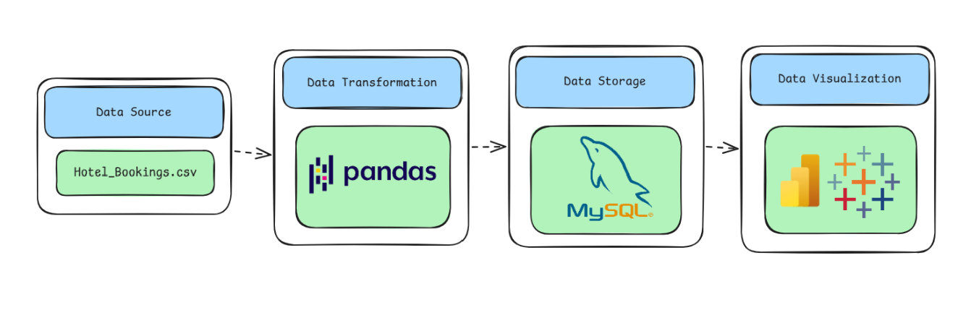
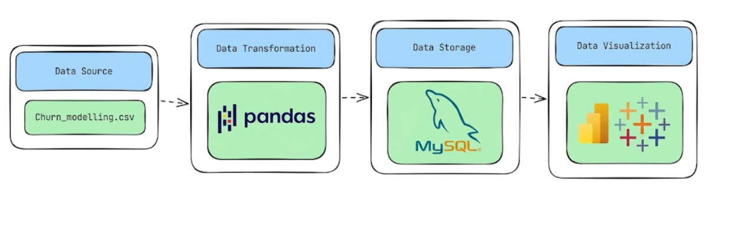
Program:
1. Python – Data Cleaning & Transformation
import pandas as pd
from sqlalchemy import create_engine, text

# Load dataset
df = pd.read_csv(r"C:\Users\Keertu\Downloads\Churn_Modelling.csv")

# Create a copy for processing
churn = df.copy()

# Remove unnecessary identifier columns
churn.drop(columns=["RowNumber", "CustomerId", "Surname"], inplace=True)

# Remove duplicate records if any exist
churn.drop_duplicates(inplace=True)

# Handle missing values (if present in specific columns)
churn["Balance"] = churn["Balance"].fillna(0)
churn["Geography"] = churn["Geography"].fillna("Unknown")

# Create derived analytical columns / business bins
# 1. Credit score tiers
churn["credit_score_segment"] = pd.cut(
churn["CreditScore"],
bins=[300, 580, 670, 740, 800, 850],
labels=["Poor", "Fair", "Good", "Very Good", "Exceptional"]
# 2. Age group categories
churn["age_group"] = pd.cut(
churn["Age"],
bins=[17, 30, 45, 60, 100],
labels=["Young Adult", "Middle-Aged", "Mature Adult", "Senior"]
)

# 3. Balance-to-estimated salary ratio
churn["balance_salary_ratio"] = (churn["Balance"] / (churn["EstimatedSalary"] + 1)).round(4)

# 4. Active engagement label
churn["engagement_status"] = churn["IsActiveMember"].map({1: "Active", 0: "Inactive"})

# 5. Churn label for readable visualization
churn["churn_label"] = churn["Exited"].map({1: "Churned", 0: "Retained"})

# Standardize column names (lowercase, no spaces, underscores)
churn.columns = (
churn.columns
.str.lower()
.str.strip()
.str.replace(" ", "_")
)

print("Original Shape:", df.shape)
print("Cleaned Shape:", churn.shape)
churn.head()
2. MySQL – Database and Data Loading
MySQL Command Prompt:
net start MySQL80
mysql -u root -p
MySQL:
CREATE DATABASE IF NOT EXISTS hotel_analytics;
Python/Jupyter:
import urllib.parse
from sqlalchemy import create_engine
import pandas as pd

# 1. Credentials
username = "root"
raw_password = "Keerthu@2108"
encoded_password = urllib.parse.quote_plus(raw_password)

host = "localhost"
port = 3306
database = "bank_analytics"

# 2. Database Engine with encoded password
db_engine = create_engine(
f"mysql+pymysql://{username}:{encoded_password}@{host}:{port}/{database}"
)

# 3. Load DataFrame into MySQL
churn.to_sql(
"bank_churn",
con=db_engine,
if_exists="replace",
index=False,
chunksize=5000
)

print("Data successfully loaded into MySQL table: bank_churn")

# 4. Verify row count
verification = pd.read_sql("SELECT COUNT(*) AS total_rows FROM bank_churn", db_engine)
print(verification)
Procedure:

Step 1: Data Preparation & Preprocessing (Python / Pandas)
- Load the raw Kaggle dataset into a Jupyter Notebook / Python script using pandas.read_csv("Churn_Modelling.csv").
- Inspect for null values and handle missing data in Balance and Geography columns, while dropping non-predictive identifier columns
- Credit score tiers (credit_score_segment via custom score bands).
- Age cohorts (age_group).
- Financial exposure ratio (balance_salary_ratio combining balance and estimatedsalary).
- Categorical status labels (engagement_status and churn_label).
Filter out invalid records (e.g., negative balances or invalid ages) and export the cleaned DataFrame to MySQL using sqlalchemy and to_sql().
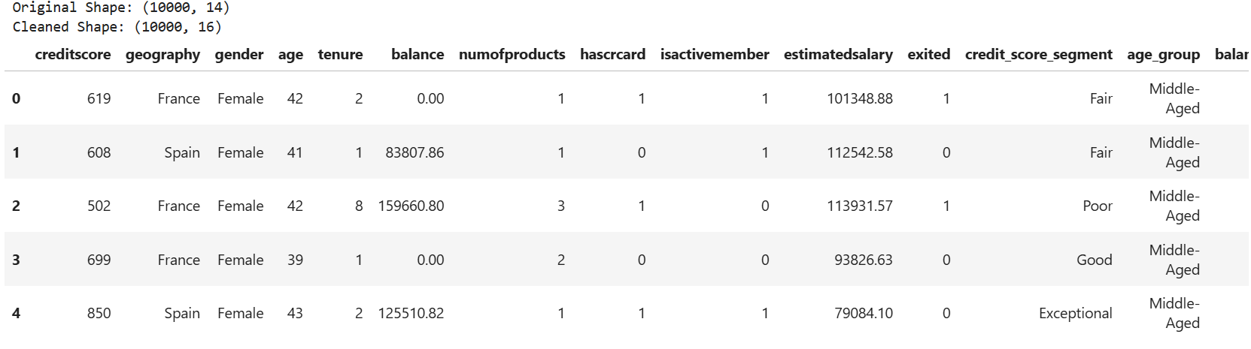
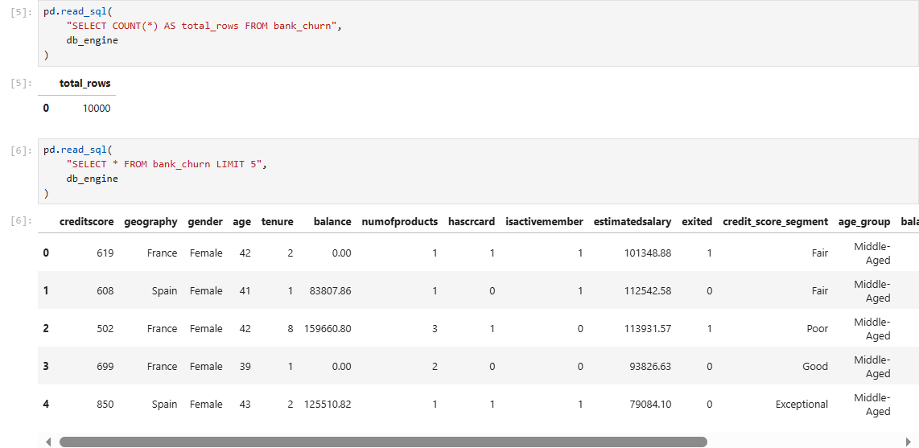

Step 2: SQL Database Connection & Data Ingestion
- Open Power BI Desktop and Get Data and Select MySQL Database.
- Enter the Server (localhost:3306) and Database Name (bank_analytics).
- Enter authentication credentials , select the cleaned flat table (bank_churn), and click Transform Data to open Power Query.

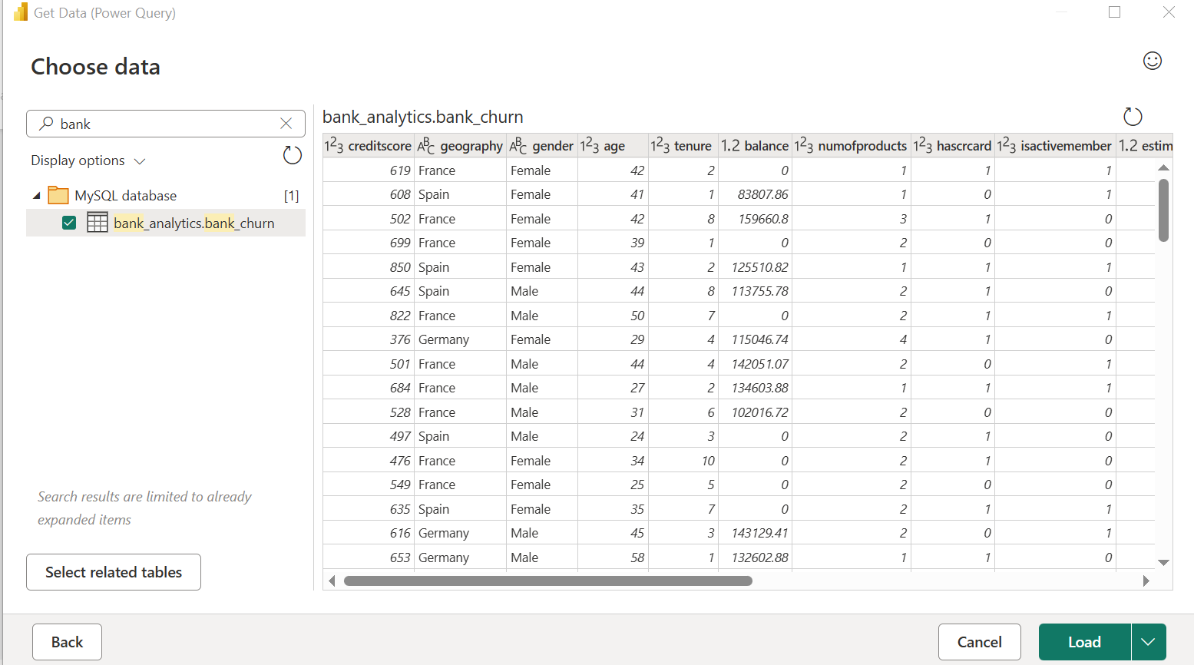

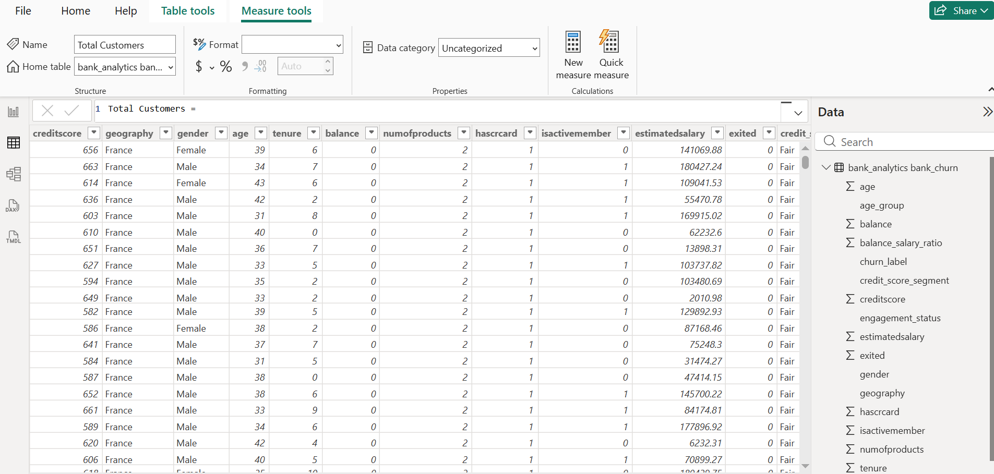

Step 3: Star Schema Data Modeling (Power BI)
- Duplicate the imported flat table (bank_churn) three times to create separate dimensional entities: Fact_Bank_Churn, Dim_Customer_Demographics, Dim_Geography, and Dim_Credit_Profile.
- In Dim_Geography, keep geography. Remove duplicates and add an Index Column (starting from 1) named GeographyID.
- In Dim_Credit_Profile, keep credit_score_segment. Remove duplicates and add an Index Column (starting from 1) named CreditSegmentID.
- In Dim_Customer_Demographics, keep gender, age, and age_group. Remove duplicates and add an Index Column (starting from 1) named DemographicID.
- In Fact_Bank_Churn:
- Merge queries with Dim_Geography on geography, expand only GeographyID, and remove the original text column geography.
- Merge queries with Dim_Credit_Profile on credit_score_segment, expand only CreditSegmentID, and remove credit_score_segment.
- Merge queries with Dim_Customer_Demographics on gender, age, and age_group, expand only DemographicID, then remove the redundant demographic text columns.
- Retain transactional/behavioral fields: creditscore, balance, tenure, numofproducts, hascrcard, isactivemember, estimatedsalary, balance_salary_ratio, engagement_status, exited, churn_label, and the new surrogate keys (GeographyID, CreditSegmentID, DemographicID).
- Click Close & Apply.

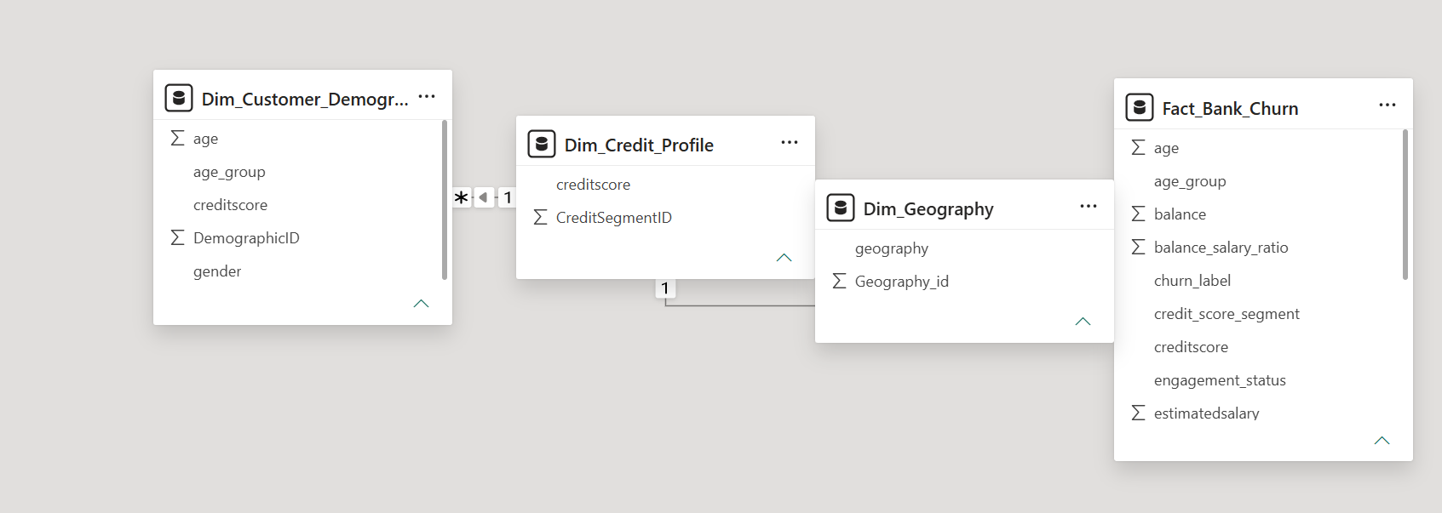

Step 4: Core Calculations & Measures (DAX)
Power BI Measures (DAX)
Create a dedicated _Measures table and add the following DAX calculations:

Churn Rate

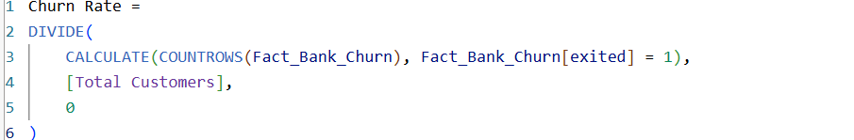
Total Balance

- Average Daily Rate (ADR):
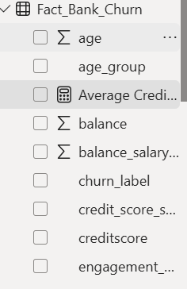
Step 5: Power BI Final Executive Dashboard & Drill-Through

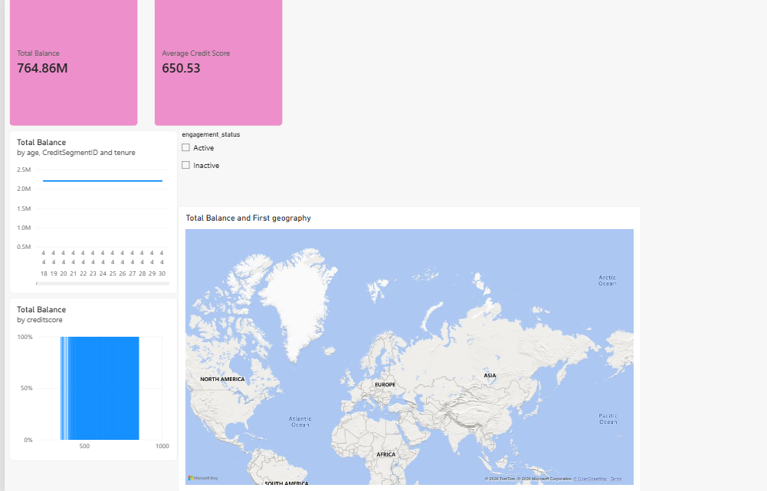

Executive Canvas:
  - Place Card Visuals across the top for Bank Customer Churn: Total Balance, Total Customers, Churn Rate, and Average Credit Score.
  - 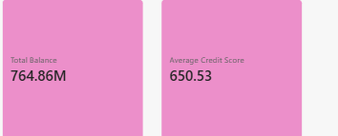

Line Chart by Customer Tenure
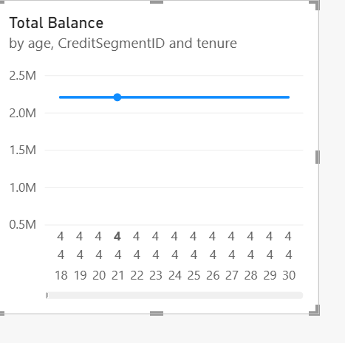

Add a Clustered Bar Chart for Churn Rate across regions using Dim_Geography[geography] (France, Spain, Germany).
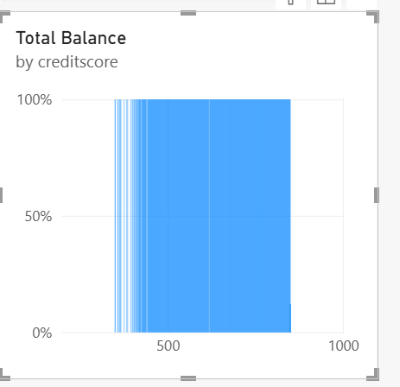

Add Slicers for Fact_Bank_Churn[engagement_status] (Active vs Inactive Member) or Fact_Bank_Churn[hascrcard]
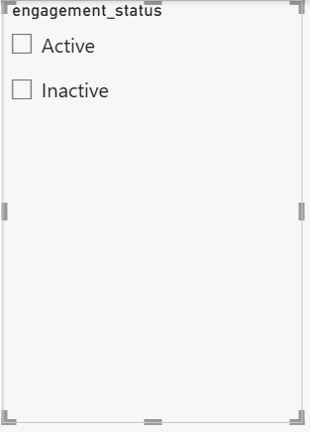
- Create a second page named Geography Details.
- Drag Bank_Churn[Geography] into the Drill-through field bucket.
- Add a Matrix/Table visual showing Geography, Total Customers, Churned Customers, and Churn Rate.

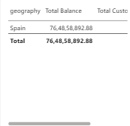

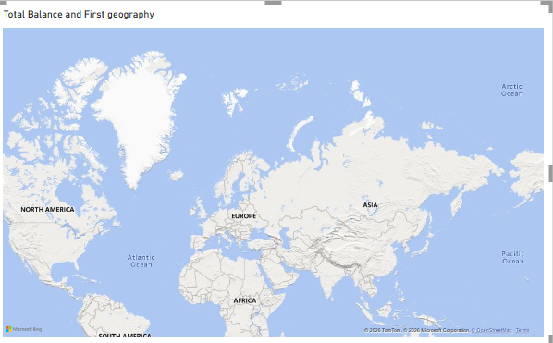
Step 6: Tableau Data Connection & Preparation
- Open Tableau Desktop / Tableau Public.
- Under To a Server, select MySQL.
- Enter Server (localhost), Database (bank_churn), and your MySQL user credentials to pull the cleaned bank churn dataset onto the canvas.

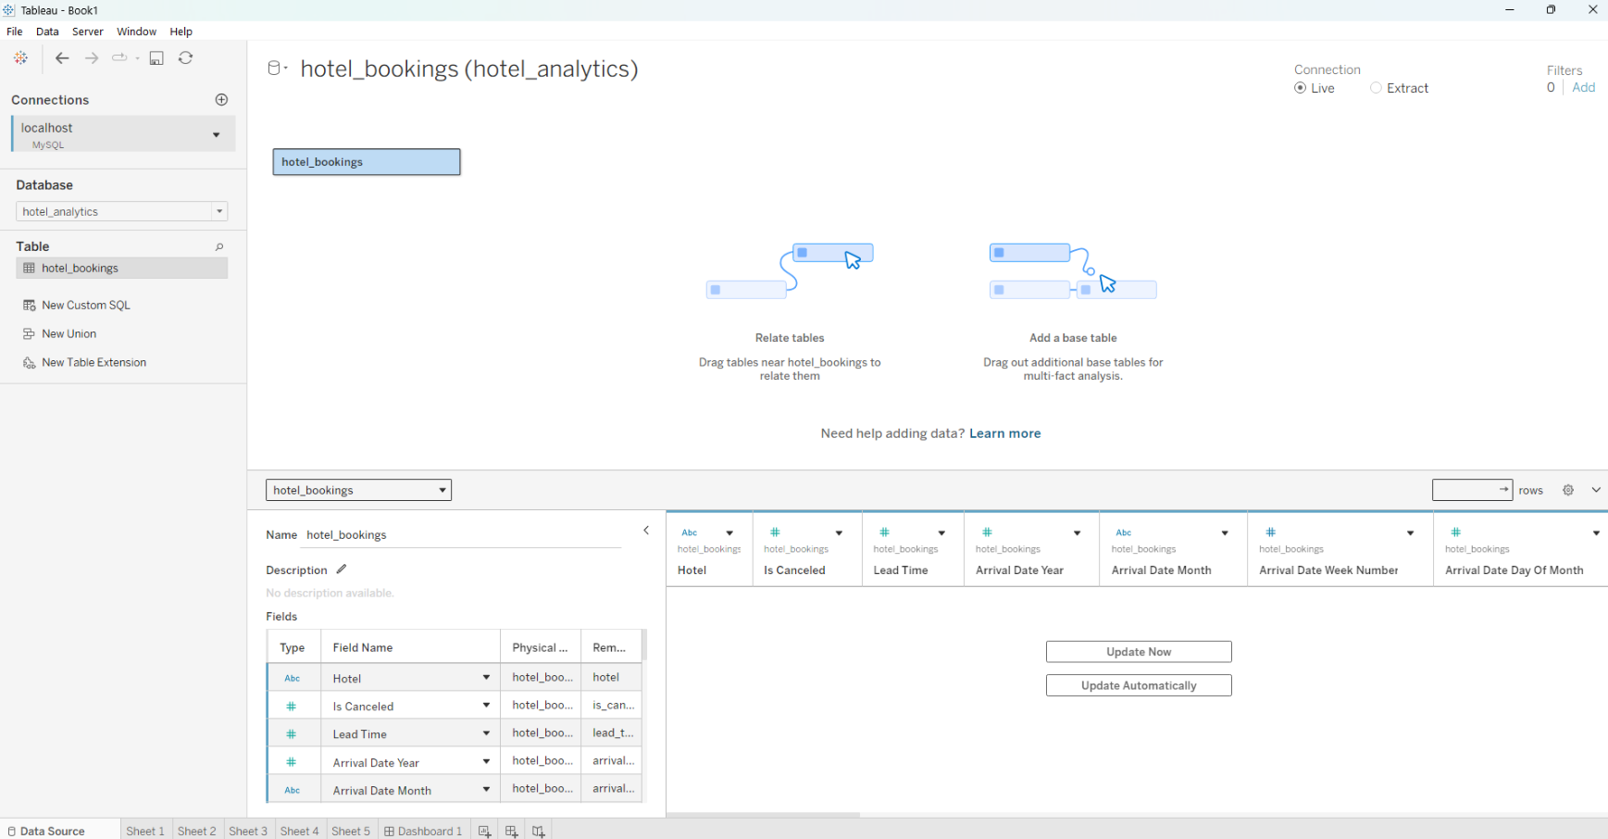
Go to any sheet and build calculated fields:
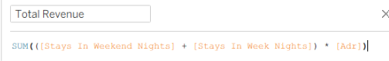
  - Total Revenue

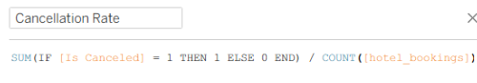
  - Cancellation Rate

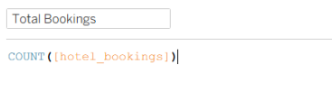
  - Total Bookings

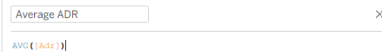
  - Average ADR

  - Select Metric Parameter: String list containing "Total Revenue", "Total Bookings", "Cancellation Rate".
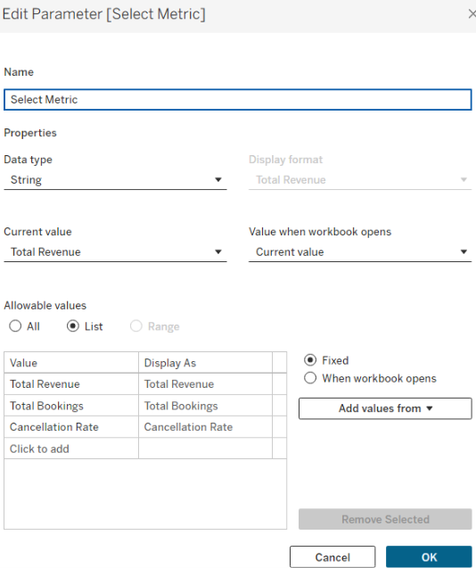

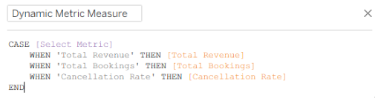
  - Dynamic Measure Formula:

Step 7: Tableau Companion Dashboard & Interactive Story
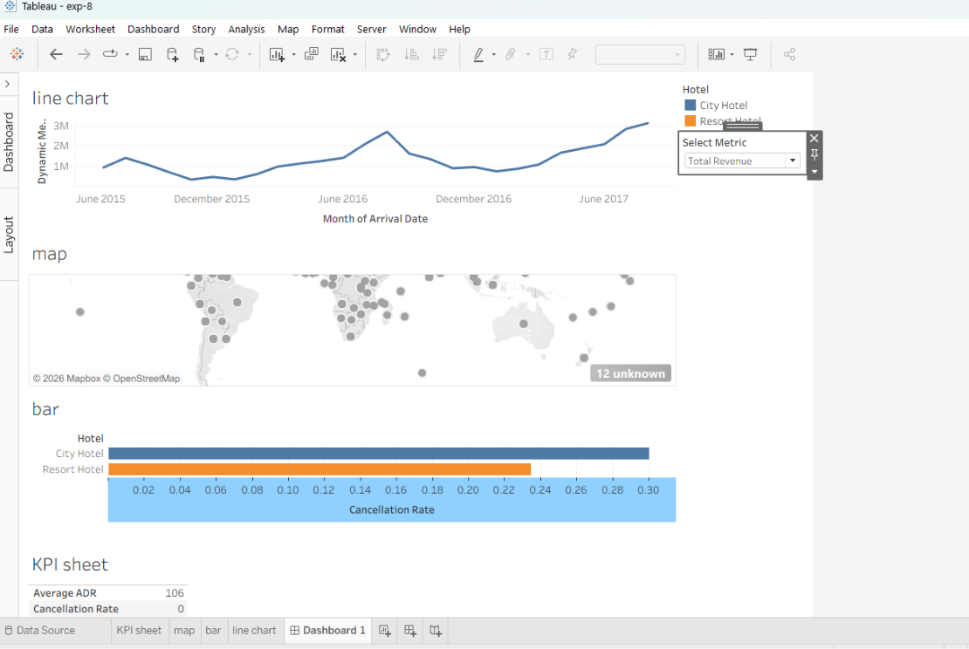

- Worksheets: Build KPI Cards, Revenue Trend Line Chart (using Dynamic Measure), Hotel Cancellation Bar Chart, and Country Map.
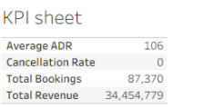
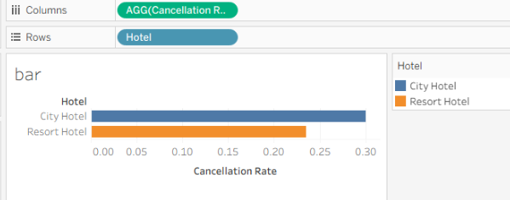

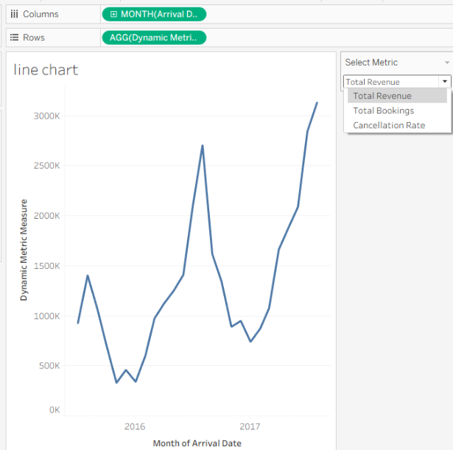

- Global Filters & Actions:
  - Drag Hotel, Deposit Type, and Arrival Date to Filters $→$ set to Apply to Worksheets $→$ All Using This Data Source.
  - Drag sheets onto a new Dashboard tab and click the Use as Filter funnel icon on the Country Map visual.
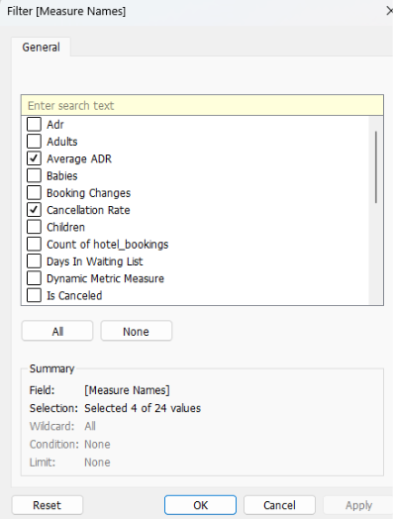

3.Drill-down map:
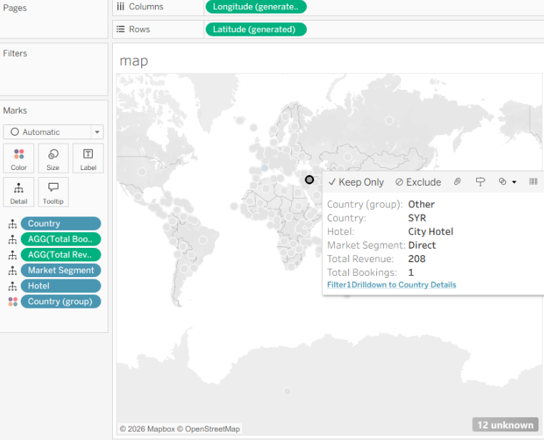

Observed Insights:
- Portfolio Revenue & Booking Volume: The dataset captures 119.4K Total Bookings generating $484.42M in Gross Revenue, maintaining a portfolio Average Daily Rate (ADR) of $99.66.
- Cancellation Rates: The overall portfolio reflects a 26% Cancellation Rate, with City Hotels exhibiting higher cancellation volatility compared to Resort Hotels.
- Seasonality Trends: Booking volume and revenue peak significantly during the European summer window (June–August), followed by a sharp drop in winter (December–January).
- Geographic Market Distribution: Demand is heavily concentrated in Western Europe, with Portugal (PRT) serving as the top origin market, followed by Great Britain (GBR), France (FRA), and Spain (ESP).

