MLA0201-Fundamentals of Machine Learning

Name: Kaviya Kumara (192425055)
Experiment 7:
Write a program to implement Logistic Regression (LR) algorithm in python

Code:
import pandas as pd
from sklearn.linear_model import LogisticRegression
from sklearn.preprocessing import LabelEncoder, StandardScaler
from sklearn.model_selection import train_test_split
from sklearn.metrics import accuracy_score
data = pd.read_csv("car_data.csv")
data['PriceCategory'] = data['PriceCategory'].apply(
lambda x: 1 if x == 'High' else 0
)
X = data.iloc[:, :-1].copy()
y = data.iloc[:, -1]
encoders = {}
for column in X.columns:
if X[column].dtype == 'object':
encoders[column] = LabelEncoder()
X[column] = encoders[column].fit_transform(X[column])
scaler = StandardScaler()
X = scaler.fit_transform(X)
X_train, X_test, y_train, y_test = train_test_split(
X, y, test_size=0.3, random_state=1
)
model = LogisticRegression()
model.fit(X_train, y_train)
print("Logistic Regression model trained successfully")
y_pred = model.predict(X_test)
accuracy = accuracy_score(y_test, y_pred)
print("Model Accuracy:", accuracy)
import matplotlib.pyplot as plt
import numpy as np
feature_names = data.columns[:-1]
coefficients = model.coef_[0]
plt.figure(figsize=(10, 5))
plt.bar(feature_names, coefficients)
plt.axhline(0, color='black', linewidth=0.8)
plt.xlabel("Features")
plt.ylabel("Coefficient Value")
plt.title("Logistic Regression Feature Weights")
plt.xticks(rotation=45)
plt.tight_layout()
plt.show()

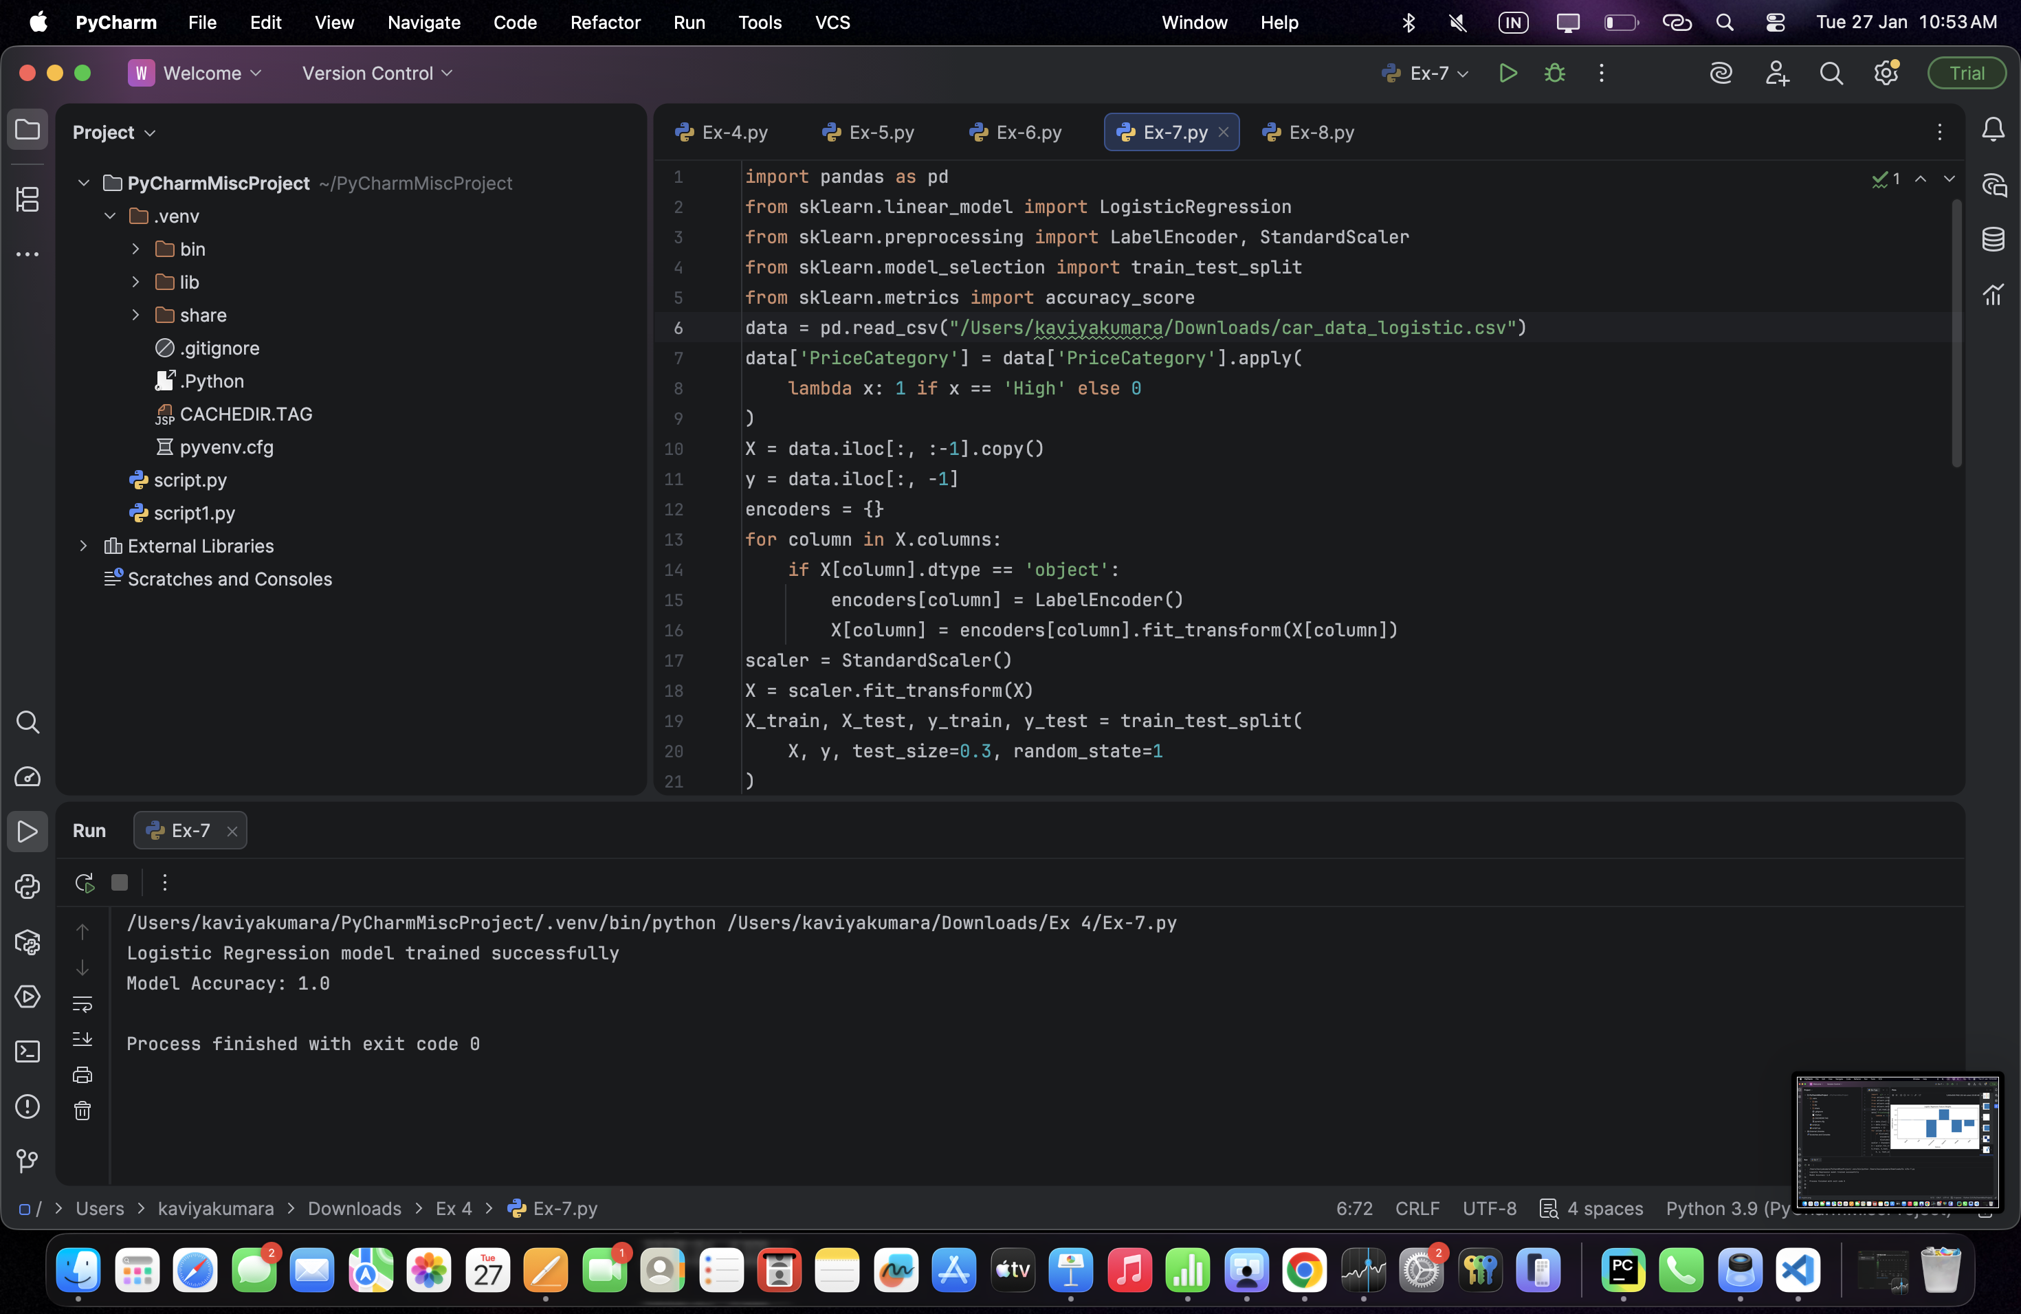
Output:

