MLA0201-Fundamentals of Machine Learning

Name: Kaviya Kumara (192425055)
Experiment 8:
Write a program to implement Linear Regression (LR) algorithm in python.

Code:
import pandas as pd
import matplotlib.pyplot as plt
from sklearn.linear_model import LinearRegression
from sklearn.model_selection import train_test_split
from sklearn.metrics import r2_score
data = pd.read_csv("car_data.csv")
X = data[['EngineCC']]
y = data['Mileage']
X_train, X_test, y_train, y_test = train_test_split(
X, y, test_size=0.3, random_state=1
)
model = LinearRegression()
model.fit(X_train, y_train)
print("Linear Regression model trained successfully")
y_pred = model.predict(X_test)
r2 = r2_score(y_test, y_pred)
print("R² Score:", r2)
new_engine = pd.DataFrame({'EngineCC': [2000]})
predicted_mileage = model.predict(new_engine)
print("Predicted Mileage for EngineCC = 2000:", predicted_mileage[0])
plt.figure(figsize=(8, 6))
plt.scatter(X, y, color='blue', label='Actual Data')
plt.plot(X_test, y_pred, color='red', linewidth=2, label='Regression Line')
plt.xlabel("EngineCC")
plt.ylabel("Mileage")
plt.title("Linear Regression: EngineCC vs Mileage")
plt.legend()
plt.show()

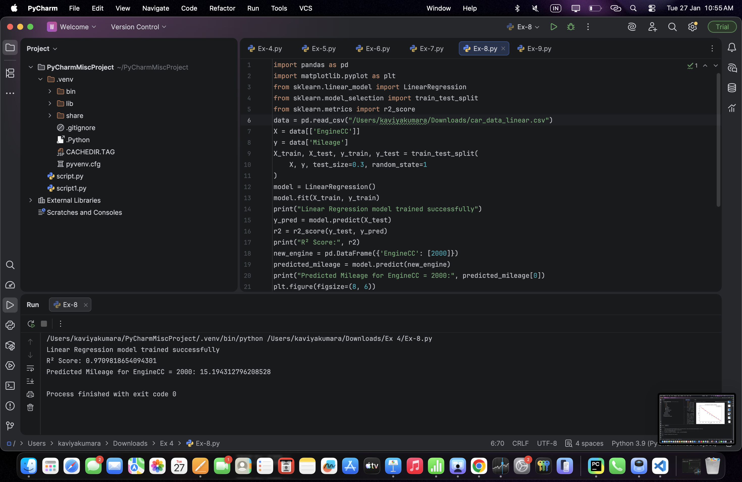
Output:
