

SWIFT SHIP TRACKER
Conversational AI Parcel Booking, Tracking & Delivery Management
on Salesforce CRM with Agentforce

PROJECT DOCUMENTATION
Naan Mudhalvan – Salesforce

Domain: Logistics | Project Type: Group
Platform: Salesforce (Objects, Flows, Prompt Builder, Agentforce)

TEAM MEMBERS
Kaviya P (Team Lead)
Deeba Dharshinie G K
Yuva Shree M

College Name:Nadar Saraswathi College of Engineering and Technology,Theni

Table of Contents
1. Use Case Scenario
2. Phase 1: Requirement Analysis & Planning
3. Phase 2: Salesforce Development – Backend & Configurations
4. Phase 3: UI/UX Development & Customization
5. Phase 4: Data Migration, Testing & Security
6. Phase 5: Deployment, Documentation & Maintenance
7. Project Limitations, Advantages & Future Scope
8. Conclusion
Appendix A: Screenshot Checklist

1. Use Case Scenario
Customers often face delays and confusion while booking, tracking and managing parcel deliveries because they need to call support or use multiple apps. A conversational AI agent can simplify this by allowing customers to book parcels, get live tracking and manage deliveries in one place.

1.1 Objective
To develop a comprehensive Parcel Management Portal on Salesforce CRM that enables customers to book parcels, track delivery status, and manage shipments through an AI-powered conversational agent and a user-friendly interface. Agents can easily update parcel details, delivery timelines and status to ensure transparent customer communication.

1.2 Student Outcomes
- Hands-on experience with Salesforce development: practical skills in configuring custom objects (Parcel), automating parcel status updates with Flows, and integrating AI agents.
- Understanding of the CRM project lifecycle: the complete end-to-end process from requirement gathering to deployment in a Salesforce environment.
- Problem-solving skills: the ability to design, troubleshoot and implement parcel tracking solutions in a CRM environment.

1.3 System Requirements
Category | Requirement
Hardware | Computer with minimum 4 GB RAM, dual-core processor, stable internet connection
Software | Salesforce Developer Org; modern web browser (e.g., Google Chrome, Firefox)
Skills | Salesforce platform expertise: data modelling & security management, automation with Flows, reporting and analytics

1.4 Key Features
- Parcel booking and record creation.
- Parcel status tracking (Booked, In Transit, Out for Delivery, Delivered).
- Weight and delivery date management.
- Automated customer notifications for delivery updates.
- Agent interface to manage and update parcel details.
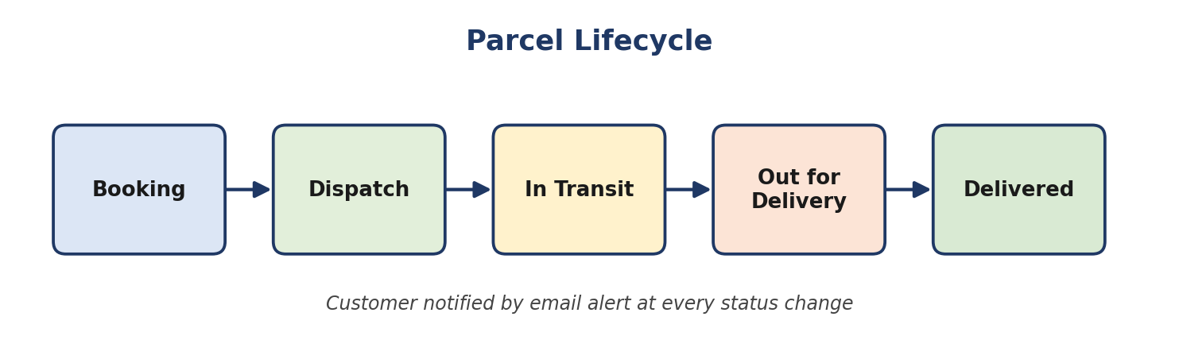
Figure 1: Parcel lifecycle

2. Phase 1: Requirement Analysis & Planning

2.1 Objective
Customers often experience delays and confusion when booking, tracking and managing parcel deliveries because they must switch between multiple platforms or contact customer support for updates. A conversational AI agent streamlines this process by providing an integrated experience allowing customers to book shipments, get real-time tracking updates and manage delivery preferences seamlessly through a single interface.

Key requirements
- Requirement gathering from end users and delivery agents.
- Defining system scope and user personas (Customer, Agent, Admin).
- Designing the data model with relationships between Parcel, Sender, Receiver and Delivery.
- Identifying use cases such as parcel booking, tracking and delivery update automation.
- Selecting tools: Salesforce Flows, Prompt Builder and AgentForce AI.

2.2 Defining Project Scope & Objectives

Project scope
- Build a scalable CRM solution for parcel delivery businesses to manage customer bookings, shipments and delivery operations efficiently.
- Support the end-to-end parcel lifecycle: parcel booking → dispatch → tracking → delivery confirmation.
- Include comprehensive data model design, automation (Flows, Apex, Email Alerts), an AI-powered prompt builder and reporting dashboards for effective management.
- Provide role-based access for admins, delivery agents and customers through Salesforce profiles, permission sets and Experience Cloud.
- Ensure real-time parcel visibility for customers and simplified operational tracking for agents through AI-integrated conversational support.

Objectives summary
- Streamline parcel operations by automating booking, tracking and delivery notifications to reduce manual updates.
- Improve customer satisfaction with transparent, real-time shipment status and self-service tracking options.
- Enhance agent efficiency through centralized dashboards and guided Flows for quick status updates.
- Enable business insights with reports and dashboards showing parcel trends, delivery performance and agent activity.
- Ensure security and reliability by implementing Salesforce role hierarchies, sharing rules and audit-based data access.

2.3 Gathering & Analysing User Needs

Users involved
User | Role in the system
Customers / Senders | End users who book parcels, track deliveries and receive real-time updates through the portal or AI agent.
Delivery Agents | Manage assigned parcels, update delivery status and ensure timely handover to customers.
Customer Support Team | Handle delivery-related issues, respond to customer queries and ensure smooth communication.
Admin Team | Configure the Salesforce environment, manage user roles, security settings and monitor operational performance.
System Integrator / Developer | Responsible for implementing automation, AI agent setup and backend integrations.

Key functional needs
- Seamless parcel booking and tracking interface for customers through Salesforce Experience Site or agent assistance.
- Ability for agents to update parcel status (Booked → In Transit → Out for Delivery → Delivered) in real time.
- Automated notifications and email alerts to customers on every delivery stage update.
- Support for Sender and Receiver details management with address, contact and email fields for communication.
- AI Agent integration (via Prompt Builder) for real-time parcel status queries and automated assistance.
- Reports and dashboards to monitor parcel flow, delivery performance and agent activity for admins.
- Security controls with role-based access, profiles and permission sets for different user levels.

Tools used
- Salesforce Developer Org – for configuration, development and testing.
- Prompt Builder (AgentForce AI) – to create intelligent parcel tracking prompts and responses.
- Salesforce Flow Builder – to automate booking, tracking and delivery updates.
- Google Sheets / Docs – for initial data planning, requirement documentation and system mapping.

2.4 Identifying Key Salesforce Features & Tools Required
Category | Features / Components
Custom Objects | Parcel__c, Delivery__c, Sender__c, Receiver__c
Standard Objects | Account, Contact, Case, Task, EmailMessage, User
Automation | Apex classes for automated parcel operations (e.g., lead-to-parcel conversion); Record-triggered Flows, Auto-launched Flows, Approval Processes, Scheduled Flows for periodic updates
UI | Lightning App Page (SwiftShip Tracker App), Dynamic Forms, Record Pages and Experience Cloud for customer access
AI | AgentForce AI & Prompt Builder: AI agent trained to fetch parcel data based on Parcel ID and respond to the user
Email Services | Email alerts (custom email alerts and templates for delivery updates, delay notifications and completion acknowledgements)
Security | Profiles, Permission Sets, Role Hierarchy, Sharing Rules and Field-Level Security for Admin, Agent and Customer

2.5 Designing the Data Model and Security Model

Data model
Object | Description
Parcel__c | Stores core parcel details such as Parcel ID, Status, Weight and Estimated Delivery Date. Linked to Sender__c and Receiver__c to identify the sender and receiver. Connected with Delivery__c to track real-time parcel location and status.
Delivery__c | Stores delivery-specific information such as current location, estimated date and the linked parcel. Connected with Sender__c and Parcel__c for relationship tracking. Used by agents to update delivery reference and automated notifications.
Sender__c | Captures sender details such as name, address, contact and email. Linked to multiple parcels to support shipment history and associated deliveries. Used for sending booking confirmations and delivery updates via automated emails.
Receiver__c | Stores receiver details such as address, contact and email for communication and delivery confirmation. Linked to Sender__c and Parcel__c to associate both ends of the shipment process. Used by agents for delivery reference and automated notifications upon completion.

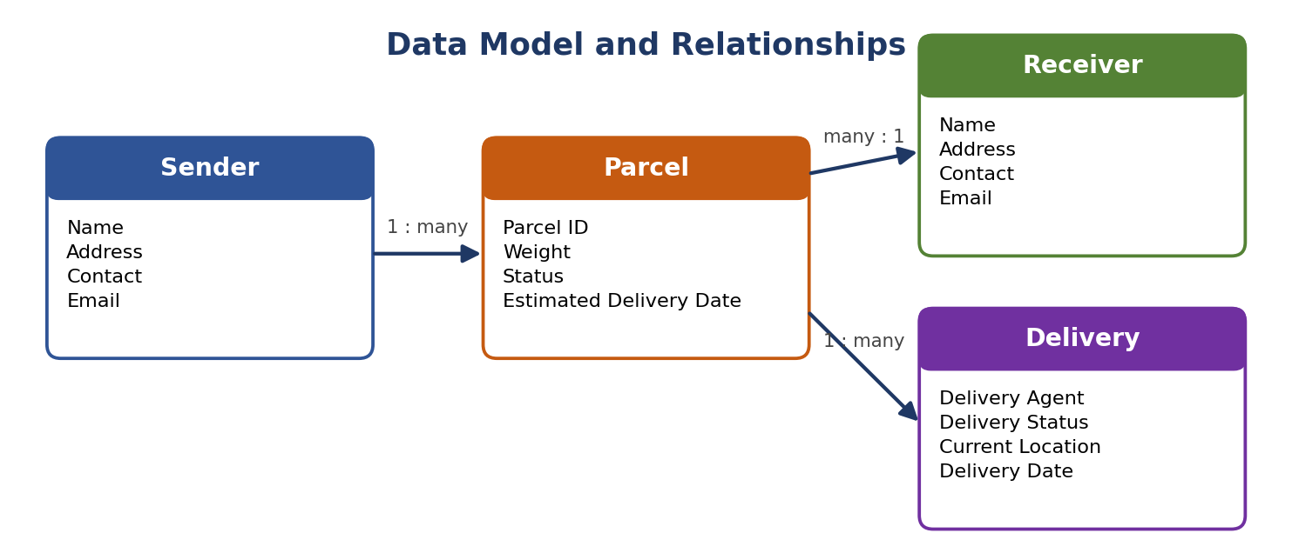
Figure 2: Data model and relationships

Security model design
- Role hierarchy: Administrator → Delivery Manager → Agent → Customer.
- Admin profile: full access to all objects and records.
- Delivery Agent profile: read/edit access to Parcel, Delivery, Sender and Receiver objects.
- Customer profile: read-only access to their own parcel details via Experience Cloud.
- Support Staff profile: access to Cases and Parcel details for issue resolution.
- Permission sets: used to grant additional privileges (e.g., “Update Delivery Status”, “Access Agent Console”).
- Record-level security: sharing rules applied for Parcel__c and Delivery__c to allow controlled access for agents and managers. Customers can only view records linked to their own Sender or Receiver details.
- Field-level security: sensitive fields such as Sender Email, Receiver Contact and Location Coordinates are restricted to Admin and Agent profiles only.

Solution architecture
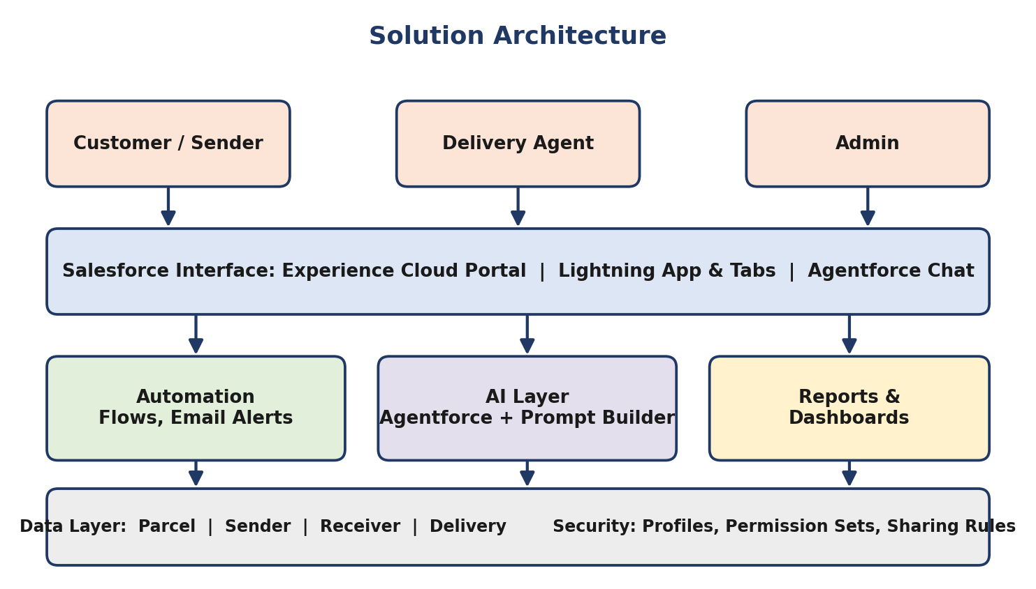
Figure 3: Solution architecture

3. Phase 2: Salesforce Development – Backend & Configurations
This phase focuses on developing the core logic of SwiftShip Tracker. Custom objects are created for Parcel, Sender, Receiver and Delivery with relationships between them. Automations are built using Flows for parcel status updates and approval processes, and an AI prompt template is configured for tracking.

Milestone 1: Salesforce Account

Creating a Developer Account
- Go to the Salesforce Developer sign-up page (developer.salesforce.com/signup).
- On the sign-up form, enter the following details: first name and last name, email, job title (Developer), company (college name) and country (India).
- Click Sign me up after filling in these details.
- Go to the inbox of the email you used while signing up and click on the verify account email. It may take 10–30 minutes and sometimes up to 2 hours.
- Click Verify Account.
- Set a password, answer a security question and click Change Password.
- You will then be redirected to your Salesforce Setup page.
[ Insert your screenshot: Developer org sign-up form ]
[ Insert your screenshot: Verification email and Setup home page ]

Milestone 2: Objects Creation

Creating the Parcel object
- From the Setup page, click Object Manager.
- Click Create → Custom Object.
- Enter the label name as Parcel.
- Enter the plural label name as Parcels.
- Enter Record Name as Parcel Name.
- Select Data Type as Text: Parcel Name.
- Select Allow Reports.
- Select Allow Search.
- Select Track Field History.
- Click Save and New.
[ Insert your screenshot: Parcel object definition screen ]
[ Insert your screenshot: Parcel object details page (API name Parcel__c) ]

Creating the Delivery object
Repeat the same steps with label Delivery, plural label Deliveries, Record Name as Delivery Name (Text: DeliveryName). Enable Allow Reports, Allow Search and Track Field History, then click Save and New.

Creating the Sender object
Repeat the same steps with label Sender, plural label Senders, Record Name as Sender Name (Text: SenderName). Enable Allow Reports, Allow Search and Track Field History, then click Save and New.

Creating the Receiver object
Repeat the same steps with label Receiver, plural label Receivers, Record Name as Receiver Name (Text: ReceiverName). Enable Allow Reports, Allow Search and Track Field History, then click Save

Milestone 3: Tabs

Creating a tab for the Parcel object
- Go to the Setup page and type Tabs in the Quick Find box.
- Click Tabs.
- Click New under Custom Object Tabs.
- Select Object (Parcel) and select a tab style.
- Click Next (add to profiles page: keep the default settings), then Next (add to Custom App: uncheck the Include tab option).
- Make sure that Append tab to the user's existing personal customizations is checked.
- Click Save.

Creating the remaining tabs
- Go to Setup → type Tabs in the Quick Find box.
- Under the User Interface section, click Tabs.
- Click New under Custom Object Tabs.
- Select the object (Delivery, Sender or Receiver) and choose a tab style.
- Click Next, keep the Add to Profiles settings as default, and click Next.
- On the Add to Custom Apps page, uncheck Include Tab.
- Ensure Append tab to the user's existing personal customizations is checked, click Save, and repeat for each object.

Milestone 4: Fields & Relationships
Fields and relationships are created for each custom object created in the previous milestone.

Fields and relationships for the Parcel object
- In the Quick Find box, click Object Manager, then search for and select the Parcel object.
- Go to Fields & Relationships → click New.
- Field 1 – Parcel ID: Data type = Auto Number, Display Format = P-{000}, Starting Number = 1. Click Next → Next → Save & New.
- Follow the same steps to create the remaining fields (Status, Weight, Estimated Delivery and Sender) as given in the table below.
Field Name | API Name | Data Type | Description
Parcel ID | Parcel_ID__c | Auto Number | Unique ID of each parcel
Status | Status__c | Picklist | Booked, In Transit, Out for Delivery, Delivered
Weight | Weight__c | Number | Weight of the parcel
Estimated Delivery | Estimated_Delivery_Date__c | Date | Expected delivery date
Sender | Sender__c | Lookup (Sender) | Links the parcel to its sender

[ Insert your screenshot: Parcel – Fields & Relationships list ]

Fields and relationships for the Delivery object
Field Name | API Name | Data Type | Description
Current Location | Current_Location__c | Geolocation | Current delivery location
Estimated Delivery Date | Estimated_Delivery_Date__c | Date | Expected delivery date
Parcel | Parcel__c | Lookup (Parcel) | Links the delivery to a parcel
Sender | Sender__c | Lookup (Sender) | Links the delivery to a sender

For Current Location, choose Data Type: Geolocation → Next, enter the field label as Current Location, then Next → Next → Save & New.
[ Insert your screenshot: Delivery – Fields & Relationships list ]

Fields and relationships for the Sender and Receiver objects
Object | Field | API Name | Data Type
Sender | Sender Address | Sender_Address__c | Text / Text Area
Sender | Sender Contact | Sender_Contact__c | Phone
Sender | Sender Email | Sender_Email__c | Email
Receiver | Receiver Address | Receiver_Address__c | Text / Text Area
Receiver | Receiver Contact | Receiver_Contact__c | Phone
Receiver | Receiver Email | Receiver_Email__c | Email
Receiver | Parcel | Parcel__c | Lookup (Parcel)
Receiver | Sender | Sender__c | Lookup (Sender)

Milestone 5: Prompt Builder

Creating the prompt template
- In Setup, search for Prompt Builder and open it.
- Click New Prompt Template and choose the template type for generating a record-based response.
- Enter the details – Label: Retrieve Parcel Details; API Name: Retrieve_Parcel_Details; Description: Retrieves parcel details where Parcel ID matches the user input.
- Enter the prompt template content. In the Prompt Template area, paste the following exactly and return the response in this format:
Parcel Tracking Update
- Parcel Name: {!$Input:Parcel.Name}
- Parcel ID: {!$Input:Parcel.Parcel_ID__c}
- Status: {!$Input:Parcel.Status__c}
- Weight: {!$Input:Parcel.Weight__c}
- Estimated Delivery Date: {!$Input:Parcel.Estimated_Delivery_Date__c}

- Add resource mapping: scroll down to the Resources / Insert Resources section, click Insert Resource and choose Object.
- Select Parcel and add the following fields: Name, Parcel_ID__c, Status__c, Weight__c, Estimated_Delivery_Date__c. Insert each one and click Save.
- Click Activate to make this prompt template available for your agent or flow.

Testing the prompt
- Open the prompt Preview.
- Select a Parcel record that exists in your org (for example, a record with Parcel ID P-001).
- It should return the details from the Parcel record in the defined format.

Milestone 6: Flow – Parcel_Details

Creating the Auto-launched Flow
- In Setup, search for Flows and click New Flow.
- Select Autolaunched Flow (No Trigger) and click Create.
- Add input variables (to allow the agent to pass values): click New Resource → Variable.
- Create Ids → Data Type: Text → Available for Input.
- Create Output → Data Type: Text → Available for Output.
- Click the Add icon to add the element Get Records → Label: Get Parcel Records. Set Object: Parcel; Condition – Field: Parcel_ID__c, Operator: Equals, Value: Ids. Choose to store the first record only.
- Add the element Action: find Retrieve Parcel Details (the prompt template), click it, set Label: Parcel Updates and set Object To Summarize = Parcel from Get Parcel Records.
- Add the element Assignment → Label: Assignment Outputs; Variable: Output, Operator: Equals, Value: Outputs from Action → Prompt Response.
- Connect the elements: Start → Get Records → Action → Assignment → End.
- Save the flow with the name Parcel Details.
- Activate the flow.
- Once the flow is saved, go back to the Flows list, click the drop-down on the flow and choose Edit Access.
- On the Flow User Access page, assign the available profiles and click Save.

4. Phase 3: UI/UX Development & Customization
The goal of this phase is to enable agents to efficiently manage parcel operations and ensure secure access control using permission sets and an AI-driven agent experience built with AgentForce.

Milestone 1: Creating a Permission Set
- In the Quick Find box (left side), type Permission Sets.
- Under Users, click Permission Sets.
- Click the New button.
- Enter the following details – Label: Swift Ship; API Name: auto-fills; License: choose Einstein Agent.
- Click Save.
- Inside the Permission Set page, under Apps → Object Settings, click Object Settings and give the required access (Read / Create / Edit) for Parcel, Delivery, Sender and Receiver, including field access.
- Save the permission set and assign it to the required users via Manage Assignments.

Milestone 2: Configuring the AgentForce Agent

Creating the agent and subagent
- In Setup, search for Agentforce Agents (Agent Builder) and create a new agent named Swift Ship Tracker / Parcel Tracking Agent.
- Add a subagent (topic) such as Parcel Details Inquiry with instructions to retrieve parcel details when the user provides a Parcel ID.
- Add an action to this subagent and select the Flow Parcel Details as the action type.
- Map the action input (Ids) to the Parcel ID provided by the user and the output (Output) to the response returned to the user.
- Save the agent.

Checking the flow association
- Go to Setup → Flows and locate the flow named Parcel Details / SwiftShip Tracker.
- Confirm the flow is Activated, and that it handles Parcel ID input, parcel details retrieval and the status update / confirmation message.
- Open the Flow's Advanced Settings and ensure Run in System Context (Without Sharing) is selected if data access is restricted.

Activating and testing the agent
- Return to Setup → Agent Builder → Parcel Tracking Agent.
- Click Activate (if not already activated).
- Once active, test using Preview / Try It Out mode.
- Type a query such as “Track parcel ID P-1234” or “Update delivery status for parcel P-0001 to Delivered”.
- Observe the agent's response.
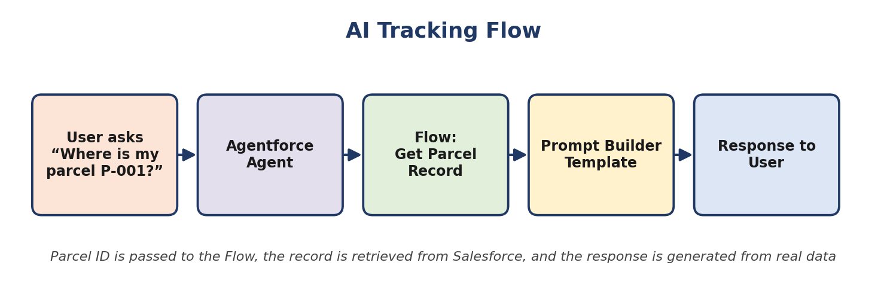
Figure 4: AI tracking flow

5. Phase 4: Data Migration, Testing & Security

5.1 Validating Data in Salesforce
- After the agent runs the flow, go to App Launcher → Parcels (Parcel__c).
- Search for the Parcel ID used during testing.
- Verify that the Status or related field is updated and that any Flow-created records (bookings, updates) appear correctly.

5.2 Functional Test Cases
Fill the Actual Result column after executing each test in your own org.
ID | Test | Expected Result | Actual Result
TC-01 | Open Parcel / Delivery / Sender / Receiver tabs | All tabs open without error | [Fill]
TC-02 | Create a Parcel with a Sender | Auto-number Parcel ID generated (P-001…) | [Fill]
TC-03 | Run Parcel_Details flow with a valid Parcel ID | Output variable returns generated response | [Fill]
TC-04 | Run flow with an invalid Parcel ID | No record found; behaviour documented | [Fill]
TC-05 | Prompt Builder preview | Response shows Parcel Name, ID, Status, Weight, Estimated Delivery | [Fill]
TC-06 | Agent query “Track parcel P-001” | Agent returns parcel details from Salesforce | [Fill]
TC-07 | Permission set assignment | User can access the four objects as configured | [Fill]

5.3 Security Testing
- Verify that users without the Swift Ship permission set cannot access parcel data.
- Verify field-level security restrictions on sender and receiver contact fields.
- Confirm role hierarchy and sharing settings give agents and managers the intended record access.

6. Phase 5: Deployment, Documentation & Maintenance

6.1 Deployment & Validation
In the scope of the SwiftShip Tracker (AgentForce) project implementation, the purpose of this phase is to validate that the Parcel Tracking Agent, created using Salesforce Agent Builder, works as intended within the Salesforce Developer Org environment.
The main goal is to understand how an AI-powered Service Agent can be tested to ensure correct logic recognition, flow execution and data retrieval from Salesforce custom objects. Testing is conducted within the Developer Org to simulate how the agent would perform in a live setup, ensuring that permissions, flows and data retrieval function correctly before any deployment stage.
Real-world production testing (UAT or sandbox deployment) is not performed in this project because Developer Edition orgs are standalone environments that do not support production-linked testing environments. Enterprise-level AgentForce deployment involves sandbox testing, staging environments and CI/CD automation, which are outside the scope of this academic/prototype implementation.

6.2 Documentation
This document, together with the screenshots captured at each milestone, serves as the project documentation covering requirements, data model, configuration steps, AI agent setup and testing.

6.3 Maintenance, Monitoring & Troubleshooting
In the SwiftShip Tracker (AgentForce) project, ongoing maintenance ensures that Parcel, Customer and Delivery data remain accurate, synchronized and up to date. Regular monitoring helps detect issues such as misrouted agent queries, failed flow executions or performance delays in AgentForce responses. Troubleshooting activities include resolving configuration errors, updating flow logic, refining agent topics and improving prompts to enhance user interactions.
Although this project is implemented within a Salesforce Developer Org for learning purposes, in real-world enterprise deployments these maintenance and monitoring practices are essential. They ensure that AI-powered service agents remain reliable, scalable and continuously aligned with evolving customer service operations and business goals.

7. Project Limitations, Advantages & Future Scope

7.1 Limitations
- Developer Org implementation only; no production or sandbox deployment.
- No external logistics or GPS integration.
- AI output depends on correct data and prompt configuration.

7.2 Advantages
- Centralized parcel, sender, receiver and delivery data.
- Simple Parcel ID retrieval through a conversational AI agent.
- Reusable Flow and prompt template.
- Permission-based secure access.

7.3 Future Scope
- Reports and dashboards for parcel trends and agent activity.
- Automated email notifications at each delivery stage.
- Experience Cloud customer portal.
- Additional Agentforce topics and actions.
- External logistics and real-time GPS integration.

8. Conclusion
SwiftShip Tracker demonstrates how Salesforce custom objects, Flow automation, Prompt Builder and Agentforce can be combined into a single conversational parcel management solution. The central technical flow is: Parcel ID → Salesforce record retrieval → Prompt Builder → Flow Output → conversational response. The project provides hands-on experience across the full CRM lifecycle, from requirement analysis to configuration, AI integration and testing.

Appendix A: Screenshot Checklist
Capture these from your own Salesforce org and paste them at the placeholders in the document.
- Developer org sign-up and Setup home page
- Parcel, Delivery, Sender and Receiver object pages
- Custom tabs list
- Fields & Relationships for each object
- Schema Builder relationships
- Prompt Builder template, resource mapping and preview
- Flow variables, Get Records, Action, Assignment and full flow (Active)
- Flow user access
- Permission set and object settings
- Agent builder configuration, flow action and agent preview conversation
- Test data in Parcel records
