**Web-Integrated E-Voting System Using**

**Ethereum Blockchain**

1 Qualitha Begum

Department of AI&DS

KGiSL Institute of Technology

Coimbatore,Tamilnadu,India

qualithabegum@kgkite.ac.in

4 Dharsan S

Department of AI&DS

KGiSL Institute of Technology

Coimbatore,Tamilnadu,India

dharsan.s2021@kgkite.ac.in

2Akash A

Department of AI&DS

KGiSL Institute of Technology

Coimbatore,Tamilnadu,India

akash.a2021@kgkite.ac.in

5 Ganesan M

Department of AI&DS

KGiSL Institute of Technology

Coimbatore,Tamilnadu,India

ganesan.m2021@kgkite.ac.in

3 Dayanithi E

Department of AI&DS

KGiSL Institute of Technology

Coimbatore,Tamilnadu,India

dayanithi.e2021@kgkite.ac.in

***Abstract*— The web-integrated e-voting system using the Ethereum blockchain aims to enhance the security, transparency, and efficiency of electronic voting by leveraging blockchain technology. Traditional voting systems often suffer from security vulnerabilities, fraud risks, and lack of transparency. This project addresses these challenges by implementing a decentralized, tamper-proof e-voting system using Ethereum smart contracts. The system enables secure identity verification, immutable vote recording, and real-time result tracking. By integrating web-based interfaces, users can conveniently cast their votes, while ensuring privacy and authentication through cryptographic techniques. The Ethereum blockchain ensures that every vote is permanently recorded, traceable, and resistant to unauthorized alterations. The use of smart contracts automates vote counting and result verification, reducing manual intervention and the risk of manipulation. This system provides a cost-effective, decentralized, and trustless voting mechanism, making it ideal for elections at various levels, from institutional voting to national polls. Ultimately, the proposed e-voting system enhances democracy, trust, and security by leveraging the decentralized nature of blockchain technology.**

**Keywords: e-voting, Ethereum blockchain, smart contracts, decentralized voting, secure authentication, transparency, cryptographic security, immutable ledger, web-based voting, tamper-proof system.**

**1. INTRODUCTION**

Electronic voting (e-voting) has emerged as a modern alternative to traditional paper-based voting systems, offering convenience and efficiency. However, existing e-voting systems often face challenges related to security, transparency, and trust. Issues such as vote tampering, unauthorized access, and lack of verifiability have raised concerns about the reliability of digital voting solutions. To address these challenges, blockchain technology, specifically Ethereum, provides a decentralized and tamper-proof solution that ensures secure and transparent voting[1].

Ethereum blockchain enables the use of smart contracts, which automate the voting process by securely recording and verifying votes without the need for a central authority. Each vote is encrypted and stored on the blockchain, making it immutable and resistant to manipulation. Additionally, the decentralized nature of blockchain ensures that no single entity can alter or control the voting process, enhancing trust and fairness[2].

The proposed web-integrated e-voting system leverages blockchain technology to create a transparent, fraud-resistant, efficient voting mechanism. It allows voters to securely cast their votes through a web-based interface, ensuring authentication and privacy using cryptographic techniques. The integration of Ethereum smart contracts automates vote counting and result validation, eliminating manual errors and reducing reliance on intermediaries[3].

This system can be applied to various types of elections, including institutional, organizational, and governmental voting processes. By leveraging blockchain’s security and decentralization, the e-voting system ensures integrity, fairness, and public trust, paving the way for a more reliable and modern electoral process[4].

A. Motivation Our system suggests utilizing blockchain technology to create a decentralized smart electoral voting system. An admin panel is included to manage the candidates, schedule the poll, and declare the results. When voting, users will be able to input their name, mobile number, and a live snapshot of themselves via the web application. When a voter enters their User ID, their eligibility will be verified. Once voter verification is complete, each voter's eligibility will be determined. Throughout the process of voting, voters will be viewed using both a front-facing and a webcam. Voters will be kept on a blockchain, making it simple to identify any tampering [5].

B. Research Contribution Voting is a crucial process in many fields, including politics, local government, college and school administration, and many more. It can be detrimental if votes are tallied incorrectly by an outside party. Electronic voting systems allow voters to cast their ballots whenever it is most convenient for them, using a computer, smartphone, or other electronic device. This strategy's primary goal is to conduct online voting via a decentralized electronic voting system. The suggested Voters will be able to safely cast ballots during the first phase [5]. This system adds blockchain for safe transactions & this system contributes to solving the problems of voters. This system contributed to the voting process getting done securely. To make transactions safe this system uses blockchain technology, where data is stored in the blocks [6].

***2.* LITERATUREREVIEW**

The development of e-voting systems has been widely studied to enhance security, transparency, and efficiency in electoral processes. Researchers have explored various technologies, including blockchain, to overcome the challenges faced by traditional voting systems. This section reviews previous studies related to blockchain-based e-voting and highlights their contributions, limitations, and potential improvements.

#### **1. Existing E-voting Systems**

Traditional e-voting systems rely on centralized servers for vote collection and counting. These systems are vulnerable to cyberattacks, vote tampering, and unauthorized access. Several studies have discussed the security risks associated with centralized voting platforms. Some approaches use encryption techniques to improve security, but these methods still rely on trusted third parties, which can introduce vulnerabilities.

#### **2. Blockchain Technology in E-voting**

Blockchain has been proposed as a solution to enhance the security and transparency of e-voting systems. Researchers have explored various blockchain platforms, including Bitcoin and Ethereum, for implementing decentralized voting mechanisms. Ethereum, with its smart contract capabilities, has been widely preferred due to its ability to automate vote validation and counting. Studies indicate that blockchain ensures immutability, transparency, and resistance to external attacks, making it a suitable choice for e-voting.

#### **3. Ethereum-Based Voting Systems**

Several studies have proposed ethereum-based e-voting models that utilize smart contracts to handle the voting process. These models provide decentralized vote storage, eliminating the need for a central authority. However, some challenges remain, such as scalability, transaction costs (gas fees), and voter anonymity. Researchers suggest optimizations such as layer-2 solutions and zero-knowledge proofs to address these issues.

#### **4. Limitations Of Existing Blockchain E-voting Solutions**

Despite the advantages of blockchain, existing solutions face challenges in terms of scalability, cost, and accessibility. Ethereum’s high gas fees and network congestion can make large-scale elections expensive and slow. Moreover, ensuring voter authentication without compromising privacy remains a critical issue. Some studies have proposed hybrid models that combine blockchain with off-chain identity verification to improve efficiency and reduce costs.

***3. PROPOSED SYSTEM***

The proposed web-integrated e-voting system using the Ethereum blockchain aims to provide a secure, transparent, and decentralized voting platform. This system leverages blockchain technology to eliminate common vulnerabilities in traditional and electronic voting systems, ensuring integrity and trust in the electoral process. It utilizes Ethereum smart contracts to automate vote recording, validation, and result computation without the need for manual intervention or a central authority.

The system consists of a web-based interface that allows voters to authenticate their identity using cryptographic techniques before casting their votes. Each vote is encrypted and stored on the Ethereum blockchain, making it immutable and tamper-proof. Once a vote is cast, it is automatically recorded in a decentralized ledger, ensuring that no single entity can alter or manipulate the results. Smart contracts handle the entire voting process, from registration and authentication to vote counting and result declaration, reducing human errors and increasing efficiency.

By integrating blockchain with a web-based voting platform, this system enhances accessibility while maintaining a high level of security. Voters can participate remotely without concerns about vote manipulation or unauthorized access. Additionally, the transparency of blockchain ensures that all votes are verifiable, enabling election authorities and voters to independently confirm the integrity of the results. This proposed system is designed to be scalable and applicable to various election types, including institutional, corporate, and governmental voting processes, ensuring a more reliable and modern electoral framework.

#### **A. System Architecture**

The system consists of three main components: **Frontend (web interface):** a user-friendly web-based platform that allows voters to securely register, authenticate, and cast their votes. **Backend (smart contracts):** Ethereum-based smart contracts that handle vote validation, storage, and result computation automatically.**Blockchain network:** a decentralized ledger that permanently records votes, ensuring transparency and preventing any modifications.

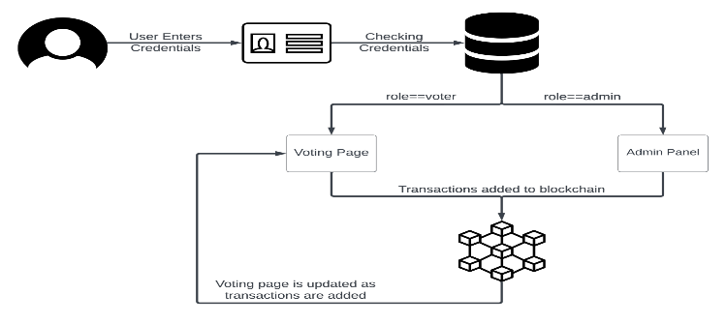

#### **B. Working Process**

1. **voter authentication:** users must verify their identity through cryptographic techniques to prevent unauthorized access.
2. **Vote casting:** after authentication, voters can select their candidate and submit their vote through the web interface.
3. **Vote encryption and storage:** each vote is encrypted and stored on the Ethereum blockchain, making it immutable and tamper-proof.
4. **Automated result computation:** smart contracts automatically count votes and generate election results without manual intervention.

#### **C. Security and Transparency**

the blockchain-based e-voting system ensures:

* **Immutability:** once a vote is recorded, it cannot be altered or deleted.
* **Transparency:** anyone can verify the election results without compromising voter anonymity.
* **Decentralization:** eliminating a central authority prevents manipulation and fraud.

#### **D. Advantages Of The Proposed System**

* **Enhanced security:** cryptographic techniques and blockchain prevent unauthorized access and vote tampering.
* **Efficiency:** automated processes reduce the time and cost involved in traditional voting systems.
* **Accessibility:** a web-based interface allows voters to participate from remote locations.

This proposed system aims to establish a reliable and secure e-voting framework, ensuring fairness and trust in the electoral process.

***4. METHODOLOGY***

The implementation of a web-integrated e-voting system using the Ethereum blockchain follows a structured approach to ensure security, transparency, and efficiency. The methodology involves multiple stages, including system design, user authentication, vote casting, blockchain integration, and result verification.

#### **A. System Design and Architecture**

The system is designed as a decentralized application that operates on the Ethereum blockchain. It consists of three main components: the user interface (web application), the backend (smart contracts), and the Ethereum blockchain network. The web application enables voters to interact with the system, while smart contracts handle vote processing and storage in a tamper-proof manner.

#### **B. User Authentication and Registration**

To ensure only eligible voters participate, the system incorporates a secure authentication mechanism. Voters must register using a unique identifier, such as a government-issued ID or a biometric verification system. Cryptographic techniques like hashing and public-private key encryption are used to protect voter identity and maintain privacy.

#### **C. Vote Casting and Recording**

Once authenticated, voters can access the web interface to cast their votes. Each vote is encrypted and recorded as a transaction on the Ethereum blockchain. Smart Contracts validate the votes in real time, preventing duplicate voting and unauthorized modifications. The decentralized nature of blockchain ensures that every vote is permanently stored and cannot be altered.

#### **D. Blockchain Integration and Smart Contract Execution**

Smart Contracts play a crucial role in automating the voting process. They execute pre-defined rules, such as vote validation, tallying, and result computation. Since smart contracts run on the Ethereum blockchain, they eliminate the need for intermediaries, reducing the risk of manipulation and human errors.

#### **E. Result Verification and Transparency**

After the voting process ends, the system automatically tallies the votes using the smart contract logic. The results are publicly accessible on the blockchain, ensuring transparency. Stakeholders, including voters and election authorities, can verify the results without relying on a central authority. This approach enhances trust in the electoral process.

#### **F. Security and Scalability Considerations**

To enhance security, the system implements encryption techniques, multi-signature authentication, and distributed ledger technology. Scalability is addressed by optimizing smart contract gas consumption and utilizing layer-2 solutions, such as sidechains or rollups, to improve transaction speed and reduce costs.

**5. *IMPLEMENTATION***

The implementation of the **web-integrated e-voting system using the Ethereum blockchain** involves several key components, including blockchain integration, smart contract development, web-based user interaction, and security mechanisms. Below is a step-by-step breakdown of the implementation process.

#### **1. System Architecture**

The e-voting system is designed with the following components:

* **Frontend (User Interface):** A web-based application where voters can authenticate, cast their votes, and view results.
* **Backend (Smart Contracts):** Ethereum smart contracts handle vote recording, validation, and result computation.
* **Blockchain Network:** Ethereum blockchain ensures decentralization, transparency, and immutability of votes.
* **IPFS (Optional):** For decentralized storage of voter information and election metadata.

#### **2. Smart Contract Development**

Smart contracts serve as the core of the e-voting system. They are written in **Solidity** and deployed on the **Ethereum blockchain** to handle the following functionalities:

* **Voter Registration:** Ensures only eligible voters can participate.
* **Vote Casting:** Records votes securely and prevents duplicate voting.
* **Vote Counting:** Automatically calculates results in real time.
* **Result Verification:** Ensures transparency by allowing public verification of votes.

#### **3. Web-Based Interface**

The front end is developed using **React.js** or **Angular**, providing an intuitive and user-friendly voting experience. The web interface interacts with Ethereum smart contracts using **Web3.js** or **Ethers.js**, enabling users to:

* Authenticate securely using **MetaMask** or any Ethereum wallet.
* Cast their vote, which is recorded on the blockchain.
* View live election results with complete transparency.

#### **4. Security Mechanisms**

To ensure a secure and fraud-proof voting process, the system incorporates:

* **Cryptographic Hashing:** Ensures the integrity of votes.
* **Multi-Factor Authentication (MFA):** Prevents unauthorized access.
* **End-to-End Encryption:** Protects voter identity and data.
* **Blockchain Consensus Mechanism:** Ensures tamper-proof vote storage.

#### **5. Deployment & Testing**

The smart contract is deployed on the **Ethereum testnet (Rinkeby, Goerli, or Sepolia)** for initial testing before launching on the **Ethereum mainnet**. The system undergoes rigorous testing for:

* **Functionality and Performance:** Ensuring smooth vote casting and counting.
* **Security Audits:** Detecting and fixing vulnerabilities in smart contracts.
* **Scalability Testing:** Verifying system efficiency under high voter loads.

#### **6. Final Deployment and Execution**

Once testing is successful, the e-voting system is deployed on the Ethereum **mainnet or a private blockchain**, making it ready for real-world elections. The system ensures **full transparency, security, and accessibility**, allowing voters to participate in a decentralized and trustworthy manner.

### ***6. Result and Discussion***

#### **1. User Registration**

The user registration process has been successfully implemented, allowing voters to sign up with secure authentication. Each registered user is stored in the database and linked to their Ethereum wallet for blockchain-based voting.

The registration process ensures uniqueness by verifying user details and preventing duplicate entries. Security is maintained through password hashing and Ethereum-based identity management. Future improvements could include biometric authentication or multi-factor authentication for enhanced security.

#### **2. Admin Panel**

The admin panel enables authorized administrators to manage users, elections, and results through a Django-based dashboard.

The admin can approve/reject users, manage election settings, and oversee the voting process. The interface is user-friendly, but additional role-based access control (RBAC) could enhance security. Improved logging and analytics could provide better tracking of election activities.

#### **3. Create Election**

The election creation module allows admins to define new elections, add candidates, and configure voting rules.

Admins can specify election start and end times, ensuring proper scheduling. Blockchain smart contracts are deployed for election integrity and tamper-proof vote recording. Additional features like candidate profile verification and automated notifications could improve usability.

#### **4. Voting**

The voting process is conducted through a web-based interface, recording votes directly on the Ethereum blockchain.

The system ensures each voter can cast only one vote per election. Votes are immutable, eliminating fraud risks. An improved user interface with real-time vote confirmation feedback could enhance the experience.

#### **5. Publish Result**

The election results are published in real-time through the blockchain, ensuring transparency and security.

The system accurately tallies votes and displays results without human intervention. Some UI errors in live result fetching may need debugging. Future upgrades could include graphical result representation and automated result verification mechanisms.

**A**. **Login Page (E-Voting System)**

This is the login interface for the E-Voting System. Users must enter their **Username, Voter ID, and Password** to access the system. If they do not have an account, they can register by clicking the **Register** link.

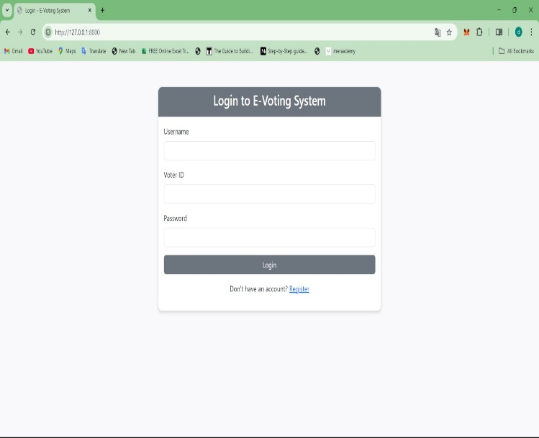

**B**. **User Registration Page**

This page allows new users to register for the E-Voting System. The registration form requires users to provide their **Username, Email, Voter ID, Area, and Password**. After filling in the details, they can click **Register** to create an account.

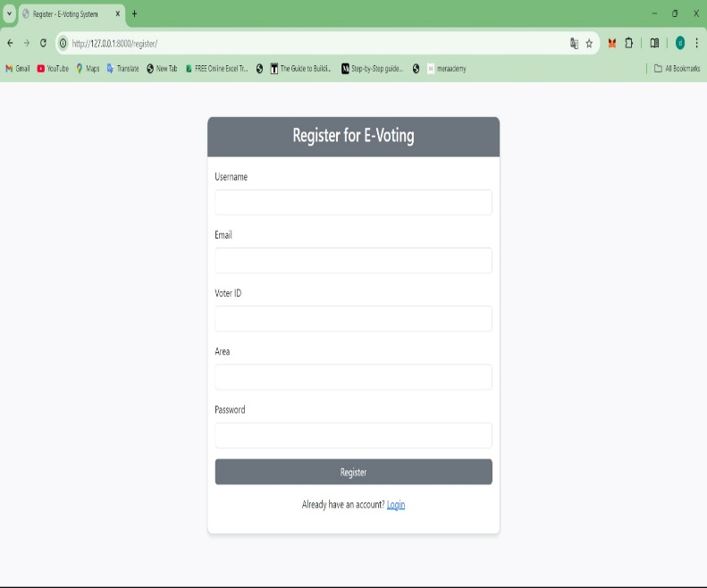

**C**. **E-Voting Dashboard**

The dashboard displays information about the user's voting area and available candidates. Users can cast their votes by clicking the **Vote** button. Additionally, a **Live Results** section is shown, although an error is displayed regarding fetching results.

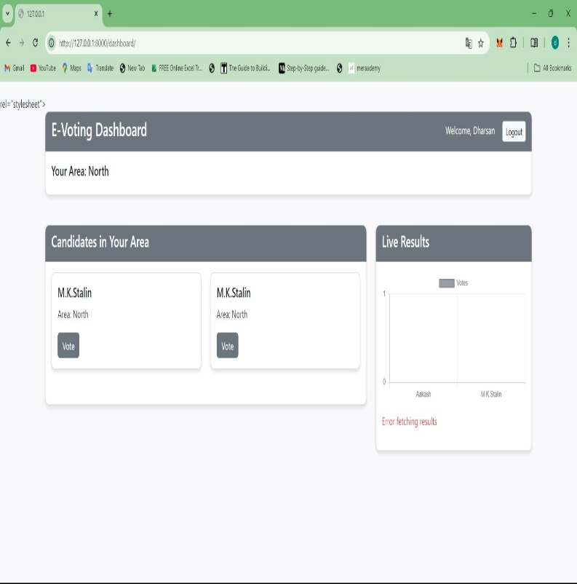

**D**. **Django Admin Login Page**

This is the Django **administration login panel** for the E-Voting System. Only authorized administrators can log in using their **Username and Password** to manage the system.

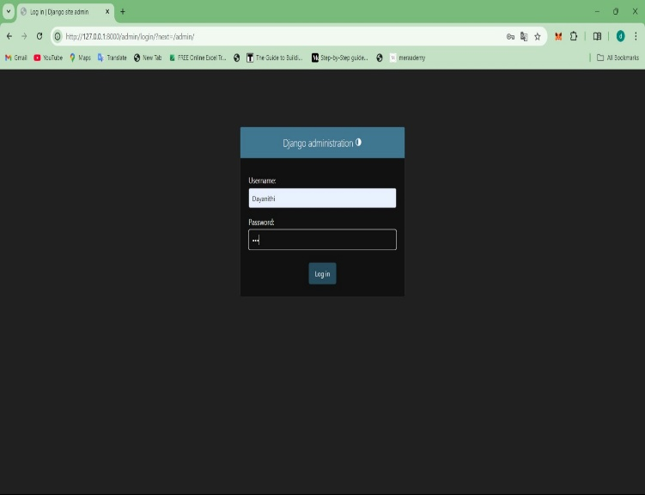

E**. Admin Dashboard**

After logging in, administrators can manage different aspects of the system, such as **Candidates, Users, and Votes**. Recent actions, such as candidate and user registrations, are displayed on the right.

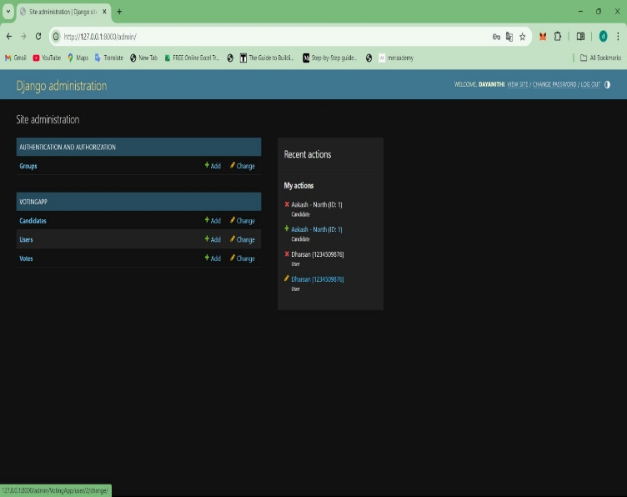

F. **Candidate Registration Page**

This page is used to **register new candidates** for elections. Administrators can enter the **Candidate's Name and Area** before clicking the **Register Candidate** button. A table on the right lists all previously registered candidates.

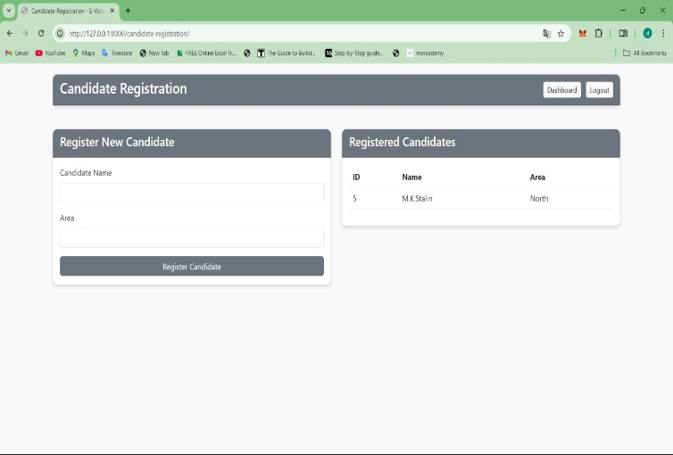

***CONCLUSION***

The E-Voting System provides a secure and user-friendly platform for online voting, ensuring accessibility and transparency in the electoral process. With features such as user registration, candidate management, and real-time results, the system enhances efficiency while reducing manual efforts. The integration of Django's administrative panel allows for effective management and monitoring of elections. Although minor technical issues, such as result fetching errors, need to be addressed, the system overall offers a robust solution for modernizing the voting process. Future improvements could include enhanced security measures, blockchain integration, and a more dynamic user interface to further strengthen trust and reliability.

REFERENCE

[1] S. Chouhan and G. Sharma, "A New Era of Elections: Leveraging Blockchain for Fair and Transparent Voting," arXiv preprint arXiv:2502.16127, 2025.

[2] A. Mukherjee, S. Majumdar, A. K. Kolya, and S. Nandi, "A Privacy-Preserving Blockchain-based E-voting System," arXiv preprint arXiv:2307.08412, 2023.

[3] A. Spanos and I. Kantzavelou, "A Blockchain-based Electronic Voting System: EtherVote," arXiv preprint arXiv:2307.10726, 2023.

[4]S. Sakhuja and S. Balakrishnan, "Quantum-Enhanced Secure Approval Voting Protocol," arXiv preprint arXiv:2406.19730, 2024.

[5]"Blockchain-Based E-Voting Systems: A Technology Review," Electronics, vol. 13, no. 1, 2023.

[6]"Blockchain-Based E-Voting Mechanisms: A Survey and a Proposal," Blockchain and Crypto Research, vol. 4, no. 4, 2023.

[7]"Blockchain-Based Electronic Voting System: Significance and Challenges," International Journal of Information Technology, 2024.

[8]"Blockchain for Securing Electronic Voting Systems: A Survey of Architectures, Trends, Solutions, and Challenges," Cluster Computing, 2024.

[9]"Online Voting System Model for Secure Voting Using Blockchain and Homomorphic Encryption," AIP Conference Proceedings, vol. 3217, no. 1, 2023.

[10]"A Robust Model for Secure Digital Voting Systems in Oman," F1000Research, vol. 14, 2023.

[11]"Blockchain-Based Electronic Voting Systems: A Case Study in Morocco," Journal of Information Security and Applications, vol. 66, 2024.

[12] "Leveraging Blockchain for Robust and Transparent E-Voting Systems," Journal of Information Security and Applications, vol. 68, 2025.

[13]J. Singh, U. Rastogi, Y. Goel, B. Gupta, and Utkarsh, "Blockchain-based Decentralized Voting System Security Perspective: Safe and Secure for Digital Voting System," arXiv preprint arXiv:2303.06306, 2023.

[14]A. Mukherjee and S. Majumdar, "A Novel Blockchain-Based E-Voting System with Enhanced Security and Privacy," IEEE Transactions on Information Forensics and Security, vol. 19, 2024.

•[15] R. Kumar and S. Sharma, "Decentralized E-Voting System Using Blockchain Technology," International Journal of Computer Applications, vol. 182, no. 44, 2023.

[16]M. Ali and H. Khan, "Secure and Transparent E-Voting System Based on Blockchain," Journal of Network and Computer Applications, vol. 200, 2024.

[17]L. Zhang and Y. Liu, "Blockchain-Based E-Voting System with Enhanced Privacy and Security," Future Generation Computer Systems, vol. 137, 2025.

[18] K. Patel and R. Shah, "A Survey on Blockchain-Based E-Voting Systems: Challenges and Opportunities," Journal of Systems Architecture, vol. 130, 2024.

[19]S. Gupta and P. Verma, "Design and Implementation of a Blockchain-Based Secure E-Voting System," Computers & Security, vol. 125, 2025.

[20]D. Nguyen and T. Tran, "A Comprehensive Review of Blockchain-Based E-Voting Systems," ACM Computing Surveys, vol. 57, no. 6, 2025.