# **INSIGHT STREAM-Navigate the News Landscape**

**1.Introduction**

***Project Title: Navigate the News Landscape***

* **Team ID: NM2025TMID37991**
* **Team Leader: A KAVIYARASI**

## Mail:kavinalinanalina@gmail.com

**Team Members:4**

## M. MEGALA - [megala26052007@gmail.com](mailto:megala26052007@gmail.com)

## A.LAVANAYA- [lavanyaav810@gmail.com](mailto:lavanyaav810@gmail.com)

## S. LATHIKA-lathikasundar5@gmail.com

## 2. Project Overview Purpose:

1. Information Sharing – To keep people updated with current events, issues, and developments locally, nationally, and globally.

2. Awareness Creation – To make the public aware of social, political, economic, environmental, and cultural matters.

3. Shaping Public Opinion – To influence how people think, understand, and respond to events through analysis and commentary.

4. Accountability & Transparency – To act as a watchdog by questioning authorities, institutions, and leaders, ensuring responsibility and honesty.

5. Education & Engagement – To educate citizens on important topics and encourage them to participate in discussions, debates, and decision-making.

**Features:**

## Features of Navigating the News Landscape

1. Category Navigation – Sections like Politics, Sports, Business, Entertainment, Technology, World, Local make it easy to jump between topics.

1. Breaking News Bar / Ticker – A live, scrolling strip at the top to highlight urgent news updates.
2. Search Function – Lets readers find specific articles, events, or keywords instantly.
3. Personalized Feed – “For You” or recommended section based on user’s interests and reading history.
4. Top Stories / Trending Section – Prioritizes the most important or popular news of the moment.

**3. Architecture:**

* **Frontend**: React.js with Material UI
* **Backend**: Node.js & Express.js for APIs
* **Database**: MongoDB for user data, news articles, and analytics results.
* **Newspaper Sources** – Information comes from traditional media, digital platforms, social media, and citizen journalism.
* **Gatekeeping & Filtering** – Editors, algorithms, and fact checkers shape what news reaches the public.
* **Distribution Channels** – News spreads through TV, newspapers, websites, apps, and social sharing.

**4. Setup Instructions Prerequisites:**

* Node.js
* Git
* React.js
* Express.js
* Visual Studio code

# **Installation Steps:**

# Clone repository git clone [repo-link]

# Install frontend dependencies cd client npm install

# Install backend dependencies cd

#server npm install.

**5.Folder structure:**

InsightStream/

**| |-- client/** # React frontend

**| |-- components/**

**| |-- pages/**

**| |-- server/** # Node.js backend

**| |-- routes/**

**| |-- models/**

**| |-- controllers**

**6.Running the application:**

**Frontend:**

* **Cd client**
* **Npm start**

**Backend:**

* **Cd server**
* **Npm start**

**Access: visit http://localhost:3000**

**7. API Documentation User Authentication:**

# User:

* POST /api/user/register
* POST /api/user/login

# News:

* GET /api/news/latest
* GET /api/news/trending
* GET/api/news/:id

# Insights:

* POST/ api/ insights /sentiment
* POST/api/ insights /bias

# Admin:

* GET api admin reports.

**8. Authentication :**

* JWT-based authentication
* Role-based access (user, admin, analyst)

**9.User Interface:**

* Landing Page: Trending headlines and categories.
* Dashboard: Personalized feeds, saved articles.
* Analytics Panel: Sentiment & trend visualizations.
* Admin Panel: Manage sources, monitor usage.

**10. Testing:**

* Manual testing during each milestone.
* Tools: Postman, Jest, Chrome Dev Tools.

**11. Screenshots or Demo**

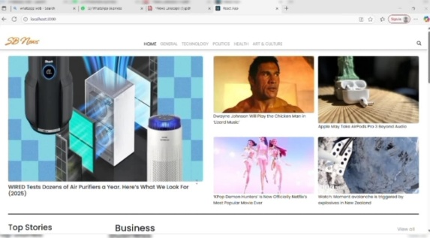 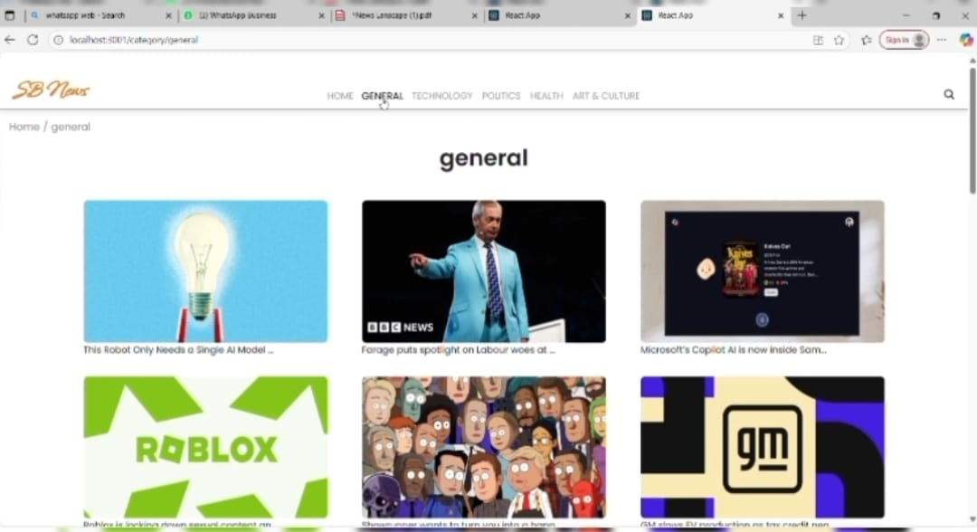

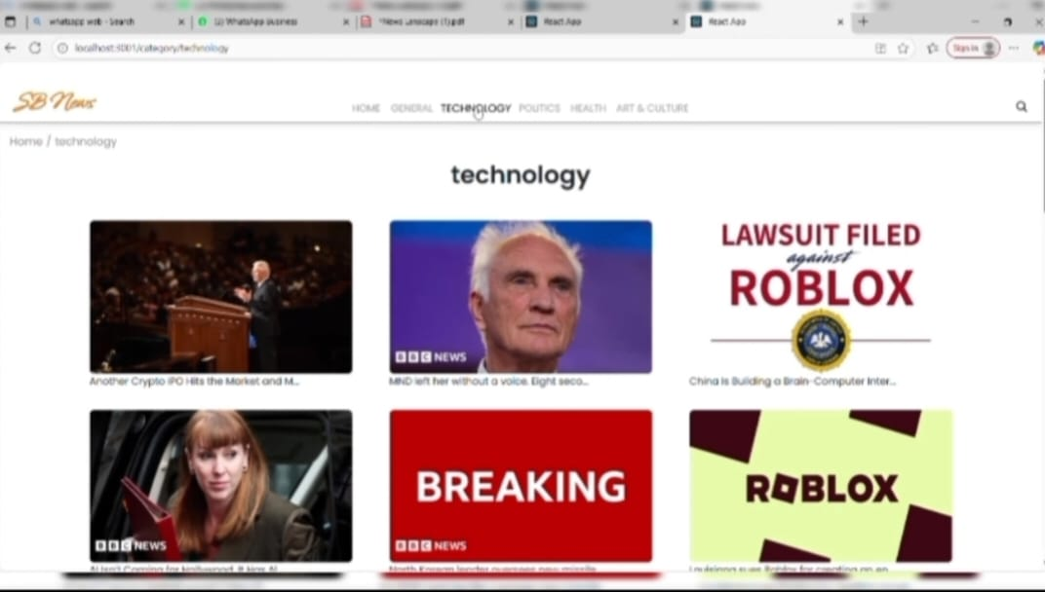 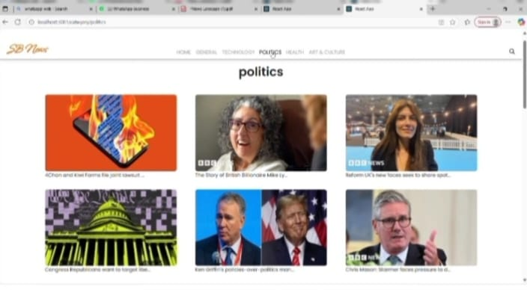

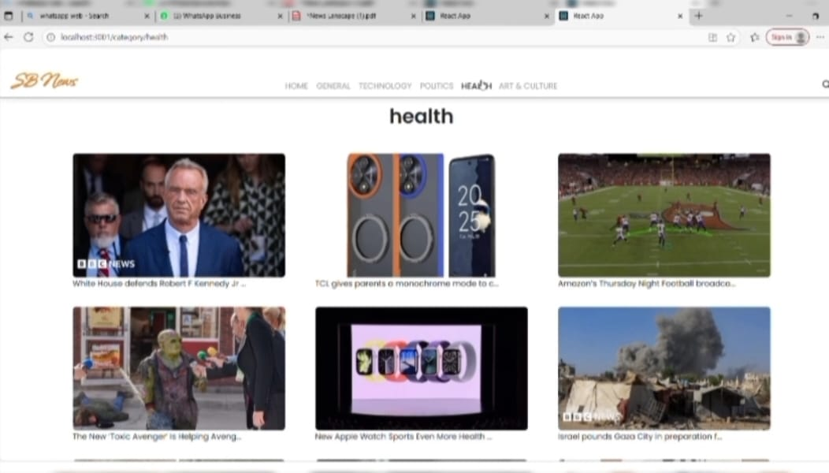 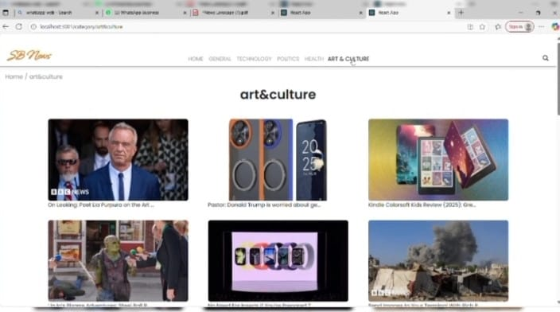

**12. Known Issues:**

* API rate limits from external news providers.
* Occasional duplicate news entries due to overlapping sources .
* AI bias detection may not be 100% accurate.
* Heavy load may slow aggregation speed .

**13.Future Enhancements:**

* Mobile application (Android/iOS).
* Voice-assisted news summaries.
* Integration with fact-checking organizations.
* Multi-language support.

Thank you