**Hybrid RR CPU Scheduling:**

**Input:**

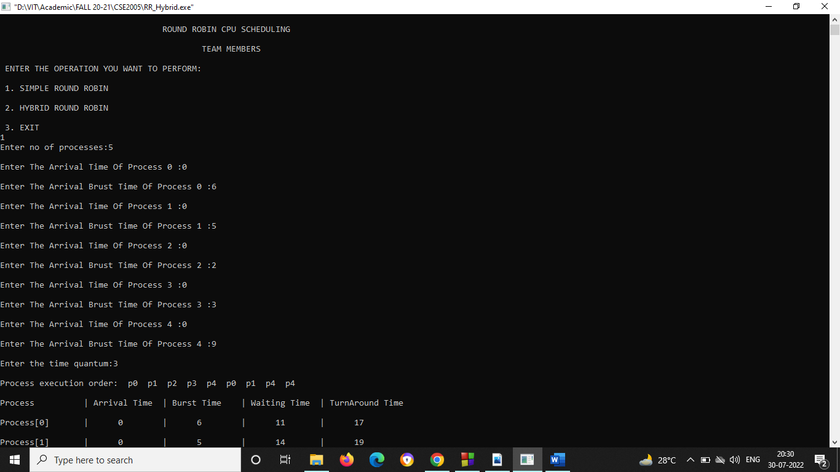

**Output:**

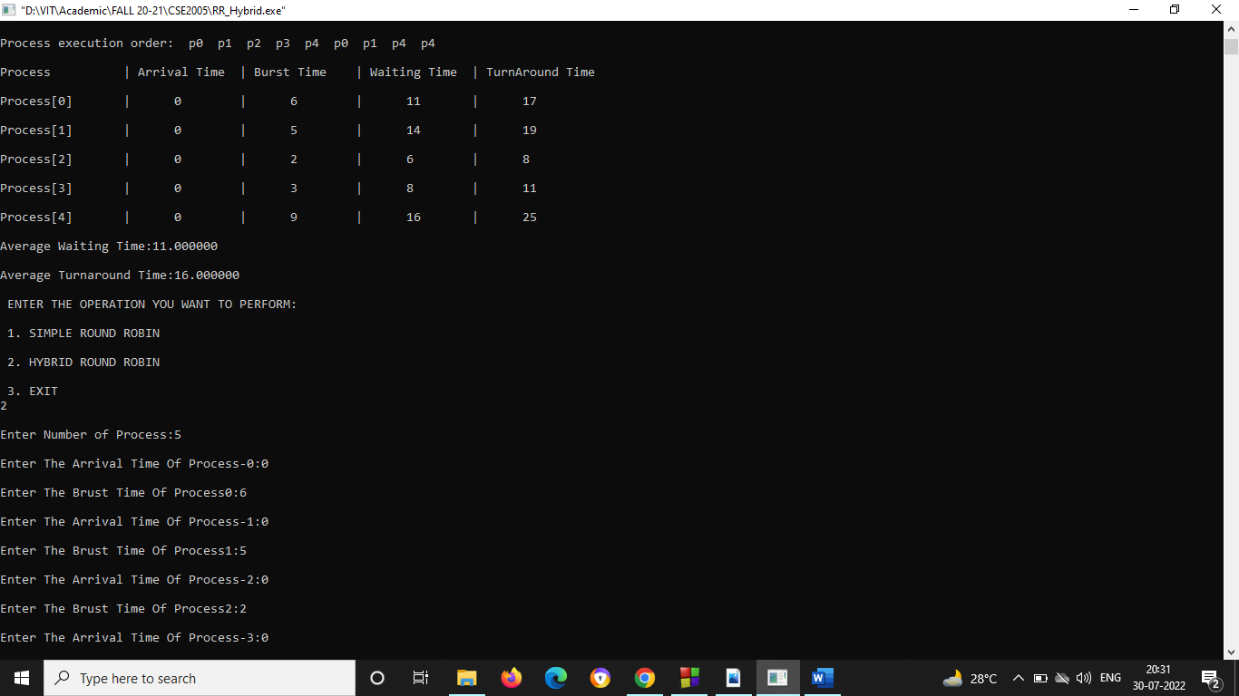

**Input:**

**Output:**

