Replace and modernize legacy VPN architectures with a cloud-native Zscaler Zero Trust solution to reduce attack surface and lateral movement.
.

List of Teammates:

S.no | NAME | COLLEGE | CONTACT
1 | KAVIYA S | PIONEER COLLEGE OF ARTS AND SCIENCE | kaviyasg2005@gmail.com
2 | ROJA THARANGINI S | PIONEER COLLEGE OF ARTS AND SCIENCE | selvarajroja7@gmail.com
3 | RAMAN S | PIONEER COLLEGE OF ARTS AND SCIENCE | ramanram093@gmail.com
4 | SATHYA G | PIONEER COLLEGE OF ARTS AND SCIENCE | gsathya278@gmail.com

Introduction
Over the past two decades, organizations have relied heavily on Virtual Private Networks (VPNs) to provide secure remote access to corporate resources. VPN technology was originally designed when most applications and data were hosted within centralized data centers and employees primarily accessed networks from trusted locations. By creating encrypted tunnels between remote users and internal networks, VPNs allowed employees to securely access internal systems as if they were physically present within the organization’s network perimeter.

However, the modern enterprise environment has evolved significantly. The widespread adoption of cloud computing, Software-as-a-Service (SaaS) platforms, mobile devices, and hybrid work models has fundamentally changed how users access applications and data. Traditional perimeter-based security models are increasingly inadequate in this distributed environment. Once authenticated through a VPN, users often gain broad network access, which can expose critical systems if credentials are compromised or endpoints become infected with malware.

Cyber attackers frequently exploit these weaknesses by gaining initial access through stolen credentials or vulnerable devices and then moving laterally across the network to reach sensitive assets. Such lateral movement significantly increases the potential impact of security breaches and makes detection more difficult for security teams.

To overcome these limitations, many organizations are transitioning to the Zero Trust security model, which eliminates implicit trust within networks. Instead of assuming that users or devices inside the network perimeter are trustworthy, Zero Trust requires continuous verification of identity, device posture, and access context before granting access to specific applications

Cloud-native Zero Trust platforms such as those developed by Zscaler enable organizations to securely connect users directly to applications without exposing the internal network. By implementing technologies like Zero Trust Network Access (ZTNA), identity-based policies, and micro-segmentation, Zscaler helps reduce the attack surface and prevents lateral movement within enterprise environments.

This paper examines how replacing legacy VPN architectures with a cloud-native Zero Trust solution can enhance enterprise security, improve scalability, and better support modern distributed work environments.

Abstract

Traditional Virtual Private Network (VPN) architectures have long been used to provide secure remote access to corporate networks. However, the rapid growth of cloud computing, remote work, and sophisticated cyber threats has exposed significant limitations in legacy VPN-based security models. VPNs often grant broad network access once users are authenticated, increasing the risk of lateral movement and expanding the organizational attack surface in the event of credential compromise or device infection. To address these challenges, organizations are increasingly adopting Zero Trust security frameworks that follow the principle of “never trust, always verify.”

Cloud-native Zero Trust solutions, such as those provided by Zscaler, offer a modern alternative to legacy VPN architectures by enforcing identity-based access controls, continuous verification, and application-level segmentation. Instead of connecting users to entire networks, Zero Trust platforms connect users directly to specific applications based on strict authentication and policy enforcement. This approach significantly reduces the risk of unauthorized access and prevents attackers from moving laterally within enterprise environments.

This study explores the limitations of traditional VPN architectures and demonstrates how implementing a cloud-native Zero Trust architecture through Zscaler can improve security posture, reduce the attack surface, and enhance network scalability and performance. The paper also discusses implementation strategies, security benefits, and the overall impact of transitioning from legacy VPN systems to a Zero Trust model.

STAGE 1

TITLE:
Replace and modernize legacy VPN architectures with a cloud-native Zscaler Zero Trust solution to reduce attack surface and lateral movement.
OVERVIEW
.
Organizations have traditionally relied on Virtual Private Networks (VPNs) to enable secure remote access to internal corporate resources. VPNs were designed when most enterprise applications and data were hosted within centralized data centers and users accessed them from trusted office environments. While VPNs provide encrypted connections between remote users and enterprise networks, they operate based on a perimeter-based security model that assumes users inside the network can be trusted. As modern IT environments have evolved toward cloud computing, mobile workforces, and distributed applications, this traditional model has become increasingly inadequate.

Legacy VPN architectures typically grant users broad network access once they successfully authenticate. This “network-level access” approach significantly increases the organization’s attack surface because compromised credentials or infected endpoints can allow attackers to gain deep access into internal networks. Once inside, attackers can move laterally between systems, escalating privileges and targeting sensitive resources. High-profile cyberattacks have demonstrated that lateral movement within networks is a major factor in the severity of security breaches.

To address these challenges, many organizations are shifting toward the Zero Trust security model, a modern cybersecurity framework based on the principle of “never trust, always verify.” Zero Trust assumes that no user, device, or application—whether inside or outside the corporate network—should be automatically trusted. Instead, access decisions are continuously verified using identity, device posture, location, and contextual security policies. This model limits user access strictly to the specific applications or services they need, rather than exposing the entire network.

A cloud-native Zero Trust platform such as Zscaler provides a scalable and secure alternative to traditional VPN architectures. Zscaler delivers security through a globally distributed cloud platform that connects users directly to applications instead of routing traffic through corporate networks. Its Zero Trust Network Access (ZTNA) approach ensures that users are authenticated and authorized before accessing specific applications, without exposing the internal network to the internet.

By implementing a Zscaler-based Zero Trust architecture, organizations can significantly reduce their attack surface. Applications remain hidden behind the platform, making them invisible to unauthorized users and external attackers. Additionally, because users are connected only to individual applications rather than the entire network, opportunities for lateral movement are greatly minimized.

Modernizing legacy VPN infrastructure with a cloud-native Zero Trust solution also provides several operational benefits. These include improved scalability for remote workforces, simplified network architecture, better performance through direct-to-cloud connectivity, and centralized security policy enforcement. Furthermore, it helps organizations align with modern security frameworks and regulatory requirements that emphasize identity-based access control and continuous monitoring.

Overall, replacing legacy VPN systems with a cloud-native Zero Trust solution like Zscaler enables organizations to strengthen their cybersecurity posture while supporting the demands of modern digital and cloud-driven business environments.

LIST OF VULNERABILITY

SNO | VULNERABILITY | CWE NO
1 | BROKEN ACCESS CONTROL | CWE-40
2 | SECURITY MISCONIFIGURATION | CWE-16
3 | SOFTWARE SUPPLY CHAIN FAILURES | CWE-6
4 | CRYPTOGRAPH FAILURE | CWE-32
5 | INJECTION | CWE-37
6 | INSECURE DESIGN | CWE-39
7 | AUTHENTICATION FAILURES | CWE-36
8 | SOFTWARE OR DATA INTEGRITY FAILURES | CWE-14
9 | SECURITY LOGGING AND ALTERING FAILURES | CWE-5
10 | MISHANDING OF EXCEPTIONAL CONDITION | CWE-24

PART A – Application Vulnerabilities (10)

1. Vulnerability Name: Broken Access Control
CWE: CWE-284 – Improper Access Control
OWASP Category: A01:2021 – Broken Access Control
Description
Broken access control occurs when an application fails to properly enforce restrictions on authenticated users, allowing them to access resources or perform actions outside their intended privileges.
Business Impact
Attackers may gain unauthorized access to sensitive data, administrative features, or other users’ accounts. This could lead to data breaches, system compromise, and loss of organizational reputation.
Steps to Reproduce
- Login as a normal user.
- Modify the URL or request parameters to access restricted resources.
- Observe that sensitive resources or administrative functions are accessible without proper authorization.
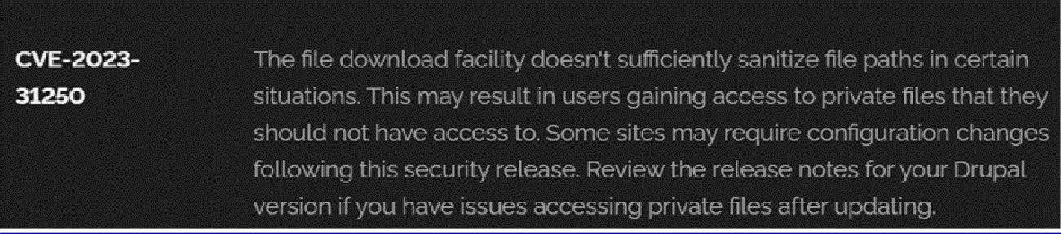

Recommendation
- Implement role-based access control (RBAC).
- Validate permissions on the server side.
- Conduct regular security testing.
- Apply the principle of least privilege.

2. Vulnerability Name: Security Misconfiguration
CWE: CWE-16 – Configuration
OWASP Category: A05:2021 – Security Misconfiguration
Description
Security misconfiguration occurs when systems, servers, frameworks, or applications are improperly configured, exposing sensitive data or functionality.
Business Impact
Attackers may exploit exposed configuration settings to gain system information, access sensitive files, or execute malicious actions.
Steps to Reproduce
- Scan the website using vulnerability scanners.
- Identify exposed services, debug messages, or unnecessary features.
- Observe misconfigured headers or directory listings.
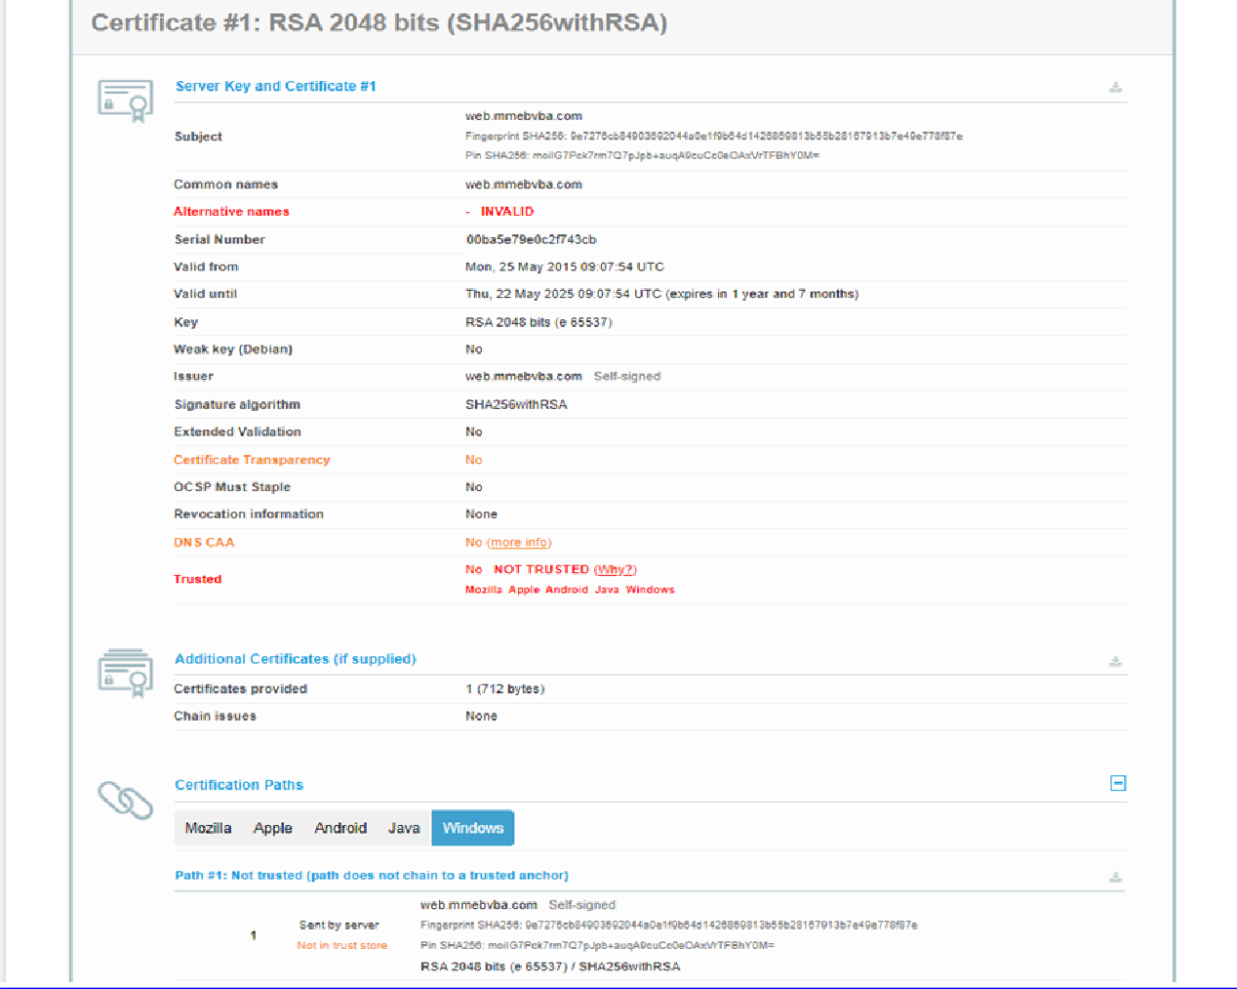

Recommendation
- Disable unnecessary services and features.
- Harden server configurations.
- Use automated configuration management.
- Conduct periodic security reviews.

Vulnerability Name: Software Supply Chain Failures
CWE: CWE-829 – Inclusion of Functionality from Untrusted Control Sphere
OWASP Category: A06:2021 – Vulnerable and Outdated Components
Description
This vulnerability occurs when applications depend on third-party libraries or components that contain known vulnerabilities.
Business Impact
Attackers may exploit vulnerabilities in third-party components to compromise the application, resulting in data breaches or malware injection.
Steps to Reproduce
- Review application dependencies.
- Identify outdated libraries or plugins.
- Compare versions against known vulnerability databases.
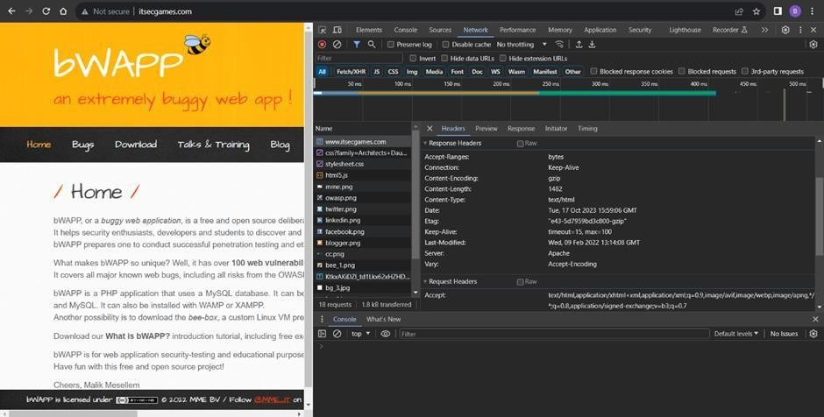

Recommendation
- Maintain an inventory of software components.
- Regularly update third-party libraries.
- Use dependency scanning tools

4. Vulnerability Name: Cryptographic Failure
CWE: CWE-327 – Use of Broken or Risky Cryptographic Algorithm
OWASP Category: A02:2021 – Cryptographic Failures
Description
Cryptographic failures occur when weak encryption algorithms or improper encryption techniques are used to protect sensitive information.

Business Impact
Sensitive data such as passwords, financial details, or personal information may be exposed to attackers.
Steps to Reproduce
- Inspect data transmission.
- Identify weak encryption algorithms.
- Attempt to decrypt captured data.

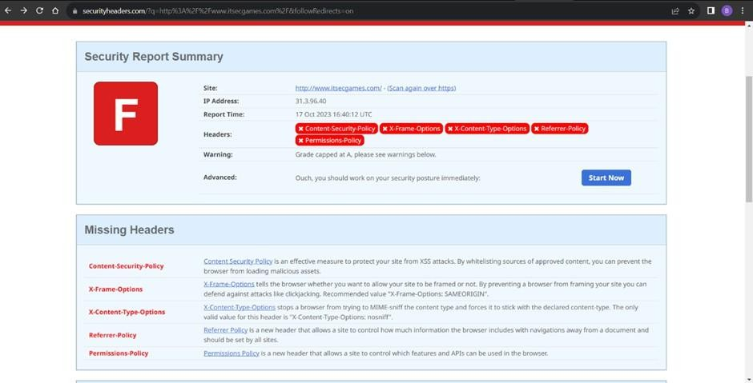

Recommendation
- Use strong encryption algorithms such as AES-256.
- Enforce HTTPS for all communications.
- Securely store encryption keys.

5. Vulnerability Name: Injection
CWE: CWE-89 – SQL Injection
OWASP Category: A03:2021 – Injection
Description
Injection vulnerabilities occur when untrusted input is executed as part of a command or query.
Business Impact
Attackers may access sensitive database data, modify records, or execute administrative commands.
Steps to Reproduce
- Enter malicious input into form fields.
- Include SQL commands such as ' OR '1'='1.
- Observe abnormal application behavior or database output.

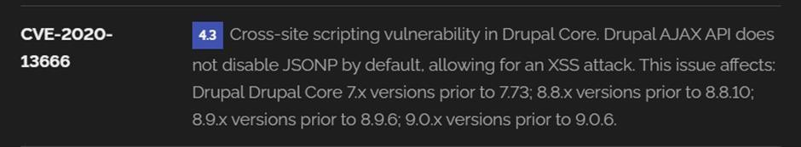

Recommendation
- Use parameterized queries.
- Validate and sanitize user input.
- Implement prepared statements.
6. Vulnerability Name: Insecure Design
CWE: CWE-657 – Violation of Secure Design Principles
OWASP Category: A04:2021 – Insecure Design
Description
Insecure design occurs when security is not considered during the application design phase.
Business Impact
Flaws in design may allow attackers to bypass authentication, manipulate data, or compromise application integrity.
Steps to Reproduce
- Analyze application workflows.
- Identify missing security controls.
- Attempt to bypass validation mechanisms.

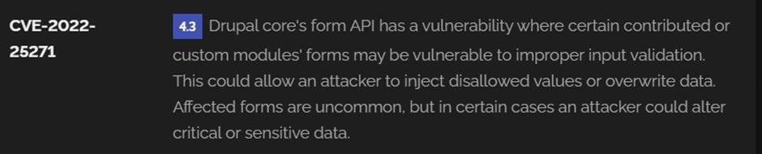

Recommendation
- Implement threat modeling during development.
- Apply secure design principles.
- Conduct design reviews.

7. Vulnerability Name: Authentication Failures
CWE: CWE-287 – Improper Authentication
OWASP Category: A07:2021 – Identification and Authentication Failures
Description
Authentication failures occur when login mechanisms are poorly implemented or insufficiently protected.
Business Impact
Attackers may gain unauthorized access to user accounts or administrative systems.
Steps to Reproduce
- Attempt multiple login attempts.
- Use weak or default credentials.
- Check if account lockout mechanisms are absent
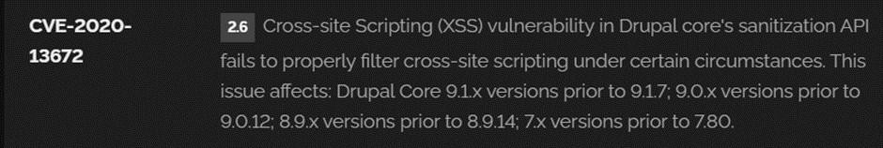

Recommendation
- Implement multi-factor authentication (MFA).
- Enforce strong password policies.
- Implement account lockout mechanisms.
8. Vulnerability Name: Software or Data Integrity Failures
CWE: CWE-353 – Missing Support for Integrity Check
OWASP Category: A08:2021 – Software and Data Integrity Failures
Description
This vulnerability occurs when software updates or data transfers are not verified for integrity.
Business Impact
Attackers may inject malicious code or tamper with application data.
Steps to Reproduce
- Examine update mechanisms.
- Check for missing signature verification.
- Attempt to modify update files.
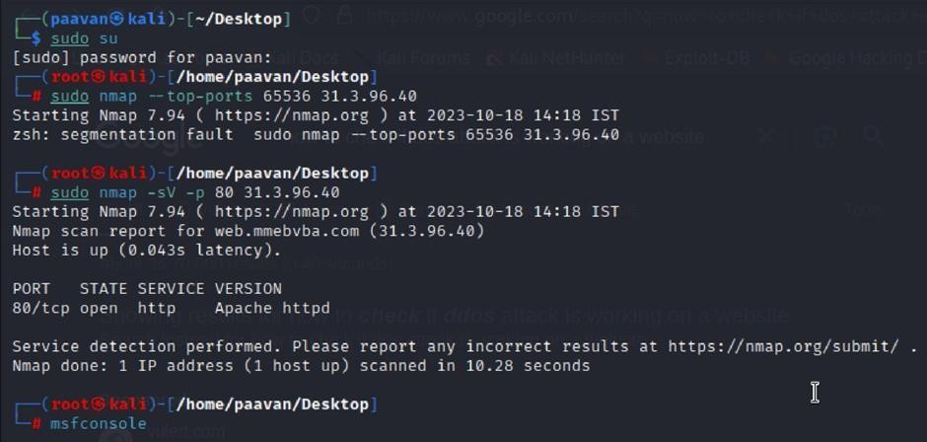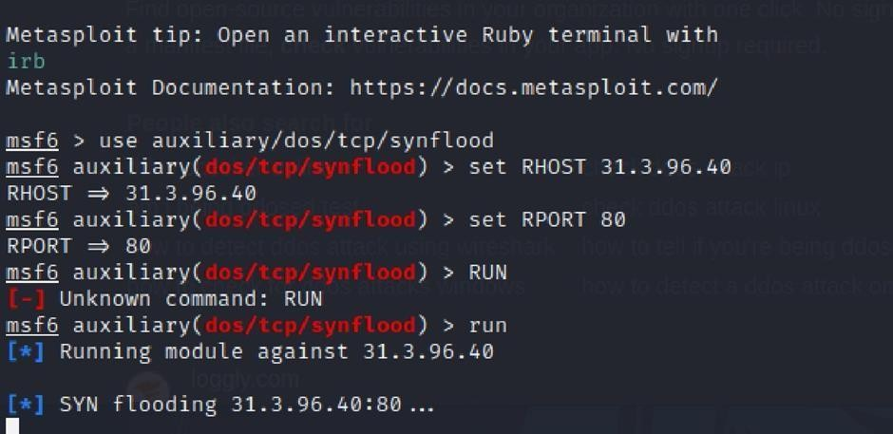

Recommendation
- Implement digital signatures.
- Validate update integrity.
- Secure software distribution channels.
9. Vulnerability Name: Security Logging and Monitoring Failures
CWE: CWE-778 – Insufficient Logging
OWASP Category: A09:2021 – Security Logging and Monitoring Failures
Description
Security events are not properly logged or monitored, preventing timely detection of attacks.
Business Impact
Security incidents may go undetected for long periods, increasing the impact of breaches.
Steps to Reproduce
- Perform suspicious activities on the application.
- Review server logs.
- Observe that events are not logged or alerts are not generated.
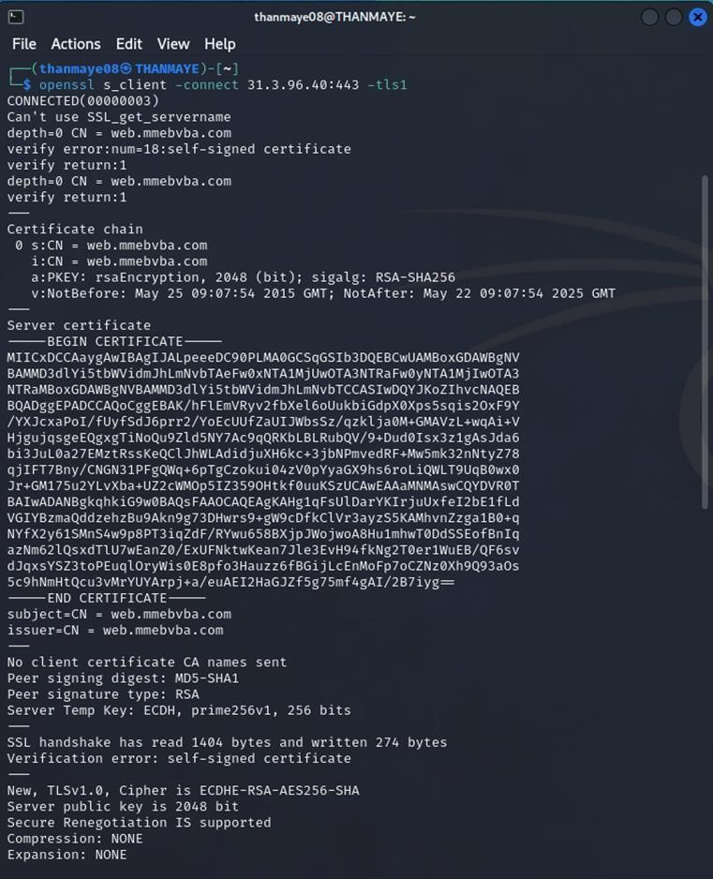

Recommendation
- Enable centralized logging.
- Implement real-time monitoring.
- Use Security Information and Event Management (SIEM) systems.
10. Vulnerability Name: Mishandling of Exceptional Conditions
CWE: CWE-703 – Improper Handling of Exceptional Conditions
Description
Improper error handling exposes sensitive information such as stack traces or system details.
Business Impact
Attackers can gather valuable information about the system architecture, which can be used for further attacks.
Steps to Reproduce
- Trigger application errors.
- Observe detailed error messages returned by the server.
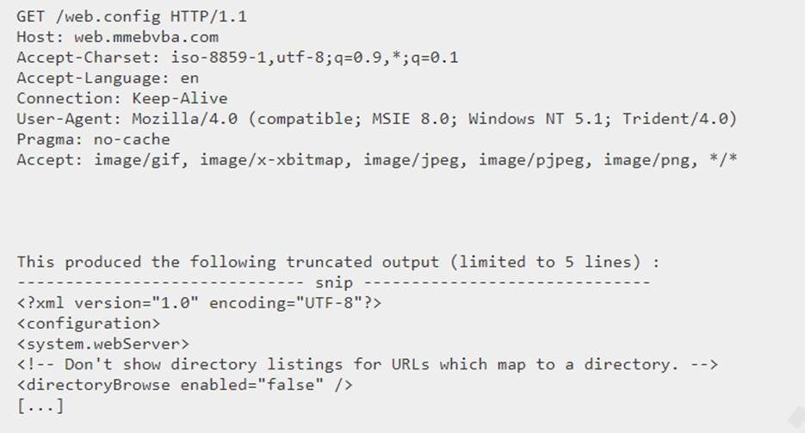

Recommendation
- Implement generic error messages.
- Log detailed errors internally.
- Avoid exposing system information.

PART B – Main Website Vulnerabilities (5)

1. Vulnerability Name: SSL Medium Strength Cipher Suites Supported (SWEET32)
CWE: CWE-200 – Exposure of Sensitive Information to an Unauthorized Actor
Description
The server supports medium strength SSL cipher suites vulnerable to the SWEET32 attack, which may allow attackers to decrypt HTTPS traffic.
Business Impact
Sensitive communications between users and the server could be intercepted.
Steps to Reproduce
- Perform an SSL scan on the website.
- Identify medium strength cipher suites.

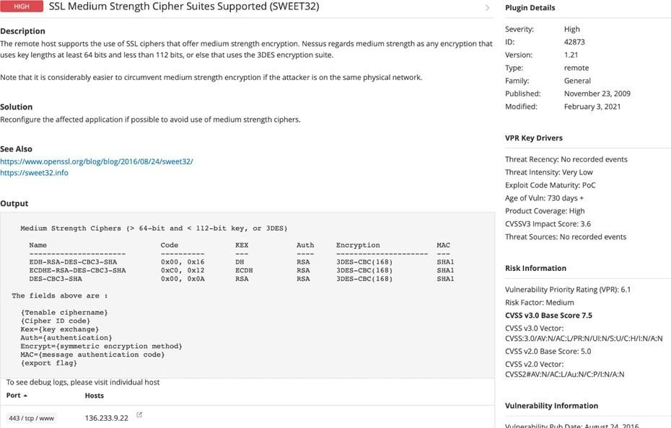

Recommendation
- Disable weak cipher suites.
- Use modern TLS configurations.

2. Vulnerability Name: Cookie SERVERID Created Without Secure Flag
CWE: CWE-614 – Sensitive Cookie in HTTPS Session Without Secure Attribute
Description
The application sets cookies without the secure flag, allowing them to be transmitted over unencrypted connections.
Business Impact
Attackers may capture session cookies and hijack user sessions.
Steps to Reproduce
- Inspect cookies in the browser.
- Observe that the Secure attribute is missing.

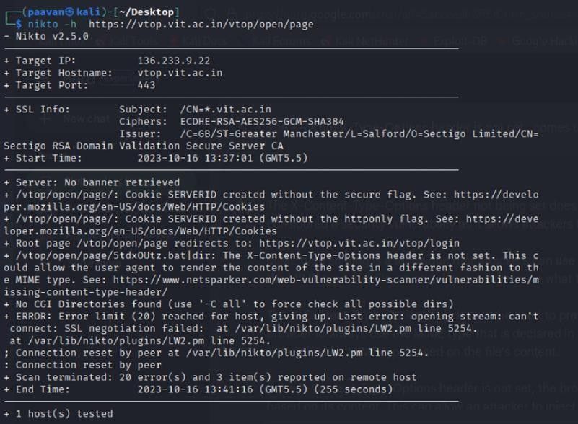

Recommendation
- Enable Secure and HttpOnly flags.
- Enforce HTTPS for all sessions.

3. Vulnerability Name: X-Content-Type-Options Header Missing
CWE: CWE-16 – Configuration
Description
The HTTP response does not include the X-Content-Type-Options header, which may allow MIME-type sniffing attacks.
Business Impact
Attackers may trick browsers into executing malicious content.
Steps to Reproduce
- Inspect HTTP response headers.
- Observe that the header is missing.

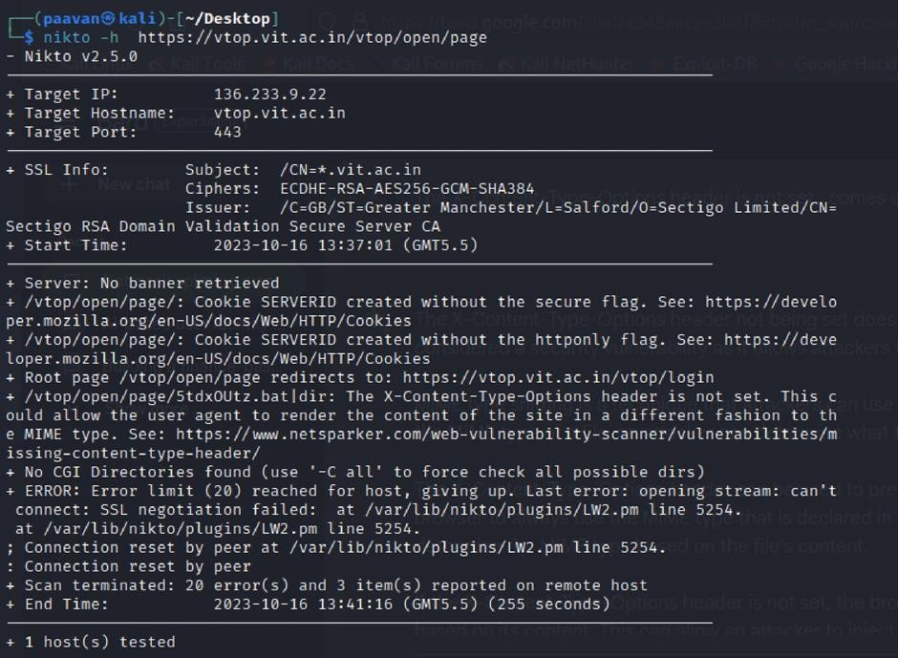

Recommendation
- Add X-Content-Type-Options: nosniff heade

4. Vulnerability Name: Denial of Service (DoS)
CWE: CWE-400 – Uncontrolled Resource Consumption
Description
The application may be vulnerable to DoS attacks where attackers overwhelm the server with excessive requests.
Business Impact
The system may become unavailable to legitimate users.
Steps to Reproduce
- Send repeated requests to the server.
- Observe performance degradation.


Recommendation
- Implement rate limiting.
- Use web application firewalls.
- Monitor traffic patterns.
5. Vulnerability Name: OS Identification
CWE: CWE-200 – Exposure of Sensitive Information
Description
The server reveals operating system information through headers or responses.
Business Impact
Attackers may use OS information to plan targeted attacks.
Steps to Reproduce
- Perform network scanning.
- Analyze server headers.
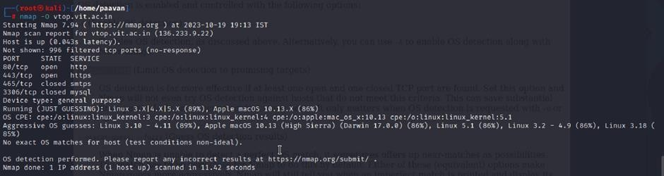

Recommendation
- Remove OS identification from headers.
- Harden server configuration.

Stage 2 – Vulnerability Assessment using Nessus
Overview
Nessus is a widely used vulnerability scanning tool developed by Tenable. It is a remote vulnerability scanner, which means it does not need to be installed on the target system in order to perform scans. Instead, Nessus analyzes systems by sending different types of probes to identify potential security vulnerabilities.

These probes may include network traffic requests, operating system queries, and application-level interactions. By analyzing the responses received from the target system, Nessus determines whether the system is exposed to known vulnerabilities.

Nessus operates using a plugin-based architecture. Plugins are small modules designed to detect specific vulnerabilities in operating systems, network devices, and applications. Nessus currently includes thousands of plugins that allow it to detect a wide range of security issues.

During a scan, Nessus first performs a host discovery process to determine information about the target system, such as the operating system, open ports, and running services. After this initial discovery phase, Nessus executes relevant plugins to test the system for known vulnerabilities.

For every vulnerability detected, Nessus generates a detailed report containing information such as:
- Vulnerability name and description
- Severity level
- Plugin ID used to detect the vulnerability
- Steps to reproduce the issue
- Recommended remediation steps

Nessus can scan various types of targets, including:
- Individual hosts
- Entire networks
- Web applications
- Specific ports and services

Scans can be performed manually or scheduled automatically at regular intervals, making Nessus an effective tool for continuous security monitoring.

Working Process of Nessus
The vulnerability scanning process performed by Nessus generally follows these steps:
- Nessus establishes communication with the target system using protocols such as TCP, UDP, and ICMP.
- It sends a series of probes to identify the operating system, services, and open ports on the target host.
- Nessus executes vulnerability detection plugins relevant to the discovered services.
- After the scan is completed, Nessus generates a detailed vulnerability report that includes the severity level, description, and recommended remediation steps.

Benefits of Using Nessus
Nessus provides several advantages for cybersecurity professionals:
- Comprehensive vulnerability detection: Nessus contains thousands of plugins that detect vulnerabilities across operating systems, applications, and network devices.
- User-friendly interface: The platform is easy to configure and allows users to run scans without complex setup procedures.
- Detailed reporting: Each detected vulnerability includes severity ratings, technical descriptions, and remediation guidance.
- Scalability: Nessus can scan single hosts, entire networks, or web applications.
- Flexible scanning options: Security teams can run scans manually or schedule them for periodic security assessments.
Because of these capabilities, Nessus is considered an essential tool for identifying and mitigating security vulnerabilities within an organization’s infrastructure

Target Information
Target Website: http://testfire.net/
Target IP Address: 65.61.137.117

List of Identified Vulnerabilities

S.No | Vulnerability Name | Severity | Plugin ID
1 | TLS Version 1.0 Protocol Detection | Medium | 104743
2 | TLS Version 1.1 Protocol Deprecated | Medium | 157288
3 | SSL/TLS Diffie-Hellman Modulus ≤1024 Bits (Logjam) | Low | 83875
4 | ICMP Timestamp Request Remote Date Disclosure | Info | 10114
5 | Additional DNS Hostnames | Info | 46180
6 | Apache Tomcat Detection | Info | 39446
7 | Common Platform Enumeration (CPE) | Info | 45590
8 | Device Type Identification | Info | 54615
9 | HSTS Missing from HTTPS Server | Info | 84502
10 | HTTP Server Type and Version Disclosure | Info | 10107
Vulnerability Report
1. TLS Version 1.0 Protocol Detection

Severity: Medium
Plugin ID: 104743
Port: 443

Description
The remote server supports connections encrypted using TLS 1.0. This protocol contains several cryptographic weaknesses and is considered outdated. Although some implementations attempt to mitigate these issues, modern versions such as TLS 1.2 and TLS 1.3 provide stronger security and should be used instead.

Many industry standards and web browsers have already deprecated support for TLS 1.0.

Solution
Disable TLS 1.0 and enable support for TLS 1.2 or TLS 1.3.

Business Impact
Continued use of TLS 1.0 exposes the organization to potential security risks, including data interception and cryptographic attacks. Additionally, it may lead to non-compliance with industry standards such as PCI DSS and compatibility issues with modern web browsers.

2. TLS Version 1.1 Protocol Deprecated

Severity: Medium
Plugin ID: 157288
Port: 443

Description
The server accepts encrypted connections using TLS 1.1, which is now considered deprecated. This protocol lacks support for modern encryption techniques and secure cipher suites.
Solution
Disable TLS 1.1 and enable TLS 1.2 or TLS 1.3.

Business Impact
Using outdated encryption protocols increases the risk of security breaches and may cause compatibility issues with modern browsers and platforms.

3. SSL/TLS Diffie-Hellman Modulus ≤1024 Bits (Logjam)

Severity: Low
Plugin ID: 83875
Port: 443

Description
The server allows SSL/TLS connections using Diffie-Hellman key exchange parameters of 1024 bits or less. These weak parameters are vulnerable to cryptographic attacks such as the Logjam attack.

Solution
Configure the server to use Diffie-Hellman parameters of at least 2048 bits.

Business Impact
Weak cryptographic parameters may allow attackers with sufficient computational resources to decrypt sensitive communication or compromise connection integrity.

4. ICMP Timestamp Request Remote Date Disclosure

Severity: Informational
Plugin ID: 10114
Port: 0

Description
The target system responds to ICMP timestamp requests. This reveals the system’s internal clock, which could assist attackers during reconnaissance activities.

Solution
Block ICMP timestamp requests and responses at the firewall level.

Business Impact
Although the risk is low, the exposure of system time information may help attackers analyze system behavior or bypass certain time-based authentication mechanisms.

5. Additional DNS Hostnames

Severity: Informational
Plugin ID: 46180

Description
Nessus identified additional hostnames associated with the target system through DNS analysis.

Solution
Review and verify all associated hostnames to ensure they are legitimate and properly secured.

Business Impact
While not a direct vulnerability, this information can reveal infrastructure details that may assist attackers during reconnaissance.

6. Apache Tomcat Detection

Severity: Informational
Plugin ID: 39446
Port: 80

Description
The scan detected the presence of an Apache Tomcat web server running on the target system.

Solution
Ensure the server is regularly updated and securely configured.

Business Impact
Knowledge of the web server software can help attackers identify potential vulnerabilities if outdated versions are used.

7. Common Platform Enumeration (CPE)

Severity: Informational
Plugin ID: 45590

Description
The scan identified software and hardware components using Common Platform Enumeration identifiers.

Solution
Maintain updated software inventories and ensure all components are patched.

Business Impact
This information helps administrators manage assets but may also provide attackers with information about the system environment.

8. Device Type Identification

Severity: Informational
Plugin ID: 54615

Description
Based on operating system fingerprinting, Nessus identified the type of device running the service.

Solution
No direct remediation is required.

Business Impact
While not a vulnerability, device identification may assist attackers in planning targeted attacks.

9. HSTS Missing from HTTPS Server

Severity: Informational
Plugin ID: 84502
Port: 443

Description
The server does not enforce HTTP Strict Transport Security (HSTS). Without HSTS, browsers may allow insecure HTTP connections, making the system vulnerable to downgrade attacks.

Solution
Enable the HSTS header on the web server.

Business Impact
Lack of HSTS may expose users to man-in-the-middle attacks and weaken protection against cookie hijacking.

10. HTTP Server Type and Version Disclosure

Severity: Informational
Plugin ID: 10107
Port: 443

Description
The scan identified the type and version of the web server running on the target host.
Solution
Limit server version disclosure through server configuration.

Business Impact
Exposing server software information may assist attackers in identifying known vulnerabilities associated with that software version

Stage 3
Title
Replacing and Modernizing Legacy VPN Architecture Using a Cloud-Native Zero Trust Solution with Zscaler to Reduce Attack Surface and Lateral Movement

Legacy VPN Architecture
Legacy VPN architecture refers to the traditional remote access model that allows users to securely connect to an organization’s internal network through encrypted tunnels. These connections are usually established using on-premises hardware appliances known as VPN concentrators.

Unlike modern security solutions, legacy VPN systems operate under an “authenticate once, trust indefinitely” model. Once a user successfully authenticates, the VPN grants them direct access to the internal network by assigning an internal IP address. As a result, the remote device becomes part of the organization's network.

This architecture was originally designed when most employees worked within office environments and business applications were hosted in centralized data centers. The model follows a “trusted internal network vs untrusted external network” concept, often referred to as the castle-and-moat security model.

In this design, the VPN concentrator acts as a gateway. Once users pass authentication, they gain broad access to internal resources based on their network location rather than their identity.

Limitations of Legacy VPN
Although legacy VPNs were effective in the past, they introduce several security and operational challenges in modern hybrid work environments.

1. Over-Permissioned Access
After authentication, users gain network-level access instead of application-specific access. If a device is compromised, attackers can scan the internal network and attempt to exploit other systems.

2. Expanded Attack Surface
VPN appliances must be exposed to the internet through open ports (such as IPsec or SSL VPN ports). This makes them visible targets for attackers performing port scans, brute-force attacks, or vulnerability exploitation.

3. Poor User Experience
Traffic is often routed through the corporate data center before reaching cloud services, creating a “hair-pinning” effect. This increases latency and slows down access to SaaS applications.

4. Scalability Limitations
Hardware VPN devices have fixed capacity limits. During high-usage periods, organizations may experience connection failures and require costly hardware upgrades.
5. Operational Complexity
IT teams must maintain and patch physical VPN appliances regularly, manage certificates, and handle firmware updates, which increases administrative workload.

The Security Problem: Attack Surface and Lateral Movement
Two major security risks associated with legacy VPN architecture are attack surface exposure and lateral movement.

Attack Surface
VPN gateways must remain publicly accessible to allow remote users to connect. This exposes them to continuous scanning by attackers searching for vulnerabilities. If a flaw is discovered, attackers may exploit it to gain unauthorized access.
For example, vulnerabilities such as CVE-2019-11510 in Pulse Secure VPN allowed attackers to access sensitive files and credentials.
Each exposed port on a VPN gateway increases the potential entry points for attackers.

Lateral Movement
If attackers successfully compromise a VPN account or exploit a vulnerability, they gain internal network access. Since many enterprise networks are relatively flat, attackers can move laterally across systems.
From a compromised device, attackers may:
- Scan internal servers and databases
- Access file shares or administrative systems
- Perform credential attacks such as pass-the-hash
- Deploy ransomware across multiple systems
This significantly increases the damage caused by a single compromised device.

Zero Trust Architecture
Zero Trust Architecture (ZTA) is a modern cybersecurity framework that removes the concept of a trusted internal network. Instead, it follows the principle:
“Never trust, always verify.”
Every access request must be continuously authenticated, authorized, and validated before access is granted.
The core principles of Zero Trust include:

1. Assume Breach
Systems are designed with the assumption that attackers may already be inside the network.
2. Verify Explicitly
Access decisions are based on identity, device health, location, and contextual risk factors.
3. Least Privilege Access
Users receive only the minimum permissions required to perform their tasks.
4. Micro-Segmentation
Applications and workloads are isolated so that attackers cannot move laterally between systems.

Zscaler Zero Trust Solution
Zscaler provides a cloud-native Zero Trust security platform that eliminates the need for traditional VPN hardware.
Two primary services support this model:

1. Zscaler Private Access (ZPA)
Zscaler Private Access enables secure remote access to private applications without placing users on the internal network. Users connect directly to specific applications rather than the entire network.
2. Zscaler Internet Access (ZIA)
Zscaler Internet Access functions as a secure web gateway that inspects internet traffic for malware, phishing, and data leaks regardless of user location.
Together, these services replace traditional VPN infrastructure while improving security and performance.

Eliminating the Attack Surface
Zscaler removes the traditional attack surface by making internal applications invisible to the public internet.
Key mechanisms include:

No Inbound Ports
ZPA uses App Connectors that establish outbound connections to the Zscaler cloud. Because connections are initiated internally, there is no need to open inbound firewall ports.

Application Invisibility
Applications are not exposed to public IP addresses or DNS records. As a result, attackers cannot discover or scan them.

Secure Cloud Broker Model
Users connect to the Zscaler cloud, which acts as a broker between users and applications. Neither side can directly see the other's IP address.

Preventing Lateral Movement
Zscaler prevents lateral movement by connecting users directly to applications instead of the internal network.

Application Micro-Segmentation
Each user session creates a dedicated encrypted connection to a specific application.

No Network Visibility
Users never receive internal IP addresses, preventing them from discovering or accessing other resources.

Identity-Based Policies
Access is controlled based on user identity, device health, and security posture.

Continuous Monitoring
Connections are continuously monitored, and suspicious activity can trigger immediate session termination.

Zscaler Architecture Components

Zscaler Client Connector
A lightweight client installed on user devices that securely routes traffic through Zscaler services.

Zscaler App Connector
A virtual appliance deployed inside the data center that connects internal applications to the Zscaler cloud.

Zscaler Cloud Platform
A globally distributed security platform with multiple data centers ensuring low latency and high availability.

Zscaler Admin Portal
A centralized management interface where administrators configure security policies and access rules.

Integration with Existing Infrastructure
Zscaler integrates with existing enterprise technologies to enhance security capabilities.

Identity Provider Integration
Integration with identity platforms such as Microsoft Azure Active Directory or Okta enables single sign-on and multi-factor authentication.

Endpoint Protection Integration
Security tools like Microsoft Defender or CrowdStrike Falcon provide device health information before granting access.

SIEM Integration
Security logs can be forwarded to SIEM platforms such as Splunk or Microsoft Sentinel for monitoring and threat analysis.

Threat Intelligence Integration
Integration with the open-source threat intelligence platform Malware Information Sharing Platform (MISP) enhances security detection.
MISP provides Indicators of Compromise (IOCs) such as:
- Malicious domains
- Command-and-control server IPs
- Malware file hashes
- Phishing URLs
These indicators are shared with the Zscaler cloud, allowing malicious connections to be blocked automatically.

Deployment Methodology
The transition from legacy VPN to Zero Trust architecture involves several phases.

Phase 1 – Discovery and Planning
Identify applications accessed via VPN and categorize user groups.

Phase 2 – Infrastructure Deployment
Deploy App Connectors and integrate the identity provider.
Phase 3 – Policy Configuration
Define application access policies and configure security controls.
Phase 4 – Pilot Deployment
Test the system with a small group of users and collect feedback.
Phase 5 – Full Deployment
Gradually migrate all users from the legacy VPN to the Zscaler platform.
Phase 6 – Optimization
Continuously monitor logs and refine access policies.

Incident Response in a Zero Trust Environment
Incident response becomes significantly more efficient within a Zero Trust architecture.
Detection
Security teams detect suspicious activities through logs and security alerts.
Containment
Compromised users or devices can be immediately blocked through the Zscaler dashboard.
Eradication
The affected device is secured and credentials are reset.
Recovery
Users regain access after verification and system cleanup.
Post-Incident Review
Security teams analyze the incident and improve security policies.

Conclusion
This project demonstrates how replacing legacy VPN architecture with a cloud-native Zero Trust solution significantly strengthens organizational security.

By implementing the Zscaler platform, organizations can eliminate publicly exposed VPN infrastructure and prevent lateral movement within their networks. Access is granted based on identity, device health, and contextual policies, ensuring that users connect only to the applications they need.

This transformation not only enhances cybersecurity defenses but also improves user experience by enabling secure, high-performance access for modern hybrid work environments.

Future Scope
The future of cybersecurity will continue to evolve with the integration of artificial intelligence, cloud security platforms, and advanced threat intelligence.
Key developments include:
- AI-driven threat detection and behavior analytics
- Automated security policy enforcement
- Advanced data loss prevention systems
- Cloud-based security monitoring platforms
- Improved SOC and SIEM integration
As organizations increasingly adopt cloud technologies and remote work models, Zero Trust frameworks will play a critical role in protecting digital infrastructure from emerging cyber threats.
Tools Explored
During this project, the following cybersecurity tools were studied and utilized:
- Nmap
- Metasploit Framework
- Nessus
- Kali Linux
- OWASP ZAP
- Burp Suite
These tools were used for vulnerability scanning, penetration testing, and security analysis.

