**INTRODUCTION**:

Temperature measurement is also known as thermometry, describes the process of measuring local temperature for immediate or later evaluation. The temperature of the air near the surface of the Earth is measured at meteorological observatories and weather stations. The world’s average surface air temperature is about 14 degree Celsius. DS18B20 Sensor is used in this project for detection of temperature.

**PROBLEM STATEMENT:**

The motivation of this project is an observation of the variation in temperature in various circumstances. The implementation of this project will help in various practical applications such as closing or opening doors and windows according to the temperature , control any product’s temperature etc.

ESP8266 Arduino core comes with libraries to communicate over WiFi using TCP and UDP, set up HTTP, mDNS, SSDP, and DNS servers, do OTA updates, use a file system in flash memory, and work with SD cards, servos, SPI and I2C peripherals.

**COMPONENTS REQUIRED:**

1. ESP8266 - 1
2. DS18B20 Temperature sensor - 1
3. Resistors – 4.7k ohm
4. Jumpers
5. Bread board
6. Blynk app

**SCHEMATIC DIAGRAM:**

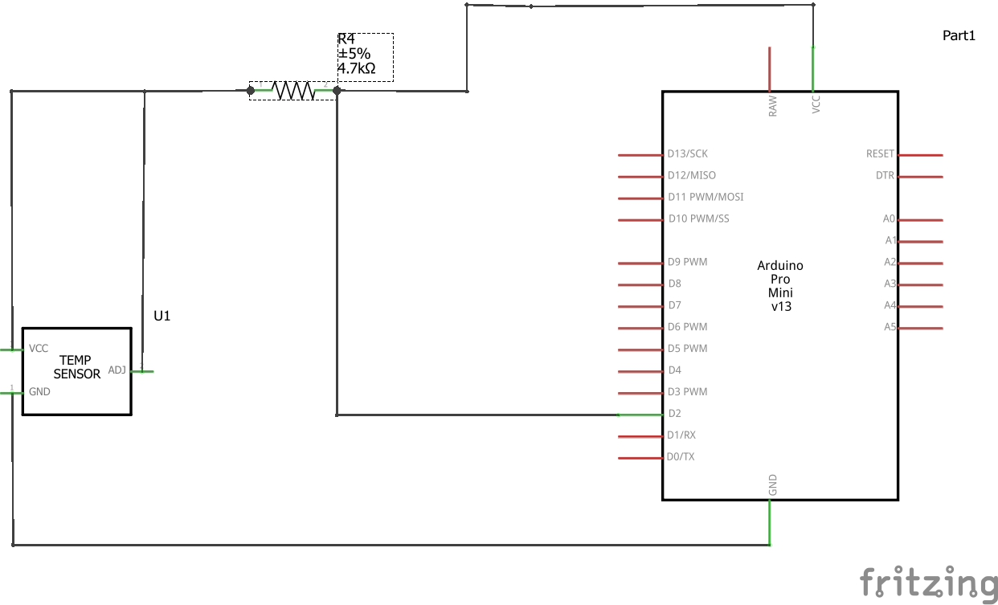

**CODE:**

#define BLYNK_PRINT Serial //used for printing messages on serial monitor port.  
#include <ESP8266WiFi.h> //provides ESP8266 specific wifi routines.  
#include <BlynkSimpleEsp8266.h> //handles all connection routines and data exchange.  
#include <OneWire.h> //to access 1-wire devices made by Dallas.  
#include <DallasTemperature.h>  
const int oneWireBus = 4;   
OneWire oneWire(oneWireBus);  
DallasTemperature sensors(&oneWire);

char auth[] = "N8sdpDxd9iifLHGh9xXy3wEzAgZMiiEF"; //authorization code used to link app with ESP8266  
char ssid[] = "kaviya"; //hotspot name to be connected  
char pass[] = "12345678@"; //password

void setup()  
{  
  Serial.begin(115200); //see the connection status in serial monitor.  
  sensors.begin(); //to establish connection with temperature sensor  
  Blynk.begin(auth, ssid, pass); //to connect with the app   
  sense();

}

void sense()  
{  
  sensors.requestTemperatures(); //ESP8266 initiates request  
  float temperatureC = sensors.getTempCByIndex(0); //get temperature in celcius  
  float temperatureF = sensors.getTempFByIndex(0); //get temperature in farenheit  
  Serial.print(temperatureC); //print temperature in celcius.  
  Serial.println("ºC");   
  Blynk.virtualWrite(V6,temperatureC); //to display in Blynk mobile app  
  Serial.print(temperatureF); //print temperature in farenheit  
  Serial.println("ºF"); //  
 Blynk.virtualWrite(V5,temperatureF);//display in Blynk app   
  delay(5000);  
}

void loop()  
{  
  Blynk.run();//to update the value in Blynk.  
  sense();  
}

**CHALLENGES FACED:**

**-**NIL-

**CONTRIBUTIONS:**

Equal contribution.

**REFERENCES:**

<https://ui.adsabs.harvard.edu/abs/1996IJSSC..31..933B/abstract>.

<https://www.instructables.com/id/IoT-Temperature-Sensor-With-ESP8266/>

**GITHUB LINK:**