FitBuddy – AI Fitness Plan Generator using Gemini Models
Project Documentation
1. PROJECT DESCRIPTION
FitBuddy is a web-based application that uses AI to generate personalized workout plans and nutrition tips
based on a user's fitness goals, such as weight loss, muscle gain, or general wellness. Built with FastAPI
and integrated with Google's Gemini AI models, FitBuddy simplifies the process of creating structured and
effective fitness routines.
The application takes in user information — such as age, weight, goal, and preferred workout intensity —
and generates a customized 7-day fitness plan. Users can also submit feedback to update and refine their
plan using AI. A complementary nutrition or recovery tip is also provided based on their selected goal.
With a clean user interface and database support via SQLite, FitBuddy ensures each user's data and
generated plan are stored and accessible. It offers both API endpoints and an interactive HTML interface
for ease of use.
2. SCENARIOS
Scenario 1:
A user inputs their personal details — name, age, weight, fitness goal (e.g., “weight loss” or “muscle
gain”), and preferred workout intensity (“high”, “medium”, or “low”) — to receive a personalized 7-day
workout plan. The system generates a day-by-day schedule tailored to the user's fitness objective and
experience level.
Scenario 2:
A user submits feedback on their existing workout plan, such as “more focus on cardio” or “include more
rest days.” The system uses this input to regenerate an updated workout plan, refining it based on the
user's evolving needs.
Scenario 3:
A user requests a nutrition or recovery tip based on their selected fitness goal. The platform delivers a
concise and relevant suggestion (e.g., “Include protein in your post-workout meal” for muscle gain).
Scenario 4:
An admin or coach accesses the platform to view all registered users and their workout plans through a
dedicated dashboard, tracking individual progress and comparing original and updated plans.
Scenario 5:
A complete beginner with no prior exercise experience selects “general wellness” as their goal and “low”
intensity. The system generates a gentler, beginner-friendly plan that emphasizes light activity, mobility
work, and gradual progression, helping the user build a sustainable exercise habit without feeling
overwhelmed.
Scenario 6:
An administrator reviews a specific user's record on the all-users dashboard and compares their original
AI-generated plan side by side with the feedback-updated version, evaluating how the user's requested
changes (e.g., more cardio, fewer rest days) were reflected in the revised schedule.

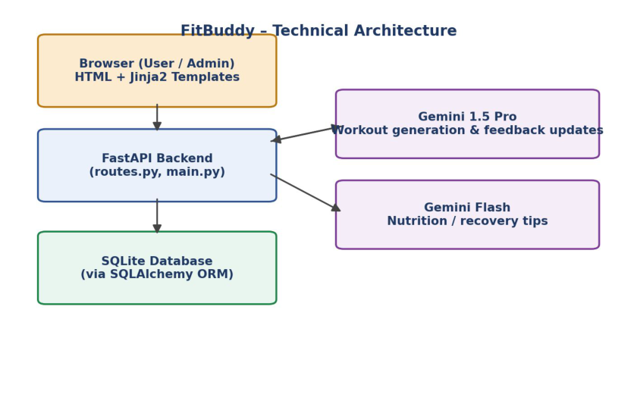

3. TECHNICAL ARCHITECTURE
Architecture Overview
• Frontend: HTML + Jinja2 templates for user input and display
• Backend: FastAPI for route handling and logic
• AI Layer: Google Gemini APIs (Pro & Flash)
• Database: SQLite with SQLAlchemy for persistence
4. PRE-REQUISITES
• FastAPI Framework Knowledge
• Gemini API Familiarity
• HTML, CSS, and Jinja2 Template Skills
• Python Programming Proficiency
• Version Control with Git
• SQLAlchemy and SQLite Basics
• Environment Setup (pip, virtualenv, or conda)
• Uvicorn ASGI Server
5. PROJECT WORKFLOW
The project was developed across five milestones:
• Milestone 1: Model Selection and Architecture
• Milestone 2: Core Functionalities Development



• Milestone 3: routes.py Development
• Milestone 4: Frontend Development
• Milestone 5: Deployment
6. MILESTONE 1: MODEL SELECTION AND ARCHITECTURE
This milestone focuses on selecting the appropriate generative AI models from Google's Gemini family for
the FitBuddy application, evaluating performance and capabilities to align with the app's core
functionalities.
Activity 1.1: Research and Select the Appropriate Generative AI Model
FitBuddy's AI model needed to:
• Generate structured 7-day workout plans
• Provide concise and actionable nutrition tips
• Update workout plans based on user feedback
• Perform well in real-time, web-based interaction
Several Hugging Face models (T5 & BART, DistilBERT, Bloom) were evaluated first, but required
hosting/GPU setup and heavy fine-tuning.
Final selection: Google Gemini 1.5 Pro (structured workout generation and plan updates) and Gemini Flash
(fast, lightweight nutrition tips), chosen for easy FastAPI integration, structured formatting support, high
accuracy, and scalability.
Activity 1.2: Define the Architecture of the Application
• Frontend Responsibilities: index.html (input form), result.html (plan, tip, feedback), all_users.html
(admin panel)
• Backend Responsibilities: receives form data, calls Gemini models, stores user info and plans,
renders dynamic templates
• AI Integration Points: Workout generation & feedback updates → Gemini Pro; Nutrition tips →
Gemini Flash
Activity 1.3: Set up the Development Environment
• Install Python and pip
• Create a virtual environment: python -m venv fitbuddy-env
• Install required libraries: fastapi, uvicorn, jinja2, sqlalchemy, python-multipart, google-generativeai
• Run server: uvicorn app.main:app --reload
• Set up project structure: /app, /templates, /static/images
Project folder structure
FitBuddy/
├── app/
│ | ├── main.py

│ | ├── routes.py

│ | ├── gemini_generator.py

│ | ├── gemini_flash_generator.py

│ | ├── updated_plan.py

│ | └── database.py
├── templates/
│ | ├── index.html






│ | ├── result.html

│ | └── all_users.html
├── static/
│ | └── images/
├── requirements.txt
└── .env
requirements.txt
fastapi
uvicorn
jinja2
sqlalchemy
python-multipart
google-generativeai
python-dotenv
7. MILESTONE 2: CORE FUNCTIONALITIES DEVELOPMENT
Activity 2.1: Develop the Core Functionalities
Workout Plan Generation
Function: generate_workout_gemini() — File: gemini_generator.py. Generates a personalized 7-day workout
plan using goal and intensity, including warm-up, main workout, and cooldown/recovery guidance.
import google.generativeai as genai
import os
genai.configure(api_key=os.getenv("GOOGLE_API_KEY"))
model = genai.GenerativeModel("gemini-1.5-pro")
def generate_workout_gemini(goal: str, intensity: str, age: int, weight: float) -> str:
prompt = f"""
Create a structured 7-day workout plan for a user with the following profile:
- Fitness goal: {goal}
- Preferred intensity: {intensity}
- Age: {age}
- Weight: {weight} kg
For each day, include a short focus area, a brief warm-up (5-10 mins),
3-5 main exercises with sets/reps or duration, and a cooldown or recovery tip.
Format the response clearly, day by day.
"""
response = model.generate_content(prompt)
return response.text
Nutrition Tip Generation
Function: generate_nutrition_tip_with_flash() — File: gemini_flash_generator.py. Generates a concise,
practical nutrition or recovery tip using Gemini Flash.
import google.generativeai as genai
import os
genai.configure(api_key=os.getenv("GOOGLE_API_KEY"))
flash_model = genai.GenerativeModel("gemini-1.5-flash")





def generate_nutrition_tip_with_flash(goal: str) -> str:
prompt = f"""
Give one short, practical nutrition or recovery tip (2-3 sentences)
for someone whose fitness goal is: {goal}.
Keep it simple, actionable and easy to follow.
"""
response = flash_model.generate_content(prompt)
return response.text.strip()
Feedback-Based Plan Updating
Function: update_workout_plan() — File: updated_plan.py. Passes the original plan and user feedback to
Gemini 1.5 Pro to produce a revised plan.
import google.generativeai as genai
import os
genai.configure(api_key=os.getenv("GOOGLE_API_KEY"))
model = genai.GenerativeModel("gemini-1.5-pro")
def update_workout_plan(original_plan: str, feedback: str) -> str:
prompt = f"""
Here is a user's current 7-day workout plan:
{original_plan}
The user has given the following feedback:
"{feedback}"
Revise the plan to reflect this feedback while keeping the
same 7-day, day-by-day structure and formatting.
"""
response = model.generate_content(prompt)
return response.text
User & Plan Storage
Functions: save_user(), save_plan(), update_plan(), get_original_plan(), get_user() — File: database.py. Stores
user info and AI-generated plans via SQLAlchemy ORM.
from sqlalchemy import Column, Integer, String, Float, Text
from sqlalchemy.orm import declarative_base, Session
Base = declarative_base()
class User(Base):
__tablename__ = "users"
id = Column(Integer, primary_key=True, index=True)
user_id = Column(String, unique=True, index=True)
username = Column(String)
age = Column(Integer)
weight = Column(Float)
goal = Column(String)
intensity = Column(String)
class Plan(Base):
__tablename__ = "plans"
id = Column(Integer, primary_key=True, index=True)




user_id = Column(String, index=True)
original_plan = Column(Text)
updated_plan = Column(Text, nullable=True)
nutrition_tip = Column(Text)
def save_user(db: Session, user_data: dict):
user = User(**user_data)
db.add(user)
db.commit()
return user
def save_plan(db: Session, user_id: str, plan: str, tip: str):
row = Plan(user_id=user_id, original_plan=plan, nutrition_tip=tip)
db.add(row)
db.commit()
return row
def update_plan(db: Session, user_id: str, new_plan: str):
row = db.query(Plan).filter(Plan.user_id == user_id).first()
if row:
row.updated_plan = new_plan
db.commit()
return row
def get_original_plan(db: Session, user_id: str):
row = db.query(Plan).filter(Plan.user_id == user_id).first()
return row.original_plan if row else None
def get_user(db: Session, user_id: str):
return db.query(User).filter(User.user_id == user_id).first()
def get_all_users(db: Session):
return db.query(User).all()
def get_all_plans(db: Session):
return db.query(Plan).all()
Admin View of All Users
Route: /view-all-users — Template: all_users.html. Displays all users and their plans using a Jinja2 loop.
<table>
<tr>
<th>Name</th><th>Age</th><th>Goal</th>
<th>Original Plan</th><th>Updated Plan</th>
</tr>
{% for user in users %}
<tr>
<td>{{ user.username }}</td>
<td>{{ user.age }}</td>
<td>{{ user.goal }}</td>
<td><pre>{{ user.original_plan }}</pre></td>
<td><pre>{{ user.updated_plan or "Not updated yet" }}</pre></td>
</tr>
{% endfor %}
</table>



Activity 2.2: Implement the FastAPI Backend to Manage Routing and User Input
Processing
• HTML form (index.html) captures username, user_id, age, weight, goal, intensity
• FastAPI captures inputs using Form(...) parameters
• Pydantic schemas (UserInput, FeedbackRequest) validate structure
• /generate-workout calls generate_workout_gemini() and generate_nutrition_tip_with_flash()
• /submit-feedback retrieves the plan and calls update_workout_plan()
8. MILESTONE 3: ROUTES.PY DEVELOPMENT
This milestone focuses on building the routing logic inside routes.py, bridging the frontend templates, AI
generation modules, and the SQLite database.
Activity 3.1: Writing the Main Application Logic in routes.py
• / — Displays the user form via index.html
• /generate-workout — Processes user input and generates a personalized workout plan
• /submit-feedback — Updates the workout plan based on user feedback
• /view-all-users — Displays an admin dashboard of all users and their plans
Workout generation & nutrition tip route — routes.py
@app.post("/generate-workout")
def generate_workout(
request: Request,
username: str = Form(...),
user_id: str = Form(...),
age: int = Form(...),
weight: float = Form(...),
goal: str = Form(...),
intensity: str = Form(...),
db: Session = Depends(get_db),
):
workout_plan = generate_workout_gemini(goal, intensity, age, weight)
nutrition_tip = generate_nutrition_tip_with_flash(goal)
save_user(db, {
"user_id": user_id, "username": username, "age": age,
"weight": weight, "goal": goal, "intensity": intensity,
})
save_plan(db, user_id, workout_plan, nutrition_tip)
return templates.TemplateResponse("result.html", {
"request": request, "username": username, "user_id": user_id,
"age": age, "weight": weight, "goal": goal, "intensity": intensity,
"workout_plan": workout_plan, "nutrition_tip": nutrition_tip,
})
Saving user info and plan — called from the route above (database.py)
# save_user() and save_plan() (see Milestone 2, database.py) persist the
# submitted profile and the freshly generated plan before the response
# is rendered back to the user.




Submit feedback and update plan route — routes.py
@app.post("/submit-feedback")
def submit_feedback(
request: Request,
user_id: str = Form(...),
feedback: str = Form(...),
db: Session = Depends(get_db),
):
original_plan = get_original_plan(db, user_id)
updated_plan = update_workout_plan(original_plan, feedback)
update_plan(db, user_id, updated_plan)
return templates.TemplateResponse("result.html", {
"request": request, "user_id": user_id,
"workout_plan": updated_plan,
"message": "Your plan has been updated based on your feedback.",
})
View all users route — routes.py
@app.get("/view-all-users")
def view_all_users(request: Request, db: Session = Depends(get_db)):
users = get_all_users(db)
plans = {p.user_id: p for p in get_all_plans(db)}
combined = [
{
"username": u.username, "age": u.age, "goal": u.goal,
"original_plan": plans[u.user_id].original_plan if u.user_id in plans else "",
"updated_plan": plans[u.user_id].updated_plan if u.user_id in plans else None,
}
for u in users
]
return templates.TemplateResponse(
"all_users.html", {"request": request, "users": combined}
)
9. MILESTONE 4: FRONTEND DEVELOPMENT
Activity 4.1: Designing and Developing the User Interface
• index.html: main entry point capturing username, user_id, age, weight, goal, intensity
• Gym-themed background, Google Fonts (Roboto), bold typography
• Responsive layout using Flexbox and media queries
• result.html: displays the 7-day AI-generated workout plan, nutrition tip, and feedback form
• all_users.html: admin panel to view users and both original and updated plans
Activity 4.2: Creating Dynamic Templates with FastAPI's Jinja2
Jinja2Templates is configured to render templates with context passed from each route, binding backend
data (e.g., {{ workout_plan }}, {{ nutrition_tip }}) into the HTML pages.
Template configuration — main.py
import os
from fastapi import FastAPI





from fastapi.templating import Jinja2Templates
app = FastAPI()
BASE_DIR = os.path.dirname(os.path.abspath(__file__))
TEMPLATE_DIR = os.path.join(BASE_DIR, "templates")
templates = Jinja2Templates(directory=TEMPLATE_DIR)
index.html — input form (excerpt)
<form action="/generate-workout" method="post">
<input type="text" name="username" placeholder="Name" required>
<input type="text" name="user_id" placeholder="User ID" required>
<input type="number" name="age" placeholder="Age" required>
<input type="number" name="weight" placeholder="Weight (kg)" required>
<input type="text" name="goal" placeholder="Fitness Goal" required>
<select name="intensity">
<option value="low">Low</option>
<option value="medium">Medium</option>
<option value="high">High</option>
</select>
<button type="submit">Generate Plan</button>
</form>
result.html — plan, tip and feedback (excerpt)
<h2>{{ username }}'s 7-Day Plan</h2>
<p>Goal: {{ goal }} | Intensity: {{ intensity }}</p>
<pre>{{ workout_plan }}</pre>
<h3>Nutrition Tip</h3>
<pre>{{ nutrition_tip }}</pre>
<form action="/submit-feedback" method="post">
<input type="hidden" name="user_id" value="{{ user_id }}">
<textarea name="feedback" placeholder="e.g. more focus on cardio"></textarea>
<button type="submit">Update Plan</button>
</form>
10. MILESTONE 5: DEPLOYMENT
Activity 5.1: Preparing the Application for Local Deployment
• Create and activate a virtual environment
• Install dependencies from requirements.txt (FastAPI, Uvicorn, SQLAlchemy, Google Generative AI
SDK)
• Store the Gemini API key in a .env file, loaded via python-dotenv
Activity 5.2: Testing and Verifying Local Deployment
The FastAPI development server is started with uvicorn main:app --reload. The application is accessed at
http://127.0.0.1:8000, with interactive API documentation available at http://127.0.0.1:8000/docs.

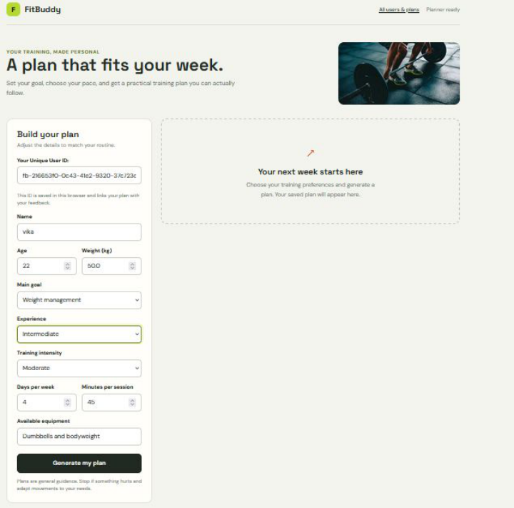

11. HOME PAGE
The homepage presents a clean, gym-themed form where users enter Name, User ID, Age, Weight, Fitness
Goal, and Workout Intensity, then click “Generate Plan” to trigger the AI-powered backend.

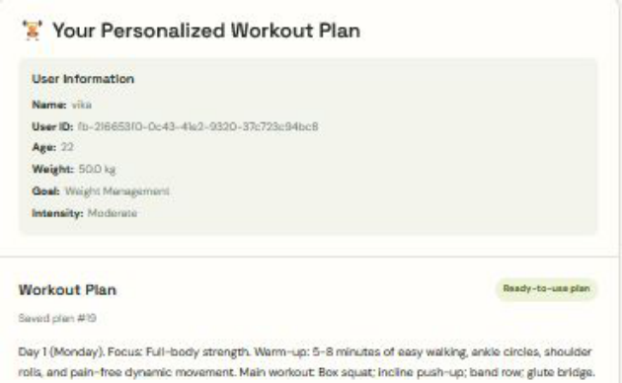
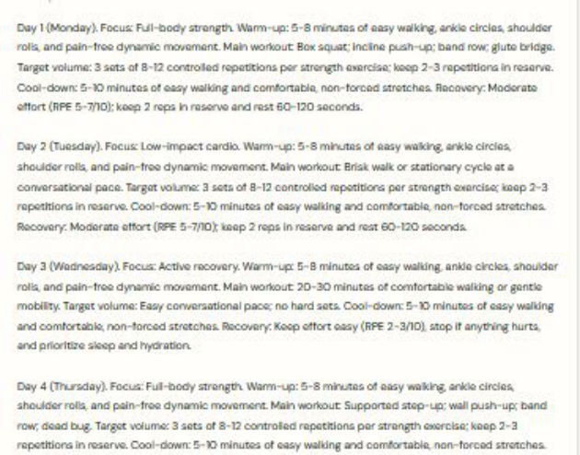

12. PERSONALIZED WORKOUT GENERATION PAGE
After submission, the app displays a summary of the user's input — Name, User ID, Age, Weight, Fitness
Goal, and Selected Intensity — before showing the generated plan.
13. WORKOUT PLAN

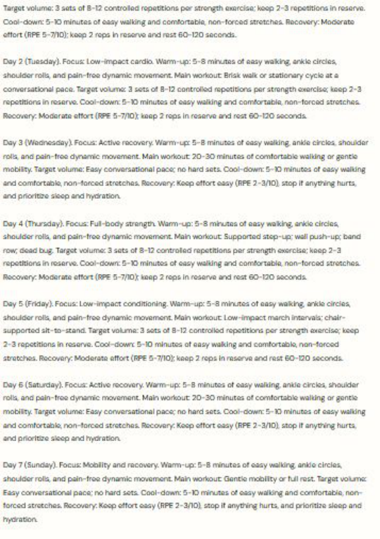
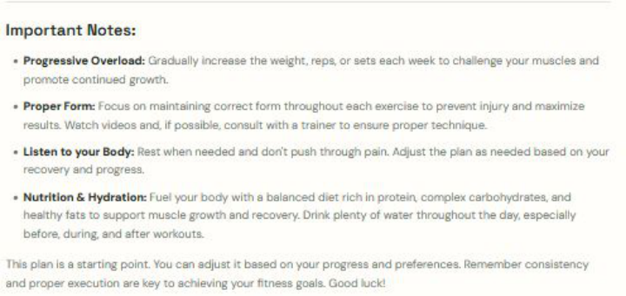

A personalized, day-wise workout plan is generated, outlining focus areas (full body, upper/lower body,
cardio, core, flexibility), exercises, sets/reps or duration, rest intervals, and warm-up/cooldown guidance.

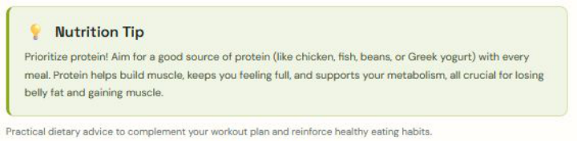
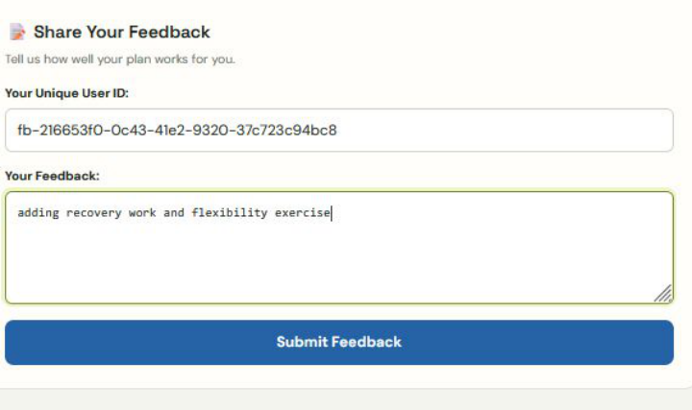
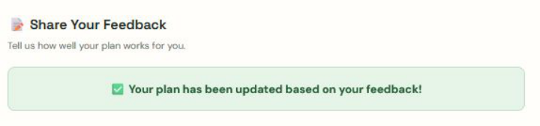

14. NUTRITION TIP
A concise, practical nutrition or recovery tip is displayed beneath the workout plan, tailored to the user's
fitness goal.
15. FEEDBACK PAGE
Users enter their User ID and specific feedback (e.g., effectiveness, difficulty, preferences), which the
system uses to regenerate an updated plan, confirmed with a success message.

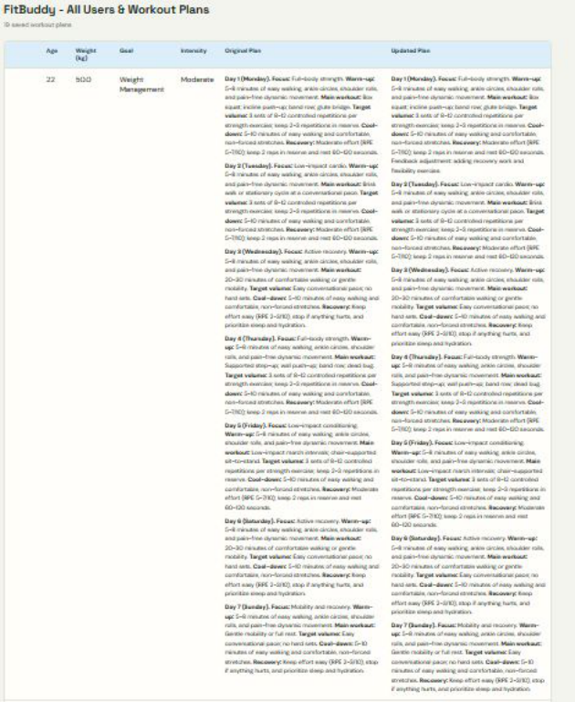

16. VIEW ALL USERS PAGE
Administrators can view every registered user's details along with their original and updated workout plans
in a structured table.
17. TESTING AND VERIFICATION SUMMARY
This section should record the actual testing outcomes once the application has been run end-to-end,
including confirmation that each feature below behaves as expected.
• Homepage and input form load correctly
• Workout plan generation tested with a valid Gemini API key
• Nutrition tip generation verified
• Feedback submission and plan update verified
• Database storage and retrieval verified
• Admin ‘view all users’ page verified

18. ADVANTAGES
• Personalized fitness planning: Generates workout suggestions based on the submitted user profile.
• Simple accessibility: Provides a browser-based interface.
• AI-generated schedules: Uses generative AI to prepare organized weekly exercise plans.
• Plan revision: The intended feedback feature supports requesting changes.
• Database storage: Provides a way to retain profiles and generated plans.
• Modular architecture: Separates backend routes, AI services, and database operations.
• Practical AI integration: Demonstrates how an external generative AI service can be used in a
Python web application.
19. LIMITATIONS
• Internet dependency: AI generation requires access to the external service.
• API dependency: Requests depend on valid credentials, model availability, and service limits.
• AI accuracy: Generated content may be incomplete, inaccurate, or unsuitable for some users.
• Limited professional assessment: The application does not replace an individualized assessment by
a qualified professional.
• Prototype database: SQLite is appropriate for a local prototype but may require a different
architecture for larger-scale deployment.
• Implementation dependency: Nutrition, feedback updates, and saved-user features should only be
presented as operational after they have been verified in the actual project.
20. SECURITY AND RESPONSIBLE USE
FitBuddy AI should follow basic security and responsible-use practices.
• Store the Gemini API key in the local .env file rather than hardcoding it in Python.
• Exclude .env from source control.
• Validate user inputs before using them in application logic or AI prompts.
• Avoid exposing personal information in public pages or screenshots.
• Handle AI service failures and database errors gracefully.
• Treat AI-generated workout and nutrition information as general guidance.
• Encourage users to seek qualified professional advice when they have injuries, medical concerns,
or uncertainty about exercise suitability.
21. FUTURE ENHANCEMENTS
21.1 User Authentication
Add registration and login functionality so that users can access their own profiles and plans.
21.2 Workout Progress Tracking
Allow users to record completed workouts, track consistency, and review previous plans.

21.3 Exercise Demonstrations
Add exercise descriptions, images, or demonstration videos to help users understand workout instructions.
21.4 Progress Charts
Introduce charts to display tracked workout activity and user-entered progress over time.
21.5 Workout Reminders
Add optional reminders to help users follow their planned schedules.
21.6 Exportable Workout Plans
Allow users to download or print their workout schedules.
21.7 Mobile-Friendly Interface
Improve responsive design so the application works comfortably on smartphones and tablets.
21.8 Improved Deployment
Introduce production hosting, stronger security controls, monitoring, and an appropriate database for
multiple users.
22. CONCLUSION
FitBuddy AI is a Generative AI-based fitness planning application designed to combine a web interface,
Python backend, AI service, and database in one cohesive system. It aims to generate personalized seven-
day workout plans, provide general nutrition tips, and support workout revisions through user feedback —
turning a handful of simple inputs (age, weight, goal, and intensity) into a structured, day-by-day fitness
routine within seconds.
Architecturally, the project demonstrates a clean separation of concerns: FastAPI handles routing and
request validation, Jinja2 renders the user-facing pages, SQLAlchemy and SQLite provide persistence for
user profiles and generated plans, and the Gemini 1.5 Pro and Gemini Flash models supply the generative
intelligence behind the workout plans, plan revisions, and nutrition tips respectively. Splitting the AI
workload across two models — a heavier model for structured, multi-day plan generation and a lighter,
faster model for short nutrition tips — keeps the application responsive while still producing rich, well-
formatted output.
The feedback loop is one of the project's more meaningful design choices: rather than treating a generated
plan as final, FitBuddy lets users describe what isn't working (“more cardio”, “fewer rest days”) and
regenerates a revised plan while preserving the original for comparison. This mirrors how a real coach
would iterate with a client, and the admin dashboard's side-by-side view of original versus updated plans
makes that iteration visible and auditable rather than something that happens silently in the background.
Building FitBuddy also involved practical engineering trade-offs that are worth reflecting on. Early
experiments with open-source Hugging Face models (T5, BART, DistilBERT, Bloom) showed that a self-
hosted approach would demand GPU infrastructure and significant fine-tuning effort just to reach usable
output quality, whereas the hosted Gemini API delivered structured, day-wise formatting almost out of the
box. This is a useful, generalizable lesson: for a small team or a single developer, an API-based
generative model can often out-perform a self-hosted one on time-to-value, even if it introduces an external
dependency in return.
That dependency is also the project's clearest limitation. FitBuddy's core functionality is only as reliable as
its network connection and the Gemini API's availability, quota, and output quality — and, as with any

generative AI system, the workout and nutrition content it produces is general guidance rather than a
substitute for a qualified trainer or clinician. Likewise, SQLite is a deliberate, appropriate choice for a
local prototype, but a production deployment serving many concurrent users would need a more robust
database and hosting setup, along with the authentication and monitoring outlined in the Future
Enhancements section.
Taken as a whole, FitBuddy succeeds in showing how a modern generative AI service can be embedded
into an everyday web application in a way that feels practical rather than gimmicky: the AI is not the
product itself, but the engine behind a focused, well-scoped fitness planning tool. The project demonstrates
the practical integration of FastAPI, Jinja2, SQLite, SQLAlchemy, and Google Gemini in a modular web
application, and provides a solid foundation for the future improvements identified above — workout
tracking, user authentication, exercise demonstrations, progress visualization, and production-grade
deployment.
The final quality of the application depends on successful integration and testing of each module. Before
submission, the developer should run through every scenario described in this document end to end, verify
the implemented features against the Testing and Verification Summary, and insert screenshots captured
from the actual running application in place of the remaining output placeholders.
End of Project Documentation

