FitBuddy
AI Fitness Plan Generator
Phase Wise Document
Field | Detail
Document Version | 1.0.0
Status | Approved

Contents
1. Brainstorming & Ideation Phase
2. Requirement Analysis Phase
3. Project Design Phase
4. Project Planning Phase
5. Project Development Phase
6. Project Testing Phase
7. Project Documentation Phase
8. Project Demonstration Phase

1. Brainstorming & Ideation Phase

1.1 Problem Statement
Generic fitness plans rarely match a person's age, weight, goal and preferred intensity, and they are hard to change once created. Users need a quick way to get a structured weekly routine and to adjust it in plain language.

1.2 Proposed Idea
FitBuddy is an intelligent, dynamic web application designed to generate structured 7-day fitness routines and complementary nutritional recommendations. Utilizing Google Gemini AI models, the application adapts plans dynamically through continuous user feedback while providing administrative oversight.

1.3 Target Users
- End users: Beginners and general users who want a personalised weekly workout and nutrition guidance.
- Administrators: Site administrators who monitor registered users and compare original and revised plans.

1.4 Key Ideas Considered
- Generate a personalised 7-day workout plan from basic inputs (age, weight, goal, intensity).
- Add a separate nutrition and recovery advice feature.
- Let users revise their plan through natural language feedback such as "more cardio".
- Keep the original plan alongside the revised plan so AI output can be reviewed by an admin.

1.5 Technology Selection
FastAPI with SQLAlchemy and SQLite keeps the backend lightweight. Jinja2 templates provide a simple server-rendered frontend. Google Gemini 1.5 Pro handles plan generation and refinement, and Gemini Flash handles fast nutrition advice.

2. Requirement Analysis Phase

2.1 Core Objectives
FitBuddy is an intelligent, dynamic web application designed to generate structured 7-day fitness routines and complementary nutritional recommendations. Utilizing Google Gemini AI models, the application adapts plans dynamically through continuous user feedback while providing administrative oversight.

2.2 System Requirements
- Demographic Input: Collect user age, body weight, target fitness goal (e.g., weight loss, muscle gain, general wellness), and intensity preference (low, medium, high).
- Plan Generation: Construct detailed, day-by-day workout schedules spanning a 7-day period.
- Dynamic Feedback Engine: Accept natural language feedback (e.g., "more cardio", "fewer rest days") and adjust active plans accordingly.
- Admin Dashboard: Provide site administrators with direct oversight of registered users and side-by-side comparison of initial versus revised workout plans.

3. Project Design Phase

3.1 Technology Stack
+-----------------------------------------------------------------------+
| FRONTEND |
| Jinja2 Templates / HTML5 / CSS3 |
+-----------------------------------------------------------------------+
|
v
+-----------------------------------------------------------------------+
| BACKEND |
| FastAPI Framework |
| SQLAlchemy ORM Layer |
+-----------------------------------------------------------------------+
| |
v v
+----------------------------------+ +--------------------------------+
| DATABASE | | AI LAYER |
| SQLite | | Gemini 1.5 Pro (Plans) |
| | | Gemini Flash (Nutrition) |
+----------------------------------+ +--------------------------------+

3.2 Relational Database Schema

Table: users
Column Name | Data Type | Constraints | Description
id | INTEGER | Primary Key, Auto Increment | Unique user identification
name | VARCHAR(100) | Not Null | User full name
email | VARCHAR(255) | Unique, Not Null | User email address
age | INTEGER | Not Null | User age in years
weight | FLOAT | Not Null | User weight in kilograms
fitness_goal | VARCHAR(50) | Not Null | Goal type (e.g., weight loss)
intensity | VARCHAR(20) | Not Null | Intensity level (low, medium, high)
created_at | DATETIME | Default: Current Timestamp | Record creation date

Table: plans
Column Name | Data Type | Constraints | Description
id | INTEGER | Primary Key, Auto Increment | Unique plan identification
user_id | INTEGER | Foreign Key (users.id) | Owner reference
original_plan | TEXT | Not Null | Initial 7-day schedule generated by AI
current_plan | TEXT | Not Null | Active modified schedule
nutrition_tips | TEXT | Not Null | AI-generated nutritional guidance
created_at | DATETIME | Default: Current Timestamp | Record creation date
updated_at | DATETIME | Default: Current Timestamp | Last modification date

Table: feedback
Column Name | Data Type | Constraints | Description
id | INTEGER | Primary Key, Auto Increment | Unique feedback entry ID
plan_id | INTEGER | Foreign Key (plans.id) | Plan target reference
user_feedback | TEXT | Not Null | Natural language feedback text
timestamp | DATETIME | Default: Current Timestamp | Submission timestamp

3.3 AI Model Engineering & Strategy

Model Roles
- Gemini 1.5 Pro: Serves as the primary engine for plan generation and iterative adjustment. Selected for its long-context handling, strict instruction adherence, and complex reasoning over multi-step schedules.
- Gemini Flash: Serves as the secondary engine for nutrition and recovery advice. Selected for fast, low-latency execution of localized content.

System Prompt: Workout Plan Generation (Gemini 1.5 Pro)
System: You are an expert fitness coach and exercise physiologist.
Context:
- User Age: {age}
- Weight: {weight} kg
- Fitness Goal: {fitness_goal}
- Intensity Preference: {intensity}

Task: Generate a structured 7-day workout plan. Organize the plan clearly
with Day 1 through Day 7 headers, specifying exercise names, sets, rep
ranges, and rest periods.

System Prompt: Nutrition Advice (Gemini Flash)
System: You are a sports nutritionist.
Context: Goal = {fitness_goal}

Task: Output 3 actionable, highly targeted daily nutrition and recovery
recommendations matching this goal. Keep responses clear and concise.

System Prompt: Plan Refinement (Gemini 1.5 Pro)
System: You are an expert fitness coach modifying an existing user routine.
Current Plan:
{original_plan}

User Modification Request:
"{feedback}"

Task: Adjust the workout schedule to fulfill the user request while
preserving progressive overload, safety, and rest balance. Return the
fully updated 7-day plan.

3.4 Frontend & UI Component Architecture

User Interfaces
- Registration & Intake Form: Form capturing demographic and preference metrics with input validation (e.g., positive numerical checks).
- Main Dashboard: Dynamic Jinja2 interface rendering the active 7-day plan side-by-side with the nutrition drawer and adjustment prompt box.
- Feedback Panel: Interactive text field allowing real-time submission of revision requests.

Admin Interfaces
- User Overview Matrix: Data table displaying user records, registration dates, and activity summaries.
- Side-by-Side Comparison Engine: Split-pane interface displaying original_plan next to current_plan alongside the historical feedback trail.

3.5 Auditability & Feedback Operations
To ensure AI traceability and support comparative evaluation, FitBuddy separates original and active plan structures within the database schema.
[ User Feedback Entry ]
|
v
[ POST /adjust-plan ]
|
v
[ AI Regenerates Plan ]
|
v
+-------------------------------------------------------------+
| Plans Table Update |
| - original_plan : [Unchanged Initial Routine] |
| - current_plan : [Newly Generated Updated Routine] |
| - updated_at : [Timestamp] |
+-------------------------------------------------------------+
|
v
[ Admin Panel View: Original Plan (Left) | Current Plan (Right) ]

4. Project Planning Phase
The project is organised into the eight phases of this document. Durations below are suggested and can be adjusted to your schedule.
Phase | Main Activities | Deliverable | Duration
Brainstorming & Ideation | Define problem, idea, users and technology | Problem statement, idea summary | Week 1
Requirement Analysis | List functional requirements and scope | Requirement specification | Week 1
Project Design | Architecture, database schema, AI prompts, UI | Design specification | Week 2
Project Planning | Task breakdown and schedule | Project plan | Week 2
Project Development | Build backend, AI integration, UI, admin panel | Working application | Weeks 3-5
Project Testing | Unit, integration, AI resilience, data integrity tests | Test report | Week 6
Project Documentation | Compile documentation with screenshots | Final document | Week 7
Project Demonstration | Present working application | Live demo | Week 7

4.1 Development Tasks
- Set up FastAPI project, SQLite database and SQLAlchemy models.
- Integrate Gemini 1.5 Pro and Gemini Flash using the prompt templates.
- Build /generate-plan, /adjust-plan and /admin endpoints.
- Create Jinja2 pages for intake, dashboard, feedback and admin views.

5. Project Development Phase

5.1 Application Endpoints
[ HTTP Client ]
|
+--> POST /generate-plan
| Validate Inputs -> Invoke Models -> Save DB -> Render View
|
+--> POST /adjust-plan
| Fetch Plan -> Call 1.5 Pro -> Update DB -> Render View
|
+--> GET /admin
Query DB -> Render Admin UI

5.2 Endpoint Functionality
- POST /generate-plan: Parses user payload, triggers asynchronous calls to Gemini 1.5 Pro (workout plan) and Gemini Flash (nutrition advice), writes records to SQLite, and returns the populated plan page.
- POST /adjust-plan: Accepts feedback input, reads the existing original_plan from DB, sends the refinement prompt to Gemini 1.5 Pro, logs feedback in the feedback table, and updates current_plan in the plans table.
- GET /admin: Joins users, plans, and feedback records to populate the administrative overview panel.

5.3 Setup Instructions
- Environment Variables: Configure local secrets inside a .env file:
GEMINI_API_KEY=your_google_gemini_api_key_here
DATABASE_URL=sqlite:///./fitbuddy.db

- Dependencies: Install requirements via Python package manager:
pip install fastapi uvicorn sqlalchemy jinja2 google-generativeai python-dotenv

- Application Server Execution: Launch ASGI server via Uvicorn:
uvicorn main:app --reload --host 0.0.0.0 --port 8000

5.4 Maintenance Schedules
- Execute daily backups of the SQLite database file (fitbuddy.db).
- Track response performance and output consistency across new versions of Gemini models.

6. Project Testing Phase

6.1 Test Matrix
- Database Unit Tests: Validate table constraints, dynamic foreign key relations, and update cascade behaviors.
- API Endpoint Integration: Execute request assertions against /generate-plan and /adjust-plan endpoints handling edge-case inputs (e.g., extreme weights or empty feedback strings).
- AI Resilience Testing: Validate system behavior during API timeouts or rate limits using mock fallback responses.
- Data Integrity Checks: Confirm that submissions to /adjust-plan strictly write updates to current_plan while keeping original_plan unchanged.

6.2 Test Case Record
Fill in the actual result and status after running each test.
ID | Test Case | Expected Result | Actual / Status
TC-01 | Submit intake form with valid data | 7-day plan and nutrition tips are displayed
TC-02 | Submit negative or zero weight | Validation error is shown
TC-03 | Submit empty feedback | Request rejected with message
TC-04 | Submit "more cardio" feedback | current_plan updated, original_plan unchanged
TC-05 | Gemini API timeout | Fallback response shown, no crash
TC-06 | Open /admin | Users and side-by-side plans are listed

7. Project Documentation Phase
This document records the complete lifecycle of FitBuddy, from ideation to demonstration. It is organised by the eight project phases so every stage can be reviewed in order.
Item | Detail
Document | FitBuddy Technical Design & Implementation Specification
Version | 1.0.0
Status | Approved
Technologies documented | FastAPI, SQLAlchemy, SQLite, Jinja2, Gemini 1.5 Pro, Gemini Flash

8. Project Demonstration Phase

8.1 Demonstration Flow
1. Open the registration and intake form and enter name, email, age, weight, goal and intensity.
2. Submit the form and show the generated 7-day plan with the nutrition drawer.
3. Enter feedback such as "more cardio" and show the updated plan.
4. Open the /admin page and show the user list.
5. Show the side-by-side comparison of original and current plans with the feedback trail.

8.2 Application Screenshots
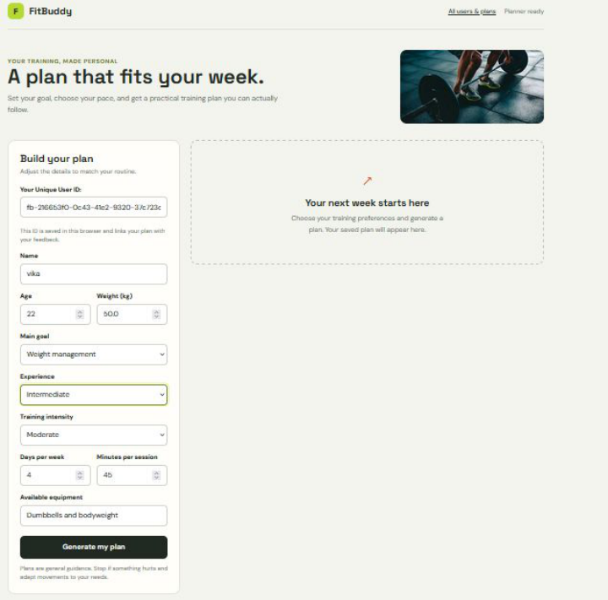
Figure 1: Registration & Intake Form (Homepage)
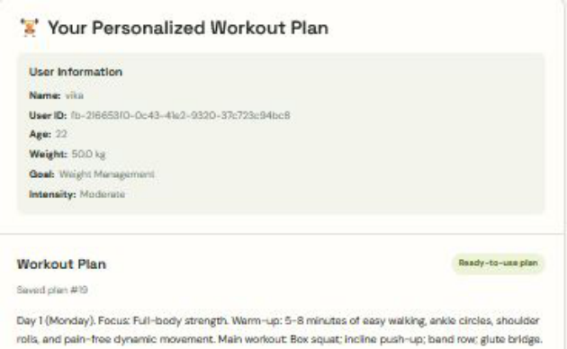
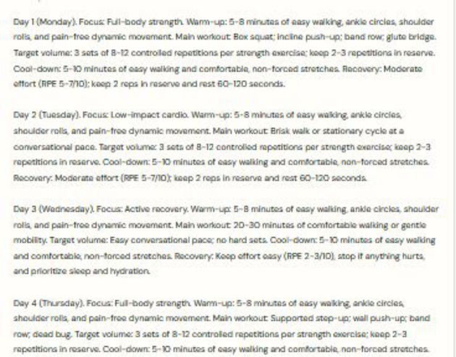
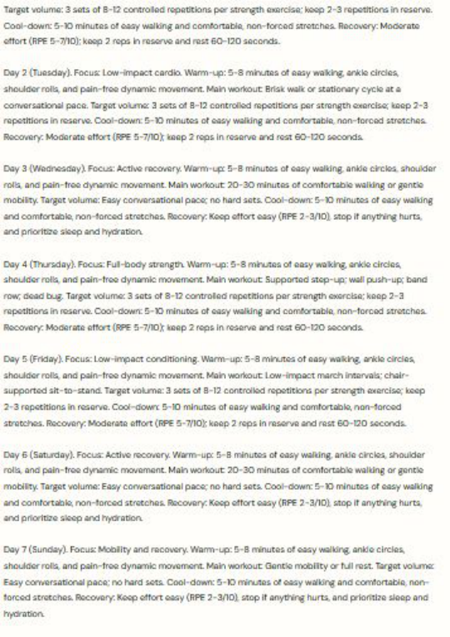
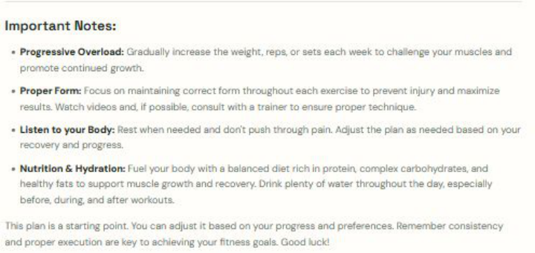
Figure 2: Generated 7-Day Workout Plan and Important Notes
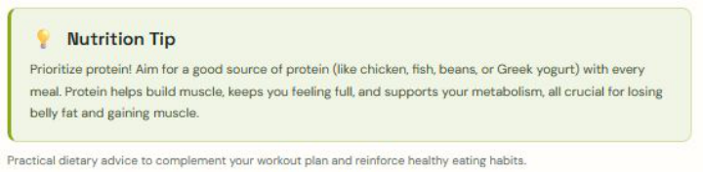
Figure 3: Nutrition Tip
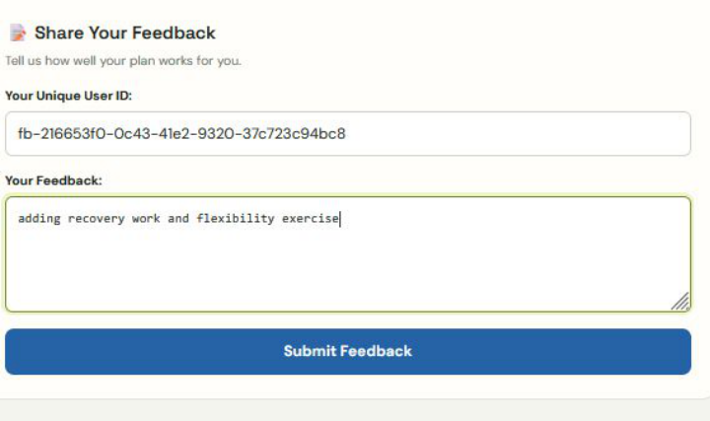
Figure 4: Feedback Submission
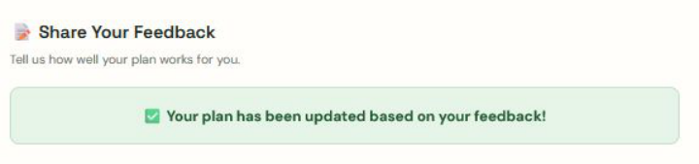
Figure 5: Plan Updated Confirmation
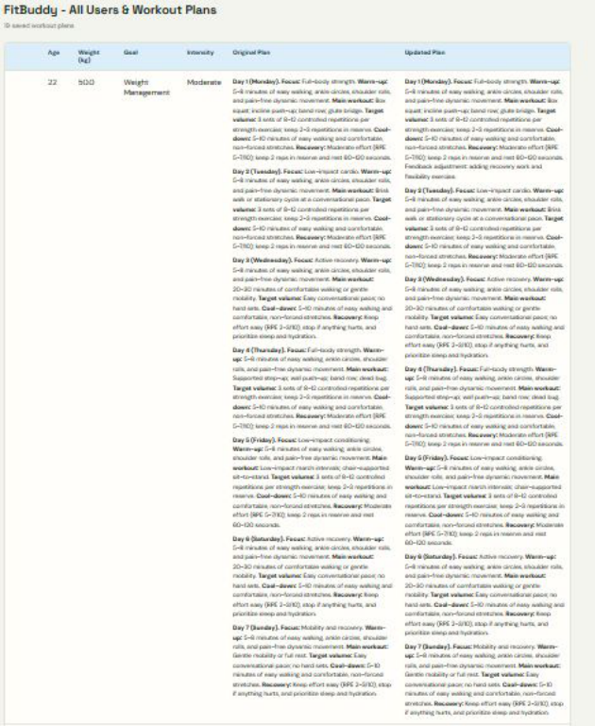
Figure 6: Admin Dashboard: All Users with Original vs Updated Plans

