ASSESSMENT - 1
NAME: U.kaviya
REG NO: 1965260209
COURSE CODE / NAME: CSA0610 - Design and Analysis Of Algorithms
Assignment Title: Scalability Audit of an E-Commerce Platform (“ShopSphere”)
– IT Application-Based Problem Solving

Introduction
ShopSphere currently contains n = 100,000 products and is expected to grow to n = 1,000,000 within a year. This report audits its back-end modules to predict how execution costs change as the catalogue expands.
The analysis identifies basic operations, derives iterative operation counts, solves recurrences using substitution and the Master Theorem, analyses search cases, proves an asymptotic bound, and recommends redesigns.

Conventions Used
- n represents the number of products, requests, or records, depending on the module.
- All logarithms are base 2.
- The assignment specifies 10⁸ basic operations per second.
- The nightly processing window is 10 minutes = 600 seconds.
- The operation budget is 10⁸ × 600 = 6 × 10¹⁰ operations.

Task (a) – Understand the Problem
Module | Input size and basic operation | Expected growth
M1 – Duplicate detector | Compare title and seller for every pair of products. | Θ(n²)
M2 – API rate limiter | Execute Audit(Request[j]) in inner loop. | Θ(n)
S1 – Sequential search | Compare search key with products one by one. | Best Θ(1); average/worst Θ(n)
S2 – Binary search | Compare key with middle entry of sorted index. | Θ(log n)
M4 – Recommendation engine | Current 4T(n/2)+n; redesign 2T(n/2)+n. | Current Θ(n²); redesign Θ(n log n)
M5 – Sales analytics | T(n)=2T(n/2)+n log n. | Θ(n log²n)
Report generator | f(n)=3n²+10n log₂n+50. | Θ(n²)

Justification
- M1 compares each product with all later products, giving a quadratic count.
- M2 doubles i each pass, so the inner-loop counts form a geometric series.
- S1 can inspect all products; S2 halves the search range after each comparison.
- M4’s four recursive calls cause more work than the two-call redesign.
- M5 performs n log n work per recursive level over logarithmically many levels.
- The report generator’s quadratic term dominates for large n.

Task (b) – Analyse the Iterative Modules

M1 – Duplicate-Listing Detector
Basic operation: comparing the title and seller of two products. For each i, the inner loop compares Product[i] with all later products.
C(n) = (n−1)+(n−2)+…+2+1
C(n) = Σ(k=1 to n−1) k = n(n−1)/2 = n²/2−n/2.
Therefore, the exact comparison count is n(n−1)/2 and the time complexity is Θ(n²). Auxiliary space is Θ(1) if duplicate marks are stored in the existing catalogue; a separate output list may require up to Θ(n).
Input size n | Exact comparisons
1,000 | 499,500
100,000 | 4,999,950,000
1,000,000 | 499,999,500,000

Increasing the catalogue from 100,000 to 1,000,000 products increases comparisons by about 100 times, making the all-pairs approach a major bottleneck.

M2 – API Rate Limiter
The outer-loop values are i=1,2,4,8,… while i<n. Each pass performs i audits.
A(n)=1+2+4+…+2ᵐ=2ᵐ⁺¹−1, where 2ᵐ is the largest power of 2 strictly less than n.
For n>1, A(n)=2^(⌊log₂(n−1)⌋+1)−1; A(1)=0. This geometric sum is Θ(n), so the team member’s Θ(n log n) claim is incorrect.
For n=1,024: A(1,024)=1+2+4+…+512=2¹⁰−1=1,023 audits.
n | Audit operations | Outer-loop passes
1,024 | 1,023 | 10
100,000 | 131,071 | 17
1,000,000 | 1,048,575 | 20

Best, average, and worst counts are identical for a fixed n. Time complexity is Θ(n); auxiliary space is Θ(1).

Task (c) – Solve a Recurrence by Substitution (S2)
Binary search has T(n)=T(n/2)+1, T(1)=1. Assume n is a power of 2 for the exact derivation.

Backward Substitution
T(n)=T(n/2)+1
=T(n/4)+2
=T(n/8)+3
…
=T(n/2ᵏ)+k
The base case is reached when n/2ᵏ=1. Thus 2ᵏ=n and k=log₂n.
T(n)=T(1)+log₂n=1+log₂n for power-of-two n. For general n, a standard binary search uses at most ⌊log₂n⌋+1 comparisons, so time complexity is Θ(log n).
Implementation | Time complexity | Auxiliary space
Iterative binary search | Θ(log n) | Θ(1)
Recursive binary search | Θ(log n) | Θ(log n), due to call stack

At n=1,000,000, the worst-case comparison count is 20. At 10⁸ operations per second, 20 comparisons take approximately 2×10⁻⁷ seconds under the simplified model.

Task (d) – Apply the Master Theorem
The Master Theorem analyses T(n)=aT(n/b)+f(n).

M4 – Current Design: T(n)=4T(n/2)+n
Parameter | Value
a | 4
b | 2
f(n) | n
n^(log_b a) | n^(log₂4)=n²
Case | Case 1: f(n) is polynomially smaller than n²
Result | T(n)=Θ(n²)

For T(1)=1 and power-of-two n, the exact solution is T(n)=2n²−n.

M4 – Proposed Redesign: T(n)=2T(n/2)+n
Parameter | Value
a | 2
b | 2
f(n) | n
n^(log_b a) | n^(log₂2)=n
Case | Case 2: f(n)=Θ(n)
Result | T(n)=Θ(n log n)

For T(1)=1 and power-of-two n, T(n)=n log₂n+n. When n doubles, the current quadratic design needs about four times the work; the redesigned n log n design needs a little more than twice the work.

M5 – Sales Analytics: T(n)=2T(n/2)+n log n
Here a=2, b=2, and n^(log_b a)=n, while f(n)=n log n. The three basic Master Theorem cases do not directly cover this form, but the extended Case 2 applies because f(n)=Θ(n^(log_b a) log¹n).
Therefore, T(n)=Θ(n log²n). In a recursion tree, level j has total work n(L−j), where L=log₂n. Summing the internal levels gives nL(L+1)/2; adding Θ(n) leaf work confirms Θ(n log²n). For power-of-two n with T(1)=1, T(n)=nL(L+1)/2+n.

Task (e) – Best, Average and Worst Cases

S1 – Sequential Search
Case | Input condition | Comparisons
Best | Target is first entry. | 1
Average, successful | Each position equally likely. | (n+1)/2
Worst | Target is last or absent. | n

If the target exists with probability p and an unsuccessful search checks all n products, E[C]=p(n+1)/2+(1−p)n.
For n=1,000,000 and p=0.5: E[C]=0.5×(1,000,001/2)+0.5×1,000,000=750,000.25 comparisons.

S2 – Binary Search
Case | Input condition | Comparisons
Best | Target is the middle entry. | 1
Average | Depends on key distribution and tree depth. | Θ(log n)
Worst | Deepest target or absent key. | At most ⌊log₂n⌋+1

At n=1,000,000, binary search needs at most 20 comparisons. Its exact average depends on the distribution of successful and unsuccessful searches. It is preferred when a sorted index can be maintained efficiently.

Task (f) – Prove an Asymptotic Bound
The report generator performs f(n)=3n²+10n log₂n+50 operations. We prove f(n)=Θ(n²).

Lower Bound: Ω(n²)
For n≥1, 10n log₂n and 50 are non-negative. Therefore f(n)≥3n². Choose c₁=3.

Upper Bound: O(n²)
For n≥2, log₂n≤n, so n log₂n≤n². Also, 50≤50n². Hence f(n)≤3n²+10n²+50n²=63n². Choose c₂=63 and n₀=2.
Thus, for every n≥2, 3n²≤f(n)≤63n². With c₁=3, c₂=63 and n₀=2, the definition proves f(n)=Θ(n²).

Show that f(n) is not O(n)
Assume f(n)=O(n). Then f(n)≤cn for some constant c and all sufficiently large n. Since f(n)≥3n², this implies 3n²≤cn, or 3n≤c, for arbitrarily large n. This is impossible. Therefore f(n) is not O(n).

Task (g) – Scalability Decision
The server executes 10⁸ basic operations per second. The 10-minute window permits 600 seconds, giving a maximum budget of 6×10¹⁰ operations.
Module | Estimated operations | Time at 10⁸ ops/s | Within 10 min?
M1 – Duplicate detector | 499,999,500,000.00 | 4,999.995000 s | No
M2 – API rate limiter | 1,048,575.00 | 0.010486 s | Yes
S2 – Binary search | 20.00 | 0.000000 s | Yes
M4 – Current design | 1,999,999,000,000.00 | 19,999.990000 s | No
M4 – Redesigned | 20,931,568.57 | 0.209316 s | Yes
M5 – Sales analytics | 209,599,497.10 | 2.095995 s | Yes
Report generator | 3,000,199,315,735.69 | 30,001.993157 s | No

Note: M4 and M5 recurrence formulas are exact for power-of-two input sizes under the stated base case. Values at n=1,000,000 use the corresponding formula estimates; implementation constants can affect measured runtime.

Modules That Fail the 10-Minute Window
- M1: approximately 5.0×10¹¹ comparisons, requiring about 83.33 minutes. Replace all-pairs comparison with a hash set keyed by (seller, normalized title), expected Θ(n), or sort by that key and compare adjacent entries in Θ(n log n).
- M4 current design: quadratic growth exceeds the operation budget. Replace the replicated four-call design with the two-call Θ(n log n) design.
- Report generator: about 3.0×10¹² operations, or approximately 8.33 hours. Investigate repeated scans and replace them with aggregation, hashing, or grouping where possible.

Modules That Pass Under the Given Model
- M2: 1,048,575 audits, approximately 0.0105 seconds.
- S2: at most 20 comparisons, approximately 0.0000002 seconds.
- M4 redesigned: approximately 20.93 million operations, about 0.209 seconds using the formula estimate.
- M5: approximately 209.6 million operations, about 2.10 seconds using the recurrence-tree estimate.
These conclusions use the assignment’s specified rate of 10⁸ operations per second. A different operation rate changes runtime estimates but not the operation counts or asymptotic results.

Graphical Runtime and Scalability Comparisons
The following graphs compare estimated basic-operation counts as the input grows. They use the operation-count formulas derived in this report and the assignment’s stated processing model (10⁸ basic operations per second). The horizontal axis is input size; the vertical axis is operation count on a logarithmic scale so the different growth rates remain visible.
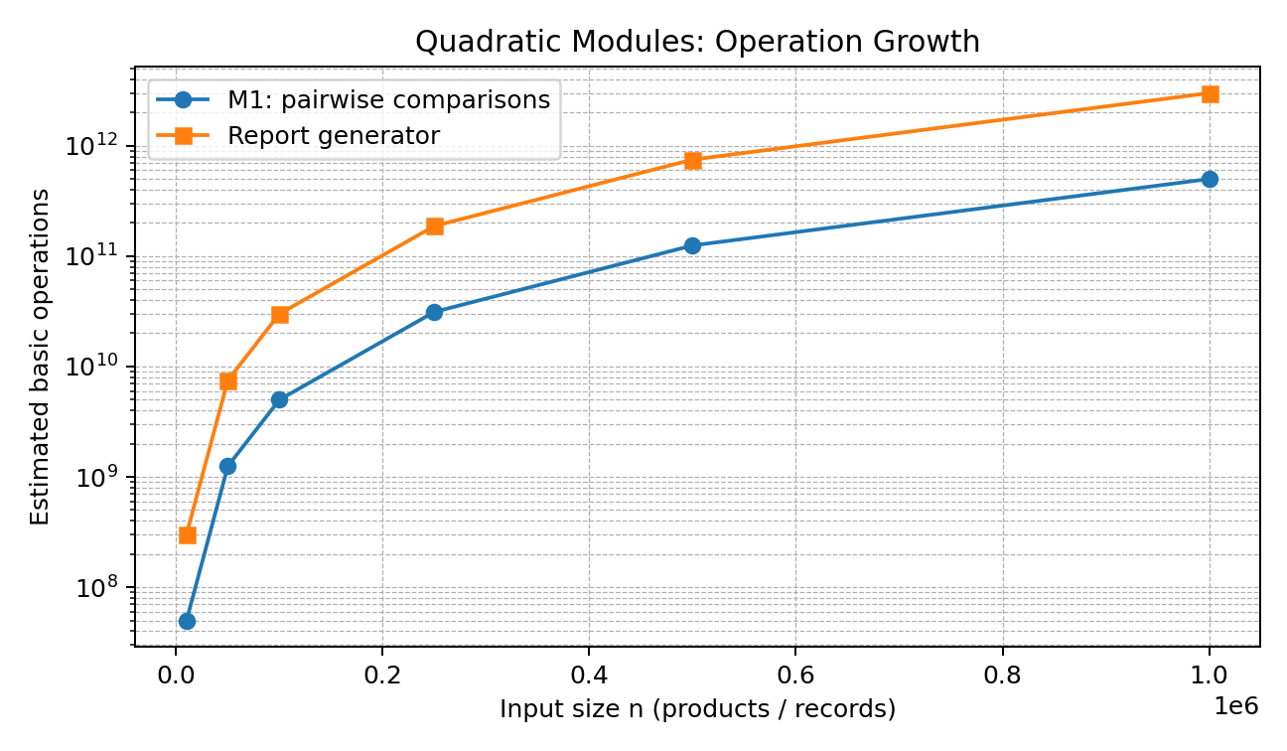
Figure 1. Operation growth of the two quadratic modules.
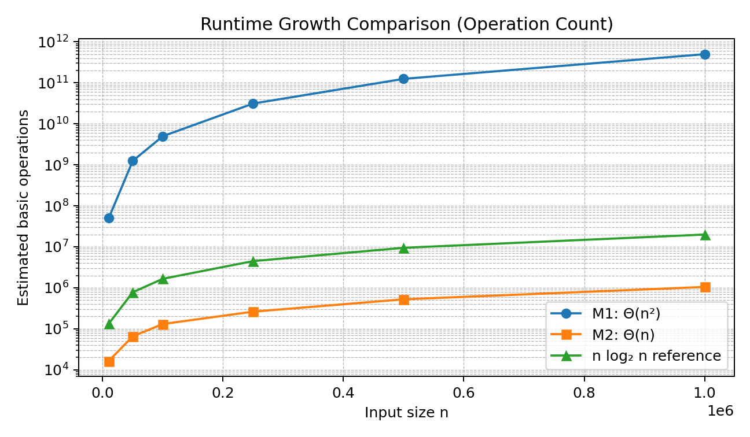
Figure 2. Comparison of pairwise, linear, and n log n operation growth.

Runtime Comparison at n = 1,000,000
Using 10⁸ operations per second, estimated runtime is operation count ÷ 10⁸. These are model-based estimates, not measured wall-clock timings.
Module / model | Operations (approx.) | Estimated runtime | 10-minute window
M1: n(n−1)/2 | 5.0 × 10¹¹ | 83.33 min | FAIL
M2: geometric loop | 1.05 × 10⁶ | 0.0105 s | PASS
S2: binary search | ≤ 20 comparisons | 0.0000002 s | PASS
M4 current: Θ(n²) | ≈ 2.0 × 10¹² | ≈ 20,000 s | FAIL
M4 redesign: Θ(n log n) | ≈ 2.09 × 10⁷ | ≈ 0.209 s | PASS
M5: Θ(n log² n) | ≈ 2.10 × 10⁸ | ≈ 2.10 s | PASS
Report generator: Θ(n²) | ≈ 3.0 × 10¹² | ≈ 8.33 h | FAIL

Interpretation
The comparison shows why asymptotic growth matters. M2 grows linearly and stays small at one million records, while M1 and the report generator grow quadratically and exceed the 600-second budget. The current M4 recurrence also fails; the proposed two-subproblem redesign is much faster under the given recurrence estimate. M5 grows faster than n log n but remains within the operation budget at this input size.

Overall Recommendation
Prioritise redesigning M1 and the report generator because their quadratic costs exceed the nightly processing budget. Adopt the M4 redesign to remove replicated recursive work. Under the stated rate, M2, S2, redesigned M4 and M5 fit within the window. Validate the estimates through profiling because real systems also incur memory, I/O, network and constant-factor costs.

Conclusion
M1 and the report generator have quadratic costs that exceed the 10-minute window, and the current M4 design should also be replaced. M2 is linear, S2 logarithmic, redesigned M4 is Θ(n log n), and M5 is Θ(n log²n). Under the specified 10⁸ operations per second, all except M1, current M4 and the report generator fit the window according to these estimates.

Code of Conduct
I ______________________________ (Name / Registration Number) certify that this submission is my original work and that I have adhered to the guidelines specified for this assessment. I understand that any violation of academic integrity rules will result in disciplinary action.
Signature of the Student: ______________________________ Date: ______________

