SIMATS ENGINEERING
ASSESSMENT TOOL 2 : SCENARIO-BASED
COURSE NAME | Cloud Computing and Big Data Analytics | COURSE CODE: CSA15
COURSE OUTCOME COVERED
CO2: Analyze virtualization architectures to identify performance and security issues in cloud computing environments. (BL3)
Bloom's Taxonomy: Manipulation (Level 2) | Question Count: 5 Total Marks: 25
Code of Conduct
I KAVIYA VARSHINI P S M(192371007) (Name / Reg No) certify that this submission is my original work and that I have adhered to the guidelines specified for this assessment.
I understand that any violation of academic integrity rules will result in disciplinary action.
Signature of the student: KAVIYA VARSHINI P S M

Question 1: Cloud Architecture for a Video Streaming Platform
Scenario: A media company wants to migrate its video streaming platform to the cloud. The system must handle millions of concurrent users with minimal buffering.
[Marks: 5]
(a) Cloud Architecture Using Scalability and Caching Techniques
- Global DNS / GeoDNS routes each user to the nearest healthy region, minimising latency at the very first hop.
- A Content Delivery Network (CDN) with edge Points of Presence (PoPs) caches popular video segments (using adaptive bitrate formats such as HLS/DASH) close to the viewer, so repeat requests never touch the origin.
- Video is pre-transcoded into multiple bitrate/resolution renditions and stored in object storage (e.g., Amazon S3), acting as the durable origin for the CDN.
- An in-memory cache (e.g., Redis/Memcached) stores frequently accessed metadata such as titles, thumbnails, and recommendations, cutting database load.
- Microservices (catalog, playback authorization, recommendation, billing) are containerised and independently scalable, avoiding a single monolithic bottleneck.
(b) Role of Load Balancing and Auto-Scaling in Smooth Streaming
- A Layer-7 load balancer distributes incoming playback/API requests evenly across a fleet of streaming servers, preventing any single node from being overwhelmed during peak hours (e.g., a new episode release).
- Health checks performed by the load balancer automatically remove unhealthy instances from rotation, so users are never routed to a failed server.
- Auto-scaling groups monitor real-time metrics (CPU, network throughput, active connections) and add new streaming/transcoding instances within minutes when a viewership spike is detected, then scale back down afterward.
- Combined with CDN caching, load balancing ensures that only a small fraction of requests reach origin servers, so buffering stays minimal even under millions of concurrent sessions.
(c) Cost Optimization Strategies for High-Demand Workloads
- Use Reserved/Committed-use instances for predictable baseline traffic and Spot/low-priority instances for elastic transcoding workloads, since transcoding jobs can tolerate interruption.
- Apply storage tiering: keep newly released, high-demand content on standard storage and move older, rarely watched content to cold/infrequent-access tiers.
- Cache aggressively at the CDN edge to reduce expensive data-egress and origin compute charges.
- Use auto-scaling with scheduled scale-down during predictable low-traffic hours, and set budgets/alerts to catch cost anomalies early.
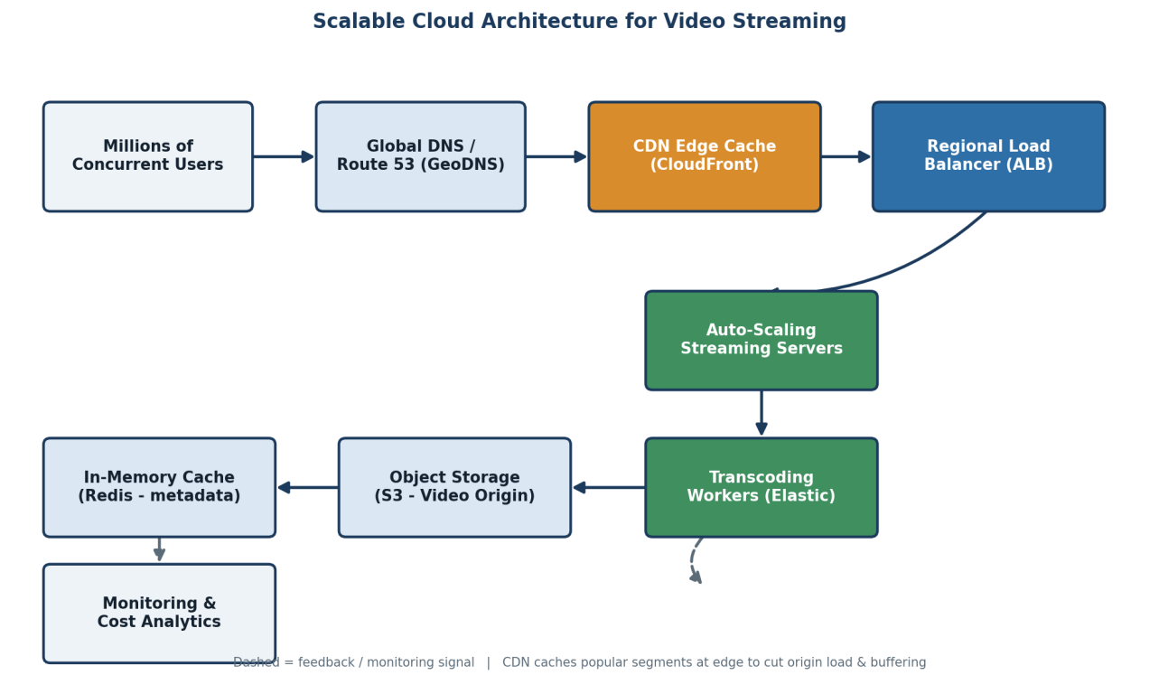
Fig 1.1 – Scalable, cached cloud architecture for the video streaming platform

Question 2: Multi-Cloud Container Orchestration for a Fintech Startup
Scenario: A fintech startup is deploying applications using containers across multiple cloud providers and faces challenges in maintaining consistency and managing deployments.
[Marks: 5]
(a) Container Orchestration and Multi-Cloud Strategy
- Package every service as a Docker container and store versioned images in a central container registry, ensuring the exact same artifact is deployed everywhere.
- Use Kubernetes as the common orchestration layer on each provider (Amazon EKS, Azure AKS, Google GKE), so deployment manifests (YAML) remain identical across clouds.
- Adopt Infrastructure-as-Code (Terraform) and GitOps (e.g., ArgoCD/Flux) so cluster configuration and application state are version-controlled and applied consistently to all clouds.
- A CI/CD pipeline builds, tests, and pushes images once, then triggers synchronized rollouts to every cloud cluster, removing manual, provider-specific deployment steps.
(b) Handling Service Discovery and Scaling
- A service mesh (e.g., Istio/Linkerd) spanning clusters provides consistent service discovery, mutual TLS, and traffic routing regardless of which cloud a service instance runs on.
- Kubernetes' internal DNS resolves service names to pod IPs within a cluster; a global/multi-cluster service registry extends this resolution across cloud boundaries.
- Horizontal Pod Autoscalers (HPA) scale pods per cluster based on CPU/memory/custom metrics (e.g., transaction rate), while the mesh's global load balancer shifts traffic toward the least-loaded or nearest cloud region.
(c) Benefits and Risks of Multi-Cloud Deployment
- Benefits: avoids vendor lock-in, improves resilience (one provider's outage does not take the platform down), and enables choosing the most cost-effective or compliant provider per workload — important for regulated fintech data.
- Risks: increased operational complexity, inconsistent native services between providers, higher networking/data-transfer cost, and a larger security surface that requires unified identity and monitoring across all clouds.
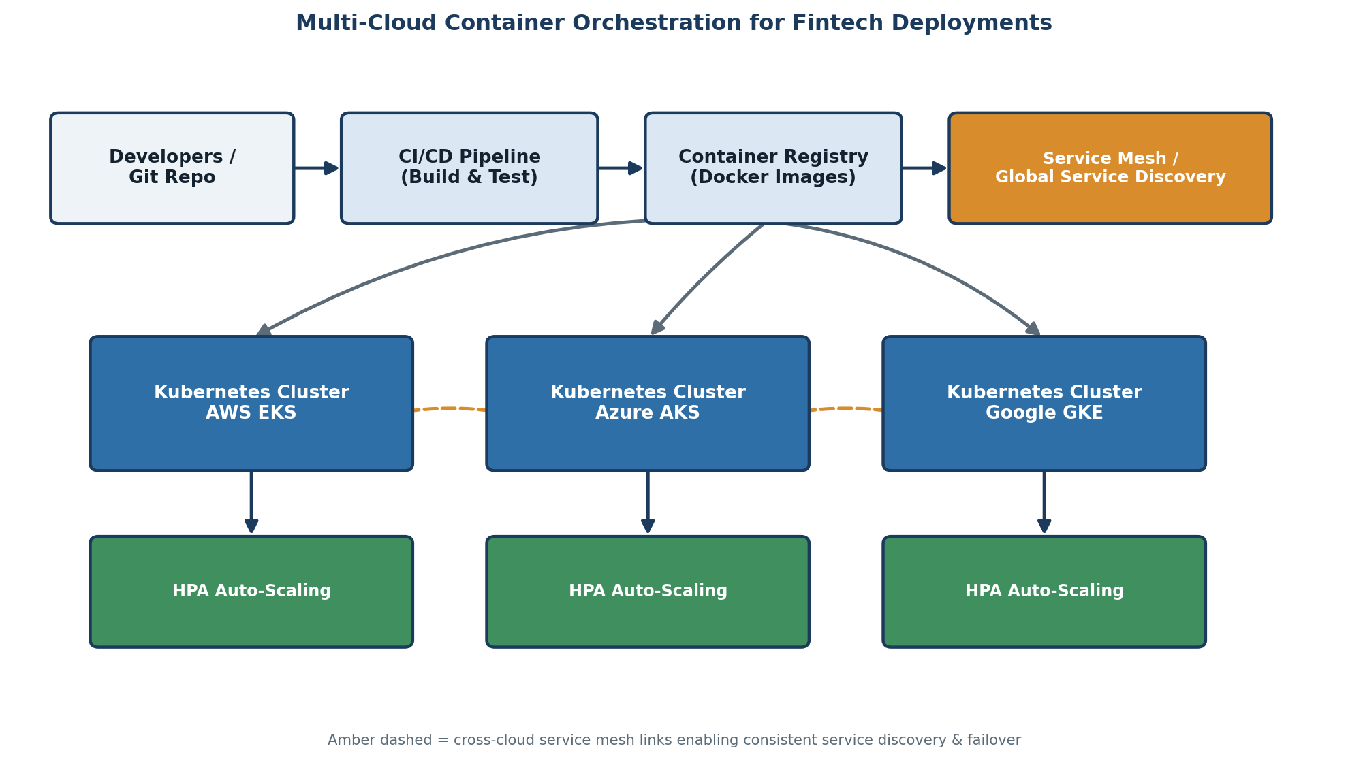
Fig 2.1 – Multi-cloud Kubernetes deployment with shared registry and service mesh

Question 3: Backup and Disaster Recovery for an E-Learning Platform
Scenario: An e-learning platform experiences data loss due to accidental deletion in the cloud and needs a robust backup and disaster recovery strategy.
[Marks: 5]
(a) Backup, Replication, and Versioning Design
- Enable object versioning on cloud storage so every overwrite or delete creates a recoverable prior version instead of destroying data permanently.
- Schedule automated, incremental snapshots of databases (hourly) and full backups (daily), stored separately from production to protect against accidental or malicious deletion.
- Configure cross-region replication so a live copy of course content, videos, and student records exists in a geographically distant secondary region.
- Store long-term backups in a write-once-read-many (WORM) or immutable backup vault so even an administrator cannot delete backups before their retention period expires.
(b) Achieving Recovery Time Objective (RTO) and Recovery Point Objective (RPO)
- RPO (maximum tolerable data loss) is achieved by tuning replication/snapshot frequency — e.g., near-continuous replication yields an RPO of seconds to minutes, while daily backups yield an RPO of up to 24 hours.
- RTO (maximum tolerable downtime) is achieved through automated recovery runbooks/scripts that spin up a standby environment or restore from the replica automatically, rather than relying on manual intervention.
- Regular disaster-recovery drills validate that the actual restore time and data currency meet the promised RTO/RPO targets.
(c) Steps to Ensure Business Continuity During Failures
  - 1. Detect the incident via monitoring/alerting (e.g., unexpected deletion event or region outage).
  - 2. Isolate the affected resource to prevent the failure from propagating further.
  - 3. Trigger the automated recovery runbook to restore from the latest valid snapshot/replica.
  - 4. Redirect user traffic (DNS/load balancer) to the recovered or standby environment.
  - 5. Verify data integrity and conduct a post-incident review to refine backup policies.
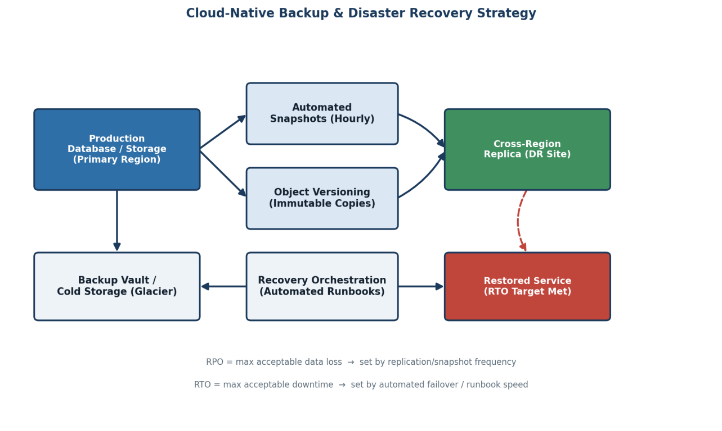
Fig 3.1 – Backup, replication, and disaster-recovery workflow with RTO/RPO checkpoints

Question 4: Hybrid Cloud Model for a Government Agency
Scenario: A government agency is adopting a hybrid cloud model for sensitive and non-sensitive data, with some applications required to remain on-premises due to compliance.
[Marks: 5]
(a) Hybrid Architecture for Secure Communication
- Keep compliance-bound applications and sensitive citizen data on-premises, inside the agency's own data centre, satisfying data-residency and regulatory requirements.
- Deploy non-sensitive, publicly facing, or highly scalable workloads (citizen portals, information services) in the public cloud, where elasticity is more cost-effective.
- Connect the two environments through a dedicated, encrypted link — a site-to-site VPN or a private connection such as AWS Direct Connect/Azure ExpressRoute — instead of routing traffic over the public internet.
- Segment networks with firewalls and private subnets on both sides so only explicitly permitted traffic can cross between on-premises and cloud.
(b) Identity Management and Encryption
- Use a federated identity model: the on-premises Identity Provider (e.g., Active Directory) is linked to the cloud's IAM/SSO via SAML or OAuth/OpenID Connect, giving one unified identity across both environments.
- Apply role-based access control (RBAC) and the principle of least privilege so cloud services can only access the specific on-premises resources they need, and vice versa.
- Encrypt data in transit (TLS/IPSec over the VPN tunnel) and at rest (cloud KMS-managed keys, on-prem disk/database encryption), with keys rotated and access-logged for audit.
- Enable multi-factor authentication (MFA) for all administrative access, especially to systems handling sensitive citizen data.
(c) Challenges in Managing Hybrid Cloud Environments
- Maintaining consistent security policy and monitoring across two fundamentally different environments (on-prem tools vs. cloud-native tools).
- Network latency and bandwidth costs on the interconnect link, especially for data-heavy workloads.
- Ensuring identity, access, and audit logs stay synchronized so a single unified view of 'who accessed what' is available for compliance reporting.
- Skill gaps — teams need expertise in both traditional on-prem infrastructure and modern cloud platforms.
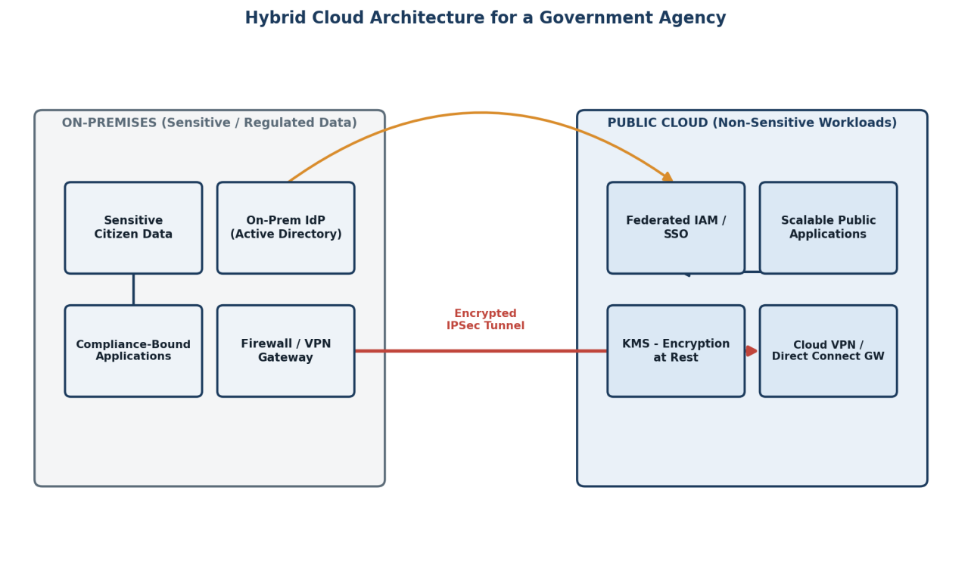
Fig 4.1 – Hybrid cloud architecture separating sensitive on-premises workloads from public-cloud workloads

Question 5: High Availability and Fault Tolerance for a SaaS Application
Scenario: A SaaS provider needs high availability and fault tolerance so the application keeps operating even if one region goes down.
[Marks: 5]
(a) Multi-Region Deployment Strategy
- Deploy the application stack (app servers, databases, caches) identically in at least two geographically separate cloud regions — an active region serving live traffic and a second active or standby region ready to take over.
- Use an active-active model where both regions serve traffic simultaneously (best resource utilisation, near-zero failover time) or active-passive where the second region stays warm/idle until needed (simpler consistency model).
- Front the regions with a global traffic manager/DNS that performs continuous health checks and routes users based on latency and region health.
(b) Data Replication and Failover Configuration
- Configure synchronous replication within a region (for strong consistency on critical data) and asynchronous cross-region replication (to keep the secondary region's data near-current without adding latency to every write).
- An automated failover controller continuously evaluates region health; on detecting a regional outage it promotes the replica database to primary and updates the global traffic manager to redirect all users to the healthy region.
- Design applications to be stateless where possible (session state in a distributed cache, not local memory) so any region can serve any user's request after failover.
(c) Monitoring and Alerting for Proactive Issue Detection
- Continuous synthetic health checks and real-user monitoring (RUM) track latency, error rates, and availability per region.
- Centralized logging and metrics dashboards (e.g., Prometheus/Grafana or cloud-native monitoring) aggregate signals from all regions into one pane of glass.
- Threshold- and anomaly-based alerts notify on-call engineers before users are significantly impacted, and automated runbooks can trigger failover without waiting for manual action.
- Regular chaos-engineering drills (deliberately failing a region) validate that failover and alerting actually work as designed.
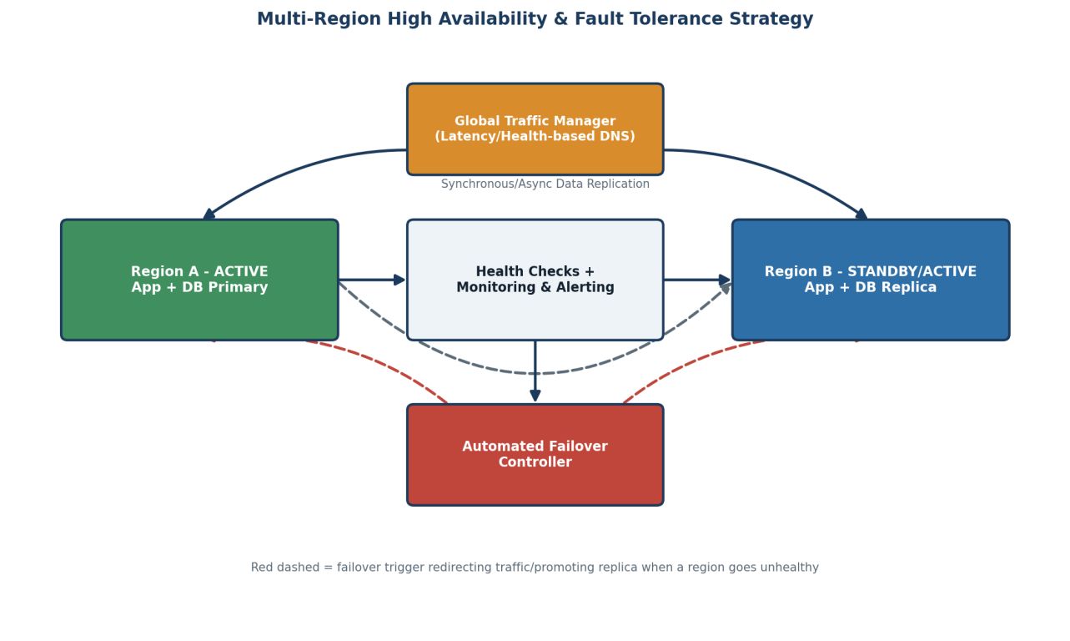
Fig 5.1 – Multi-region active-active deployment with replication, failover, and monitoring

