SIMATS ENGINEERING
ASSESSMENT TOOL 2: CASE STUDY
Course Name: Cloud Computing and Big Data Analytics Course Code: CSA1513
Course Outcome (CO3): Implement cloud-based solutions using cloud storage, web APIs, and platform services for real-world applications. (BL3)

Case Study 1: Smart Retail Inventory Management System
A retail chain implements a cloud-based inventory system connected to store devices, with clients (POS systems and dashboards) communicating via APIs to centralized cloud services. Cloud storage holds product data, transaction logs, and analytics datasets. Platform services drive analytics and demand forecasting, while VPNs, firewalls, and API gateways secure access.
1. Understanding of the Case
The system integrates three cloud service layers to support real-time retail operations:
- Client layer: POS terminals at each store and management dashboards generate and consume inventory data continuously.
- Service layer: Web APIs act as the communication bridge between distributed store devices and centralized cloud services, decoupling clients from backend implementation.
- Platform layer: Managed analytics and forecasting services process transaction data to predict demand and optimize stock levels.
- Storage layer: Cloud storage persists product catalogs, transaction logs, and analytics datasets with durability and scale.
2. Application of Cloud Concepts and Tools
- IaaS/PaaS mix: Compute for API hosting can run on managed container services (e.g., Kubernetes/App Service), while analytics and forecasting use PaaS offerings (e.g., managed ML/analytics platforms) to avoid infrastructure overhead.
- Cloud storage: Object storage (e.g., Amazon S3 / Azure Blob) for transaction logs and analytics datasets; a managed relational or NoSQL database for structured product/inventory data.
- Web APIs: A RESTful API Gateway exposes endpoints for stock updates, sales transactions, and dashboard queries, enabling each POS device to sync independently.
- Security: API Gateway performs authentication/rate-limiting; VPN connects store networks privately to the cloud VPC; firewalls restrict inbound/outbound traffic to required ports only.
3. Analysis and Trade-offs
- Consistency vs. availability: Inventory counts across stores favor eventual consistency for high availability during peak hours, with periodic reconciliation jobs to correct drift.
- Cost vs. performance: Using PaaS analytics reduces operational effort but costs more per compute-hour than self-managed VMs; justified here since demand forecasting is not constant, so pay-per-use PaaS is more economical than idle dedicated servers.
- Latency: Edge caching or regional API endpoints near stores reduce round-trip latency for POS transactions compared to a single centralized region.
- Security vs. convenience: VPN + firewall adds setup complexity but is essential given sensitive transaction and customer data flowing from public store locations.
4. Solution Design
Proposed layered architecture (see diagram below):
- Store POS/dashboards connect over a VPN tunnel into the cloud Virtual Private Cloud (VPC).
- An API Gateway authenticates requests (API keys / OAuth tokens) and routes them to backend microservices.
- Inventory and transaction microservices write to cloud storage (object store for logs, database for live stock records).
- A platform analytics service consumes stored data on a schedule to generate demand forecasts, feeding results back to dashboards via the same API layer.
- Firewalls restrict access to the VPC; only the API Gateway is internet-facing.
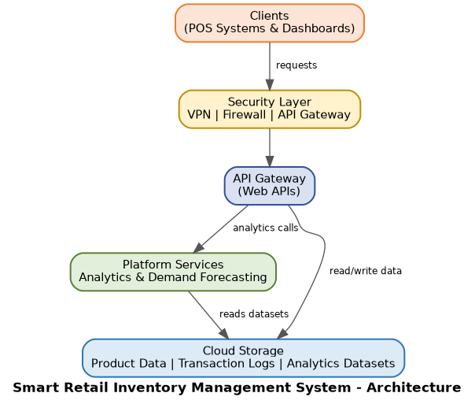
Figure 1: Block diagram — Smart Retail Inventory Management System
5. Clarity / Summary
This design cleanly separates client devices, secured communication, API-driven services, analytics, and storage, allowing the retail chain to scale store locations independently while keeping data centralized, secure, and analytics-ready.

Case Study 2: Cloud-Based Document Collaboration System
An enterprise deploys a Google-Docs-like collaboration tool. Users access it via browsers for real-time editing and sharing. Documents live in distributed cloud storage with version control. Web APIs synchronize clients/devices, global network infrastructure ensures low latency and high availability, and security relies on encryption, identity management, and access permissions.
1. Understanding of the Case
- Client layer: Multiple simultaneous browser sessions across devices and locations edit shared documents.
- Synchronization layer: Web APIs propagate edits between clients in near real time, requiring conflict resolution for concurrent edits.
- Storage layer: Distributed cloud storage keeps document content along with version history for rollback and audit.
- Network layer: A globally distributed infrastructure (CDN / multi-region deployment) keeps latency low for geographically spread users.
2. Application of Cloud Concepts and Tools
- Real-time sync: WebSocket-based APIs (or long-polling) push incremental changes (operational transforms / CRDTs) between clients instead of full-document reloads.
- Distributed storage: Object storage with multi-region replication (e.g., S3 Cross-Region Replication) plus a metadata database tracking document versions and ownership.
- Version control: Each edit is stored as an immutable delta/snapshot, enabling users to view history and restore prior versions.
- Global delivery: A CDN and multi-region API deployment route each user to the nearest edge, reducing round-trip latency.
- Security: TLS encryption in transit, at-rest encryption for stored documents, an Identity and Access Management (IAM) service for authentication, and per-document access control lists for sharing permissions.
3. Analysis and Trade-offs
- Consistency vs. responsiveness: Real-time collaborative editing favors eventual consistency with conflict-resolution algorithms (CRDT/OT) over strict locking, which would block concurrent users.
- Storage cost vs. version depth: Keeping full version history for every edit increases storage cost; a trade-off is to store periodic snapshots plus deltas rather than every keystroke.
- Latency vs. global reach: Multi-region replication improves latency and availability but adds replication lag and cost; justified because collaboration quality depends heavily on responsiveness.
- Security vs. usability: Fine-grained per-document permissions add management overhead but are necessary for enterprise data governance.
4. Solution Design
- Browser clients connect through an authenticated session (IAM) over HTTPS/WebSocket.
- Edits are sent as small delta operations to Web APIs, which broadcast them to all active collaborators on that document.
- A synchronization service resolves conflicting simultaneous edits using operational transformation/CRDT logic.
- Confirmed edits are persisted to distributed cloud storage with a version entry; global network infrastructure replicates data across regions for availability.
- Access permissions are checked on every read/write request against the document's ACL.
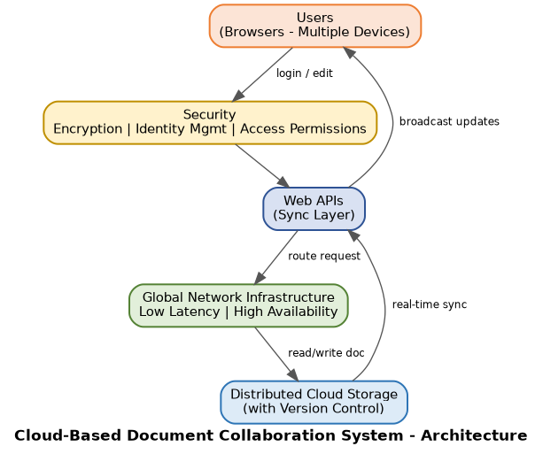
Figure 2: Block diagram — Cloud-Based Document Collaboration System
5. Clarity / Summary
The design supports real-time multi-user editing through API-driven synchronization, keeps a durable and versioned record of documents in distributed storage, and protects data with encryption and identity-based access control across a globally available network.

Case Study 3: Online Food Ordering Platform
A startup builds a cloud-based food ordering system accessible via web and mobile clients. Frontend clients call backend services through RESTful Web APIs on a cloud platform. Cloud storage holds menu images, invoices, and customer data. Virtual machines and managed Kubernetes provide scalability and reliability. Security uses authentication tokens, HTTPS, and role-based access control (RBAC).
1. Understanding of the Case
- Client layer: Web browsers and mobile apps place orders, browse menus, and track order status.
- API layer: RESTful Web APIs expose endpoints for menu browsing, cart management, order placement, and payment.
- Compute layer: Backend services run on virtual machines and are orchestrated by managed Kubernetes for autoscaling during demand spikes (e.g., meal-time surges).
- Storage layer: Cloud storage keeps menu images (object storage), invoices (document/object storage), and customer data (database).
2. Application of Cloud Concepts and Tools
- Compute: Managed Kubernetes (e.g., EKS/AKS/GKE) hosts containerized microservices (order, payment, restaurant, delivery) on top of VM node pools, enabling horizontal autoscaling.
- APIs: REST endpoints (e.g., /menu, /orders, /payments) with JSON payloads, consumed identically by web and mobile clients.
- Storage: Object storage for static menu images (served via CDN), a relational database for orders/customers, and a document store or object storage for invoice records.
- Security: OAuth2/JWT authentication tokens validate every API call; HTTPS encrypts all traffic; RBAC restricts actions by role (customer, restaurant admin, delivery agent, platform admin).
3. Analysis and Trade-offs
- Scalability vs. cost: Kubernetes autoscaling handles meal-time traffic spikes without permanently over-provisioning VMs, trading some cold-start latency for lower steady-state cost.
- Consistency: Order and payment data require strong consistency (relational database with transactions), whereas menu images can tolerate eventual consistency via CDN caching.
- Security vs. performance: Validating JWT tokens on every request adds minor latency but is necessary to prevent unauthorized order/payment actions.
- Reliability: Managed Kubernetes provides self-healing (auto-restarting failed containers), improving availability over a single-VM deployment, at the cost of added orchestration complexity.
4. Solution Design
- Web/mobile clients authenticate and receive a token, then call RESTful APIs over HTTPS.
- The API layer routes requests to the relevant microservice running in a Kubernetes-managed VM cluster.
- Order/customer data is written to a transactional database; menu images and invoices are written to cloud object storage.
- RBAC policies at the API layer restrict which operations each authenticated role can perform.
- Kubernetes autoscaling adds VM/pod capacity automatically as order volume rises.
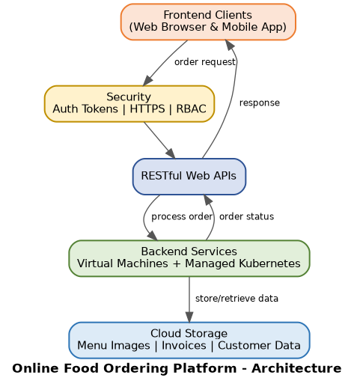
Figure 3: Block diagram — Online Food Ordering Platform
5. Clarity / Summary
The architecture cleanly separates client apps, a secured REST API layer, scalable Kubernetes-orchestrated backend services, and purpose-fit cloud storage, meeting the startup's need for reliability, scalability, and secure handling of customer and payment-related data.

